Software Package Document eXchange (SPDX™) Tools

Version 1.0 Beta

Please send your comments and suggestions for this document to:
spdx-tech@fossbazzar.org
Table of Contents
Table of Contents 2
Preface 3
1 Introduction 4
2 Creating SPDX Content 4
2.1 Populating a Spreadsheet with SPDX Content 4
2.2 Populating a RDF-formatted SPDX Document 7
2.3 Populating a Tag/Value-formatted SPDX Document 8
2.4 Writing your own Tools 8
3 Open Source Tools for SPDX Creation 8
3.1 Available Tools 9
3.1.1 SPDX Viewer 9
3.1.2 SPDX Translator 9
3.2 Contributing to SPDX Tools 10
4 Using the SPDX Tools 10
4.1 SPDX Viewer 10
4.2 SPDX Translator 11
4.2.1 Converting a Spreadsheet to a SPDX document 11
4.2.2 Converting a SPDX Document to a Spreadsheet 11
4.3 SPDX Tool Javadoc 12
5 Notices 13

Preface
Intended Audience
This manual is designed to help users become familiar with the tools available for viewing SPDX documents and for converting RDF formatted SPDX documents into spreadsheet format and converting spreadsheets with formatted SPDX content into SPDX documents.

Contents Overview
Section 1: Introduction—Provides a brief overview of the SPDX standards organization and the SPDX specification.
Section 2: Creating SPDX Content—Describes how to create SPDX documents
Section 3: Open Source Tools for SPDX Creation
Section 4: Using SPDX Tools—Describes how to use the SPDX tools.
Section 5: Notices—Copyright and license information

Related Documents
The following related documents are available:
- The current version of the SPDX Specification is available here:
  - http://spdx.org/spec/current
- The current list of SPDX standard licenses is available here:
  - http://spdx.org/licenses/
- RDF vocabulary (an OWL ontology) for expressing SPDX as RDF is available here:
  - http://spdx.org/rdf
The following online resources provide more information about the SPDX Group and how you can participate:
- http://spdx.org/

Introduction
The Software Package Data Exchange (SPDX™) specification “is a standard format for communicating the components, licenses and copyrights associated with a software package. An SPDX file is associated with a particular software package and contains information about that package in the SPDX format.”
You can learn more about the SPDX Group and the SPDX specification here:
- http://spdx.org/
The SPDX Group is hosting a beta program designed to ensure that the SPDX specification meets the needs of its target audience. The SPDX beta program is expected to run between April 2011 and June 2011. Beta participants are organized into pairs, made up of two trading partners that need to communicate license and copyright information about software packages that are shared between the two partners.

Creating SPDX Content
The SPDX Specification supports two formats: RDF/XML and Tag/Value. There are a number of ways that SPDX Documents can be created.
- Tools: Open source and commercial tools are available to create SPDX Documents in the RDF/XML format.
- Spreadsheet: For convenience, the tools can take spreadsheet data as input and can create spreadsheet output from an RDF/XML SPDX Document.
- Write your own: You may also choose to write your own tooling to produce an SPDX Document per the specification.
- Manual: You can edit an existing SPDX Document to reflect the appropriate information for a different package.

Populating a Spreadsheet with SPDX Content
Today, many organizations use spreadsheets to share license data about software packages between different teams in the organization. For this reason, the SPDX Group has provided a spreadsheet template with specific sheet and column names reflecting SPDX Document properties.
The spreadsheet template is provided for convenience and the format is not supported by the specification. The spreadsheet template is available for download here:
- http://spdx.org/tools
If you wish to translate spreadsheet data into an SPDX RDF document, you can use the SPDX Translator tool The Translator tool requires the input spreadsheet be in a very specific format. For translation, the spreadsheet must have the following sheets:
- Origins
  - States the SPDX specification version used for this document
  - Captures information on how the meta data was generated and when.

- Package Info
  - Captures information about the package such as name, download location, license, copyright, and verification data.
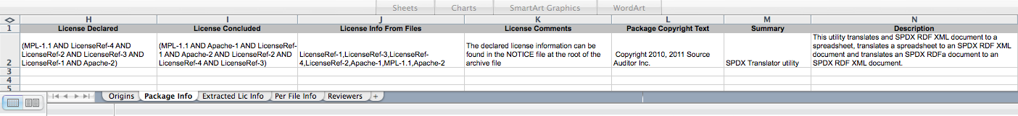

- Extracted Lic Info
  - Captures information for any detected or declared licenses that are not included in the SPDX standard license set.
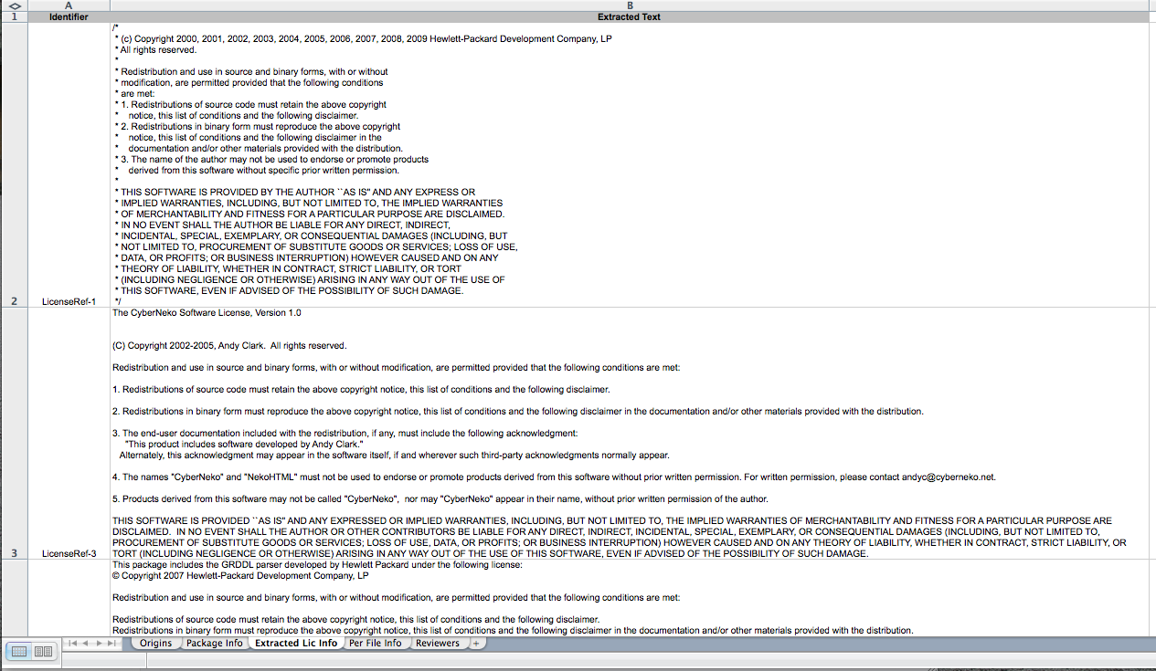

- Per File Info
  - Captures per-file license and copyright text (if any), verification data, and, optionally, indication that a file has been derived from a specific project.
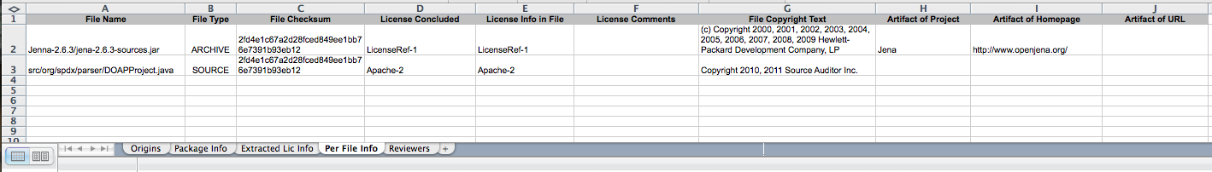

- Reviewers
  - Optional. Captures information from any review of the SPDX Document, such as reviewer, review date and comment.
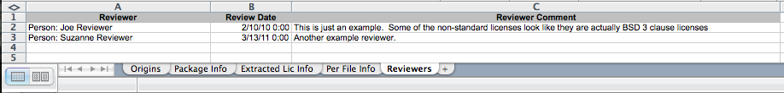

Populating a RDF-formatted SPDX Document
A SPDX Document can also be created and shared in RDF/XML format as shown below.
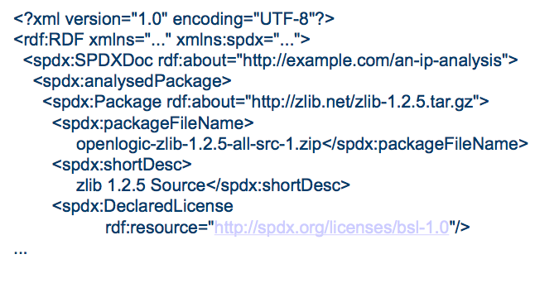

Open source and commercial tools are available to create an RDF-formatted SPDX document. Detailed information about the tools and how to use them is covered in Section 3 of this document.
A RDF-formatted template SPDX document is available here:
- http://spdx.org/tools

Populating a Tag/Value-formatted SPDX Document
You can create an SPDX tag/value format document, as shown below:
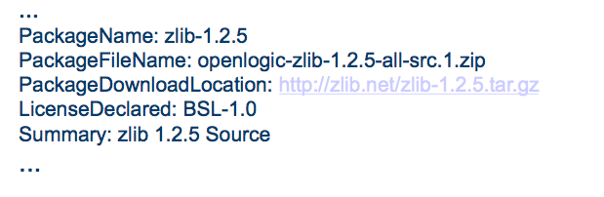
An example Tag/Value-formatted SPDX document is available here:
- http://spdx.org/spec/examples
Note that for Beta, the SPDX Translator does not parse the tag/value format. This functionality is planned for after Beta.

Writing your own Tools
If you are using Java, you may want to look at the open source implementation of the SPDX RDF tools. They contain an implementation of the SPDX object model using Jena to parse and render the RDF documents.

Open Source Tools for SPDX Creation
The SPDX Group has developed some tools to assist with viewing and managing SPDX documents. The tools are intended to:
- Reduce the effort of creating, consuming and validating SPDX Documents
- Provide a translation from the technical document (e.g. RDF/XML or tag-value format) and a more readable format
- Provide a mechanism for validating SPDX documents
- Enable contributions and review of the tool implementation by the broader technical community through open source licensing

Available Tools
Currently, there are two tools available to support the SPDX beta: SPDX Viewer and SPDX Translator. You can download the tools here:
- http://spdx.org/tools

SPDX Viewer
The SPDX Viewer is a command line driven Java application that formats a valid SPDX RDF document into a text file for easier viewing. The SPDX Viewer application validates the SPDX document during formatting and provides Warning messages when parsing issues are encountered. An attempt will be made to create the text file even if validation errors are encountered.
Insert screenshot of output here

SPDX Translator
The SPDX Translator is a command line driven Java application that provides two types of translation. Specifically, the Translator:
- Converts a spreadsheet containing SPDX information into a valid SPDX/RDF file
- Converts a valid SPDX/RDF file into a spreadsheet
The SPDX Translator requires the input spreadsheet be in a very specific format. The SPDX Translator validates the input and provides Warning messages when parsing issues are encountered.

A spreadsheet template with the specific column names and order is available for download here:
- http://spdx.org/tools
When entering license information into the spreadsheet, follow these syntax rules:
- For a standard license, use the short form license ID
- For a non-standard license, use the LicenseRef-N ID as described in the Specification. The same LicenseRef-N must also be present in the “Non Standard Licenses” sheet.
- For a disjunctive license set, enclose the set in parentheses and separate each license reference by “OR” (e.g. (Apache-2 OR LicenseRef-2))
- For a conjunctive license set, enclosed the set in parentheses and separate each license reference by “AND” (e.g. Apache-2 AND LicenseRef-2))
  - Note: A disjunctive or conjunctive license set can include a reference to another license set (e.g. (Apache-2 OR (LicenseRef-1 AND LicenseRef-2)))
- For columns where there are multiple license references allowed (License Info from Files and License Info in File), the license references are separated by comma’s (e.g. Apache-2, LicenseRef-1, Apache-1, LicenseRef-2).

Contributing to SPDX Tools
A GIT repository for SPDX tools can be found at:
- http://git.linuxfoundation.org/spdx-tools.git/
Contributions and suggestions are welcome. Report any defects or suggest any improvements to:
- http://bugs.linux-foundation.org
You can sign up for a bugzilla account at https://bugs.linux-foundation.org.
You can also contribute to development of the SPDX specification by joining the SPDX group. Click on the Participation link on the SPDX home page at http://spdx.org to get started.

Using the SPDX Tools
You can download the SPDX tools here:
- http://spdx.org/tools
Once you’ve downloaded the application, unzip the files in your preferred location.
- Unzip <filename> into your preferred location
- Make sure you have JRE version 1.6 installed. (JRE version 1.5 may work, but has not been tested.)

SPDX Viewer
The SPDX Viewer is a command line driven Java application that formats a valid SPDX RDF document into a text file for easier viewing. The SPDX Viewer validates the SPDX document during formatting and provides error messages when parsing issues are encountered.
Execute the SPDXViewer.jar with a single text parameter of a file path for the SPDX RDF document. For example, on Windows:
- Copy the example RDF file into the same directory with the SPDX Viewer application
- cd to the directory with the Viewer application and run the tool which the following command
- java –jar SPDXViewer.jar examples\zlib-1.2.5.spdxv3.rdf

Insert graphic here

SPDX Translator
The SPDX Translator is a command line driven Java application that provides two types of translation. Specifically, the Translator:
- Converts a spreadsheet containing SPDX information into a valid SPDX/RDF file
- Converts a valid SPDX/RDF file into a spreadsheet
- Converts from HTML/RDFa to SPDX/RDF … need to add section
- Converts from SPDX/RDF to HTML/RDFa …… need to add section below

Converting a Spreadsheet to a SPDX document
You can use the Translator to translate a spreadsheet to an SPDX RDF document. The SPDX Translator requires the input spreadsheet be in a very specific format. A spreadsheet template with the specific column names and order is available for download here:
- http://spdx.org/tools
Usage: SpreadsheetToRDF <spreadsheetfile.xls> <rdfxmlfile.rdf> where spreadsheetfile.xls is a valid SPDX Spreadsheet and rdfxmlfile.rdf is the output SPDX RDF document file. For example:
- Copy the example spreadsheet file into the same directory with the Translator application
- cd to the directory with the Translator application and run the tool which the following command
- java –jar SPDXTranslator.jar SpreadsheetToRDF <spreadsheetfile.xls> <rdfxmlfile.rdf>

Converting a SPDX Document to a Spreadsheet
You can use the Translator to translate a RDF XML file to an SPDX spreadsheet format. An example RDF file can be found here:
- http://spdx.org/spec/examples
Usage: RdfToSpreadsheet rdfxmlfile.rdf spreadsheetfile.xls where rdfxmlfile.rdf is a valid SPDX RDF XML file and spreadsheetfile.xls is the output SPDX spreadsheeet file. For example:
- Copy the example RDF file into the same directory with the Translator application
- cd to the directory with the Translator application and run the tool which the following command
- java –jar SPDXTranslator.jar RdfToSpreadsheet <rdfxmlfile.rdf> <spreadsheetfile.xls>

Insert graphic here

SPDX Tool Javadoc
Javadoc for the SPDX tools can be found here:
- http://spdx.org/tools/docs/javadocs

Notices
The SPDX Tools contain the following copyrights and notices:
Copyright 2010, 2011 Source Auditor Inc.

Licensed under the Apache License, Version 2.0 (the "License"); you may not use this file except in compliance with the License. You may obtain a copy of the License at
http://www.apache.org/licenses/LICENSE-2.0
Unless required by applicable law or agreed to in writing, software distributed under the License is distributed on an "AS IS" BASIS, WITHOUT WARRANTIES OR CONDITIONS OF ANY KIND, either express or implied. See the License for the specific language governing permissions and limitations under the License.

This package includes software from Jenna under the following License:
(c) Copyright 2000, 2001, 2002, 2003, 2004, 2005, 2006, 2007, 2008, 2009 Hewlett-Packard Development Company, LP
All rights reserved.
Redistribution and use in source and binary forms, with or without modification, are permitted provided that the following conditions are met:
1. Redistributions of source code must retain the above copyright notice, this list of conditions and the following disclaimer.
2. Redistributions in binary form must reproduce the above copyright notice, this list of conditions and the following disclaimer in the documentation and/or other materials provided with the distribution.
3. The name of the author may not be used to endorse or promote products derived from this software without specific prior written permission.
THIS SOFTWARE IS PROVIDED BY THE AUTHOR ``AS IS'' AND ANY EXPRESS OR IMPLIED WARRANTIES, INCLUDING, BUT NOT LIMITED TO, THE IMPLIED WARRANTIES OF MERCHANTABILITY AND FITNESS FOR A PARTICULAR PURPOSE RE DISCLAIMED. IN NO EVENT SHALL THE AUTHOR BE LIABLE FOR ANY DIRECT, INDIRECT, INCIDENTAL, SPECIAL, EXEMPLARY, OR CONSEQUENTIAL DAMAGES (INCLUDING, BUT NOT LIMITED TO, PROCUREMENT OF SUBSTITUTE GOODS OR SERVICES; LOSS OF USE, DATA, OR PROFITS; OR BUSINESS INTERRUPTION) HOWEVER CAUSED AND ON ANY THEORY OF LIABILITY, WHETHER IN CONTRACT, STRICT LIABILITY, OR TORT (INCLUDING NEGLIGENCE OR OTHERWISE) ARISING IN ANY WAY OUT OF THE USE OF THIS SOFTWARE, EVEN IF ADVISED OF THE POSSIBILITY OF SUCH DAMAGE.

This package includes the GRDDL parser developed by Hewlett Packard under the following license:
© Copyright 2007 Hewlett-Packard Development Company, LP
Redistribution and use in source and binary forms, with or without modification, are permitted provided that the following conditions are met:
Redistributions of source code must retain the above copyright notice, this list of conditions and the following disclaimer.
Redistributions in binary form must reproduce the above copyright notice, this list of conditions and the following disclaimer in the documentation and/or other materials provided with the distribution.
The name of the author may not be used to endorse or promote products derived from this software without specific prior written permission.
THIS SOFTWARE IS PROVIDED BY THE AUTHOR ``AS IS'' AND ANY EXPRESS OR IMPLIED WARRANTIES, INCLUDING, BUT NOT LIMITED TO, THE IMPLIED WARRANTIES OF MERCHANTABILITY AND FITNESS FOR A PARTICULAR PURPOSE ARE DISCLAIMED. IN NO EVENT SHALL THE AUTHOR BE LIABLE FOR ANY DIRECT, INDIRECT, INCIDENTAL, SPECIAL, EXEMPLARY, OR CONSEQUENTIAL DAMAGES (INCLUDING, BUT NOT LIMITED TO, PROCUREMENT OF SUBSTITUTE GOODS OR SERVICES; LOSS OF USE, DATA, OR PROFITS; OR BUSINESS INTERRUPTION) HOWEVER CAUSED AND ON ANY THEORY OF LIABILITY, WHETHER IN CONTRACT, STRICT LIABILITY, OR TORT (INCLUDING NEGLIGENCE OR OTHERWISE) ARISING IN ANY WAY OUT OF THE USE OF THIS SOFTWARE, EVEN IF ADVISED OF THE POSSIBILITY OF SUCH DAMAGE.

The Jena GRDDL Reader is built on top of other sub-systems which we gratefully acknowledge:
The Saxon XSLT and XQuery Processor from Saxonica Limited
This is distributed under Mozilla Public License Version 1.0 . The version used is Saxon B 8.8; source and binary versions are available from the Saxon download area on SourceForge
CyberNeko HTML Parser
The version used is 0.9.5. It is redistributed, in binary form, under The CyberNeko Software License, Version 1.0.
BrowserLauncher2
The version used is 1.0. It is redistributed, in binary form, under the GNU Lesser GENERAL PUBLIC LICENSE. Each source file is copyrighted separately, please download the source code for details.
BrowserLauncher2 is distributed in the hope that it will be useful, but WITHOUT ANY WARRANTY; without even the implied warranty of MERCHANTABILITY or FITNESS FOR A PARTICULAR PURPOSE. See the GNU Lesser General Public License for more details. See also the Jena license and its list of subsystems.
This package includes software developed by the
Apache Software Foundation (http://www.apache.org/).

