

**FACULTY OF COMPUTING AND INFORMATICS**

**BACHLEOR IN COMPUTER SCIENCE**

**DATA VISUALISATION – CDS6324**

**TRIMESTER 1, Session 2024/2025**

**ASSIGNMENT 2**

**A Visual Analysis of Data Science Job Salaries**

**Tutorial Section TT6L**

|  |  |  |
| --- | --- | --- |
| **Student ID** | **Student Name** | **Student Email** |
| **1211101619** | **Nik Syareena Aida Binti Nik Ahmad Faizul** | **1211101619@student.mmu.edu.my** |
| **1211103984** | **Nur Afreen Junaidah Binti Noorul Ameen Mohamed Eliyas** | **1211103984@student.mmu.edu.my** |

Table of Contents

1. Dataset Description 3

2. Most Interesting Visualisations 3

3. Trends, Patters or Relationships 6

4. Possible Story or Explanation 7

References 8

# **Dataset Description**

We utilised a dataset of Data Science Job Salaries from the year 2020-2025 (sourced from Kaggle), containing around 100,000 records. It includes details such as job title, salary in USD, employment type, and other useful features for analyzing trends in roles and salary dynamics.

# **Most Interesting Visualisations**

* Remote Ratio Distribution in US

Figure 2.1

Figure 2.2

Based on Figure 2.1 and 2.2, we found the shift from remote and hybrid roles in 2020 to predominantly on-site roles by 2025 to be both interesting and somewhat unexpected, particularly within the U.S. data science job market. Given that data science is a tech-oriented field where most tasks can be done remotely, we initially assumed that the flexibility brought on by the COVID-19 pandemic would lead to a lasting adoption of remote and hybrid work arrangements.

In the early years, this seemed to be the case—remote roles percentage increased notably from 2020 through 2022, likely as a necessary response to lockdowns and health concerns. Interestingly, the absolute number of remote jobs continues to increase year by year, but their percentage share has declined because the growth in on-site roles has been even greater. By 2025, on-site positions make up the majority of job listings, even though remote roles are still growing in count.

We assume that as pandemic restrictions eased, many companies appeared to return to pre-pandemic norms, favouring in-person work. This may be driven by several factors, including leadership preferences, a desire for face-to-face collaboration, or concerns over productivity and team cohesion in fully remote environments. It's also possible that certain organizational cultures or industries within the U.S. were simply not ready to fully commit to remote work in the long term.

Overall, while remote work initially surged during the height of the pandemic, its share of total roles has since declined—not because remote opportunities are shrinking, but because on-site roles have grown even more rapidly. This visualization shows that flexible work is still on the rise in absolute terms, but hasn’t overtaken traditional in-person setups in the U.S. data science field. It also suggests that remote adoption is growing steadily, though its pace and extent still depend heavily on company policies, industry norms, and the specific requirements of each role.

* 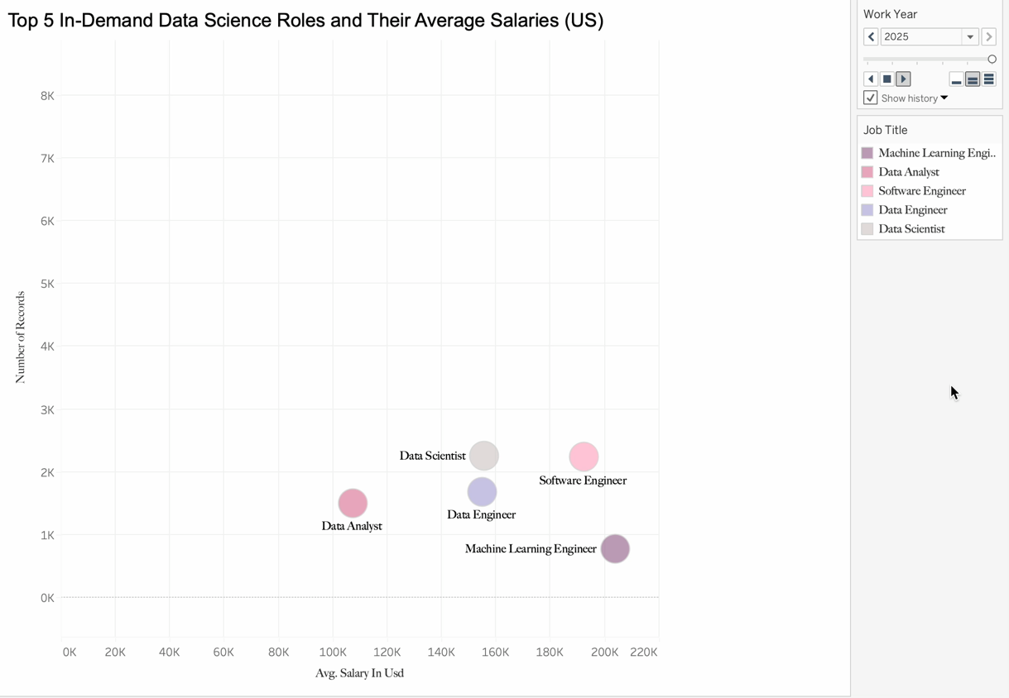Top 5 In-Demand Data Science Roles and Their Average Salaries in US

Figure 2.3 (double click to play)

Figure 2.3 deemed particularly interesting and insightful to us as it shows how the top 5 in demand jobs evolve through out the years. There is a notable increase in the demand for the top five job roles after 2021, which likely reflects the growing importance of data-driven decision-making across industries. As companies recovered from the pandemic, many began investing more in digital transformation, automation, and AI— all of which require skilled data professionals.

What’s also interesting is the way these roles are ranked relative to each other. Data Scientist, Software Engineer and Data Engineer are consistently at the top, which makes sense given how foundational they are in any data team—from model building to managing large-scale infrastructure. In comparison, Data Analyst and Machine Learning Engineer tend to appear lower within the top five. This could be because Data Analysts often handle reporting, visualisation tasks and having entry requirements that don’t scale the same way as engineering or science roles. Meanwhile, Machine Learning Engineers, although highly skilled, are more specialised and often found in companies that are further along in AI adoption. This helps explain why their job volume might be smaller, even though the demand for the role is growing steadily.

An especially noteworthy change that we noticed is the sudden appearance of the Software Engineer role in 2024, which positions itself between Data Scientist and Data Engineer in terms of demand. This shift may indicate a growing overlap between software development and data science, particularly as more companies seek to operationalize AI and machine learning models. We considered that the demand for Software Engineers could be driven by the need for professionals who can integrate data pipelines, model outputs, and product environments—essentially bridging the gap between traditional engineering and data science roles. It also reflects how software engineering itself is evolving to include more data-centric and AI-related responsibilities.

The visualisation also highlights the dynamic nature of the data science field- some roles remain stable in demand while others grow rapidly, indicating evolving industry needs and priorities. It’s important to note that the slight dip in 2025 isn’t necessarily a decline in demand, but rather a result of the dataset only capturing job listings up to March 2025. Hence, the full picture of that year isn’t represented.

All in all, this chart gives a clear view of where the data science job market is heading, and which roles are gaining the most momentum. It's helpful not only for understanding industry trends but also for identifying which skill sets are increasingly valued in the field.

# **Trends, Patters or Relationships**

The dashboard reveals a consistent upward trend in the average salary for data science roles in the U.S. from 2021 to 2024, peaking at $164,887 before a slight decline in 2025. The U.S leads global demand for data science talent, followed by Canada and the United Kingdom. On-site positions dominate the employment landscape (79%) and also offer the highest average salary. Among the top job titles, Data Scientist, Data Engineer and Software Engineer stand out with both high pay and strong demand, as illustrated by their positions in the scatter plot.

# **Possible Story or Explanation**

From 2021 to 2024, average salaries for data science roles steadily climbed, reflecting how companies increasingly relied on data and AI to make smarter decisions. While 2025 shows a slight dip, it’s likely just due to incomplete data, since figures only cover the first few months of the year. Most roles are still on-site, and they also tend to pay the most—perhaps because businesses value in-person teamwork or secure data environments. The U.S. clearly leads in job demand, which fits with its strong tech presence, while Canada and the UK are emerging as growing markets. Among all roles, Data Scientist , Data Engineer and Software Engineer continue to stand out. They’re well paid and highly sought after likely because they sit at the core of innovation—turning raw data into insights and building the systems that power everything from apps to analytics. In this era, their impact is hard to overstate.

# **References**

Team, I. Q. (2024, October 23). *15 Highest Paying Data science Jobs in 2025: Data Science Salary Insights*. Interview Query. <https://www.interviewquery.com/p/highest-paying-data-science-jobs>

Staff, C. (2025b, January 6). *6 In-Demand Data Scientist jobs in 2025*. Coursera. https://www.google.com/aclk?sa=L&ai=DChcSEwi2ufaSzKSNAxVAo2YCHd-mD2oYABAAGgJzbQ&co=1&gclid=CjwKCAjw_pDBBhBMEiwAmY02NqvTgMojIeHQs7mXboGaGBXm4yMHFHaZZXyB-4WpMla1EXDdX9jpzRoCSl4QAvD_BwE&cce=1&sig=AOD64_1Oiv6uV18SiA8fHqXlw2OZ0Ciccg&q&adurl&ved=2ahUKEwjK2fCSzKSNAxUTnGMGHWtVAKwQ0Qx6BAgqEAE