Vessel-Scheduling

**Story –**

We are exploring the optimum scheduling scheme for vessel movement in Houston Ship Channel (HSC) in order to minimize the traffic delay in the channel. We considered 3 restrictions in this optimization model:

1. Width restriction
2. Daylight restriction
3. Channel closure.

The data were provided by Houston Pilots. I used PuLP package in Python and applied genetic algorithm to find the best scheduling scheme with minimum delay.

**Screenshots –**

The following is the snippet of the transit dataset.

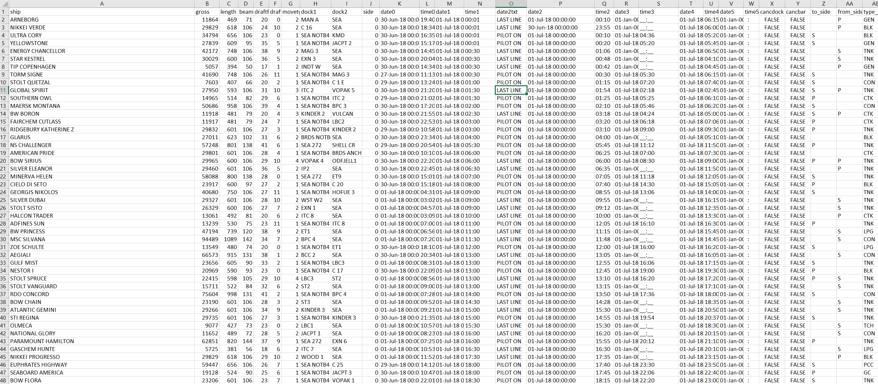

**Final result –**

The output of this model will be the optimum scheduling scheme for vessel movement.

**GitHub Repository –**

This is the link to our GitHub repository:

<https://github.com/spdzh/Ship-Movement-Scheduling/blob/main/Vessel-Scheduling.ipynb>