MnM Fighter Rework

SUMMARY

MnM’s current version of the Fighter lacks a distinct and cohesive class identity. By augmenting two of the class-specific systems already present on Fighter– Berserk and Stances – we are able to create a versatile tank/brawler with a playstyle that is both familiar but unique to the MnM class catalog.

DESIGN GOALS

1) Create an identity comprised of elements already present and unique to the Fighter
2) Develop a more engaging and dynamic playstyle that is thematic with Fighter’s identity
3) Ensure Fighter fills the role of tank/dps while offering a distinct play experience from other tanks

Balance is a critical component of class design but is not the primary focus of this document.

PROPOSED CHANGES

The Fighter’s abilities are modified to interact with the following three stances:
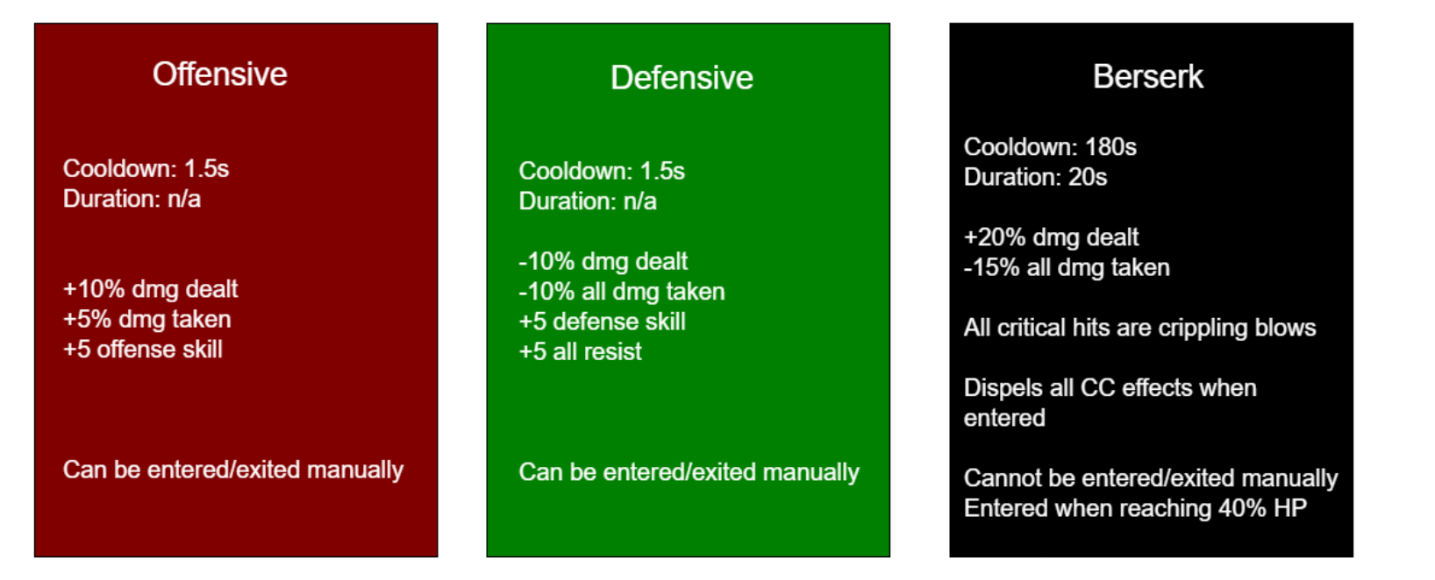
- 7-ability stancebar for each stance
- Abilities have different effects depending on the stance they are used in
- Only the active stance's hotbar is visible
- Abilities share CDs across different stances
- Any ability can be assigned to Offensive and/or Defensive Stance
- Berserker stancebar can only contain abilities already bound to Offensive or Defensive Stance
MODIFIED ABILITIES

*Indicates a new ability
Values for abilities are for illustrative purposes only.

Ability | Offensive Stance Effect | Defensive Stance Effect | Berserker Stance Effect
Double Down* | Cooldown: 180s  Duration: 20s  Offensive Stance effect replaced with:  +25% dmg dealt  +10% all dmg taken  +15% threat generated  +10 offensive skill  Offensive Stance cannot be manually exited during this effect. | Cooldown: 180s  Duration: 20s  Defensive Stance effect replaced with:  -20% dmg dealt  -25% all dmg taken  +10 defense skill  +10 all resist  Defensive Stance cannot be manually exited during this effect. | Double Down is not usable in Berserker Stance.
Riposte* | Passive Skill  Chance to riposte a melee attack, avoiding it and counterattacking with your mainhand weapon. | Passive Skill  Chance to riposte a melee attack, avoiding it and counterattacking with your mainhand weapon. | Passive Skill  Chance to riposte a melee attack, avoiding it and counterattacking with your mainhand weapon.
Kick | 3 yard pushback  25% Weapon Damage Ratio (WDR)  1s stun if target is movement impaired | 2s immobilize | +100% Weapon Damage Ratio (WDR)  2s immobilize
Battle Cry | No changes | Commanding Cry: +15sta instead of str | Duration: 60s  Berserker’s Cry: +15str +15sta  Overwrites Battle/Commanding Cry  (cannot be overwritten by battle/commanding cry)
Charge | 1s stun instead of immobilize | Charges an ally within range  Applies protective barrier on ally equal to 10% of current HP. Lasts 4s. | Charges an enemy  3s stun within 8y area of target
Unnerving Shout | Decreases enemy phys dmg 2%, stacks 3 times | Decreases enemy phys dmg 2%, stacks 3 times  Increases your ac by 10, stacks 3 times | Crippling Shout: Decreases enemy physical damage by 10%, stacks once  Overwrites Unnerving Shout  If enemy already has 3 stacks of Unnerving Shout, decreases ALL enemy dmg by 10% instead.
Armor Break | Adds 25% WDR against targets that already have 3 stacks of armor break applied. (3rd hit applies this damage) | Slows the target by 5% for 5s against targets that already have 3 stacks.  Slow stacks with everything | Applies 3 stacks at once  Slows enemy attack by 10% for 10s  Stacks w/ everything except armor break slow
Distracting Taunt | 1s silence | 3s 20% snare | +10% chance to riposte for 8s  All ripostes double attack for 8s
Intimidation | You party gains +10% movespeed for 5s | 3s 20% snare | 3s 20% snare  Dispel 2 beneficial buffs on enemies
Clobber | 6s stun | 6s stun | 6s stun  100% WDR
Defense | +40% PDR for 30s  Breaks CC  Immune to CC for 3s | +40% PDR for 30s  +20% MDR for 30s  30s 20% snare on self (undispellable) | +40% PDR for 30s  +20% MDR for 30s  Breaks CC  Extends Berserk by 10s
Frenzy | No changes | No 10% attack speed buff  Healing on you increased by 10% for 20s | DMG is 40% - 80% instead of 20% -40%  Rend has 40% chance to reset
Shield Bash | DMG scales with shield AC  Dispels 1 beneficial buff from enemy  Dispels 2 buffs from enemy (40+) | DMG scales with shield AC  Dispels 1 debuff from self | DMG scales with shield AC  3s Stun  Rend has 20% chance to reset
Final Stand | Usable while CCed  Increase max hp by 15% for 30s  Enter Berserker Stance | Usable while CCed  Increase your party’s max hp by 20% for 30s | Increase max hp by 30% for 30s  Heals self for 50% max hp  Cannot be healed for 30s
Merciless Assault | Removed | Removed | Removed
Disarm | You deal +10% dmg to the target for 8s | +10% chance to riposte target for 8s | Enemy takes +10% dmg from all sources for 8s
Rallying Shout | Removed | Removed | Removed
Taunt | If hit by target in next 3s, reduce cd of Charge by 3s (max 5s) | Take -10% all damage from the target for the next 3s. | AOE taunt  Snare yourself and all targets around you by 20% for 3s  -10% all damage taken for the next 3s
Rend | 50% chance to apply a 30s bleed equal to 50% of damage dealt, stacks 3 times | Gain buff “Unflinching”  2% increased chance to Riposte, stacks 3 times  Buff lasts 15s | Consumes your Rend bleeds on target  Adds remaining bleed damage to attack  100% chance to riposte all melee attacks  Consumes Unflinching stacks  Lasts 2s plus 1s per stack of Unflinching

GAMEPLAY

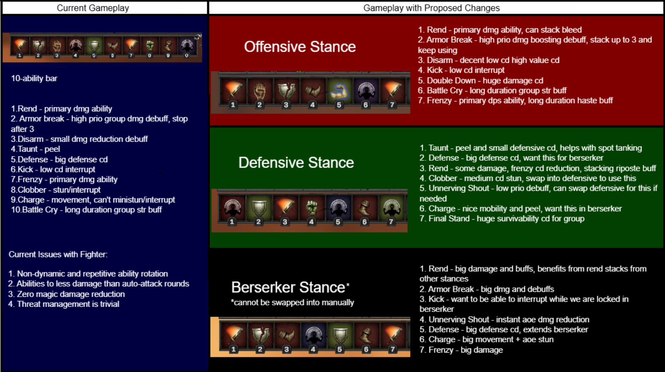
The example below demonstrates a dps-oriented ability loadout and should not be considered the optimal setup for all scenarios.
In the reworked version of Fighter, abilities like Kick and Charge have secondary uses, Unnerving Shout and Armor Break are useful beyond their first/third cast, and abilities like Rend and Frenzy can build up debuffs and stacks. These changes give the Fighter impactful ability choices even when Rend and Frenzy are on cooldown.

CONCLUSION

This reworked version of the Fighter has a cohesive identity and interactive gameplay revolving around tactical stances. These changes increase player agency both in the spellbook and on the battlefield, giving players more opportunities to personalize their gameplay and respond dynamically to combat situations. Fighter remains a strong but distinct option as a tank class while also maintaining its ability to fill the role of brawler/offtank.

