A Better Trade for Normalized Rage

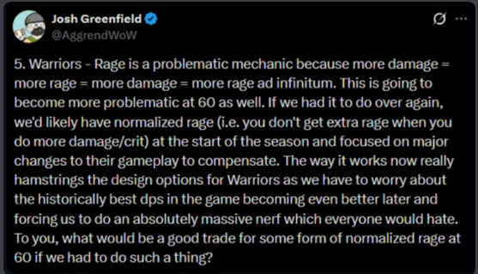
Josh Greenfield (Aggrend), @AggrendWoW, 18 April 2024, during Season of Discovery Phase 3 (Greenfield).
In April 2024, during Season of Discovery, Aggrend floated the idea of normalized rage for warriors and ended his post with a question: “what would be a good trade for some form of normalized rage at 60 if we had to do such a thing?” SoD never made that change. Two and a half years later, WoW: Forever has: its beta replaces Classic’s damage-based rage with a fixed amount per swing. That puts rage generation in Forever closer to Cataclysm than to Classic. Damage was part of the rage formula in Classic, The Burning Crusade and Wrath of the Lich King, and was only removed in Cataclysm (see Background). This document aims to answer Aggrend’s question, and proposes a trade that controls warrior rage and damage without throwing away what makes rage feel like rage.

Summary
The post’s concern is a feedback loop (“more damage = more rage = more damage = more rage ad infinitum”) that makes warriors difficult to balance and could force a massive nerf later on. In WoW: Forever, the proposed solution is rage that ignores damage entirely: each landed swing gives a fixed amount of rage per second of weapon speed, and since 30 September crits give extra (Marrow, “Rage on Crit”). Aggrend asks what a good trade for some form of normalized rage would be at 60; this document aims to answer that question.
The trade:
- Keep damage-based rage, but curve it at level 60. Use the Classic rage formula for levels 1–59, and keep using it at 60 until roughly pre-raid gear. From there, rage per swing bends smoothly toward a cap that scales with swing time, which gives a ceiling (about 1,800–1,900 true RPM) that future gear tiers can’t push through. Because rage still comes from damage, every stat and upgrade that makes a warrior hit harder still means more rage, and rage keeps the swingy, damage-driven feel it has in Classic. The shape of the curve is a choice: developers decide where diminishing returns start and where the ceiling sits.
- Fix warrior damage at the source: Bloodthirst 45% → 40% AP, Flurry 35% haste for 2 swings (instead of 30% for 3), Death Wish 20% → 15%, and a 4 second cooldown on Execute. The proposal also keeps two of Forever’s changes: Unbridled Wrath at 60%, and Whirlwind hitting with both weapons costing 22 rage once talented. Together, this cuts DPS by 4–9% against Classic depending on gear (section 5).
Terms used in this document:
Term | What it means
Classic rage | Classic’s linear formula: rage = 7.5 × damage ÷ C
Forever rage | Forever’s rage formula (v2: a fixed rate × weapon speed per landed swing, crits ×2) with Forever’s talents and abilities as of the 1 October beta build (section 3)
Curved rage | Our formula: Classic rage up to a threshold, then a smooth curve toward a per-swing cap, both scaled to swing time (section 4)
The proposal | Curved rage + ability adjustments to Bloodthirst, Flurry, Death Wish and Execute, plus Forever’s Unbridled Wrath and two-handed Whirlwind (section 5)
Why not Forever rage?
- Rage isn’t the main driver of warrior damage. Cutting a Naxx BiS, world-buffed warrior’s rage by 24% (2,196 → 1,674 true RPM) with Curved rage only lowers DPS by 4%. Warriors lead every raid tier, including T1 without world buffs; the gap is the result of base damage, not rage scaling (sections 1–2).
- Forever rage ignores the gear warriors care about. Attack power and weapon damage give exactly zero rage under every version of Forever’s rules (Marrow, “Rage on Crit” sec. 4.6.1). Crit, hit modifiers (including expertise) and haste become the only stats that add rage, which makes them the stats to stack.
- Forever is already moving toward this proposal. Its newest rules normalize rage to weapon speed, double rage on a crit, and get a ceiling from the attack table. The one missing piece is that damage does nothing. Curved rage keeps everything Forever is reaching for and adds that piece back (section 3).
Gear (3 min fight, with Execute) | Classic | Forever | Curved rage only | The proposal
Prebis, self-buffed, no WB | 474 | 494 (+4%) | 474 (0%) | 446 (−6%)
Prebis, raid-buffed, no WB | 838 | 778 (−7%) | 831 (−1%) | 803 (−4%)
Prebis + WB | 1454 | 1279 (−12%) | 1438 (−1%) | 1376 (−5%)
R14 / MC / 20-man, no WB | 1050 | 909 (−13%) | 1035 (−1%) | 953 (−9%)
Naxx BiS, no WB | 1211 | 1067 (−12%) | 1189 (−2%) | 1144 (−5%)
Naxx BiS + WB | 1968 | 1689 (−14%) | 1889 (−4%) | 1837 (−7%)
DPS. Percentages are against Classic. “Curved rage only” changes the rage formula and nothing else.
At raid gear, the proposal and Forever deal similar damage (the proposal is 3–9% higher), but the proposal generates 36–91% more rage, and two to three times as much rage beyond what Bloodthirst and Whirlwind cost. That spare rage is what pays for Heroic Strike, Hamstring and a strong execute phase: the decisions that make warrior play like a warrior. Forever caps warrior damage by taking those decisions away; the proposal caps it while keeping them.

Background: how rage is generated
In WoW Classic (and until Cataclysm), rage from white hits depends on their damage. At level 60 in Classic the rage formula is (Marrow, “Rage Generation” sec. 2.1):
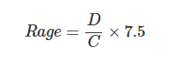
Where D is the hit’s damage after mitigation and C is a level constant, about 230.6 at level 60. That’s a straight line: a 500 damage hit gives about 16.3 rage.
How rage has changed before. Classic is the only version where rage came entirely from damage, but it isn’t the only one where damage mattered. Blizzard never published the exact constants, so the formulas below come from the community sims that reproduce each version (wowsims):
Version | Rage from a white hit | Does damage matter?
Classic | 7.5 × D ÷ C | Fully
The Burning Crusade | (7.5 × D ÷ C + f × s) ÷ 2, where f is 3.5 for the main hand and 1.75 for the off hand (doubled on a crit) and s is weapon speed | Half: the other half is a fixed amount per second of weapon speed
Wrath of the Lich King | Same as TBC, capped at 15 × D ÷ C per hit | Half
Cataclysm (patch 4.0.1) | A fixed amount per swing: about 6.5 × weapon speed for the main hand, half for the off hand | No
WoW: Forever (beta) | A fixed amount per swing: about 3.46 × weapon speed for the main hand, half for the off hand, with bonuses below | No (crits only)
The Burning Crusade’s change was itself called rage normalization at the time: rage was “based around an internal number of how much rage a warrior could be expected to normally generate at each given level per DPS,” but still followed damage (Drysc and Kalgan, in “Rage normalization summary”). Cataclysm was the first version to take damage out entirely: “Rage is being normalized so that its generation is no longer based on damage done by auto-attacks” (patch 4.0.1 notes, Warcraft Wiki). Forever follows Cataclysm’s approach.
In WoW: Forever, a white swing that lands gives a fixed rate times the weapon’s listed speed: about 3.46 per second of speed in the main hand and 1.73 in the off hand, whatever the swing’s damage (Marrow, “Rage Generation”). The speed cancels out, so each hand gives a fixed rage per second. Three things matter for this document:
- Damage doesn’t matter. Weapon damage, attack power and damage modifiers give no rage. Misses and dodges give none either.
- Haste does. A hasted swing gives full rage, so 10% faster swings give 10% more rage (Marrow, “Rage Generation”).
- Crit now does too. On 30 September, Blizzard announced that crits give 75% more rage and Dual Wield Specialization would no longer double the off hand’s rage. Zirene, one of Forever’s developers, then said a bug had thrown off testing, and the fix will make crits give 100% more and the off hand 50% more. Marrow calls these v1 and v2 (v0 being the old rules), and models them in “Rage on Crit”. This document uses v2, the most recent.
Version | Off hand (Dual Wield Specialization) | A crit’s rage
Forever v0 (before 30 Sep) | ×2 | ×1
Forever v1 (30 Sep) | ×1 | ×1.75
Forever v2 (announced fix) | ×1.5 | ×2
Why Forever changed rage, as we read it. Neither Forever nor the post explains the change in detail. Reading the post, some reasons are stated and some are implied. Sections 1–3 test each one:
- Rage creates an “infinite” feedback loop: damage → rage → damage → rage.
- Warrior is the best DPS class (and it isn’t close).
- The loop limits design options for new gear and talents.
- (Implied) Removing damage from rage fixes this while preserving the class’s identity.

1) The loop is real, but bounded
What warriors spend rage on. Outside execute, every warrior presses Bloodthirst > Whirlwind > everything else. Bloodthirst costs 30 rage every 6 seconds and Whirlwind 25 every 10. Pressing both on cooldown costs about 415 RPM in our Classic sims, after refunds and the odd delayed Whirlwind, and including Battle Shout and Death Wish (screenshots in Appendix D). With Forever’s 22-rage Whirlwind, which the proposal also uses, it drops to about 402 RPM. Marrow gets almost the same number for Forever: 6.8 rage per second, or 408 RPM, without Battle Shout or Death Wish, which account for nearly all of the gap (Marrow, “Rage on Crit” sec. 4.4). It’s the same at every gear level, because nothing shortens these cooldowns.
So we split warrior DPS in two:
- Base DPS: auto attacks, procs (Windfury, weapon procs, Deep Wounds), Bloodthirst and Whirlwind. This is the damage of a warrior spending 415 RPM.
- Extra DPS: everything that rage beyond 415 RPM buys: Heroic Strike, Hamstring, Execute, and the extra attacks and procs they cause.
Total DPS = Base DPS + Extra DPS
We measure Extra DPS as Total DPS (normal rotation) minus Base DPS at six gear levels, from prebis self-buffed up to Naxx BiS with world buffs. The full setup is in Appendix B, and the results in Appendix C and the “Rage Formulas” tab.
Why simulate world buffs when Forever won’t have them? Two reasons. Most Classic players raided with world buffs, so they shape how people remember Classic rage and class balance, and the gap between buffed and unbuffed runs shows how much they skewed it. World buffs are also a stand-in for the character power of future gear tiers that Forever will add without them.
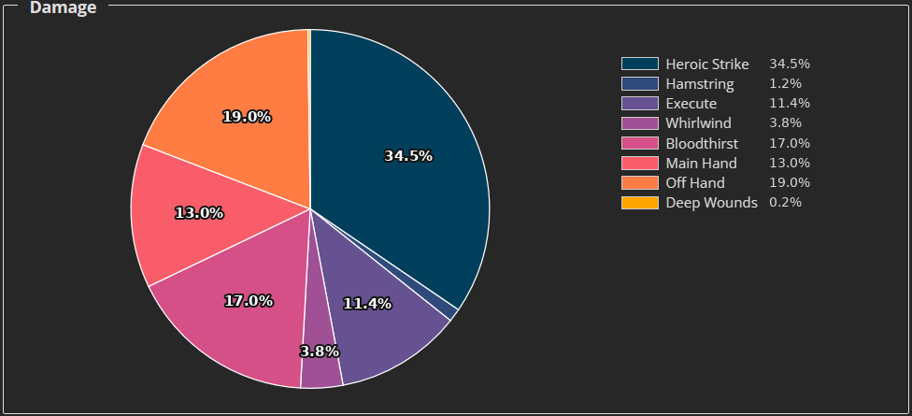
Damage by ability, Naxx BiS warrior with raid and world buffs (using a modified Guybrush sim). Heroic Strike replaces a white swing, so its real added damage is far smaller than its slice.
The loop exists. In Classic, abilities don’t give rage directly, but they do indirectly: ability crits trigger Flurry, a queued Heroic Strike removes the off hand’s dual-wield miss penalty, more hits mean more Unbridled Wrath, and more abilities mean more Windfury procs. With Naxx BiS + WB, a Bloodthirst + Whirlwind-only rotation generates about 2,022 RPM, about 1,607 more than it needs. Letting the sim also spend that surplus raises it to an effective 2,196 RPM.
But it isn’t infinite. Spending 1,607 surplus RPM gave back 174 RPM, a loop gain of about 0.11, and that’s after every round of the loop has played out. It’s also physically capped: once every main-hand swing is a Heroic Strike, extra rage has nothing to buy, and the 100 rage cap throws the rest away.
And extra rage is a fairly constant share of damage. Once raid buffs are in, rage above 415 RPM produces 16–22% of total DPS without world buffs and about 24% with them (24–29% in fights with an execute phase). Each surplus rage buys about 13–17 damage outside execute. The big jump is right around the 415 RPM breakpoint: a self-buffed prebis warrior (about 570 RPM) gets only 6% of its damage from extra rage, and the same warrior with raid buffs (about 970 RPM) gets 16%.
Takeaway: surplus rage is what makes a warrior feel like a warrior. At 415 RPM, a warrior can only press Bloodthirst and Whirlwind as they come off cooldown, and spends the time in between waiting for rage. There are no decisions to make, and the class feels passive. By about 900 RPM, there’s rage to spare, and the warrior is constantly choosing: Heroic Strike now or save for Bloodthirst, Hamstring for a Windfury proc, how much rage to carry into execute. Actions per minute tell the same story: about 15 for the self-buffed prebis warrior, 40 with raid buffs, and close to 70 at Naxx BiS with world buffs. Somewhere around 30–40 actions per minute is where warrior starts feeling nice; an instant-cast caster pressing every GCD manages 40. Below that, the class barely plays like a Classic warrior. By the time we’ve reached 70 APM, the rotation has devolved into pressing everything as fast as possible. That’s the case for diminishing returns on rage at the top end, even though rage isn’t what drives warrior damage.

2) Warriors lead every tier, with or without world buffs
Warrior is the meta DPS class of endgame Classic. The top three Era Naxxramas speedclears (lineups) bring 24 warriors and 6 other DPS. Less well known is how dominant warriors are at low gear. Top parses on the Anniversary (Fresh) servers, with gear limited to each phase:
Boss | Warrior | Rogue | Hunter | Warlock | Mage | Warrior ÷ 2nd
Ragnaros (P1) | 1798 | 1176 | 903 | 892 | 812 | 1.53×
Ebonroc (P3) | 2070 | 1361 | 1379 | 1017 | 1092 | 1.50×
Fankriss (P5) | 3560 | 2492 | 1467 | 1669 | 2271 | 1.43×
Patchwerk (P6, Era) | 2415 | 1975 | 1410 | 1881 | 3153 | 0.77× (vs 1st)
Maexxna (P6, Era) | 3353 | 2485 | 1650 | 2214 | 2847 | 1.18×
We also look at raids without world buffs, since WoW: Forever won’t allow them. Season of Mastery had no world buffs in raids and no major class changes (Icy Veins), which makes it the best available look at warriors without them. Most of its fights had different mechanics from Classic, so it’s an approximation:
Boss (SoM, no WB) | Warrior | Rogue | Hunter | Warlock | Mage | Warrior ÷ 2nd
Ragnaros | 691 | 626 | 498 | 567 | 491 | 1.10×
Ebonroc + Flamegor | 1001 | 786 | 697 | 767 | 640 | 1.27×
Fankriss | 2045 | 1715 | 1044 | 1355 | 1746 | 1.17×
Patchwerk | 1888 | 1747 | 1373 | 1024 | 1386 | 1.08×
Maexxna | 1852 | 1531 | 888 | 782 | 1172 | 1.21×
Looking at only the top parse per class is noisy, especially since warriors have the largest player pool. Even so, warriors lead from the first raid tier to the last, with and without world buffs: about 1.17× the second class in SoM and about 1.41× on Anniversary/Era (excluding Patchwerk, where rolling Ignite makes mage an outlier). A T1 warrior on Ragnaros generates less than half the rage of a Naxx warrior, yet leads by a similar margin. The imbalance is there before rage scaling has much to work with.

3) What Forever rage does
v0 was flat. Under the old rules, a dual-wield Fury warrior got about 6.92 rage per second (415 RPM) at any gear level, and “a phase 4 weapon gives exactly the same rage as a pre-BiS one” (Marrow, “Rage Design Proposals” sec. 5.1.2). That’s almost exactly the 415 RPM the core rotation costs, leaving very little for Heroic Strike. Marrow’s own verdict: what Forever is missing “isn’t a floor, it’s growth” (sec. 5.1.2).
v2 adds growth, but only through crit, hit and haste. Marrow’s simulations of v2 (“Rage on Crit” Tables 4.3, 4.6 and 4.7). No world buffs and Windfury Totem up; 7.5% hit and 2000 attack power unless the row says otherwise. Forever rage doesn’t depend on attack power, so only the Classic Heroic Strike column uses each row’s attack power.
Crit | Forever v2 rage | Classic rage (2000 AP) | v2 Heroic Strikes/min | Classic Heroic Strikes/min
15% | 7.28/s (437 RPM) | 7.88/s (473 RPM) | — | —
20% (early gear, 5% hit, 1250 AP) | 7.47/s (448 RPM) | — | 4.3 | 1.9
30% (mid gear) | 8.18/s (491 RPM) | 9.04/s (542 RPM) | 7.1 | 10.1
40% (late gear, 10% hit, 2750 AP) | 8.79/s (527 RPM) | — | 9.9 | 15.9
45% | 8.68/s (521 RPM) | 9.44/s (566 RPM) | — | —
Three things stand out:
- v2 fixes the early game. It has more rage than v0 everywhere, and more than Classic at low gear. At low gear, the “absolutely massive nerf” a flat 415 RPM implied is mostly gone. Our higher-geared sets below tell a different story.
- Attack power and weapon damage give nothing. Going from 1000 to 3000 attack power moves v2’s rage by 0.00 per second; it moves Classic’s by up to 4.2 (Marrow, “Rage on Crit” sec. 4.6.1). Crit, hit and haste are the only gear that adds rage. Crit adds it twice, through the ×2 on the crit itself and through the extra swings Flurry gives, and hit adds it twice, through the swings it lands and the crits those swings can have (sec. 4.5). The same is true in Classic. The difference is that in Forever these are the only routes to rage, so they become the stats to stack. Curved rage keeps every damage stat in play.
- v2 already has a ceiling, from the attack table. A white swing can’t crit more often than the attack table leaves room for (about 34% for the main hand at 7.5% hit), so every version flattens out past about 35% crit (sec. 4.6.2). It’s the same idea as the attack-table cap in Appendix A.
So v2 lands much closer to this proposal than v0 did: rage normalized to swing time, a crit worth two normal swings, growth with some stats on gear, and a ceiling. What it drops is the link between hitting harder and having more rage: a new weapon or a pile of attack power is invisible to your rage bar. Marrow’s own design criteria for a better curve ask for it to “respond to gear, so each phase’s weapon upgrade feels like it matters for rage and not only for damage” (Marrow, “Rage Design Proposals” sec. 5.2). Curved rage does that, and keeps the ceiling.
Our six gear sets under Forever. Marrow’s warrior has no world buffs and modest gear, so we re-ran our six setups with Forever’s rules as of the 1 October beta build (Seramate). That means Forever rage (v2) plus Forever’s talents and abilities:
- Dual Wield Specialization: off hand ×1.5 rage (and +25% off-hand damage, as in Classic).
- Furious Precision: +10% off-hand hit.
- Unbridled Wrath: 60%, white swings only.
- Flurry: 25% for 3 hits.
- Bloodthirst: 45% of attack power, unchanged from Classic.
- Whirlwind: hits with both weapons and costs 22 rage with Raging Blows. Our sim assumes neither hit takes the dual-wield miss penalty, as in TBC.
We used our modified GuyBrush sim with the full rotation including Execute and a 3 minute fight:
Gear | DPS: Classic → Forever | True RPM: Classic → Forever | Forever spare rage (over 402 RPM)
Prebis, self-buffed, no WB | 474 → 494 (+4.1%) | 567 → 548 (−3.4%) | 146
Prebis, raid-buffed, no WB | 838 → 778 (−7.1%) | 966 → 659 (−31.8%) | 257
Prebis + WB | 1454 → 1279 (−12.1%) | 1578 → 820 (−48.1%) | 418
R14 / MC / 20-man, no WB | 1050 → 909 (−13.4%) | 1173 → 656 (−44.0%) | 254
Naxx BiS, no WB | 1211 → 1067 (−11.9%) | 1428 → 700 (−51.0%) | 298
Naxx BiS + WB | 1968 → 1689 (−14.2%) | 2196 → 855 (−61.1%) | 453
What this shows:
- Forever rage barely grows with gear. From prebis raid-buffed to Naxx BiS without world buffs, Classic rage rises by 462 RPM and Forever rage by 41. A full raid tier’s worth of weapons and attack power is almost invisible to the rage bar. The only real jumps come from world buffs’ crit and haste, which Forever won’t have.
- The nerf comes from rage, and it grows with gear. Forever’s talent and ability changes are a net buff on their own. Bloodthirst is unchanged from Classic, Whirlwind now hits with both weapons for less rage, and the off hand gets 10% more hit; only Flurry is weaker. So nearly all of Forever’s DPS loss comes from rage. It leaves a self-buffed prebis warrior 4% ahead of Classic, then loses 7% with raid buffs and another 12–14% from there up. That targets scaling, but section 2 showed warriors already lead at T1, before scaling does much.
- It costs far more rage than it needs to. The proposal (section 5) cuts less DPS and keeps most of the rage:
Gear | Forever: DPS / rage vs Classic | The proposal: DPS / rage vs Classic | Spare rage: Forever → proposal
Prebis, raid-buffed, no WB | −7% / −32% | −4% / −7% | 257 → 495
R14 / MC / 20-man, no WB | −13% / −44% | −9% / −11% | 254 → 644
Naxx BiS, no WB | −12% / −51% | −5% / −13% | 298 → 839
Naxx BiS + WB | −14% / −61% | −7% / −26% | 453 → 1226
At raid gear, Forever leaves warriors with 656–700 true RPM, closer to the passive Bloodthirst + Whirlwind rotation than to the roughly 900–1,000 RPM where section 1 found warrior starts to play like a warrior.

4) The proposal, part 1: Curved rage
Keep Classic’s formula for levels 1–59. At 60, keep it unchanged up to about the rage a pre-raid 60 generates, then bend it smoothly toward a per-swing cap. Any per-swing cap has to be normalized to swing time, or it penalizes slow weapons (a flat “50 rage per hit” cap would push everyone toward fast weapons). Targets, in true RPM (all rage plus the white swings Heroic Strike replaced), with Forever for comparison:
Level / tier | Target true RPM | Classic rage | Curved rage | Forever | Note
1–59, fresh 60 | Classic formula | — | — | — | Linear
T0 (prebis, self-buffed) | 550–600 | 568 | 554 | 548 | Diminishing returns start here
T3 (Naxx BiS, no WB) | 1300–1400 | 1428 | 1280 | 700 | Curved slightly under target
T7 (Naxx BiS + WB as a stand-in) | 1600–1700 | 2196 | 1674 | 855
T20 | 1800–1900 | — | ~1819 (model) | — | Functional ceiling
How each kind of hit is treated:
- Main hand: multiplier 1.0.
- Off hand: the threshold and cap are 62.5% of the main hand’s, matching the off hand’s damage with talents.
- Crit: double threshold and double cap, so a crit is always worth exactly two normal hits on the curve (the same ×2 Forever v2 settled on).
- Glance: a normal hit using its glanced damage.
- Windfury and other extra attacks: 0.75 × the rage of a normal hit of the same damage (Windfury’s attack power included).
- Haste: the threshold and cap scale with the current, hasted swing time. Haste still raises rage below the cap (like more damage), but can’t raise the ceiling.
- Two-handers: out of scope (see Scope and limitations).
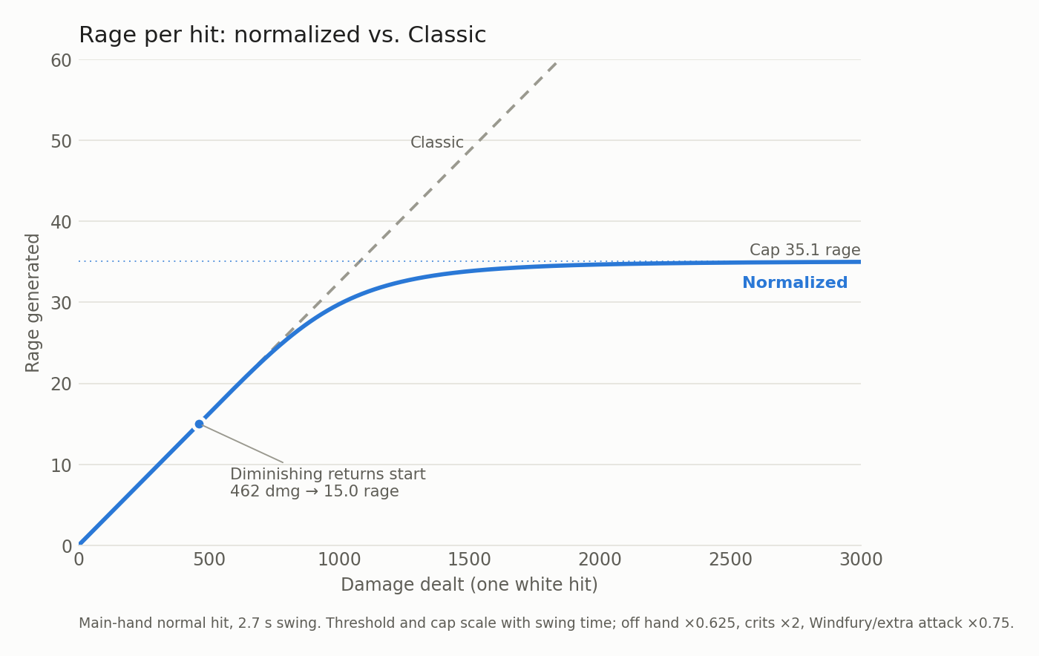
The formula. For each white hit:
- L = 7.5 × damage ÷ 230.6 (Classic rage)
- t = weapon speed ÷ haste (current swing time)
- f = 0.625 for the off hand, 1 for the main hand; × 2 on a crit
- R₀ = 7.5 × k × t × f ÷ 230.6 (where diminishing returns start)
- C = cap × t × f (the per-hit cap)
- If L ≤ R₀: R = L (Classic rage, unchanged)
- Otherwise: R = R₀ + x ÷ (1 + (x ÷ (C − R₀))^p)^(1/p), with x = L − R₀
- Windfury swing: R × 0.75. A dodge gives 0.75 × R of the weapon’s average swing (Classic’s dodge rule, through the curve).
Variable | Value | Meaning
k | 171 | Threshold in damage per second of swing time. Puts the start of diminishing returns at about 570 true RPM on prebis
cap | 13 | Rage limit per second of swing time: a hand can never pass about 780 RPM (main hand) or 488 (off hand) from hits; crits double it
p | 3 | Sharpness of the bend. Higher stays Classic longer, then bends harder
0.75 | fixed | Share of rage for Windfury swings and for dodges
The numbers are a choice, and that’s the point. The threshold k decides where diminishing returns begin, the cap decides where rage tops out, and p decides how sharply it bends between them. Each can be moved on its own, to put the floor, the growth and the ceiling wherever the developers want, today or ten tiers from now. That control is the real argument for a curve over a flat rate: it keeps damage as an input. Damage is moved by nearly every stat a warrior gears for (attack power, weapon damage, damage modifiers, crit, hit, haste), so every upgrade can feel like more rage. Forever rage can only grow through crit, hit and haste, which leaves attack power and weapon damage invisible to the rage bar and pushes players toward stacking a few stats. Marrow reaches the same conclusion about his own curves: the shape is the decision that matters, and the specific numbers are easy to adjust (Marrow, “Rage Design Proposals” sec. 5.5).
What it does in the sims:
Gear | DPS lost | True RPM lost | Surplus over 415: Classic → Curved | DPS lost per RPM lost
Prebis, self-buffed | −0.2 (0.0%) | −13 (2.3%) | 152 → 139 | ~0 (noise)
Prebis, raid-buffed | −6.3 (0.7%) | −55 (5.7%) | 551 → 496 | 0.11
R14 / MC / 20-man, no WB | −15.1 (1.4%) | −64 (5.5%) | 758 → 694 | 0.24
Prebis + WB | −16.5 (1.1%) | −179 (11.3%) | 1163 → 984 | 0.09
Naxx BiS, no WB | −22.0 (1.8%) | −148 (10.4%) | 1013 → 865 | 0.15
Naxx BiS + WB | −79.4 (4.0%) | −522 (23.8%) | 1781 → 1259 | 0.15
Curved rage does what it’s meant to: almost nothing at prebis, real diminishing returns at Naxx, and over 500 RPM less with world buffs, for at most 4% DPS and about 6–7% fewer actions per minute. Each RPM removed costs only 0.1–0.24 DPS, because surplus rage mostly buys Heroic Strikes and some of it would have overflowed anyway. To cut warrior damage meaningfully through rage, you’d have to push it close to 415 RPM, and a warrior at 415 RPM doesn’t feel like a warrior. That’s why the damage fix belongs in section 5.
Most stats show strong diminishing returns at Naxx BiS under Curved rage, but crit, hit and extra attacks keep most of their rage value. For infinite progression, Appendix A adds an optional attack-table cap that holds the ceiling even against extreme hit and crit (about 1,890 true RPM at the extremes we could sim).

5) The proposal, part 2: ability adjustments
If Extra DPS isn’t the problem, Base DPS is: auto attacks, procs, Bloodthirst and Whirlwind. We first tested each change on its own, on Naxx BiS without world buffs with Curved rage (Classic’s abilities otherwise):
Change | DPS | True RPM
Baseline (Curved rage) | 1188 | 1279
Bloodthirst 45% → 35% AP | 1141 (−4.0%) | 1279
Flurry 30% → 25% (3 swings) | 1163 (−2.1%) | 1252
Flurry 30%, 3 swings → 2 swings | 1153 (−2.9%) | 1243
Death Wish 20% → 15% | 1174 (−1.2%) | 1273
Execute 0 s → 4 s cooldown | 1141 (−4.0%) | 1251
The proposal combines Curved rage with these adjustments:
Ability | Classic | Forever | The proposal
Bloodthirst | 45% AP | 45% AP | 40% AP
Flurry | 30% for 3 swings | 25% for 3 swings | 35% for 2 swings
Death Wish | 20% for 30 s | 20% for 30 s | 15% for 30 s
Execute | no cooldown | no cooldown | 4 s cooldown
Unbridled Wrath (5/5) | 40% | 60%, white swings only | 60%, white swings only
Whirlwind | main hand, 25 rage | both weapons, 22 rage | both weapons, 22 rage
Off-hand hit bonus | none | +10% (Furious Precision) | none
Why each one:
- Bloodthirst 40% AP: a modest cut to the ability every warrior presses most, and 11% less Bloodthirst damage, against 22% for the 35% version Forever briefly tested.
- Flurry 35% for 2 swings: a crit feels better, but the buff is more fleeting, which brings back some of rage’s volatility.
- Death Wish 15%: 30 seconds of 20% damage with fear immunity is probably the strongest DPS cooldown in the game. Many endgame fights last 60–90 seconds, which gives it 33–50% uptime. This cooldown drastically inflates boss damage numbers when paired with other cooldowns (Recklessness, MRP, Trinkets, etc) during execute phase.
- Execute, 4 second cooldown: irrelevant in solo and group content, where one Execute finishes the target, but it stops raid execute phases from being GCD after GCD of Execute. Its damage per rage could be raised if needed. Similar to Death Wish, this is a very efficient single target (boss) nerf that doesn’t cause many collateral problems.
- Unbridled Wrath and Whirlwind: kept from Forever. Both are good changes: Whirlwind hitting with both weapons makes dual wielding feel better, and the extra Unbridled Wrath rage is flat, so it doesn’t scale with gear.
The proposal across gear:
Gear | DPS: Classic → proposal | True RPM: Classic → proposal | Proposal vs Forever: DPS / rage
Prebis, self-buffed, no WB | 474 → 446 (−6.0%) | 567 → 547 (−3.5%) | −9.7% / 0%
Prebis, raid-buffed, no WB | 838 → 803 (−4.1%) | 966 → 897 (−7.1%) | +3.2% / +36%
Prebis + WB | 1454 → 1376 (−5.4%) | 1578 → 1353 (−14.2%) | +7.6% / +65%
R14 / MC / 20-man, no WB | 1050 → 953 (−9.2%) | 1173 → 1046 (−10.8%) | +4.8% / +59%
Naxx BiS, no WB | 1211 → 1144 (−5.5%) | 1428 → 1241 (−13.1%) | +7.2% / +77%
Naxx BiS + WB | 1968 → 1837 (−6.7%) | 2196 → 1628 (−25.9%) | +8.8% / +91%
The proposal cuts 4–9% of Classic’s DPS at every gear level, rather than a cut that grows with gear the way Forever’s does, and keeps far more rage than Forever everywhere above self-buffed prebis. A self-buffed prebis warrior has the same rage under both (Curved rage is identical to Classic below the threshold), so the ability nerfs show up there with no extra rage to offset them, and Forever’s buffs put it 10% ahead. That case could be helped in many ways (including minor adjustments to our curve’s parameters), but it’s also rare: few warriors raid with no group buffs and no consumables at all.
Applied to the class gaps (rough, since logs and sims differ):
Content | Warrior ÷ best other class | With Forever | With the proposal
T1 without WB (SoM Ragnaros) | 1.10× | ~1.02× | ~1.05×
Naxx without WB (SoM Patchwerk + Maexxna) | 1.15× | ~1.01× | ~1.08×
T1 with WB (Anniversary Ragnaros) | 1.53× | ~1.34× | ~1.45×
Naxx with WB (Era Maexxna) | 1.18× | ~1.01× | ~1.10×
The proposal keeps warriors slightly ahead without world buffs, which Forever won’t have. That’s deliberate. The goal isn’t to push warriors below other classes; it’s to bound how far warriors scale. The other DPS classes have plenty of room to be brought up, and section 6 suggests how.
Single-target damage and the rogue goal. Forever’s developers have said rogues should be “the highest single target damage dealers in the game, given mechanics, given the encounter” (Squishei). If that’s the goal, Execute is the dial to turn. Its cooldown mostly affects boss fights, where execute phases are GCD after GCD of Execute, and barely touches solo play, group content or the rest of the rotation; a 4 second cooldown alone costs about 4% at Naxx gear. Under the proposal, warriors on Patchwerk land at roughly 1.02× the best rogue in Season of Mastery, against 1.08× in Classic, and a longer Execute cooldown would close the rest of that gap without changing how the class plays.
Death Wish is also a strong candidate for nerf. Our sims showed a 20% → 15% nerf on Death Wish damage only resulted in a 1.2% loss in overall DPS but functionally this ends up being far greater when the fight is shorter or longer than 3 minutes (sim was exactly 3 minutes). Furthermore, we intentionally did not include the use of Recklessness, active trinkets, or Mighty Rage potion in our sims which all massively inflate the dps contribution of Death Wish.

6) Beyond warriors
Rage is the only Classic resource with meaningful scaling: a better-geared warrior can spend more, and choosing how to spend it is a big part of what makes the class fun. As section 1 showed, surplus rage is a modest share of warrior power, but most of its fun. Other classes don’t get that. Rogues have a handful of gear- and cooldown-bound energy options, and most casters can’t turn more mana into much more damage. TBC moved the other way, with Combat Potency for rogues (about 12% DPS for a BiS TBC sword rogue, per wowsims) and Arcane Blast for mages. Rather than remove resource scaling from warriors, Forever could give it to everyone, for example by giving higher spell ranks better coefficients, so spending more mana for more damage becomes a real choice. That gives other classes another way to scale, and more importantly, have more depth and engaging gameplay.

7) Conclusion
Forever’s newest rage rules show the developers want what this document wants: a floor for fresh 60s, growth with gear, a crit that feels like a crit, and a ceiling. Curved rage delivers all four while keeping the one thing Forever rage drops: hitting harder still means more rage, so a weapon upgrade still feels like a weapon upgrade.
It also keeps rage volatile. Because rage still follows damage, every swing’s rage depends on its roll, whether it glanced, and whether it crit, so the rage bar keeps the ebb and flow that makes rage management engaging. Marrow measured this: Classic’s damage-based rage varies the most from fight to fight (the middle 90% of fights spread over 1.2–1.3 rage per second, against about 0.8 under Forever’s earlier, flat rules; “Rage Design Proposals” sec. 5.6.1). Forever v2’s crit bonus adds some swing-to-swing variance back, but crits are the only thing that varies. Curved rage is identical to Classic below the threshold, and only flattens the biggest hits above it. We haven’t measured its spread directly, but it should sit between the two, and closest to Classic for most of the game.
Warrior damage is better controlled directly, through Bloodthirst, Flurry, Death Wish and Execute. The proposal deals about as much damage as Forever at raid gear while keeping 36–91% more rage, and two to three times as much rage to spend on decisions.

Scope and limitations
- Two-handed builds are out of scope. The proposal is built and simmed for dual wielding.
- Tanks: rage from damage taken is unchanged and wasn’t simulated. Threat depends on rage, so tanks need separate testing.
- PvP and leveling: levels 1–59 keep the Classic formula. PvP isn’t analyzed.
- Excluded from the sims: Recklessness, Mighty Rage Potion and other in-combat potions, so real logs will show bigger execute-phase and burst numbers.
- Forever’s numbers: Marrow’s are models, and v2 is built on announcements not yet visible in logs. Our Forever runs model the rage formula and the talent and ability changes listed in section 3; other Forever talent changes aren’t modeled. Whirlwind’s off-hand hit is assumed to work as in TBC.
- Model estimates: the stat scaling table and the extreme hit/crit example hold swing counts fixed. Everything else is a full sim run.

Appendix A: formula details
Everything that raises rage under Curved rage:
- Bigger hits (these get the diminishing returns): attack power, weapon damage, damage % modifiers, armor debuffs on the target, glance damage from weapon skill.
- Haste: works exactly like +% damage, with the same diminishing returns.
- More landed swings (little diminishing returns): hit, weapon skill, crit (up to the white crit cap).
- Extra swings: Windfury Totem at 75%; other extra attacks at 100%.
- Flat rage, outside the curve: Unbridled Wrath, Bloodrage, Anger Management, Mighty Rage Potion, refunds, rage from damage taken.
Weapon speed barely matters (rage per second follows weapon DPS), and both hands scale similarly at these gear levels.
How each stat scales at Naxx BiS (RPM gained per step; swing counts held fixed):
Change | No WB: Classic → Curved | Kept | WB: Classic → Curved | Kept
+100 attack power | +38.9 → +28.4 | 73% | +53.2 → +12.0 | 23%
+1% damage | +14.0 → +10.3 | 74% | +22.8 → +5.3 | 23%
+1% haste | +14.0 → +10.2 | 73% | +22.8 → +5.2 | 23%
+5% main-hand weapon damage | +47.3 → +32.8 | 69% | +76.2 → +14.7 | 19%
+5% off-hand weapon damage | +22.5 → +17.1 | 76% | +38.0 → +9.6 | 25%
+1% glance damage | +4.4 → +3.4 | 78% | +6.7 → +1.8 | 27%
+1% crit | +11.6 → +10.7 | 92% | +5.5 → +4.5 | 81%*
+1% hit | +11.6 → +10.7 | 92% | +17.6 → +13.3 | 76%
+1 extra main-hand swing/min | +25.4 → +24.6 | 97% | +35.5 → +28.0 | 79%
+1 Windfury swing/min | +25.4 → +18.4 | 73% | +35.5 → +21.0 | 59%
*Main-hand white crit is already capped in the WB run, so only the off hand gains.
Optional attack-table cap. Hit, crit and dodge reduction can still push past the ceiling (adding +10% hit and +10% crit to Naxx BiS + WB reaches about 1,910 true RPM in the model). The fix: compare each hand’s white attack table to a reference table and shrink the cap if yours is stronger. A reference table’s strength is
M = P(hit) + 2 × P(crit) + P(glance) + 0.75 × P(dodge)
where a miss counts 0, P(crit) is capped by what’s left after miss, dodge and glance (the white crit cap), and crit from Recklessness and Elune’s Light is excluded. With the Naxx BiS + WB table as the reference:
Hand | Hit | Crit | Glance | Dodge | Miss | M_ref
Main hand | 0% | 41.27% | 40.00% | 5.41% | 13.33% | 1.266
Off hand | 3.73% | 43.50% | 40.00% | 5.40% | 6.37% | 1.348
the cap becomes C = cap × t × f × min(1, M_ref ÷ M). With it on, pushing hit, crit and dodge reduction to extremes reached about 1,890 true RPM, inside the T20 target. Only extra attacks and flat rage can still move the ceiling. This is the same mechanism that gives Forever v2 its ceiling (Marrow, “Rage on Crit” sec. 4.6.2), applied deliberately.

Appendix B: sim setup
All sims use a modified Guybrush WarriorSim (RAGE NORM builds 5–10) in Classic mode. Settings for every gear set:
- Character: Human, 17/34/0 Fury talents. Every weapon in every set is a sword, so Human Sword Specialization (+5 sword skill) applies throughout.
- Fight: 3 minutes against a level 63 raid boss, 0 starting rage, Battle Shout precast. The execute phase is the last 20% (36 seconds), and Death Wish is used 31 seconds before the end of the fight.
- Target debuffs: 5 × Sunder Armor, Faerie Fire and Curse of Recklessness, which bring the boss to 336 armor.
- Rotation: Bloodthirst > Whirlwind > Heroic Strike / Hamstring, with priorities and rage thresholds tuned per gear set for the most DPS. For example, the Hamstring threshold is lower at higher gear, and higher gear sets keep using Bloodthirst during execute phase.
- Not used: Recklessness, Mighty Rage Potion or any other in-combat potion, Grace of Air Totem, AQ books (higher ability ranks), on-use trinkets.
Buffs by setup:
Setup | Buffs and consumables
Prebis, self-buffed | Battle Shout only, no consumables
Every other “no WB” setup | Raid buffs: Leader of the Pack, Improved Mark of the Wild, Trueshot Aura, Blessing of Kings, Improved Blessing of Might, Windfury Totem, Strength of Earth. Consumables: Elixir of the Mongoose, Juju Power, Juju Might, Smoked Desert Dumplings. Both paladin and shaman buffs are included, since both will be available in WoW: Forever
“+ WB” setups | All of the above, plus Rallying Cry of the Dragonslayer, Spirit of Zandalar, Sayge’s Dark Fortune of Damage, Warchief’s Blessing, Songflower Serenade, Fengus’ Ferocity, Slip’kik’s Savvy, Moldar’s Moxie
Gear. Close approximations of the best gear for each category, not exact BiS (for example, no on-use trinkets). Enchants are the best for each era: no shoulder enchant on prebis, the 30 attack power shoulder enchant on R14, and the Sapphiron shoulder enchant on Naxx BiS. The “+ WB” setups use the same gear as their “no WB” versions.
Slot | Prebis | R14 / MC / 20-man | Naxx BiS
Main hand | Dal’Rend’s Sacred Charge | R14 Longsword | Gressil, Dawn of Ruin
Off hand | Dal’Rend’s Tribal Guardian | R14 Swift Blade | The Hungering Cold
Head | Lionheart Helm | Lionheart Helm | Lionheart Helm
Neck | Mark of Fordring | Onyxia Tooth Pendant | Onyxia Tooth Pendant
Shoulders | Truestrike Shoulders | R13 Plate Shoulders | Conqueror’s Spaulders
Back | Cape of the Black Baron | Cape of the Black Baron | Shroud of Dominion
Chest | Savage Gladiator Chain | Savage Gladiator Chain | Ghoul Skin Tunic
Wrist | Battleborn Armbraces | Berserker Bracers | Wristguards of Vengeance
Hands | Devilsaur Gauntlets | Flameguard Gauntlets | Gauntlets of Annihilation
Waist | Omokk’s Girth Restrainer | Onslaught Girdle | Girdle of the Mentor
Legs | Devilsaur Leggings | R12 Plate Legguards | Legplates of Carnage
Feet | Bloodmail Boots | R12 Plate Boots | Chromatic Boots
Ring 1 | Painweaver Band | Quick Strike Ring | Quick Strike Ring
Ring 2 | Blackstone Ring | Don Julio’s Band | Band of Unnatural Forces
Trinket 1 | Hand of Justice | Hand of Justice | Drake Fang Talisman
Trinket 2 | Blackhand’s Breadth | Blackhand’s Breadth | Hand of Justice
Ranged | Satyr’s Bow | Striker’s Mark | Striker’s Mark

Appendix C: sim data
True RPM includes the rage of the white swings Heroic Strike replaced. Setup as in Appendix B.
Gear | Formula | BT + WW DPS | + HS/Hamstring DPS | + Execute DPS | True RPM (+ HS) | True RPM (+ Execute)
Prebis, self-buffed | Classic | 383.3 | 408.6 | 474.5 | 569 | 567
Prebis, self-buffed | Curved | 383.5 | 408.6 | 474.3 | 548 | 554
Prebis, raid-buffed | Classic | 637.5 | 761.3 | 837.6 | 968 | 966
Prebis, raid-buffed | Curved | 637.9 | 756.9 | 831.3 | 902 | 911
Prebis + WB | Classic | 1026.0 | 1343.5 | 1454.4 | 1586 | 1578
Prebis + WB | Curved | 1026.5 | 1343.7 | 1437.9 | 1399 | 1399
R14 / MC / 20-man | Classic | 764.5 | 973.8 | 1049.7 | 1167 | 1173
R14 / MC / 20-man | Curved | 764.5 | 958.0 | 1034.7 | 1110 | 1109
Naxx BiS, no WB | Classic | 895.3 | 1120.3 | 1210.6 | 1437 | 1428
Naxx BiS, no WB | Curved | 895.0 | 1107.4 | 1188.6 | 1278 | 1280
Naxx BiS + WB | Classic | 1393.2 | 1842.5 | 1968.5 | 2210 | 2196
Naxx BiS + WB | Curved | 1392.4 | 1790.1 | 1889.1 | 1676 | 1674
Full numbers, including extra damage per rage and share of DPS, are in the “Rage Formulas” tab. Forever and proposal results are in the “Forever vs Proposal” tab.

Appendix D: Sim screenshots

Human prebis, no WB (self-buffed), 3 min fight. Classic rage
BT+WW
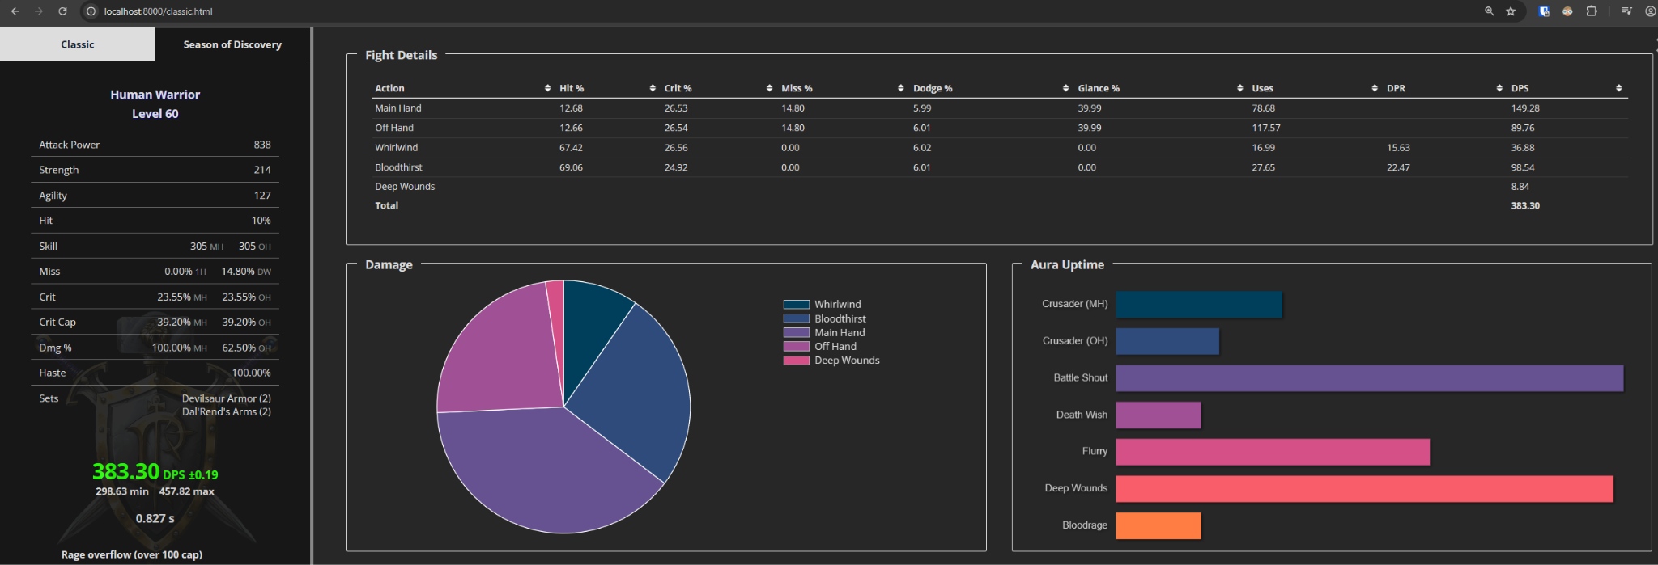
BT+WW+HS+HS
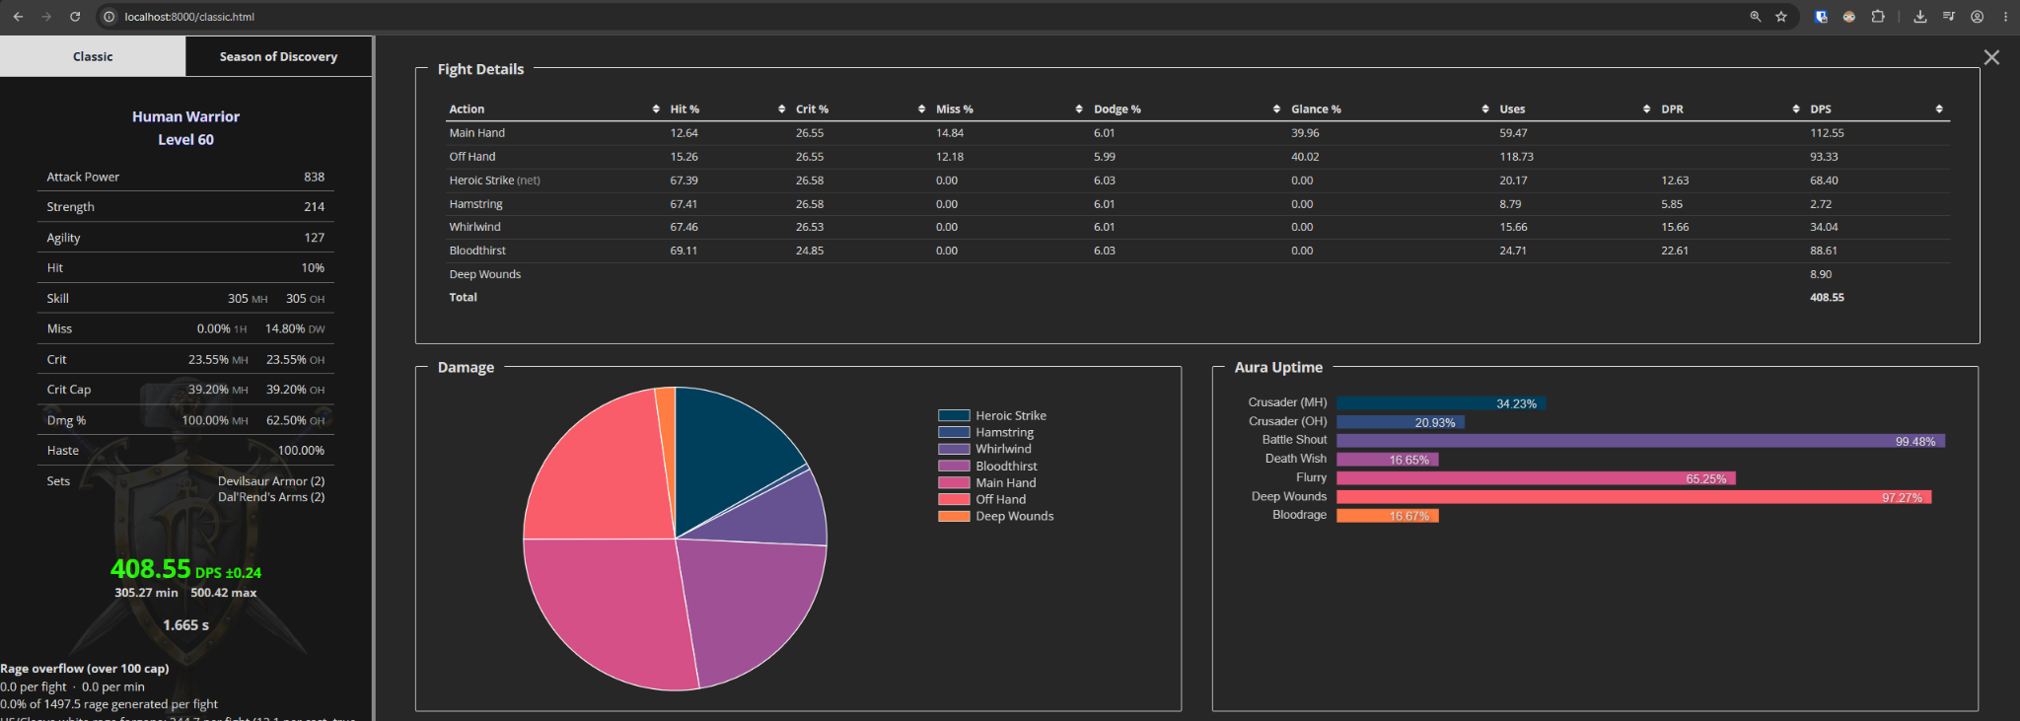
BT+WW+HS+HS+Exe
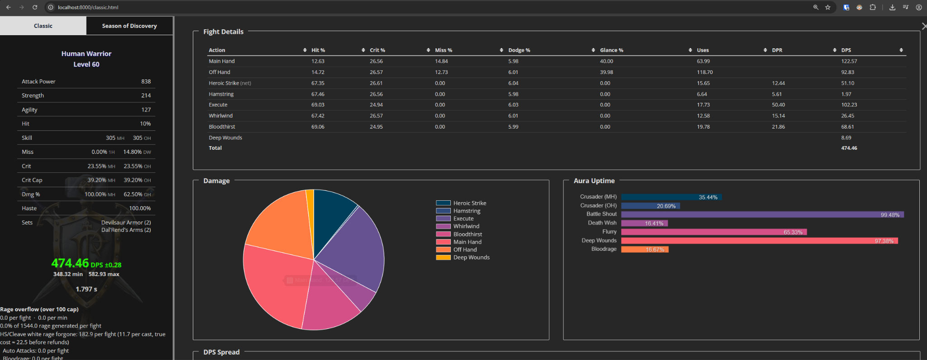

Human prebis, no WB (raid-buffed), 3 min fight. Classic rage
BT+WW
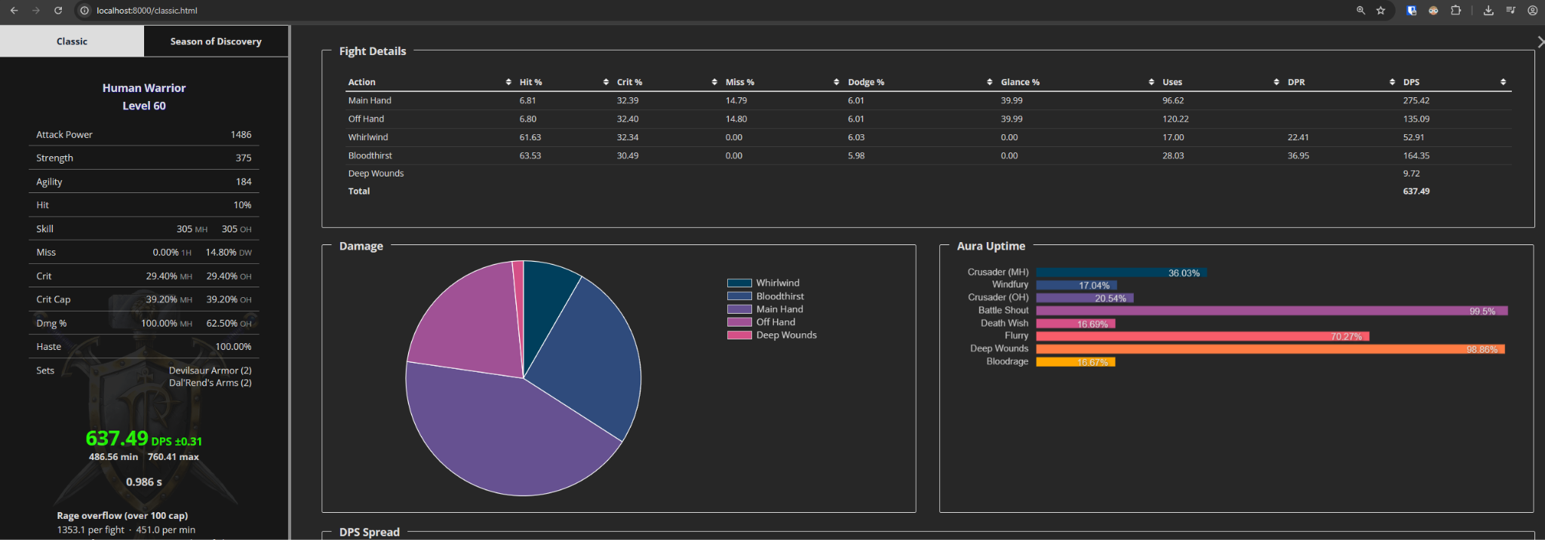
BT+WW+HS+HS
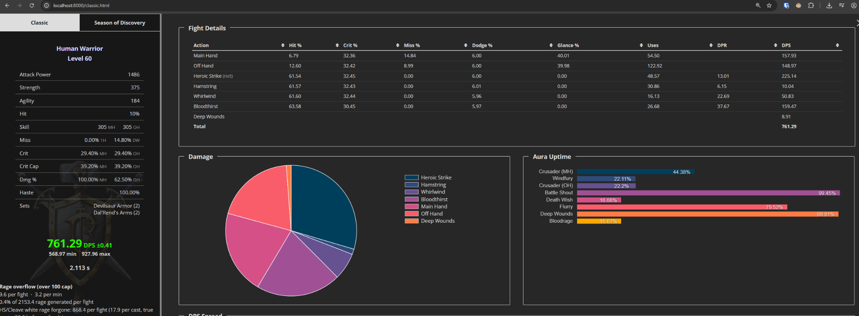
BT+WW+HS+HS+Exe
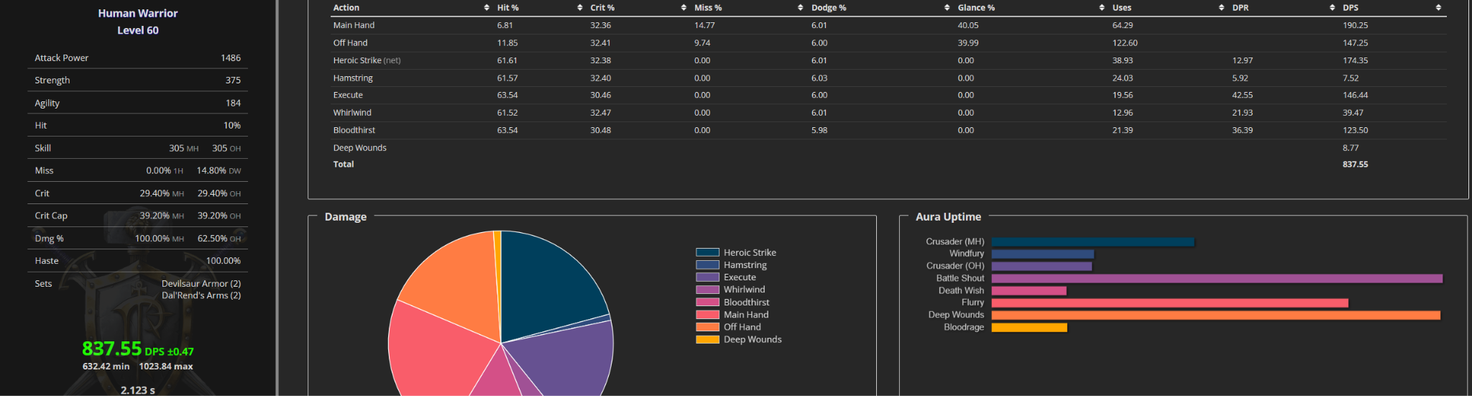

Human prebis + WB, 3 min fight. Classic rage
BT+WW
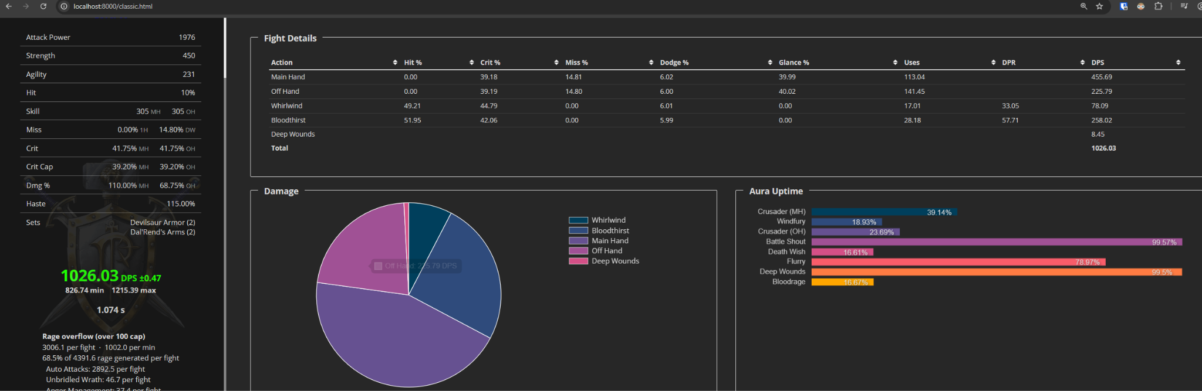
BT+WW+HS+HS
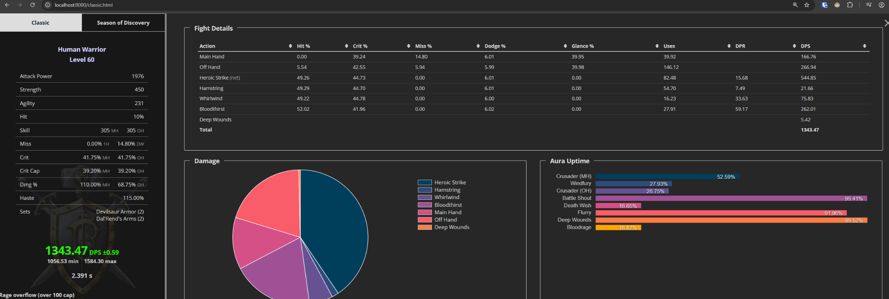
BT+WW+HS+HS+Exe
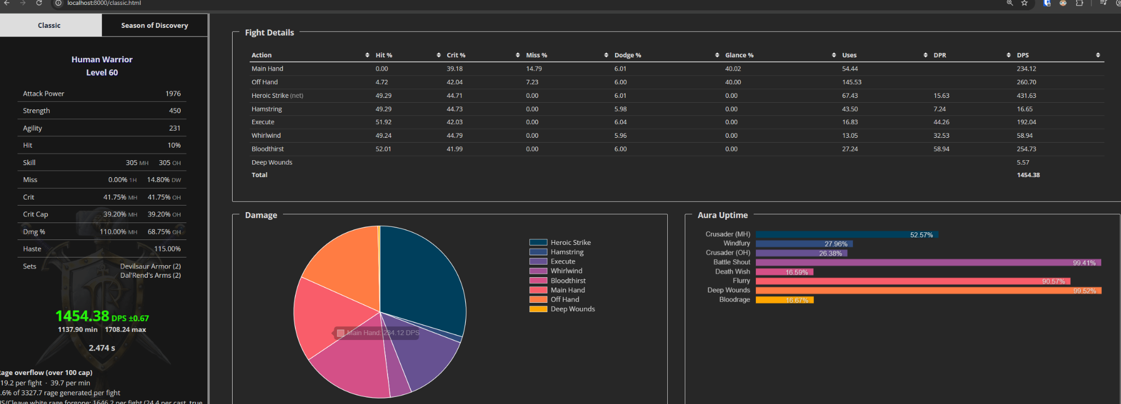

Human R14/MC/20-man, no WB, 3 min fight. Classic rage
BT+WW
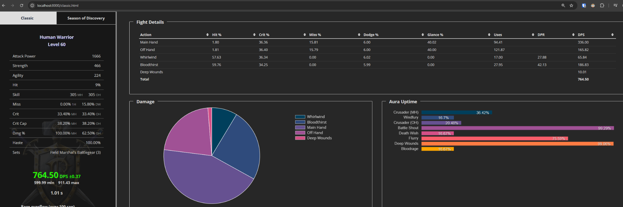
BT+WW+HS+HS
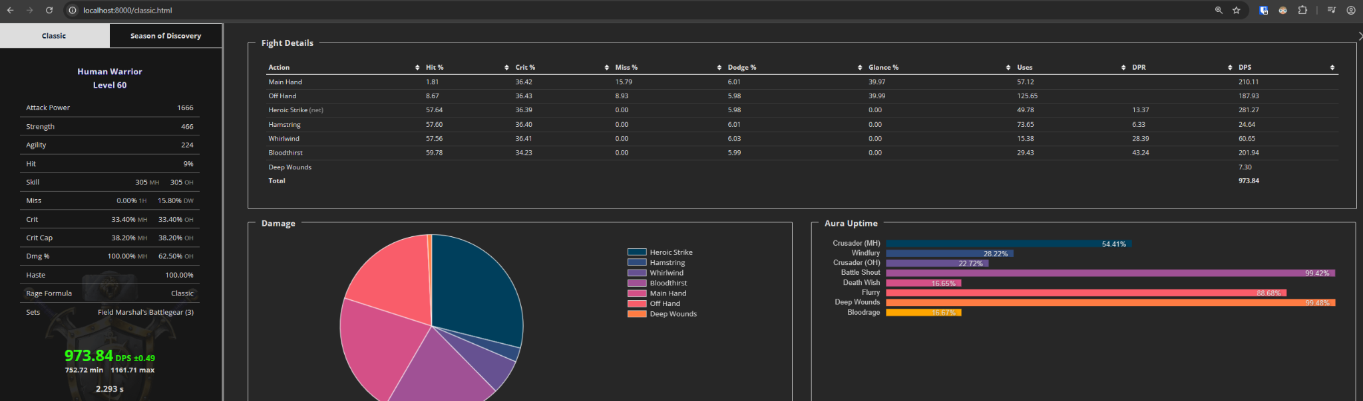
BT+WW+HS+HS+Exe
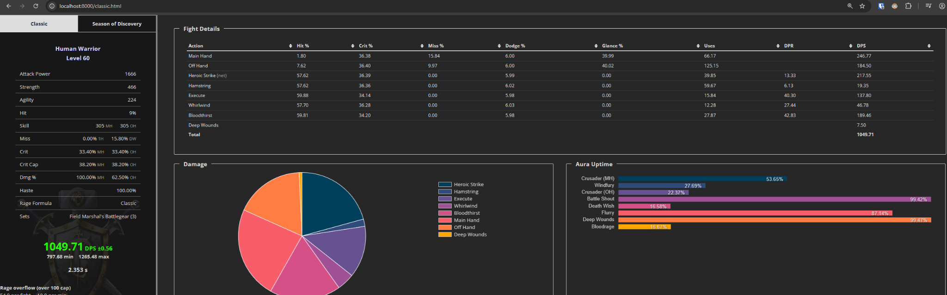

Human Naxx BiS, no WB, 3 min fight. Classic rage
BT+WW
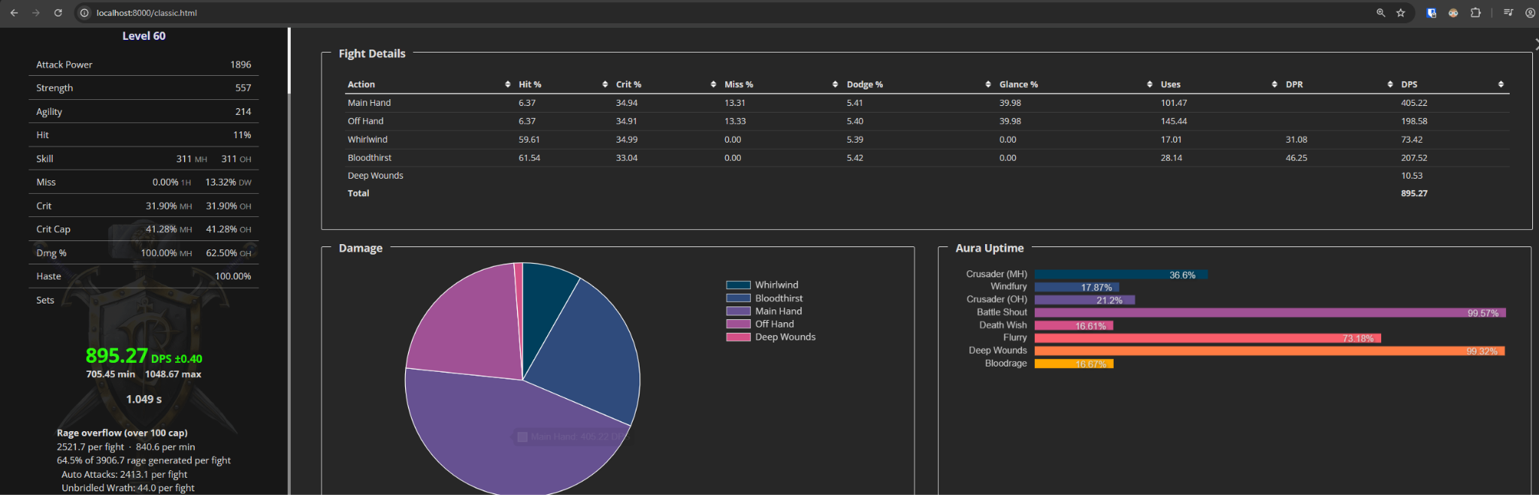
BT+WW+HS+HS
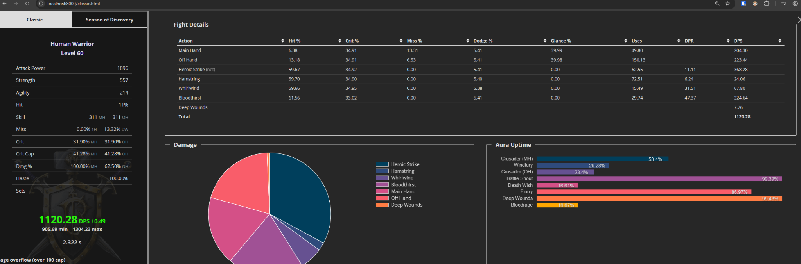
BT+WW+HS+HS+Exe
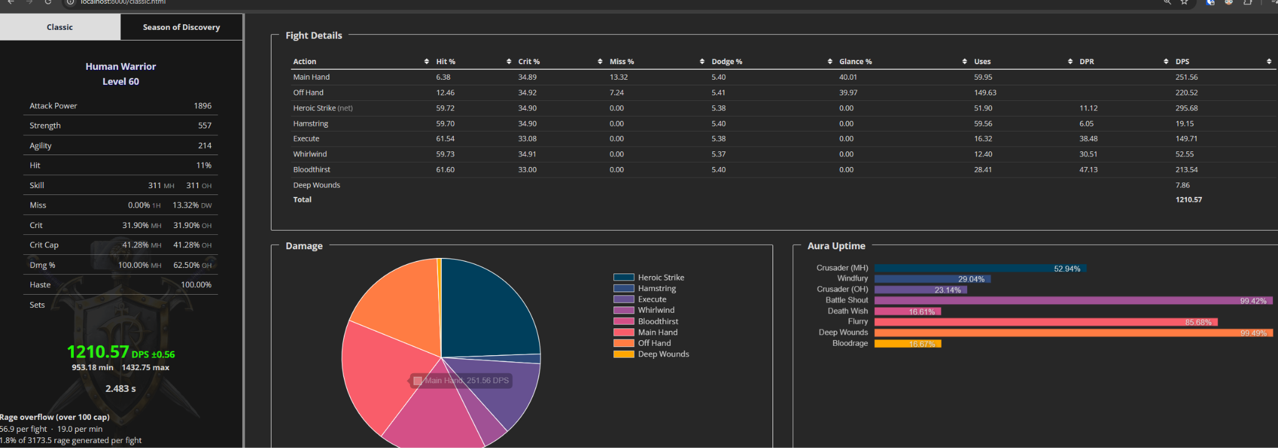

Human Naxx BiS + WB, 3 min fight. Classic rage
BT+WW
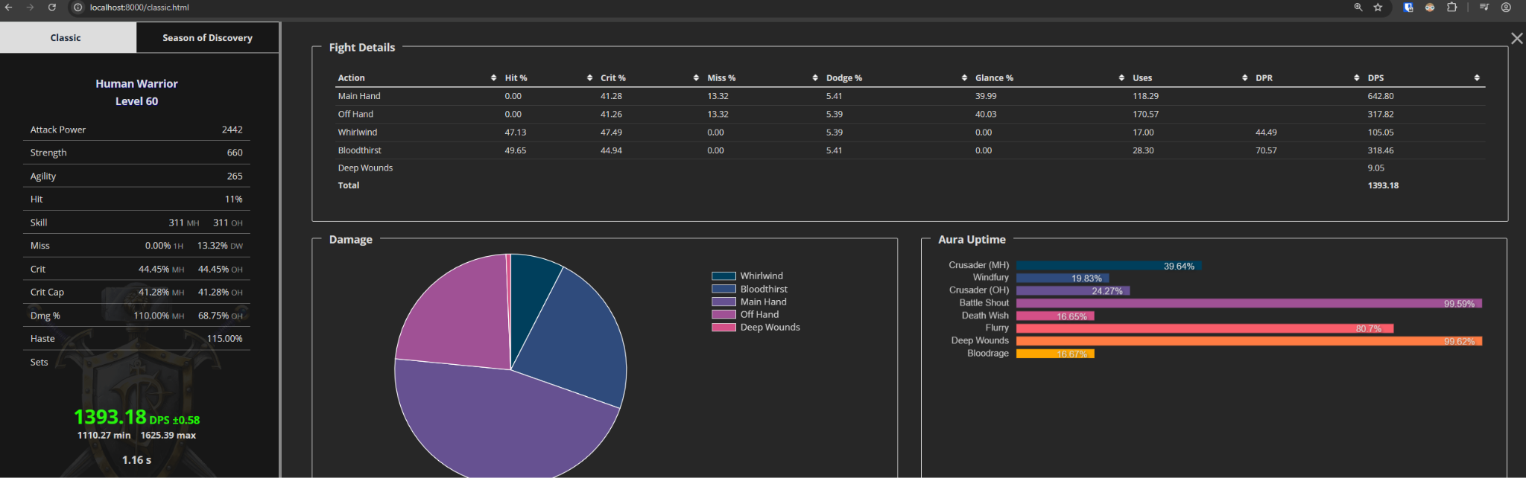
BT+WW+HS+HS
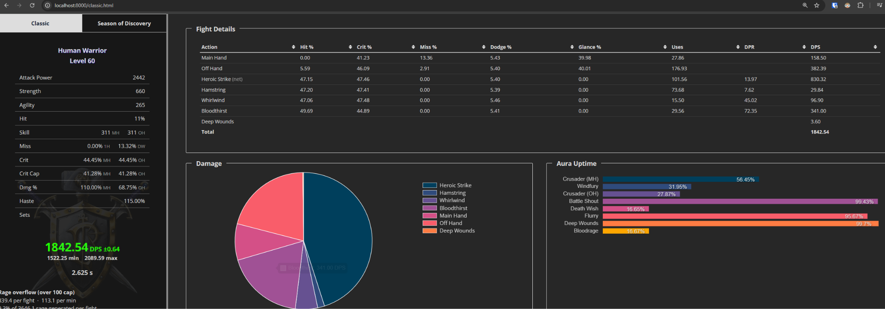
BT+WW+HS+HS+Exe
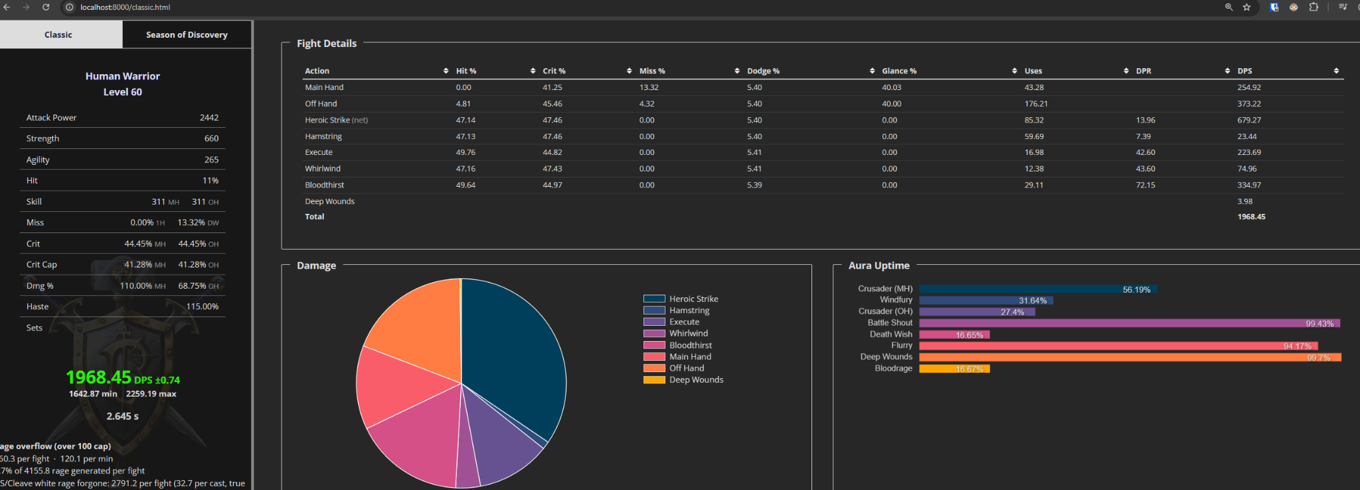

Human prebis, no WB (self-buffed), 3 min fight. Curved rage
BT+WW
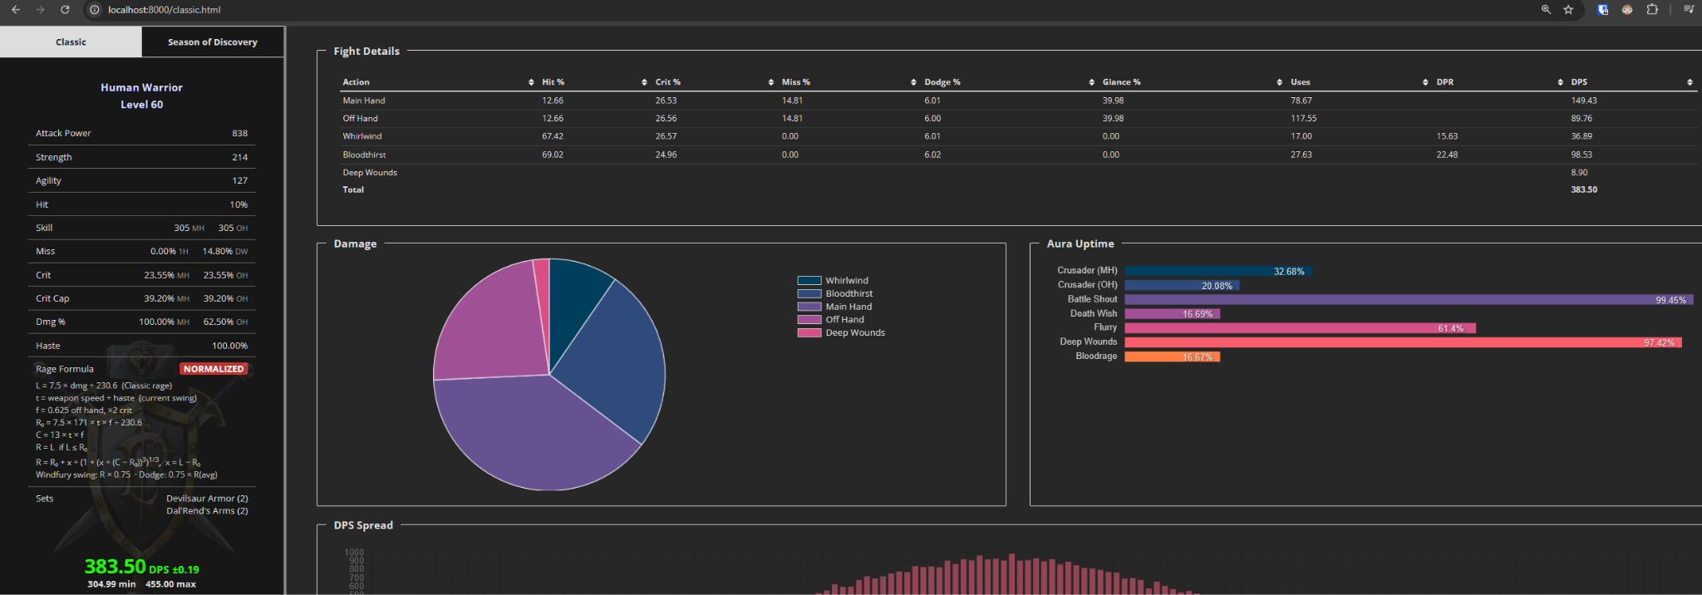
BT+WW+HS+HS
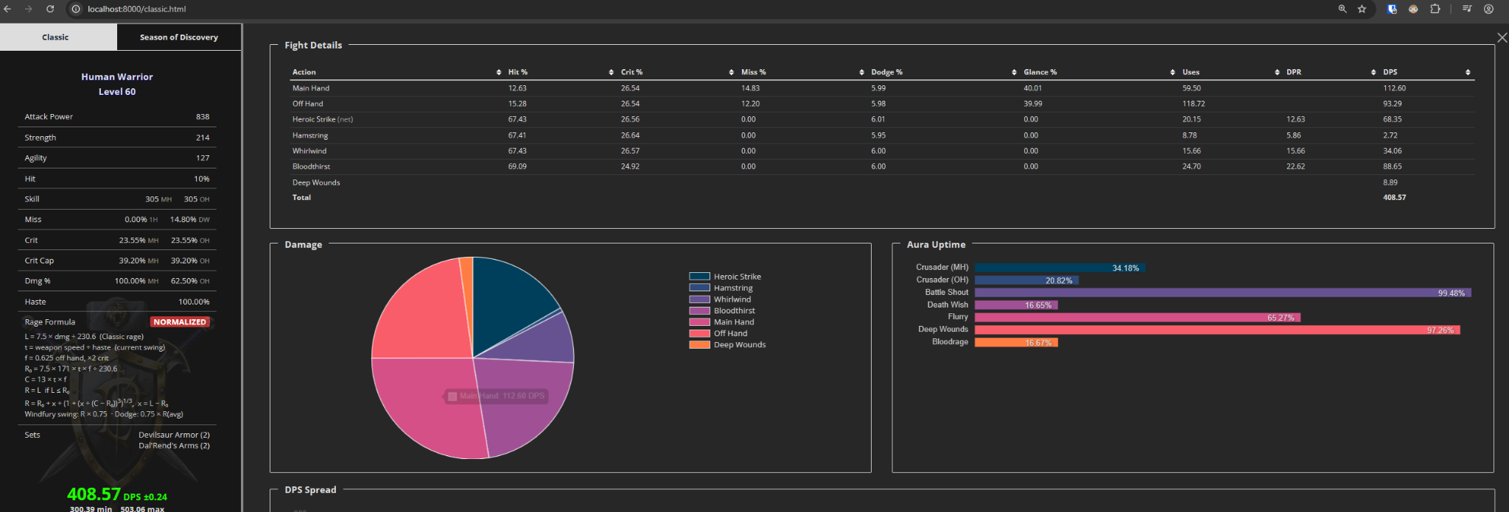
BT+WW+HS+HS+Exe
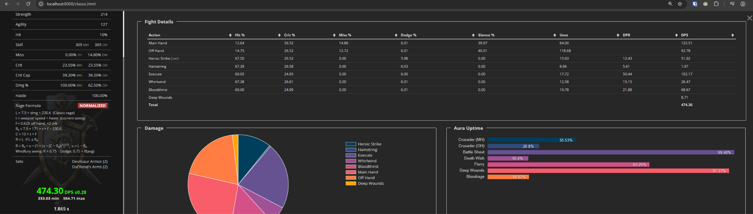

Human prebis, no WB (raid-buffed), 3 min fight. Curved rage
BT+WW
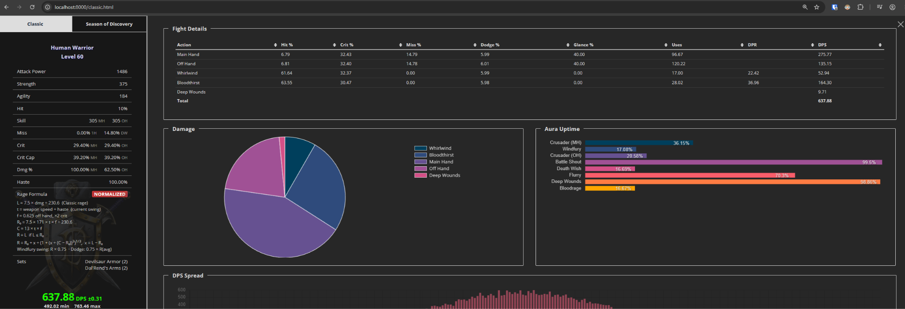
BT+WW+HS+HS
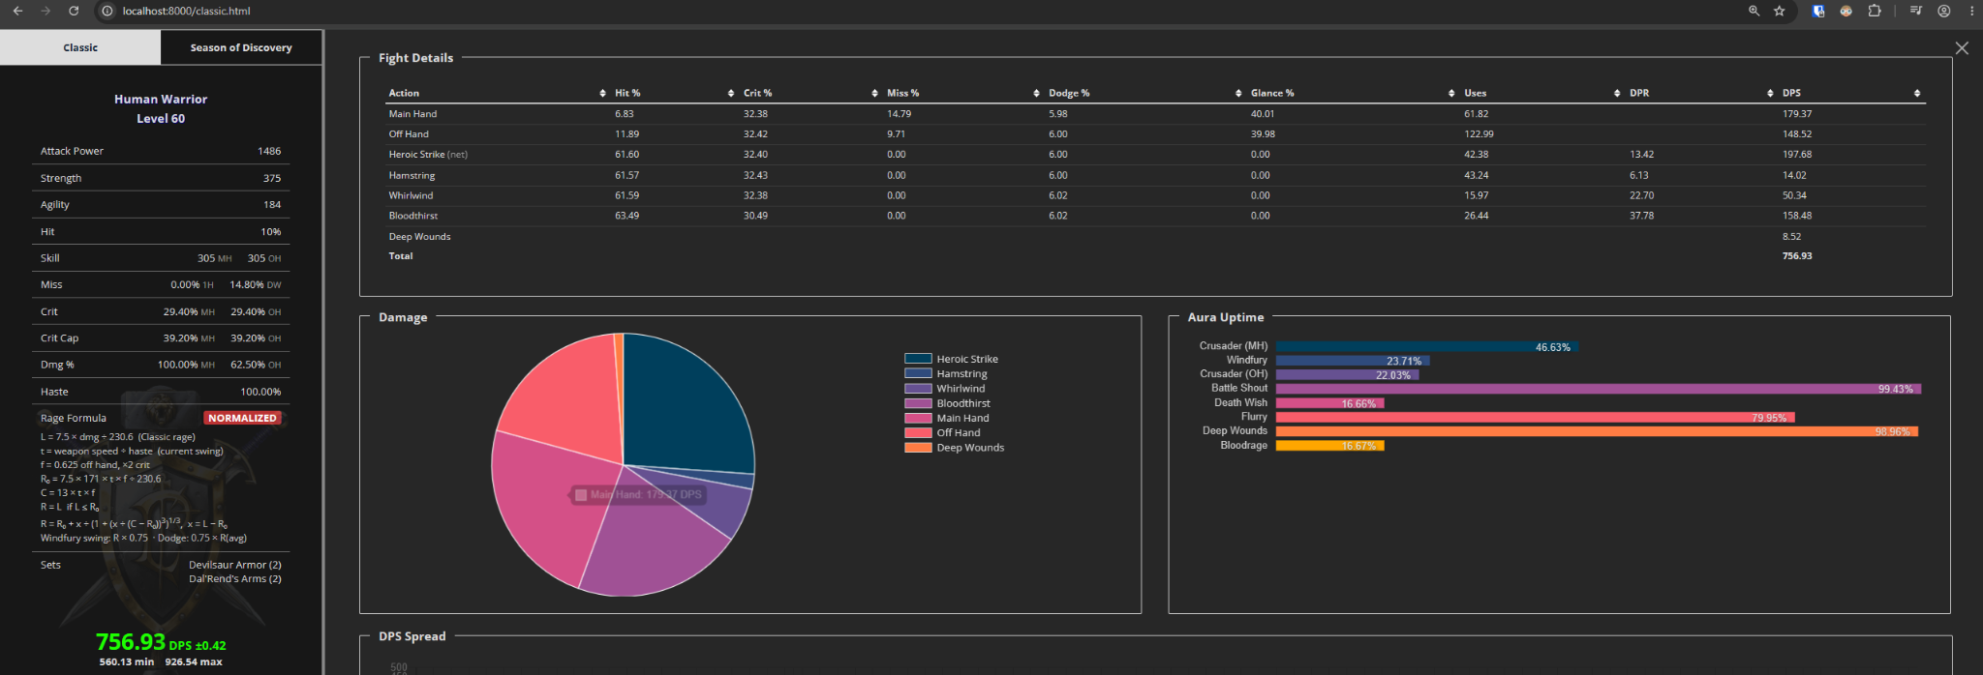
BT+WW+HS+HS+Exe
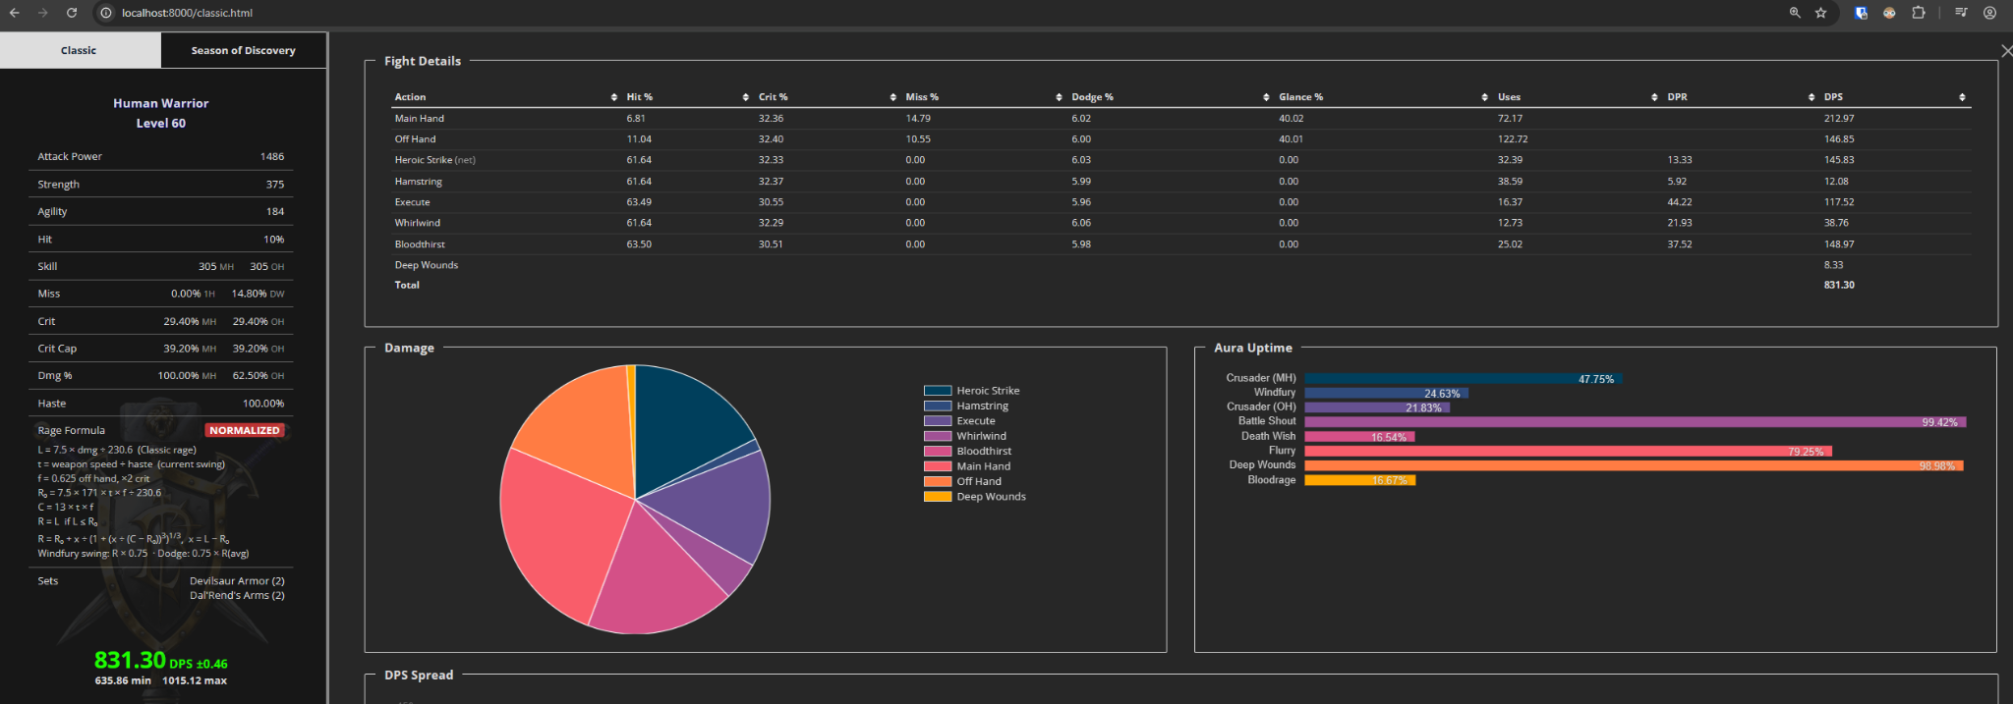

Human prebis + WB, 3 min fight. Curved rage
BT+WW
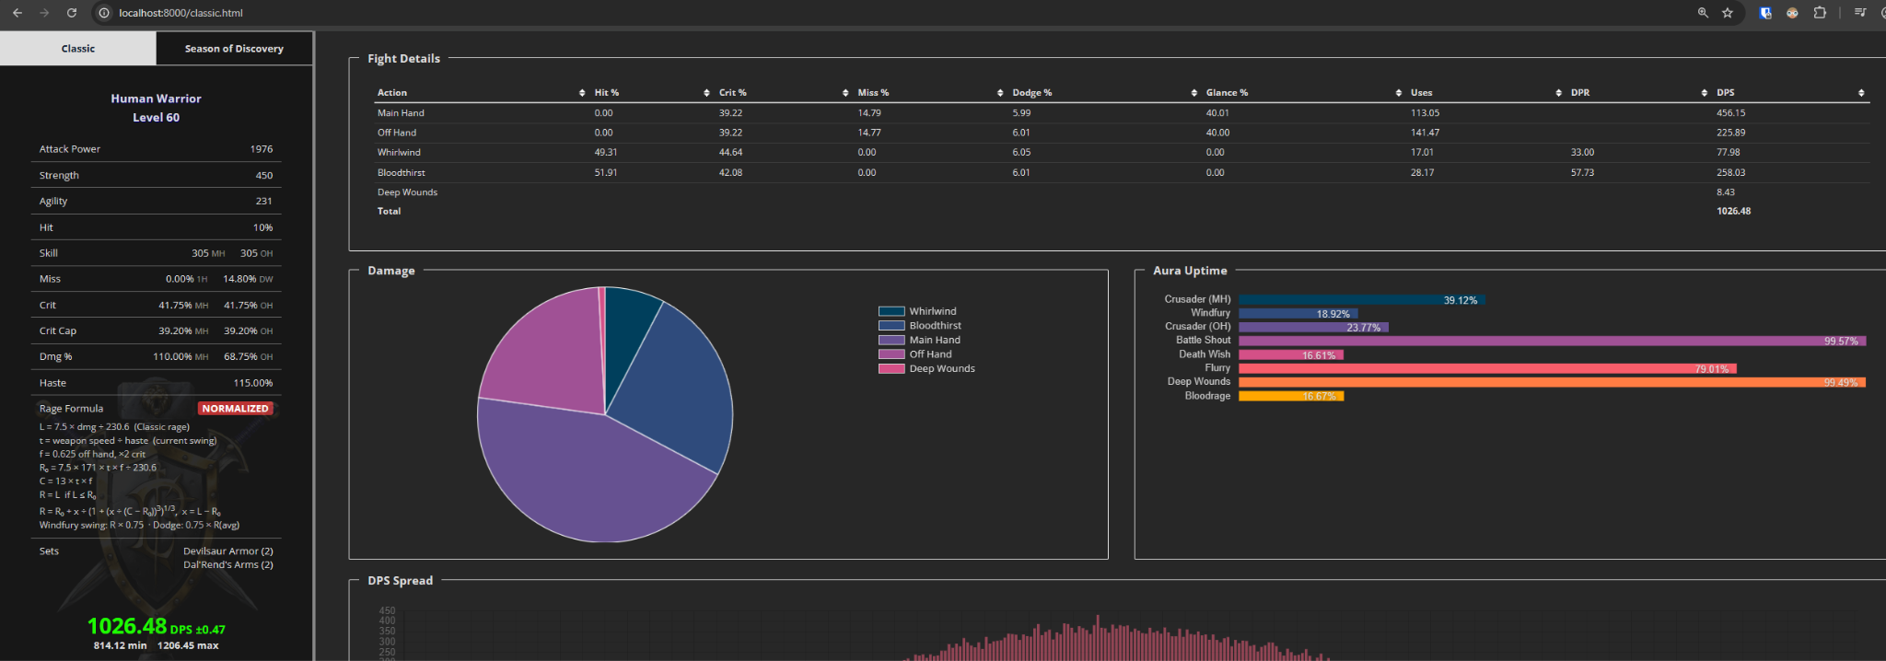
BT+WW+HS+HS
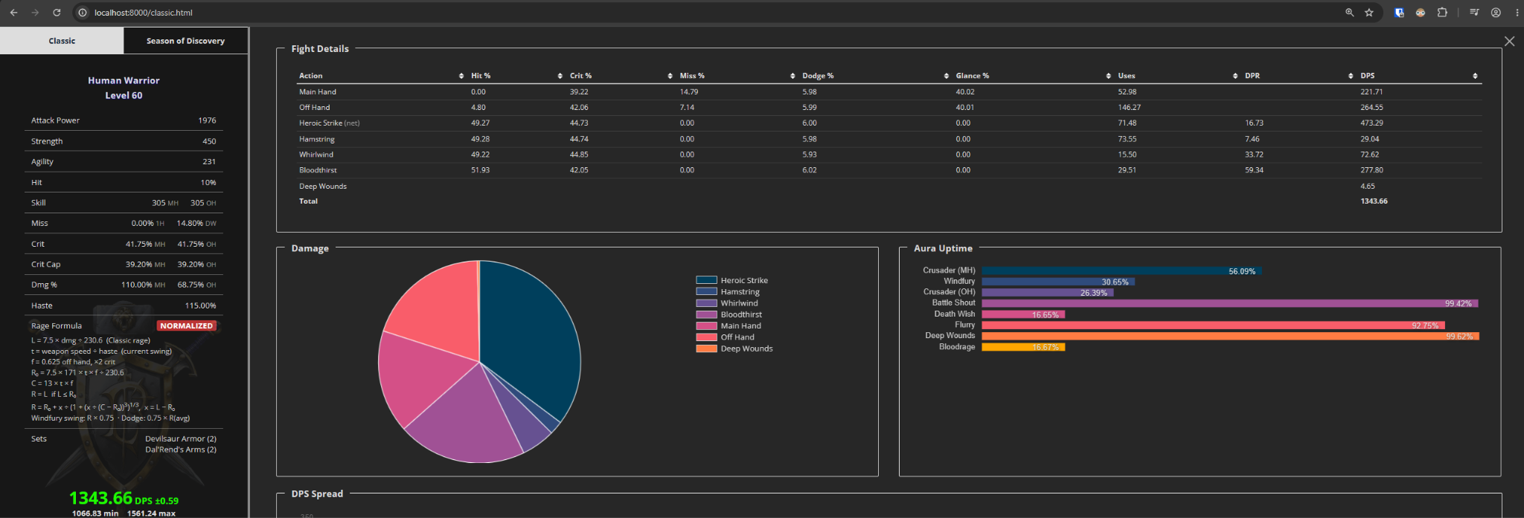
BT+WW+HS+HS+Exe
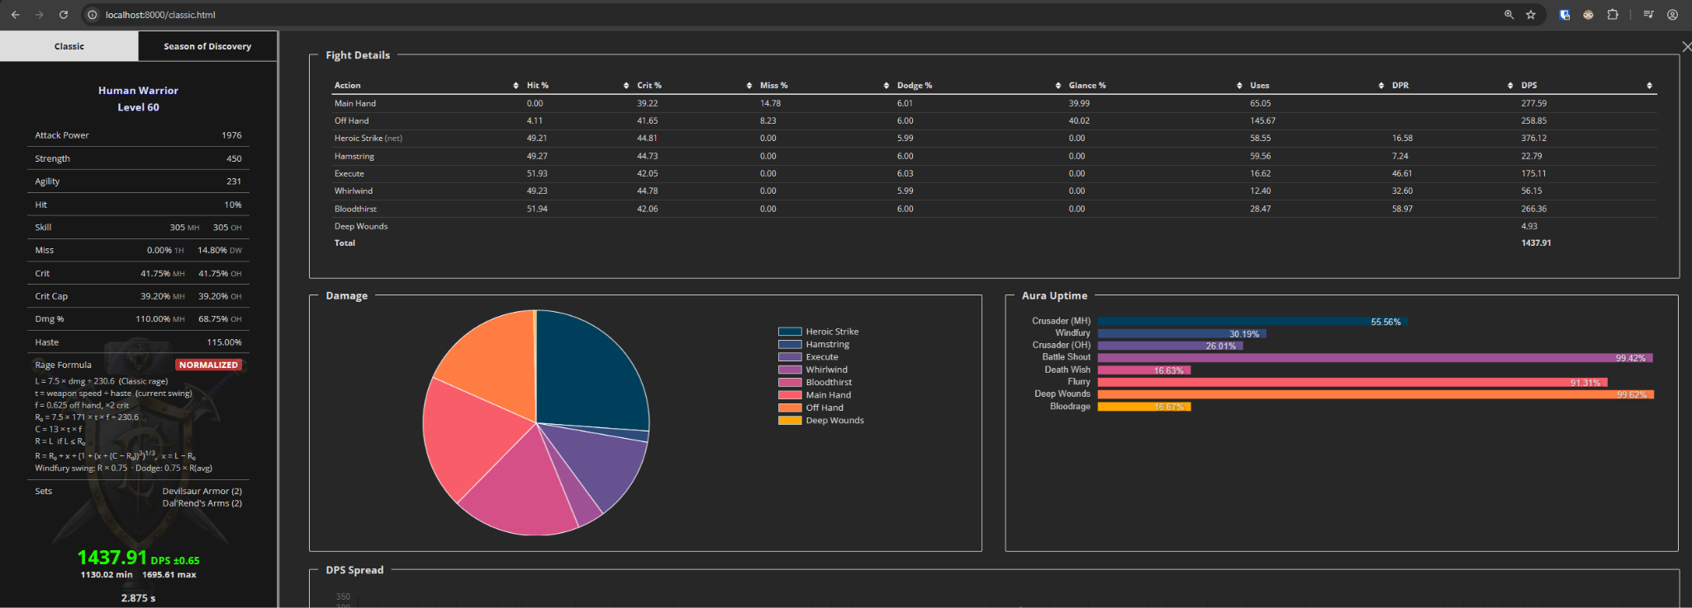

Human R14/MC/20-man, no WB, 3 min fight. Curved rage
BT+WW
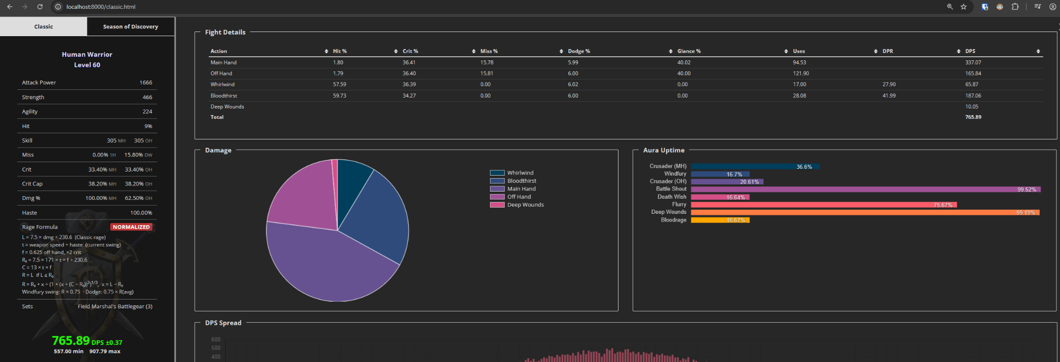
BT+WW+HS+HS
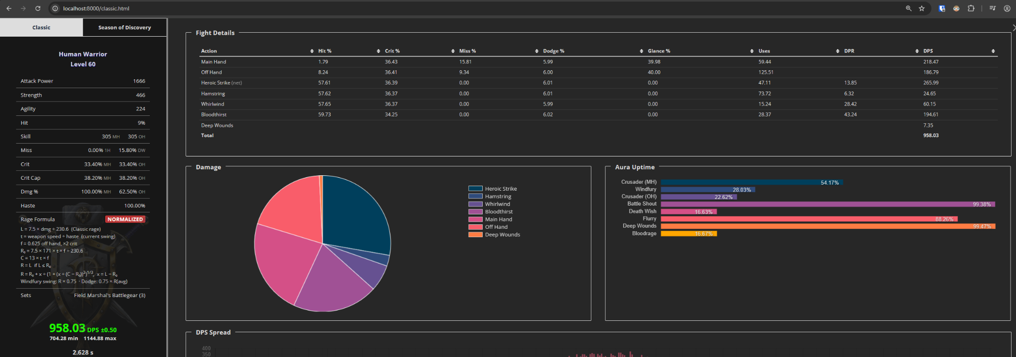
BT+WW+HS+HS+Exe
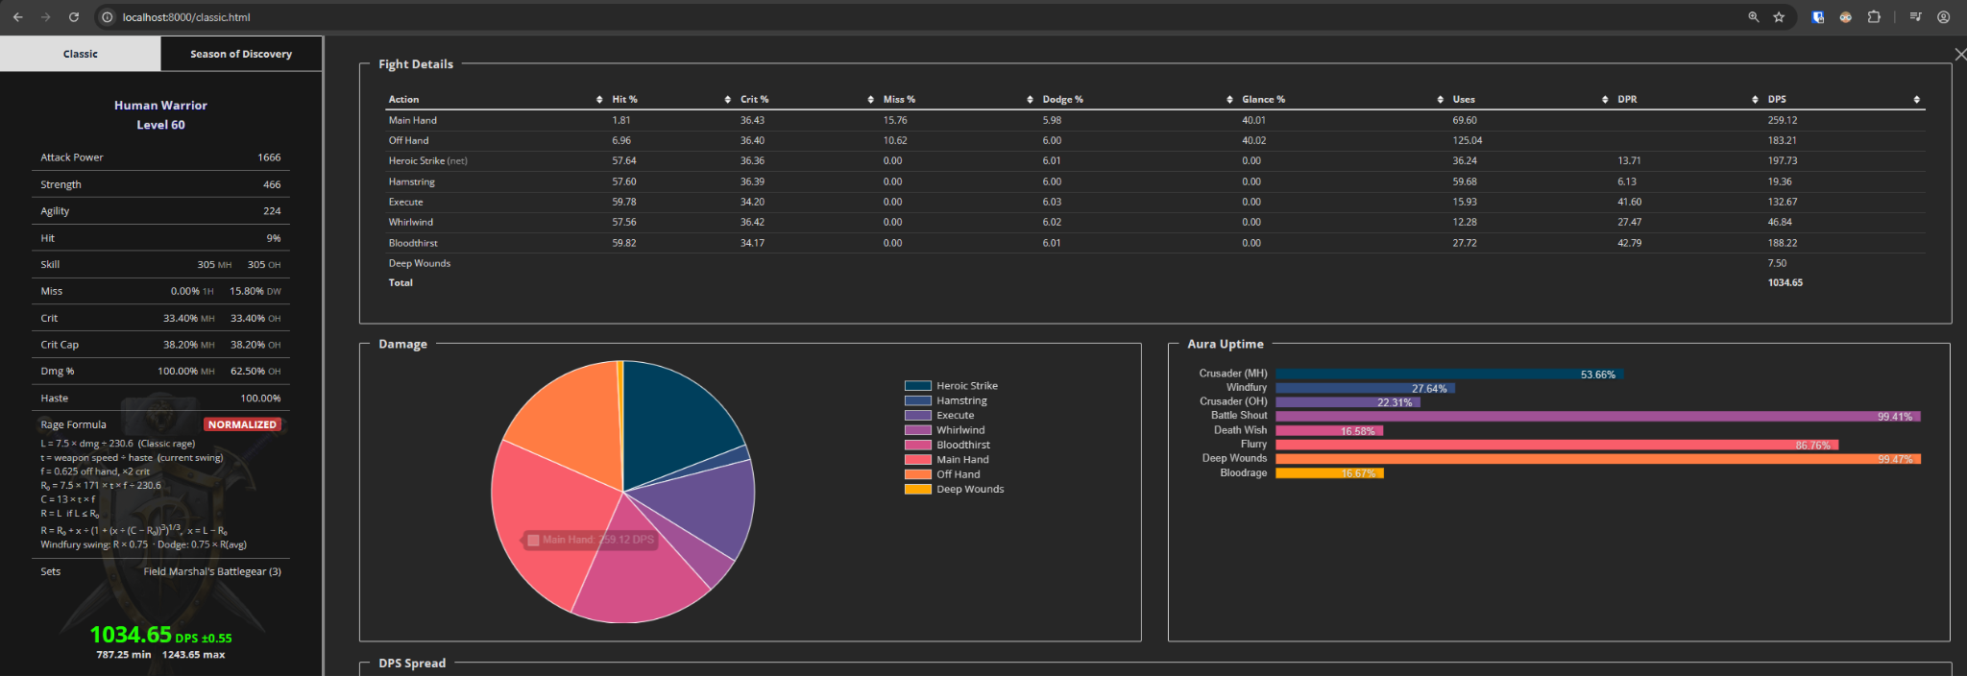

Human Naxx BiS, no WB, 3 min fight. Curved rage
BT+WW
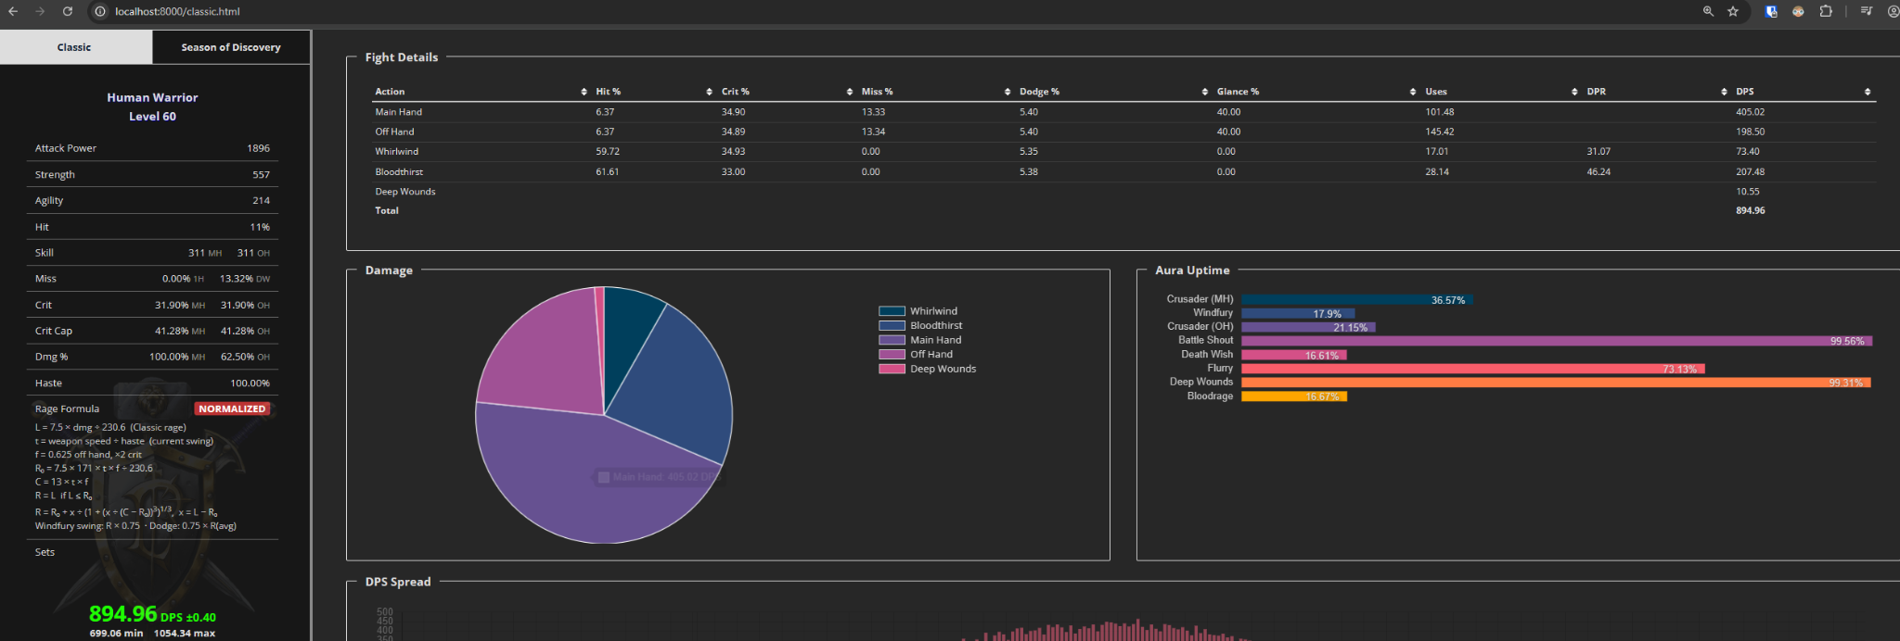
BT+WW+HS+HS
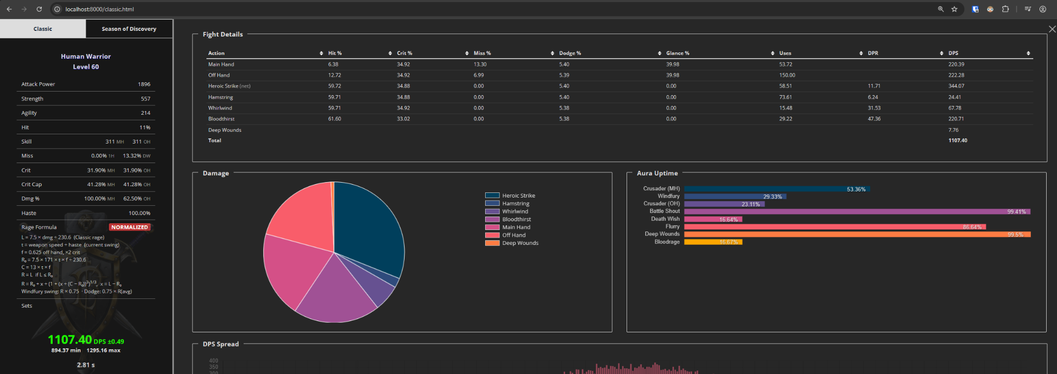
BT+WW+HS+HS+Exe
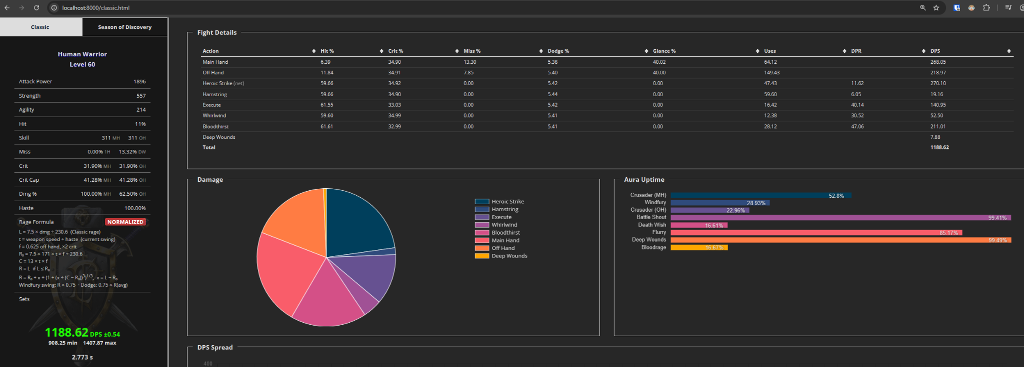

Human Naxx BiS + WB, 3 min fight. Curved rage
BT+WW
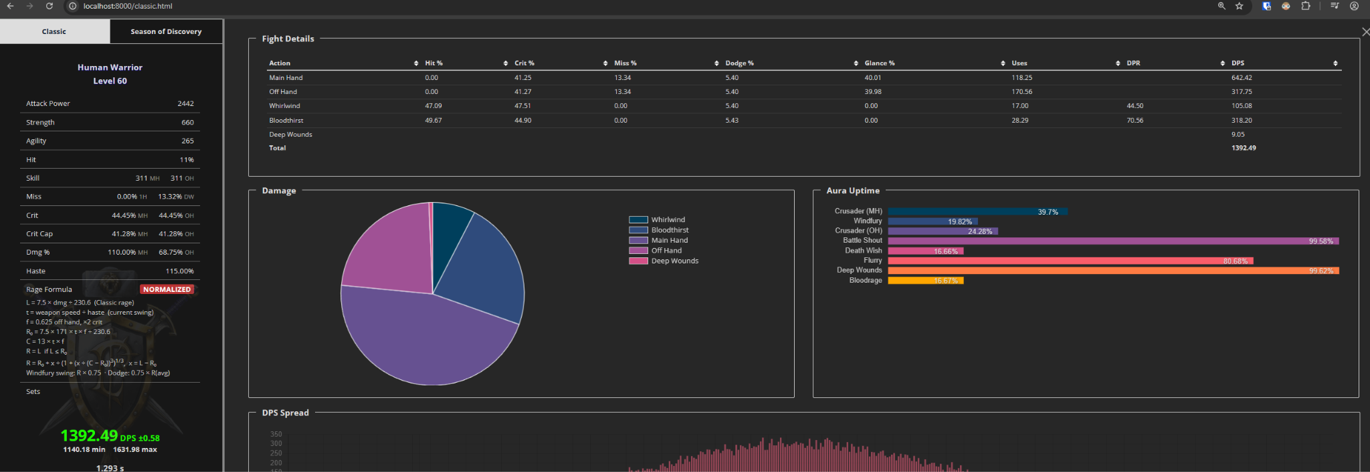
BT+WW+HS+HS
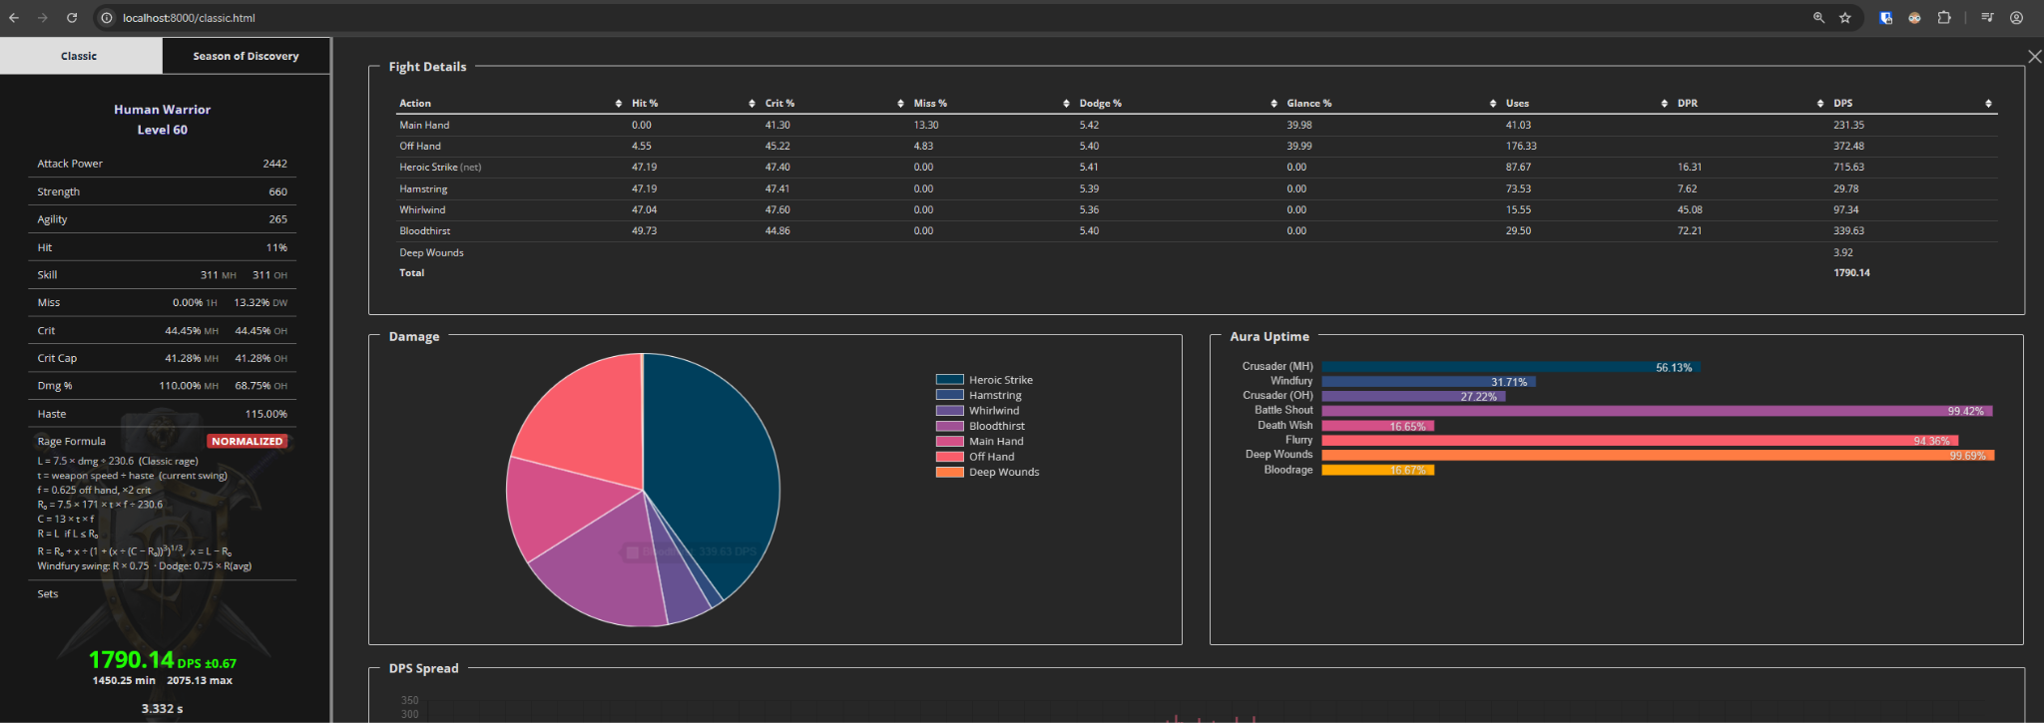
BT+WW+HS+HS+Exe
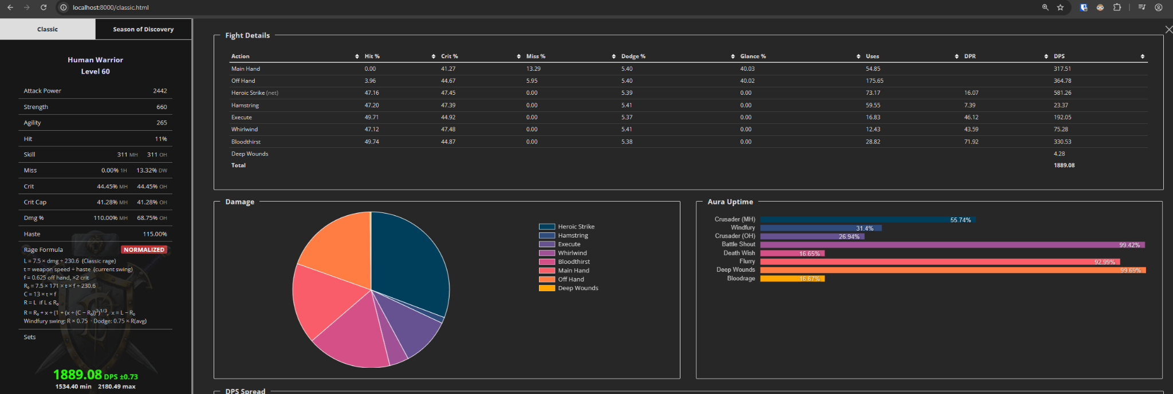

Works Cited
Bluetracker. “Rage normalization summary.” Blizzard forum thread with posts by Drysc and Kalgan, 22 Oct. 2006, www.bluetracker.gg/wow/topic/us-en/37024708-rage-normalization-summary/.
Greenfield, Josh (@AggrendWoW). Post on X (Twitter) about warrior rage in Season of Discovery. 18 Apr. 2024, x.com/AggrendWoW/status/1781039375134199872.
Guybrush. WarriorSim (Classic), guybrushgit.github.io/WarriorSim/classic.html. A modified version (RAGE NORM builds 5–10) with rage tracking, Curved rage, and Forever’s rage rules, talents and abilities was used for all sims in this document.
Icy Veins. WoW Classic Season of Mastery Survival Guide, www.icy-veins.com/wow-classic/season-of-mastery-survival-guide. Accessed 30 Sept. 2026.
Marrow. “Abilities: Classic vs Forever.” Marrow’s Eternal Compendium of Dragonslaying, version 2.0.0, 25 Sept. 2026, ppach-warriorcompendium.share.connect.posit.cloud/abilities.html.
Marrow. “Flurry.” Marrow’s Eternal Compendium of Dragonslaying, version 1.2.1, 25 Sept. 2026, ppach-warriorcompendium.share.connect.posit.cloud/flurry.html.
Marrow. “Rage Design Proposals.” Marrow’s Eternal Compendium of Dragonslaying, version 2.0.0, 25 Sept. 2026, ppach-warriorcompendium.share.connect.posit.cloud/rage-proposals.html.
Marrow. “Rage Generation.” Marrow’s Eternal Compendium of Dragonslaying, version 3.1.0, 1 Oct. 2026, ppach-warriorcompendium.share.connect.posit.cloud/rage.html.
Marrow. “Rage on Crit.” Marrow’s Eternal Compendium of Dragonslaying, version 1.0.0, 1 Oct. 2026, ppach-warriorcompendium.share.connect.posit.cloud/rage-on-crit.html.
Seramate. “Warrior Updates in Today’s WoW: Forever Beta Build.” Seramate, 1 Oct. 2026, seramate.com/news/forever/2026/10/01/warrior-beta-build-updates-1f1be0e6. Summarizing Wowhead, www.wowhead.com/news=383230.
Squishei. “Rogues Will Have the Highest Single-Target Damage in WoW: Forever.” Wowhead, Oct. 2026, www.wowhead.com/forever/news/rogues-will-have-the-highest-single-target-damage-in-wow-forever-383209. Accessed 2 Oct. 2026.
Warcraft Logs. Damage rankings for Classic Anniversary (fresh.warcraftlogs.com), Classic Era and Season of Mastery (vanilla.warcraftlogs.com). Pulled 29 Sept. 2026.
Warcraft Wiki. “Rage.” warcraft.wiki.gg/wiki/Rage. Patch 4.0.1 notes. Accessed 2 Oct. 2026.
wowsims. Rage generation code for The Burning Crusade, Wrath of the Lich King and Cataclysm (sim/core/rage.go), github.com/wowsims/tbc, github.com/wowsims/wotlk, github.com/wowsims/cata. Accessed 2 Oct. 2026.

