Keep the Rage, Cap the Scaling
A better trade for normalized rage in WoW: Forever
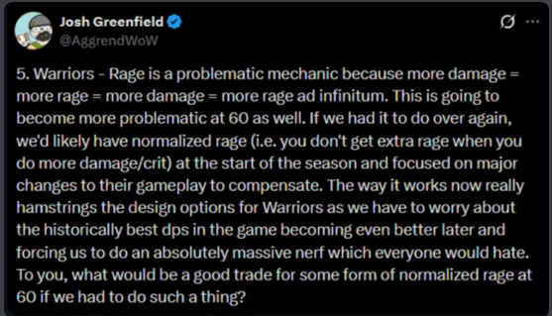
Josh Greenfield (Aggrend), @AggrendWoW, 18 April 2024, during Season of Discovery Phase 3 (Greenfield).
In April 2024, during Season of Discovery, Aggrend floated the idea of normalized rage for warriors and ended his post with a question: “what would be a good trade for some form of normalized rage at 60 if we had to do such a thing?” SoD never made that change. Two and a half years later, WoW: Forever has: its beta replaces Classic’s damage-based rage with a fixed amount per swing. That puts rage generation in Forever closer to Cataclysm than to Classic. Damage was part of the rage formula in Classic, The Burning Crusade and Wrath of the Lich King, and was only removed in Cataclysm (see Background). This document aims to answer Aggrend’s question, and proposes a trade that controls warrior rage and damage without throwing away what makes rage feel like rage.

Summary
Aggrend’s post begins with a concern that rage is part of a feedback loop (“more damage = more rage = more damage = more rage ad infinitum”) that makes warriors difficult to balance and could force a massive nerf later on. In WoW: Forever, the proposed solution is a rage formula that ignores damage entirely: each landed swing gives a fixed amount of rage per second of weapon speed, and since 30 September crits give extra (Marrow, “Rage on Crit”). Aggrend asks what a good trade for some form of normalized rage would be at 60; this document aims to answer that question.
The trade:
- Keep damage-based rage, but curve its tail end at level 60. The scaling problem starts at 60, so that’s where we start: rage follows Classic’s formula up to roughly pre-raid gear, then bends smoothly toward a per-swing cap that scales with swing time. That gives a ceiling of our choosing (for example 1,600–1,800 true RPM) that future gear tiers can’t push through. Because rage still comes from damage, every stat and upgrade that makes a warrior hit harder still means more rage, and rage keeps the swingy, damage-driven feel it has in Classic. Our final proposal also raises the formula’s coefficient by 20% at every level, 1–60, to make up for the ability nerfs, Forever’s changes and the lost weapon skill, all of which hit leveling warriors too (section 5). The shape of the curve is a choice: developers decide where diminishing returns start, where the ceiling sits, and the steepness of the curve in between.
- Fix warrior damage at the source: Bloodthirst 45% → 40% AP, Death Wish 20% → 15%, and a 4 second cooldown on Execute. Our final proposal also keeps most of WoW: Forever’s changes: Unbridled Wrath at 60% (and only procing on white hits, which is new to Forever), Flurry giving 25% haste for 3 swings, Deep Wounds being able to stack with itself, 10% off-hand hit from the Furious Precision talent, and Whirlwind hitting with both weapons (and costing 22 rage once talented). With the 300 weapon skill we expect in Forever, our proposal lands us 2–10% below Classic and within 6% of the current Forever formula at all gear levels we tested (section 5).
Terms used in this document:
Term | What it means
Classic rage | Classic’s linear formula: rage = 7.5 × damage ÷ C
Forever | Forever’s rage formula (v2: a fixed rate × weapon speed per landed swing, crits ×2) together with Forever’s warrior talent, ability and mechanic changes as of the 1 October beta build (section 3)
Curved rage | Our starting model, for level 60 only: Classic rage (coefficient 7.5) up to a threshold, then a smooth curve toward a per-swing cap, both scaled to swing time (section 4). It’s where we started, not what we propose
The final proposal | Classic’s formula with a coefficient of 9 instead of 7.5 at every level, bent at 60 by Curved rage’s threshold and cap + Forever’s talent and mechanic changes + our changes to Bloodthirst, Death Wish and Execute (section 5)
Weapon skill | Classic is simmed at 305 weapon skill, how most Classic warriors played. Forever and our final proposal are simmed at 300, because Forever removes racial weapon skill (section 3)
Why not Forever rage?
- Rage isn’t the main driver of warrior damage. In our sims, cutting a Naxx BiS, world-buffed warrior’s rage by 43% (2,071 → 1,177 true RPM) with the starting version of Curved rage (section 4) lowered DPS by only 10%. Warriors lead every raid tier, including T1 without world buffs; the gap is the result of base damage, not rage scaling (sections 1–2).
- Forever rage ignores the gear warriors care about. Attack power and weapon damage give exactly zero rage under every version of Forever’s rules (Marrow, “Rage on Crit” sec. 4.6.1). Crit, hit modifiers (including expertise) and haste become the only stats that add rage.
- Forever is already moving toward this proposal. Its newest rules normalize rage to weapon speed, double rage on a crit, and get a ceiling from the attack table. Two pieces are missing. Damage does nothing for rage, and without damage in the formula, rage loses much of its swing-to-swing volatility, which is a big part of what makes rage feel like rage. Our proposal keeps everything Forever is reaching for and adds both pieces back (section 3).
- Forever reduces rage to an extent that cripples DPS warrior gameplay. Our sims show that under Forever’s rage formula and changes, a Naxx BiS, world-buffed warrior would generate less rage (843 true RPM) than a Classic warrior in prebis gear with raid buffs and no world buffs (967 true RPM, Appendix C).
Gear (3 min fight, with Execute) | Classic (305 skill) | Forever (300 skill) | The final proposal (300 skill)
Prebis, self-buffed, no WB | 482 | 489 (+1%) | 463 (−4%)
Prebis, raid-buffed, no WB | 854 | 778 (−9%) | 787 (−8%)
Prebis + WB | 1473 | 1264 (−14%) | 1321 (−10%)
R14 / MC / 20-man, no WB | 1010 | 902 (−11%) | 944 (−7%)
Naxx BiS, no WB | 1211 | 1122 (−7%) | 1184 (−2%)
Naxx BiS + WB | 1956 | 1787 (−9%) | 1866 (−5%)
DPS. Percentages are against Classic. Results for every setup are in Appendix C.
At raid gear, our final proposal deals 1–6% more damage than Forever, but generates 17–60% more rage, and up to two and a half times as much rage beyond what Bloodthirst and Whirlwind cost. That spare rage is what pays for Heroic Strike, Hamstring and a strong execute phase: the decisions that make warrior play like a warrior. Forever caps warrior damage by taking those decisions away; our final proposal caps damage while preserving the decision making and gameplay that are distinct to the Classic warrior.

Background: how rage is generated
In WoW Classic (and until Cataclysm), rage from white hits depends on their damage. At level 60 in Classic the rage formula is (Marrow, “Rage Generation” sec. 2.1):
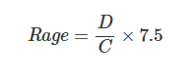
Where D is the hit’s damage after mitigation and C is a level constant, about 230.6 at level 60. That’s a straight line: a 500 damage hit gives about 16.3 rage.
How rage has changed before. Classic is the only version where rage came entirely from damage, but it isn’t the only one where damage mattered. Blizzard never published the exact constants, so the formulas below come from the community sims that reproduce each version (wowsims):
Version | Rage from a white hit | Does damage matter?
Classic | 7.5 × D ÷ C | Fully
The Burning Crusade | (7.5 × D ÷ C + f × s) ÷ 2, where f is 3.5 for the main hand and 1.75 for the off hand (doubled on a crit) and s is weapon speed | Half: the other half is a fixed amount per second of weapon speed
Wrath of the Lich King | Same as TBC, capped at 15 × D ÷ C per hit | Half
Cataclysm (patch 4.0.1) | A fixed amount per swing: about 6.5 × weapon speed for the main hand, half for the off hand | No
WoW: Forever (beta) | A fixed amount per swing: about 3.46 × weapon speed for the main hand, half for the off hand, with bonuses below | No (crits only)
The Burning Crusade’s change was itself called rage normalization at the time: rage was “based around an internal number of how much rage a warrior could be expected to normally generate at each given level per DPS,” but still followed damage (Drysc and Kalgan, in “Rage normalization summary”). Cataclysm was the first version to take damage out entirely: “Rage is being normalized so that its generation is no longer based on damage done by auto-attacks” (patch 4.0.1 notes, Warcraft Wiki). Forever follows Cataclysm’s approach.
In WoW: Forever, a white swing that lands gives a fixed rate times the weapon’s listed speed: about 3.46 per second of speed in the main hand and 1.73 in the off hand, whatever the swing’s damage (Marrow, “Rage Generation”). The speed cancels out, so each hand gives a fixed rage per second. Three things matter for this document:
- Damage doesn’t matter. Weapon damage, attack power and damage modifiers give no rage. Misses and dodges give none either.
- Haste does. A hasted swing gives full rage, so 10% faster swings give 10% more rage (Marrow, “Rage Generation”).
- Crit now does too. On 30 September, Blizzard announced that crits give 75% more rage and Dual Wield Specialization would no longer double the off hand’s rage. Zirene, one of Forever’s developers, then said a bug had thrown off testing, and the fix will make crits give 100% more and the off hand 50% more. We call these v1 and v2, and the old rules v0. This document uses v2, the most recent. Section 3 lists the rest of Forever’s warrior changes, after which we call the whole package simply “Forever”.
Version | Off hand (Dual Wield Specialization) | A crit’s rage
Forever v0 (before 30 Sep) | ×2 | ×1
Forever v1 (30 Sep) | ×1 | ×1.75
Forever v2 (announced fix) | ×1.5 | ×2
Why Forever changed rage, as we read it. Neither Forever nor Aggrend’s post about Season of Discovery explains the change in detail. Reading the post, some reasons are stated and some are implied. Sections 1–3 test each one:
- Rage creates an “infinite” feedback loop: damage → rage → damage → rage.
- Warrior is the best DPS class (and it isn’t close).
- The feedback loop limits design options for new gear and talents.
- (Implied) Removing damage from rage fixes this while preserving the class’s identity.

1) The loop is real, but bounded
What warriors spend rage on. Outside of execute phase, every warrior presses Bloodthirst > Whirlwind > everything else. Bloodthirst costs 30 rage every 6 seconds and Whirlwind 25 every 10. Pressing both on cooldown costs about 415 RPM in all of our Classic sims, after refunds and the odd delayed Whirlwind, and including Battle Shout and Death Wish (see our spreadsheet). With Forever’s 22-rage Whirlwind, which the final proposal also uses, it drops to about 402 RPM. Marrow gets almost the same number for Forever: 6.8 rage per second, or 408 RPM, without Battle Shout or Death Wish, which account for nearly all of the gap (Marrow, “Rage on Crit” sec. 4.4). It’s the same at every gear level, because nothing shortens these cooldowns.
So we split warrior DPS into two pieces:
- Base DPS: auto attacks, procs (Windfury, weapon procs, Deep Wounds), Bloodthirst and Whirlwind. This is the damage of a warrior spending 415 RPM.
- Extra DPS: everything that rage beyond 415 RPM buys: Heroic Strike, Hamstring, Execute, and the extra attacks and procs they cause.
Total DPS = Base DPS + Extra DPS
We measure Extra DPS as Total DPS (normal rotation) minus Base DPS at six gear levels, from prebis self-buffed up to Naxx BiS with world buffs. The full setup is in Appendix B, with the results in Appendix C and the “Rage Formulas” tab of our spreadsheet.
Why simulate world buffs when Forever won’t have them? Two reasons. Many Classic players raided with world buffs, so they shape how people remember Classic rage and class balance, and the gap between buffed and unbuffed runs shows how much they skewed it. World buffs are also a stand-in for the character power of future gear tiers that Forever will add without them.
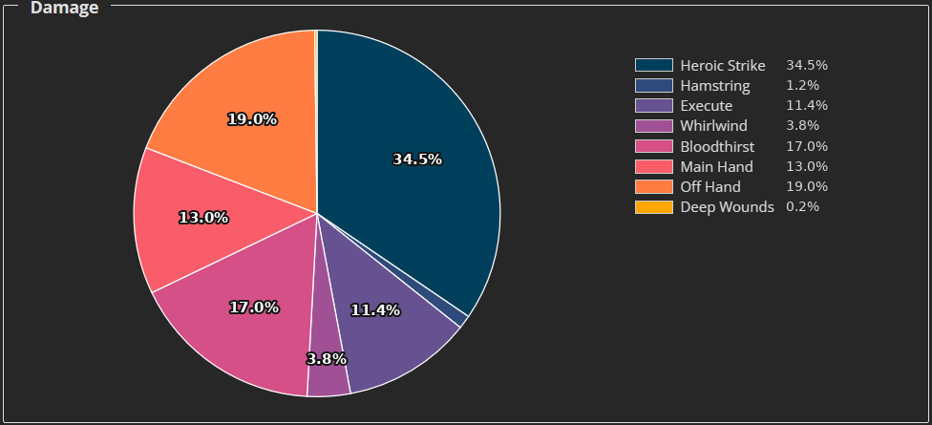
Damage by ability, Naxx BiS warrior with raid and world buffs (using our modified Guybrush sim). Heroic Strike replaces a white swing, so its real added damage is far smaller than its slice.
The loop exists. In Classic, abilities don’t give rage directly, but they do indirectly: ability crits trigger Flurry, a queued Heroic Strike removes the off hand’s dual-wield miss penalty, more hits mean more Unbridled Wrath procs, and more abilities mean more Windfury procs. In our Classic sims with Naxx BiS + WB, a Bloodthirst + Whirlwind-only rotation generated about 2,027 RPM, about 1,612 more than it needs. Letting the sim also spend that surplus raises it to an effective 2,071 RPM.
But it isn’t infinite. Spending 1,612 surplus RPM gave back 44 RPM, a loop gain of about 0.03, and that’s after every round of the loop has played out. It’s also physically capped: once every main-hand swing is a Heroic Strike, extra rage has nothing to buy, and the 100 rage cap throws the rest away.
And extra rage is a fairly constant share of damage. Once raid buffs are in, rage above 415 RPM produces 18–21% of total DPS without world buffs and about 25% with them (25–30% in fights with execute included). Each surplus rage buys about 14–18 damage outside execute. The big jump is around the 415 RPM breakpoint: a self-buffed prebis warrior (about 530 RPM) gets only 7% of its damage from extra rage while the same warrior with raid buffs (about 960 RPM) gets 18%.
Takeaway: surplus rage is what makes a warrior feel like a warrior. At 415 RPM, a warrior can only press Bloodthirst and Whirlwind as they come off cooldown, and spends the time in between waiting for rage. There are no decisions to make, and the class feels passive. By about 900 RPM, there’s rage to spare, and the warrior is now making choices: Heroic Strike or save for Bloodthirst, Hamstring for a Windfury proc, how much rage to carry into execute. Actions per minute tell a similar story: about 22 for the self-buffed prebis warrior, 46 with raid buffs, and close to 70 at Naxx BiS with world buffs. Somewhere around 30–40 actions per minute is where warrior starts feeling nice; an instant-cast caster pressing every GCD manages 40. Below that, the class barely plays like a Classic warrior. By the time we’ve reached 70 APM, the rotation has devolved into pressing everything as fast as possible. The case for diminishing returns and a ceiling on rage isn’t about controlling warrior damage; it’s about controlling the gameplay. Too little rage leaves a warrior with no decisions to make, and so does too much. A ceiling keeps every point of rage spent a real choice by making sure warriors can never reach a point where rage is effectively unlimited (e.g. our Naxx BiS with world buffs).

2) Warriors lead every tier, with or without world buffs
Warrior is the meta DPS class of endgame Classic. The top three Era Naxxramas speedclears (lineups) bring 24 warriors and 6 other DPS. Less well known is how dominant warriors are at lower gear levels. Top parses on the Anniversary (Fresh) servers, with gear limited to each phase:
Boss | Warrior | Rogue | Hunter | Warlock | Mage | Warrior ÷ 2nd
Ragnaros (P1) | 1798 | 1176 | 903 | 892 | 812 | 1.53×
Ebonroc (P3) | 2070 | 1361 | 1379 | 1017 | 1092 | 1.50×
Fankriss (P5) | 3560 | 2492 | 1467 | 1669 | 2271 | 1.43×
Patchwerk (P6, Era) | 2415 | 1975 | 1410 | 1881 | 3153 | 0.77× (vs 1st)
Maexxna (P6, Era) | 3353 | 2485 | 1650 | 2214 | 2847 | 1.18×
We also look at raids without world buffs, since WoW: Forever won’t allow them. Season of Mastery had no world buffs in raids and no major class changes (Icy Veins), which makes it one of our best available looks at warriors without them. Most of its fights had different mechanics from Classic, so it’s an approximation:
Boss (SoM, no WB) | Warrior | Rogue | Hunter | Warlock | Mage | Warrior ÷ 2nd
Ragnaros | 691 | 626 | 498 | 567 | 491 | 1.10×
Ebonroc + Flamegor | 1001 | 786 | 697 | 767 | 640 | 1.27×
Fankriss | 2045 | 1715 | 1044 | 1355 | 1746 | 1.17×
Patchwerk | 1888 | 1747 | 1373 | 1024 | 1386 | 1.08×
Maexxna | 1852 | 1531 | 888 | 782 | 1172 | 1.21×
Looking at only the top parse per class is noisy, especially since warriors have the largest player pool. Even so, warriors lead from the first raid tier to the last, with and without world buffs: about 1.17× the second class in SoM and about 1.41× on Anniversary/Era (excluding Patchwerk, where rolling Ignite makes mage an outlier). A T1 warrior on Ragnaros generates less than half the rage of a Naxx warrior, yet leads by a similar margin. The imbalance is there before rage scaling has much to work with.

3) What Forever does
To see what Forever does at real gear levels, we re-ran our six setups with Forever’s rules as of the 1 October beta build (Seramate). Besides the v2 rage formula, Forever changes these warrior talents, abilities and mechanics, all of which our Forever sims include:
- Dual Wield Specialization: off hand ×1.5 rage (and +25% off-hand damage, as in Classic).
- Furious Precision: a new talent, +10% off-hand hit.
- Unbridled Wrath: 60%, white swings only.
- Missed and dodged white swings give zero rage.
- A missed or dodged Heroic Strike refunds no rage.
- Flurry: 25% for 3 hits.
- Bloodthirst: 45% of attack power, unchanged from Classic.
- Whirlwind: hits with both weapons and costs 22 rage with Raging Blows. Our sim assumes neither hit takes the dual-wield miss penalty, as in TBC.
- Deep Wounds stacks with itself. In Classic, a crit refreshes a single bleed. In Forever, each crit adds a new bleed worth 20/40/60% of the main-hand weapon’s average damage (without attack power) on top of whatever is still ticking, and overlapping ticks pay every bleed. Beta logs show this (ElliotWood, PR #506). It makes Deep Wounds hit noticeably harder than in Classic, and makes every extra chance to crit worth more, including cheap fillers like Hamstring.
- Weapon skill is much harder to get. “There are no racial abilities that increase weapon skill in WoW: Forever.” Human Sword Specialization and Orc Axe Specialization give crit instead, and gear like Edgemaster’s Handguards drops from +7 weapon skill to +1 (Warcraft Tavern). In Classic, most warriors played a race with +5 weapon skill for their weapon type, which cut misses, dodges and glancing penalties against raid bosses.
That last change matters for any comparison with Classic. Our Classic sims use 305 sword skill (Human), which reflects how Classic was played. Our Forever and final proposal sims use 300, which reflects what Forever warriors will have. The crit that Forever’s racials give instead isn’t modeled.
From here on, “Forever” means all of the above together: Forever’s v2 rage formula plus these changes.
We used our modified GuyBrush sim with the full rotation including Execute and a 3 minute fight:
Gear | DPS: Classic → Forever | True RPM: Classic → Forever | Forever spare rage (over 402 RPM)
Prebis, self-buffed, no WB | 482 → 489 (+1.5%) | 551 → 505 (−8.4%) | 103
Prebis, raid-buffed, no WB | 854 → 778 (−8.9%) | 967 → 648 (−33.0%) | 246
Prebis + WB | 1473 → 1264 (−14.2%) | 1524 → 785 (−48.5%) | 383
R14 / MC / 20-man, no WB | 1010 → 902 (−10.7%) | 1140 → 659 (−42.2%) | 257
Naxx BiS, no WB | 1211 → 1122 (−7.3%) | 1375 → 694 (−49.5%) | 292
Naxx BiS + WB | 1956 → 1787 (−8.6%) | 2071 → 843 (−59.3%) | 441
Classic at 305 sword skill, Forever at 300.
What this shows:
- Forever rage barely grows with gear. From prebis raid-buffed to Naxx BiS without world buffs, Classic rage rises by 407 RPM and Forever rage by 46. Under Forever’s formula, attack power and weapon damage give no rage at all, so three full raid tiers’ worth of weapons and attack power, the entirety of gear progression in Classic, is almost invisible to the rage bar. The only real jumps come from world buffs’ crit and haste, which Forever won’t have.
- A fresh 60 does fine on damage, but not on rage. A self-buffed prebis warrior deals 1.5% more damage than in Classic, thanks to Forever’s talent and ability changes, but already has 8% less rage (505 true RPM), only about 100 RPM above what Bloodthirst and Whirlwind cost.
- The nerf comes from rage, and it grows with gear. Forever’s talent and ability changes are a net buff on their own. Bloodthirst is unchanged from Classic, Whirlwind now hits with both weapons for less rage, the off hand gets 10% more hit, and Deep Wounds stacks; only Flurry is weaker. So nearly all of Forever’s DPS loss comes from rage and weapon skill. It leaves a self-buffed prebis warrior 1.5% ahead of Classic, then loses 9% with raid buffs and 7–14% from there up. That targets scaling, but section 2 showed warriors already lead at T1, before scaling does much.
- It costs far more rage than it needs to. The final proposal (section 5) cuts less DPS and keeps much more of the rage:
Gear | Forever: DPS / rage vs Classic | The final proposal: DPS / rage vs Classic | Spare rage: Forever → final proposal
Prebis, raid-buffed, no WB | −9% / −33% | −8% / −22% | 246 → 354
R14 / MC / 20-man, no WB | −11% / −42% | −7% / −17% | 257 → 540
Naxx BiS, no WB | −7% / −50% | −2% / −19% | 292 → 711
Naxx BiS + WB | −9% / −59% | −5% / −37% | 441 → 912
At raid gear without world buffs, Forever leaves warriors with 648–694 true RPM, closer to the passive Bloodthirst + Whirlwind rotation than to the roughly 900–1,000 RPM where section 1 found warrior starts to play like a warrior.
What v2 gets right, and what it drops. Forever’s v2 formula already shares a lot with our proposal: rage normalized to swing time, a crit worth two normal swings, and a natural ceiling, since a white swing can’t crit more often than the attack table leaves room for (the same idea as the attack-table cap in Appendix A). What it drops is the link between hitting harder and having more rage: a new weapon or a pile of attack power is invisible to the rage bar, and without damage in the formula, rage loses much of its swing-to-swing volatility. Our proposal keeps what v2 gets right and adds both back.

4) Curved rage: a starting curve
Keep rage tied to damage, but bend it. Rage per swing follows a damage-based formula up to a threshold, then curves smoothly toward a per-swing cap. Any per-swing cap has to be normalized to swing time, or it penalizes slow weapons (a flat “50 rage per hit” cap would push everyone toward fast weapons), so the threshold and the cap both scale with swing time.
Our first step tackles the scaling problem where it starts: level 60, from roughly pre-raid gear up. The starting curve keeps Classic intact below that point, with Classic’s own coefficient of 7.5, and only adjusts the tail end. It applies at level 60 only; levels 1–59 are untouched at this stage.
The curve below is our starting point, not our final answer, and not something we’d ship on its own. Its parameters are dials. Up to the threshold it gives exactly Classic’s rage; only bigger hits are bent toward the cap. Section 5 builds the final proposal on top of it.
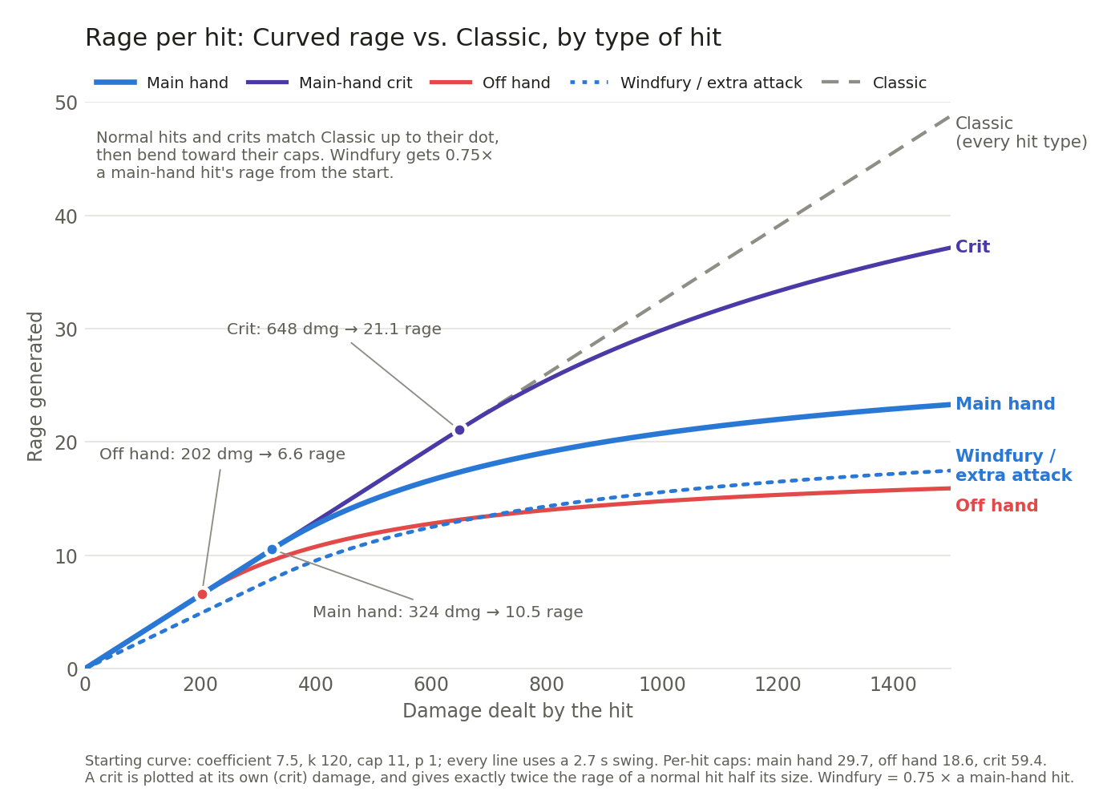
How each kind of hit is treated:
- Main hand: multiplier 1.0.
- Off hand: the threshold and cap are 62.5% of the main hand’s, matching the off hand’s damage with talents. With the same swing time, an off-hand hit always gives 62.5% of the rage of a main-hand hit 1.6 times its size, at any point on the curve.
- Crit: double threshold and double cap, so a crit is always worth exactly two normal hits on the curve (the same ×2 Forever v2 settled on).
- Glance: a normal hit using its glanced damage.
- Windfury and other extra attacks: 0.75 × the rage of a normal hit of the same damage (Windfury’s attack power included).
- Haste: the threshold and cap scale with the current, hasted swing time. Haste still raises rage below the cap (like more damage), but can’t raise the ceiling.
- Two-handers: out of scope (see Scope and limitations).
The formula. For each white hit:
- L = 7.5 × damage ÷ 230.6 (Classic rage)
- t = weapon speed ÷ haste (current swing time)
- f = 0.625 for the off hand, 1 for the main hand; × 2 on a crit
- R₀ = 7.5 × k × t × f ÷ 230.6 (where diminishing returns start)
- C = cap × t × f (the per-hit cap)
- If L ≤ R₀: R = L (Classic rage, unchanged)
- Otherwise: R = R₀ + x ÷ (1 + (x ÷ (C − R₀))^p)^(1/p), with x = L − R₀. With p = 1 this is R = R₀ + x × (C − R₀) ÷ (C − R₀ + x)
- Windfury swing: R × 0.75. A dodge gives 0.75 × R of the weapon’s average swing (Classic’s dodge rule, through the curve).
Variable | Value | Meaning
k | 120 | Threshold in damage per second of swing time: 324 damage on a 2.7 second main hand
cap | 11 | Rage limit per second of swing time: a hand can never pass 660 RPM (main hand) or 413 (off hand) from normal hits; crits double it
p | 1 | Sharpness of the bend. At 1 the bend is soft: rage keeps growing with damage well past the threshold, but each extra point of damage is worth less, and the cap is only approached at very high damage
0.75 | fixed | Share of rage for Windfury swings and for dodges
The numbers are a choice, and that’s the point. The threshold k decides where diminishing returns begin, the cap decides where rage tops out, and p decides how sharply it bends between them. Each can be moved on its own, to put the floor, the growth and the ceiling wherever the developers want, today or ten tiers from now. That control is the real argument for a curve over a flat rate: it keeps damage as an input. Damage is moved by nearly every stat a warrior gears for (attack power, weapon damage, damage modifiers, crit, hit, expertise, haste), so every upgrade can feel like more rage. Forever rage can only grow through crit, hit, expertise and haste, which leaves attack power and weapon damage invisible to the rage bar and pushes players toward stacking a few stats. Marrow reaches the same conclusion about his own curves: the shape is the decision that matters, and the specific numbers are easy to adjust (Marrow, “Rage Design Proposals” sec. 5.5).
Cutting rage cuts far less damage. We simmed our starting curve with nothing else changed: Classic’s abilities and mechanics, 305 sword skill, and only the rage formula swapped (full results in Appendix C):
Gear | DPS lost | True RPM lost | Surplus over 415: Classic → starting curve | DPS lost per RPM lost
Prebis, self-buffed | −5 (1.0%) | −15 (2.7%) | 136 → 121 | 0.33
Prebis, raid-buffed | −42 (4.9%) | −163 (16.9%) | 552 → 389 | 0.26
Prebis + WB | −137 (9.3%) | −487 (32.0%) | 1109 → 622 | 0.28
R14 / MC / 20-man | −60 (5.9%) | −247 (21.7%) | 725 → 478 | 0.24
Naxx BiS, no WB | −85 (7.0%) | −393 (28.6%) | 960 → 567 | 0.22
Naxx BiS + WB | −193 (9.9%) | −893 (43.1%) | 1656 → 762 | 0.22
DPS and true RPM lost by our starting curve compared to the Classic formula.
The starting curve does what it’s meant to: almost nothing for a fresh 60, real diminishing returns from raid gear up, and nearly 900 RPM less at Naxx BiS with world buffs. That’s 43% of the rage for 10% of the DPS. Each RPM removed cost only 0.22–0.33 DPS, because surplus rage mostly buys Heroic Strikes and some of it would have overflowed anyway. To cut warrior damage meaningfully through rage, you’d have to push it close to 415 RPM, and a warrior at 415 RPM doesn’t feel like a warrior. That’s why the damage fix belongs in the abilities (section 5), and why the curve’s job is to shape gameplay, not to control damage.
Measured against our RPM targets in the following section, our starting curve comes in slightly under our goal for a fresh 60 (536 true RPM), close to our T0 goal (prebis, raid-buffed: 804), and short of our T3 (Naxx BiS, no WB) and T7 (Naxx BiS + WB) goals (982 and 1,177). Section 5’s higher coefficient combined with Forever’s talent/mechanics changes and our ability adjustments make up the difference.
Most stats keep part of their rage value under Curved rage; crit, hit, expertise and extra attacks keep the most (Appendix A, measured on a similar curve we tested). For infinite progression scenarios, Appendix A also adds an optional attack-table cap that holds the ceiling even against extreme values of hit, crit, and expertise.

5) The final proposal
The starting curve handles rage at the top end. Looking at the full scope of Forever’s changes (its mechanics, its talent and ability changes, the loss of racial weapon skill) made it clear that a complete solution has to come from several directions at once.
If Extra DPS (the damage resulting from spending surplus rage) isn’t the primary problem, Base DPS is: auto attacks, procs, Bloodthirst and Whirlwind. That’s why we nerf Bloodthirst and Death Wish and keep Forever’s weaker Flurry. Execute isn’t part of Base DPS, but it’s a huge part of warrior damage on bosses, and it can be nerfed without hurting the rest of the warrior experience. Those nerfs, together with the lost weapon skill, would leave early gear levels feeling bad, so we put something back: a higher rage coefficient for smaller hits, at every level from 1 to 60.
Our final proposal is Classic’s formula with its coefficient raised from 7.5 to 9 at every level, bent at 60 by the starting curve from section 4, plus three ability changes of our own, combined with most of Forever’s talent and mechanic changes from section 3.
Ability, talent or mechanic | Classic | Forever | The final proposal
Rage formula | Classic rage | Forever v2 | Coefficient 9; curved at 60
Bloodthirst | 45% AP | 45% AP | 40% AP
Death Wish | 20% for 30 s | 20% for 30 s | 15% for 30 s
Execute | no cooldown | no cooldown | 4 s cooldown
Flurry | 30% for 3 swings | 25% for 3 swings | 25% for 3 swings
Unbridled Wrath (5/5) | 40% | 60%, white swings only | 60%, white swings only
Whirlwind | main hand, 25 rage | both weapons, 22 rage | both weapons, 22 rage
Off-hand hit bonus | none | +10% (Furious Precision) | +10% (Furious Precision)
Dual Wield Specialization | +25% off-hand damage | +25% off-hand damage, +50% off-hand rage | +25% off-hand damage
Deep Wounds | refreshes | stacks | stacks
Dodged white swing | 75% of an average swing’s rage (dodge) | no rage | 75% of an average swing’s rage (dodge)
Missed or dodged Heroic Strike | 80% refund | no refund | 80% refund
Weapon skill (simmed) | 305 | 300 | 300
Why each one:
- Bloodthirst 40% AP: a modest cut to the ability every warrior presses most, and 11% less Bloodthirst damage, against 22% for the 35% AP version Forever briefly tested.
- Death Wish 15%: 30 seconds of 20% damage with fear immunity on a 3 minute cooldown is probably the strongest DPS cooldown in the game. Many endgame fights last 60–90 seconds, which gives it 33–50% uptime. This cooldown drastically inflates boss damage numbers when paired with other cooldowns (Recklessness, Mighty Rage Potion, trinkets, etc.) during execute phase.
- Execute, 4 second cooldown: a nerf that is largely unfelt in solo and group content, where one Execute finishes the target, but it stops raid execute phases from being GCD after GCD of Execute. Its damage per rage could be raised if needed. Similar to Death Wish, this is a very efficient single target (boss) nerf that doesn’t cause much collateral discomfort for warrior.
- Kept from Forever: Unbridled Wrath, Whirlwind, Flurry, Furious Precision and Deep Wounds. Whirlwind hitting with both weapons makes dual wielding feel better, and the extra Unbridled Wrath rage is flat, so it doesn’t scale with gear. Stacking Deep Wounds makes every crit matter and gives cheap fillers like Hamstring a real job. We like the direction and flavor of most of the Forever changes and want to incorporate as many of them as possible.
- Dual Wield Specialization’s off-hand rage: dropped. The curve already sets the off hand’s share through its 0.625 factor.
- Dodged auto attacks, missed/dodged Heroic Strikes: kept from Classic on purpose. A dodged white swing still gives rage, and a missed or dodged Heroic Strike still refunds 80%. Damage-based rage is already volatile, as it was in Classic; we are trying to preserve that feel rather than add to it.
Raising the coefficient to 9. The final proposal uses a coefficient of 9 instead of Classic’s 7.5 at every level, so small hits give 20% more rage. From 1 to 59 that is simply rage = 9 × D ÷ C; at 60, the threshold, the cap and the bend stay where section 4 put them. It does three jobs:
- Offsetting the nerf package. The Bloodthirst, Death Wish, Flurry and Execute changes cost damage at every gear level and at every level, 1–59 included, and so does the loss of racial weapon skill. The extra rage gives some of it back where warriors are weakest, without touching the ceiling.
- A better 1–59 and fresh 60. No one says warriors are too strong while leveling. Warrior was one of the most tedious classes to level in Classic and is weak until geared, mostly from being rage starved and heavily gear reliant. Gear is rarely in good shape for a character’s level while leveling, and that punishes warriors more than almost any other class. Forever’s rage doesn’t care what weapon you hold, which helps when upgrades are hard to find; a higher coefficient gives similar help without breaking the link between damage and rage that defines Classic warrior. After Forever’s changes and the nerf package, the 20% higher coefficient isn’t a net 20% more rage (or damage), and even if it turns out to be generous for levels 1–59, it’s far from game-breaking.
- Offsetting glancing blows. Against a boss 3 levels higher, 40% of white swings are glancing blows. At 305 weapon skill a glance deals 15% less damage; at 300 it deals 35% less. Under Classic’s formula and ours, less damage means less rage, so losing Classic’s racial +5 weapon skill costs a warrior about 14% of its white-swing damage and rage to glances alone, against about 6% at 305. (Forever completely sidesteps this: a glance gives full rage there.)
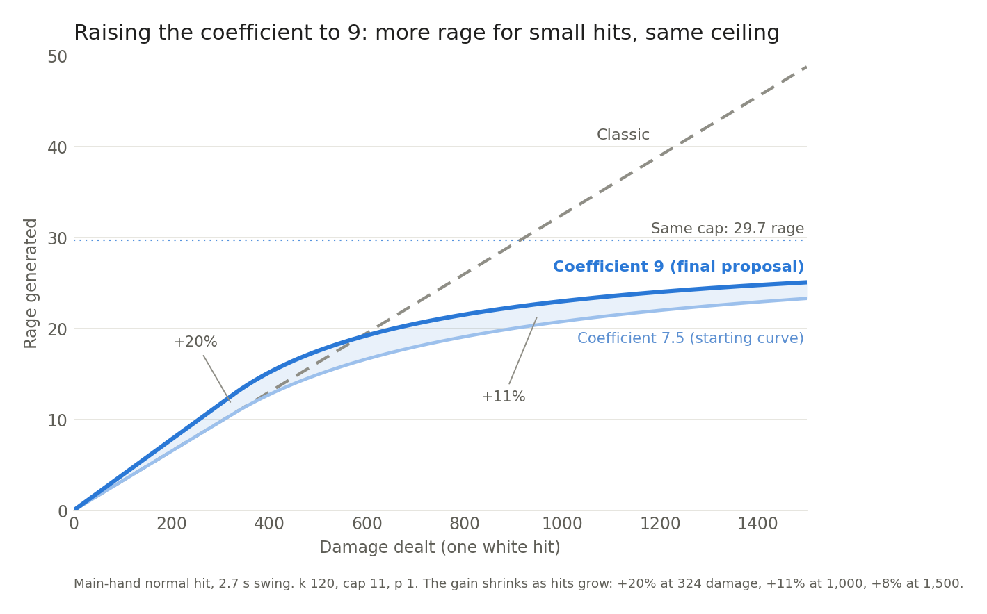
The extra rage is biggest exactly where warriors struggle, and shrinks as hits grow: +20% up to the threshold, +11% at 1,000 damage and +8% at 1,500 on a 2.7 second main hand, relative to the starting curve. The cap doesn’t change, so the ceiling doesn’t move.
The higher coefficient isn’t a 20% damage buff. Its main job is to balance out the rest of the package: our ability nerfs, Forever’s talent and mechanic changes, and the lost weapon skill. Here is the starting curve from section 4 (Classic’s abilities, 305 sword skill) against the final proposal (every change, 300 sword skill):
Gear | DPS: starting curve → final proposal | True RPM: starting curve → final proposal
Prebis, self-buffed, no WB | 477 → 463 (−2.9%) | 536 → 588 (+9.6%)
Prebis, raid-buffed, no WB | 812 → 787 (−3.1%) | 804 → 756 (−6.0%)
Prebis + WB | 1336 → 1321 (−1.1%) | 1037 → 1107 (+6.8%)
R14 / MC / 20-man, no WB | 950 → 944 (−0.6%) | 893 → 942 (+5.5%)
Naxx BiS, no WB | 1126 → 1184 (+5.2%) | 982 → 1113 (+13.3%)
Naxx BiS + WB | 1763 → 1866 (+5.8%) | 1177 → 1314 (+11.6%)
Despite 20% more rage for small hits, the final proposal deals 1–3% less damage than the starting curve on prebis gear and about the same at R14, and pulls ahead only at Naxx BiS, by 5–6%. It has more rage at every gear level except raid-buffed prebis. Many of the changes behind this are ones Forever has already adopted.
Rage targets. In true RPM (all rage plus the white swings Heroic Strike replaced), without world buffs unless stated:
Level / tier | Target true RPM | Classic (305 skill) | The final proposal (300 skill) | Forever (300 skill)
Fresh 60 (prebis, self-buffed) | 550–600 | 551 | 588 | 505
T0 (prebis, raid-buffed) | 750–800 | 967 | 756 | 648
T3 (Naxx BiS) | 1100–1200 | 1375 | 1113 | 694
T7 (Naxx BiS + WB as a stand-in) | 1300–1400 | 2071 | 1314 | 843
T20 (hard cap) | 1600–1800 | — | ~1,750 (estimate from the per-swing caps) | —
The final proposal lands inside every target. Classic overshoots from T0 up, and Forever falls short of every one.
Each of our three ability changes was first tested on its own, on Naxx BiS without world buffs, with an earlier version of the curve (coefficient 7.5, k = 171, cap = 13, p = 3) and Classic’s abilities otherwise:
Change | DPS | True RPM
Baseline (earlier curve) | 1188 | 1279
Bloodthirst 45% → 35% AP | 1141 (−4.0%) | 1279
Flurry 30% → 25% (3 swings) | 1163 (−2.1%) | 1252
Flurry 30%, 3 swings → 2 swings | 1153 (−2.9%) | 1243
Death Wish 20% → 15% | 1174 (−1.2%) | 1273
Execute 0 s → 4 s cooldown | 1141 (−4.0%) | 1251
The final proposal across gear:
Gear | DPS: Classic → final proposal | True RPM: Classic → final proposal | APM: Classic → final proposal | Final proposal vs Forever: DPS / rage
Prebis, self-buffed, no WB | 482 → 463 (−3.9%) | 551 → 588 (+6.6%) | 22 → 23 | −5.3% / +16%
Prebis, raid-buffed, no WB | 854 → 787 (−7.8%) | 967 → 756 (−21.9%) | 46 → 37 | +1.2% / +17%
Prebis + WB | 1473 → 1321 (−10.3%) | 1524 → 1107 (−27.4%) | 61 → 50 | +4.5% / +41%
R14 / MC / 20-man, no WB | 1010 → 944 (−6.5%) | 1140 → 942 (−17.4%) | 51 → 44 | +4.7% / +43%
Naxx BiS, no WB | 1211 → 1184 (−2.2%) | 1375 → 1113 (−19.0%) | 56 → 50 | +5.5% / +60%
Naxx BiS + WB | 1956 → 1866 (−4.6%) | 2071 → 1314 (−36.5%) | 68 → 55 | +4.4% / +56%
Classic at 305 sword skill, the final proposal and Forever at 300. Classic actions per minute are from the previous Classic run (Appendix C).
The final proposal cuts 2–10% of Classic’s DPS at every gear level, rather than a cut that grows with gear the way Forever’s does, and keeps far more rage than Forever everywhere. Actions per minute stay at 37–55 on raid gear, well short of the 70 where section 1 found Classic’s rotation turns into pressing everything as fast as possible; Forever stays at 37–45.
Actions per minute aren’t the focal point; they only give a rough sense of how busy the rotation is. Stacking Deep Wounds makes Hamstring a strong filler, so the tuned Forever and final proposal rotations lean on Hamstring. A rotation that favors Heroic Strike instead, which many players would use, performs about the same (in most of these sims within 1–2 DPS) with roughly 5–10 fewer actions per minute at most gear levels. Rage tells the fuller story. It’s what pays for every choice, including Cleave, which is used constantly in multi-target fights and which our single-target sims never use. More rage means more decisions, and the final proposal has far more of it than Forever.
A fresh, self-buffed 60 now has more rage under the final proposal than under Classic or Forever (588 true RPM, against 551 and 505), so rage is no longer what holds it back. It is 4% behind Classic and 5% behind Forever in DPS, and that gap comes from the Bloodthirst, Death Wish and Execute changes and the lost weapon skill, not from the curve.
Applied to the class gaps (rough, since logs and sims differ):
Content | Warrior ÷ best other class | With Forever | With the final proposal
T1 without WB (SoM Ragnaros) | 1.10× | ~1.00× | ~1.01×
Naxx without WB (SoM Patchwerk + Maexxna) | 1.15× | ~1.07× | ~1.12×
T1 with WB (Anniversary Ragnaros) | 1.53× | ~1.31× | ~1.37×
Naxx with WB (Era Maexxna) | 1.18× | ~1.08× | ~1.13×
The final proposal keeps warriors slightly ahead without world buffs, which Forever won’t have. That’s deliberate. The goal isn’t to push warriors below other classes; it’s to bound how far warriors scale. The other DPS classes have plenty of room to be brought up, and section 6 suggests how.
Our sims understate the Death Wish and Execute nerfs. In practice, Death Wish is used together with Recklessness, Mighty Rage Potion and trinkets that give large amounts of attack speed or attack power. None of these are used in our sims. The nerf takes the same 4% off every hit made during Death Wish (1.15 ÷ 1.20), so the more of a fight’s damage is packed into that window, the more the nerf costs; stacking those cooldowns into it makes the real cost bigger than our sims show. Our sims also use 3 minute fights, where Death Wish is up for 30 of 180 seconds (17%). Real kills are often shorter, or just long enough for a second use: the parses behind the table above lasted 3m14s (SoM Ragnaros, two uses, about 23% uptime), 1m34s (SoM Patchwerk, 32%), 44 s (Anniversary Ragnaros, 68%) and 37 s (Era Maexxna, 81%). The final proposal is the only one of the three that touches Death Wish, so its cut to boss damage is bigger than these sims show.
Single-target damage and the rogue goal. Forever’s developers have said rogues should be “the highest single target damage dealers in the game, given mechanics, given the encounter” (Squishei). If that’s the goal, Execute and Death Wish are the dials to turn. A cooldown added to Execute mostly affects boss fights, where execute phases are GCD after GCD of Execute, and barely touches solo play, group content or the rest of the rotation; a 4 second cooldown alone costs about 4% at Naxx gear. Under our final proposal, warriors on Patchwerk land at roughly 1.06× the best rogue in Season of Mastery, against 1.08× in Classic, and a longer Execute cooldown would close the rest of that gap without changing how the class plays. On a fight as short as Patchwerk, the Death Wish nerf also costs more than our 3 minute sims show, which narrows the gap further.
Classic vs Forever vs the final proposal. All three side by side, from the latest runs (Appendix C; Classic actions per minute from the previous Classic run):
Gear | Classic (305): DPS / true RPM / APM | Forever (300): DPS / true RPM / APM | Final proposal (300): DPS / true RPM / APM
Prebis, self-buffed, no WB | 482 / 551 / 22 | 489 / 505 / 22 | 463 / 588 / 23
Prebis, raid-buffed, no WB | 854 / 967 / 46 | 778 / 648 / 37 | 787 / 756 / 37
Prebis + WB | 1473 / 1524 / 61 | 1264 / 785 / 43 | 1321 / 1107 / 50
R14 / MC / 20-man, no WB | 1010 / 1140 / 51 | 902 / 659 / 37 | 944 / 942 / 44
Naxx BiS, no WB | 1211 / 1375 / 56 | 1122 / 694 / 39 | 1184 / 1113 / 50
Naxx BiS + WB | 1956 / 2071 / 68 | 1787 / 843 / 45 | 1866 / 1314 / 55
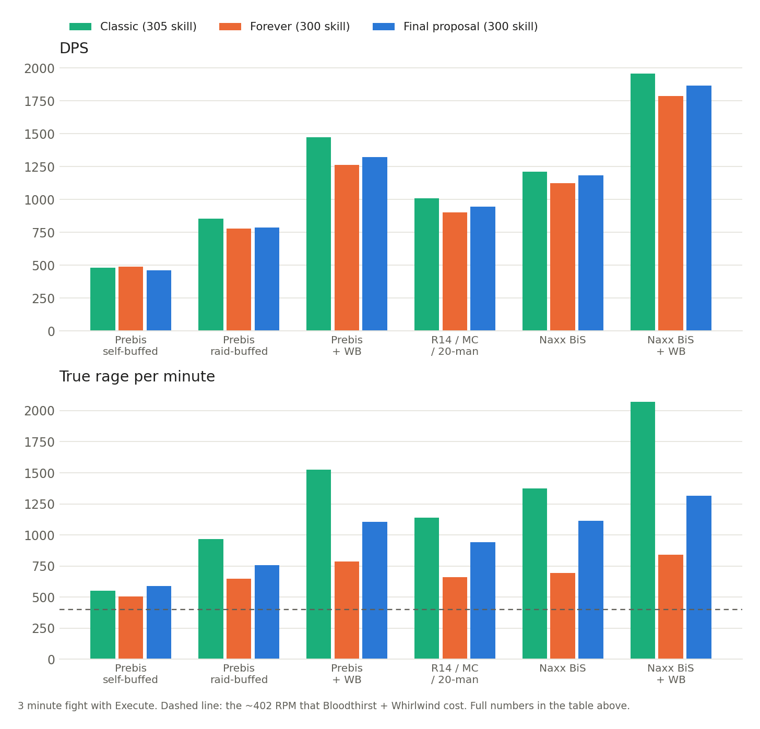
From raid-buffed prebis up, damage under the final proposal sits between Forever’s and Classic’s, closer to Forever’s. Rage is where they part: Classic’s keeps climbing with gear, Forever’s barely moves past raid-buffed prebis, and the final proposal’s grows with every tier but levels off well below Classic’s. Crucially, the final proposal’s rage stays in the range where there’s enough to make real decisions, and never gets near Classic’s high end, where a single attack round fills most of the rage bar. Rage stays meaningful at every gear level, and keeps scaling with gear under a ceiling the developers control.

6) Beyond warriors
Rage is the only Classic resource with meaningful scaling: a better-geared warrior can spend more, and choosing how to spend it is a big part of what makes the class fun. As section 1 showed, surplus rage is a modest share of warrior power, but most of its fun. Other classes don’t get that. Rogues have a handful of gear- and cooldown-bound energy options, and most casters can’t turn more mana into much more damage. TBC moved the other way, with Combat Potency for rogues (about 12% DPS for a BiS TBC sword rogue, per wowsims) and Arcane Blast for mages. Rather than remove resource scaling from warriors, Forever could give it to everyone, for example by giving higher spell and ability ranks better coefficients and damage scaling, giving players a meaningful choice between a rotation that maximizes damage and one that conserves mana. That gives other classes more ways to scale and, more importantly, more depth and more engaging gameplay.

7) Conclusion
Forever’s newest rage rules show the developers want what this document wants: a floor for fresh 60s, growth with gear, a crit that feels like a crit, and a ceiling. Our proposal delivers all four while preserving the one thing Forever’s rage formula drops: hitting harder still means more rage, so a weapon upgrade still feels like a weapon upgrade. It also gives leveling warriors and fresh 60s more rage than Classic did.
Our proposal also keeps rage volatile like it was in Classic. Because rage still follows damage, every swing’s rage depends on its damage roll, whether it glanced, and whether it crit, so the rage bar keeps the ebb and flow that makes rage management engaging. Marrow measured this: Classic’s damage-based rage varies the most from fight to fight (the middle 90% of fights spread over 1.2–1.3 rage per second, against about 0.8 under Forever’s earlier, flat rules; “Rage Design Proposals” sec. 5.6.1). Forever v2’s crit bonus adds some swing-to-swing variance back, but crits are the only thing that varies. Our proposal follows damage at every level, giving a little more than Classic for small hits and, at 60, flattening the bigger ones. We haven’t measured its spread directly, but it should sit between the two, and closest to Classic for most of the game.
Our testing has shown that warrior damage is better controlled directly, through modifications to Bloodthirst, Death Wish, Flurry and Execute. Our final proposal deals about as much damage as Forever at raid gear (1–6% more) while keeping 17–60% more rage, which is up to about two and a half times as much rage to spend on decisions.

Scope and limitations
- Two-handed builds are out of scope. The final proposal is built and simmed for dual wielding. A similar curve with a different threshold k would likely work, but we haven’t tested it.
- Tanks: rage from damage taken is unchanged and wasn’t simulated. Threat depends on rage, so tanks need separate testing.
- Leveling and PvP: the final proposal’s coefficient of 9 applies at every level; the curve applies only at 60. We haven’t simmed leveling; the 20% is the coefficient change alone, not a net gain, before weapon skill and the ability, talent and mechanic changes. PvP isn’t analyzed.
- Weapon skill: Forever and the final proposal are simmed at 300 sword skill and Classic at 305, to reflect how each is played. The crit that Forever’s Human and Orc racials give in place of weapon skill isn’t modeled.
- Missed and dodged swings: the final proposal keeps Classic’s rules (rage from dodged white swings, Heroic Strike refunds) on purpose, so rage doesn’t become more volatile than it was in Classic.
- Excluded from the sims: Recklessness, Mighty Rage Potion and other in-combat potions, so real logs will show bigger execute-phase and burst numbers.
- Forever’s numbers: v2 is built on announcements not yet visible in raid logs. Our Forever runs model the rage formula and the talent, ability and mechanic changes listed in section 3, including stacking Deep Wounds as seen in beta logs (ElliotWood, PR #506); other Forever talent changes aren’t modeled. Whirlwind’s off-hand hit is assumed to work as in TBC.
- Model estimates: the stat scaling table and the extreme hit/crit example hold swing counts fixed, and were done with an earlier curve (coefficient 7.5, k = 171, cap = 13, p = 3), as was the per-ability test in section 5. The T20 ceiling is an estimate from the per-swing caps. Everything else is a full sim run.

Appendix A: formula details
Everything that raises rage under Curved rage and our final proposal:
- Bigger hits (these get the diminishing returns): attack power, weapon damage, damage % modifiers, armor debuffs on the target, glance damage from weapon skill.
- Haste: works exactly like +% damage, with the same diminishing returns.
- More landed swings (little diminishing returns): hit, weapon skill, crit (up to the white crit cap).
- Extra swings: Windfury Totem at 75%; other extra attacks at 100%.
- Flat rage, outside the curve: Unbridled Wrath, Bloodrage, Anger Management, Mighty Rage Potion, refunds, rage from damage taken.
Weapon speed barely matters (rage per second follows weapon DPS), and both hands scale similarly at these gear levels.
How each stat scales at Naxx BiS (earlier curve: coefficient 7.5, k = 171, cap = 13, p = 3; RPM gained per step; swing counts held fixed):
Change | No WB: Classic → Curved | Kept | WB: Classic → Curved | Kept
+100 attack power | +38.9 → +28.4 | 73% | +53.2 → +12.0 | 23%
+1% damage | +14.0 → +10.3 | 74% | +22.8 → +5.3 | 23%
+1% haste | +14.0 → +10.2 | 73% | +22.8 → +5.2 | 23%
+5% main-hand weapon damage | +47.3 → +32.8 | 69% | +76.2 → +14.7 | 19%
+5% off-hand weapon damage | +22.5 → +17.1 | 76% | +38.0 → +9.6 | 25%
+1% glance damage | +4.4 → +3.4 | 78% | +6.7 → +1.8 | 27%
+1% crit | +11.6 → +10.7 | 92% | +5.5 → +4.5 | 81%*
+1% hit | +11.6 → +10.7 | 92% | +17.6 → +13.3 | 76%
+1 extra main-hand swing/min | +25.4 → +24.6 | 97% | +35.5 → +28.0 | 79%
+1 Windfury swing/min | +25.4 → +18.4 | 73% | +35.5 → +21.0 | 59%
*Main-hand white crit is already capped in the WB run, so only the off hand gains.
Optional attack-table cap. Hit, crit and dodge reduction can still push past the ceiling (adding +10% hit and +10% crit to Naxx BiS + WB reaches about 1,910 true RPM in the model). The fix: compare each hand’s white attack table to a reference table and shrink the cap if yours is stronger. A reference table’s strength is
M = P(hit) + 2 × P(crit) + P(glance) + 0.75 × P(dodge)
where a miss counts 0, P(crit) is capped by what’s left after miss, dodge and glance (the white crit cap), and crit from Recklessness and Elune’s Light is excluded. With the Naxx BiS + WB table as the reference:
Hand | Hit | Crit | Glance | Dodge | Miss | M_ref
Main hand | 0% | 41.27% | 40.00% | 5.41% | 13.33% | 1.266
Off hand | 3.73% | 43.50% | 40.00% | 5.40% | 6.37% | 1.348
the cap becomes C = cap × t × f × min(1, M_ref ÷ M). With it on, pushing hit, crit and dodge reduction to extremes reached about 1,890 true RPM with that earlier curve (cap 13); the final curve’s lower cap of 11 brings that ceiling down. Only extra attacks and flat rage can still move the ceiling. This is the same mechanism that gives Forever v2 its ceiling (Marrow, “Rage on Crit” sec. 4.6.2), applied deliberately.

Appendix B: sim setup
All sims use our modified Guybrush WarriorSim (RAGE NORM builds 5–16, speak-gg.github.io/guybrushsim-rage-norm). Settings for every gear set:
- Character: Human, 17/34/0 Fury talents. Every weapon in every set is a sword. Classic runs use Human Sword Specialization (305 sword skill). Forever and final proposal runs use 300 sword skill, since Forever removes racial weapon skill; Naxx BiS gear adds 6 more.
- Deep Wounds: Classic’s (refresh) for Classic and starting-curve runs; Forever’s (stacking) for Forever and final proposal runs.
- Fight: 3 minutes against a level 63 raid boss, 0 starting rage, Battle Shout precast. The execute phase is the last 20% (36 seconds), and Death Wish is used 31 seconds before the end of the fight.
- Target debuffs: 5 × Sunder Armor, Faerie Fire and Curse of Recklessness, which bring the boss to 336 armor.
- Rotation: Bloodthirst > Whirlwind > Heroic Strike / Hamstring, with priorities and rage thresholds tuned per gear set for the most DPS. For example, the Hamstring threshold is lower at higher gear, and higher gear sets keep using Bloodthirst during execute phase. The thresholds used for every run are in Appendix C.
- Not used: Recklessness, Mighty Rage Potion or any other in-combat potion, Grace of Air Totem, AQ books (higher ability ranks), on-use trinkets.
Buffs by setup:
Setup | Buffs and consumables
Prebis, self-buffed | Battle Shout only, no consumables
Every other “no WB” setup | Raid buffs: Leader of the Pack, Improved Mark of the Wild, Trueshot Aura, Blessing of Kings, Improved Blessing of Might, Windfury Totem, Strength of Earth. Consumables: Elixir of the Mongoose, Juju Power, Juju Might, Smoked Desert Dumplings. Both paladin and shaman buffs are included, since both will be available in WoW: Forever
“+ WB” setups | All of the above, plus Rallying Cry of the Dragonslayer, Spirit of Zandalar, Sayge’s Dark Fortune of Damage, Warchief’s Blessing, Songflower Serenade, Fengus’ Ferocity, Slip’kik’s Savvy, Moldar’s Moxie
Gear. Close approximations of the best gear for each category, not exact BiS (for example, no on-use trinkets). Enchants are the best for each era: no shoulder enchant on prebis, the 30 attack power shoulder enchant on R14, and the Sapphiron shoulder enchant on Naxx BiS. The “+ WB” setups use the same gear as their “no WB” versions.
Slot | Prebis | R14 / MC / 20-man | Naxx BiS
Main hand | Dal’Rend’s Sacred Charge | R14 Longsword | Gressil, Dawn of Ruin
Off hand | Dal’Rend’s Tribal Guardian | R14 Swift Blade | The Hungering Cold
Head | Lionheart Helm | Lionheart Helm | Lionheart Helm
Neck | Mark of Fordring | Onyxia Tooth Pendant | Onyxia Tooth Pendant
Shoulders | Truestrike Shoulders | R13 Plate Shoulders | Conqueror’s Spaulders
Back | Cape of the Black Baron | Cape of the Black Baron | Shroud of Dominion
Chest | Savage Gladiator Chain | Savage Gladiator Chain | Ghoul Skin Tunic
Wrist | Battleborn Armbraces | Berserker Bracers | Wristguards of Vengeance
Hands | Devilsaur Gauntlets | Flameguard Gauntlets | Gauntlets of Annihilation
Waist | Omokk’s Girth Restrainer | Onslaught Girdle | Girdle of the Mentor
Legs | Devilsaur Leggings | R12 Plate Legguards | Legplates of Carnage
Feet | Bloodmail Boots | R12 Plate Boots | Chromatic Boots
Ring 1 | Painweaver Band | Quick Strike Ring | Quick Strike Ring
Ring 2 | Blackstone Ring | Don Julio’s Band | Band of Unnatural Forces
Trinket 1 | Hand of Justice | Hand of Justice | Drake Fang Talisman
Trinket 2 | Blackhand’s Breadth | Blackhand’s Breadth | Hand of Justice
Ranged | Satyr’s Bow | Striker’s Mark | Striker’s Mark

Appendix C: sim data
Setup as in Appendix B. True RPM includes the rage of the white swings Heroic Strike replaced.
Forever and the final proposal (3 minute fight with Execute, 300 sword skill; Naxx BiS gear adds 6 for 306). “HS” and “Ham.” are the rage thresholds at which the sim uses Heroic Strike and Hamstring, tuned per gear set; 100 means the sim never uses it. The final proposal uses Classic’s rules for missed and dodged white swings and Heroic Strikes; Forever uses Forever’s.
Gear | Model | DPS | True RPM | Actions per minute | HS | Ham.
Prebis, self-buffed | Final proposal | 463 | 587.7 | 22.7 | 75 | 100
Prebis, raid-buffed | Final proposal | 787 | 755.7 | 37.3 | 70 | 30
Prebis + WB | Final proposal | 1321 | 1107.0 | 50.3 | 60 | 30
R14 / MC / 20-man | Final proposal | 944 | 942.3 | 44.0 | 60 | 40
Naxx BiS, no WB | Final proposal | 1184 | 1113.0 | 49.7 | 55 | 15
Naxx BiS + WB | Final proposal | 1866 | 1314.0 | 55.3 | 40 | 10
Prebis, self-buffed | Forever | 489 | 505.0 | 22.3 | 75 | 100
Prebis, raid-buffed | Forever | 778 | 647.7 | 36.7 | 75 | 30
Prebis + WB | Forever | 1264 | 785.0 | 43.3 | 65 | 25
R14 / MC / 20-man | Forever | 902 | 659.0 | 36.7 | 75 | 35
Naxx BiS, no WB | Forever | 1122 | 694.0 | 39.3 | 70 | 25
Naxx BiS + WB | Forever | 1787 | 843.0 | 45.3 | 65 | 30
Classic and the starting curve (rage formula only: Classic abilities and mechanics, 305 sword skill; the starting curve is section 4’s, with coefficient 7.5, k = 120, cap = 11, p = 1). “BT + WW” is Bloodthirst and Whirlwind only, “+ HS/Ham.” adds Heroic Strike and Hamstring without Execute, and “+ Exe.” adds Execute: the full rotation used everywhere else in this document. Classic’s actions per minute (22.0 / 46.3 / 60.7 / 50.7 / 56.0 / 68.0 from top to bottom) are from the previous Classic run, whose DPS was within 0.5% of these.
Gear | Formula | BT + WW DPS | + HS/Ham. DPS | + Exe. DPS | True RPM (+ HS) | True RPM (+ Exe.) | HS | Ham.
Prebis, self-buffed | Classic | 383 | 413 | 482 | 533 | 551.3 | 75 | 100
Prebis, self-buffed | Starting curve | 384 | 410 | 477 | 519 | 536.3 | 75 | 100
Prebis, raid-buffed | Classic | 638 | 779 | 854 | 957 | 967.3 | 60 | 30
Prebis, raid-buffed | Starting curve | 637 | 744 | 812 | 794 | 804 | 65 | 25
Prebis + WB | Classic | 1026 | 1365 | 1473 | 1519 | 1524 | 45 | 25
Prebis + WB | Starting curve | 1026 | 1254 | 1336 | 1028 | 1036.7 | 55 | 25
R14 / MC / 20-man | Classic | 737 | 934 | 1010 | 1132.3 | 1140.3 | 50 | 10
R14 / MC / 20-man | Starting curve | 737 | 882 | 950 | 882.3 | 893 | 65 | 10
Naxx BiS, no WB | Classic | 895 | 1122 | 1211 | 1372 | 1374.7 | 45 | 10
Naxx BiS, no WB | Starting curve | 894 | 1056 | 1126 | 972.7 | 982 | 60 | 10
Naxx BiS + WB | Classic | 1393 | 1843 | 1956 | 2051.7 | 2070.7 | 20 | 10
Naxx BiS + WB | Starting curve | 1392 | 1682 | 1763 | 1170.7 | 1177.3 | 20 | 10
Full numbers, including extra damage per rage and share of DPS, are in the “Rage Formulas” tab.

Works Cited
Bluetracker. “Rage normalization summary.” Blizzard forum thread with posts by Drysc and Kalgan, 22 Oct. 2006, www.bluetracker.gg/wow/topic/us-en/37024708-rage-normalization-summary/.
ElliotWood. “Deep Wounds: weapon damage without attack power, refresh keeps what was owed (beta logs).” Pull request #506, Forever, github.com/ElliotWood/Forever/pull/506. Accessed 4 Oct. 2026.
Greenfield, Josh (@AggrendWoW). Post on X (Twitter) about warrior rage in Season of Discovery. 18 Apr. 2024, x.com/AggrendWoW/status/1781039375134199872.
Guybrush. WarriorSim (Classic), guybrushgit.github.io/WarriorSim/classic.html. A modified version (RAGE NORM builds 5–16, maintained by Speak-Grobbulus, speak-gg.github.io/guybrushsim-rage-norm/classic.html) with rage tracking, Curved rage, and Forever’s rage rules, talents, abilities and mechanics was used for all sims in this document.
Icy Veins. WoW Classic Season of Mastery Survival Guide, www.icy-veins.com/wow-classic/season-of-mastery-survival-guide. Accessed 30 Sept. 2026.
Marrow. “Rage Design Proposals.” Marrow’s Eternal Compendium of Dragonslaying, version 2.0.0, 25 Sept. 2026, ppach-warriorcompendium.share.connect.posit.cloud/rage-proposals.html.
Marrow. “Rage Generation.” Marrow’s Eternal Compendium of Dragonslaying, version 3.1.0, 1 Oct. 2026, ppach-warriorcompendium.share.connect.posit.cloud/rage.html.
Marrow. “Rage on Crit.” Marrow’s Eternal Compendium of Dragonslaying, version 1.0.0, 1 Oct. 2026, ppach-warriorcompendium.share.connect.posit.cloud/rage-on-crit.html.
Seramate. “Warrior Updates in Today’s WoW: Forever Beta Build.” Seramate, 1 Oct. 2026, seramate.com/news/forever/2026/10/01/warrior-beta-build-updates-1f1be0e6. Summarizing Wowhead, www.wowhead.com/news=383230.
Squishei. “Rogues Will Have the Highest Single-Target Damage in WoW: Forever.” Wowhead, Oct. 2026, www.wowhead.com/forever/news/rogues-will-have-the-highest-single-target-damage-in-wow-forever-383209. Accessed 2 Oct. 2026.
Warcraft Logs. Damage rankings for Classic Anniversary (fresh.warcraftlogs.com), Classic Era and Season of Mastery (vanilla.warcraftlogs.com). Pulled 29 Sept. 2026.
Warcraft Tavern. “Weapon Skills in World of Warcraft Forever.” Warcraft Tavern, 14 Sept. 2026, www.warcrafttavern.com/forever/news/weapon-skills-in-world-of-warcraft-forever/. Accessed 4 Oct. 2026.
Warcraft Wiki. “Rage.” warcraft.wiki.gg/wiki/Rage. Patch 4.0.1 notes. Accessed 2 Oct. 2026.
wowsims. Rage generation code for The Burning Crusade, Wrath of the Lich King and Cataclysm (sim/core/rage.go), github.com/wowsims/tbc, github.com/wowsims/wotlk, github.com/wowsims/cata. Accessed 2 Oct. 2026.

