 | RecruitActive Ltd.  1 Temple Avenue, London  EC4Y 0HA, United Kingdom  Head Office: +44 1 925 320 241  International:+1 844 783-6796  Website: www.rapidrecruiters.com  Company No.: 05162307

RecruitActive Ltd.

Employment Agreement

BETWEEN: [Joshua Okoro Chijindu] (hereinafter called "Employee"), an individual with his main address at:
[House 12, K Close, 7th Avenue, Festac Town, Lagos.]

AND: RecruitActive Ltd. (hereinafter called "Company"), a corporation organized and existing under the laws (Company No: 05162307) with its head office located at:
1 TEMPLE AVENUE, LONDON, EC4Y 0HA

RECITALS
Employee is willing to be employed by employer, and employer is willing to employ employee, on the terms, covenants, and conditions set forth in this Agreement:

1. Employment
1.1. For good consideration, the Company employs the Employee on the following terms and conditions stated in this Agreement. Employee will devote full time, attention, and energies to the business of the Company and will receive compensation for the services.
1.2. The set of complicated operations stated in the EXHIBIT A as a professional activity of Employee is the service performed by corporation. EXHIBIT A is an integral part of this Agreement and contains principles and values regulating relationships between corporation and Employee. EXHIBIT A contains duties of the Employee, term of employment and compensation of employee.

2. Generalities
2.1. Any modification of this Agreement or additional obligation assumed by either party in connection with this Agreement shall be binding only if evidenced in writing signed by each party or an authorized representative of each party.
2.2. Employee renders services in accordance with EXHIBIT A in order to gain maximum profit. EXHIBIT A is signed by both parties along with signing the following agreement.
2.3. This agreement cancels all previous negotiations, Agreements and bindings.

3. Reimbursement of expenses
3.1. All taxes and charges (if any) paid by Employee under the following Agreement, are Reimbursed by the Company within 10 (ten) days term.
3.2. Employee must provide scanned copies of the receipts or other confirmation of expenses.

RecruitActive Ltd.
1 Temple Avenue, London
EC4Y 0HA, United Kingdom
Head Office: +44 1 925 320 241
International:+1 844 783-6796
Website: www.rapidrecruiters.com
Company No.: 05162307
RecruitActive Ltd.
1 Temple Avenue, London
EC4Y 0HA, United Kingdom
Head Office: +44 1 925 320 241
International:+1 844 783-6796
Website: www.rapidrecruiters.com
Company No.: 05162307

4. Compulsory financial statements

4.1. Employee is obliged to report results of work every month. By Company’s request Employee must prepare report for a certain period. The results should be sent via confidential report on a special Company’s form.

5. Confidentiality
5.1 Any information under this Agreement is confidential and shall not be disclosed to a third party only if evidenced in writing and signed by the Company
5.2. Employee shall inform and the Company about any recommendations and suggestions that will be of a benefit for the Company and can be used by the Company while and after termination of this Agreement.
5.3. Employee shall not at any time or in any manner, disclose to any person information about accounts, operations and key elements of corporation for third parties only if evidenced in writing and signed by the corporation.

6. Rights and obligations
6.1. Both parties bear responsibility for violation or failure to execute obligations under this Agreement.
6.2. Both parties bear responsibility for disclosure any confidential information under this Agreement.

7. Term of Employment
7.1. The term of this Agreement shall be a period of 6 months from the date it is signed.
7.2. This Agreement can be terminated by mutual agreement of Parties.
7.3. This Agreement can be terminated by the corporation’s initiative, providing a written notice for the other Party.

8. Taxes and payments
8.1. Company shall pay Employee’s taxes, raised as a result of work.
8.2. In order to receive payments from the company’s clients and payroll Company shall transfer them to Employee’s bank account.

9. Accommodation of disputes
9.1. Disputes should be accommodated by negotiation of the Parties.
9.2. In the event of inability to come to consensus, Parties arbitrate to the Employee’s domiciliary court

RecruitActive Ltd.
1 Temple Avenue, London
EC4Y 0HA, United Kingdom
Head Office: +44 1 925 320 241
International:+1 844 783-6796
Website: www.rapidrecruiters.com
Company No.: 05162307

10. Notifications
10.1. Written or sent via e-mail/fax, HR Portal notifications are admitted as valid.

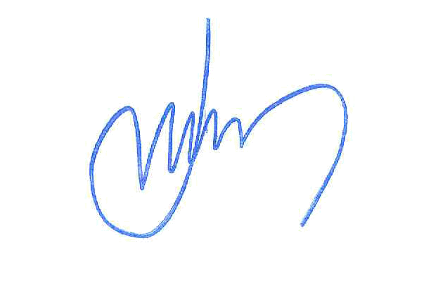
11. Signatures

EMPLOYEE COMPANY



Authorized Signature Authorized Signature

_Joshua Okoro______ Philip Ford, CEO ____________ _
Print Name and Title Print Name and Title

EXHIBIT A

LOCAL AGENT
Duties, benefits and work conditions

1. Duties:
1.1. Company assigns Employee to perform the following tasks:
- Receive correspondence using your own address;
- Check your mailbox daily and confirm receipt;
- Forward envelopes to our office using USPS Labels; USPS Labels will be provided by the Company;
- Maintain accurate records of items shipped and received;
- Receive payments from our customers in your area (the payment from our customers for services provided under the contract. Since our company works all over the world, it is easier for our customers to transfer their money to our managers who are located in the same state/region);
- Create reports for each transaction;
- Follow the instructions from Supervisor / Manager.

RecruitActive Ltd.
1 Temple Avenue, London
EC4Y 0HA, United Kingdom
Head Office: +44 1 925 320 241
International:+1 844 783-6796
Website: www.rapidrecruiters.com
Company No.: 05162307
RecruitActive Ltd.
1 Temple Avenue, London
EC4Y 0HA, United Kingdom
Head Office: +44 1 925 320 241
International:+1 844 783-6796
Website: www.rapidrecruiters.com
Company No.: 05162307

2. Term of Employment:
2.1. The term of EXHIBIT A shall be a period of 6 months from the date it is signed.

3. Benefits:
The Company offers the following benefits: Life Insurance, Sickness and Accident income plans, Vacation Pay, Holiday Pay, Medical Care, Education Assistance Programs, Employee Assistance Programs, 401(k) Plan, Job-Related Travel And Accident Insurance, Long Term Care Insurance, Stock Options/ Product discounts, Flexible Workplace.

4. Payment:
4.1. The compensation of the Local Agent consists of a variable part, which constitutes the rate of:

- $725.00 per week;
- 8% (eight) of each payment processing operation;
- $20.00 per each completed mailed order;
- $500.00 Application Bonus.

provided the latter is effected on time, with duly accuracy and in strict compliance with the instructions from the Corporation.

4.2. The Corporation shall have the right to decrease the Employee’s commission in case the payment processing terms were violated by the Employee. In this case the Employee’s commission will be decreased at a rate of 1% per day.

4.3. In case of refusal from the part of the Employee to resend the money, accepted to his bank account, or delay of payment for the period exceeding 3 days without any explicit reason, the Company shall have the right to apply to the arbitration and claim for the reimburse of the amount transferred to his account or for compensation for other damage if any, evicted due to the delay.
4.4 Salary and the Employee’s commission are paid on a monthly basis starting from the 1st working day of this Agreement shall be in force. Payment Day – last Friday of the month.
5. Signatures

EMPLOYEE
COMPANY ___________ __

Authorized Signature Authorized Signature

Joshua Okoro_______ Philip Ford, CEO______ _______
Print Name and Title Print Name and Title

