I have developed the .NET Core Web Api with .Net Core 6.0, EF Core and SQL Server Database.

I have tested the enpoints with Swagger and XUnit test.

Below are the highlights:

**Highlights/Approach**:

* Used the **Database First** approach of **Entity Framework Core**.
* Designed the database tables and its relationship
* Generated Models with **Scaffold-DbContext** and DTO objects.
* Implemented **Repository Pattern** to implement the Web Api endpoints.
* Created **XUnit** Test project to test some of the WebAPI Endpoints.
* Used **Swagger and Postman** to test all API End points.
* Used **FluentValidation** to validate input fields provided in json.

I have provided screenshots of the testing done with results.

SQL tables scripts are provided to recreate the tables



**Bar Table**

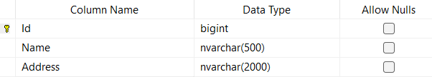

**Brewery Table**

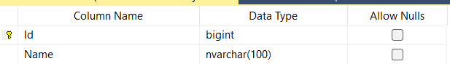

**Beer Table**

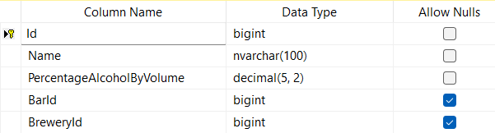

**Project files and structure:**

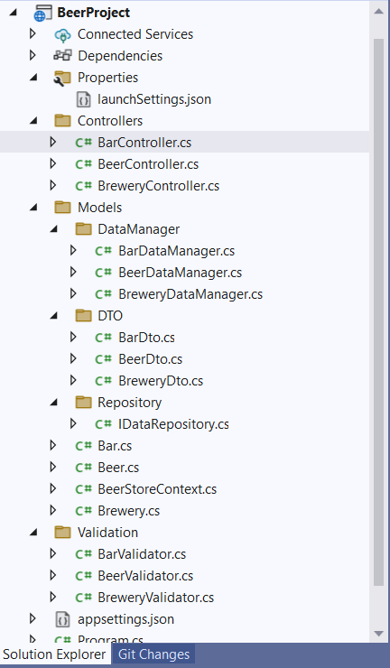

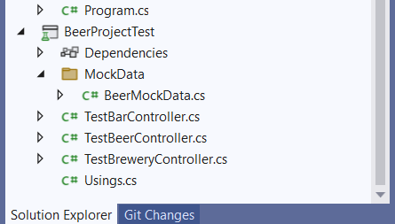

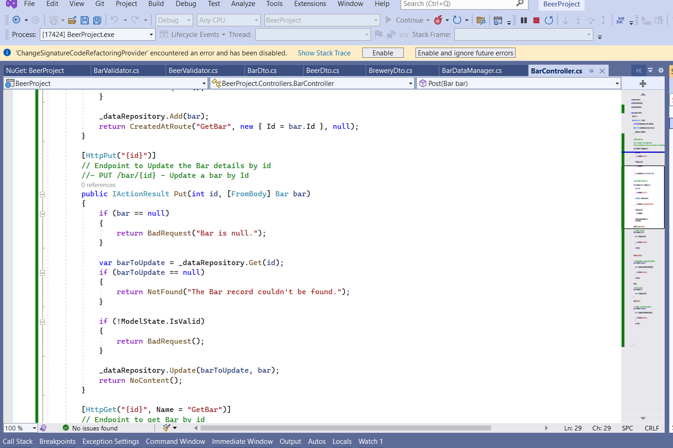

**Testing Artifacts:**

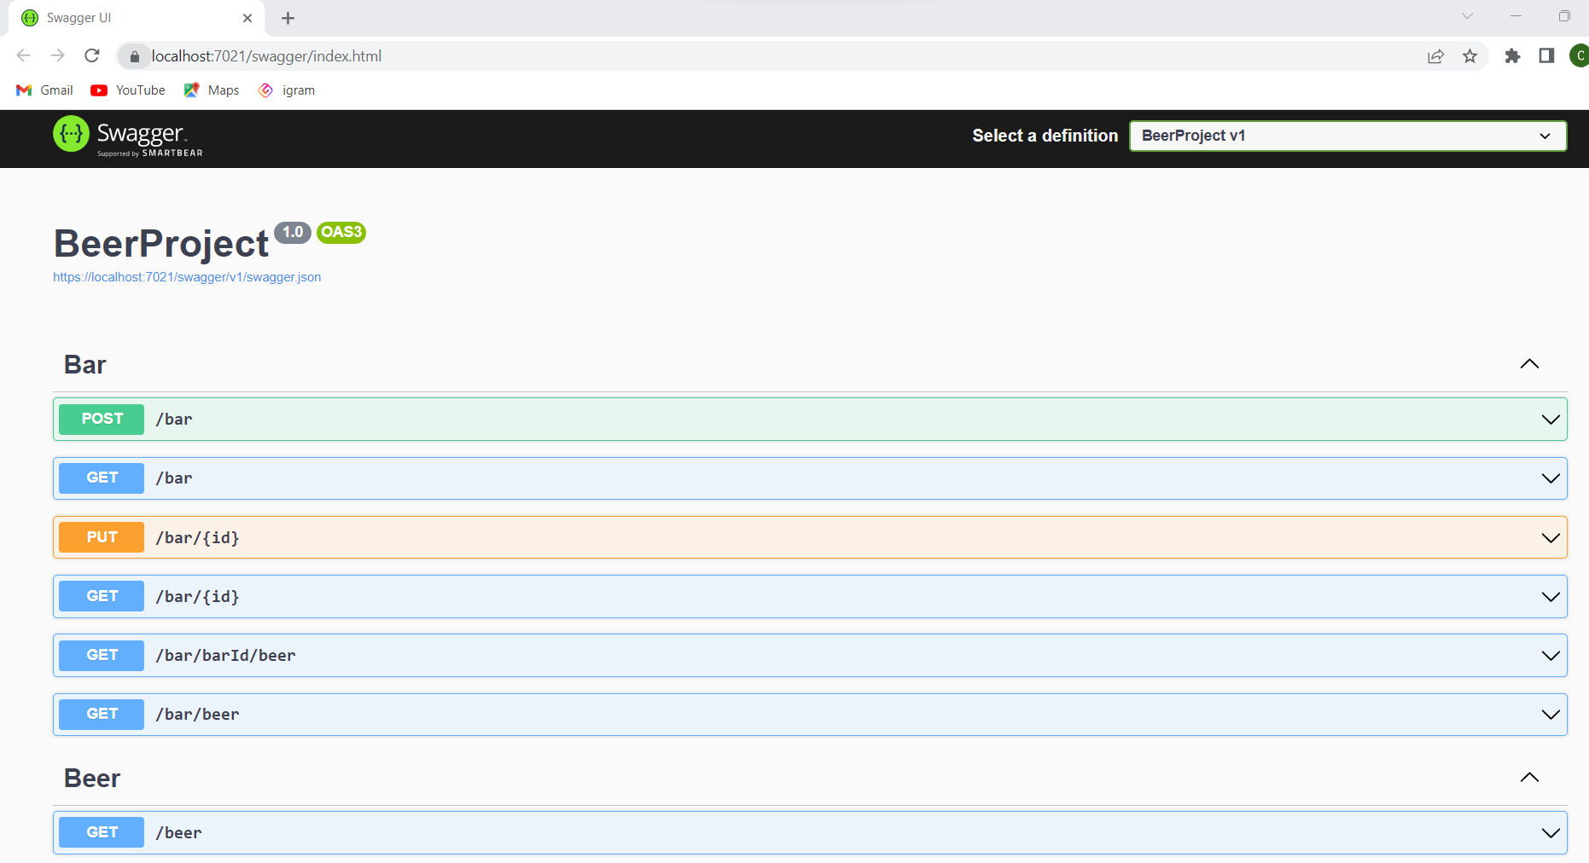

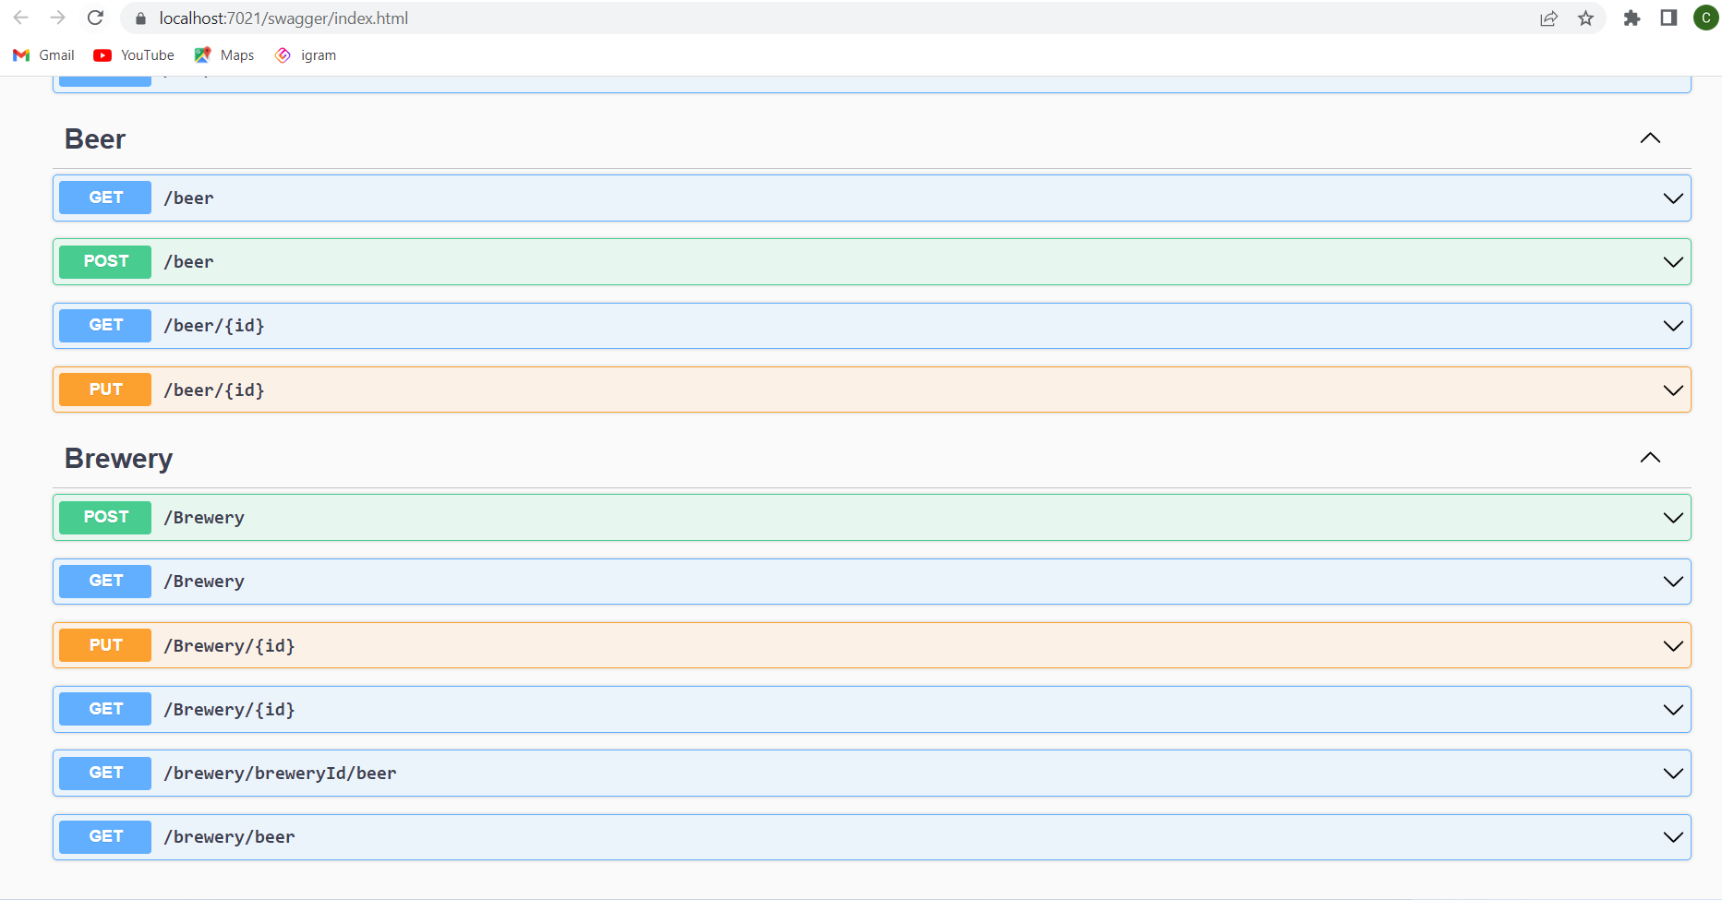

**- POST /bar/beer - Insert a single bar beer link**

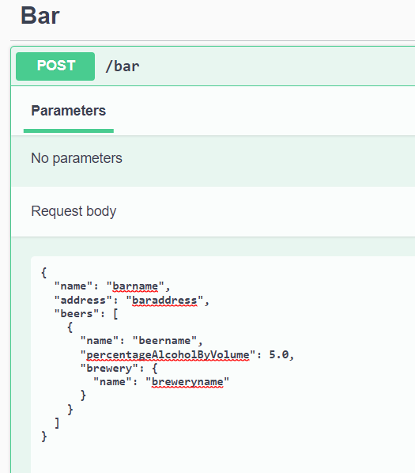

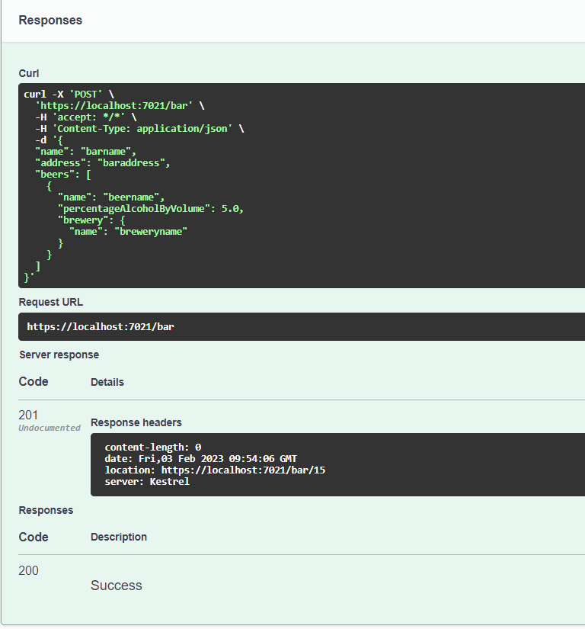

**- POST /brewery/beer - Insert a single brewery beer link**

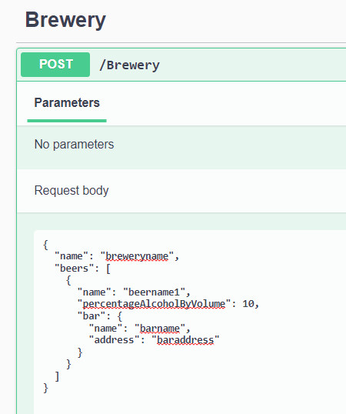

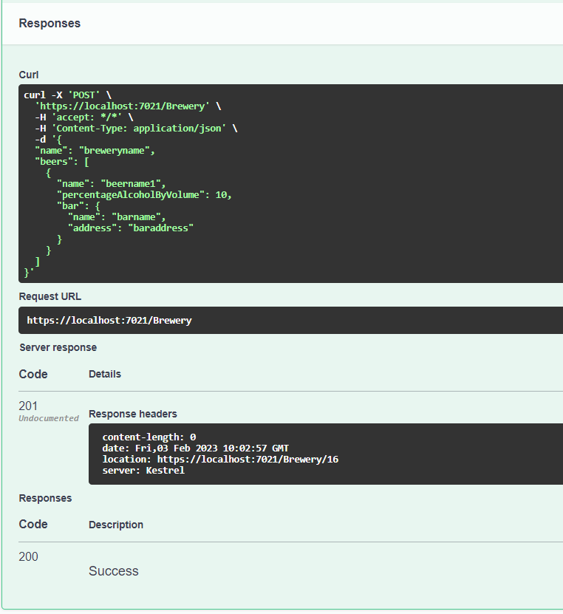

**- POST /beer - Insert a single beer**

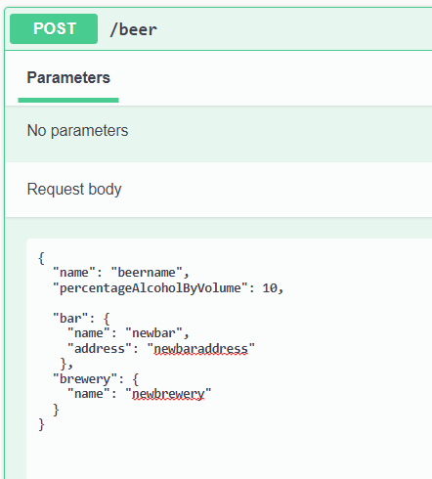

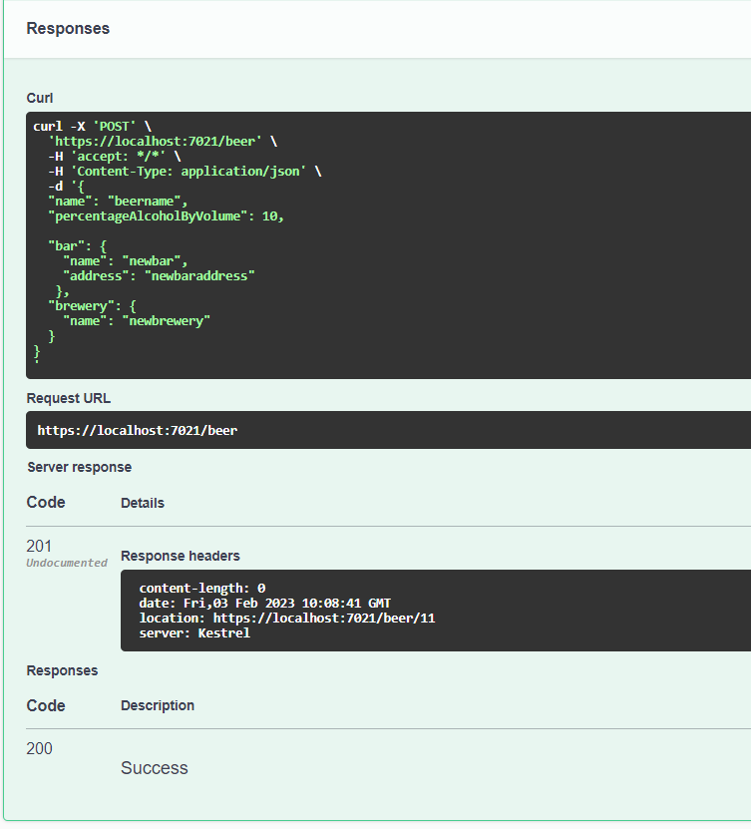

**- GET /beer?gtAlcoholByVolume=5.0&ltAlcoholByVolume=8.0 - Get all beers with optional filtering query parameters for alcohol content (gtAlcoholByVolume = greater than, ltAlcoholByVolume = less than)**

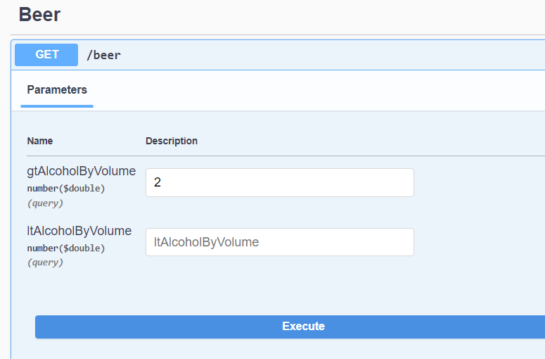

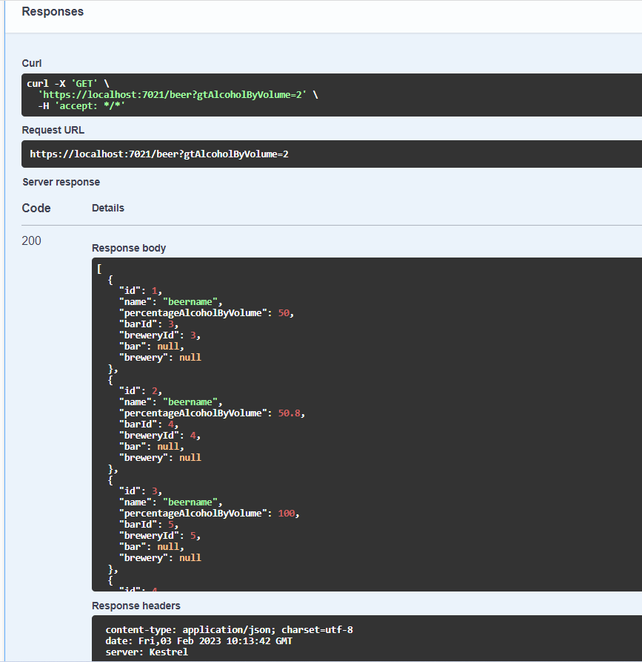

**Validations**:

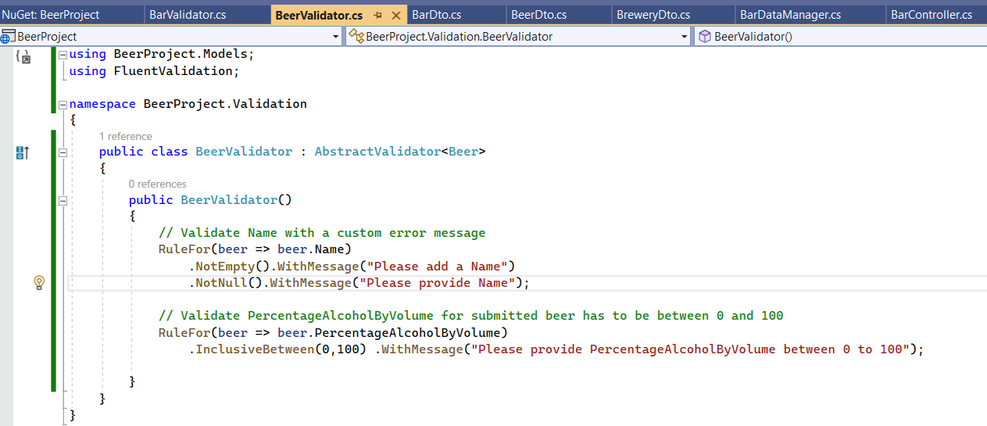

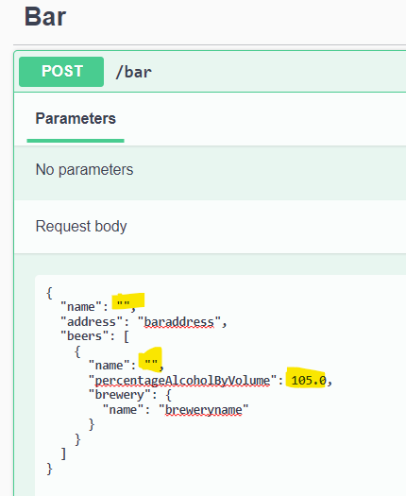

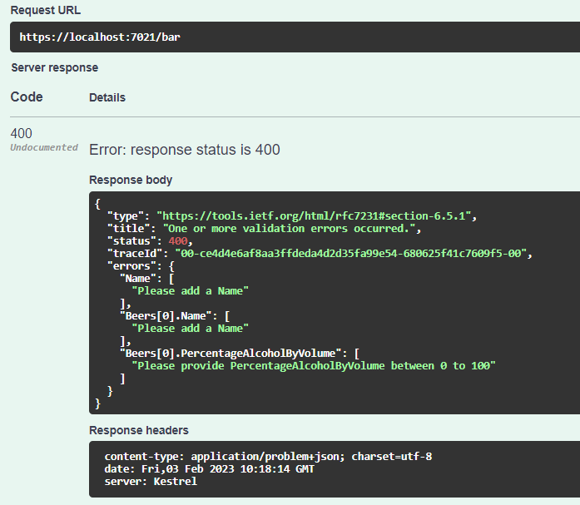

**Testing With Postman:**

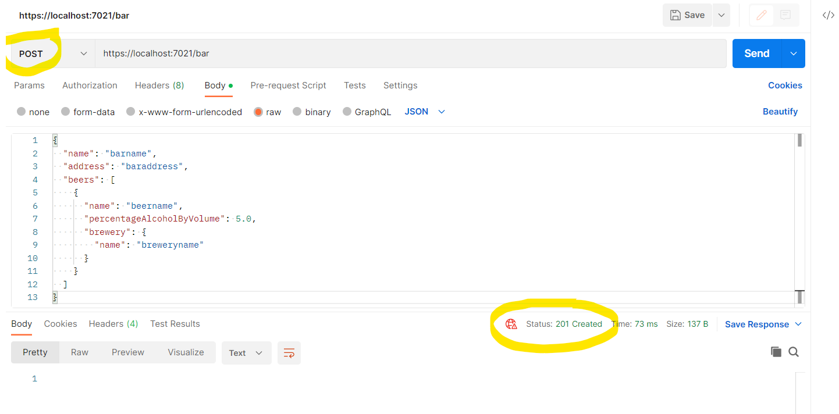

**Testing With xUnit Test:**

