**Excel Challenge Narrative**

Jay Spears

June 17, 2020

**Categories**

Conclusion: Creative Arts campaigns were more successful than other categories of campaign on the Kickstarter funding platform between May 2009 and March 2017. Of the 4,114 total campaigns recorded over this time period, campaigns tagged with the categories Theater, Music, and Film & Video had the highest success rates, accounting for 77% of all successful campaigns.

Some significance may be lent to highlighting Kickstarter success in the creative arts, as Theater, Music, and Film & Video are the only three categories where more than 50% of proposed campaigns succeeded. Photography comes in as a close fourth with around 47% of campaigns succeeding.

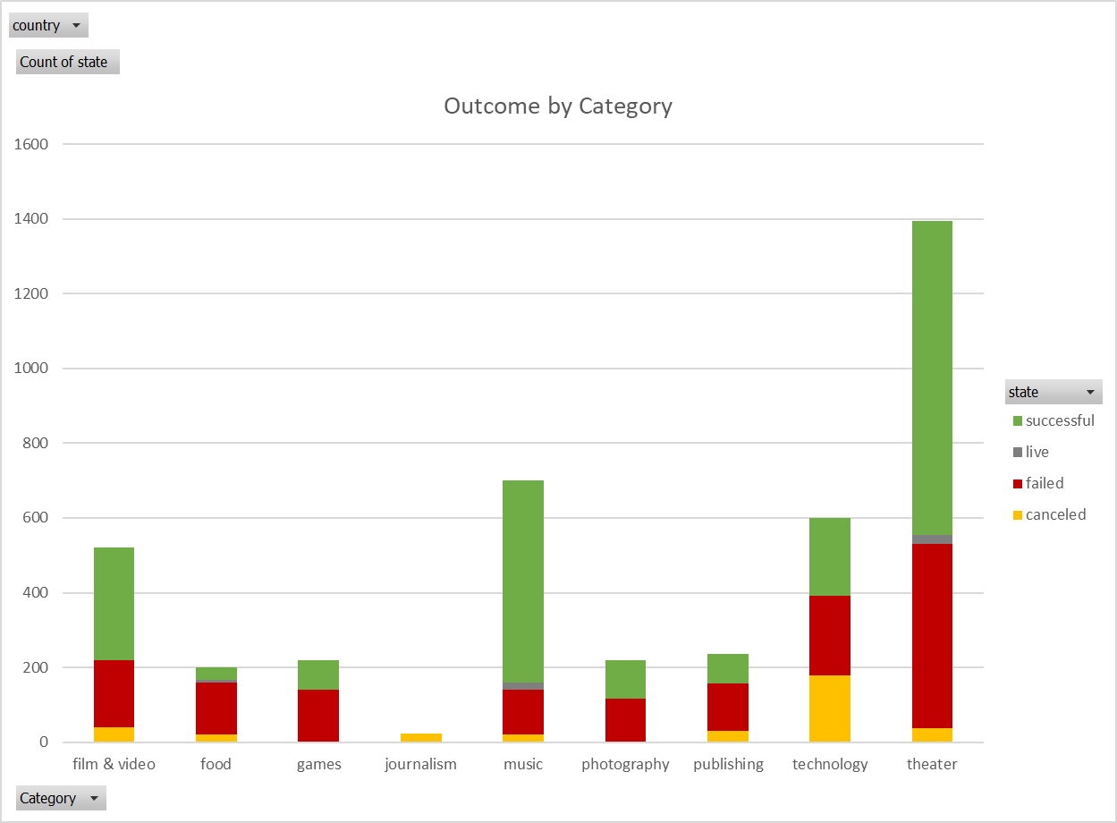

**Subcategories**

Conclusion: Excellent success rates were not limited to the creative arts categories explored above. Drilling down into the data produces a list of subcategories outside of the creative arts where 100% of projects were funded to their goal. While the count of campaigns in each of these subcategories may be relatively small, we could make the projection that future campaigns submitted in these subcategories may have higher success rates than campaigns submitted in other subcategories.

These subcategories might be worth further study as trending in popularity. I’d be interested to narrow down the year graph (below) to just the below subcategories. If a rising trendline in number of campaigns submitted, then I’d like to see the values for the below categories for the rest of 2017, 2018, and 2019 and to compare that data with both financial and anecdotal data relating to, say, the growth of small batch distilleries and breweries. The data points to interesting places to ask more questions.

Subcategories with 100% successful projects include (but are not limited to):

|  |  |  |
| --- | --- | --- |
| Subcategory | Category | Number of Campaigns (100% successful) |
| Small Batch | Food | 34* |
| Tabletop Games | Games | 80 |
| Nonfiction, Radio & Podcasts | Publishing | 80 |
| Hardware | Technology | 140 |

* Six small batch campaigns had a status of live and were excluded from these numbers.

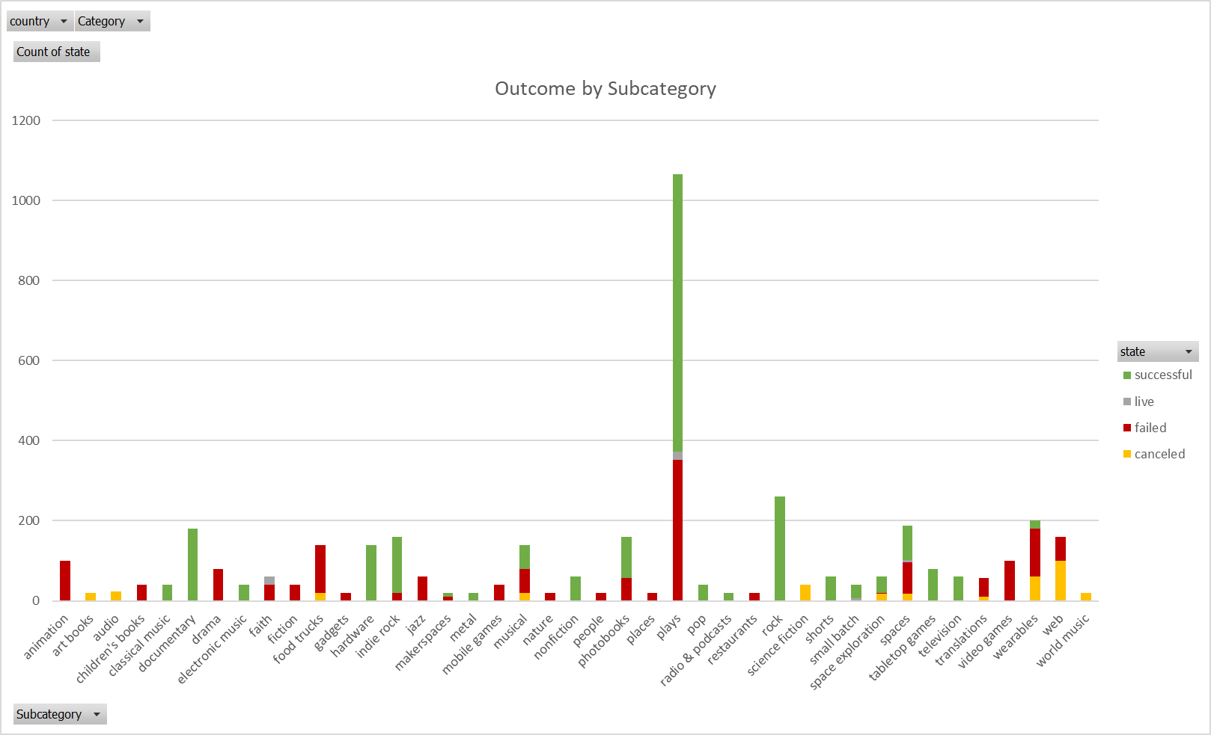

**Over the Years**

Conclusion: Kickstarter campaigns had their community funding heyday between 2013 and 2016.

All lines for successful, failed, and cancelled campaigns trend roughly the same directions. It’s useful to note that we only have the first three months of data for 2017, accounting for the sharp drop in the number of campaigns on the graph below. The full data may show a more gradual downward trend.

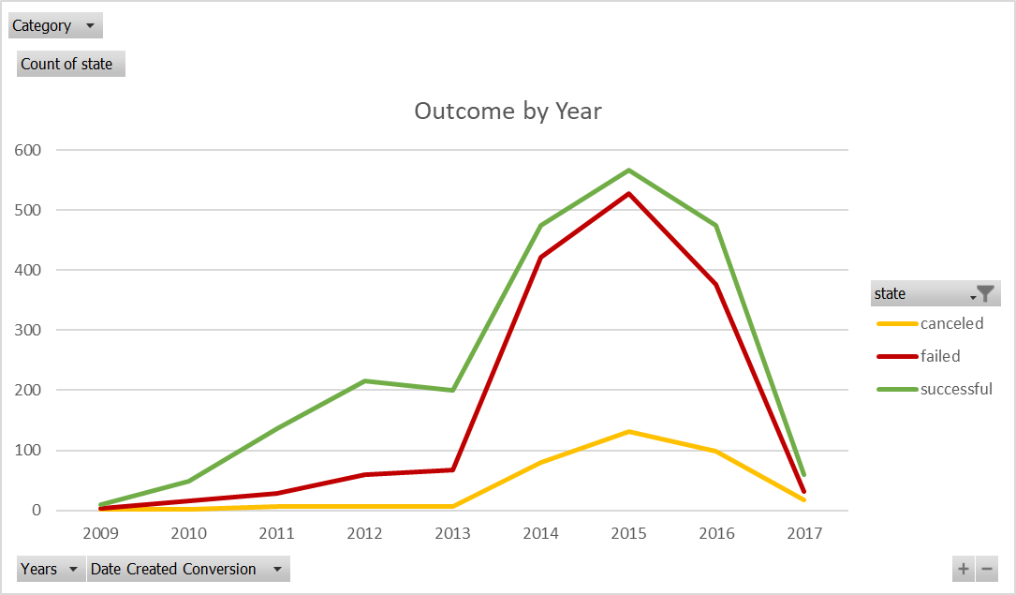

**Goal Dollar Amounts**

Conclusion: Campaigns (regardless of category) tended to be more successful when funding goals are set at lower dollar values.

Even at larger dollar values ($10,000 - $44,999), campaigns were close to or over 40% successful.

Success status drops off sharply when the funding goal was set at greater than or equal to $45,000. (see graph below)

**Backers**

Conclusion: Successful campaigns had an average of 194 backers, with a large amount of variance and standard deviation in the data. This could be explained by how many backers it might take to gain a status of successful with a dollar goal amount <$1,000, versus how many backers it might take to gain a status of successful with a dollar goal amount >$49,999. This can be investigated further by amalgamating the data in the above chart with the data below. Because average donation amounts per funder are roughly equivalent between failed ($104.77) and successful campaigns ($95.56), the true determinant of success for Kickstarter campaigns is number of backers.

Failed campaigns had a much smaller average number of backers (18) and a much smaller median number of backers (4). Failed campaigns also had a much smaller standard deviation and variance. This makes sense, as the Min and Max values in terms of number of backers include a much shorter range for failed campaigns than for successful campaigns.

|  |  |  |
| --- | --- | --- |
|  | Successful | Failed |
| Mean Number of Backers | 194 | 18 |
| Median Number of Backers | 62 | 4 |
| Minimum Number of Backers | 1 | 0 |
| Maximum Number of Backers | 26457 | 1293 |
| Variance Number of Backers | 713167 | 3776 |
| Standard Deviation Number of Backers | 844 | 61 |

**Limitations**

More specific geographic data for the campaign would be interesting. Right now, the data set only contains the country of the campaign. I might want to look at US data as well. For example, I bring the assumption that theater projects would be more successful on the East Coast and Film & Video campaigns more successful on the West Coast. I may be right. I may be crazy. And I might discover there’s a weird hotspot in Detroit for small batch brewing and short documentaries (hipsters?), but without the more-specific geographical data…we’ll never know!

Full data from 2017 would be useful to check my conclusion that crowd funding through Kickstarter began waning in 2016.

**Other Possible Tables/Graphs**

I’d like to look at number of backers and average donation amounts, seeing how they line up with success. Below I put together a pivot table and chart just to see how average donations by category compare.

The technology category has the highest average donation for successful campaigns at $124.25, also having the highest number of backers at 757. It’s interesting to note that technology campaigns also took in the largest sum of money overall at over $19.5 million, about half of the overall pledged amounts for successful campaigns. So, while less than 1/3 of technology campaigns succeeded, the success in that category was defined by big money!

|  |  |  |  |  |
| --- | --- | --- | --- | --- |
| state | successful |  |  |  |
|  |  |  |  |  |
| **Row Labels** | **Sum of Pledged/Backers** | **Sum of backers_count** | **Sum of pledged** | **Average of backers_count2** |
| film & video | $97.04 | 54758 | $5,313,576.17 | 183 |
| food | $71.67 | 11853 | $849,487.14 | 349 |
| games | $63.14 | 44208 | $2,791,408.56 | 553 |
| music | $70.26 | 44801 | $3,147,611.64 | 83 |
| photography | $115.33 | 18882 | $2,177,693.42 | 183 |
| publishing | $45.71 | 33591 | $1,535,350.90 | 420 |
| technology | $124.25 | 158269 | $19,665,020.16 | 757 |
| theater | $87.51 | 58457 | $5,115,585.38 | 70 |
| **Grand Total** | **$95.56** | **424819** | **$40,595,733.37** | **194** |

Well, I’m off to start a Kickstarter campaign for a play I’m writing about a group of film makers doing a documentary short about small batch brewers who play tabletop games and listen to electronic music in their spare time. (That should be successful, right???)