Homework #2

by Scott Pease

2016

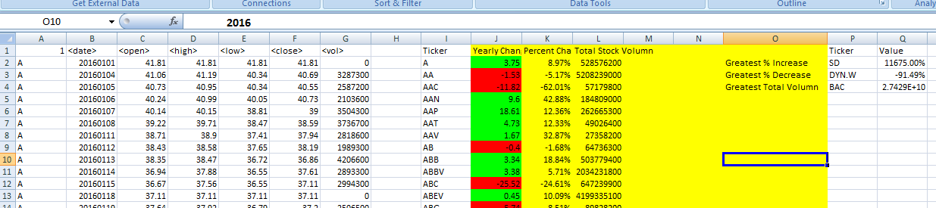

2015

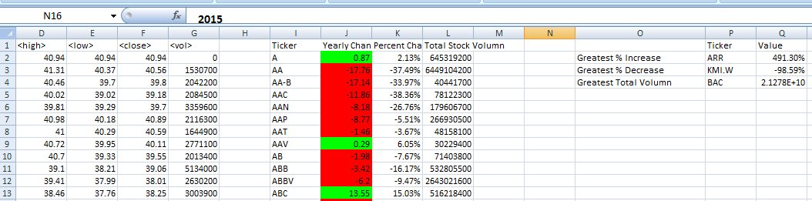

2014

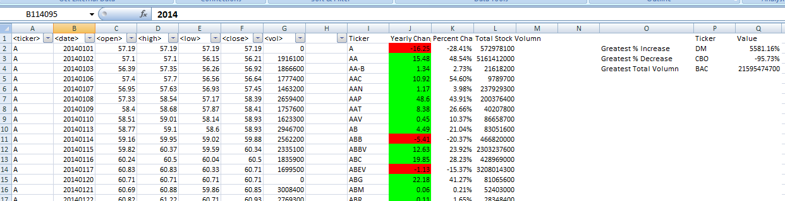

Investigating the abnormally high % change. It comes from the original data set in the early part of the year when the reported stock price was two order of magnitude smaller than the close. This could be an a couple bad data points, or really happened. It would warrant further investigation, but the number crunching seems right

