1. File -> Preferences -> Keyboard Shortcuts.

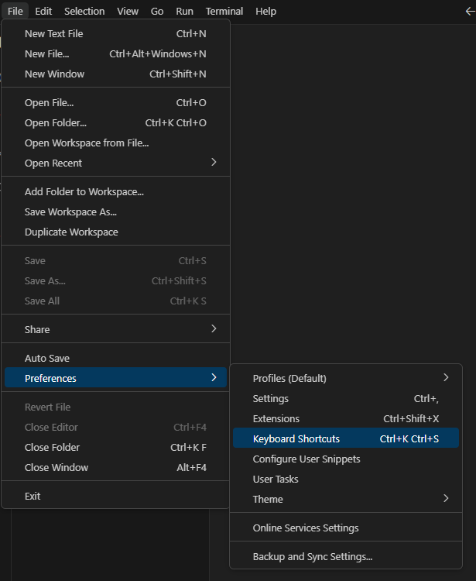

1. Find needed function.
2. Add keywording.
3. Press Ctrl + k, Ctrl + s.
4. Find needed function.
5. Add keywording.