Settings python venv

1. Install python.

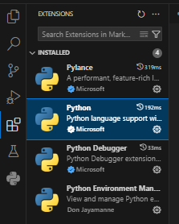

1. Install python environment manager.

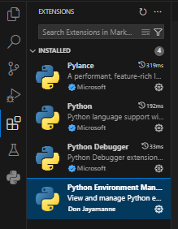

1. Create python environment.

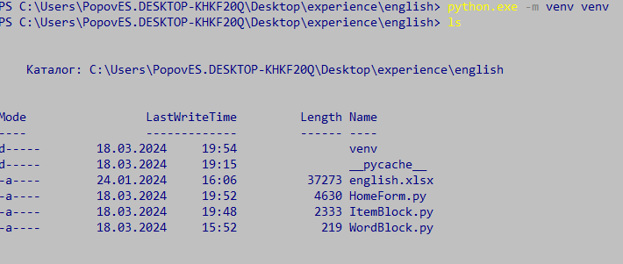

1. Activate python environment.



1. Install all modules.

Python -m pip install <module-name> or python -m pip -r install requirements.txt

1. Select language mode.

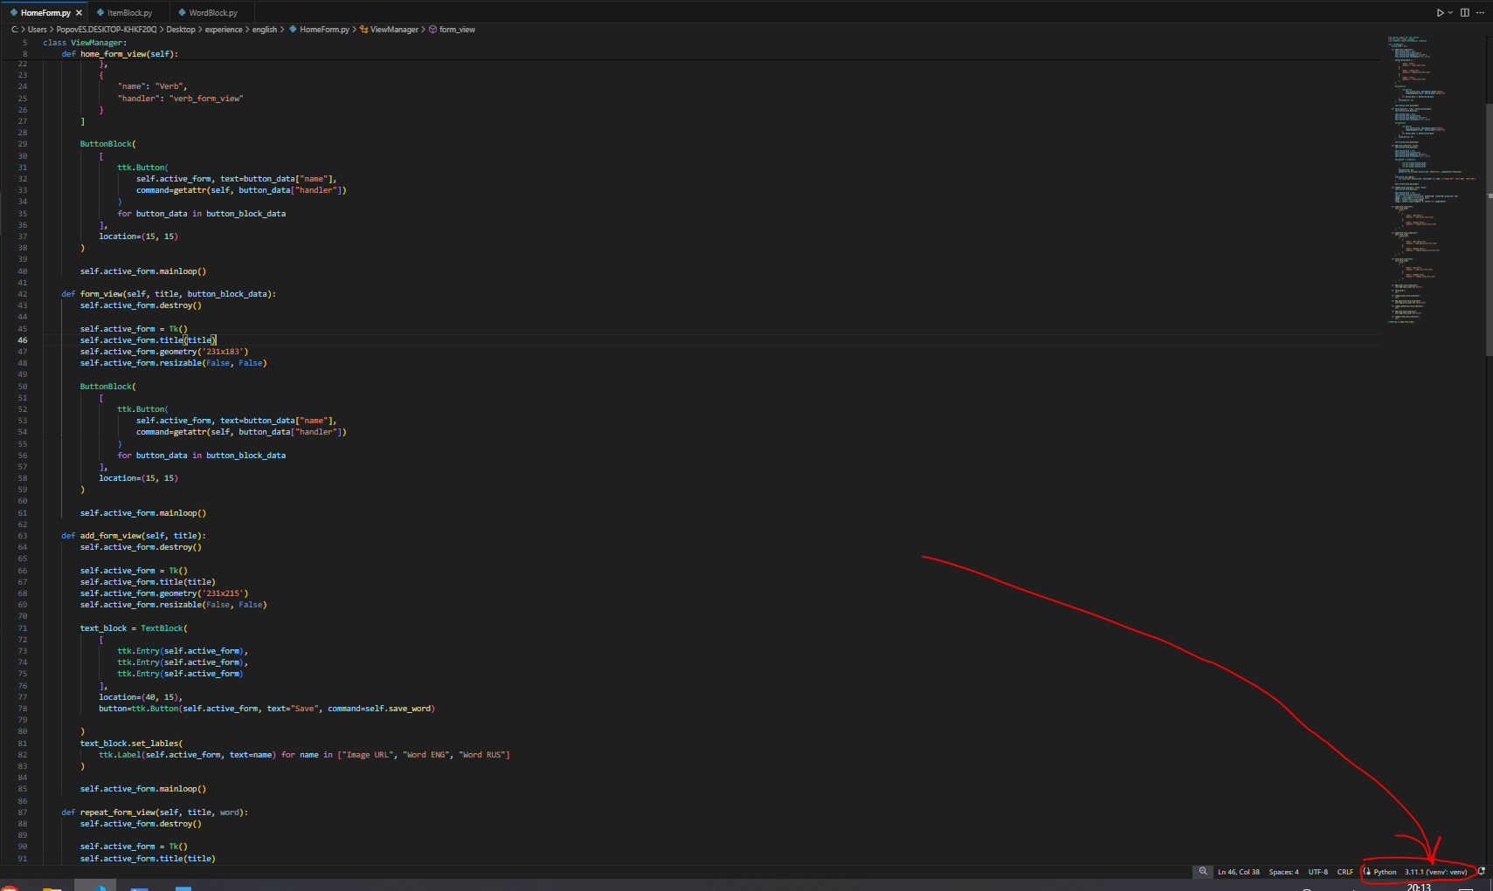

1. Select Enter interpreter path

