
MEAT DEPARTMENT
COMPREHENSIVE OPERATIONS MANUAL & DAILY CHECKLIST
From Opening to Closing — A Complete Daily Workflow Guide
Date: ____________ Branch: ____________ Shift: ☐ AM ☐ PM Staff: ____________ Manager: ____________
CHAPTER 1
SHIFT OPENING
Start every shift right. Safety and preparation set the standard for the entire day.
☐ | Check meat case temperatures (32-40°F) — Record: ___°F
☐ | Check walk-in cooler temperature — Record: ___°F
☐ | Inspect meat display for proper organization
☐ | Check for expired or near-expiration products
☐ | Verify all items are properly labeled with dates
☐ | Check meat case lights are working
☐ | Wipe down display case glass (inside & outside)
☐ | Ensure cutting boards and knives are clean & sanitized
☐ | Organize meat storage in walk-in cooler
☐ | Put on clean apron and gloves


CHAPTER 2
DAILY PRODUCTION
The core of your shift. Prep every item to exact specifications. ⭐ = Must-stock best sellers.
🐷 PORK — Pork Products
PORK BELLY — Belly Cuts
# | 📷 | ITEM | CUT METHOD | SIZE | PLU | PREP✓ | QTY | DISP✓ | PRICE✓ | FRESH✓ | NOTES
1 | 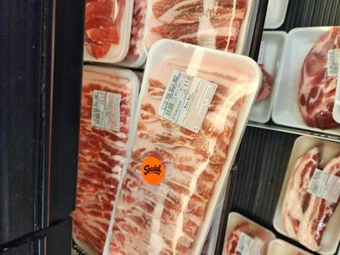 | ⭐ PORK BELLY SAMGYUPSAL (SKIN ON) | CLEAN CUT - MACHINE | 1 CM | 9207
2 | 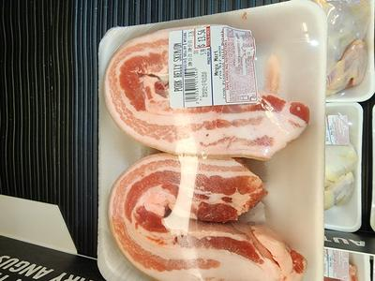 | ⭐ PORK BELLY SUYOOK (SKIN ON) | CLEAN CUT - MACHINE | 3 CM | 9921
3 | 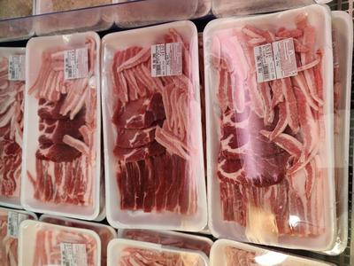 | ⭐ PORK BELLY CROSS CUT (SKINLESS) | CROSS CUT | 4 MM | 9923
4 | 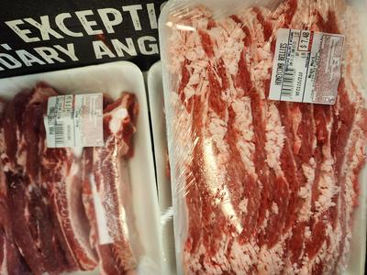 | PORK BELLY ROLL (SKINLESS) | HONEYCOMB | 1.5 CM | 9303
5 | 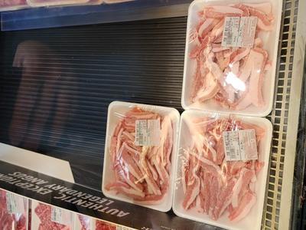 | ⭐ PORK BELLY FLOWER CUT | CLEAN CUT - MACHINE | 4 MM
6 | 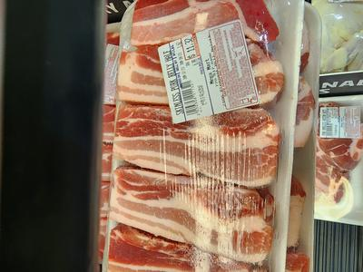 | PORK BELLY FLAT (SKINLESS) | CLEAN CUT - MACHINE | 1 CM | 9207
7 |  | PORK BELLY HALF CUT | CLEAN CUT - MACHINE | 1.5/1 CM | 9304
8 |  | PORK BELLY SUYOOK (SKINLESS) | CLEAN CUT - MACHINE | 3 CM | 9924
9 | 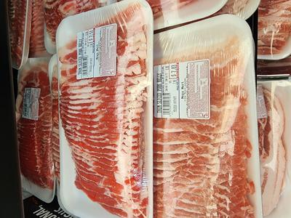 | ⭐ PORK BELLY SHABU - FLAT | CLEAN CUT - MACHINE | 2 MM | 9922
10 |  | PORK BELLY SHABU - ROLL | CLEAN CUT - MACHINE | 2 MM | 9302
PORK SHOULDER / LOIN / OTHERS
# | 📷 | ITEM | CUT METHOD | SIZE | PLU | PREP✓ | QTY | DISP✓ | PRICE✓ | FRESH✓ | NOTES
11 | 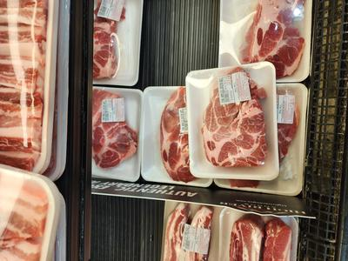 | ⭐ BONELESS PORK SHOULDER STEAK | THICK CUT | 1.5 CM | 9212
12 | 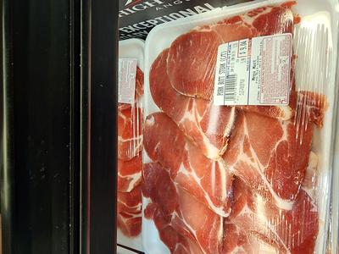 | ⭐ SPECIAL PORK SHOULDER SET | REG - HONEY | 1.5 CM | 9221
13 | 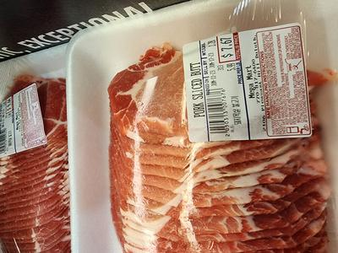 | SPECIAL PORK SHOULDER & BELLY | REG - HONEY | 1.5 CM | 9222
14 | 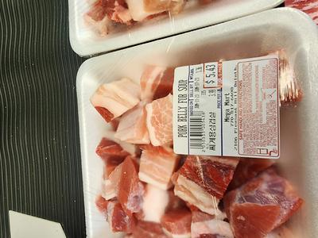 | MIXED PORK FOR SOUP | CHOP | 2~3 CM | 9206
15 |  | ⭐ PORK GALBI / HONEYCOMB | HONEYCOMB | 1.5 CM | 9220
16 | 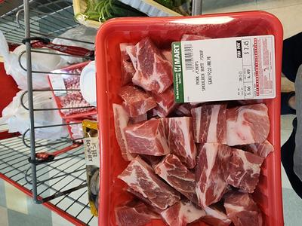 | PORK SHOULDER SHABU | CLEAN CUT - MACHINE | 2 MM | 9313
17 | 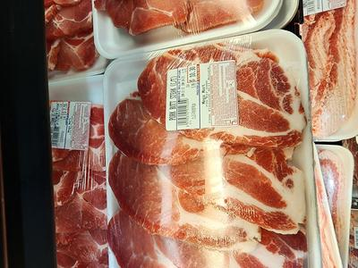 | PORK SHANK STEAK (BONE IN) | CLEAN CUT - MACHINE | 1.5 CM | 9230
18 | 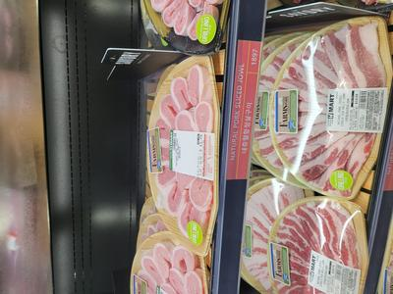 | ⭐ PORK JOWL - HANGJEONG (항정살) | REG | 1 CM | 9158
19 |  | ⭐ PORK JOWL - MARBLING | REG - CURVE | 0.5 MM | 9159
20 |  | SPECIAL SET - PORK JOWL | ASSORTED | 0.5 MM | 9160
21 | 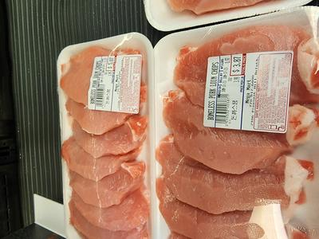 | PORK LOIN BONELESS (KATSU) | KATSU CUT | 1.5 CM | 9224
22 | 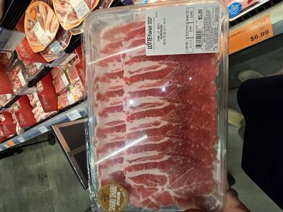 | PORK LOIN SHABU ROLL | CLEAN CUT - MACHINE | 2 MM | 9227
23 | 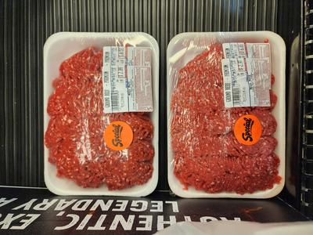 | MIXED PORK GROUND | GROUND | GROUND | 9915
PORK RIBS / BONES
# | 📷 | ITEM | CUT METHOD | SIZE | PLU | PREP✓ | QTY | DISP✓ | PRICE✓ | FRESH✓ | NOTES
24 | 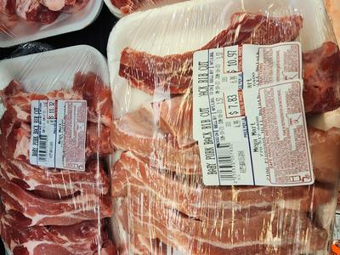 | ⭐ PORK BABY BACK RIB CUT | CLEAN CUT |  | 9319
25 | 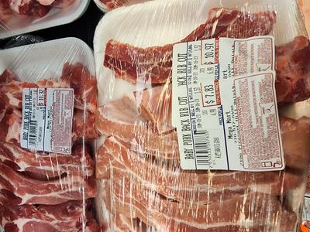 | PORK BABY BACK RIBS - CHAIN | CLEAN CUT - MACHINE | 3 CM | 9928
26 |  | PORK BABY BACK RIBS - WHOLE | WHOLE / SKIN OUT
27 | 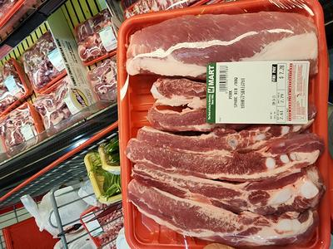 | PORK SPARE RIB CUT | CLEAN CUT |  | 9326
28 | 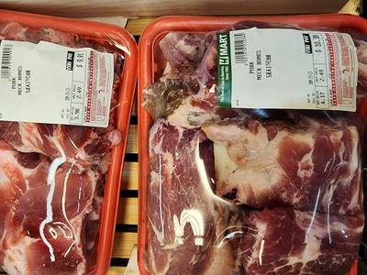 | PORK NECK BONE | CLEAN CUT - MACHINE | 5 CM | 9311
29 | 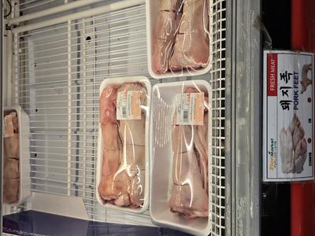 | PORK FRONT FEET | CLEAN CUT - MACHINE | 5 CM | 9306
30 | 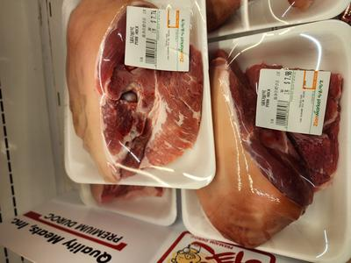 | PORK HOCK | CLEAN CUT - MACHINE | WHOLE | 9316
31 | [ photo ] | PORK BONE - FEMUR (SOUP) | CLEAN CUT - MACHINE | 5 CM | 9317

🐂 BEEF — Beef Products
BEEF RIBEYE / BRISKET
# | 📷 | ITEM | CUT METHOD | SIZE | PLU | PREP✓ | QTY | DISP✓ | PRICE✓ | FRESH✓ | NOTES
32 | 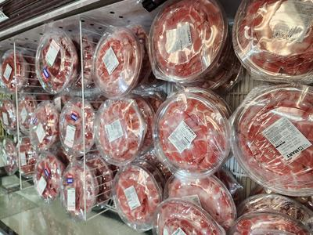 | ⭐ BEEF RIBEYE THIN - BULGOGI | CLEAN CUT - MACHINE | 2 MM | 9203
33 | 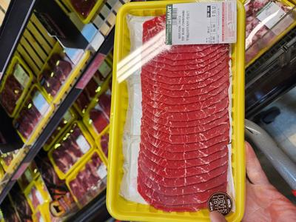 | ⭐ BEEF RIBEYE SHABU | CLEAN CUT - MACHINE | 2 MM | 9106
34 | 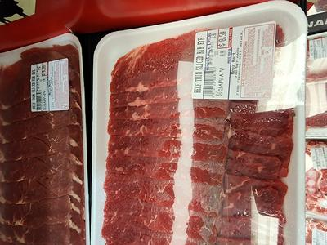 | BEEF RIBEYE SAEWOO | SHRIMP CUT |  | 9216
35 | 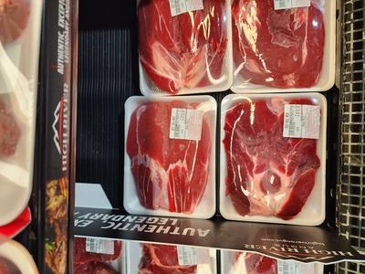 | ⭐ BEEF RIBEYE STEAK | STEAK CUT | 1.5 CM | 9138
36 | 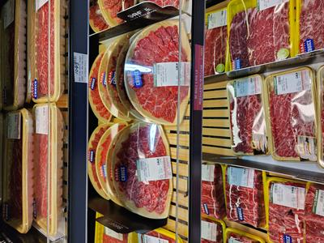 | ⭐ SPECIAL BEEF SET | ASSORTED | 0.5 CM | 9171
37 | 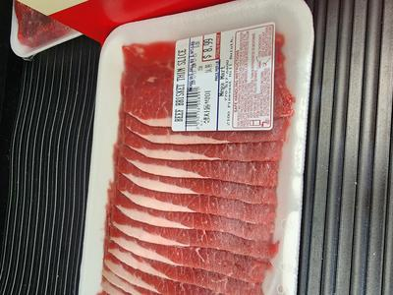 | ⭐ BEEF BRISKET SHABU (FLAT) | CLEAN CUT - MACHINE | 2 MM | 9162
38 |  | ⭐ BEEF BRISKET SHABU (ROLL) | CLEAN CUT - MACHINE | 2 MM | 9163
39 | 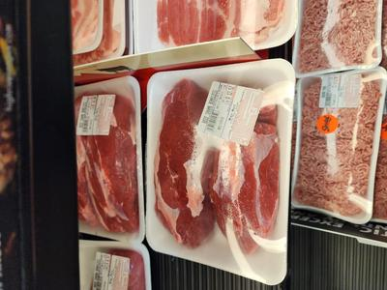 | BEEF BRISKET STEAK | STEAK CUT | 1.5 CM | 9164
40 | 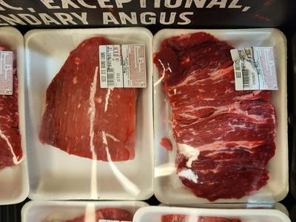 | BEEF BRISKET WHOLE | WHOLE |  | 9166
41 |  | ⭐ BEEF NAVEL SHABU | CLEAN CUT - MACHINE | 2 MM | 9127
42 |  | BEEF NAVEL STEAK | THICK SLICED | 1.5 CM | 9168
BEEF CHUCK / ROUND / OTHER
# | 📷 | ITEM | CUT METHOD | SIZE | PLU | PREP✓ | QTY | DISP✓ | PRICE✓ | FRESH✓ | NOTES
43 | 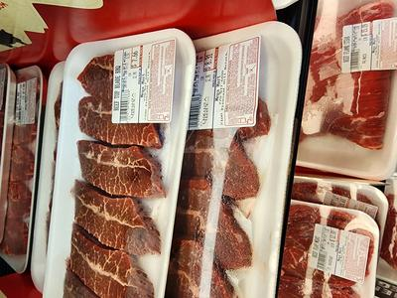 | ⭐ BEEF CHUCK TOP BLADE STEAK | STEAK CUT | 1.5 CM | 9153
44 | 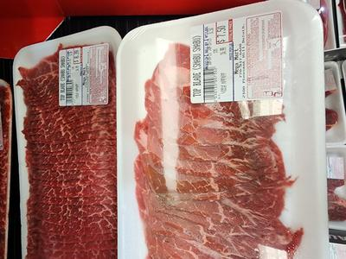 | BEEF CHUCK TOP BLADE SHABU | CLEAN CUT - MACHINE | 2 MM
45 | 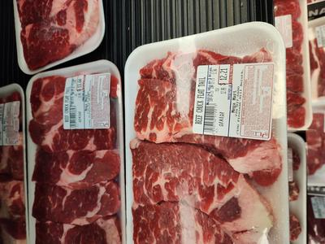 | ⭐ BEEF CHUCK FLAP TAIL (살치살) | GALBISAL CUT | 0.5 CM | 9202
46 |  | BEEF CHUCK FLAP STEAK | STEAK CUT | 1.5 CM
47 | 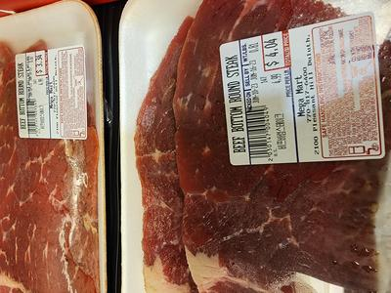 | BEEF EYE ROUND STEAK | STEAK CUT | 1.5 CM | 9170
48 |  | BEEF EYE ROUND SHABU | CLEAN CUT - MACHINE | 2 MM
49 | 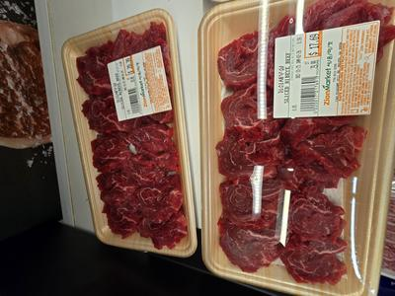 | ⭐ BEEF SKIRT STEAK | STEAK CUT | 1.5 CM | 9134
50 | [ photo ] | BEEF SKIRT SHABU | CLEAN CUT - MACHINE | 2 MM
BEEF SHORT RIB / SOUP BONES
# | 📷 | ITEM | CUT METHOD | SIZE | PLU | PREP✓ | QTY | DISP✓ | PRICE✓ | FRESH✓ | NOTES
51 | 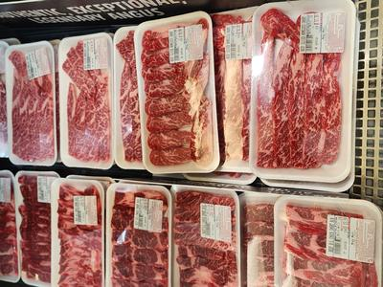 | ⭐ BEEF SHORT RIB 3-BONE (LA GALBI) | CLEAN CUT - MACHINE |  | 9205
52 | 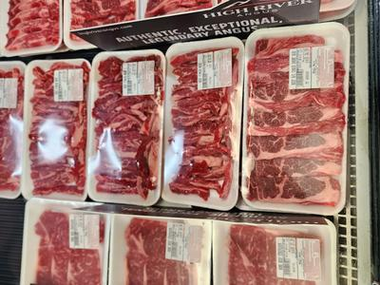 | BEEF SHORT RIB BONE (SOUP) | CLEAN CUT - MACHINE |  | 9156
53 |  | ⭐ BONELESS BEEF SHORT RIB (갈비살) | 3~4 BONE MEAT | 0.5 CM | 9215
54 | 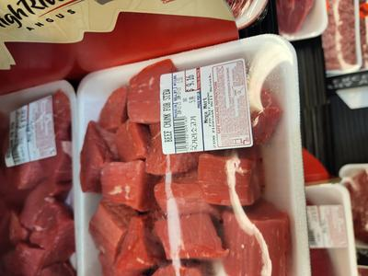 | BEEF SHORT RIB FOR STEW | CLEAN CUT - MACHINE |  | 9149
55 | [ photo ] | BEEF BACK RIB |  |  | 9167
56 |  | BEEF CHUCK SHORT RIB W/BONE | 4 BONES
57 |  | BEEF CHUCK SHORT RIB (STEW) | CLEAN CUT - MACHINE |  | 9161
58 |  | ⭐ BEEF CHUCK SHORT RIB BONELESS | 4 BONES | 0.5 CM | 9219
59 |  | BEEF GROUND | MACHINE GROUND |  | 9914
60 |  | MIXED BEEF FOR SOUP | HAND SPECIAL |  | 9137
61 | 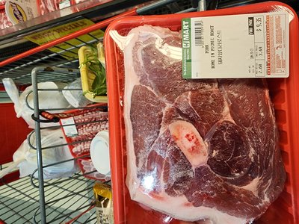 | PORK PICNIC ROAST (BONE-IN) | WHOLE | -- | NEW |  |  |  |  |  | NEW
62 | 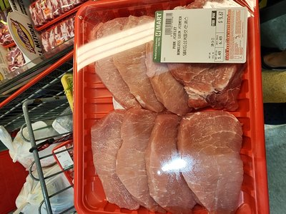 | PORK COUNTRY STYLE RIBS | CUT | -- | NEW |  |  |  |  |  | NEW
63 | 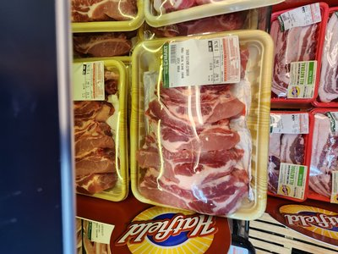 | PORK BONE-IN LOIN CHOPS | CHOP CUT | 1.5 CM | NEW |  |  |  |  |  | NEW
64 | 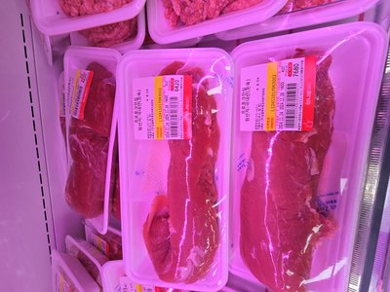 | PORK TENDERLOIN | WHOLE / SLICED | -- | NEW |  |  |  |  |  | NEW
65 | 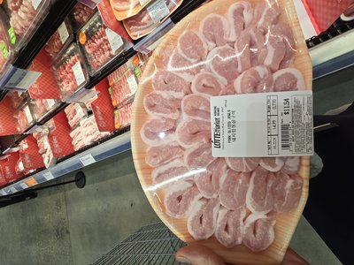 | PORK TONGUE | WHOLE | -- | NEW |  |  |  |  |  | NEW
66 | 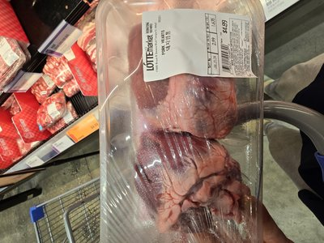 | PORK HEARTS | WHOLE | -- | NEW |  |  |  |  |  | NEW
67 | 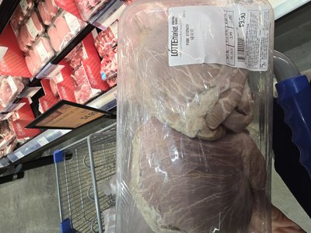 | PORK STOMACH | WHOLE | -- | NEW |  |  |  |  |  | NEW
68 | 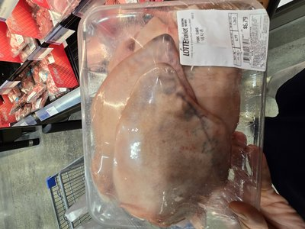 | PORK EARS | WHOLE | -- | NEW |  |  |  |  |  | NEW
69 | 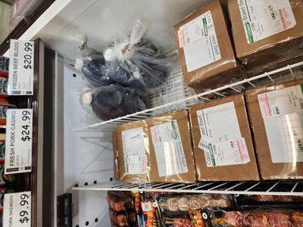 | PORK INTESTINES / SKIN | CLEANED | -- | NEW |  |  |  |  |  | NEW
70 | 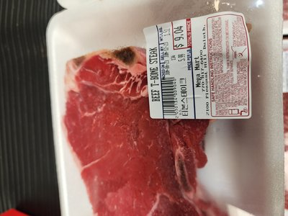 | BEEF T-BONE STEAK | STEAK CUT | 1.5 CM | NEW |  |  |  |  |  | NEW
71 | 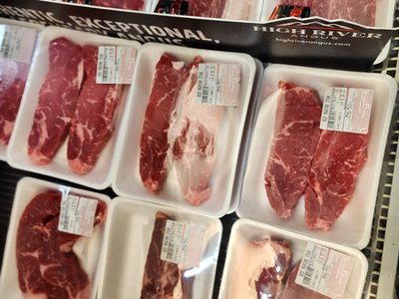 | BEEF NY STRIP STEAK | STEAK CUT | 1.5 CM | NEW |  |  |  |  |  | NEW
72 | 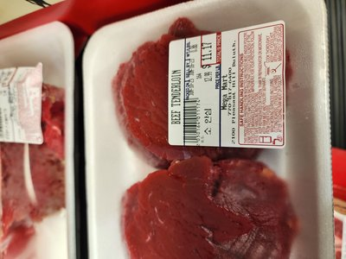 | BEEF TENDERLOIN | STEAK CUT | 1.5 CM | NEW |  |  |  |  |  | NEW
73 | 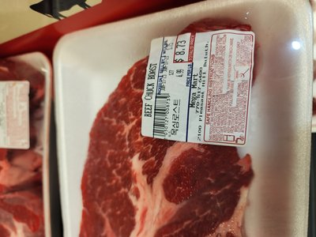 | BEEF CHUCK ROAST | WHOLE | -- | NEW |  |  |  |  |  | NEW
74 | 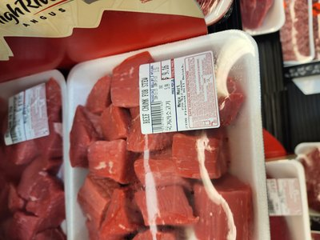 | BEEF STEW MEAT CUBED | CUBED | 2~3 CM | NEW |  |  |  |  |  | NEW
75 | 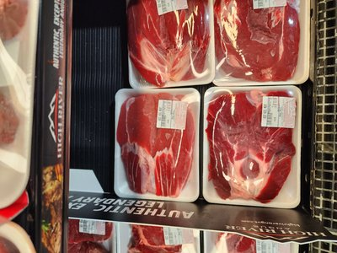 | BEEF ROUND STEAK | STEAK CUT | 1.5 CM | NEW |  |  |  |  |  | NEW
76 | 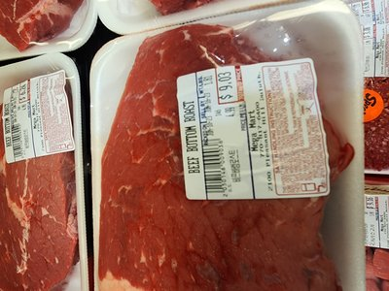 | BEEF BOTTOM ROUND | ROAST / STEAK | -- | NEW |  |  |  |  |  | NEW
77 | 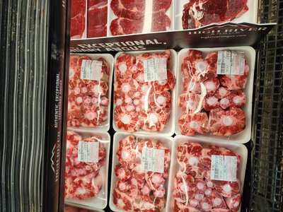 | BEEF OXTAIL | CROSS CUT | 5 CM | NEW |  |  |  |  |  | NEW
78 | 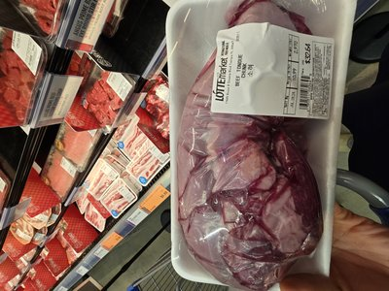 | BEEF TONGUE | WHOLE | -- | NEW |  |  |  |  |  | NEW
79 | 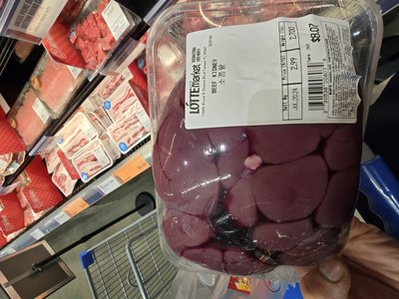 | BEEF KIDNEY | WHOLE | -- | NEW |  |  |  |  |  | NEW
80 | 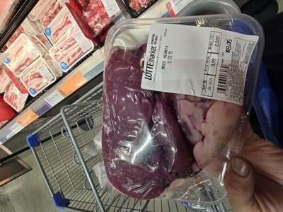 | BEEF HEART | WHOLE | -- | NEW |  |  |  |  |  | NEW
81 | 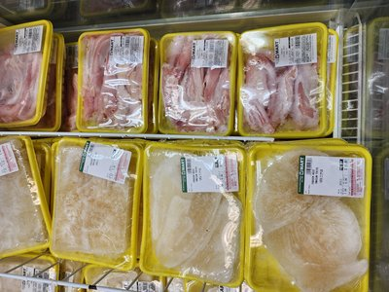 | BEEF LIVER | SLICED | -- | NEW |  |  |  |  |  | NEW
82 | 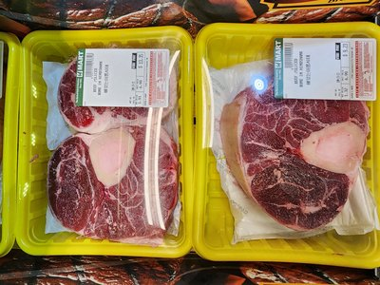 | BEEF SHANK CROSS CUT | CROSS CUT | 3 CM | NEW |  |  |  |  |  | NEW
83 | 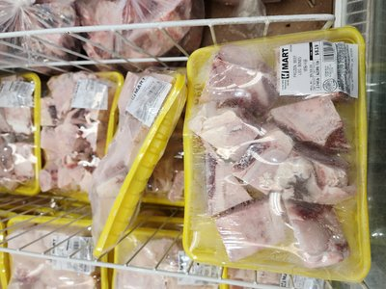 | BEEF SOUP BONES (LEG) | CUT | 5 CM | NEW |  |  |  |  |  | NEW
84 | 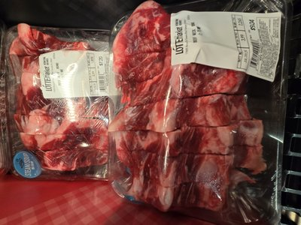 | BEEF NECK BONE (SOUP) | CUT | -- | NEW |  |  |  |  |  | NEW
85 | 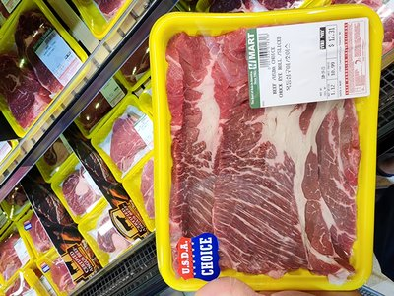 | BEEF CHUCK EYE ROLL | SLICED | 0.5 CM | NEW |  |  |  |  |  | NEW
86 | 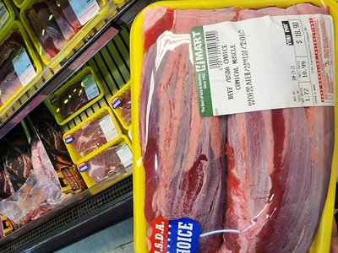 | BEEF CHADOL (CHUCK MUSCLE) | THIN SLICED | 2 MM | NEW |  |  |  |  |  | NEW
87 | 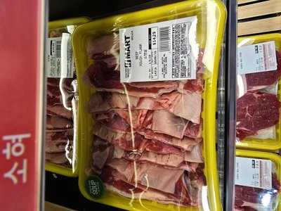 | BEEF ROUGH FLANK | WHOLE | -- | NEW |  |  |  |  |  | NEW
88 | 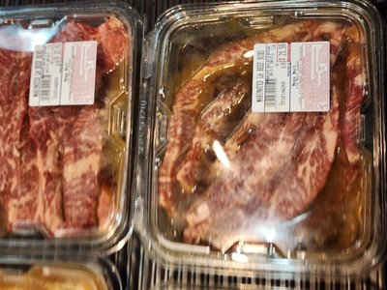 | MARINATED BEEF LA GALBI | MARINATED | -- | NEW |  |  |  |  |  | NEW
89 | 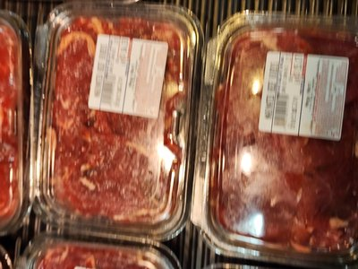 | MARINATED BEEF BULGOGI | MARINATED | -- | NEW |  |  |  |  |  | NEW
90 | 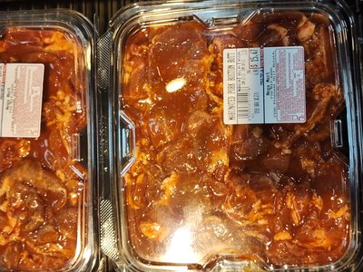 | MARINATED PORK BOSTON BUTT | MARINATED | -- | NEW |  |  |  |  |  | NEW
91 | 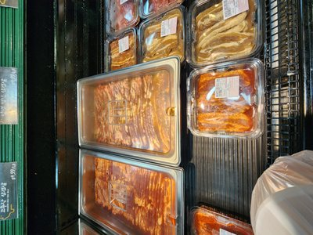 | MARINATED PORK BELLY | MARINATED | -- | NEW |  |  |  |  |  | NEW
92 | 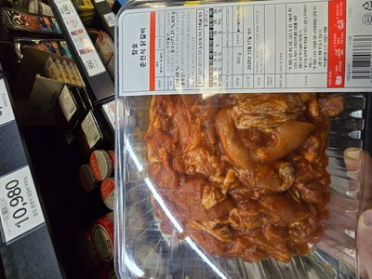 | MARINATED CHICKEN GALBI | MARINATED | -- | NEW |  |  |  |  |  | NEW
93 |  | MARINATED CHICKEN BBQ DRUMSTICK | MARINATED | -- | NEW |  |  |  |  |  | NEW

DAILY SUMMARY
Total Items Prepped:
Total Items Displayed:
Prep Completion %:
Display Completion %:


CHAPTER 3
PREMIUM CUTS SPECIFICATION
High-margin specialty cuts. Ordering specs MUST be followed exactly to prevent yield loss.
# | 📷 | ENGLISH NAME | KOREAN | ORDERING SPECIFICATION (CRITICAL) | MARGIN
1 | [ photo ] | Hanger Steak, Cleaned | 토시살 | "Peeled/Denuded" — Membrane must be fully removed before delivery. | ★★★
2 | [ photo ] | Shoulder Tender (Teres Major) | 제비추리 | "Whole" form only. Do NOT accept pre-sliced. | ★★★
3 | [ photo ] | Inside Skirt Steak, Peeled | 안창살 | INSIDE skirt only — not Outside. Inside = correct Korean Anchangsal. | ★★★
4 | 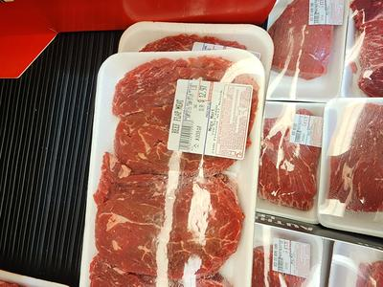 | Beef Flap Meat (Sirloin Flap) | 치마살 | "Peeled" required. Without this spec, yield loss reaches 40%. | ★★★
5 |  | Chuck Flap Tail | 살치살 | PRIME GRADE required. Choice grade = reject for grilling use. | ★★★
6 |  | Flat Iron (Top Blade) | 부채살 | Must be separated from Shoulder Clod. Verify clean seam. | ★★☆
7 | 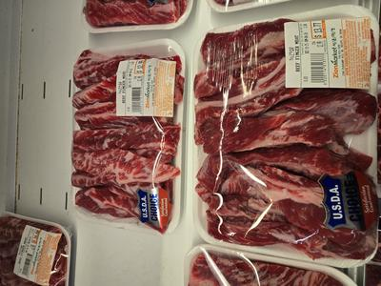 | Rib Fingers (Intercostal) | 늙간살 | "Peeled" — membrane and bone-side tissue fully removed. | ★★☆
8 | 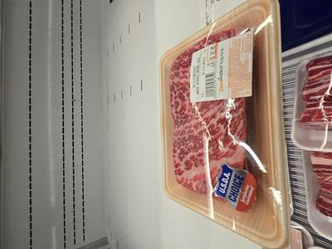 | Short Plate (Beef Belly) | 업진살 | "Boneless" and "Trimmed" — verify both specs on every delivery. | ★★☆
9 | 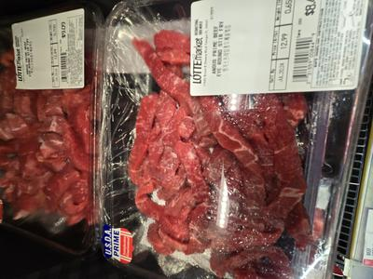 | Ribeye Cap (Spinalis) | 새우살 | "Deckle-off" Spinalis only. Highest margin item. | ★★★
10 |  | Ribeye Roll, Export Style | 알등심 | "Lip-off" required. Lip-on = excess fat = waste. | ★★☆
11 |  | Eye of Round | 홍두깨살 | "Denuded" — all external fat must be removed. | ★★☆
12 | [ photo ] | Lifter Meat (Blade Meat) | 꽃등심덧살 | ⚠️ Do NOT confuse with Ribeye Cap. Different cut, different price. | ★☆☆

📋 RECEIVING INSPECTION CHECKLIST — Use when accepting premium cut deliveries
☐ | Correct cut name matches purchase order
☐ | Grade matches spec (Prime / Choice / Select)
☐ | "Peeled" / "Denuded" / "Trimmed" spec verified visually
☐ | Weight matches PO within ±5% tolerance
☐ | Temperature at receiving ≤ 40°F (4°C)
☐ | No off-odor, discoloration, or excess purge
☐ | Packaging intact, no tears or contamination
☐ | Supplier lot number and date recorded


CHAPTER 4
SERVICE CASE DISPLAY MAP
Every item has its place. Zero visible gaps by 11:00 AM. Follow this planogram exactly.
◀ CUSTOMER SIDE (Front of Case) ▶
FRONT MIDDLE | ⭐ LA GALBI (LA갈비) | ⭐ RIBEYE BULGOGI (불고기) | ⭐ SAMGYUPSAL (삼겨살) | ⭐ BRISKET SHABU (차돌샤브) | ⭐ SPECIAL BEEF SET (세트) | ⭐ PORK BELLY CROSS (대패삼격) | ⭐ PORK SHOULDER (목살)

BOTTOM ROW 1 | BEEF SHORT RIB STEW (갈비찜) | BEEF CHUCK BLADE (부채살) | PORK GALBI (돼지갈비) | PORK JOWL HANGJEONG (항정살) | PORK JOWL MARBLING (뼈살) | PORK LOIN KATSU (돈까스) | BEEF/PORK GROUND (다짐육)

BOTTOM ROW 2 | BEEF SOUP BONES (사골/꼬리) | PORK NECK BONE (감자탕뼈) | PORK FEET (족발/앞발) | PORK HOCK (사태) | PORK SPARE RIBS (갈비) | BABY BACK RIBS (등갈비) | MIXED SOUP MEAT (탕류)

◀ BACK WALL / PREP AREA SIDE ▶
⭐ FRONT ROW: Best sellers & highest-margin cuts ONLY. Visible from 3m. Refill priority = HIGHEST.
🔵 BOTTOM ROW 1: Secondary movers and specialty cuts. Refill within 30 min of gap.
🟣 BOTTOM ROW 2: Bone cuts, soup items, bulk. Must be fully stocked by 11AM.
📏 ZERO GAP at 11:00 AM. ANY empty space = immediate restock.
🔄 FIFO always. Oldest product at front of each slot. Check dates on every restock.


CHAPTER 5
SHIFT OPERATIONS & SAFETY
Maintain quality, hygiene, and display standards throughout your entire shift.
⚙️ DURING SHIFT TASKS
☐ | Rotate stock — FIFO (First In, First Out)
☐ | Check meat color and quality regularly
☐ | Remove discolored or spoiled items immediately
☐ | Keep display case organized and attractive
☐ | Restock items as needed throughout shift
☐ | Change gloves frequently (especially between raw meats)
☐ | Clean cutting boards and knives after each use
☐ | Check display case temperature every 2 hours
☐ | Dispose of trim and waste properly
☐ | Face and organize products regularly
🧼 SAFETY & HYGIENE
☐ | Wash hands thoroughly and frequently
☐ | Wear gloves at all times when handling meat
☐ | Change gloves between different meat types
☐ | Use separate cutting boards for different meats
☐ | Sanitize work surfaces with approved sanitizer
☐ | Never cross-contaminate cooked and raw products
☐ | Report any cuts or injuries immediately

CHAPTER 6
TEMPERATURE LOG
Food safety is non-negotiable. Record temperatures every 2 hours without exception.
TIME | MEAT CASE TEMP (°F) | WALK-IN TEMP (°F) | INITIALS
Opening
10:00 AM
12:00 PM
2:00 PM
4:00 PM
Closing


CHAPTER 7
WEEKLY KPI TRACKER
What gets measured gets managed. Track daily, review weekly, improve continuously.
KPI METRIC | MON | TUE | WED | THU | FRI | SAT | SUN | AVG | TARGET
DISPLAY CONTROL
Display Completion @ 11AM (%) |  |  |  |  |  |  |  |  | ≥ 95%
Empty Gaps Count @ 11AM |  |  |  |  |  |  |  |  | 0
Gap Recovery Time (avg min) |  |  |  |  |  |  |  |  | ≤ 15
Premium Cuts Front-Facing ✓ |  |  |  |  |  |  |  |  | 100%
PREP CONTROL
Total Items Prepped
Prep Completion Rate (%) |  |  |  |  |  |  |  |  | ≥ 90%
Best Seller Items All Prepped ✓ |  |  |  |  |  |  |  |  | 100%
PRICE & FRESHNESS
Price Tag Accuracy (%) |  |  |  |  |  |  |  |  | 100%
Freshness Check Passed (%) |  |  |  |  |  |  |  |  | 100%
Customer Complaints |  |  |  |  |  |  |  |  | 0
HYGIENE & SAFETY
Case Temperature OK ✓ |  |  |  |  |  |  |  |  | ✓
Sanitization Complete ✓ |  |  |  |  |  |  |  |  | ✓
No Cross-Contamination ✓ |  |  |  |  |  |  |  |  | ✓
OVERALL
Daily Score (0-100) |  |  |  |  |  |  |  |  | ≥ 90
PASS / FAIL |  |  |  |  |  |  |  |  | PASS


CHAPTER 8
SHIFT CLOSING
End the day strong. A clean close means a smooth open tomorrow.
☐ | Record final temperatures in Temperature Log (Chapter 6)
☐ | Cover or wrap all displayed meat properly
☐ | Store all meat products in walk-in cooler
☐ | Clean and sanitize ALL cutting boards and knives
☐ | Wipe down and sanitize all work surfaces
☐ | Clean meat display case thoroughly (inside & outside)
☐ | Sweep and mop entire floor area
☐ | Take out trash and sanitize trash cans
☐ | Organize walk-in cooler — FIFO arrangement
☐ | Complete Daily Summary in Chapter 2
☐ | Complete Weekly KPI entry in Chapter 7
☐ | Turn off display case lights (if applicable)
Employee Signature: ____________________ Manager Review: ____________________ Date: ______________

