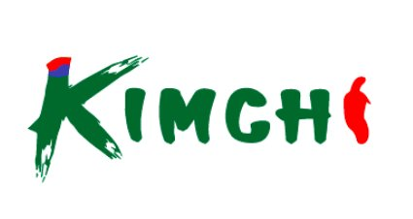
PRODUCE DEPARTMENT
COMPREHENSIVE OPERATIONS MANUAL & DAILY CHECKLIST
From Opening to Closing — A Complete Daily Workflow Guide
Date: ____________ Branch: ____________ Shift: ☐ AM ☐ PM Staff: ____________ Manager: ____________
CHAPTER 1
SHIFT OPENING
Start with temperature, freshness, and display organization. Set the standard for the day.
☐ | Check produce cooler temperature — Record: ___°F
☐ | Inspect all produce for freshness
☐ | Remove any spoiled or damaged items
☐ | Rotate stock — oldest items to front (FIFO)
☐ | Mist vegetables that need moisture
☐ | Wipe down display tables/shelves
☐ | Check floor for water or debris
☐ | Organize produce attractively
☐ | Verify all items have price signs
☐ | Restock items from cooler as needed


CHAPTER 2
QUALITY STANDARDS & REJECT CRITERIA
Know what to accept and what to reject. This is your quality bible.
🛑 REJECT IMMEDIATELY IF:
☐ | Wilted, brown, or yellowing leaves
☐ | Soft spots, bruising, or visible mold
☐ | Unpleasant or rotten odors
☐ | Insect damage or pests present
☐ | Slimy texture or excessive moisture
☐ | Overly dry or shriveled appearance
🔍 VISUAL INSPECTION GUIDE — Category Specific
LEAFY VEGETABLES
ITEM | INSPECTION CHECKLIST | PASS/FAIL
Lettuce / Leaf Mix | ☐ Leaf color vivid ☐ No browning ☐ No wilting ☐ No crushing ☐ No water pooling | ☐ PASS ☐ FAIL
Perilla Leaf | ☐ Deep green color ☐ No damage ☐ No wilting ☐ No excess moisture ☐ Stem normal | ☐ PASS ☐ FAIL
Bok Choy | ☐ Firm stems ☐ No leaf browning ☐ No root rot ☐ No excess moisture | ☐ PASS ☐ FAIL

MUSHROOMS
ITEM | INSPECTION CHECKLIST | PASS/FAIL
King Oyster | ☐ Cap intact ☐ No base softening ☐ No discoloration | ☐ PASS ☐ FAIL
Enoki | ☐ No base slime ☐ Package sealed ☐ No crushing | ☐ PASS ☐ FAIL
Shimeji | ☐ No base rot ☐ Uniform color ☐ Package intact | ☐ PASS ☐ FAIL

ROOT VEGETABLES
ITEM | INSPECTION CHECKLIST | PASS/FAIL
Korean Radish | ☐ No surface damage ☐ No browning ☐ Firm texture | ☐ PASS ☐ FAIL
Onion | ☐ No bottom softening ☐ No mold | ☐ PASS ☐ FAIL
Potato | ☐ No sprouting ☐ No green discoloration | ☐ PASS ☐ FAIL

SALAD / PREP
ITEM | INSPECTION CHECKLIST | PASS/FAIL
Ready Salad | ☐ Expiry date OK ☐ Dressing included ☐ No leaf discoloration | ☐ PASS ☐ FAIL
Chicken Salad | ☐ Package sealed ☐ No excess moisture ☐ Color maintained | ☐ PASS ☐ FAIL
Ricotta Salad | ☐ No cheese discoloration ☐ Dressing normal | ☐ PASS ☐ FAIL


CHAPTER 3
DAILY CHECK — BULK & WEIGHT ITEMS
Group A: Unpackaged whole produce. Restock, sort, and remove damaged items continuously.
# | 📷 | ITEM | 한국어 | DETAIL | STATUS CHECK
1 | [ 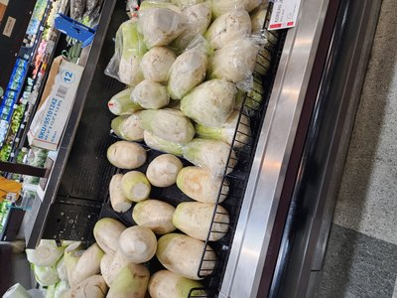 | Korean Jeju Radish | 한국산 제주무 | Soil removal & skin damage inspection | ☐ Restock/Sort
2 | [ 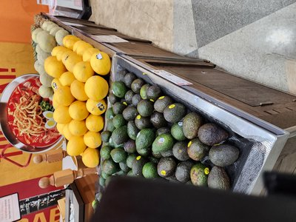 | Avocado | 아보카도 | Sort by ripeness (green/black) separately | ☐ Ripeness
3 | [ photo ] | Korean Chamoe Melon | 한국 참외 | Yellow color uniformity & soft spot check | ☐ Sort
4 | [ 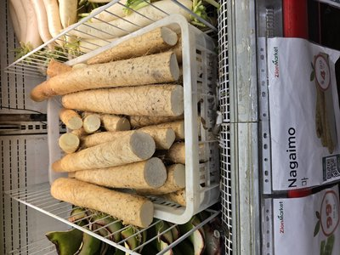 | Nagaimo (Mountain Yam) | 마 | Cut surface browning check ($4.99/lb) | ☐ Browning
5 | [ 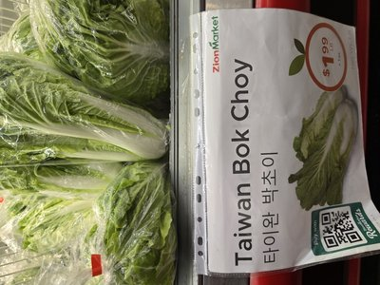 | Taiwan Baby Bok Choy | 타이완 박초이 | Bundle condition & leaf wilting ($1.99/lb) | ☐ Restock
6 | [ 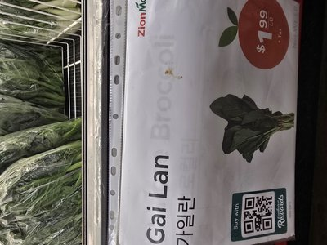 | Chinese Broccoli (Gai Lan) | 가이란 | Stem end drying & flower bud check ($1.99/lb) | ☐ Freshness
7 | [ 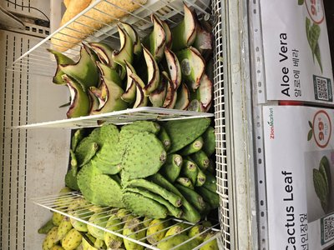 | Cactus Pad (Nopales) | 선인장 잎 | Spine removal status & surface bruising | ☐ Prep status
8 | [ 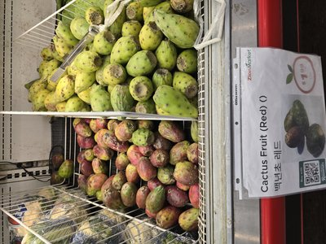 | Cactus Fruit (Tuna) | 선인장 열매 | Red/green color sort & flesh splitting | ☐ Sort
9 | [ 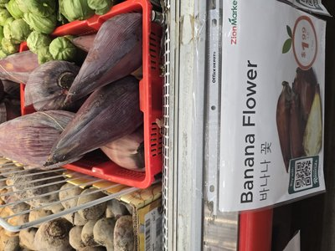 | Banana Blossom | 바나나 꽃 | Specialty section stock & outer drying | ☐ Stock
10 | 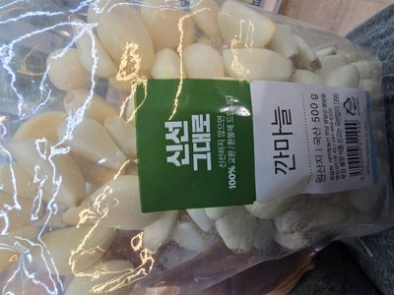 | PEELED GARLIC | 깐마늘 | ROOT | ☐ | Cloves intact / no discolor |  | NEW
11 | 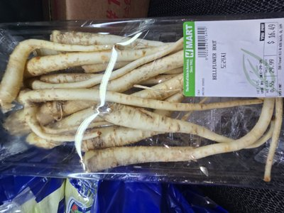 | BELLFLOWER ROOT | 도라지 | ROOT | ☐ | Firm white / no soft spots |  | NEW
12 | 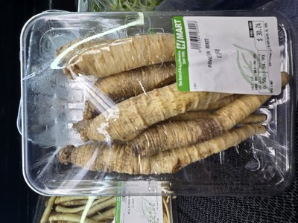 | ARALIA ROOT | 독활 | ROOT | ☐ | Firm / no mold / clean cut |  | NEW
13 | 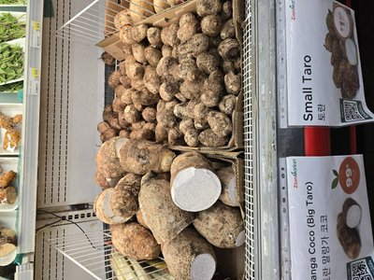 | SMALL TARO | 토란 | ROOT | ☐ | Firm / dry skin / no sprouts |  | NEW
14 | 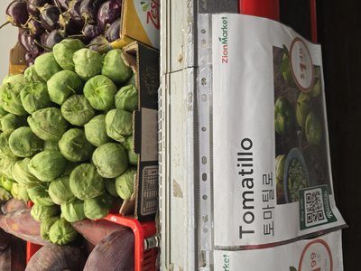 | TOMATILLO | 토마틸로 | FRUIT | ☐ | Husk dry / fruit firm green |  | NEW
15 | 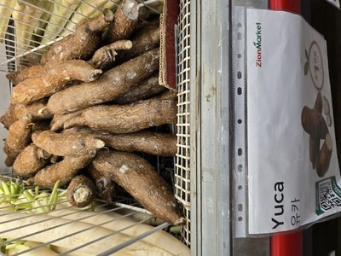 | YUCA | 유카 | ROOT | ☐ | No cracks / firm / white flesh |  | NEW
16 | 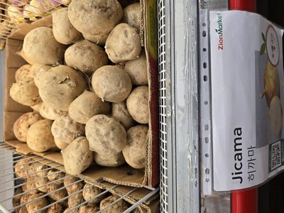 | JICAMA | 히까마 | ROOT | ☐ | Firm / smooth skin / no soft |  | NEW
17 | 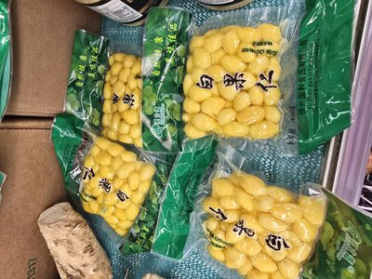 | GINKGO NUTS | 은행 | NUT | ☐ | Yellow color / sealed pkg |  | NEW
18 | 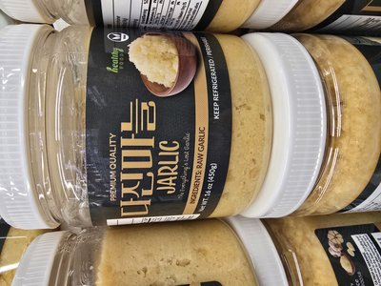 | MINCED GARLIC JAR | 다진마늘 | ROOT | ☐ | Sealed / no discolor / fresh |  | NEW
19 | 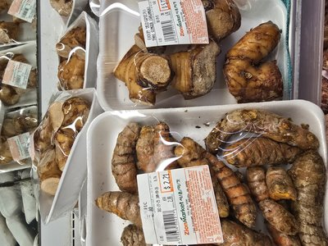 | TURMERIC ROOT | 강황 | ROOT | ☐ | Firm / bright orange inside |  | NEW


CHAPTER 4
DAILY CHECK — PACK, MUSHROOM & SPECIALTY
Group B+C: Bagged produce and tray-packed mushrooms. Focus on moisture, package damage, and shelf life.
# | 📷 | ITEM | 한국어 | DETAIL | STATUS CHECK
1 | [ 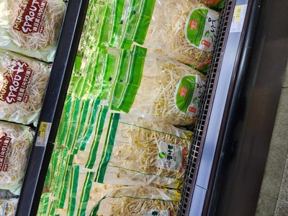 | Soy Bean Sprouts (Organic) | 콩나물 (무농약) | Retail bag — check moisture inside | ☐ Moisture
2 | [ 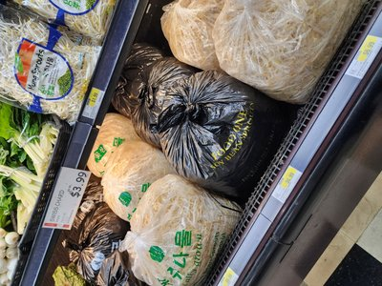 | Soy Bean Sprouts (Bulk) | 업소용 콩나물 | Bulk bag (5.54kg) — damage & stock | ☐ Damage/Stock
3 | [ 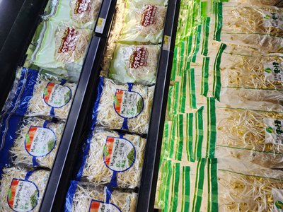 | Mung Bean Sprouts | 숙주나물 | Retail bag ($1.49) — discoloration | ☐ Discolor
4 | [ photo ] | Mung Bean Sprouts (Bulk) | 업소용 숙주 | Bulk bag (4.53kg) | ☐ Restock
5 | [ 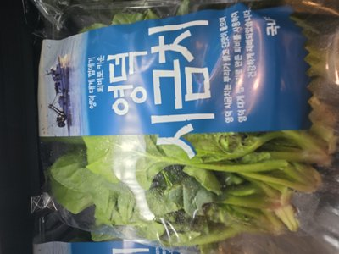 | Spinach (Korean Brand) | 영덕/섬시금치 | Brand bag (250g) — soil check | ☐ Soil
6 | [ 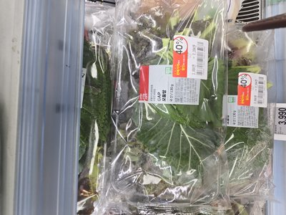 | Perilla Leaf | 깻잎 | Dark green color, no damage, stem intact | ☐ Freshness
7 | [ photo ] | Onion (Mesh Bag) | 양파 (망) | Mesh bag — bottom soft spot check | ☐ Soft spots
8 | [ 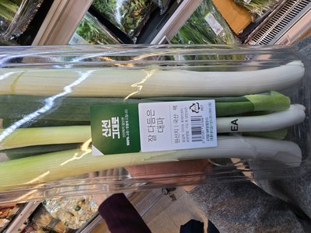 | Green Onion (Daepa) | 대파 (단) | Whole bundles — prevent drying | ☐ Drying
9 | [ 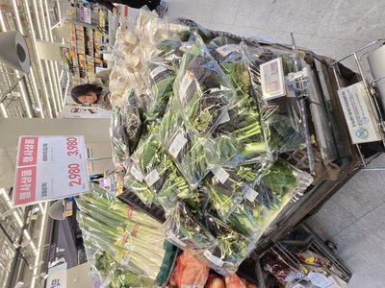 | Potato | 감자 | No sprouting, no green discoloration | ☐ Sprout
10 | [ 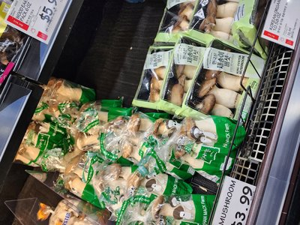 | King Oyster Mushroom | 새송이버섯 | Organic tray (300g/$5.99) — cap damage | ☐ Cap damage
11 | [ 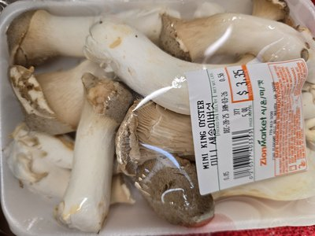 | Mini King Oyster | 미니 새송이 | Small pack ($3.35) — separate display | ☐ Display
12 | [ 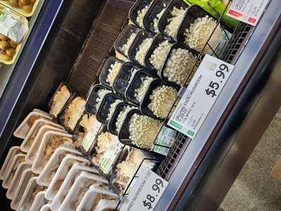 | Enoki Mushroom | 팡이버섯 | Organic/regular multipack ($5.99) | ☐ Base rot
13 | [ 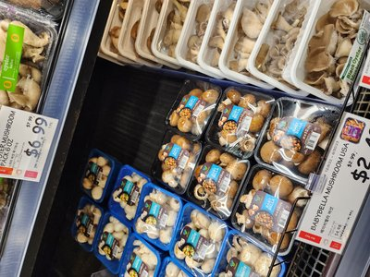 | Oyster Mushroom | 느타리버섯 | Tray pack ($6.99~$7.41) | ☐ Wrap damage
14 | [ 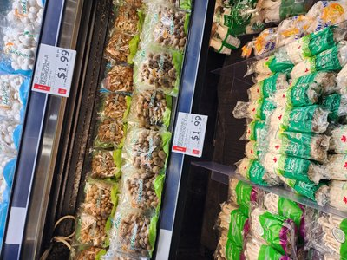 | Shimeji Mushroom (W/B) | 시메지 | White/Brown individual pack ($1.99) | ☐ Base soft
15 | [ 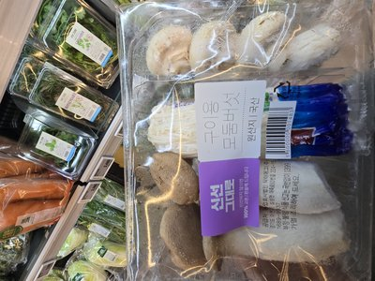 | Grilled Mushroom Set | [혼합] 구이모둠 | [MIX] Enoki/King Oyster/White set | ☐ Mix fresh
16 | [ 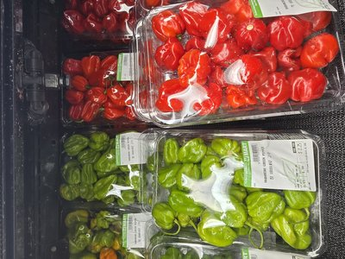 | Orange Habanero | 오렌지 하바네로 | Small pack ($3.56) | ☐ Low qty
17 | 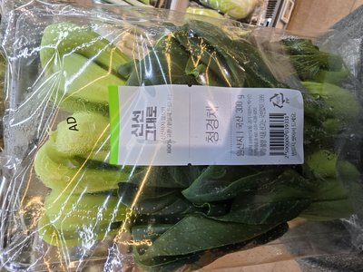 | BOK CHOY | 청경채 | LEAF | ☐ | Leaves crisp / stem white |  | NEW
18 | 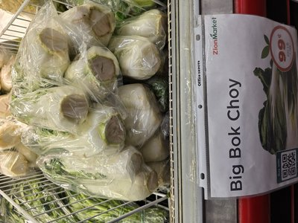 | BIG BOK CHOY | 큰복초이 | LEAF | ☐ | Leaves green / stem firm |  | NEW
19 | 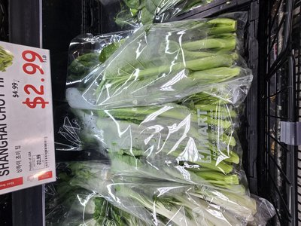 | SHANGHAI CHOY | 상해초이 | LEAF | ☐ | Tender stem / leaves fresh |  | NEW
20 | 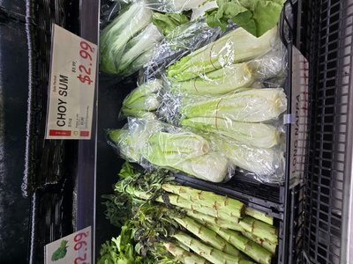 | CHOY SUM | 초이섬 | LEAF | ☐ | Stems crisp / flowers minimal |  | NEW
21 | 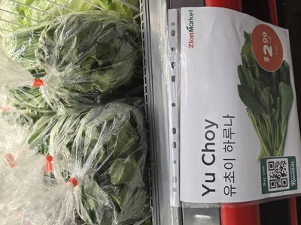 | YU CHOY | 유초이 | LEAF | ☐ | Leaves dark green / no wilt |  | NEW
22 | 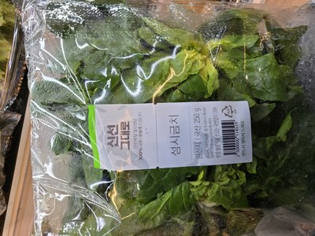 | CROWN DAISY | 쑥갓 | LEAF | ☐ | Aromatic / leaves fresh green |  | NEW
23 | 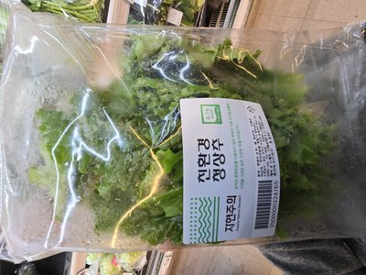 | RED LEAF LETTUCE | 적상추 | LEAF | ☐ | No wilt / vibrant red-green |  | NEW
24 | 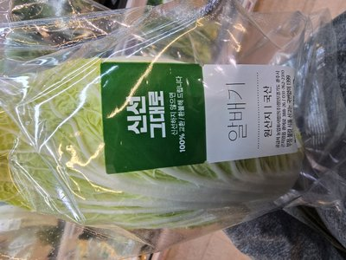 | ROMAINE LETTUCE | 로메인상추 | LEAF | ☐ | Crisp heart / no brown edges |  | NEW
25 | 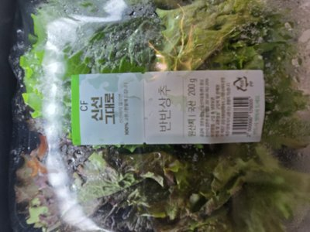 | BIBIM LETTUCE MIX | 비비상추 | LEAF | ☐ | Mixed colors / no wilt |  | NEW
26 | 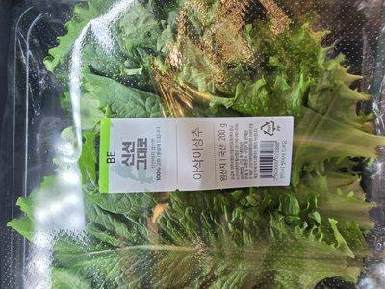 | CRUNCHY LETTUCE | 아삭이상추 | LEAF | ☐ | Crisp texture / bright green |  | NEW
27 | 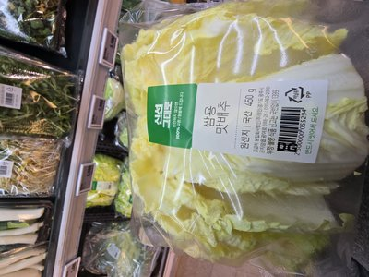 | SSAM NAPA CABBAGE | 쌈배추 | LEAF | ☐ | Compact head / leaves tender |  | NEW
28 | 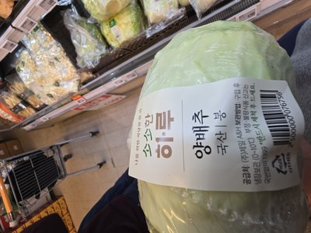 | GREEN CABBAGE | 양배추 | LEAF | ☐ | Firm head / no cracks |  | NEW
29 | 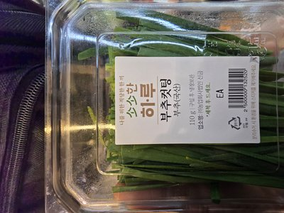 | CHIVE CUT | 부추 | LEAF | ☐ | Bright green / cut fresh |  | NEW
30 | 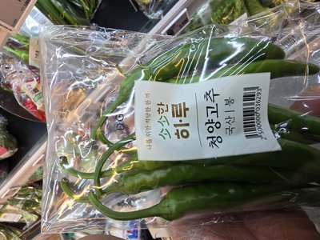 | CHEONGYANG HOT PEPPER | 청양고추 | PEPPER | ☐ | Firm / bright green / no soft |  | NEW
31 | 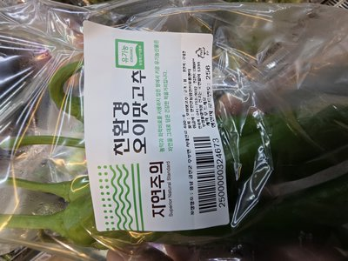 | CUCUMBER PEPPER | 오이맛고추 | PEPPER | ☐ | Thick flesh / mild / crisp |  | NEW
32 | 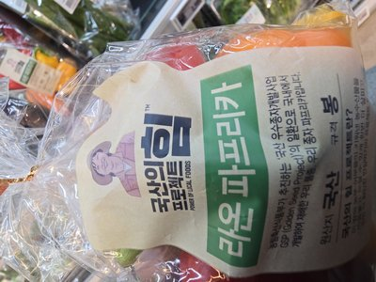 | COLOR PAPRIKA | 컬러파프리카 | PEPPER | ☐ | Firm / vibrant color / no wrinkle |  | NEW
33 | 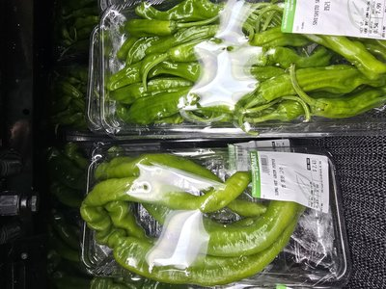 | KOREAN GREEN PEPPER | 꽈리고추 | PEPPER | ☐ | Thin skin / no damage |  | NEW
34 | 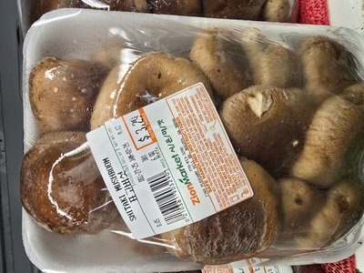 | SHIITAKE MUSHROOM | 표고버섯 | MUSHROOM | ☐ | Cap firm / no slime / dry |  | NEW
35 | 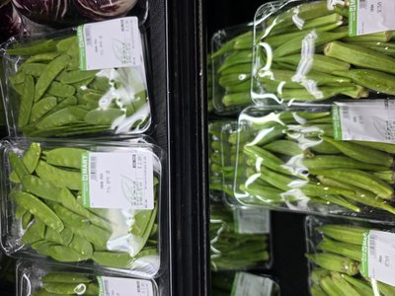 | SNOW PEA | 스노우피 | BEAN | ☐ | Flat / bright green / snap |  | NEW
36 | 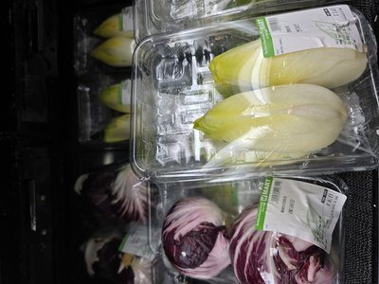 | ENDIVE | 엔다이브 | LEAF | ☐ | Tight head / pale yellow-white |  | NEW
37 | 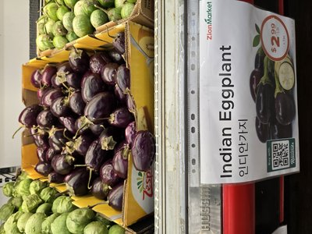 | INDIAN EGGPLANT | 인디안가지 | FRUIT | ☐ | Firm / glossy purple / small |  | NEW
38 | 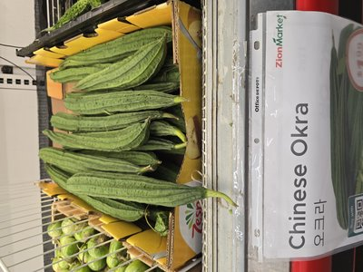 | CHINESE OKRA (LUFFA) | 중국오크라 | FRUIT | ☐ | Firm ridges / bright green |  | NEW
39 | 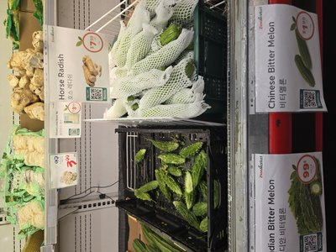 | BITTER MELON | 비터멜론 | FRUIT | ☐ | Firm / green / bumpy texture |  | NEW
40 | 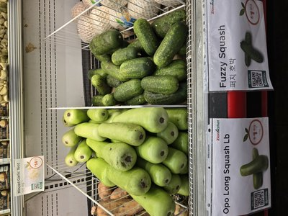 | FUZZY SQUASH | 동과 | FRUIT | ☐ | Fuzzy skin / firm / green |  | NEW
41 | 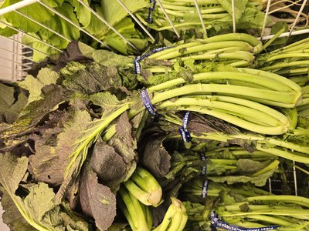 | MUSTARD GREENS | 갓 | LEAF | ☐ | Pungent aroma / leaves firm |  | NEW
42 | 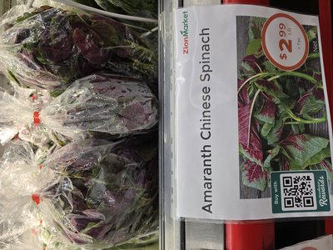 | AMARANTH SPINACH | 아마란스시금치 | LEAF | ☐ | Purple-green / stems tender |  | NEW
43 | 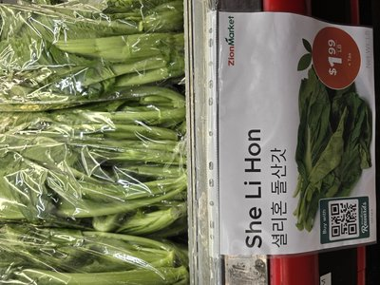 | SHE LI HON | 셀리혼/들산갓 | LEAF | ☐ | Dark green / stems crisp |  | NEW
44 | 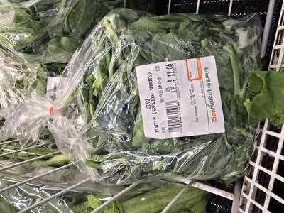 | PEA TIP SHOOTS | 완두순 | LEAF | ☐ | Tender tips / bright green |  | NEW
45 | 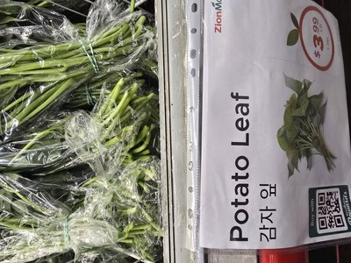 | POTATO LEAF | 감자잎 | LEAF | ☐ | Fresh / no yellow / stems firm |  | NEW
46 | 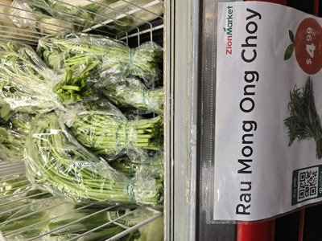 | WATER SPINACH | 공심채 | LEAF | ☐ | Hollow stem / leaves dark |  | NEW
47 | 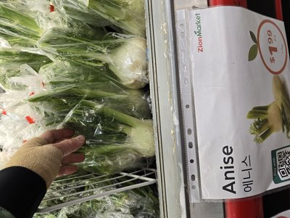 | ANISE (FENNEL) | 에니스 | ROOT | ☐ | White bulb / fronds green |  | NEW
48 | 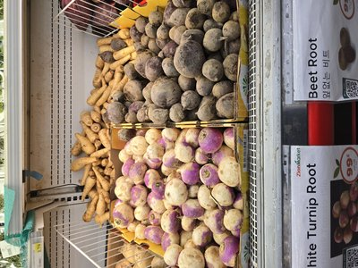 | BEET ROOT | 비트 | ROOT | ☐ | Firm / deep red / no soft |  | NEW
49 | 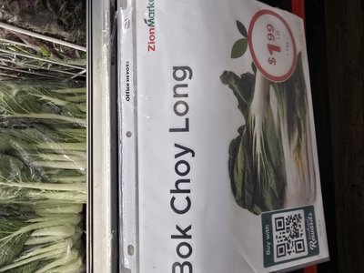 | BOK CHOY LONG | 복초이롱 | LEAF | ☐ | Long stem / leaves crisp |  | NEW
50 | 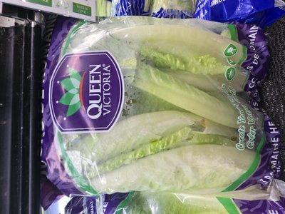 | ROMAINE HEARTS | 로메인하트 | LEAF | ☐ | Compact / crisp / no browning |  | NEW


CHAPTER 5
DAILY CHECK — PREP & READY-TO-EAT
Group D: Same-day production/sale. Shortest shelf life — apply 30~50% markdowns proactively.
# | 📷 | ITEM | 한국어 | DETAIL | STATUS CHECK
1 | [ 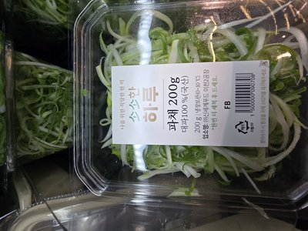 | Shredded Green Onion | 손질 파채 | Plastic container (200g) — same-day date | ☐ Date
2 | [ 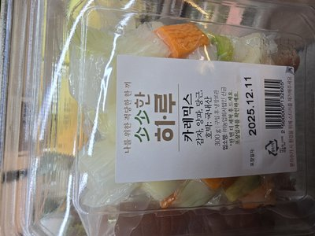 | Curry Veggie Mix | [혼합] 카레믹스 | [MIX] Potato+onion+carrot+squash (300g) | ☐ Browning
3 | [ 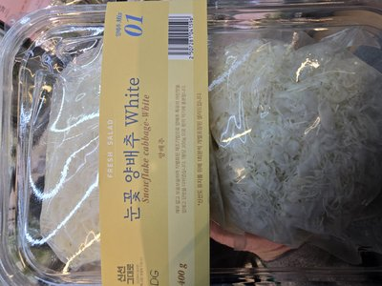 | Snowflake Cabbage | 눈꽃 양배추 | White/Purple 400g pack | ☐ Cut fresh
4 | [ 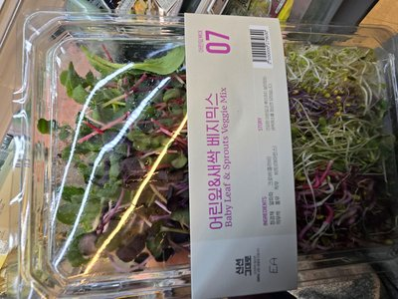 | Veggie Mix 07 | 베지믹스 07 | Baby leaf & sprout mixed pack | ☐ Bruising
5 | [ 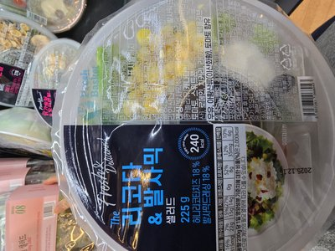 | Complete Salad | 완성형 샐러드 | Chicken/Ricotta/Squash w/ dressing | ☐ Sauce
6 | [ 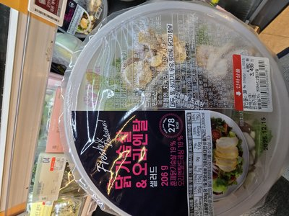 | Chicken Salad | 치킨 샐러드 | Sealed pack — moisture & color | ☐ Seal
7 | [ 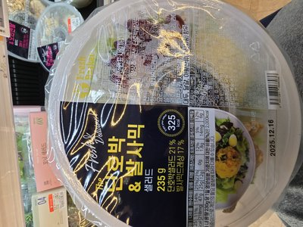 | Ricotta Salad | 리코타 샐러드 | Cheese discoloration & dressing check | ☐ Cheese
8 | [ 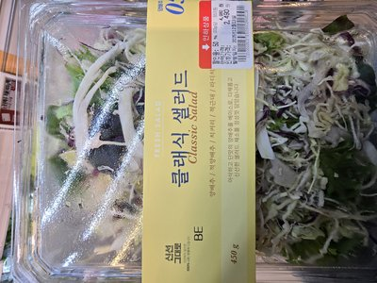 | Clearance Classic | [할인] 클래식 | 50% off items — focused display zone | ☐ Labels
9 | [ 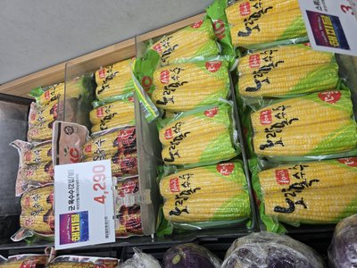 | Roasted Corn (2pc) | 군옥수수 | Vacuum pack (2pc) — seal integrity | ☐ Vacuum
10 | 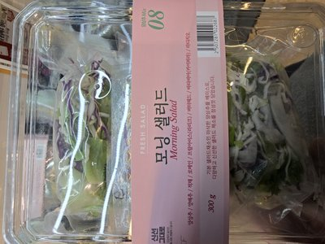 | MORNING SALAD | 모닝샐러드 | SALAD | ☐ | Fresh mix / no wilt / sealed |  | NEW
11 | 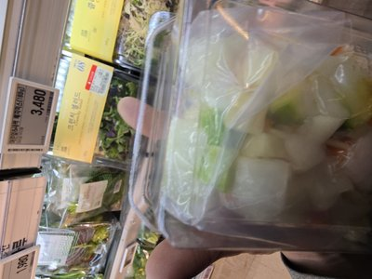 | CRUNCHY SALAD | 크런치샐러드 | SALAD | ☐ | Diced fresh / sealed / crisp |  | NEW
12 | 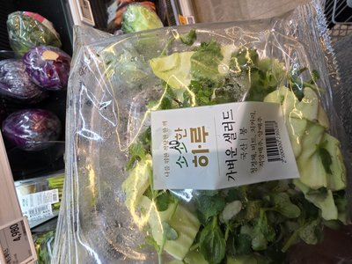 | SSAM VEGETABLE MIX | 쌈용채소 | MIX | ☐ | Assorted leaves / no wilt |  | NEW
13 | 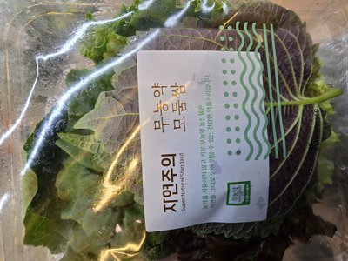 | ASSORTED SSAM LEAVES | 모듬쌈 | MIX | ☐ | Mixed leaves / fresh / vibrant |  | NEW


CHAPTER 6
SHIFT OPERATIONS & CATEGORY CARE
Maintain freshness by category. Each produce type needs different handling throughout the shift.
🌿 LEAFY VEGETABLES (Lettuce, Cabbage, Greens)
☐ | Mist to maintain moisture
☐ | Remove wilted or brown leaves
☐ | Keep refrigerated items cold
☐ | Face products attractively
🥔 ROOT VEGETABLES (Daikon, Carrots, Potatoes)
☐ | Check for soft spots or sprouting
☐ | Keep dry (not too much moisture)
☐ | Remove damaged items
☐ | Maintain organized display
🍑 FRUITS (Asian Pears, Persimmons, etc.)
☐ | Check for bruising or soft spots
☐ | Remove overripe items
☐ | Handle gently to avoid damage
☐ | Keep display neat and attractive
🌿 FRESH HERBS
☐ | Check for wilting or discoloration
☐ | Keep properly misted
☐ | Remove spoiled bunches immediately
☐ | Maintain in cooler if available
🧹 GENERAL MAINTENANCE
☐ | Keep floor clean and dry (slip hazard!)
☐ | Wipe up water spills immediately
☐ | Clean display tables/shelves regularly
☐ | Check price signs visible and correct
☐ | Look for pests — report immediately
☐ | Dispose of culled produce properly
☐ | Assist customers with selections


CHAPTER 7
TEMPERATURE & WASTE LOG
Food safety is non-negotiable. Temperature every 2 hours. Track waste to optimize ordering.
TIME | COOLER TEMP (°F) | DISPLAY TEMP (°F) | INITIALS
Opening
10:00 AM
12:00 PM
2:00 PM
4:00 PM
Closing
🗑️ WASTE LOG — Items removed due to spoilage (helps optimize ordering)
TIME | ITEM REMOVED | QTY | REASON | INITIALS


CHAPTER 8
SHIFT CLOSING & WEEKLY KPI
End strong. A clean close means a smooth open tomorrow. Complete all logs.
☐ | Final quality check of all produce
☐ | Remove any items past prime
☐ | Store temperature-sensitive items in cooler
☐ | Wipe down all display areas
☐ | Sweep and mop floor thoroughly
☐ | Check cooler is organized (FIFO)
☐ | Complete Temperature Log (Chapter 7)
☐ | Complete Waste Log (Chapter 7)
☐ | Take out produce waste/compost
☐ | Note low-stock items for ordering
☐ | Report any equipment issues
☐ | Complete Daily Summary in Chapters 3-5
📊 WEEKLY KPI TRACKER
KPI METRIC | MON | TUE | WED | THU | FRI | SAT | SUN | AVG | TARGET
FRESHNESS CONTROL
Freshness Check Passed (%) |  |  |  |  |  |  |  |  | ≥ 95%
Spoilage Waste ($ value) |  |  |  |  |  |  |  |  | ≤ $50
Items Past Prime Removed by 11AM |  |  |  |  |  |  |  |  | 100%
DISPLAY CONTROL
Display Full @ 11AM (%) |  |  |  |  |  |  |  |  | ≥ 95%
Price Signs Correct (%) |  |  |  |  |  |  |  |  | 100%
Misting Completed on Schedule |  |  |  |  |  |  |  |  | ✓
TEMPERATURE & SAFETY
Cooler Temp OK All Day ✓ |  |  |  |  |  |  |  |  | ✓
Floor Clean & Dry ✓ |  |  |  |  |  |  |  |  | ✓
No Pest Sightings ✓ |  |  |  |  |  |  |  |  | ✓
OVERALL
Daily Score (0-100) |  |  |  |  |  |  |  |  | ≥ 90
PASS / FAIL |  |  |  |  |  |  |  |  | PASS
Employee Signature: ____________________ Manager Review: ____________________ Date: ______________

