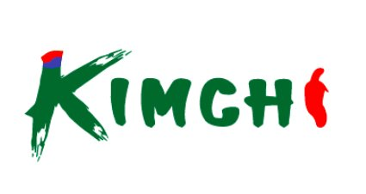
SEAFOOD DEPARTMENT
COMPREHENSIVE OPERATIONS MANUAL & DAILY CHECKLIST
From Opening to Closing — A Complete Daily Workflow Guide
Date: ____________ Branch: ____________ Shift: ☐ AM ☐ PM Staff: ____________ Manager: ____________
CHAPTER 1
SHIFT OPENING
Temperature first, freshness second, ice third. Seafood safety starts the moment you walk in.
☐ | Check seafood case temperature (32-40°F) — Record: ___°F
☐ | Check freezer temperature (0°F or below) — Record: ___°F
☐ | Inspect all seafood for quality and freshness
☐ | Remove any items past expiration
☐ | Check that all items are properly iced
☐ | Verify proper labeling (name, date, price)
☐ | Clean and sanitize work surfaces
☐ | Check display case for cleanliness
☐ | Organize frozen seafood section
☐ | Put on clean apron and gloves


CHAPTER 2
QUALITY STANDARDS & REJECT CRITERIA
Your nose and eyes are your best tools. Know exactly what fresh looks like — and what to reject.
✅ FRESH FISH ACCEPTANCE CRITERIA:
☐ | Clear, bright eyes (not cloudy or sunken)
☐ | Firm flesh that springs back when pressed
☐ | Mild ocean smell (not strong or fishy)
☐ | Bright red gills (not brown or gray)
☐ | Shiny, metallic skin with tight scales
❄️ FROZEN SEAFOOD CRITERIA:
☐ | Solidly frozen throughout (no soft spots)
☐ | No ice crystals or freezer burn
☐ | Proper packaging intact, no tears
☐ | No discoloration or dried edges
🛑 REJECT IMMEDIATELY IF:
☐ | Strong fishy or ammonia odor
☐ | Discoloration (brown, yellow, or gray)
☐ | Slimy texture on surface
☐ | Damaged or torn packaging
☐ | Soft spots on frozen items
☐ | Cloudy eyes or brown gills on whole fish
☐ | Temperature above 40°F at receiving


CHAPTER 3
DAILY CHECK — SQUID & OCTOPUS
Chapter 3: 11 items. Frozen & cleaned squid products plus octopus. Check packaging integrity.
SQUID — 오징어
# | 📷 | ITEM | 한국어 | TYPE | PREP✓ | QTY | DISP✓ | PRICE✓ | FRESH✓ | NOTES
1 | 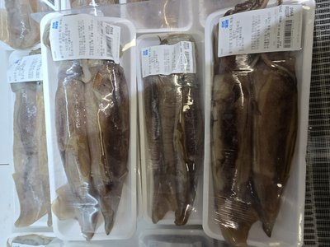 | ⭐ KOREAN SQUID | 한국 오징어 | FROZEN
2 | 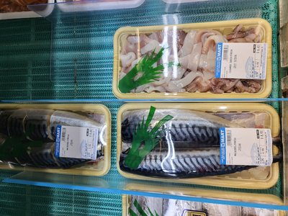 | CLEANED SQUID | 손질한 오징어 | CLEANED
3 | [📷] | SUSHI GRADE SQUID | 스시용 오징어 | SUSHI
4 | [📷] | TUBE SQUID | 손질된 몸통 오징어 | CLEANED
5 | [📷] | ⭐ BIG CUTTLEFISH | 갑오징어 큰거 | FROZEN
6 | 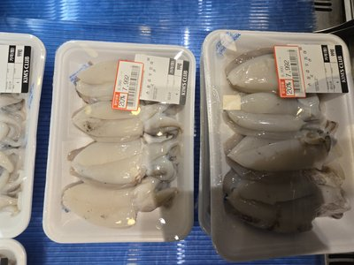 | SMALL CUTTLEFISH | 갑오징어 작은것 | FROZEN
7 | [📷] | RING SQUID PACKAGE | 오징어 링 패키지 | PKG
8 | [📷] | CHOPPED SQUID PACKAGE | 솔방울 오징어 패키지 | PKG
9 | [📷] | SLICED SQUID PACKAGE | 볶음용 오징어 패키지 | PKG
OCTOPUS — 문어/낙지
# | 📷 | ITEM | 한국어 | TYPE | PREP✓ | QTY | DISP✓ | PRICE✓ | FRESH✓ | NOTES
10 | 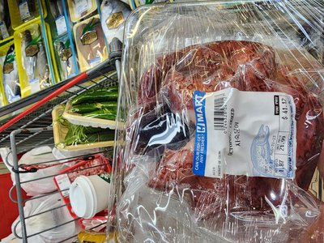 | ⭐ WHOLE OCTOPUS | 통 낙지 | FROZEN
11 | 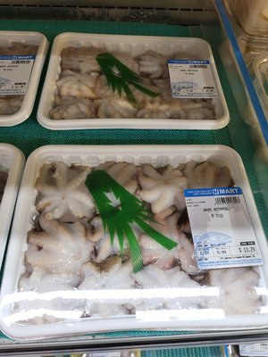 | SMALL OCTOPUS | 쩌꾸미 패키지 | PKG


CHAPTER 4
DAILY CHECK — FISH (WHOLE & FILLET)
Chapter 4: 21 items. Whole fish and fillets. Fresh items need ice coverage. Check eyes, gills, flesh firmness.
WHOLE FISH — 통 생선
# | 📷 | ITEM | 한국어 | TYPE | PREP✓ | QTY | DISP✓ | PRICE✓ | FRESH✓ | NOTES
12 | 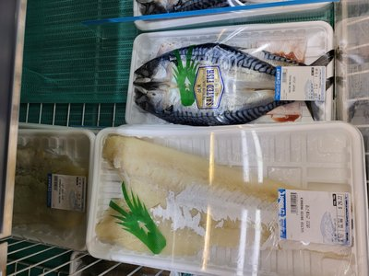 | ⭐ MACKEREL | 고등어 | FROZEN
13 | 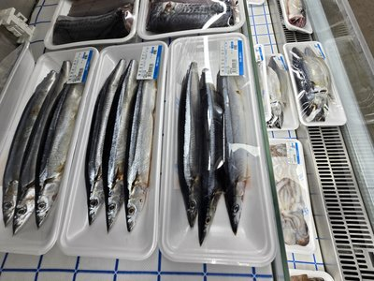 | MACKEREL (SAURY) | 꽁치 | FROZEN
14 | 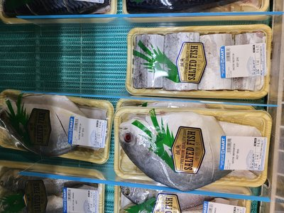 | ⭐ BELT FISH | 갈치 | FROZEN
15 | [📷] | MILK FISH | 밀크피쉬 | WHOLE
16 | 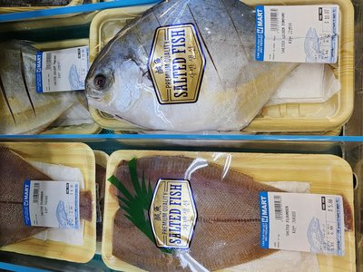 | GOLDEN POMPANO | 골든 폼파노/병어 | WHOLE
17 | 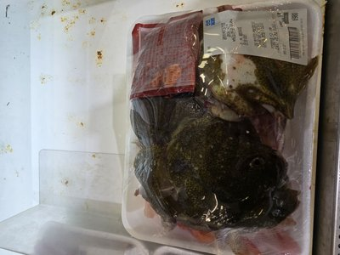 | ⭐ FRESH FLOUNDER | 생 광어 | FRESH
18 | 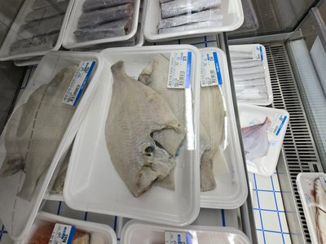 | FROZEN FLOUNDER | 가자미 | FROZEN
19 | 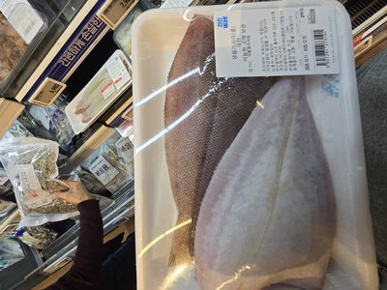 | CLEANED FLOUNDER | 손질한 가자미 | CLEANED
20 | 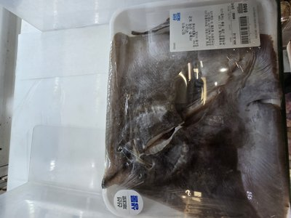 | SKATE WING FISH | 홍어 | FROZEN
21 | 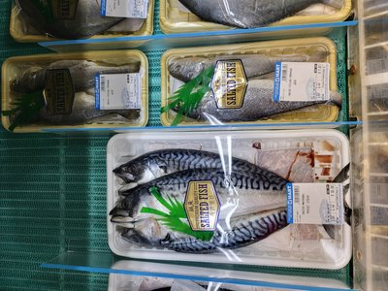 | ⭐ YELLOW CROAKER | 조기 | FROZEN
22 | 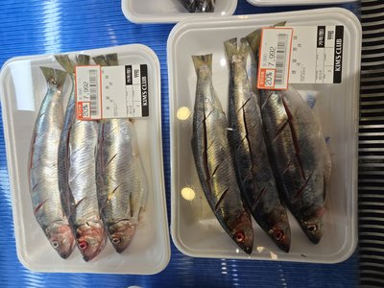 | ROUND SCAD | 전갱이 | FROZEN
FILLET & CUT — 필렛/절단
# | 📷 | ITEM | 한국어 | TYPE | PREP✓ | QTY | DISP✓ | PRICE✓ | FRESH✓ | NOTES
23 | 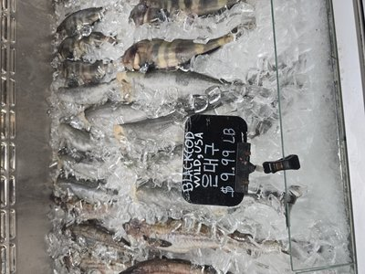 | ⭐ BLACK COD | 은대구 | CUT
24 | 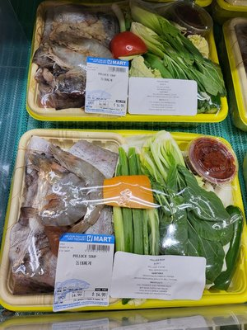 | TUNA SUSHI CUT | 튀나 스시용 | SUSHI
25 | 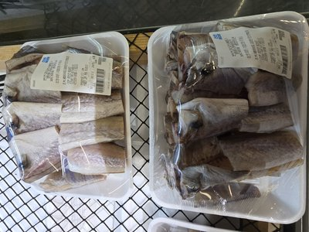 | POLLACK | 동태 | FROZEN
26 | 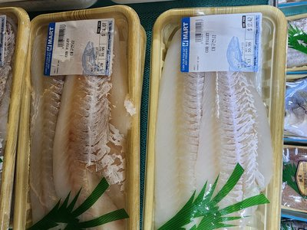 | COD | 대구 | FROZEN
27 | 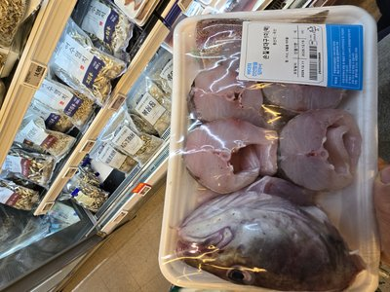 | CATFISH | 메기 | FROZEN
28 | 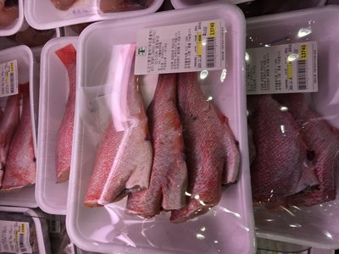 | RED SNAPPER | 붉은 방어 | FROZEN
29 | [📷] | CROAKER FILLET | 참조기 살 | FILLET
30 | [📷] | TILAPIA | 틸라피아 | WHOLE
31 | 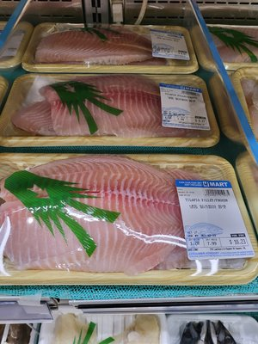 | TILAPIA FILLET | 손질 틸라피아 | FILLET
32 | [📷] | POLLACK FILLET | 동태 전감 | FILLET


CHAPTER 5
DAILY CHECK — SHELLFISH, SHRIMP & SUSHI GRADE
Chapter 5: 27 items. High-value items. Sushi grade requires strict temperature control. Live lobster check vitality.
ROE & SPECIALTY — 알/특수
# | 📷 | ITEM | 한국어 | TYPE | PREP✓ | QTY | DISP✓ | PRICE✓ | FRESH✓ | NOTES
33 | 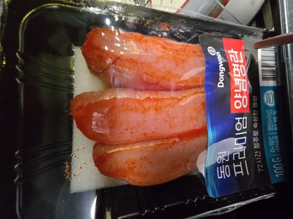 | ⭐ POLLACK ROE | 동태 알 | FROZEN
34 | 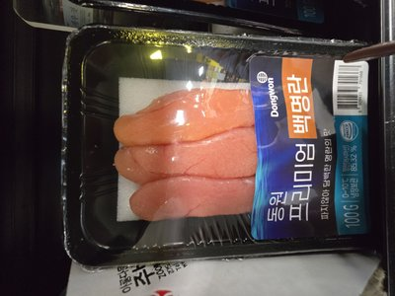 | COD MILT | 대구 곤이 | FROZEN
35 | 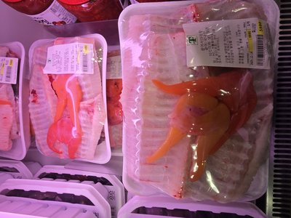 | SEA SQUIRT | 냉동 미더덕 | FROZEN
CRAB — 게류
# | 📷 | ITEM | 한국어 | TYPE | PREP✓ | QTY | DISP✓ | PRICE✓ | FRESH✓ | NOTES
36 | [📷] | ⭐ FROZEN CRAB PACKAGE | 절단 꽃게 패키지 | PKG
37 | 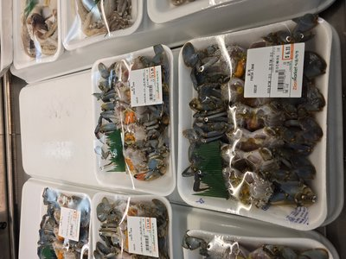 | BLUE CRAB CLEANED | 손질 블루크랩 | CLEANED
38 | [📷] | ⭐ FRESH LOBSTER | 생 랍브스터 | LIVE
39 | 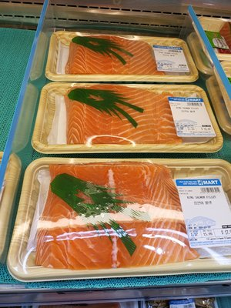 | OSAKI CRAB STICK | 오자키 크랩맛살 | PKG
SHELLFISH & CLAM — 조개/홍합
# | 📷 | ITEM | 한국어 | TYPE | PREP✓ | QTY | DISP✓ | PRICE✓ | FRESH✓ | NOTES
40 | 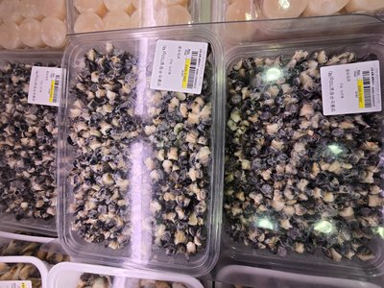 | MUSSEL MEAT | 홍합 살 | FROZEN
41 | 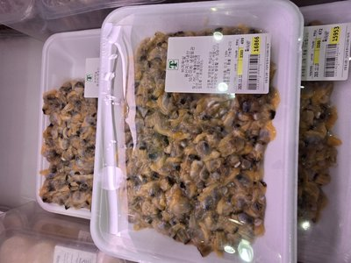 | ⭐ CLAM MEAT | 조개 살 | FROZEN
42 | 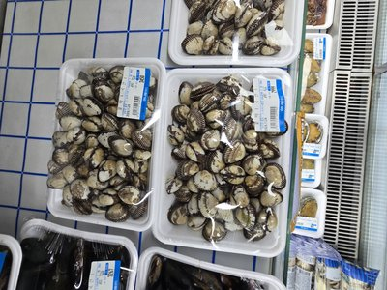 | FRESH CLAM MEDIUM | 생 껍질 조개 | FRESH
43 | 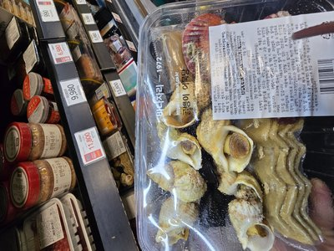 | CONCH MEAT | 소라 살 | FROZEN
44 | 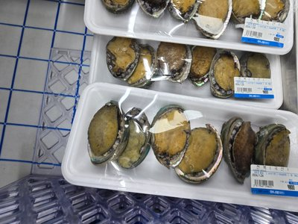 | ⭐ ABALONE | 전복 | FROZEN
45 | [📷] | SCALLOP - SMALL | 관자 SMALL | FROZEN
46 | 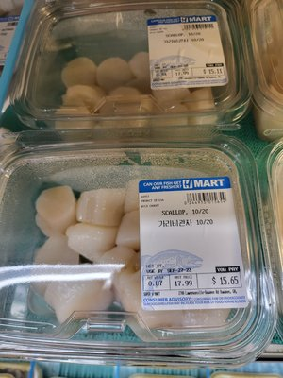 | SCALLOP - U10 | 관자 MEDIUM | FROZEN
SHRIMP — 새우류
# | 📷 | ITEM | 한국어 | TYPE | PREP✓ | QTY | DISP✓ | PRICE✓ | FRESH✓ | NOTES
47 | [📷] | ⭐ COOKED SHRIMP 26-30 | 깐 분홍새우 | PKG
48 | 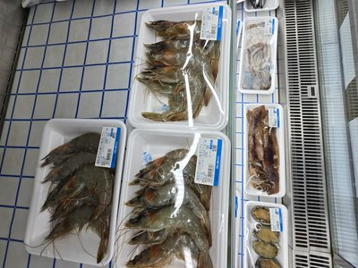 | WHITE SHRIMP 26-30 | 생 새우 패키지 | PKG
SEAFOOD MIX — 해물 모듬
# | 📷 | ITEM | 한국어 | TYPE | PREP✓ | QTY | DISP✓ | PRICE✓ | FRESH✓ | NOTES
49 | 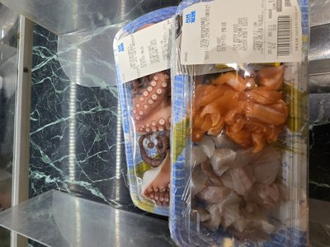 | ⭐ SEAFOOD MIX PACKAGE | 해물 모듬 패키지 | PKG
50 | 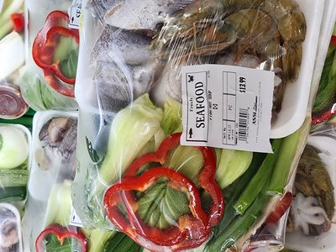 | SEAFOOD SOUP SET | 꽃게-조개-해물 모듬 | PKG
SUSHI ITEMS — 스시 재료
# | 📷 | ITEM | 한국어 | TYPE | PREP✓ | QTY | DISP✓ | PRICE✓ | FRESH✓ | NOTES
51 | [📷] | ⭐ SURF CLAM / HOKKIGAI | 호키가이 | SUSHI
52 | 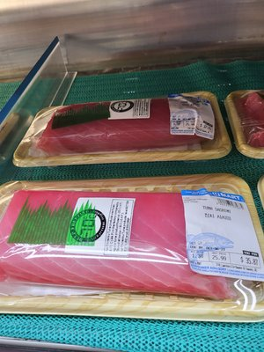 | SUSHI OCTOPUS LEG (2PC) | 스시용 문어다리 | SUSHI
53 | 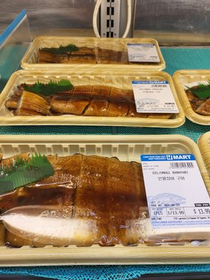 | ⭐ SUSHI EEL | 스시용 양념장어 | SUSHI
54 | 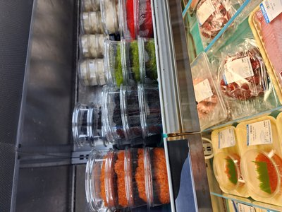 | MASAGO (ALL COLORS) | 마사고 전종류 | SUSHI
55 | 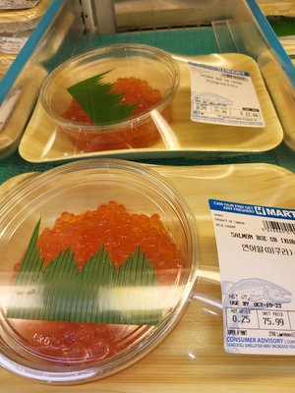 | ⭐ IKURA | 이쿠라 알 | SUSHI
56 | [📷] | IKA SANSAI | 이카 산사이 | SUSHI
57 | [📷] | SEAWEED SALAD | 시위드 샐러드 | SIDE
58 | 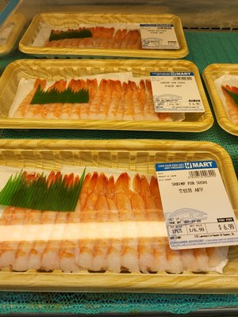 | COOKED SHRIMP FOR SUSHI | 스시 분홍새우 | SUSHI
59 | [📷] | WHITE SHRIMP FOR SUSHI | 스시 하얀새우 | SUSHI
60 | 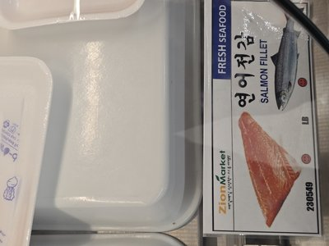 | SALMON FILLET | 연어 필렛 | Fresh | NEW |  |  |  |  | NEW ITEM
61 | 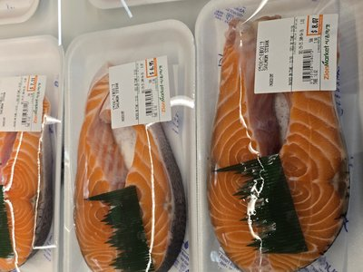 | SALMON STEAK | 연어 스테이크 | Fresh | NEW |  |  |  |  | NEW ITEM
62 | 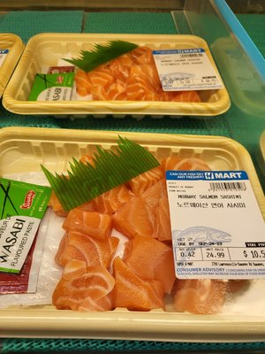 | SALMON SASHIMI CUT | 연어 사시미 | Fresh | NEW |  |  |  |  | NEW ITEM
63 | 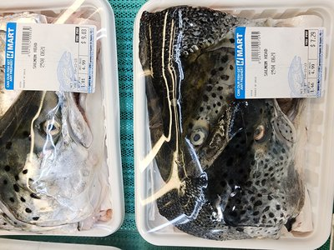 | SALMON HEAD | 연어 머리 | Fresh | NEW |  |  |  |  | NEW ITEM
64 | 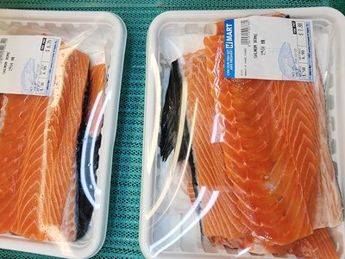 | SALMON BONE (SOUP) | 연어 뼈 | Fresh | NEW |  |  |  |  | NEW ITEM
65 | 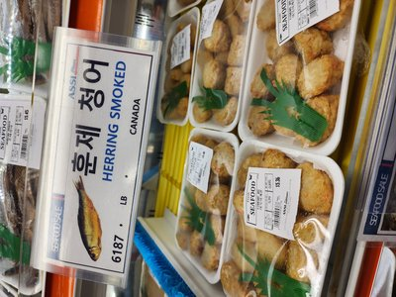 | SMOKED HERRING | 훈제 청어 | Processed | NEW |  |  |  |  | NEW ITEM
66 | 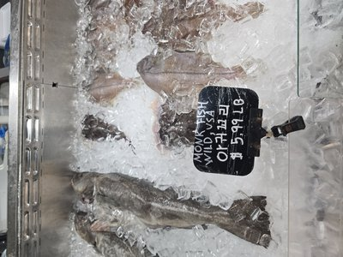 | MONKFISH | 아귀 | Fresh | NEW |  |  |  |  | NEW ITEM
67 | 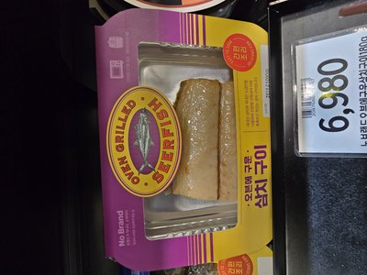 | SPANISH MACKEREL GRILLED | 삼치 구이 | Cooked | NEW |  |  |  |  | NEW ITEM
68 | 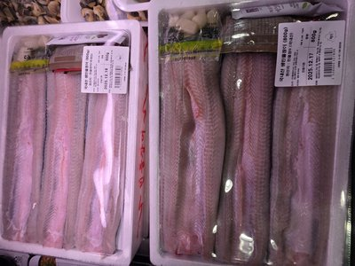 | FRESH EEL FILLET | 장어 필레 | Fresh | NEW |  |  |  |  | NEW ITEM
69 | 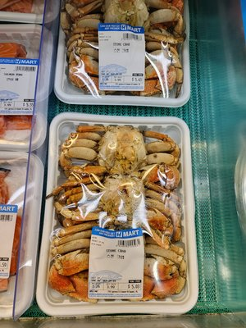 | STONE CRAB | 스톤 크랩 | Fresh | NEW |  |  |  |  | NEW ITEM
70 | 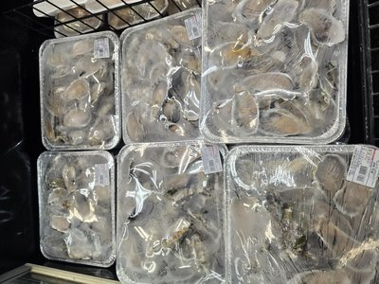 | FRESH OYSTER (SHUCKED) | 생굴 | Fresh | NEW |  |  |  |  | NEW ITEM
71 | 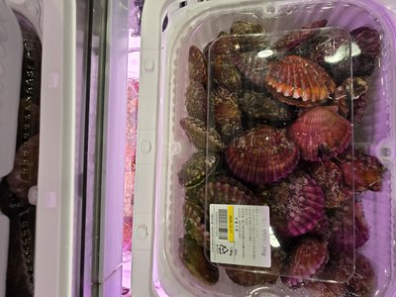 | FRESH SCALLOP SHELL-ON | 가리비 | Fresh | NEW |  |  |  |  | NEW ITEM
72 | 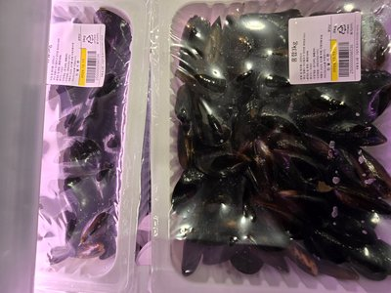 | FRESH MUSSEL WHOLE | 홍합 | Fresh | NEW |  |  |  |  | NEW ITEM
73 | 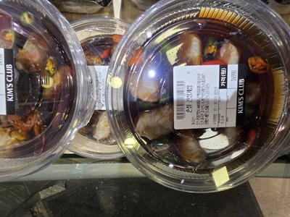 | SASHIMI COMBO PLATTER | 모듬회 | Prepared | NEW |  |  |  |  | NEW ITEM
74 | 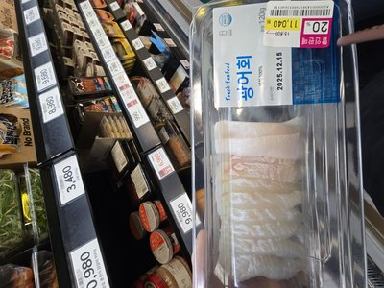 | FLATFISH SASHIMI | 광어회 | Prepared | NEW |  |  |  |  | NEW ITEM
75 | 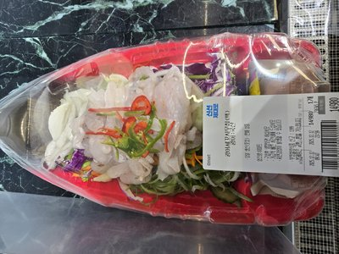 | RAW FISH SALAD | 회무침 | Prepared | NEW |  |  |  |  | NEW ITEM
76 | 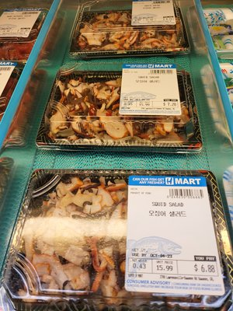 | SQUID SALAD | 오징어 샐러드 | Prepared | NEW |  |  |  |  | NEW ITEM
77 | 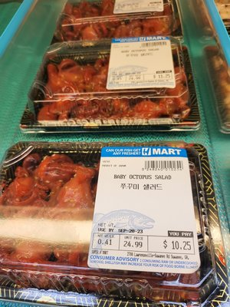 | BABY OCTOPUS SALAD | 쭈꾸미 샐러드 | Prepared | NEW |  |  |  |  | NEW ITEM
78 | 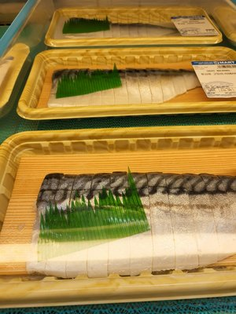 | SUSHI MACKEREL (SHIMESABA) | 시메사바 | Prepared | NEW |  |  |  |  | NEW ITEM
79 | 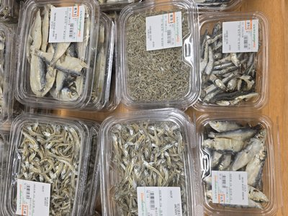 | DRIED ANCHOVIES | 멸치 | Dried | NEW |  |  |  |  | NEW ITEM
80 | 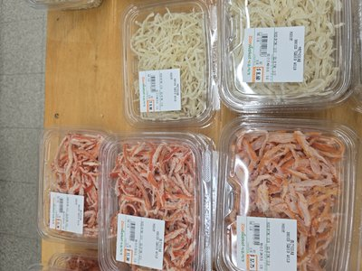 | DRIED SHRIMP | 건새우 | Dried | NEW |  |  |  |  | NEW ITEM
81 | 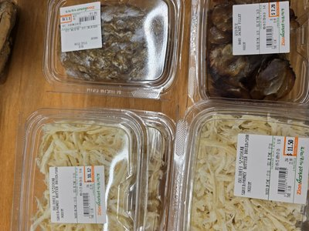 | DRIED SQUID SHRED | 오징어채 | Dried | NEW |  |  |  |  | NEW ITEM
82 | 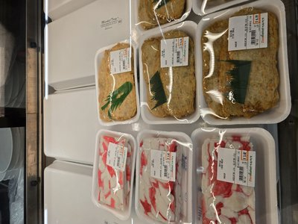 | FISH CAKE (EOMUK) | 어묵 | Processed | NEW |  |  |  |  | NEW ITEM
83 | 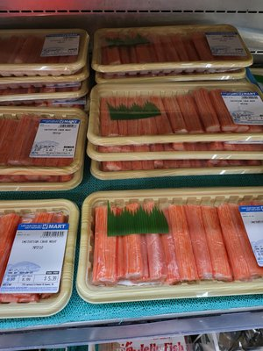 | IMITATION CRAB MEAT | 게맛살 | Processed | NEW |  |  |  |  | NEW ITEM


CHAPTER 6
SHIFT OPERATIONS & HYGIENE
Seafood demands the highest hygiene standards. Gloves every 30 min. Ice coverage continuous. Zero compromise.
⚙️ DURING SHIFT
☐ | Rotate stock regularly (FIFO)
☐ | Check seafood quality every hour
☐ | Maintain proper ice coverage on display
☐ | Replenish ice as needed
☐ | Remove items showing signs of spoilage
☐ | Keep display attractive and organized
☐ | Monitor temperatures continuously
☐ | Change gloves frequently
☐ | Sanitize work surfaces after each use
☐ | Check frozen items remain solidly frozen
☐ | Assist customers with selections
☐ | Face and organize products regularly
🧼 SAFETY & HYGIENE (CRITICAL!)
☐ | Wash hands before handling seafood
☐ | Wear gloves at ALL times when handling seafood
☐ | Change gloves every 30 minutes minimum
☐ | Never handle ready-to-eat after touching raw seafood
☐ | Use separate cutting boards and tools for seafood
☐ | Sanitize all surfaces and tools after use
☐ | Keep seafood at proper temperature at all times
☐ | Never leave seafood at room temperature
☐ | Report any suspicious odors or appearance immediately


CHAPTER 7
TEMPERATURE LOG
Seafood is the most temperature-sensitive department. Fresh case AND freezer — both logged, no exceptions.
TIME | FRESH CASE (°F) | FREEZER (°F) | ICE LEVEL OK? | INITIALS
Opening
10:00 AM
12:00 PM
2:00 PM
4:00 PM
Closing


CHAPTER 8
SHIFT CLOSING & WEEKLY KPI
End strong. Proper ice disposal, thorough sanitization. Complete all logs before you leave.
☐ | Record final temperatures in Temperature Log (Ch 7)
☐ | Cover or wrap all displayed seafood
☐ | Store all fresh seafood properly iced in cooler
☐ | Verify all frozen items secure in freezer
☐ | Clean and sanitize ALL cutting boards and tools
☐ | Clean and sanitize all work surfaces
☐ | Clean display case thoroughly
☐ | Dispose of ALL ice properly
☐ | Sweep and mop floor area
☐ | Take out trash and sanitize cans
☐ | Complete Daily Summary in Chapters 3-5
☐ | Report any quality concerns to manager
📊 WEEKLY KPI TRACKER
KPI METRIC | MON | TUE | WED | THU | FRI | SAT | SUN | AVG | TARGET
FRESHNESS & ICE CONTROL
Freshness Check Passed (%) |  |  |  |  |  |  |  |  | ≥ 98%
Ice Coverage Maintained All Day |  |  |  |  |  |  |  |  | ✓
Items Rejected/Removed |  |  |  |  |  |  |  |  | ≤ 3
Sushi Grade Temp Compliance |  |  |  |  |  |  |  |  | 100%
DISPLAY CONTROL
Display Full @ 11AM (%) |  |  |  |  |  |  |  |  | ≥ 95%
Price Labels Correct (%) |  |  |  |  |  |  |  |  | 100%
Live Tank Status OK |  |  |  |  |  |  |  |  | ✓
TEMPERATURE & SAFETY
Fresh Case Temp OK All Day |  |  |  |  |  |  |  |  | ✓
Freezer Temp OK All Day |  |  |  |  |  |  |  |  | ✓
Glove Change Compliance |  |  |  |  |  |  |  |  | ✓
Sanitization Complete |  |  |  |  |  |  |  |  | ✓
OVERALL
Daily Score (0-100) |  |  |  |  |  |  |  |  | ≥ 90
PASS / FAIL |  |  |  |  |  |  |  |  | PASS
Employee Signature: ____________________ Manager Review: ____________________ Date: ______________

