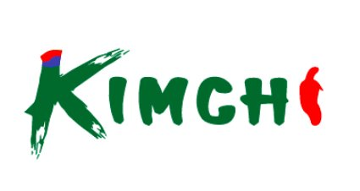
UMAGA — K-FOOD KITCHEN
COMPREHENSIVE OPERATIONS MANUAL v2
From Opening to Closing — Korean Food Production Complete Daily Workflow
Date: ____________ Branch: ____________ Shift: ☐ AM ☐ PM Head Chef: ____________ Manager: ____________
CHAPTER 1
OPENING & RECIPE COMPLIANCE
9:30 AM — Attendance first, recipe book second. No estimation, no modification, no exception.
☐ | Head Chef: _______ — Arrival: ___:___
☐ | Line Cook 1: _______ — Arrival: ___:___
☐ | Line Cook 2: _______ — Arrival: ___:___
☐ | Prep Cook: _______ — Arrival: ___:___
☐ | Banchan Prep: _______ — Arrival: ___:___
☐ | ⚠️ If absent: Contact manager immediately + call backup staff
☐ | Verify recipe book for today’s menu
☐ | Confirm measuring cups, spoons, and timers are ready
☐ | ❌ NO ‘eyeballing’ or guessing — USE TOOLS ONLY
☐ | Review Kimchi Mart production targets for today


CHAPTER 2
BULK REPACKAGING MANAGEMENT
⚠️ CRITICAL — Repackaging quality = Brand reputation. Every container represents Kimchi Mart to the customer.
⚠️⚠️ REPACKAGING IS NOT JUST FILLING CONTAINERS — IT IS BRAND MANAGEMENT ⚠️⚠️

🥢 KIMCHI REPACKAGING — Targets & Standards
☐ | Napa Kimchi 500g: ___packs (Target: 30) — weigh EVERY pack
☐ | Napa Kimchi 1kg: ___packs (Target: 20) — weigh EVERY pack
☐ | Radish Kimchi (Kkakdugi) 500g: ___packs (Target: 15)
☐ | Weight accuracy: ±10g tolerance ONLY
☐ | Label: Product name + Pack date + Weight + Price
☐ | Container must be clean, no sauce on outside
☐ | Seal must be airtight — check EVERY lid
☐ | Store refrigerated immediately after packing
🍱 BANCHAN BULK REPACKAGING — Standards
☐ | Egg Roll: ___containers (Target: 20) — uniform pieces
☐ | Fish Cake: ___containers (Target: 15) — sauce level consistent
☐ | Acorn Jelly: ___containers (Target: 10) — clean presentation
☐ | Kimchi Stew: ___containers (Target: 10) — temp check before seal
☐ | Doenjang Stew: ___containers (Target: 10) — temp check before seal
☐ | ALL containers: Clean edges, no drips, no smudges
☐ | ALL labels: Product + Date + Weight + Price + Allergens
☐ | Cross-contamination: Change gloves between EACH product
🚚 DELIVERY TO KIMCHI MART DISPLAY
☐ | 11:30 AM — 1st delivery: Verify ALL packs on shelf + price labels
☐ | 3:00 PM — 2nd delivery: Restock if needed + rotate (FIFO)
☐ | Check display temperature is correct
☐ | Remove any damaged or leaking packages immediately
☐ | Photo of display after each delivery (for record)


CHAPTER 3
DAILY CHECK — BANCHAN & PICKLES
32 items. The foundation of K-food. Seasoning balance and freshness are everything.
ANCHOVY — 멸치
# | 📷 | ITEM | 한국어 | TYPE | Y/N | QTY | TIME | STATUS CHECK
1 | 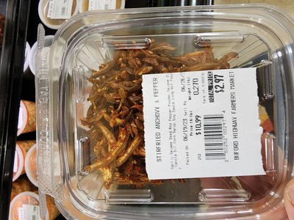 | ANCHOVY SMALL (JIRI) | 멸치볶음 (지리) | DRY |  |  |  | ☐ Clumping / evenly spread
2 |  | ANCHOVY MEDIUM (BOKKUM) | 멸치볶음 (중멸치) | DRY |  |  |  | ☐ Seasoning coated evenly
3 | [📷] | ANCHOVY MEDIUM (DASHI) | 멸치볶음 (다시) | DRY |  |  |  | ☐ Crispness maintained

SEAFOOD BANCHAN — 해물반찬
# | 📷 | ITEM | 한국어 | TYPE | Y/N | QTY | TIME | STATUS CHECK
4 | 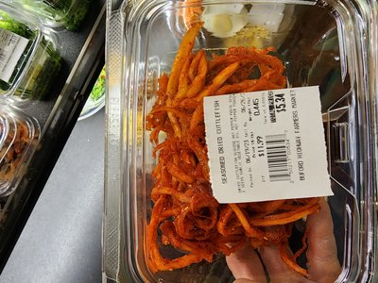 | SEASONED SHREDDED DRIED SQUID | 양념 오징어채 | WET |  |  |  | ☐ Sauce evenly distributed
5 | [📷] | SEASONED SHREDDED POLLACK | 양념 북어채 | WET |  |  |  | ☐ No discoloration / sauce moist
6 |  | SEASONED POLLACK TRIPE | 양념 북어 내장 | WET |  |  |  | ☐ Off-odor check / freshness
7 | [📷] | SEASONED CRAB (BANGGAE) | 양념 게장 (방게) | WET |  |  |  | ☐ Soy sauce level / meat intact
8 | 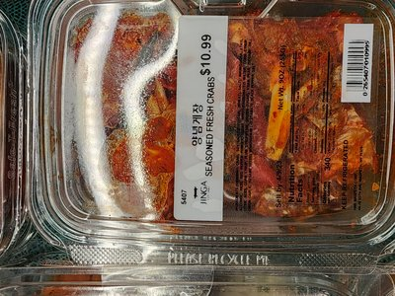 | SEASONED RAW CRAB (GYEJANG) | 간장게장 | RAW |  |  |  | ☐ Refrigeration required / clarity
9 | [📷] | SEASONED OCTOPUS | 양념 문어 | WET |  |  |  | ☐ Chewy texture / no discoloration
10 | 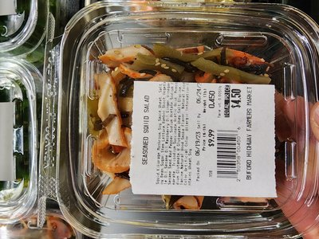 | SEASONED SQUID | 양념 오징어 | WET |  |  |  | ☐ Chili color uniform
11 | 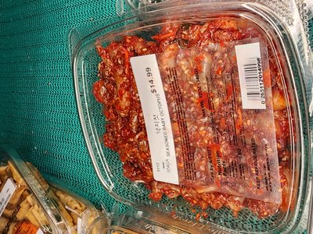 | SEASONED BABY OCTOPUS | 양념 쩌꾸미 | WET |  |  |  | ☐ Uniform size / penetration

VEGETABLE BANCHAN — 야채반찬
# | 📷 | ITEM | 한국어 | TYPE | Y/N | QTY | TIME | STATUS CHECK
12 | 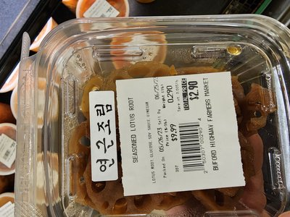 | SEASONED LOTUS ROOT | 양념 연근 | WET |  |  |  | ☐ No browning / glaze even
13 | 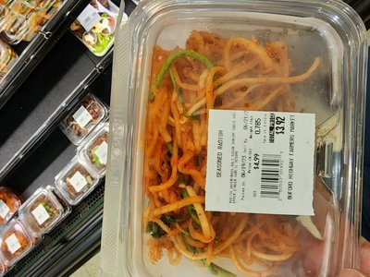 | SEASONED DRIED RADISH | 양념 무말랭이 | DRY |  |  |  | ☐ Chewy / sweet-spicy balance
14 | 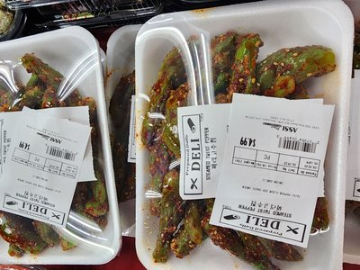 | SEASONED GREEN PEPPER | 양념 고추 | WET |  |  |  | ☐ Pepper fresh / no wilting
15 | [📷] | SEASONED BEAN SPROUT | 숙주나물 무침 | WET |  |  |  | ☐ Water drained / crunch
16 | 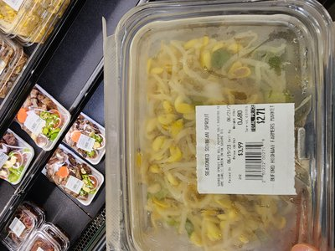 | SEASONED SOY SPROUT | 콩나물 무침 | WET |  |  |  | ☐ Bean heads intact / drained
17 | 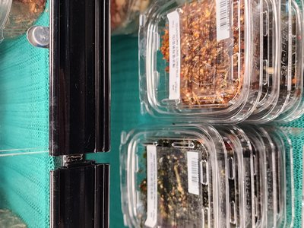 | SEASONED BURDOCK | 양념 우엉 | WET |  |  |  | ☐ Soy glaze / firm texture
18 | 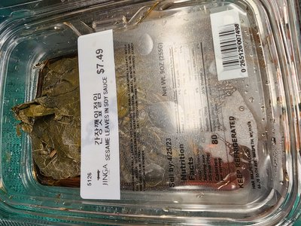 | SEASONED SESAME LEAF | 양념 깻잎 | WET |  |  |  | ☐ Leaves not torn / sauce proper
19 |  | SEASONED K-CHILI PEPPER LEAF | 양념 고추잎 | WET |  |  |  | ☐ No discoloration / even

TOFU & FISH CAKE — 두부&어묵
# | 📷 | ITEM | 한국어 | TYPE | Y/N | QTY | TIME | STATUS CHECK
20 | 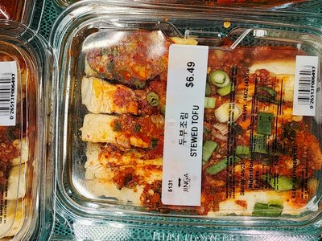 | SEASONED TOFU SPICY | 양념 두부 (매운) | WET |  |  |  | ☐ Tofu not crumbled / coated
21 | [📷] | SEASONED TOFU SOY SAUCE | 양념 두부 (간장) | WET |  |  |  | ☐ Shape maintained / color even
22 | 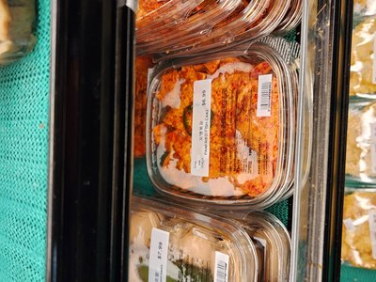 | SEASONED FISH CAKE SPICY | 양념 어묵 (매운) | WET |  |  |  | ☐ Not dried / sauce ratio
23 | 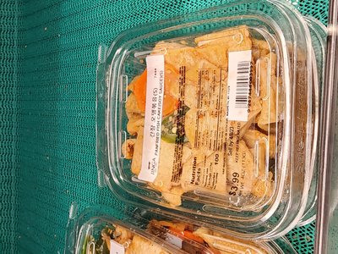 | SEASONED FISH CAKE SOY | 양념 어묵 (간장) | WET |  |  |  | ☐ Stir-fry condition / balanced

SUSHI & PICKLES — 스시&절임
# | 📷 | ITEM | 한국어 | TYPE | Y/N | QTY | TIME | STATUS CHECK
24 |  | IKA SANSAI | 이카 산사이 | SUSHI |  |  |  | ☐ Refrigeration / no off-odor
25 | 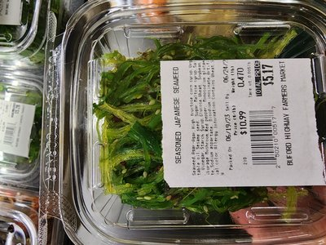 | SEAWEED SALAD | 시위드 샐러드 | SUSHI |  |  |  | ☐ Vibrant color / drained
26 | 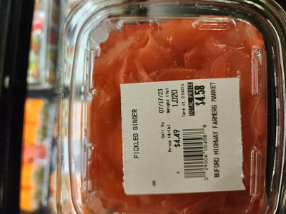 | SUSHI GINGER PINK | 초생강 (핑크) | SUSHI |  |  |  | ☐ Vinegar level / pink hue
27 |  | SUSHI GINGER WHITE | 초생강 (화이트) | SUSHI |  |  |  | ☐ Vinegar level / no discolor
28 | 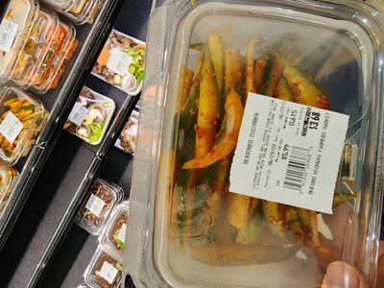 | CUCUMBER KIMCHI | 오이소박이 | PICKLE |  |  |  | ☐ Crunchiness / seasoning fresh
29 |  | SLICED RADISH (SPICY) | 무생채 (매콤) | PICKLE |  |  |  | ☐ Radish crunch / chili color
30 |  | SLICED RADISH (WHITE) | 무생채 (백) | PICKLE |  |  |  | ☐ Transparency / vinegar level
31 |  | PICKLED MYEONGI | 명이나물 장아찌 | PICKLE |  |  |  | ☐ Soy depth / stem texture
32 | [📷] | MIXED PICKLED | 모듬 장아찌 | PICKLE |  |  |  | ☐ Ingredient ratio / sauce level
33 | 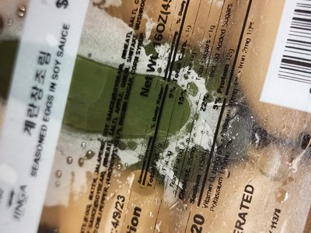 | SEASONED EGGS SOY SAUCE | 계란장조림 | WET | ☐ | Egg intact / soy depth |  | NEW
34 | 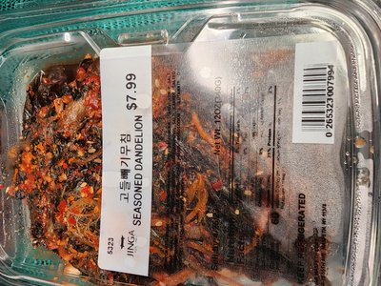 | SEASONED DANDELION | 고들빼기무침 | WET | ☐ | Bitterness balanced / fresh |  | NEW
35 | 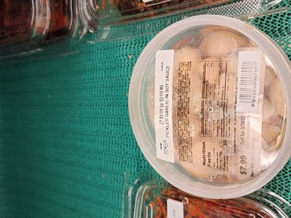 | PICKLED GARLIC SOY | 간장마늘장아찌 | PICKLE | ☐ | Garlic firm / soy level |  | NEW
36 | 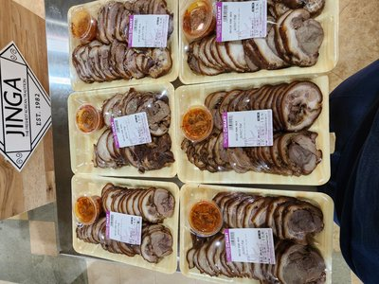 | BOSSAM BOILED PORK | 보쌈 | WET | ☐ | Slice even / temp check |  | NEW
37 | 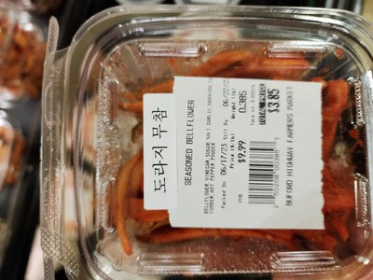 | SEASONED BELLFLOWER | 도라지무침 | WET | ☐ | Crunch retained / no bitter |  | NEW
38 | 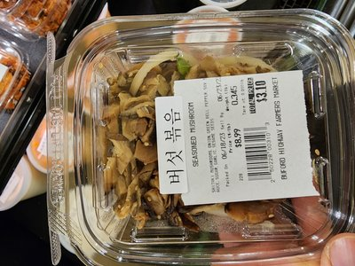 | SEASONED MUSHROOM | 버섯볶음 | WET | ☐ | No water / seasoning even |  | NEW
39 | 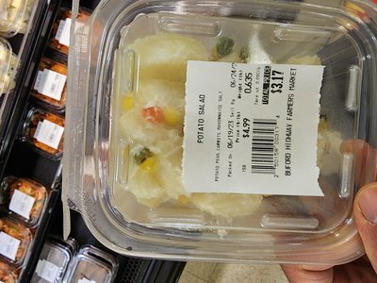 | POTATO SALAD | 감자샐러드 | WET | ☐ | Creamy / no discoloration |  | NEW
40 | 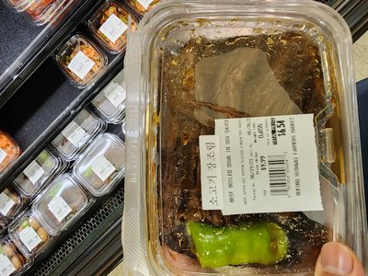 | BEEF BRAISED SOY SAUCE | 소고기장조림 | WET | ☐ | Meat tender / soy balanced |  | NEW
41 | 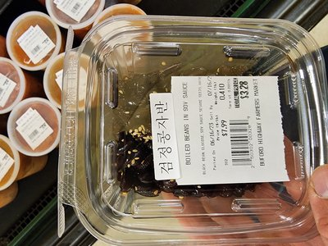 | BOILED BLACK BEANS SOY | 검정콩자반 | WET | ☐ | Beans glossy / not cracked |  | NEW
42 | 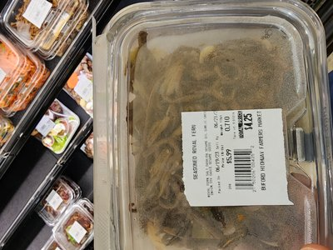 | SEASONED ROYAL FERN | 고사리나물 | WET | ☐ | Tender / sesame oil aroma |  | NEW
33 |  | SEASONED EGGS SOY SAUCE | 계란장조림 | WET | ☐ | Egg intact / soy depth |  | NEW
34 |  | SEASONED DANDELION | 고들빼기무침 | WET | ☐ | Bitterness balanced / fresh |  | NEW
35 |  | PICKLED GARLIC SOY | 간장마늘장아찌 | PICKLE | ☐ | Garlic firm / soy level |  | NEW
36 |  | BOSSAM BOILED PORK | 보쌈 | WET | ☐ | Slice even / temp check |  | NEW
37 |  | SEASONED BELLFLOWER | 도라지무침 | WET | ☐ | Crunch retained / no bitter |  | NEW
38 |  | SEASONED MUSHROOM | 버섯볶음 | WET | ☐ | No water / seasoning even |  | NEW
39 |  | POTATO SALAD | 감자샐러드 | WET | ☐ | Creamy / no discoloration |  | NEW
40 |  | BEEF BRAISED SOY SAUCE | 소고기장조림 | WET | ☐ | Meat tender / soy balanced |  | NEW
41 |  | BOILED BLACK BEANS SOY | 검정콩자반 | WET | ☐ | Beans glossy / not cracked |  | NEW
42 |  | SEASONED ROYAL FERN | 고사리나물 | WET | ☐ | Tender / sesame oil aroma |  | NEW
33 |  | SEASONED EGGS SOY SAUCE | 계란장조림 | WET | ☐ | Egg intact / soy depth |  | NEW
34 |  | SEASONED DANDELION | 고들빼기무침 | WET | ☐ | Bitterness balanced / fresh |  | NEW
35 |  | PICKLED GARLIC SOY | 간장마늘장아찌 | PICKLE | ☐ | Garlic firm / soy level |  | NEW
36 |  | BOSSAM BOILED PORK | 보쌈 | WET | ☐ | Slice even / temp check |  | NEW
37 |  | SEASONED BELLFLOWER | 도라지무침 | WET | ☐ | Crunch retained / no bitter |  | NEW
38 |  | SEASONED MUSHROOM | 버섯볶음 | WET | ☐ | No water / seasoning even |  | NEW
39 |  | POTATO SALAD | 감자샐러드 | WET | ☐ | Creamy / no discoloration |  | NEW
40 |  | BEEF BRAISED SOY SAUCE | 소고기장조림 | WET | ☐ | Meat tender / soy balanced |  | NEW
41 |  | BOILED BLACK BEANS SOY | 검정콩자반 | WET | ☐ | Beans glossy / not cracked |  | NEW
42 |  | SEASONED ROYAL FERN | 고사리나물 | WET | ☐ | Tender / sesame oil aroma |  | NEW


CHAPTER 4
DAILY CHECK — KIMBAP, RICE BOWLS & GRILL
21 items. Must be completed before morning peak. Kimbap = freshness deadline critical.
KIMBAP ROLLS — 김밥
# | 📷 | ITEM | 한국어 | TYPE | Y/N | QTY | TIME | STATUS CHECK
1 | 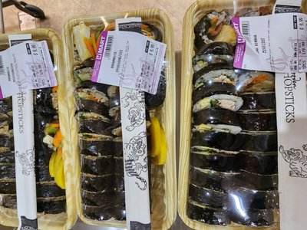 | KIMBAP VEGETABLE | 야채 김밥 | ROLL |  |  |  | ☐ Rice temp / fillings even
2 | 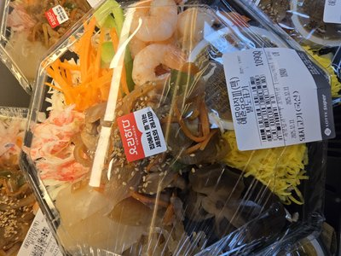 | KIMBAP PORK | 돼지 김밥 | ROLL |  |  |  | ☐ Meat cooked / clean cut
3 | 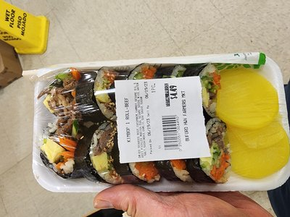 | KIMBAP BEEF | 소고기 김밥 | ROLL |  |  |  | ☐ Meat portion / seaweed crisp

SAMGAK — 삼각김밥
# | 📷 | ITEM | 한국어 | TYPE | Y/N | QTY | TIME | STATUS CHECK
4 |  | SAMGAK BEEF | 삼각 소고기 | GRAB |  |  |  | ☐ Shape uniform / sealed
5 |  | SAMGAK PORK | 삼각 돼지 | GRAB |  |  |  | ☐ Rice temp / filling ratio
6 | 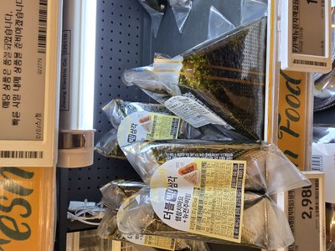 | SAMGAK TUNA MAYO | 삼각 참치마요 | GRAB |  |  |  | ☐ Mayo fresh / refrigerated
7 |  | SAMGAK TUNA SPICY | 삼각 참치 매콤 | GRAB |  |  |  | ☐ Spicy sauce ratio / cold
8 | [📷] | SAMGAK SPAM | 삼각 스팸 | GRAB |  |  |  | ☐ Spam grilled / size uniform
9 |  | SAMGAK FRIED KIMCHI | 삼각 볶음김치 | GRAB |  |  |  | ☐ Kimchi stir-fry / moisture out

JAPCHAE — 잡채
# | 📷 | ITEM | 한국어 | TYPE | Y/N | QTY | TIME | STATUS CHECK
10 | 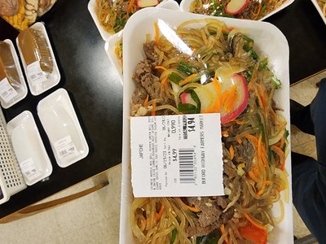 | JAPCHAE | 잡채 | SIDE |  |  |  | ☐ Noodles not stuck / colors

BIBIMBAP & CUP BAP — 비빔밥&컵밥
# | 📷 | ITEM | 한국어 | TYPE | Y/N | QTY | TIME | STATUS CHECK
11 | 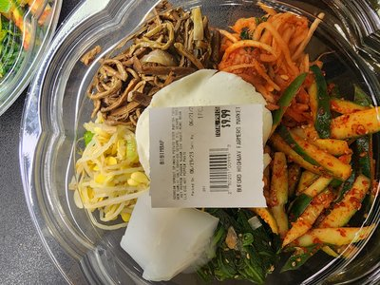 | BIBIMBAP BEEF | 소고기 비빔밥 | BOWL |  |  |  | ☐ Toppings neat / rice warm
12 | [📷] | BIBIMBAP PORK | 돼지 비빔밥 | BOWL |  |  |  | ☐ Meat portion / veggie fresh
13 |  | CUP BAP BEEF | 소고기 컵밥 | CUP |  |  |  | ☐ Topping visible / lid sealed
14 |  | CUP BAP PORK | 돼지 컵밥 | CUP |  |  |  | ☐ Topping visible / cup sealed

GRILLED & MARINATED — 구이&양념
# | 📷 | ITEM | 한국어 | TYPE | Y/N | QTY | TIME | STATUS CHECK
15 | [📷] | BEEF GALBI | 소갈비 | GRILL |  |  |  | ☐ Marinade depth / cut grain
16 | 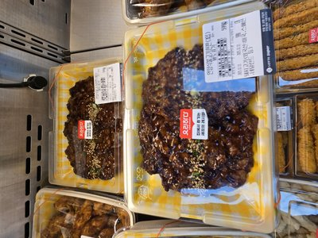 | BEEF BULGOGI | 소불고기 | GRILL |  |  |  | ☐ Sauce color / slice even
17 |  | PORK BULGOGI SPICY | 돼지불고기 (매운) | GRILL |  |  |  | ☐ Gochujang even / no discolor
18 |  | PORK BULGOGI SOY | 돼지불고기 (간장) | GRILL |  |  |  | ☐ Soy soaked / meat color
19 | [📷] | PORK BELLY SPICY | 매운 삼겨살 | GRILL |  |  |  | ☐ Slice uniform / sauce coated
20 |  | CHICKEN TERIYAKI | 치킨 데리야끼 | GRILL |  |  |  | ☐ Sauce glaze / fully cooked
21 | [📷] | MARINATED SQUID | 양념 오징어 구이 | GRILL |  |  |  | ☐ Texture chewy / sauce ratio
22 | 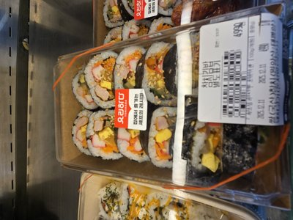 | KIMBAP TUNA | 참치김밥 | ROLL | ☐ | Filling even / seaweed crisp |  | NEW
23 | 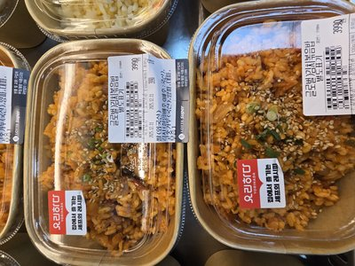 | KIMCHI FRIED RICE | 김치볶음밥 | BOWL | ☐ | Stir-fry done / no excess oil |  | NEW
24 | 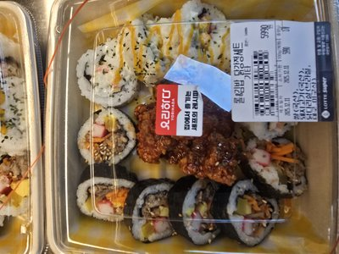 | SHRIMP FRIED RICE | 새우볶음밥 | BOWL | ☐ | Shrimp cooked / rice loose |  | NEW
25 | 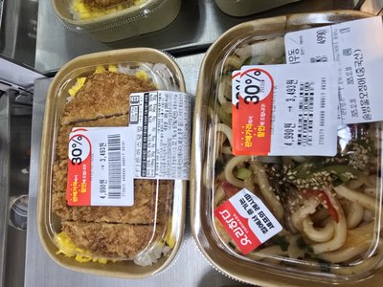 | DONKATSU BENTO | 돈까스도시락 | BOX | ☐ | Crispy / sides fresh |  | NEW
26 | 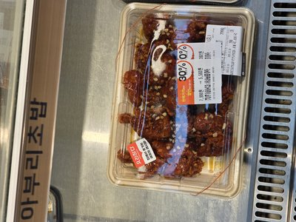 | SEASONED FRIED CHICKEN | 양념치킨 | GRILL | ☐ | Sauce even / crispy coat |  | NEW
22 |  | KIMBAP TUNA | 참치김밥 | ROLL | ☐ | Filling even / seaweed crisp |  | NEW
23 |  | KIMCHI FRIED RICE | 김치볶음밥 | BOWL | ☐ | Stir-fry done / no excess oil |  | NEW
24 |  | SHRIMP FRIED RICE | 새우볶음밥 | BOWL | ☐ | Shrimp cooked / rice loose |  | NEW
25 |  | DONKATSU BENTO | 돈까스도시락 | BOX | ☐ | Crispy / sides fresh |  | NEW
26 |  | SEASONED FRIED CHICKEN | 양념치킨 | GRILL | ☐ | Sauce even / crispy coat |  | NEW
22 |  | KIMBAP TUNA | 참치김밥 | ROLL | ☐ | Filling even / seaweed crisp |  | NEW
23 |  | KIMCHI FRIED RICE | 김치볶음밥 | BOWL | ☐ | Stir-fry done / no excess oil |  | NEW
24 |  | SHRIMP FRIED RICE | 새우볶음밥 | BOWL | ☐ | Shrimp cooked / rice loose |  | NEW
25 |  | DONKATSU BENTO | 돈까스도시락 | BOX | ☐ | Crispy / sides fresh |  | NEW
26 |  | SEASONED FRIED CHICKEN | 양념치킨 | GRILL | ☐ | Sauce even / crispy coat |  | NEW


CHAPTER 5
DAILY CHECK — FRIED, KIMCHI & SOUP
17 items. Fried = cook to order. Kimchi NDM = check fermentation. Soup = temperature critical.
FRIED & STEAMED — 튀김&찐
# | 📷 | ITEM | 한국어 | TYPE | Y/N | QTY | TIME | STATUS CHECK
1 | 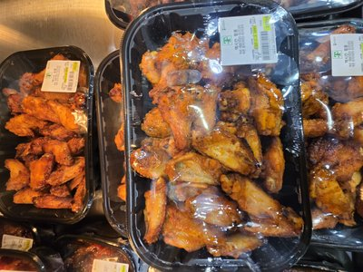 | CHICKEN WING REGULAR | 치킨윙 (일반) | FRY |  |  |  | ☐ Crispness / oil drained
2 | [📷] | CHICKEN WING SPICY | 치킨윙 (매운) | FRY |  |  |  | ☐ Sauce even / crispy
3 | [📷] | CORN DOG | 콘도그 | FRY |  |  |  | ☐ Golden color / oil drained
4 | [📷] | TORNADO POTATO | 토네이도 감자 | FRY |  |  |  | ☐ Crispy / shape uniform
5 |  | FRIED DUMPLING | 군만두 | FRY |  |  |  | ☐ Wrapper crispy / cooked
6 |  | STEAM BUN | 찐빵 / 호빵 | STEAM |  |  |  | ☐ Steam temp / skin intact

KIMCHI — 김치류
# | 📷 | ITEM | 한국어 | TYPE | Y/N | QTY | TIME | STATUS CHECK
7 |  | GREEN ONION KIMCHI NDM | 파김치 (NDM) | NDM |  |  |  | ☐ Scallion fresh / marinated
8 | 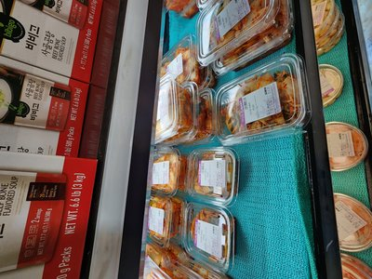 | WHOLE KIMCHI NDM | 포기김치 (NDM) | NDM |  |  |  | ☐ Leaf browning / ferment level
9 | 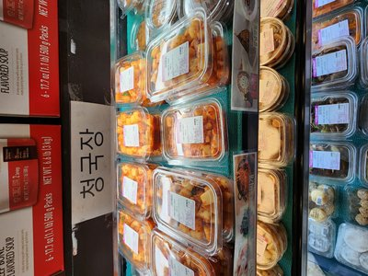 | KKAKDUGI KIMCHI NDM | 깍두기 (NDM) | NDM |  |  |  | ☐ Cube size / color vibrant
10 | [📷] | YOUNG RADISH KIMCHI NDM | 총각김치 (NDM) | NDM |  |  |  | ☐ Stem fresh / ferment check
11 | [📷] | YUL MOO KIMCHI NDM | 열무김치 (NDM) | NDM |  |  |  | ☐ Green color / broth clarity
12 |  | WHITE KIMCHI NDM | 백김치 (NDM) | NDM |  |  |  | ☐ Broth clear / tartness
13 | [📷] | DONGCHIMI NDM | 동치미 (NDM) | NDM |  |  |  | ☐ Broth clear / radish crunch
14 | 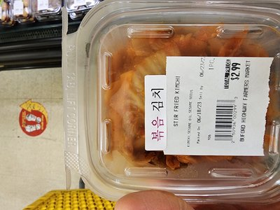 | STIR FRY KIMCHI | 볶음김치 | COOK |  |  |  | ☐ Stir-fry done / tartness

SOUP — 국/탕
# | 📷 | ITEM | 한국어 | TYPE | Y/N | QTY | TIME | STATUS CHECK
15 | [📷] | KIMCHI SOUP | 김치찌개 | SOUP |  |  |  | ☐ Ferment level / broth rich
16 | [📷] | MISO SOUP | 된장국 | SOUP |  |  |  | ☐ Doenjang concentration / clear
17 |  | BEEF BONE SOUP | 사골국 | SOUP |  |  |  | ☐ Milky opacity / fat skimmed
18 | 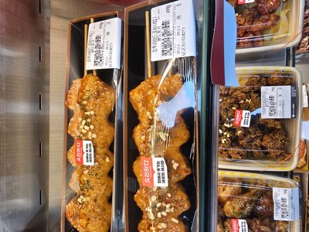 | SWEET CRISPY CHICKEN | 닭강정 | FRY | ☐ | Coating crispy / sauce sticky |  | NEW
19 | 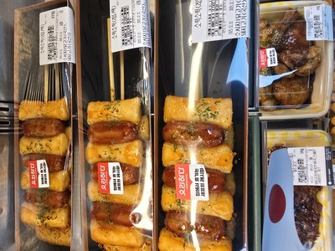 | SAUSAGE RICE CAKE SKEWER | 소떡소떡 | FRY | ☐ | Grilled even / skewer firm |  | NEW
20 | 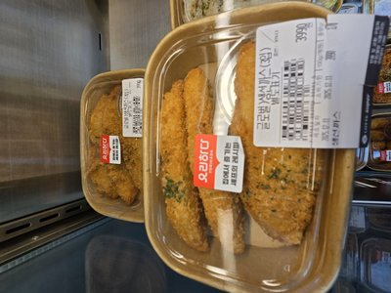 | PORK CUTLET | 돈까스 | FRY | ☐ | Golden crisp / meat cooked |  | NEW
21 | 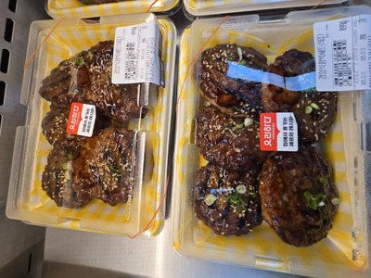 | KOREAN BEEF PATTY | 떡갈비 | FRY | ☐ | Shape uniform / cooked thru |  | NEW
22 | 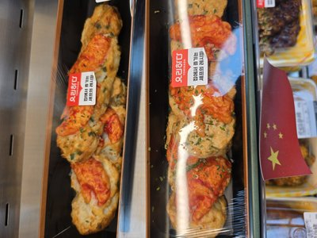 | KIMCHI PANCAKE | 김치전 | FRY | ☐ | Crispy edges / even thickness |  | NEW
18 |  | SWEET CRISPY CHICKEN | 닭강정 | FRY | ☐ | Coating crispy / sauce sticky |  | NEW
19 |  | SAUSAGE RICE CAKE SKEWER | 소떡소떡 | FRY | ☐ | Grilled even / skewer firm |  | NEW
20 |  | PORK CUTLET | 돈까스 | FRY | ☐ | Golden crisp / meat cooked |  | NEW
21 |  | KOREAN BEEF PATTY | 떡갈비 | FRY | ☐ | Shape uniform / cooked thru |  | NEW
22 |  | KIMCHI PANCAKE | 김치전 | FRY | ☐ | Crispy edges / even thickness |  | NEW
18 |  | SWEET CRISPY CHICKEN | 닭강정 | FRY | ☐ | Coating crispy / sauce sticky |  | NEW
19 |  | SAUSAGE RICE CAKE SKEWER | 소떡소떡 | FRY | ☐ | Grilled even / skewer firm |  | NEW
20 |  | PORK CUTLET | 돈까스 | FRY | ☐ | Golden crisp / meat cooked |  | NEW
21 |  | KOREAN BEEF PATTY | 떡갈비 | FRY | ☐ | Shape uniform / cooked thru |  | NEW
22 |  | KIMCHI PANCAKE | 김치전 | FRY | ☐ | Crispy edges / even thickness |  | NEW


CHAPTER 6
CROSS-DEPARTMENT COLLABORATION
You don’t work alone. Meat, Seafood, and Produce teams supply your raw materials. Coordinate daily.
☐ | 9:50 AM — Visit Meat Team: Receive bulgogi beef ___lbs → ___portions
☐ | Receive pork ___lbs → Spicy Pork ___portions
☐ | ⚠️ Check EXPIRING items (1-2 days) → Priority cooking plan: _____
☐ | Visit Seafood Team: Receive squid ___lbs → Spicy Squid ___portions
☐ | Visit Produce Team: Spinach ___bunches → Namul ___portions
☐ | Bean sprouts ___lbs → Muchim ___portions
☐ | 10:30 AM - 2:00 PM: Cook & package all converted items
☐ | 2:00 PM: Deliver to Kimchi Mart
☐ | 2:30 PM: Verify display placement

🗑️ WASTE & ERROR REPORT
# | ITEM | QTY | TIME | REASON | ACTION
❌ PRODUCTION ERROR
# | ITEM | QTY | ERROR | WHO | ACTION | COST($)
🍱 UMAGA INGREDIENT ORDER
ITEM | SUPPLIER | ORDERED | RECEIVED | PRICE | TOTAL($) | OK?
📦 PACKAGING ORDER
ITEM | SUPPLIER | ORDERED | RECEIVED | PRICE | TOTAL($) | OK?
💰 DAILY COST SUMMARY
CATEGORY | TOTAL ($)
Vegetables & Herbs
Rice & Grains
Sauces & Seasonings
Meat (from Meat Dept)
Seafood (from Seafood Dept)
Containers & Lids
Labels & Wraps
Other
TOTAL INGREDIENTS
TOTAL PACKAGING
COMBINED TOTAL
📝 ORDER ISSUE MEMO
# | DATE | ISSUE | SUPPLIER | ACTION | RESOLVED?


CHAPTER 7
RECIPE MONITORING & NEW MENU CHALLENGE
Follow the recipe. Then dare to create something new. Innovation lives alongside discipline.
⏰ HOURLY COMPLIANCE CHECK
☐ | 12:00 PM — Recipe followed? ☐ Yes ☐ No — Tools used? ☐ Yes ☐ No
☐ | 2:00 PM — Recipe followed? ☐ Yes ☐ No — Tools used? ☐ Yes ☐ No
☐ | 4:00 PM — Recipe followed? ☐ Yes ☐ No — Tools used? ☐ Yes ☐ No
TASTE TEST — 10:30 AM First Batch:
☐ | Bulgogi taste: _______ (signature) → Matches recipe? ☐ Yes ☐ No
☐ | If NO: Recook immediately — do NOT serve
⚠️ RECIPE CHANGE PROCESS (NO shortcuts!):
☐ | ❌ DO NOT change recipe on your own
☐ | ✓ Write idea on suggestion sheet
☐ | ✓ Submit to manager for review
☐ | ✓ Test cooking ONLY after approval
☐ | ✓ Update recipe book if approved
☐ | ✓ Train ALL staff before implementation

🚀 NEW MENU CHALLENGE — This Week’s Innovation
Great food starts with curiosity. Propose ONE new dish this week!

Challenge Menu: ____________________________________________
Inspiration: ☐ Customer Request ☐ Trend ☐ Inventory Use ☐ Staff Idea
Ingredients needed: ________________________________________
Estimated cost per portion: $________
Tasting Score (1-5): Taste ___ Visual ___ Cost ___ Overall ___
Adopt to menu? ☐ YES → Register in Recipe Book ☐ NO → Reason: ____________
Manager Approval: ____________________ Date: ____________

🌡️ TEMPERATURE LOG
TIME | WALK-IN (°F) | PREP AREA (°F) | FOOD TEMP (°F) | INITIALS
9:30 AM
12:00 PM
2:00 PM
4:00 PM
6:00 PM
8:00 PM
🧼 CRITICAL HYGIENE
☐ | Wash hands before handling food
☐ | Gloves at ALL times
☐ | Change gloves between products
☐ | Separate cutting boards
☐ | Sanitize surfaces every hour
☐ | Never leave food at room temp
☐ | Report injuries immediately


CHAPTER 8
DAILY REVENUE REPORT
UMAGA sells too. Every dollar tracked.
💰 REVENUE SUMMARY
CATEGORY | AMOUNT ($)
Gross Sales
Cash
Card
Mobile
Other
(-) Employee Discount
(-) Manager Discount
(-) Promo/Coupon
(-) TOTAL DISCOUNTS
(-) Refund-Return
(-) Refund-Wrong Order
(-) Refund-Quality
(-) TOTAL REFUNDS
NET REVENUE
📝 DISCOUNT/REFUND DETAIL
# | TIME | TYPE | ITEM | AMT($) | REASON | APPROVED BY


CHAPTER 9
CUSTOMER COMPLAINTS & GOOGLE REVIEWS
Listen to every complaint. Respond to every review.
😤 COMPLAINT LOG
# | TIME | CUSTOMER | COMPLAINT | ITEM | ACTION | REFUND($) | RESOLVED?
⭐ GOOGLE REVIEW TRACKER
# | DATE | REVIEWER | STARS | SUMMARY | RESPONDED? | BY | DATE
Target: ALL reviews within 24hrs. 1-2 stars = Manager personally.


CHAPTER 10
SHIFT CLOSING & WEEKLY KPI
End strong. Verify all deliveries, conversions, and compliance before you leave.
☐ | All banchan delivered to Kimchi Mart: ☐ Yes
☐ | Kimchi repackaging complete: ☐ Yes
☐ | Final display check complete: ☐ Yes
☐ | Meat team inventory fully used: ☐ Yes
☐ | Fish team inventory fully used: ☐ Yes
☐ | Vegetable team inventory fully used: ☐ Yes
☐ | Today’s recipe violations: ☐ None ☐ Yes → Record: _____
☐ | Head Chef departure: ___:___
☐ | Line Cook departure: ___:___
☐ | Cash count + Lock safe + Equipment off + Security armed
☐ | Complete Daily Summary in Chapters 3-5
☐ | Complete Weekly KPI below
📊 WEEKLY KPI TRACKER
KPI METRIC | MON | TUE | WED | THU | FRI | SAT | SUN | AVG | TARGET
PRODUCTION & DELIVERY
Banchan Production Target Met (%) |  |  |  |  |  |  |  |  | ≥ 95%
Kimchi Repack Target Met (%) |  |  |  |  |  |  |  |  | ≥ 95%
Delivery to Mart on Time (11:30/3:00) |  |  |  |  |  |  |  |  | ✓
Display Verification Complete |  |  |  |  |  |  |  |  | ✓
RECIPE & QUALITY
Recipe Compliance Rate (%) |  |  |  |  |  |  |  |  | 100%
Taste Test Passed |  |  |  |  |  |  |  |  | ✓
Customer Complaints |  |  |  |  |  |  |  |  | 0
New Menu Challenge Submitted |  |  |  |  |  |  |  |  | ✓
COLLABORATION & INVENTORY
Cross-Dept Inventory Fully Converted |  |  |  |  |  |  |  |  | ✓
Expiring Items Prioritized |  |  |  |  |  |  |  |  | ✓
Waste/Loss ($) |  |  |  |  |  |  |  |  | ≤ $30
REVENUE & COST
Net Revenue ($)
Ingredient Cost ($)
Packaging Cost ($)
Total Discounts ($) |  |  |  |  |  |  |  |  | ≤ $20
Total Refunds ($) |  |  |  |  |  |  |  |  | ≤ $10
CUSTOMER & REVIEWS
Customer Complaints |  |  |  |  |  |  |  |  | 0
Google Avg Stars |  |  |  |  |  |  |  |  | ≥ 4.5
Reviews <24hrs (%) |  |  |  |  |  |  |  |  | 100%
HYGIENE & TEMP
Temp Log Complete |  |  |  |  |  |  |  |  | ✓
Hygiene Check OK |  |  |  |  |  |  |  |  | ✓
STAFF & COMPLIANCE
Staff Attendance (no absent) |  |  |  |  |  |  |  |  | ✓
On-Time Arrival Rate |  |  |  |  |  |  |  |  | 100%
Daily Score (0-100) |  |  |  |  |  |  |  |  | ≥ 90
PASS / FAIL |  |  |  |  |  |  |  |  | PASS
Head Chef Signature: ____________________ Manager Review: ____________________ Date: ______________

