22 Richards Drive

Halfway House

Midrand 1685

Johannesburg

South Africa

Phone (27) (0)11 312 9718

(27)(0) 11 312 9860

Fax(27) (0) 11 312 3628

Co Reg 2010/007137/07

Vat 4890252317

**ELECTRICAL ENGINEERING**

**COMPLETED PROJECTS**

1. ***Hospital maintenance/Eastern Cape***

* Value-(US$2,800,000.00)R23million
* Length-36 months
* Client Department of Health
* Minor Electrical maintenance of hospitals in the eastern Cape area.

ONGOING PROJECTS

1. ***Labour Contracts/City Power Johannesburg***

* Value-(US$1,400,000.00)=R11,4million
* Length-36months
* Client-City Power Johannesburg
* Description-Labour contracts for the installation and maintenance of medium and low voltage electrical infrastructure including public lighting and high mast refurbishment.

1. ***Tsakane 11kV switching station/Ekurhuleni***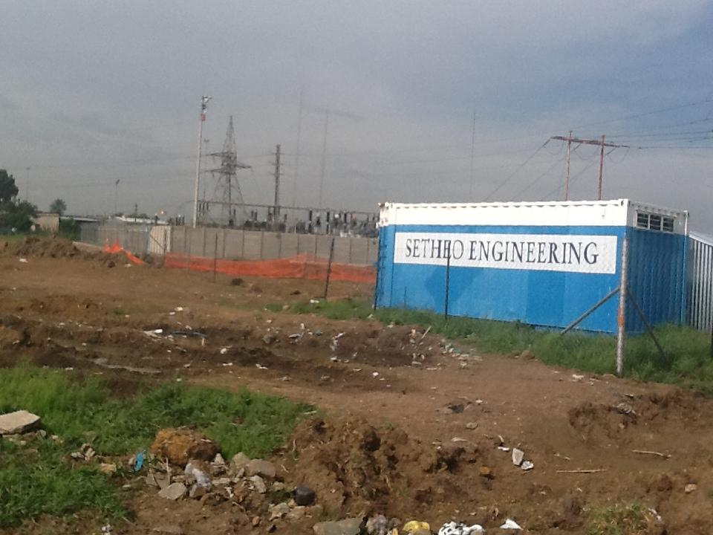

* Value-(US$1500,000.00)=R12,7million
* Length-12 months
* Client-Ekurhuleni Metropolitan Municpality
* Description-Building a new 11kV switching station including the 11kV connection to Eskom’s Transformer and the supply and delivery and installation of all associated equipment and material.

1. ***Substation Maintenance/Mpumalanga***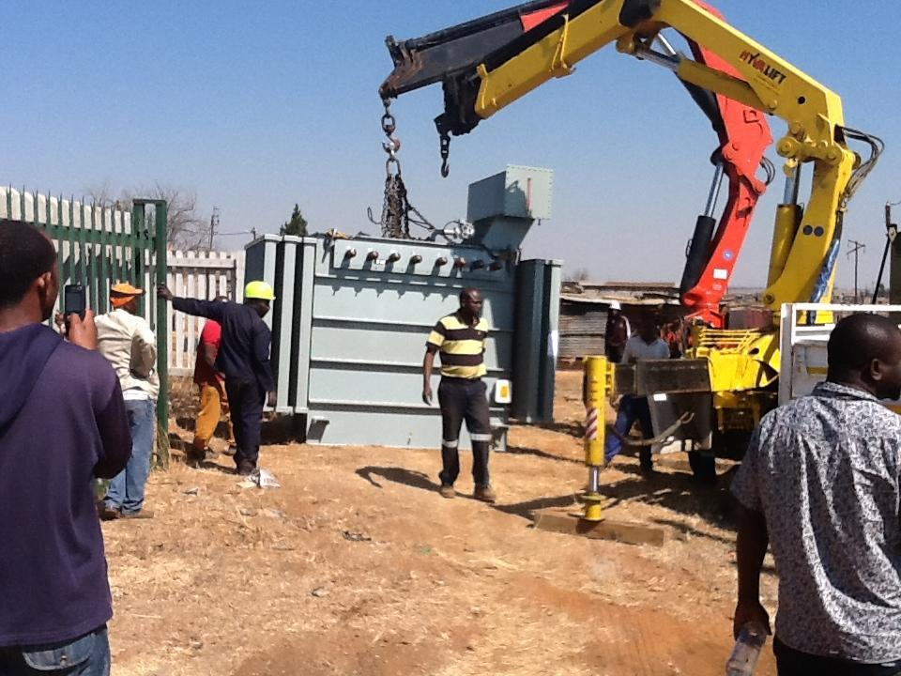

* Value-(US$4,500,000.00)=RR38,2million.
* Client-Chief Albert Luthuli Municipality
* Description-Proffessional Consultant for provision of Substation Maintenance and Protection Audit.

**CIVIL PROJECTS**

**ONGOING**

1. ***Sewer Reticulation/Eastern Cape***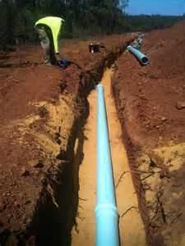

* Value-(US$700,000.00)=R5,9million
* Length-12 months
* Client-Makana Municipality
* Description-carry out sewer reticulation system for Grahamstown area extension 6.

1. ***Gravel Road/Elukwatini***

* Value-(US$500 000.00)=R4,2million
* Length-6months
* Client-chief Albert Luthuli Municipality
* Description-Construction of Landfill site access road.

1. ***Ekurhuleni /Stormwater Drains***

* Value-US$1400,000.00)=R11,9million
* Length-12months
* Client-Ekurhuleni Metropolitan Municipality
* Description-Construction,repair and maintain sidewalks,paved areas and storm water drains on an as and when required basis.

**BUILDING PROJECTS**

**COMPLETED**

1. *Building of Fast Track Project houses./Mpumalanga*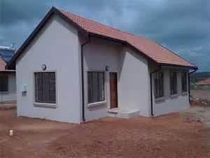

* Value – (US$6,500,000.00) =R55million
* Length -24 months
* Client - Chief Albert Luthuli Municipality
* Description-Principal contractor to develop and build 1000 to 2000 houses at a time for a fast track project for the municipality.The project included demolition of old structures and excavations.

1. *Mayflower Low cost Housing/Mpumalanga*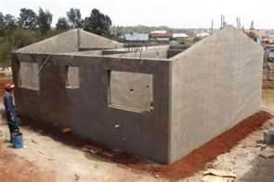

* Value –(US$5,000,000.00)=R42million
* Length-24 months
* Client –Eagle Wings Engineering
* Description –Building of 1400 low cost houses.the project included all other civil and electrical installation works upto completion.

1. *Community Residential Units/Mpumalanga*

* Value-(US$7,500,000.00)=R63million
* Length-30months
* Client-Tamilika Consulting
* Description-construction of Community Residential Units in Lebohang for Govan Mbeki Municipality.the project included all the excavations and demolitions and site preparation and clearance.it also included civil and electrical works.

1. *Design and Construction/Eastern Cape*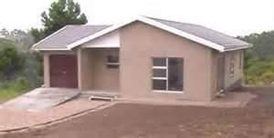

* Value-(US$5,500,000.00)=R46million
* Length-24 months
* Client-Ark tech Engineering
* Description-Design and Construction of 1260 low cost housing units for department of human settlements .this project also included installation of low pressure solar water heaters for the houses and all electrical installations.

1. *Construction and Upgrade/Govan Mbeki*

* Value-(US2,500,000.00)=R21million
* Length-18months
* Client-Govan Mbeki Municipality
* Drescription-construction and Upgrade of Govan Mbeki Municipality offices.The projected included construction of additional offices and renovation of existing office buildings.other additional work included plumbing and painting.

**ONGOING PROJECTS**

1. ***School construction/Eastern Cape***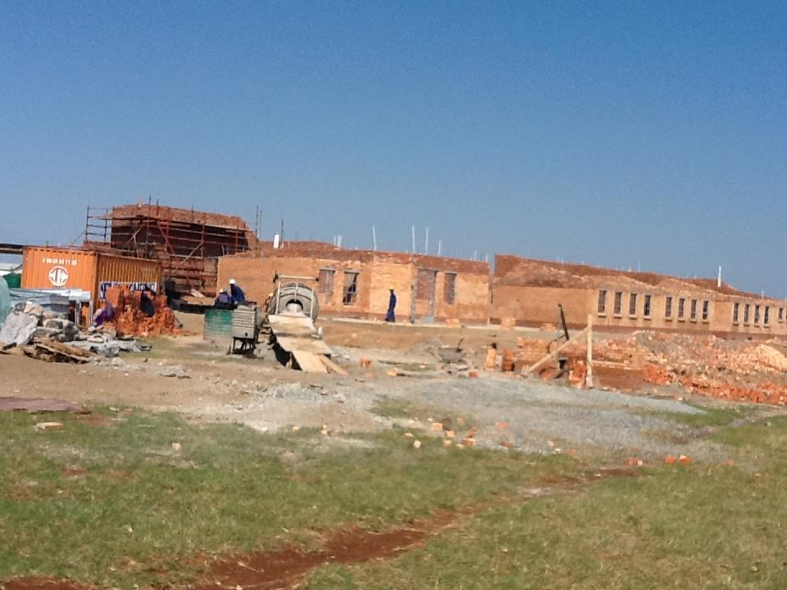

* Value –(US$ 2,500,000.00)=R21million
* Length -18 months
* Client-Development Bank of Southern Africa
* Description-Building of Primary school in the Eastern Cape provincefor DBSA under their accelerated school infrastructure development initiative.the project includes all the civil works and electrical installations as well as landscaping.