Using the mapping, Google Earth and BioGeomancer tools:

The WorkBench has a number of tools that make use of external services. Three examples are the Record Mapping Tool, the Google Earth exporter, and the BioGeomancer Geo-referencing Tool. All of these tools can work on the entire set of records in a Data Set, or only the selected records.

Record Mapping Tool

If your Data Set contains columns that are mapped to the latitude1 and longitude1 fields of the Locality table, you can view your records on a satellite image map. These maps are obtained through a pair of map servers, one hosted by NASA and one hosted at the University of Kansas. Specify then overlays the record locations onto the satellite imagery.

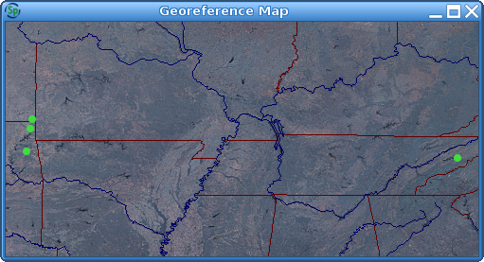

Google Earth

If your Data Set contains columns that are mapped to the latitude1 and longitude1 fields of the Locality table, you can view your records in Google Earth. Clicking the Google Earth Export tool button will open Google Earth and display the record locations and data on a 3-D image of the globe. (For help using Google Earth, please see earth.google.com. Google Earth must be installed in order for this tool to work properly. After installing Google Earth, a system reboot is required.)

BioGeomancer

BioGeomancer is a web service that uses locality description data to infer geo-coordinates for that locality. In order to use BioGeomancer to perform geo-referencing of a Data Set's records, a number of fields must be present in the Data Set's mapping. These are localityName, latitude1 and longitude1 from the Locality table and country, state and county from the Geography table. The BioGeomancer tool uses the data present in the localityName, country, state and county fields to query the BioGeomancer service. (See www.biogeomancer.org for more information about this service.) If BioGeomancer is able to obtain results for any of the records, a dialog is presented, displaying those results. The dialog presents the results for each Data Set record one at a time, not displaying anything for those records for which no results were obtained. For example, if a user selects 90 records in a Data Set and performs a BioGeomancer query, BioGeomancer may return results for any number of these records. The BioGeomancer Results Chooser dialog displays the number of records with results in the title bar.
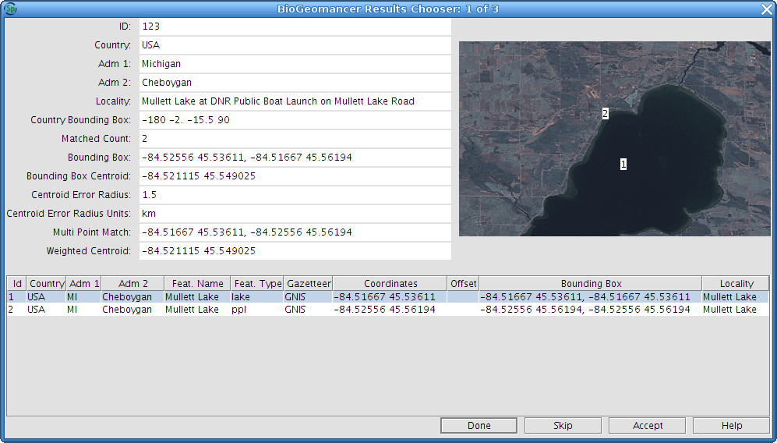
The BioGeomancer Results Chooser dialog allows the user to view the results obtained through BioGeomancer's web service and select the results (if any) the user deems to be correct. The upper left portion of the dialog presents the details about the query sent to BioGeomancer. The upper right portion displays the results in a map, using the same services used by the Record Mapping Tool. The lower portion of the dialog presents the BioGeomancer results. Often, if the locality description is specific enough, BioGeomancer will provide only one result. At times, the service provides numerous results. In order to choose a result, the user must select from the lower table, the row that corresponds with the correct geo-coordinates of the Data Set record. (To deselect an already selected row, either select a different row or hold the Control key while clicking on the already selected row.) Clicking the "Accept" button will associate the chosen result (if any) with the Data Set record corresponding to the query, storing the latitude and longitude values in the appropriate cells. Clicking "Skip" will ignore all results obtained for a given record, moving onto the next Data Set record for which results were obtained. Clicking the "Done" button will accept the currently selected row and hide the BioGeomancer Results Chooser dialog. After the user has worked through each record with results, accepting or skipping the provide options, the dialog will automatically be hidden. Any records for which a result was chosen will have values showing the the latitude and longitude columns.

