Main menu

1. Port scanning

Time taken for run: 213s

If server is not started up using any of the two nmap functions of Main menu option 2

2a. Download file from Server

Before

Normal process

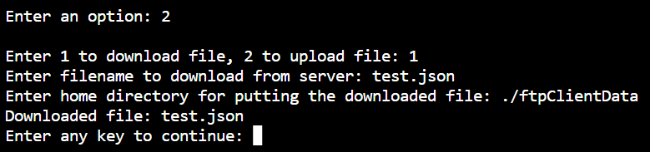

After

If file does not exist

If client directory does not exist

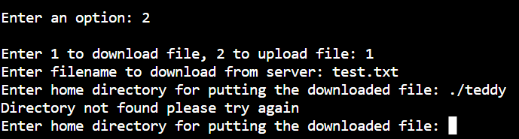

2b. Uploading file to server

Before

Normal input

File does not exist

Client directory does not exist

3. Custom packet

URL input

Inputs with limit 1 <= i <= 65536

Dry run: 0, 65536, -1, “o”, “”, 65535 (valid)

Source port

Destination port

No of packet

Type (“T”, “U”, “I”)

