# Backend Development Module Assignment 1, p2205810

# Endpoint 1: GET /users/

### Normal response: HTTP 200 OK

Screenshot provided after testing Endpoint 2 and inserting a second user with a different email using Endpoint 2.

# Endpoint 2: POST /users/

### Normal response: HTTP 201 Created

### Error response: HTTP 500 Internal Server Error on unknown error

Here, a key is misspelled.

### Error response: HTTP 422 on duplicate email

Screenshot after sending a duplicate POST request after one that is acknowledged with a 201 Created. This is because the email is exactly the same as the previous one

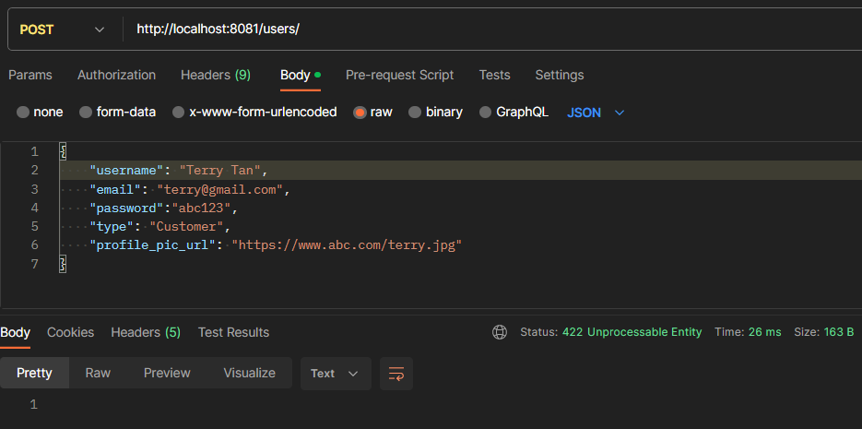

# Endpoint 3: GET /users/:id/

### Normal response: HTTP 200 OK

Screenshot provided after testing Endpoint 2 and inserting a second user with a different email using Endpoint 2.

# Endpoint 4: POST /category

### Normal response: HTTP 201 Created

### Error response: HTTP 500 Internal Server Error on unknown error

Here, a key is misspelled.

### Error response: HTTP 422 on duplicate catname

Screenshot after sending a duplicate POST request after one that is acknowledged with a 201 Created. This is because the catname is exactly the same as the previous one

# Endpoint 5: POST /platform

### Normal response: HTTP 201 Created

### Error response: HTTP 500 Internal Server Error on unknown error

Here, a key is misspelled.

### Error response: HTTP 422 on duplicate platform_name

Screenshot after sending a duplicate POST request after one that is acknowledged with a 201 Created. This is because the platform_name is exactly the same as the previous one

# Endpoint 6: POST /game

### Normal response: HTTP 201 Created

Screenshot after creating three platforms, one category.

### Error response: HTTP 500 Internal Server Error on unknown error

Here, a key is misspelled.

Here, the key is spelt correctly but a foreign key constraint fails, as platform id 4 does not exist in platforms (image 1) neither does category id 2 exist in categories (image 2)

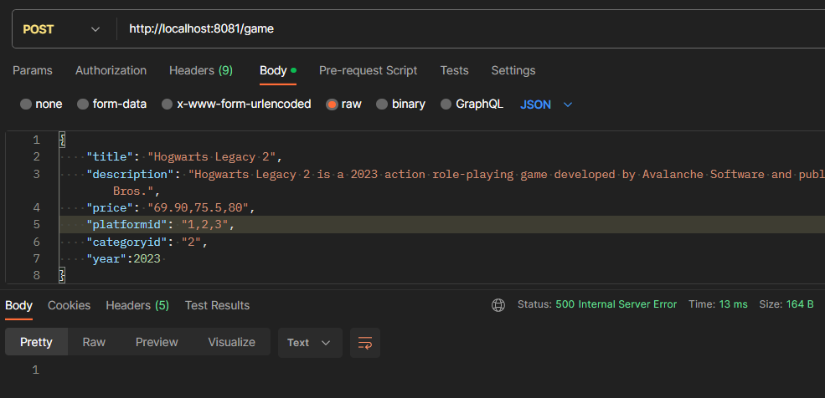

# Endpoint 7: GET /game/:platform

### Normal response: HTTP 200 OK

Screenshot after inserting 1 game through Endpoint 6

# Endpoint 8: DELETE /game/:id

### Normal response: HTTP 204 No Content

Screenshot after inserting a game with gameid 1 using endpoint 6 and inserting a review using endpoint 10

Screenshot of endpoint 11 before deleting the game with gameid 1

Screenshot of endpoint 11 after deleting the game with gameid 1. All reviews associated with game 1 have been deleted in the process.

### Error response: HTTP 500 Internal Server Error on unknown error

Id doesnt exist?

# Endpoint 9: PUT /game/:id

### Error response: HTTP 204 No Content

Screenshot after inserting a game with id 1

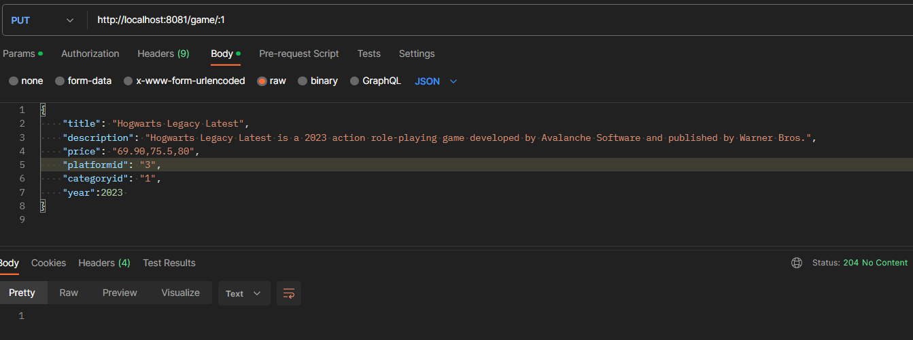

The title and description have changed

### Error response: HTTP 500 Internal Server Error on unknown error

Here, a key is misspelled.

# Endpoint 10: POST /user/:uid/game/:gid/review/

### Normal response: HTTP 201 Created

### Error response: HTTP 500 Internal Server Error on unknown error

Here, a key is misspelled.

# Endpoint 11: GET /game/:id/review

### Normal response: HTTP 204 OK

Screenshot after inserting the test review through Endpoint 10

# Additional feature documentation: Image upload and fetch

Allows upload and storage of image to games table. Image in the endpoint is validated to be below 1MB and is of jpg format

### Usage:

Run server.js in the root directory and endpoints will be available.

**This endpoint assumes that the game with gameid=gid exists as it uses SQL UPDATE** Upload image endpoint: PUT http://localhost:8081/game/:gid/image Replace gid with the gameid Support only form-encoded requests with body:

{"image": <image data>}

Fetch image endpoint: GET http://localhost:8081/game/:gid/image Replace gid with the gameid

### Responses:

##### PUT http://localhost:8081/game/:gid/image

HTTP 204 No Content: Normal response, no content

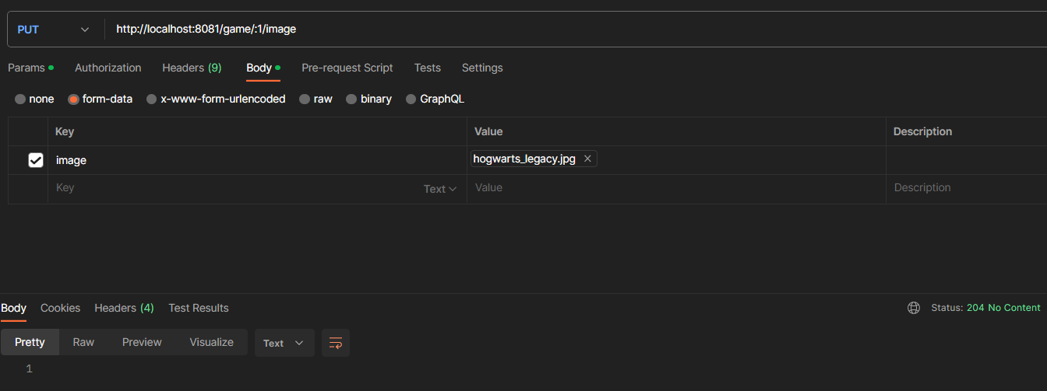

HTTP 500 Internal Server Error: Unknown error, no content

HTTP 400 Bad Request: File extension is bad (not /jpg|jpeg/). Returns

{"error_code": "BAD_FILE_EXTENSION", "message": "Only images with extension jpg are accepted"}

HTTP 413 Content Too Large: File is too big but file extension is okay since it passed validation (exceeds 1MB and is /jpg|jpeg/). Returns

{"error_code": "FILE_TOO_BIG", "message": "Image size should not exceed 1MB"}

Image tested is 1.03MB


##### GET http://localhost:8081/game/:gid/image

HTTP 200 OK: Normal response, with image

HTTP 500 Internal Server Error: Unknown error, no content

HTTP 404 Not Found: Image not found. Returns

{"error_code": "IMAGE_NOT_FOUND", "message": "Image not found for given gameid"}

# Additional feature documentation: SHA256 hashing of user passwords:

Endpoint 2 includes the hashing of user passwords for increased security. The user passwords are hashed using SHA-256

