RWTH Aachen University · M.Sc. Robotic Systems
Internship Report
Vision Guard: A Vision-Based PPE Compliance Interlock for Flat Belt Grinding
Student | Arun Nair
Student ID (matriculation number) | [matriculation number]
Company | GE Aerospace
Company address | [company address, Pune, India]
Internship period | [start date] to [end date]
Industrial supervisor (trainer) | [name, designation]
Academic supervisor | [name, chair]

Company stamp | Signature of the trainer, date
Confidential: prepared for academic assessment only. Part numbers, part geometry, production volumes, cycle times, supplier names, commercial terms, network addresses, hostnames, credentials and employee names are excluded throughout. No image shows a component, a drawing or an identifiable person.

Abstract
During my internship at GE Aerospace in Pune, India, I designed, built and commissioned Vision Guard, a camera-based interlock that turns PPE compliance at a flat belt grinding station from an administrative control into an engineering control. Two cameras observe the operator. An industrial PC without a GPU runs a YOLO11s detector compiled with OpenVINO and decides whether the required PPE is worn. An Ethernet relay module, addressed over Modbus TCP, drives a tower light and buzzer and grants or withholds the grinder motor’s run permissive.
Migrating inference from PyTorch to OpenVINO cut end-to-end latency from 300–400 ms to about 40 ms. Six model versions were trained. The first deployed version reached a validation precision of 0.942, a recall of 0.955 and an mAP@0.5 of 0.966, and the station now runs an eight-class version that adds the apron. The system passed two Management of Change approvals, was installed and relocated, and was approved for deployment on every flat belt grinder at the plant.
The most consequential finding was not a model result. Operators stand at an angle to the machine to inspect their work, outside the geometry the cameras were placed for. This is a requirements failure, and it changed how the rollout is specified. A review of the code against the project record also found weaknesses in the fail-safe behaviour, chief among them an emergency stop that does not yet act independently of the software. These are reported with remedies.
I also contributed to a droplet-transfer measurement study in robotic TIG welding, an automated tube-trimming cell and the site’s welding automation roadmap.
Contents
1. Introduction 4
1.1 Motivation 4
1.2 Host organisation 4
1.3 Origin, scope and objective 4
2. Technical background 5
2.1 Compliance is a decision, not a detection 5
2.2 Detector and runtime 6
2.3 Two error directions 6
3. System overview 6
4. Dataset and model 8
4.1 Class schema and site-specific data 8
4.2 Local annotation and failure-driven expansion 8
4.3 Training and convergence 9
4.4 Model selection 10
5. Inference pipeline 13
5.1 Threads and stale frames 13
5.2 Camera scheduling 13
5.3 Letterboxing, bandwidth and the rejection of MJPEG 14
6. Compliance logic and interlock 15
6.1 From detections to a verdict 15
6.2 The debounce and hold-window trade-off 16
6.3 Warning before inhibition 17
6.4 Failure behaviour 18
7. Deployment and commissioning 19
7.1 Hardware and commissioning 19
7.2 Installation and relocation 20
7.3 Safety approval, documentation and reviews 20
8. Results and evaluation 21
8.1 Latency 21
8.2 Detection performance 22
8.3 The operator feedback finding 22
8.4 Evaluation against the objective 23
9. Rollout and secondary assignments 24
9.1 Plant-wide rollout 24
9.2 Secondary assignments 24
10. Critical reflection 25
10.1 Supervision 25
10.2 Learning achievements 25
10.3 Problems and what I would do differently 26
11. Conclusion and outlook 26
References 28
Attachments 30
Attachment A — Training record 30
Attachment B — Compliance parameters and Modbus map 31
Attachment C — Fail-safe analysis 32
Attachment D — Open items and discrepancies 33
Attachment E — Code and configuration 34
Attachment F — Figures still required 34

1. Introduction

1.1 Motivation
Flat belt grinding is a manual finishing operation. The operator holds a component by hand against a moving abrasive belt. The hazards are three:
- abrasive dust;
- sparks;
- contact injury to the hands and forearms.
The station’s required PPE answers each of them: safety glasses, gloves, sleeves and a mask. The deployed system also checks a head net, which the site requires at the station.
Before this project, compliance was assured by training, signage and supervision. In the hierarchy of controls these are all administrative controls. Each depends on a person’s decision at the moment of use, and on a supervisor being present. None of them acts on the machine. When the decision goes the wrong way, the grinder runs regardless. Vision Guard moves the control one tier up: it detects missing PPE from camera images and inhibits the machine. It does not replace the machine’s guarding or its emergency stop. It closes the gap between the rule that PPE must be worn and the fact of the machine running.

1.2 Host organisation
GE Aerospace designs and manufactures commercial and military aircraft engines, components and systems. It has operated as an independent, publicly listed company since April 2024.
[Site-specific description of the Pune facility: its role, products and processes, and the department in which the internship took place. To be written and verified by the author.]

1.3 Origin, scope and objective
The project did not exist when the internship began. In my first two weeks I studied the shopfloor systematically, covering:
- material flow and the process sequence;
- weld preparation and manual welding;
- the robotic TIG welding cell.
Throughout, I spoke with welders, operators and engineers. The grinding station emerged from that study as a candidate for an engineering control. The project came from observation, not from a prepared brief.
The objective was a system that withholds the grinder’s run permissive unless the operator at the machine wears the required PPE. It had to do so quickly enough, and steadily enough, to be accepted by the people who work at the machine. The work covered the whole life of the system:
- dataset, model and inference pipeline;
- compliance logic and interlock;
- hardware, commissioning and safety approval;
- installation, relocation and operator documentation;
- the specification of a plant-wide rollout.
Chapter 9 describes three secondary assignments. Chapter 10 reflects critically on the internship.

2. Technical background

2.1 Compliance is a decision, not a detection
An object detector answers is there a glove in this image, and where? An interlock must answer is this operator, now, protected as the site rules require? The difference between the two questions accounts for most of the engineering in this report. It has three dimensions.
- Ownership. A glove on a bystander or on a bench protects nobody. The decision needs to know whose equipment is judged.
- State. An object can be present and still not compliant. A glove can be held in the hand instead of worn. Prescription spectacles can be worn instead of safety glasses. A sleeve can be worn so that it can be caught. In each case the detector may be entirely right about the object, and the compliance decision still wrong.
- Time. A glove hidden for a few hundred milliseconds behind the workpiece has not been removed. A single compliant frame does not prove that the operator is compliant now. The decision must integrate evidence over time.
Validation metrics measure only the detection question. They are necessary but not sufficient.

2.2 Detector and runtime
YOLO [1] is a single-stage detector: one network pass predicts boxes and class scores for the whole image, so the inference cost is fixed and predictable. YOLO11 [2] is the Ultralytics release used here, in its s scale (about 9.4 million parameters). Ultralytics names the family YOLO11; my project notes wrote YOLOv11, and this report uses YOLO11 throughout. Detection transformers such as DETR [3] and RF-DETR [4] predict object sets directly and need no non-maximum suppression, but their attention layers are costly on a CPU.
OpenVINO [5] compiles a trained network for a specific CPU. Detection quality is reported as precision $P=TP/\left(TP+FP\right)$, recall $R=TP/\left(TP+FN\right)$ and mean average precision (mAP) at an IoU threshold of 0.5, and averaged over thresholds from 0.5 to 0.95 [6].

2.3 Two error directions
An interlock can be wrong in two directions, which Table 1 sets out. A single accuracy figure would weight them equally, which is wrong for both.
Table 1. Error directions of the PPE interlock.
Decision truth | Operator protected | Operator not protected
Machine permitted | Correct | False permit: hazard present while the machine runs
Machine inhibited | False stop: compliant operator stopped | Correct
A false stop usually follows a missed detection (a false negative) of equipment that is worn. Its cost is lost production, and with it the operator’s trust: a station that stops compliant people gets worked around. A false permit is the exposure the system exists to prevent. Every parameter in Chapter 6 is a position on this trade-off.
Such a system is a permissive: a condition that must hold before the machine may run, layered on top of the machine’s safety functions and never in place of them [7]. It talks to the relay module over Modbus TCP [8], with the pymodbus library [9]. Modbus is stateless and driven by the client. A device keeps its outputs as last written until it is told otherwise, unless it has its own communication watchdog.

3. System overview
Figure 1 shows the system as built. Two USB cameras view the operator from the front and the side. The industrial PC, which runs on its CPU only, carries the whole software stack:
- capture;
- detection;
- the compliance logic;
- the motor-permissive latch;
- an operator interface on a monitor at the station.
The relay module’s outputs drive the green, amber and red lamps, the buzzer and the motor permissive (DO1–DO5). Its inputs read the emergency stop and a start/stop push button (DI1, DI2). A control panel houses the relay module, its power supply, the e-stop, the push button and the PC. An overload relay protects the motor, and the camera stands were fabricated to measured dimensions.
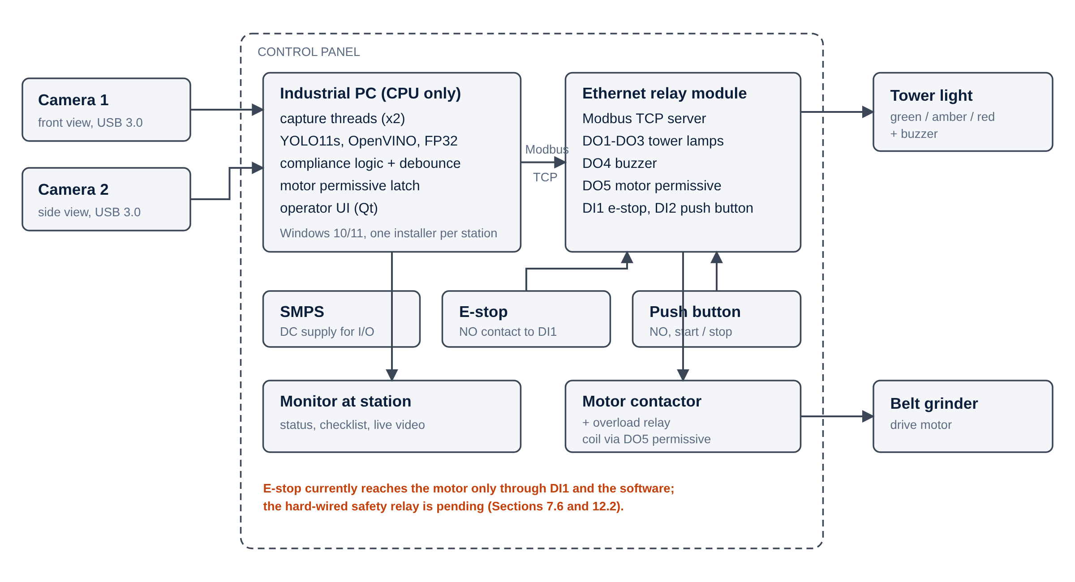
Figure 1. System architecture.
The software is a Python application of about 5,800 lines, with a test suite. Its main dependencies are:
- Ultralytics;
- OpenVINO;
- OpenCV;
- PySide6 (Qt);
- pymodbus.
Library versions are pinned for a Windows installer, so that every station runs an identical build. Each cycle takes one camera frame through letterboxing, inference, the compliance decision and the relay write. The result is shown over the live video, with a checklist of the required items and a countdown whenever a correction window is running.
My project record describes the emergency stop as hard-wired and independent of the detection system. The code contradicts this. The e-stop is a normally open contact into DI1, and the configuration states that, until a safety relay is fitted, this input is the only thing the e-stop does. Section 6.4 returns to this point.

4. Dataset and model

4.1 Class schema and site-specific data
The model described in this report detects seven classes (Table 2). They are five items of equipment, the person who wears them, and one non-compliant state, Wrong Sleeve, which the station treats as a violation whenever it is detected. The station now runs a later version, best-apron, that adds an Apron class (Section 4.4). Section 4.3 describes the seven-class model that was deployed first and that the repository still ships.
Table 2. Class schema and the role of each class.
Class | Role in the decision | Count required
Gloves | must be worn | 1 (2 before station tuning)
sleeves | must be worn, or an apron instead | 1 (2 before station tuning)
Safetyglasses, Mask, headnet | must be worn | 1 each
Wrong Sleeve | forbidden: detecting it is the violation | 0
person | identifies whom to judge | —
Apron | the sleeves alternative; in the retrained station model | 1
All training images were captured on the shopfloor, and no public PPE dataset was used. Public datasets centre on construction-site equipment. The station’s lighting, background, operator postures and issued PPE are particular to it, and sleeves are absent from most public sets. Starting from COCO-pretrained weights and fine-tuning on site data gave the model general features from a large dataset, and everything station-specific from the station. Images were deliberately taken from varying camera positions, which proved its worth when the installation was moved (Section 7.2).
Discrepancy: the checkpoint records a dataset path whose name refers to a commercial cloud dataset platform’s export. That may denote only the file format. It must be reconciled with the statement that site data was used exclusively (see the gap list).

4.2 Local annotation and failure-driven expansion
Company data compliance rules forbid uploading shopfloor images to cloud annotation services. I therefore built an auto-annotation tool that pre-labels images locally with the current model. An annotator corrects the boxes rather than drawing them all, which is several times faster. One remote day yielded 200 annotated images. The station software later gained a capture mode that keeps frames worth training on during normal operation, pre-labelled, and never sends them off the site network. Its triggers are:
- a timer;
- a violation;
- a motor start or stop;
- a required item going out of sight.
The dataset grew in rounds, each aimed at failures found in systematic testing of the previous model. The failures fall into two categories, and the distinction is the conceptual core of the data work.
- Detection failures are cases where the model misses or confuses an object that is there. Examples are partly occluded PPE, unusual poses, confusion between gloves and sleeves at the wrist, missed items in the side view after the relocation, and erratic detection of people in the background. More annotated examples of the hard case are the right fix.
- Decision failures are cases where the object is detected correctly and the compliance decision is still wrong. Examples are prescription spectacles worn in place of safety glasses, and gloves carried rather than worn. More data with the same labels cannot fix them, because the labels do not encode the distinction. There are only two fixes. The schema can label the non-compliant state explicitly, or the decision can test whether the item lies on the body part it should cover.
Leaving the non-compliant case unlabelled teaches the model weakly to ignore it. Worse, it makes the dangerous error unmeasurable, because a missed worn glove and a correctly ignored carried glove both produce no box.
The code resolves the open question of whether the schema was changed, but only in part. For sleeves it was: Wrong Sleeve is an explicit class with the strictest settings in the system. For glasses and gloves it was not. The relational test checks only that an item’s box lies inside the person’s box, relaxed to 10 % containment for gloves, and a glove held in the hand passes it.

4.3 Training and convergence
The model is YOLO11s, fine-tuned from COCO weights:
- input 640 × 640, batch size 16;
- cosine learning-rate schedule from 0.01;
- mosaic, colour and ±5° rotation augmentation;
- up to 150 epochs, with early stopping after 30 epochs without improvement.
It was trained on a CUDA GPU in about two hours. I recovered the full configuration from the checkpoint itself, because the run directory was not kept (Attachment A).
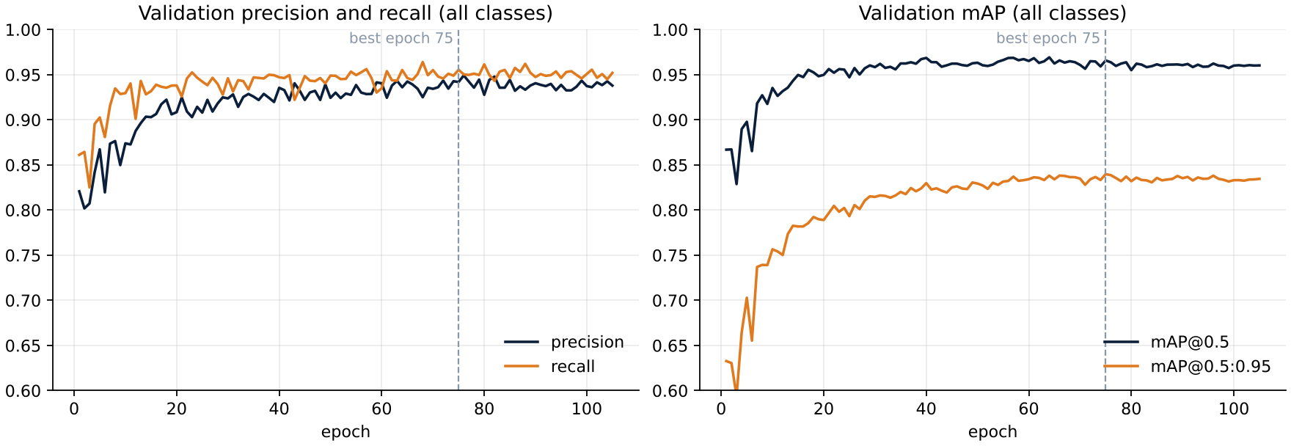
Figure 2. Validation precision, recall and mAP over 105 epochs.
Figure 2 shows the convergence in three phases:
- Rapid adaptation. The pretrained network reached an mAP@0.5 of 0.867 after one epoch.
- Steady gains in localisation. mAP@0.5 reached 0.96 by about epoch 40, and mAP@0.5:0.95 kept rising until epoch 75.
- Plateau. The validation losses stopped improving while the training losses kept falling, the classic onset of over-fitting.
Early stopping ended training at epoch 105 and kept epoch 75. At that epoch the model reached precision 0.942, recall 0.955, mAP@0.5 0.966 and mAP@0.5:0.95 0.840, averaged over the seven classes.
Mosaic switch-off and the final low-learning-rate phase were scheduled against the planned 150 epochs, so early stopping meant they never ran. Both are free improvements at the next retraining.

4.4 Model selection
Table 3 lists the configurations evaluated.
Table 3. Configurations evaluated on the station hardware.
Model | Runtime | End-to-end latency | Outcome
YOLO11 | PyTorch | 300–400 ms (inference 200–300 ms) | superseded
YOLO11 | OpenVINO | ≈ 40 ms | carried forward
YOLO11n | OpenVINO | slower than baseline; cause not established | not adopted
YOLO11s | OpenVINO | within budget | deployed
RF-DETR | — | ≈ 1500 ms | rejected on latency; accuracy good
The nano anomaly deserves care. YOLO11n needs about a third of the arithmetic of YOLO11s (6.5 against 21.5 GFLOPs [2]), so it should have been two to three times faster. A fixed per-call overhead or graph optimisation favouring wider layers could narrow that gap, but not reverse it. Only a mismatch in how the nano was exported or run predicts a reversal. A controlled re-measurement at the end of the internship confirmed this, as described below.
Model versions. Table 4 compares the six checkpoints that were kept. The comparison is drawn from the training records stored inside each file, and Figure A2 in Attachment A shows their training curves. The repository’s ppe-yolo11s.pt has the same weights as v2, bit for bit: the v2 file is a re-run on 3 September that, with the fixed seed, reproduced it exactly.
Table 4. Model versions: validation metrics at each run’s best epoch, and CPU inference time after conversion to OpenVINO with the same tool (FP32, 640 × 640, median of 60 calls on one 4-core CPU).
Version | Trained | Classes | Epochs (best) | P | R | mAP@0.5 | mAP@0.5:0.95 | OpenVINO ms
v2 (first deployed) | 23 Aug | 7 | 105 (75) | 0.942 | 0.955 | 0.966 | 0.840 | 35.0
nano 3 | 30 Aug | 7 | 100 (98) | 0.969 | 0.967 | 0.985 | 0.858 | 16.5
v4 | 10 Sep | 7 | 100 (70) | 0.945 | 0.952 | 0.970 | 0.842 | 34.5
v5 | 10 Sep | 7 | 104 (74) | 0.948 | 0.955 | 0.975 | 0.843 | 35.1
v6 | 20 Sep | 7 | 100 (70) | 0.941 | 0.964 | 0.972 | 0.844 | 34.1
best-apron (default) | 12 Oct | 8 | 93 (63) | 0.971 | 0.979 | 0.987 | 0.864 | 33.5
The table supports three readings:
- v2 to v6 differ only in their data. Every training setting is identical. The time per epoch on the same GPU grew from about 60 s to 94 s, which fits a dataset that grew round by round, as Section 4.2 describes. Each version scored marginally higher in mAP@0.5:0.95 (0.840 to 0.844), and v6 had the best recall (0.964). But each was validated on its own, growing, validation split, so differences of a few thousandths are not evidence that one version beats another.
- The nano and the apron model were trained on different data and settings. The nano was trained on a cloud notebook against a separate copy of the dataset, for a fixed 100 epochs, without the cosine schedule or rotation augmentation. Its scores look higher, but its mAP@0.5:0.95 was already 0.78 after the first epoch, against 0.63–0.69 for the small models. A smaller network should not start ahead on the same data. This points to an easier validation split, or to images shared between training and validation, rather than a better model. The apron model was trained on a combined dataset with an eighth class, starting from an earlier fine-tuned run, so its higher figures are not comparable either.
- None of the six was compared on common ground during training. Table 5 therefore scores all of them on one test set from station footage, held out from training. The scoring is by class name, so differences in class order or class count do not matter. Each image is also judged with the station’s own decision logic, to count false permits and false stops directly.
Table 5. All model versions on one common test set. [To be filled by running python -m ppe.evaluate --data data.yaml --root <dataset folder> --report internship-report.md.]
[Interpretation of Table 5, to be written once the tool has run: which version detects best on the common classes, how the false-permit and false-stop counts compare, and whether best-apron’s eighth class costs accuracy on the other seven.]
The nano anomaly is resolved. All six checkpoints were converted to OpenVINO with the station’s own export tool and timed on one CPU. The nano took 16.5 ms per call against 34–35 ms for the small models, so it is about twice as fast, as its arithmetic predicts. In PyTorch it was three times as fast (40 ms against 122 ms). The architecture was therefore never slower. The station measurement came from how that particular nano export was produced or run, the only explanation that could reverse the result. All five small models cost the same, so choosing between them is purely a question of accuracy. The nano’s speed is not needed: the small model already fits the budget, and the nano’s accuracy cannot be judged until it is evaluated on the same test set as the others. The repository’s default model is now best-apron, converted the same way.
RF-DETR’s accuracy was good, but closing 1500 ms to 40 ms needs about a fortyfold speed-up, and the runtime migration gave about tenfold. The useful conclusion is not that RF-DETR is unsuitable. It is that RF-DETR’s accuracy shows headroom the deployed model does not reach. The open question is how to capture that headroom inside the latency budget, for example by distillation.

5. Inference pipeline

5.1 Threads and stale frames
The pipeline rests on one principle: no stage waits for a slower one, and no stage works on stale input. Each camera thread keeps only its newest frame in a one-frame slot, and older frames are overwritten, never queued. The pipeline thread takes only frames it has not processed before. When no camera has delivered for 1.5 s, the station switches to DEGRADED and withdraws the permissive. A queue would have been the obvious design and the wrong one. Under load it fills, so every decision is made on an older frame, and for an interlock the age of the frame is the response time.
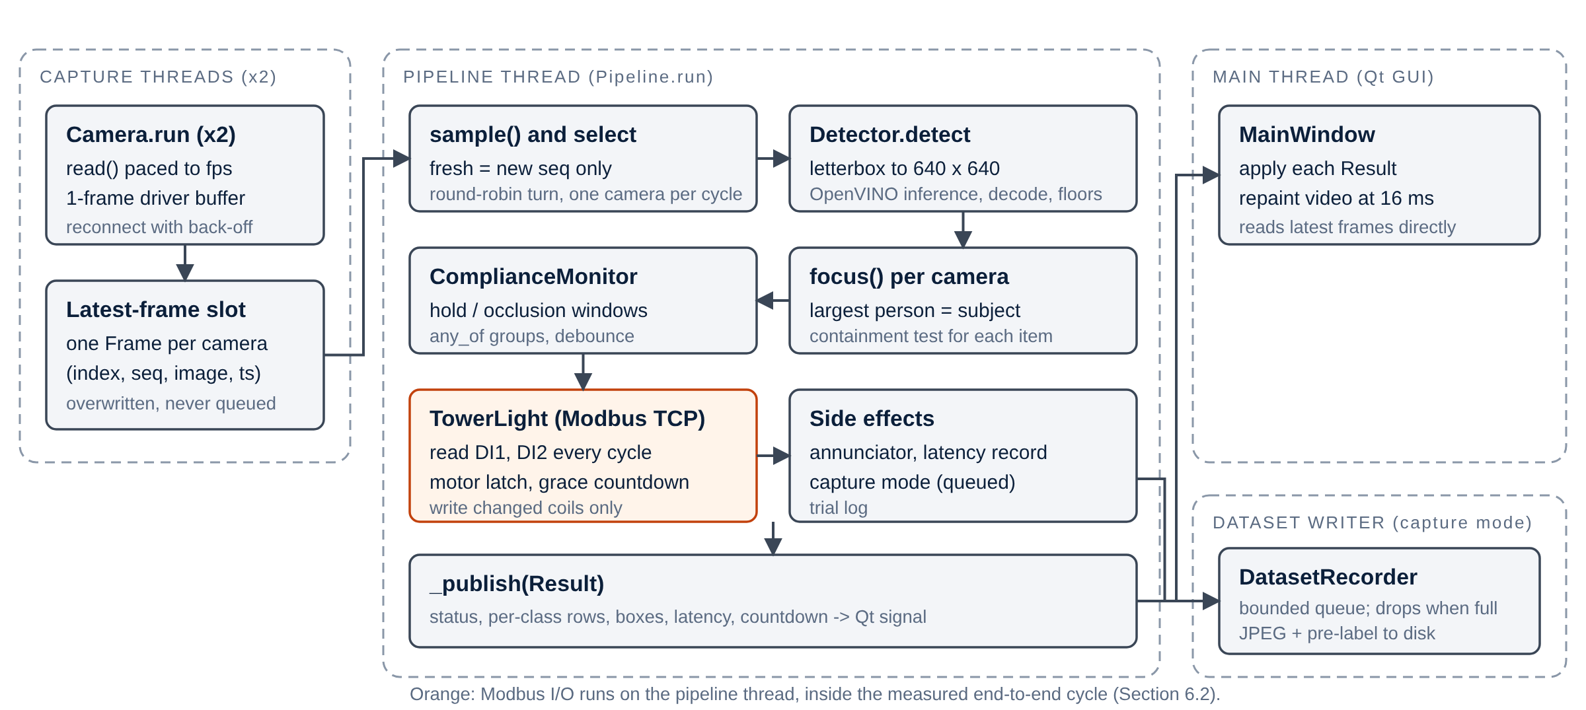
Figure 3. Threads and data flow as implemented.
My notes place Modbus on the user-interface thread, off the critical path. In the code, the Modbus reads and writes run on the pipeline thread (Figure 3). This fixes their order, latch first and lamps second, but puts network round trips inside every cycle. Their cost on the station network has not been measured.

5.2 Camera scheduling
On a CPU, one camera is served per cycle. A batch of two cost 1.89 times a batch of one, and made each frame wait for the other. Taking turns therefore halved the latency per frame: 64 ms against 122 ms on the development host.
A scheduling bug starved the slower camera. My notes describe it as a freshest-frame selector; the repository records it as a round-robin cursor that a camera served alone did not advance. A camera with a fresh frame every second cycle was served on only 3 of its 6 chances. After the fix, both cameras are served whenever they have a frame, alternating strictly when both deliver.

5.3 Letterboxing, bandwidth and the rejection of MJPEG
Frames are letterboxed to the square 640 × 640 model input:
- scaled by a single factor;
- centred;
- padded with grey.
Boxes are mapped back by the exact inverse. A direct resize would stretch the image, and several PPE classes are small and are told apart partly by shape.
Two cameras streaming uncompressed video saturated USB. One camera at 1280 × 720 and 30 fps produces about 55 MB/s. Measured on the cameras, 1280 × 720 delivered only 10 fps, while 640 × 480 delivered the full 30 fps. Capture was changed to 640 × 480 at 30 fps, a threefold improvement in temporal resolution, and detection accuracy was verified to be unaffected. That is expected: the letterbox scales a 1280-pixel-wide frame down by half before inference anyway.
Compressed MJPEG transport would have allowed the higher resolution. I established a working method through the Media Foundation (MSMF) backend, which reached 30 fps at 720p. It required an operating-system environment variable set before the program starts. Setting it from inside the program, the obvious fix, was shown on the hardware not to work. That made it a machine-dependent, system-level modification. For a system meant to be reproduced across the plant, a fix applied host by host is unacceptable. It will be missing on some hosts, lost when IT re-images a PC, and fail silently when it is. I kept the raw stream on USB 3.0 ports. This was a rejection of a working solution on deployment grounds, and Section 8 shows how that choice pays off. The station now captures at 640 × 480 (front) and 640 × 360 (side) through DirectShow. Its configuration still requests MJPEG, which DirectShow was measured to ignore on these cameras, so the stream is in effect uncompressed, as intended. The repository’s default configuration, which the installer ships, still requests 1280 × 720 and must be aligned before rollout.
Exporting to OpenVINO cut the time per inference call from 145 ms to 28 ms (5.2×), with detections identical to within 1.2 px. All of this gain came from compilation, because the export stays at FP32. INT8 quantisation remains available, but it needs calibration on site images.

6. Compliance logic and interlock

6.1 From detections to a verdict
Figure 4 shows the decision path from detections to the motor permissive.
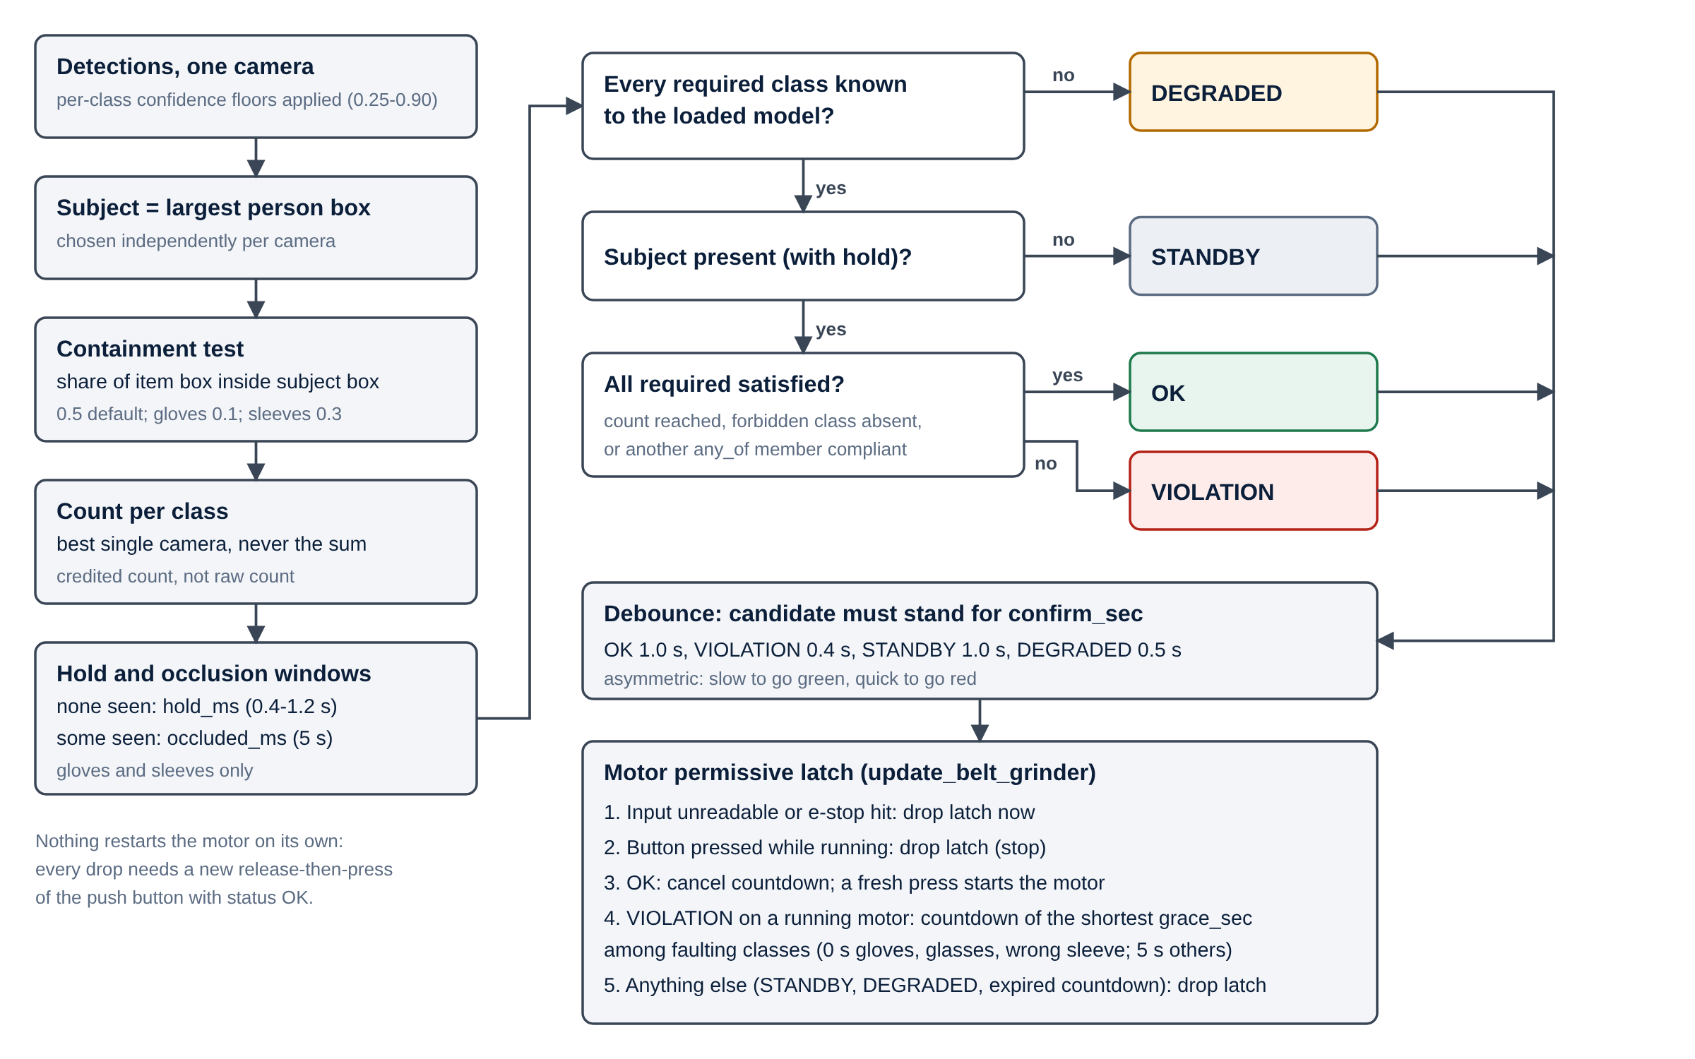
Figure 4. Decision flow from detections to the motor permissive.
The verdict takes one of four values:
- OK: the operator is compliant;
- VIOLATION: an item is missing, or a forbidden class is present;
- STANDBY: nobody is present;
- DEGRADED: the station cannot judge.
Only OK permits the motor.
Two choices recur throughout. First, counts come from the best single camera, never the sum: two cameras that each see the same two gloves must not report four. Second, the operator is the largest person in each camera’s view, which is a cheap and robust proxy for being closest to the machine. An item counts only if a large enough share of its box lies inside the operator’s box:
- 50 % in general;
- 30 % for sleeves;
- 10 % for gloves, which sit at the ends of outstretched arms beyond the person box.
Bystanders and their equipment are ignored. A missed person gives STANDBY, which darkens the lamp but still stops the motor. The same mechanism explains the large-workpiece problem in Section 7.4.

6.2 The debounce and hold-window trade-off
Early tests showed the person box, and the detections that depend on it, fluctuating from frame to frame. Driven directly, the interlock would have chattered against a workpiece held to the belt. Two mechanisms stabilise the verdict, and they pull in opposite directions.
The debounce applies a new status only after it has stood for a confirmation period. After senior management raised response time at the first demonstration, the debounce was reduced. The original counted three agreeing cycles. That was about 1 s at PyTorch cycle rates, but varied with CPU load. It was replaced by periods in seconds that differ by status:
- 0.4 s to go red;
- 1.0 s to go green;
- 1.0 s to conclude that nobody is there.
The station is quick to alarm and slow to claim compliance. The cost is stability: a shorter debounce lets briefer detection gaps through.
Per-class hold windows restore the stability, but only where it is needed. A class that drops out keeps its credited count for its hold period, from 0.4 s to 1.2 s. Gloves and sleeves also get a separate 5 s occlusion window that applies only while some but not all of the pair are visible. One visible glove is evidence that the pair is worn, so the tolerance is granted on evidence. Safety glasses, rarely occluded the same way, get only their 1.1 s hold. Tests confirmed that the revised logic handles occlusion of gloves and sleeves well.
Testing also found a defect, which I measured rather than assumed. Both windows had been timed from the last full sighting, so a partial view silently consumed the dropout hold. After one second of seeing a single glove, the configured 1.0 s hold was zero, on exactly the classes the occlusion window was added for. Timing each window from its own evidence fixed it.
The trade-off had an honest cost. An operator who removed one glove while the other stayed visible was still credited for up to about 5.4 s. This bounded exposure was accepted in exchange for not stopping operators whose second glove was behind the workpiece.
Station tuning has since moved this trade-off further. The station configuration now requires one glove and one sleeve, not two. That removes the false stops of the side view, which can rarely see both hands at once. Because a set of one cannot be partly visible, the occlusion window, now 8 s, no longer applies. The cost is that an operator with one bare hand is judged compliant indefinitely: in simulation, removing one of two gloves never stopped the motor. The station also raised:
- the person confidence floor from 0.25 to 0.70, which suppresses background people at the cost of losing the operator more easily;
- the Wrong Sleeve hold from 0.4 s to 1.2 s.
These are risk decisions, not only tuning decisions, and they belong in the risk assessment. Attachment B tabulates every class’s thresholds and timings.

6.3 Warning before inhibition
A violation on a running machine opens a correction window instead of stopping it at once. The lamp turns red, the buzzer warns, and the screen counts down. If the operator puts the item back, the machine never stops. Otherwise the permissive is withdrawn at the end of the window.
This is a deliberate safety trade-off: for the length of the window the machine runs with a detected violation. As implemented, the window has four properties:
- it was first set at 5 s, with no window at all for safety glasses, gloves and Wrong Sleeve, whose absence is the immediate hazard;
- on the station it is now 8 s by default, 5 s for safety glasses and gloves, and still 0 s for Wrong Sleeve;
- the shortest window among the current violations applies, so a missing head net cannot shelter a missing glove;
- it is set once and never renewed, so flickering PPE cannot hold the machine open.
Figure 5 shows the resulting stop times. I obtained them by running the station’s compliance and latch code on its configuration with simulated detections. The same method reproduces the times recorded earlier for the first configuration (1.5 s for gloves, 6.3 s for a mask). A detected wrong sleeve still stops a running machine in 0.5 s. But a missing glove or missing safety glasses now keep it running for about 6.5 s, and a missing mask, head net or sleeves for about 9.5 s. The station is configured as my notes describe, to let “a glove that has slipped” be corrected. That is a defensible choice for nuisance stops, but it reverses the earlier decision to give no window to the items whose absence is the immediate hazard. It needs an explicit, documented EHS position before rollout.
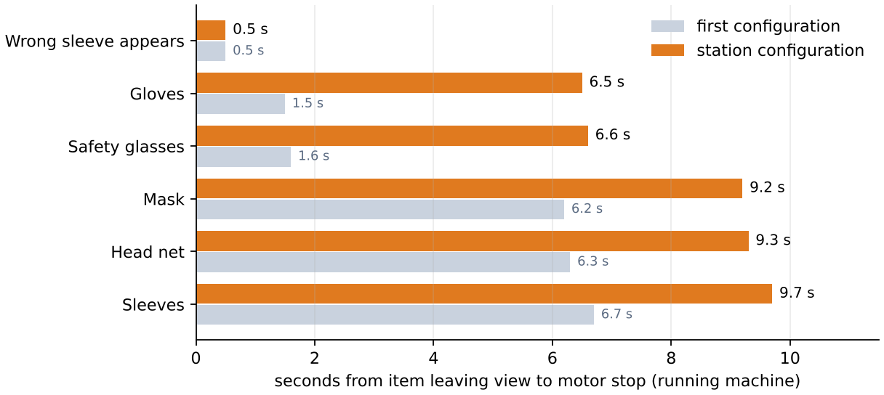
Figure 5. Time from an item leaving view to motor stop, station configuration (simulated with the station’s own logic).
The permissive is a latch, like the seal-in contact of a motor starter. Pressing the button starts the motor only when four conditions hold:
- the operator is compliant;
- the e-stop is not pressed;
- the press is a genuine release-then-press edge that the software observed;
- the machine is idle.
Pressing the button while the motor runs stops it. Nothing restarts the motor on its own. The coils are written only when they change, the inputs are polled every cycle, and every output is switched off at connection and at shutdown.

6.4 Failure behaviour
I analysed what the code does when each part fails (Attachment C), and confirmed two paths by running the real pipeline against a stubbed model. The behaviour divides as follows.
Fail-safe paths:
- loss of all cameras;
- a model that fails to load;
- an unreadable input;
- the operator leaving the cell.
Paths that can leave the grinder enabled while detection is not working:
- One camera freezes while the other runs. Its last detections stay in force indefinitely. This was confirmed by simulation, with the status kept OK while the live camera saw no gloves.
- An exception during inference. The pipeline thread ends without switching the relay off, and the window stays open, so the supervisor does not restart it. This was also confirmed by simulation.
- Loss of communication, a hang, or a PC crash or power loss. The relay module keeps its last outputs unless its own communication watchdog is enabled. The deployment guide relies on that watchdog, but nothing records that it was tested.
- The emergency stop depends on the software path. In every case above, the e-stop cannot stop the motor either, and a broken wire to its normally open contact goes unnoticed. ISO 13850 [10], IEC 60204-1 [11] and IEC 60947-5-5 [12] require a hard-wired e-stop with normally closed, direct-opening contacts. Until the pending safety relay is fitted, the station’s e-stop should not be relied upon as an emergency stop.
None of these concerns the model. Each lies at the boundary between software and machine, where a permissive must be most conservative. The software fixes for the first two are small.

7. Deployment and commissioning

7.1 Hardware and commissioning
I researched industrial PCs against two sets of requirements:
- compute: a multi-core x86 CPU without a GPU, as the measurements had shown;
- the shopfloor: dust, panel mounting, and two separate USB ports for the cameras.
I obtained quotations, and evaluated the IT department’s standard configuration so that the station would sit inside existing support arrangements. The chosen unit was tested on the shopfloor before commissioning. [IPC specification: to be completed.]
Electrical commissioning was done with the maintenance department. I verified the wiring of the vendor-built panel (tower light, relay module, e-stop and push button) before installation. Modbus was commissioned in two separate stages:
- Network connectivity. The module is reachable and its Modbus TCP port accepts connections.
- Protocol-level communication. Using pymodbus, I wrote each coil, confirmed the physical actuation, and read the inputs with the switches operated.
Separating the stages makes failures unambiguous. A module can accept a TCP connection and still drive the wrong relay, because Modbus addresses start at 0 while the module’s labels start at 1.

7.2 Installation and relocation
The station was installed at one grinder. Three items of scope remained at that point:
- camera cable routing;
- the overload relay;
- mounting the PC in the panel.
Management then decided to move the installation to a more accessible position. That required a new Management of Change request, measurement of the new location, and re-finalisation of the camera positions from the model’s performance there. Maintenance carried out the move.
The relocation exposed a dependency on camera geometry: in the side view, the model began to miss gloves, glasses and masks. Capturing training images from varied positions limited the damage, but did not eliminate it.

7.3 Safety approval, documentation and reviews
The system went through the site’s Management of Change (MOC) process [14]. An EHS meeting reviewed its features, the station’s existing safety practices and the expected requirements, and identified scope for further development. A second MOC covered the relocation [15]. I obtained the station’s EHS Risk Assessment from the responsible High Performance Team, updated it to reflect the system, and submitted it for approval [13]. I wrote a Standard Operating Procedure for operator training, which was reviewed and revised [16]. A 3D model of the installation was requested from the design department.
The system was demonstrated to four audiences in turn. Each review changed something.
- Shopfloor staff. Their feedback shaped later iterations.
- Site senior management. They raised the size of the control panel and the response time.
- Site executives.
- The CEO of Unison Industries, a GE Aerospace subsidiary.
The plant then decided to deploy the system on all flat belt grinders, and to present it as a safety moment to the global CEO of GE Aerospace. I prepared the presentation and a video of the system in operation over several review rounds with the department head and site leadership.

8. Results and evaluation

8.1 Latency
End-to-end latency on the station fell from 300–400 ms to about 40 ms, measured from camera grab to relay write. A controlled benchmark on a 4-core development host reproduced the effect (Figure 6):
- the median fell from 488 ms to 48 ms;
- the cycles completed in 25 s rose from 56 to 793.
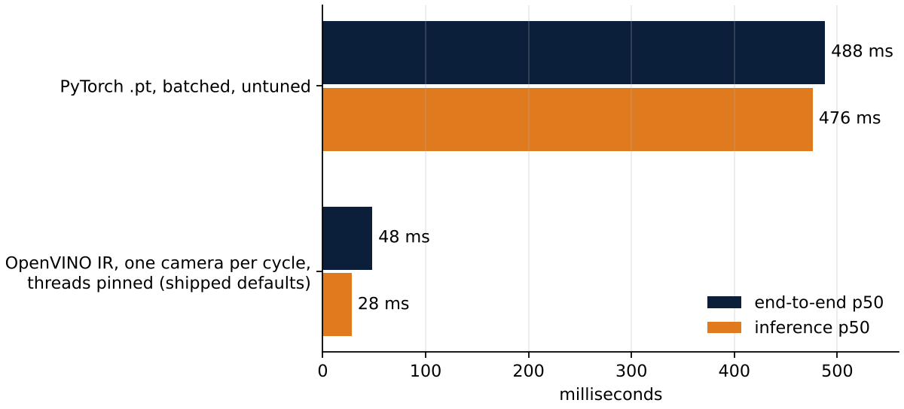
Figure 6. Median end-to-end and inference latency before and after optimisation (development host).
Per-stage instrumentation decided the fix. In the untuned pipeline, inference took 98.6 % of each cycle, and all the code I had written myself took under 2 %. Only the forward pass was worth optimising, through the runtime, the model size or the input size. The second-largest gain came from noticing that two measurements which should have agreed did not: inference inside the application was three times slower than in the benchmark, because the capture threads’ OpenCV pools competed with the model for the cores. Pinning capture to one thread per camera closed the gap. One honest qualification applies. The pipeline grew while it was being optimised, so the intermediate measurements are not comparable, and I report only the two endpoints measured under identical conditions.

8.2 Detection performance
The validation figures (P 0.942, R 0.955, mAP@0.5 0.966) are strong for a seven-class site detector, but they carry four limits:
- they are averages over the classes;
- they come from the split used to select the model;
- they share their viewpoints with the training data;
- they measure detection, not decision.
They say nothing about carried gloves or prescription spectacles. In operation the model is no longer the main source of risk. The false stops that mattered came from viewpoints it was not designed for, and the false permits come from decisions the schema cannot express (Section 4.2) and from the software–machine boundary (Section 6.4).

8.3 The operator feedback finding
The most consequential result came from watching the deployed system in use and talking to the operators. Three things emerged.
- Posture. Operators customarily stand at an angle to the machine, to inspect the flatness of the trim. That is outside the cameras’ favourable viewing angle, so items are missed and the machine stops falsely.
- Aprons. Operators want to wear aprons against grinding dust, and the model had no apron class.
- Large workpieces. Larger parts force the operator to stand further back, partly out of frame. The station then finds nobody, and the machine cannot start.
Three remedies were identified:
- reposition the cameras for large workpieces;
- angle them so that every class stays observable in the posture operators actually adopt;
- retrain with an apron class. This has since been done: the station runs best-apron, an eight-class version (Table 4), and its configuration accepts an apron in place of sleeves.
This is a requirements failure, not a model failure. The model correctly reported that it could not see a glove turned away from it. The camera placement had been derived from an assumed posture, not the observed one. Every downstream step inherited that assumption, including the validation set, so no metric could reveal it. The finding generalises: across the plant, camera placement cannot be specified from the machine layout alone. It must be derived from how each operation is actually performed, which is why the rollout began with a gemba walk.

8.4 Evaluation against the objective
Section 1.3 set four requirements. Measured against them, the system meets two in full, one in part, and one only with qualifications that the rollout must close.
- It withholds the run permissive. Met. Only the OK status permits the motor. Every other status, an unreadable input and the e-stop all withdraw it. Nothing restarts the motor without a fresh press of the button. The correction window delays the stop on purpose for every item except a wrong sleeve, by 5–8 s. That delay is a documented trade-off, but one that still needs its EHS position.
- It judges the operator at the machine. Met, with one known limitation. The largest-person filter and the containment test ignore bystanders and their equipment, but the person nearest the camera is judged. That is usually, though not necessarily, the person at the belt.
- It responds quickly enough. Met. At about 40 ms, the pipeline is no longer what limits the response. The station declares a violation in 0.4 s plus the class’s hold. Its response time is now a choice made in the logic rather than a limit set by the hardware, which is the honest answer to management’s concern.
- It is steady enough to be accepted. Partly met. The hold and occlusion windows, and later the single-glove requirement, removed the chatter caused by occluded gloves and sleeves. The false stops caused by the angled working posture and by large workpieces remain, until the cameras are repositioned.
Two properties the objective took for granted are not yet met:
- Fail-safe behaviour at the boundary between software and machine (Section 6.4).
- Detection of decision failures such as carried gloves (Section 4.2).
Neither is a matter of model accuracy, and both are on the list of open items in Chapter 11.

9. Rollout and secondary assignments

9.1 Plant-wide rollout
The rollout to every flat belt grinder (45 machines when specified; the deployment tooling now says 32) is to be carried out through an external supplier. I developed the specification package over several rounds of review:
- The RFQ. I added a sequence of operations to it, because the system is not a catalogue item and the split of responsibility between supplier and site had to be unambiguous.
- A Bill of Quantities and Scope of Work for each station.
- Acceptance test protocols, with a pulled-wire test on each switch input.
I also evaluated industrial cameras to replace the consumer webcams, which are not defensible in a dusty environment. The specification asked for USB 3 direct to the PC on a 2 m cable, and working distances of 0.5–1.0 m for the front camera and 1.0–1.5 m for the side camera. A gemba walk surveyed every grinder in the condition in which it actually operates.
Standardisation rests on a single self-testing Windows installer whose only per-station input is the machine number. Here two earlier decisions pay off: rejecting the machine-dependent MJPEG setting saves an operating-system change at every station, and local annotation lets every station contribute failure cases without an exception to the data rules.
The station was also redesigned as an integrated tower that fits within the grinder’s own envelope: 0.76 m³ against 1.63 m³ for the prototype’s separate units, a 53 % reduction in volume. This answers management’s comment on the size of the panel.

9.2 Secondary assignments
Droplet transfer measurement in robotic TIG welding. Droplet transfer frequency indicates weld quality, and the cell had no way to measure it. I reviewed the candidate techniques: optical observation of the arc, analysis of the process’s electrical signals, and indirect acoustic or optical sensing. I consulted the welding engineer on the practical constraints and pitfalls, reviewed the literature, and presented the candidate methods with a recommendation to the team. [Recommended method and rationale: to be completed.]
Automated trimming cell. Tube trimming before welding is manual, and an automated cell is under development. I attended a vendor meeting on robotic laser profile cutting, covering:
- recurring difficulties with bending accuracy;
- techniques to mitigate them;
- fixturing.
These are the governing constraints for trimming a tube whose as-received geometry varies. The parallel with Vision Guard is direct: the system plans against idealised geometry, and the process supplies variation.
Welding automation roadmap 2026–2030. I supported the preparation of a presentation that places the individual projects within the site’s longer-term plan for its welding operations.

10. Critical reflection

10.1 Supervision
[To be written by the author. The guidelines ask for a critical reflection on supervision. For example: how often and in what form you met your industrial supervisor; how much independence you had, and whether it suited the project; the support you received from EHS, maintenance and IT; what worked well; and what you would have wanted differently.]

10.2 Learning achievements
Deployment is most of the work. The model passed 0.96 mAP@0.5 early. Most of the internship went on what stands between that number and an operator starting a machine.
Diagnose before optimising. Instrumentation showed inference at 98.6 % of the cycle. Without it I would have optimised my own code, which cost under 2 %.
Requirements come from watching the operation. No metric revealed the angled working posture. Observation and conversation did, just as observation had produced the project in the first place.
Take the deployment constraint seriously, even when it costs performance. The MSMF route worked, and rejecting it still proved the right decision once the rollout was in view.
A safety system lives inside a process. The system became a control when the risk assessment described it, not when the code ran. The questions EHS asked (what happens when a camera, the network or the PC fails?) led to the analysis that found my own code’s weakest points.
Different audiences need different accounts of the same system. Explaining a part of it to someone who would never read its code was the best test of whether I understood it.

10.3 Problems and what I would do differently
- Camera placement was decided too early. I would observe operators at work before fixing the camera positions and before capturing training data, not after deployment.
- Requirements drifted away from the documents. The correction window, the switch wiring and the scheduler all changed after they had been documented, and the specifications had to follow. Keeping one owner for those documents, and a record of each change, would have saved review rounds.
- Measurements were not archived. The training run directory, the per-class metrics and the nano export were not kept, so this report cannot show the per-class results. I would archive every run with the model it produced.
- Safety integration lagged behind the software. The hard-wired e-stop is still pending, and two software failure paths were found only in the final review. A failure-mode analysis written before the first installation, not after it, would have found them earlier.
- A comparison that was not like for like stood for months. The nano was judged slower on a measurement that differed from the small model’s in how it was exported. I let it go once the larger model met the budget. A like-for-like benchmark at the end showed the opposite result. I would compare models only through one export and one benchmark tool.

11. Conclusion and outlook
The internship delivered a working, approved and replicable PPE interlock:
- a two-camera, CPU-only station with about 40 ms latency;
- a site-specific seven-class detector;
- compliance logic that separates detection from decision and balances responsiveness against stability class by class;
- two MOC approvals, an updated risk assessment and an SOP;
- a rollout package for every flat belt grinder at the plant.
It also produced a finding that changed how the rollout is specified, and an honest list of what must be fixed before the system is relied upon.
The open items, in order of priority, are:
- Fit the hard-wired emergency-stop safety relay.
- Discard stale per-camera results.
- Switch the outputs off on any pipeline exception.
- Verify the relay module’s communication watchdog.
- Document the EHS position on the 5–8 s correction windows and the single-glove requirement.
- Run ppe.evaluate on the held-out test set and fill Table 5.
- Reposition the cameras for the observed posture.
- Keep model comparisons like for like: one export tool, one benchmark, one test set.
Attachment D lists all open items. Beyond them, the outlook is:
- use the latency headroom to capture the accuracy that RF-DETR showed is available;
- make the decision failures measurable with a targeted evaluation set, then fix them with a relational test of each glove against the detected hands;
- close the loop from the capture mode to periodic retraining;
- aggregate stop records across the fleet into evidence for tuning;
- apply the approach to other manual operations, starting each time from how the operation is actually performed.

References
[1] J. Redmon, S. Divvala, R. Girshick and A. Farhadi, “You Only Look Once: Unified, Real-Time Object Detection,” in Proc. IEEE CVPR, 2016, pp. 779–788. arXiv:1506.02640.
[2] G. Jocher and J. Qiu, “Ultralytics YOLO11,” Ultralytics, 2024. [Online]. Available: https://docs.ultralytics.com/models/yolo11/
[3] N. Carion, F. Massa, G. Synnaeve, N. Usunier, A. Kirillov and S. Zagoruyko, “End-to-End Object Detection with Transformers,” in Proc. ECCV, 2020, pp. 213–229. arXiv:2005.12872.
[4] “RF-DETR: a real-time object detection transformer,” software repository, 2025. [Online]. Available: https://github.com/roboflow/rf-detr
[5] Intel Corporation, “OpenVINO Toolkit documentation,” 2026. [Online]. Available: https://docs.openvino.ai/
[6] T.-Y. Lin et al., “Microsoft COCO: Common Objects in Context,” in Proc. ECCV, 2014, pp. 740–755. arXiv:1405.0312.
[7] Safety of machinery — General principles for design — Risk assessment and risk reduction, ISO 12100:2010.
[8] Modbus Organization, “MODBUS Application Protocol Specification V1.1b3,” 2012.
[9] PyModbus contributors, “PyModbus,” version 3.16. [Online]. Available: https://github.com/pymodbus-dev/pymodbus
[10] Safety of machinery — Emergency stop function — Principles for design, ISO 13850:2015.
[11] Safety of machinery — Electrical equipment of machines — Part 1: General requirements, IEC 60204-1:2016+A1:2021.
[12] Low-voltage switchgear and controlgear — Part 5-5: Electrical emergency stop device with mechanical latching function, IEC 60947-5-5.
[13] GE Aerospace, Pune, “EHS Risk Assessment, flat belt grinding station,” doc. no. [EHSRA reference]. Internal.
[14] GE Aerospace, Pune, “Management of Change record: PPE detection interlock,” no. [MOC reference 1]. Internal.
[15] GE Aerospace, Pune, “Management of Change record: relocation,” no. [MOC reference 2]. Internal.
[16] GE Aerospace, Pune, “Standard Operating Procedure: PPE detection station,” doc. no. [SOP reference]. Internal.

Attachments

Attachment A — Training record
Table A1. Training configuration, recovered from the checkpoint (models/ppe-yolo11s.pt, key train_args).
Parameter | Value | Parameter | Value
Initial weights | yolo11s.pt (COCO) | Image size | 640 (square, rect: false)
Epochs planned / run | 150 / 105 | Patience | 30 (best epoch 75)
Batch | 16 | Optimiser | auto (resolved choice not recorded)
lr0 / lrf | 0.01 / 0.01, cosine | Momentum / weight decay | 0.937 / 0.0005
Warm-up | 3 epochs | Loss gains box / cls / dfl | 7.5 / 0.5 / 1.5
HSV h / s / v | 0.015 / 0.7 / 0.4 | Rotation / translate / scale | ±5° / 0.1 / 0.5
Flip left–right / up–down | 0.5 / 0 | Mosaic / mixup / copy-paste | 1.0 / 0 / 0
Auto-augment / erasing | RandAugment / 0.4 | AMP / seed | on / 0 (deterministic)
Device | CUDA GPU 0 | Duration | 7,180 s (≈ 2 h)
Ultralytics (train / export / run) | 8.4.126 / 8.4.130 / 8.3.253 | Export | OpenVINO IR, FP32, batch 1, static 640 × 640
Table A2. Validation metrics of the seven-class model (v2) at its best epoch (75), all classes. Table 4 gives the other versions, including the apron model the station now runs. The per-class breakdown and the confusion matrix are to be regenerated with yolo detect val model=models/ppe-yolo11s.pt data=<data.yaml> split=val plots=True.
Precision | Recall | F1 | mAP@0.5 | mAP@0.5:0.95
0.942 | 0.955 | 0.949 | 0.966 | 0.840
[Dataset composition (images per split, instances per class) and per-class metrics: to be added.]
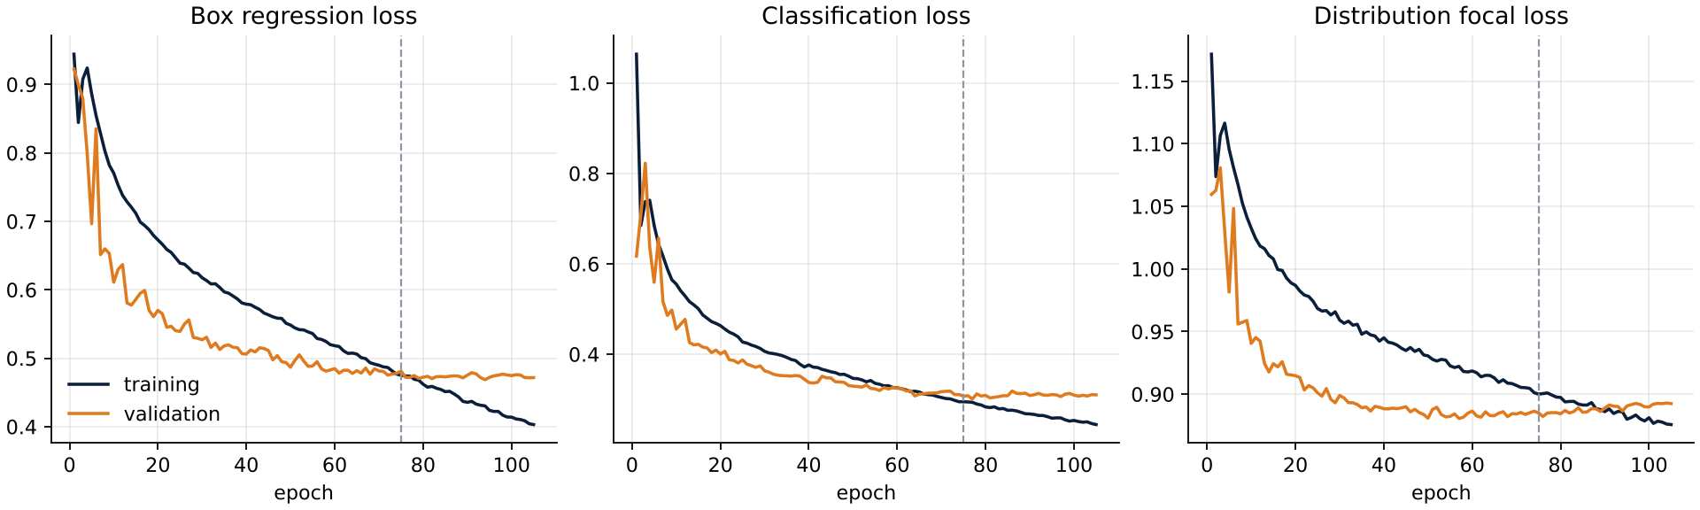
Figure A1. Training and validation losses of v2; dashed line at the best epoch.
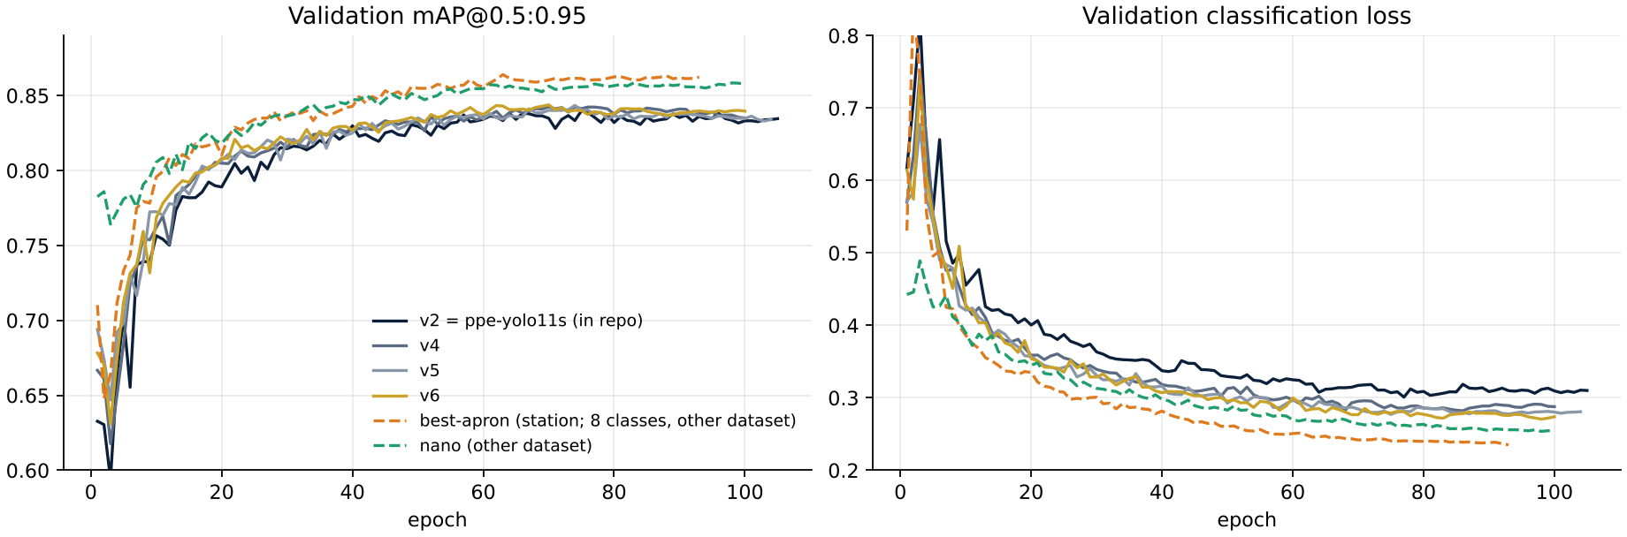
Figure A2. Validation mAP@0.5:0.95 and classification loss of the six model versions. Dashed lines were trained on different data and are not directly comparable.
[Per-class AP@0.5, AP@0.5:0.95, recall and station decisions on the common test set (Tables A3–A6): filled by python -m ppe.evaluate ... --report internship-report.md.]

Attachment B — Compliance parameters and Modbus map
Table B1. Per-class settings of the station configuration, and the time from an item leaving view to the motor stopping, simulated with the station’s own logic on a running machine. Values from the first configuration are given in brackets where they changed.
Class | Confidence | Containment | Hold | Count | Correction window | Motor stops after
Head net | 0.50 | 0.5 | 0.8 s | 1 | 8 s (5 s) | 9.3 s (6.3 s)
Safety glasses | 0.60 | 0.5 | 1.1 s | 1 | 5 s (0 s) | 6.6 s (1.6 s)
Mask | 0.60 | 0.5 | 0.7 s | 1 | 8 s (5 s) | 9.2 s (6.2 s)
Gloves | 0.67 (0.60) | 0.1 | 1.0 s | 1 (2) | 5 s (0 s) | 6.5 s (1.5 s); one of two removed: never (5.5 s)
Sleeves | 0.75 | 0.3 | 1.2 s | 1 (2) | 8 s (5 s) | 9.7 s (6.7 s); one of two removed: never (10.5 s)
Apron | 0.60 | 0.5 | 1.2 s | 1 | 8 s | as sleeves (alternative)
Wrong Sleeve (forbidden) | 0.90 | 0.5 | 1.2 s (0.4 s) | 0 | 0 s | 0.5 s after it appears
Person (subject) | 0.70 (0.25) | — | 1.0 s | — | — | STANDBY, motor stops after ≈ 2 s
Other settings: confirmation periods OK 1.0 s, VIOLATION 0.4 s, STANDBY 1.0 s, DEGRADED 0.5 s; occlusion window 8 s (5 s), which no longer applies with a count of one; runtime NMS IoU 0.50; global confidence floor 0.35.
Table B2. Modbus map of the relay module (addresses 0-based).
Signal | Object | Address | Channel | 1 means
Green / amber / red lamp | Coil | 0 / 1 / 2 | DO1–DO3 | lamp on
Buzzer | Coil | 3 | DO4 | sounding
Motor permissive | Coil | 4 | DO5 | permissive granted
E-stop | Discrete input | 0 | DI1 | operated (normally open)
Push button | Discrete input | 1 | DI2 | pressed (normally open)
Lamps: red means an e-stop or a violation; green means compliant and running; amber means compliant and idle, or DEGRADED; dark means STANDBY.
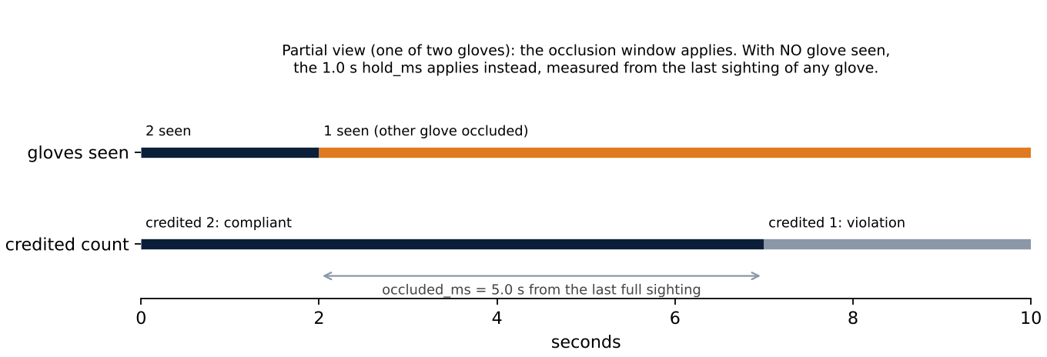
Figure B1. The two windows for a pair of gloves.

Attachment C — Fail-safe analysis
Table C1. Behaviour of the implemented code under failure.
Failure | What the code does | Grinder ends up
Both cameras stop | DEGRADED after 1.5 s stale + 0.5 s confirm; latch dropped | Inhibited (≈ 2 s)
One camera stops, other runs | Stale camera’s last result still counted | Can stay enabled (simulated)
Camera streams a frozen image | Treated as fresh frames | Can stay enabled
Model fails to load | Board blanked before load; pipeline closes the board | Inhibited
Inference throws mid-run | Thread ends without blanking; process stays up | Stays in last state (simulated)
Relay unreachable | Latch dropped in software; write cannot arrive | Last state unless module watchdog
Crash or kill | Supervisor restarts after ≥ 2 s; board blanked on connect | Enabled until restart
Hang, PC power loss, cable pulled | Nothing detects it | Last state unless module watchdog
E-stop pressed | Read on DI1; latch dropped | Inhibited, via software only
E-stop wire broken (normally open) | Reads as “not pressed” | E-stop ineffective
Operator leaves | STANDBY after ≈ 2 s | Inhibited

Attachment D — Open items and discrepancies
Table D1. Open technical items.
# | Item | Next action
1 | Hard-wired e-stop | Fit the safety relay; normally closed, direct-opening contacts in the contactor circuit
2 | Single frozen camera | Discard per-camera results older than 1.5 s
3 | Inference exception | Blank the board and exit, so the supervisor restarts
4 | Module watchdog | Enable; test by pulling the network cable with the motor running
5 | Modbus on the critical path | Measure the relay stage on the station
6 | Apron model | Add its validation results; confirm in the risk assessment that an apron replaces sleeves
7 | Spectacles and carried gloves | Targeted evaluation set; relational hand test
8 | Camera geometry | Reposition and angle for the observed posture
9 | Correction windows and counts | Document the EHS position on 5 s for gloves and glasses, 8 s for the rest, and one glove instead of two
10 | Nano anomaly | Resolved: nano is 2× faster when exported like the small model
11 | Default capture configuration | Align the shipped default with the station (640 × 480) before rollout
12 | Library version split | Align at the next retraining
Table D2. Discrepancies between the project record and the code.
Topic | Project record | Code
Emergency stop | hard-wired, independent | NO contact into DI1; no safety relay yet
Correction window | lets a slipped glove be corrected | First 0 s for gloves and glasses; now 5 s on the station, as the notes describe
Modbus thread | off the critical path | on the pipeline thread
Required PPE | glasses, gloves, sleeves, mask | also head net; Wrong Sleeve forbidden
Capture | 640 × 480 raw; MJPEG rejected | Station 640 × 480 and 640 × 360 via DirectShow (MJPEG request not applied); shipped default still 1280 × 720
Original capture size | 1280 × 1080 | 1280 × 720 measured
Scheduler history | freshest-frame selector | batching, then round-robin with a turn-spending fix
Dataset provenance | site data only, no cloud tools | dataset path names a cloud platform’s export
Rollout scope | 45 machines | tooling configured for 32
Required PPE count | gloves and sleeves (pairs) | first 2 each; station now 1 each

Attachment E — Code and configuration
The station software is held in the project repository (ppe/, main.py, config.yaml). The key excerpts are the compliance decision (ppe/tower.py:209-216), the Modbus write (ppe/tower.py:557-577), the camera scheduler (ppe/pipeline.py:238-243) and the letterbox (ppe/letterbox.py:45-65). They are reproduced, with the configuration and the training hyperparameters, in Appendices A and B of the full working draft (docs/report/internship-report-full-draft.md). The relay module’s network address is redacted there.
# ppe/pipeline.py:238-243 — camera scheduler (one camera per cycle on a CPU)
if self.detector.batches:
return fresh
n = len(self.cameras)
chosen = min(fresh, key=lambda f: (f.index - self._turn) % n)
self._turn = (chosen.index + 1) % n
return [chosen]
# ppe/tower.py:209-216 — the verdict
def _evaluate(self) -> Status:
required = [c for c in self.classes if c.required]
if not required or self.unavailable():
return Status.DEGRADED
if self._subject is not None and not self._subject.present:
return Status.STANDBY
return Status.OK if all(c.satisfied for c in required) else Status.VIOLATION

Attachment F — Figures still required
- F1. Operator interface in operator mode, with no person in frame.
- F2. The installed station, preferably from the requested 3D model.
- F3. Three-panel examples of correct operation: a compliant front view; an occluded glove credited; a bystander set aside.
- F4. Three-panel examples of failure cases: a side-view miss; glove–sleeve confusion; the angled posture.
- F5. Normalised confusion matrix from the validation run.
- F6. The annotation workflow.
All faces must be blurred, and no component may be visible.

