**ITEC 4200 Advanced Database Semester Project**

Project Name: Concert Halls

Spring 2021

Samuel Mckinney & Yaris Cotto (Group 3)

[smckinney1@ggc.edu](mailto:smckinney1@ggc.edu) & [ycottoquinones@ggc.edu](mailto:ycottoquinones@ggc.edu)

Table of Contents

PART I. Executive Summary 3

Objective 3

Goals 3

Solution 3

Benefits 3

Project Outline 3

PART I. Schema Design 4

PART I. Entity-Relationship Diagram 5

PART II. DDL: Schema Implementation 6

PART III. DML: Table Implementation 7

Customer Outputs and Table 7

OrderT Outputs and Table 9

Hall Outputs and Table 11

Performer Outputs and Table 13

PerformanceT Outputs and Table 15

Tickets Outputs and Table 17

Part IV. Queries 19

Queries 1-3 19

Query 1 19

Query 2 19

Query 3 20

Queries 4-5 20

Query 4 20

Query 5 21

Queries 6-7 21

Query 6 21

Query 7 22

Part V. Schema Objects 22

# PART I. Executive Summary

### Objective

The purpose of this database is to help administrate the operations of multiple concert halls by sorting and ordering tickets, tracking available and booked concert halls, keeping track on customers, and sorting the performances being performed.

### Goals

This database aims to simplify the storage of data involved in the day-to-day operation of multiple concert halls by simply storing data and making use of queries and reports that would give reliable, relevant information to ensure smooth running, that no concert hall is overbooked, every performer can perform their booked performance, and that every paying customer gets a working ticket.

### Solution

We will be making a total of six tables using Oracle 18c Express to tackle the goals above: ***Customer, Hall, Order, PerformanceT, Ticket,*** and ***Performer***. All six tables would, at a bare minimum, be crucial to the daily operating of multiple concert halls and needed to properly schedule, run a ticketing system, and generate queries and reports needed for success.

### Benefits

A database will provide the means necessary to generate helpful information such as reports, trends, customer insights, or needed queries, but also help make certain information convenient and readily available to customers such as the status of their own ticket.

### Project Outline

This project will contain the following major components:

* Schema Design
* Entity-Relationship Diagram
* Table Implementation
* Queries
* Reports

## Schema Design

**CUSTOMER** (Customer_ID, Last_Name, First_Name, Email_Address)

**ORDER** (Order_ID, Order_Date, Total, Customer_ID)

FK Customer_ID -> CUSTOMER

**HALL** (Hall_ID, CapacityH, Hall_Name)

**PERFORMER** (Performer_ID, Performer_First_Name, Performer_Last_Name, Genre)

**PERFORMANCET** (Performance_ID, Hall_ID, Performer_ID, Performance_Date)

FK Hall_ID -> HALL

FK Performer_ID -> PERFORMER

**TICKET** (Ticket_Number, Order_ID, Performance_ID)

FK Order_ID -> ORDER

FK Performance_ID -> PERFORMANCET

## Entity-Relationship Diagram

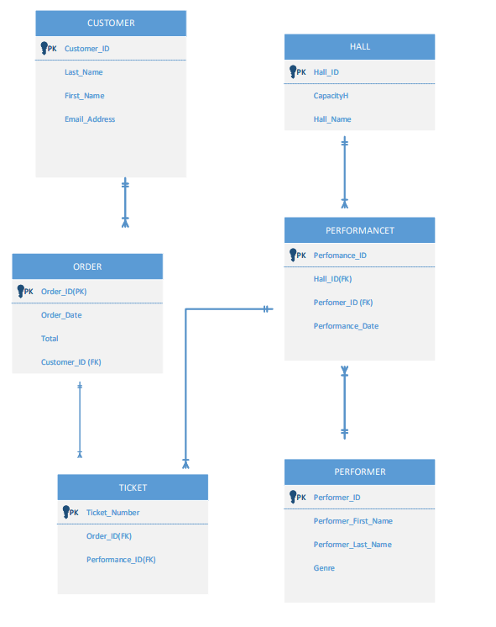

# PART II. DDL: Schema Implementation

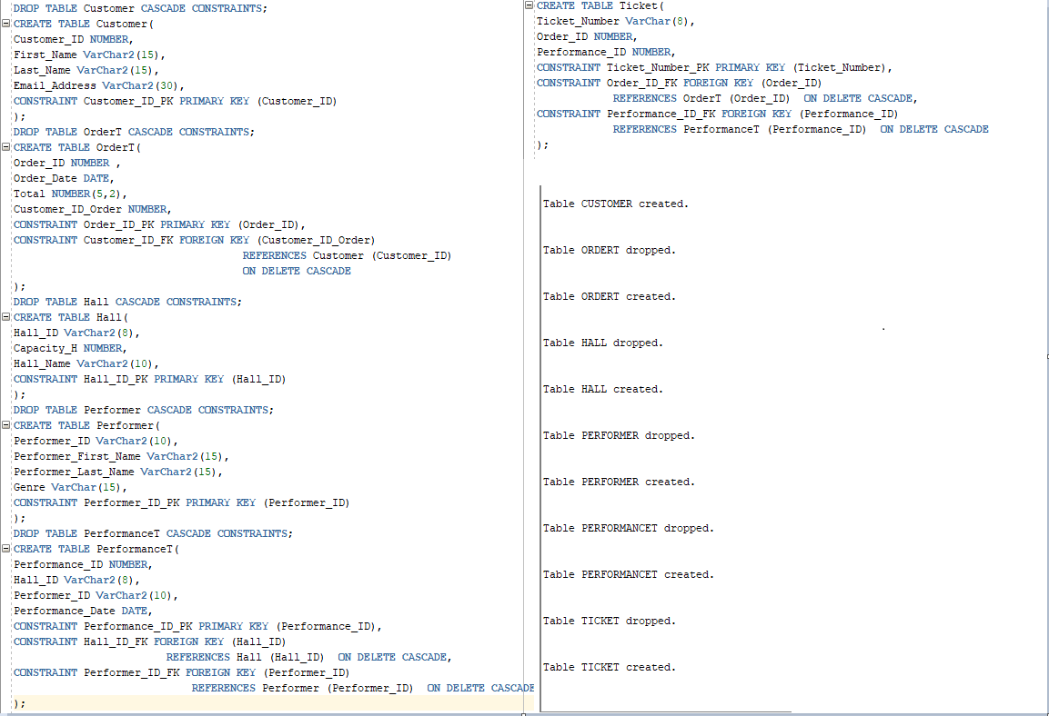

# PART III. DML: Table Implementation

## Customer Outputs and Table

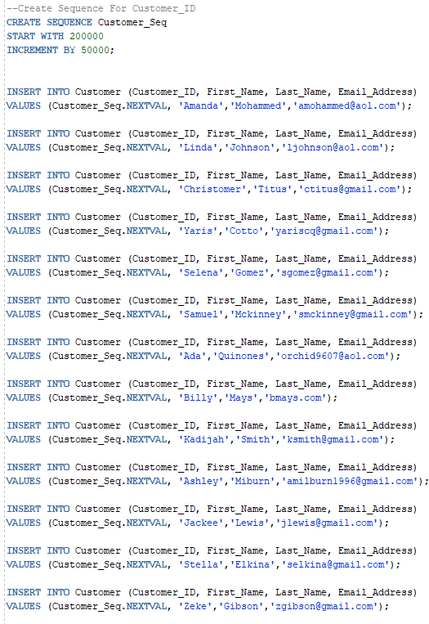

## OrderT Outputs and Table

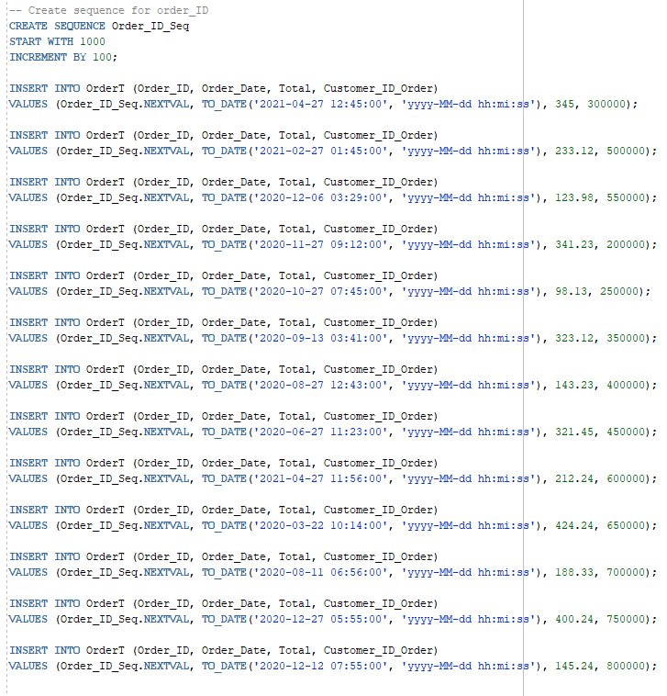

## Hall Outputs and Table

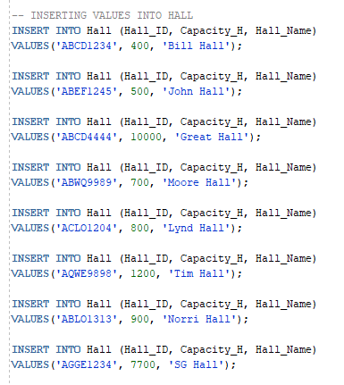

## Performer Outputs and Table

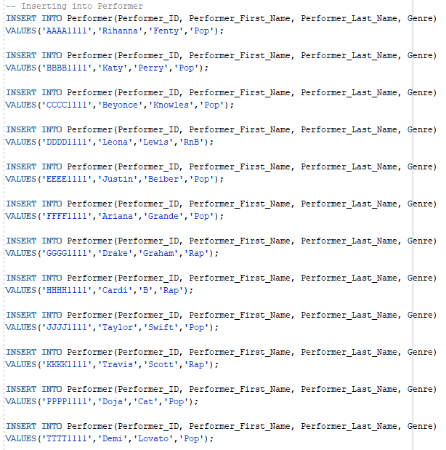

## PerformanceT Outputs and Table

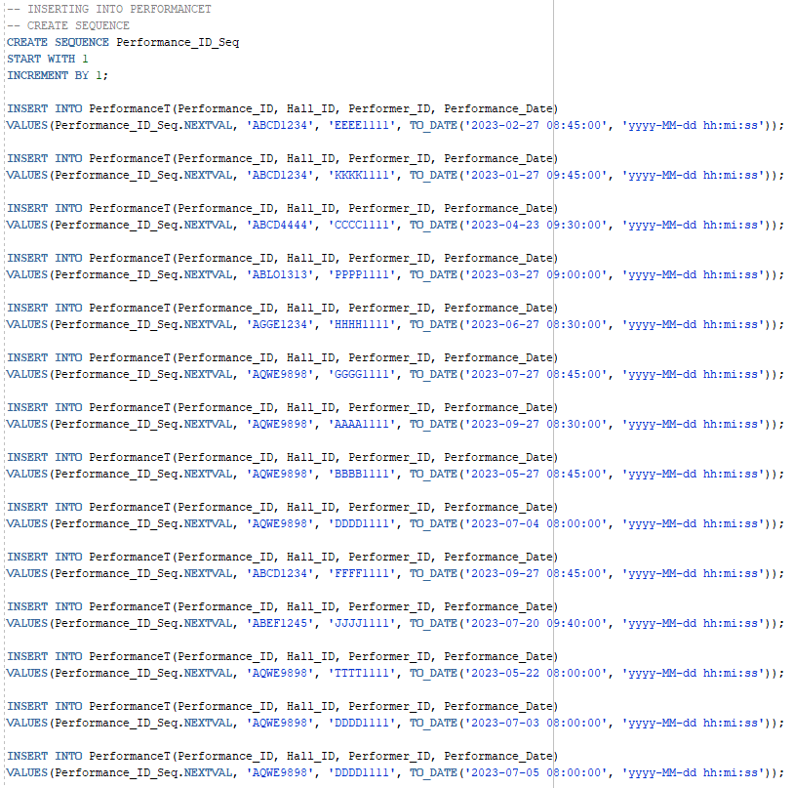

## Tickets Outputs and Table

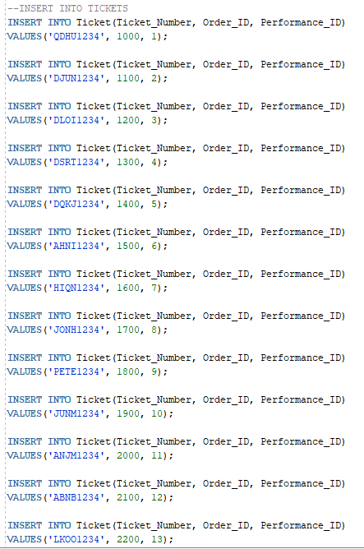

# Part IV. Queries

## Queries 1-3

### Query 1

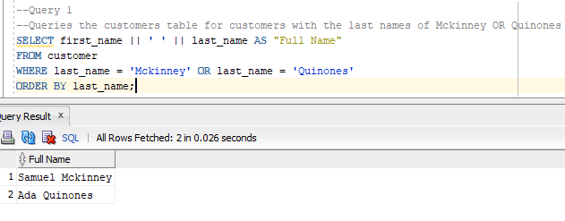

### Query 2

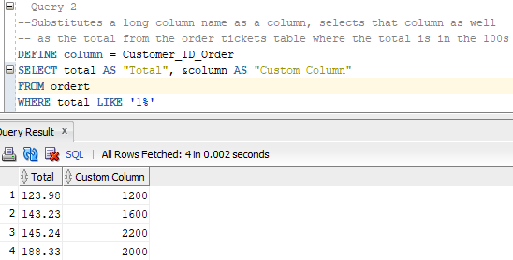

### Query 3

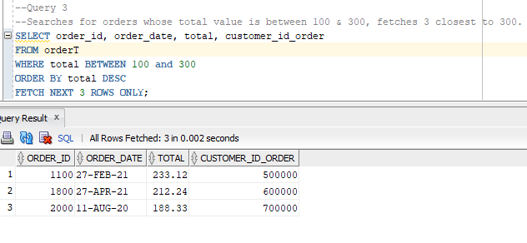

## Queries 4-5

### Query 4

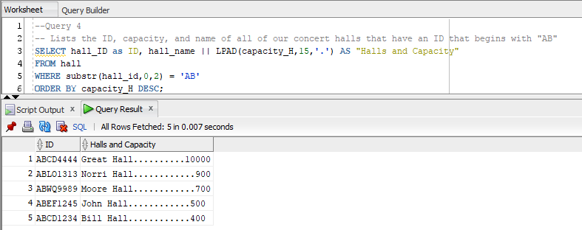

### Query 5

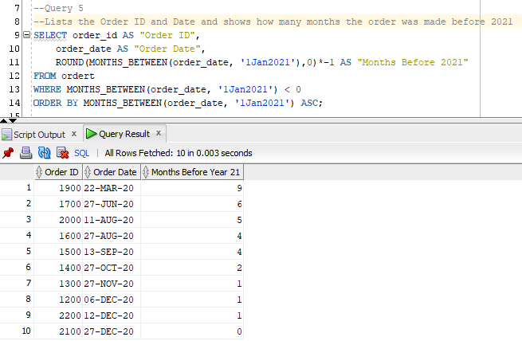

## Queries 6-7

### Query 6

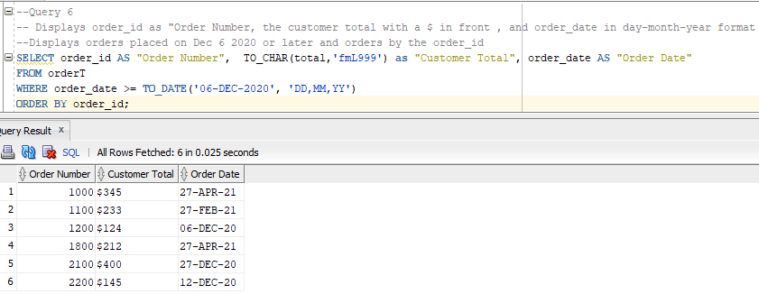

### Query 7

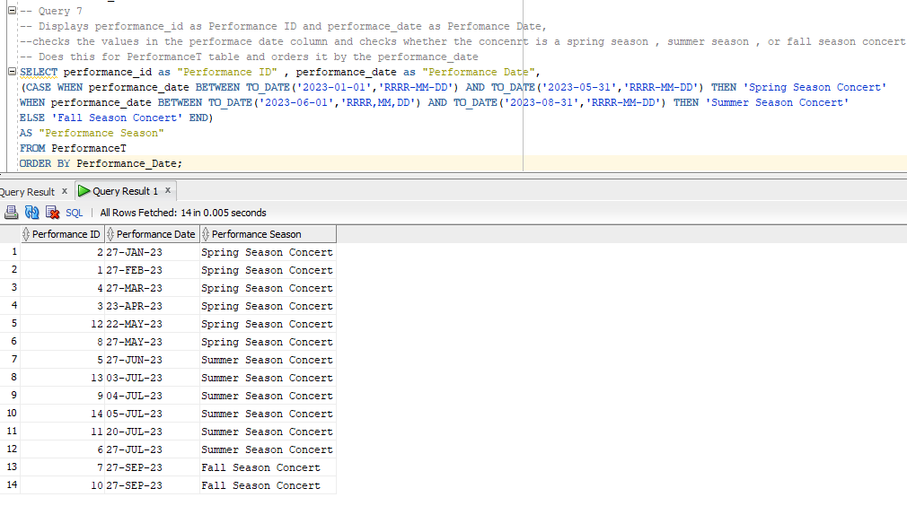

# Part V. Schema Objects