DevOps and Git in a Nutshell

* Continuous improvement – commits
* Simultaneous stability and development – branches
* Improved quality – pull requests

Git Overview

* Version control enables teams to manage a collection of files in a agile way
* Git is a distributed version control system
  + Each user has a local copy of a Git repository
* A repository contains the project history as commits
  + A commit is a snapshot of the entire project
* You have the choice of working with Git using a command line and/or a graphical interface

Sourcetree Installation and Getting Started

* Source tree can be installed on Mac or Windows at <https://www.sourcetree.app.com/>
* Other Git clients can be found at <https://git-scm.com/downloads/guis>

Git locations

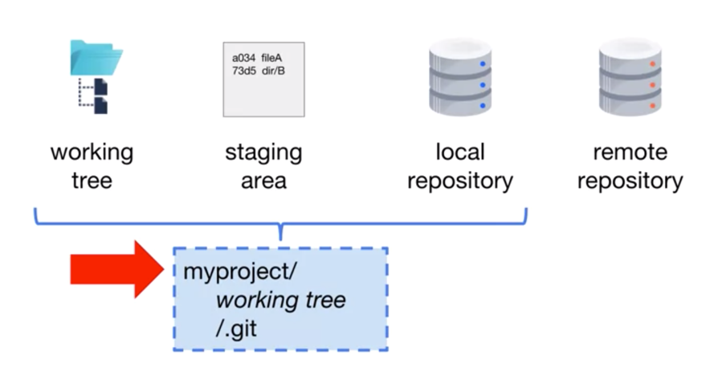

The working tree contains the project files for a single commit;

The staging area holds a list of files that will be included in the next commit;

The local repository contains all of the commits of the project;

On your local computer, you have a project directory that contains the working tree as well as a hidden .git directory. The staging area and local repository are located in this directory;

The remote repository contains the commits of the project on a remote computer;

* The working tree, .git directory, staging area and local repository are in the project directory.

Commit to a Local Repository

* *git status* – view the status of files in the working tree and staging area
* *git* *add* <*file-or-directory>* - add untracked or modified files to the staging area
* *git* *commit* – create a snapshot of the current project
  + *git commit [-m “short message”]* – add short message to your commit
* *git log* – view the commit history
  + *git log --oneline* – condensed version of the log
  + *git log -#* - limit the log to the most recent # commits

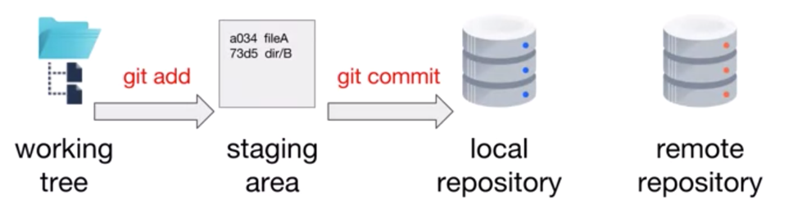

Create a Remote Repository

* A remote repository is a bare repository
* Often serves as the project’s source of truth
* Hosting providers make creating remote repositories easy

Push to a Remote Repository

* Clone: a clone is a local copy of a remote repository

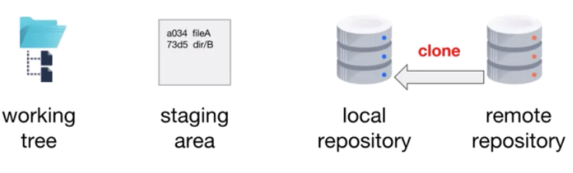

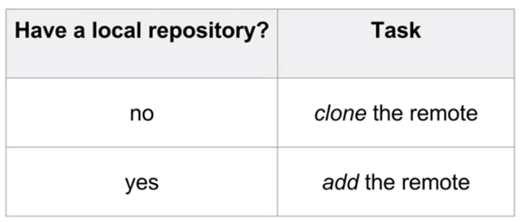

* *git clone <url/to/projectname.git> [localprojectname]* – create a local copy of a remote repository
* *git remote* --verbose – display information about remote repositories associated with the local repository
* *git remote add <reponame> <url>* - add a remote repository
* *git push [-u] [<repository>] [<branch>]* – write commits for a branch to a remote repository
  + *<repository>* can be a name (shortcut) or url
  + *-u* track this branch (--set-upstream)