Git’s Graph Model

* Git uses a directed acyclic graph (DAG) to represent commit history
  + *git log --oneline --graph*
* Commits point to their parent commits

Git IDs

* Git object names are also known as Git IDs
* Git objects are named with SHA-1 values
* SHA-1 values are unique for a given piece of content (statistically speaking)
* Git IDs are often shortened to the first four or more characters
* Use git *hash-object <file>* to create a SHA-1 for any content
* *git show <shortened Git ID>* to identify an object

Git Reference

* Reference is user-friendly name that points to
  + A commit SHA-1 hash
  + Another reference
    - Known as symbolic reference
* ~ refers to a prior commit
  + ~ or ~1 = parent
  + ~2 or ~~ = parent’s parent
* ^ refers to a parent in a merge commit (^parentnum)
  + ^ or ^1 = first parent of the commit
  + ^2 = second parent of a merge commit
  + ^^ = first parent’s first parent
* *HEAD* is a reference that points to the current commit
  + *git show HEAD*
* Tag is a reference/label attached to a specific commit

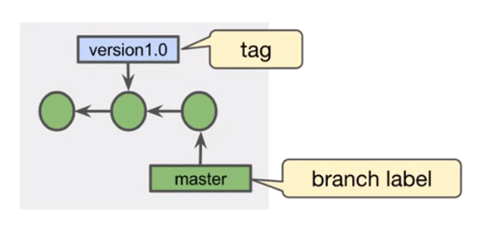

* + Lightweight tag: a simple reference to a commit
  + Annotated tag:
    - A full Git object that reference a commit
    - Include tag author information, tag date, tag message, the commit ID
    - Optionally can be signed and verified with GNU Privacy Guard (GPG)
* *git tag –* view all tags in the repository
* *git show <tag> -* show information associated with the tag
* To tag a commit with a lightweight tag:
  + *git tag <tagname> [<commit>]*
  + *<commit>* defaults to *HEAD*
* To tag a commit with an annotated tag:
  + *git tag -a [-m <msg> | -F <file>] <tagname> [<commit>]*
  + *<commit>* defaults to *HEAD*
* git push does not automatically transfer tags to the remote repository
* To transfer a single tag:
  + *git push <remote> <tagname>*
* To transfer all of your tags:
  + *git push <remote> --tags*

Git branches

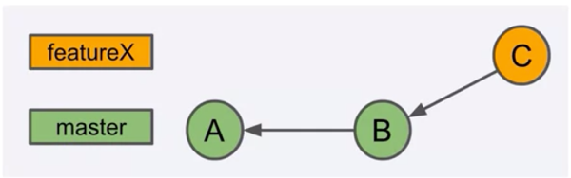

* A branch is the set of commits that trace back to the project’s first commit
  + Brach master: A, B
  + Brach feature X: A, B, C
* A branch can have two types:
  + Topic
    - A feature, a bug fix, a hotfix, a configuration change, etc.
  + Long-lived
    - Master, develop, release, etc.
* *git branch* – see a list of branches in the local repository, the branch with a \* is the branch that you are currently on
* *git branch <name>* - create a branch, that only creates a branch label
* *git checkout <branch-or-commit>* - check out a branch or a commit (to switch to a branch)
  + *git checkout -b <branchname>* - the -b option combines git branch and git checkout, but only for new branches
* Detached HEAD:
  + The HEAD reference is detached from a branch label

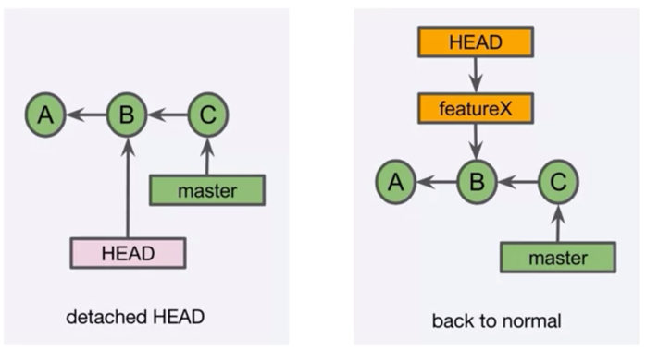

* Delete a branch
  + *git branch -d <branch>*
  + *git branch -D <branch>*
* Dangling commits
  + Commits that do not belong to any branch (usually because of the delete of a branch label)

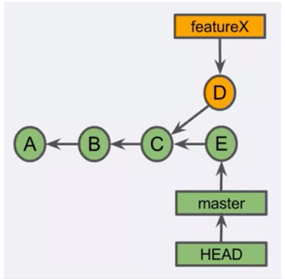

* + Undo an accidental branch delete: git reflog - return a local list of recent HEAD commits

REVIEW

A branch is a set of commits that trace back to the project's first commit.

Creating a branch creates a branch label.

Checkout involves updating the HEAD reference and updating the working tree.

A detached HEAD reference points directly to a commit.

Fix a detached HEAD by creating a branch.

Deleting a branch deletes a branch label.

Dangling commits will eventually be garbage collected.

Merging

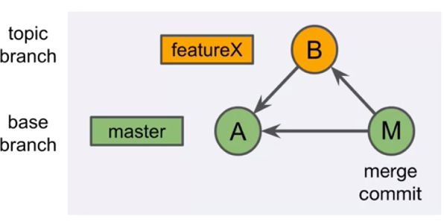

* Merge types:
  + Fast-forward merge
  + Merge commit
  + Squash merge\*
  + Rebase\*
* Fast-forward (FF) Merge

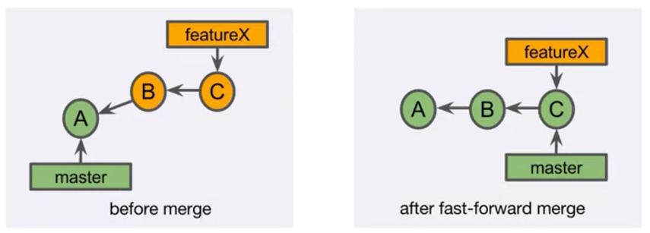

* + Fast-forward merge is possible if no other commits have been made to the base branch since branching
  + Performing an FF merge
    - *git checkout master*
    - *git merge featureX*
      * attempting an FF is default
    - *git branch -d featureX*
* Merge commit
  + Combines the commits at the tips of merged branches
  + Places the result in the merge commit

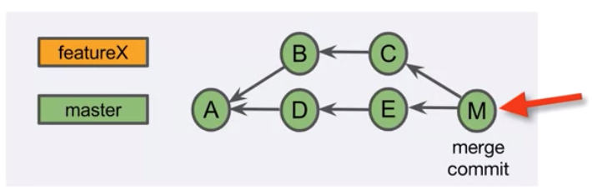

* + Performing a merge commit
    - *git checkout master*
    - *git merge featureX* 
      * accept or modify the merge message
      * optionally you can use git merge --no-ff featureX to always perform non-FF merge
    - *git branch* -*d featureX*