3GPP RAN WG3 Meeting #123 R3-240384

Athens, Greece, 26th February – 1st March 2024
CR-Form-v12.2
CHANGE REQUEST
 | 37.483 | CR | 0093 | rev | 2 | Current version: | 17.7.0
For HELP on using this form: comprehensive instructions can be found at
http://www.3gpp.org/Change-Requests.

Proposed change affects: | UICC apps |  | ME |  | Radio Access Network | X | Core Network

Title: | Correction on multiple F1-U tunnels per broadcast MRB
Source to WG: | CATT, Nokia, Nokia Shanghai Bell, Huawei, Samsung, ZTE, Qualcomm, CMCC, CBN, Lenovo, Ericsson, China Broadnet
Source to TSG: | R3
Work item code: | NR_MBS-Core |  |  |  |  |  | Date: |  |  | 2024-01-10
Category: | F |  |  |  |  |  | Release: |  |  | Rel-17
 | Use one of the following categories:  F (correction)  A (mirror corresponding to a change in an earlier release)  B (addition of feature),  C (functional modification of feature)  D (editorial modification)  Detailed explanations of the above categories can  be found in 3GPP TR 21.900. |  |  |  |  |  |  |  | Use one of the following releases:  Rel-8 (Release 8)  Rel-9 (Release 9)  Rel-10 (Release 10)  Rel-11 (Release 11)  …  Rel-16 (Release 16)  Rel-17 (Release 17)  Rel-18 (Release 18)  Rel-19 (Release 19)
Reason for change: |  | For split gNB scenario, it is possible that MBS session contexts for the same MBS session are established in multiple gNB-DUs which means there maybe multiple F1-U tunnels for one MRB.However, management of mutiple F1-U tunnels for one MRB is not supported for broadcast service.  Current E1AP functionality for BC Bearer Context modification is limited to setup one F1-U tunnel context. In order to enable setup of multiple F1-U bearer contexts, one per DU, every new instance of the gNB-CU-CP initiated BC Bearer Context modification procedure containing a per MRB BC Bearer Context F1-U TNL Info at DU IE procedure is interpreted as an addition of one (set of) new F1-U tunnel(s) (towards one gNB-DU).
.
Summary of change: |  | 1. Adding new IEs “F1-U TNL Info to Add or Modify List” and “F1-U TNL Info to Remove List” into the “BC MRB To Modify Item” structure for managing multiple F1-U TNL contexts, as well as adding a new IE “F1-U TNL Info Added or Modified List” into the response structure.  2. Adding new IEs “F1-U TNL Info to Add List” into the “BC MRB To Add Item” structure for managing multiple F1-U TNL contexts, as well as adding a new IE “F1-U TNL Info Added List” into the response structure.  3. Introducing a “Broadcast F1-U Context Reference” IE type in order to enable correlating F1-U resources to the respective resources at the gNB-CU-UP.  Impact assessment towards the previous version of the specification (same release):  This CR has an isolated impact towards the previous version of the specification (same release).  This CR only has an impact on the broadcast MBS session management function.  This CR is backward compatible from a protocol and functional point of view.
Consequences if not approved: |  | Management of a BC Bearer context, which is performed by means of E1AP BC Beaer Modification, would be limited to one F1-U tunnel context for one DU, and multiple F1-U tunnels for one broadcast MRB (towards multiple gNB-DUs) will not be supported .
Clauses affected: |  | 8.6.1.1.2, 8.6.1.2.2, 9.3.1.114, 9.3.1.139a (new), 9.3.3.27, 9.3.3.28, 9.3.3.29, 9.4.5, 9.4.7.
 |  | Y | N
Other specs |  |  | X | Other core specifications |  |  |  | TS/TR ... CR ...
affected: |  |  | X | Test specifications |  |  |  | TS/TR ... CR ...
(show related CRs) |  |  | X | O&M Specifications |  |  |  | TS/TR ... CR ...
Other comments:
This CR's revision history: |  | Rev1: Resubmission.  Rev2: Update according to the outcome of RAN3#122.

///////////////////////////////////////////////////////////////////////skip unrelated///////////////////////////////////////////////////////////////////////

8.6.1.1 BC Bearer Context Setup

8.6.1.1.1 General
The purpose of the BC Bearer Context Setup procedure is to allow the gNB-CU-CP to establish MBS session resources for a broadcast MBS session in the gNB-CU-UP. The procedure uses MBS-associated signalling.

8.6.1.1.2 Successful Operation
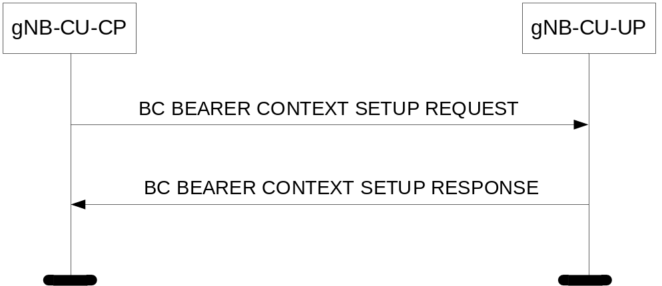
Figure 8.6.1.1.2-1: BC Bearer Context Setup procedure: Successful Operation.
The gNB-CU-CP initiates the procedure by sending the BC BEARER CONTEXT SETUP REQUEST message to the gNB-CU-UP. If the gNB-CU-UP succeeds to establish the requested MBS session resources, it replies to the gNB-CU-CP with the BC BEARER CONTEXT SETUP RESPONSE message.
The gNB-CU-UP shall report to the gNB-CU-CP, in the BC BEARER CONTEXT SETUP RESPONSE message, the result of all the requested resources in the following way:
- A list of BC MRBs which are successfully established shall be included in the BC MRB Setup Response List IE;
- A list of BC MRBs which failed to be established shall be included in the BC MRB Failed List IE;
- For each established BC MRB, a list of MBS QoS Flows which are successfully established shall be included in the MBS QoS Flow Setup List IE;
- For each established BC MRB, a list of MBS QoS Flows which failed to be established shall be included in the MBS QoS Flow Failed List IE;
- For each newly established BC MRB, if the F1-U TNL Info to Add List IE was included for an MRB within the BC MRB Setup Configuration IE, the gNB-CU-UP shall establish multiple F1-U resources which have one to one mapping with F1-U context referred by the Broadcast F1-U Context ReferenceE1 IE and include the F1-U TNL Info Added List IE in the BC MRB Setup Response List IE;
When the gNB-CU-UP reports the unsuccessful establishment of a BC MRB or MBS QoS Flow the cause value should be precise enough to enable the gNB-CU-CP to know the reason for the unsuccessful establishment.
If the Requested Action for Available Shared NG-U Termination IE in the BC Bearer Context To Setup IE in the BC BEARER CONTEXT SETUP REQUEST message is set to
- "apply available configuration" and an appropriate Shared NG-U Termination is available, the gNB-CU-UP shall apply the radio bearer configuration of the Shared NG-U Termination, and indicate in the BC BEARER CONTEXT SETUP RESPONSE message within the Available BC MRB Configuration IE in the BC Bearer Context To Setup Response IE the radio bearer configuration of the Shared NG-U Termination, if the radio bearer configuration of the Shared NG-U Termination is different than the one requested by the gNB-CU-CP.
- "apply requested configuration" the gNB-CU-UP shall make use of an available appropriate Shared NG-U Termination if the radio bearer configuration of the Shared NG-U Termination, is the same as the one requested by the gNB-CU-CP, otherwise allocate separate resources as requested by the gNB-CU-CP and indicate in the BC BEARER CONTEXT SETUP RESPONSE message within the Available BC MRB Configuration IE in the BC Bearer Context To Setup Response IE the radio bearer configuration of the Shared NG-U Termination.
- "apply available configuration if same as requested" the gNB-CU-UP shall make use of an available appropriate Shared NG-U Termination only if the radio bearer configuration of the Shared NG-U Termination is the same as the one requested by the gNB-CU-CP and reply with BC BEARER CONTEXT SETUP RESPONSE message.

8.6.1.1.3 Unsuccessful Operation
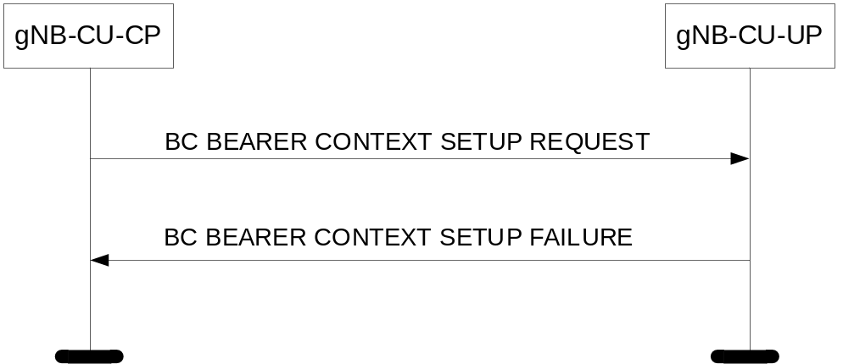
Figure 8.6.1.1.3-1: BC Bearer Context Setup procedure: Unsuccessful Operation.
If the gNB-CU-UP cannot establish the requested resources for the MBS session, it shall consider the procedure as failed and respond with the BC BEARER CONTEXT SETUP FAILURE message and an appropriate cause value.
If the Requested Action for Available Shared NG-U Termination IE in the BC Bearer Context To Setup IE in the BC BEARER CONTEXT SETUP REQUEST message is set to "apply available configuration if same as requested" and the requested configuration does not match the available shared NG-U termination, the gNB-CU UP shall reply with BC BEARER CONTEXT SETUP FAILURE message.

8.6.1.1.4 Abnormal Conditions
void.

8.6.1.2 BC Bearer Context Modification (gNB-CU-CP initiated)

8.6.1.2.1 General
The purpose of the gNB-CU-CP initiated BC Bearer Context Modification procedure is to allow the gNB-CU-CP to modify MBS session resources for a broadcast MBS session. The procedure uses MBS-associated signalling.

8.6.1.2.2 Successful Operation
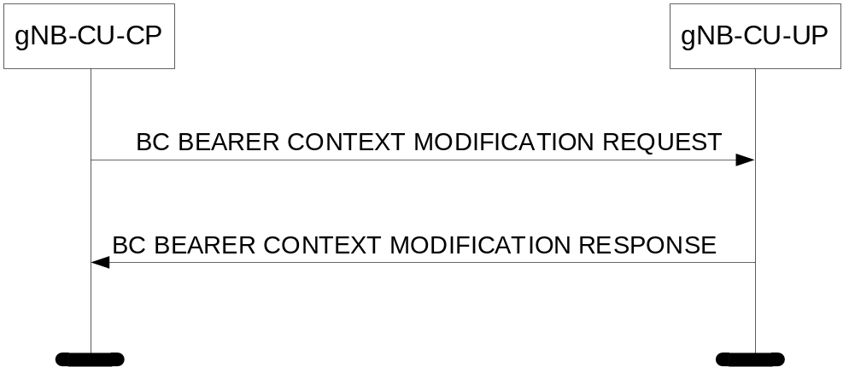
Figure 8.6.1.2.2-1: BC Bearer Context Modification procedure, gNB-CU-CP initiated: Successful Operation.
The gNB-CU-CP initiates the procedure by sending the BC BEARER CONTEXT MODIFICATION REQUEST message to the gNB-CU-UP. If the gNB-CU-UP succeeds to perform at least partially the requested modifications it replies to the gNB-CU-CP with the BC BEARER CONTEXT MODIFICATION RESPONSE message.
The gNB-CU-UP shall report to the gNB-CU-CP, in the BC BEARER CONTEXT MODIFICATION RESPONSE message, the result of all the requested MBS session resources in the following way:
- A list of BC MRBs which are successfully established or modified shall be included in the BC MRB Setup or Modify Response List IE;
- A list of BC MRBs which failed to be established or modified shall be included in the BC MRB Failed List IE;
- For each newly established or modified BC MRB, a list of MBS QoS Flows which are successfully established or modified shall be included in the MBS QoS Flow Setup List IE;
- For each newly established or modified BC MRB, a list of MBS QoS Flows which failed to be established or modified shall be included in the MBS QoS Flow Failed List IE;
- If the BC Bearer Context F1-U TNL Info at DU IE is included in the F1-U TNL Info to Add or Modify List IE for an MRB indicated in the BC Bearer Context To Modify IE, the gNB-CU-UP shall allocate or update respective F1-U resources for the F1-U context refered by Broadcast F1-U Context ReferenceE1 IE and indicate in the BC Bearer Context To Modify Response IE the BC Bearer Context F1-U TNL Info at CU IE if updated;
- If the F1-U TNL Info to Release List IE is included for an MRB indicated in the BC Bearer Context To Modify IE, the gNB-CU-UP shall release the respective F1-U resources.
When the gNB-CU-UP reports the unsuccessful establishment of a BC MRB or MBS QoS Flow the cause value should be precise enough to enable the gNB-CU-CP to know the reason for the unsuccessful establishment.
If the BC Bearer Context NG-U TNL Info at 5GC To Setup or Modify IE is contained in the BC BEARER CONTEXT MODIFICATION REQUEST message, the gNB-CU-UP shall update the previously received BC Bearer Context NG-U TNL Info at 5GC.

8.6.1.2.3 Unsuccessful Operation
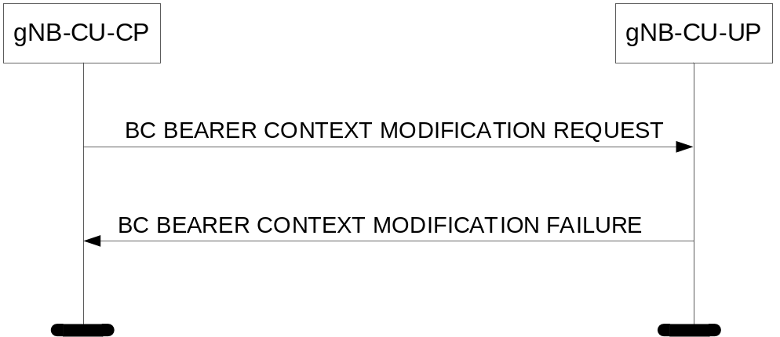
Figure 8.6.1.2.3-1: BC Bearer Context Modification procedure, gNB-CU-CP intiated: Unsuccessful Operation.
If the gNB-CU-UP cannot successfully perform any of the requested modifications, it shall respond with a BC BEARER CONTEXT MODIFICATION FAILURE message and an appropriate cause value.

8.6.1.2.4 Abnormal Conditions
void.
///////////////////////////////////////////////////////////////////////skip unrelated///////////////////////////////////////////////////////////////////////

9.3.1.114 BC MRB Setup Configuration
This IE contains MRB configuration information for a BC Bearer Context Context.
IE/Group Name | Presence | Range | IE type and reference | Semantics description | Criticality | Assigned Criticality
BC MRB To Setup List |  | 1..<maxnoofMRBs> |  |  | -
>MRB ID | M |  | 9.3.1.16a |  | -
>MBS PDCP Configuration | M |  | PDCP Configuration  9.3.1.38 |  | -
>MBS QoS Flows Information To Be Setup | M |  | QoS Flow QoS Parameters List  9.3.1.25 |  | -
>MRB QoS | O |  | QoS Flow Level QoS Parameters  9.3.1.26 | Indicates the MRB QoS when more than one QoS Flow is mapped to the MRB. | -
>F1-U TNL Info to Add List |  | 0..1 |  |  | YES | ignore
>>F1-U TNL Info to Add Item |  | 1..<maxnoofDUs> |  |  | -
>>>Broadcast F1-U Context ReferenceE1 | M |  | 9.3.1.139a |  | -

Range bound | Explanation
maxnoofMRBs | Maximum no. of MRBs for one MBS Session. Value is 32.
maxnoofDUs | Maximum no. of DUs in a RAN node. Value is 512.

///////////////////////////////////////////////////////////////////////skip unrelated///////////////////////////////////////////////////////////////////////

9.3.1.139a Broadcast F1-U Context ReferenceE1
This IE contains a reference to a Broadcast F1-U Context used within an MBS-associated logical E1-connection. In case of location independent Broadcast service, one Broadcast F1-U Context corresponds to a F1-U tunnel towards one gNB-DU for one MRB. In case of location dependent Broadcast service, one Broadcast F1-U Context corresponds to all F1-U tunnel(s) toward one gNB-DU for one MRB.
IE/Group Name | Presence | Range | IE type and reference | Semantics description
Broadcast F1-U Context ReferenceE1 | M |  | OCTET STRING (SIZE(4)) | This value is allocated to uniquely denote a Broadcast F1-U Context within an MBS-associated logical E1-connection.

///////////////////////////////////////////////////////////////////////skip unrelated///////////////////////////////////////////////////////////////////////

9.3.3.27 BC Bearer Context To Setup Response
This IE contains MBS session resource related information used to confirm BC Bearer Context Setup.
IE/Group Name | Presence | Range | IE type and reference | Semantics description | Criticality | Assigned Criticality
BC Bearer Context NG-U TNL Info at NG-RAN | O |  | 9.3.1.116 |  | -
BC MRB Setup Response List |  | 1..<maxnoofMRBs> |  |  | -
>MRB ID | M |  | 9.3.1.16a |  | -
>MBS QoS Flow Setup List | M |  | QoS Flow List  9.3.1.12 |  | -
>MBS QoS Flow Failed List | O |  | Flow Failed List  9.3.1.45 |  | -
>BC Bearer Context F1-U TNL Info at CU | M |  | 9.3.1.118 | Indicates the F1-U TNL Info at CU if there is only one gNB-DU within the gNB-CU supporting the MBS service.  This IE is ignored in case F1-U TNL Info Added List IE is present | -
>F1-U TNL Info Added List |  | 0..1 |  |  | YES | ignore
>>F1-U TNL Info Added Item |  | 1..<maxnoofDUs> |  |  | -
>>>Broadcast F1-U Context ReferenceE1 | M |  | 9.3.1.139a |  | -
>>>BC Bearer Context F1-U TNL Info at CU | M |  | 9.3.1.118 |  | -
BC MRB Failed List |  | 0..<maxnoofMRBs> |  |  | -
>MRB ID | M |  | 9.3.1.16a |  | -
>Cause | M |  | 9.3.1.2 |  | -
Available BC MRB Configuration | O |  | BC MRB Setup Configuration  9.3.1.114 |  | -

Range bound | Explanation
maxnoofMRBs | Maximum no. of MRBs for one MBS Session. Value is 32.
maxnoofDUs | Maximum no. of DUs in a RAN node. Value is 512.

9.3.3.28 BC Bearer Context To Modify
This IE contains MBS session resource related information used to request BC Bearer Context Modification.
IE/Group Name | Presence | Range | IE type and reference | Semantics description | Criticality | Assigned Criticality
BC Bearer Context NG-U TNL Info at 5GC To Setup or Modify | O |  | BC Bearer Context NG-U TNL Info at 5GC  9.3.1.112 |  | -
BC MRB To Setup List | O |  | BC MRB Setup Configuration  9.3.1.114 |  | -
BC MRB To Modify List |  | 0..<maxnoofMRBs> |  |  | -
>MRB ID | M |  | 9.3.1.16a |  | -
>BC Bearer Context F1-U TNL Info at DU | O |  | 9.3.1.119 | Indicate the F1-U TNL Info at DU if there is only one gNB-DU within the gNB-CU supporting the MBS service.  This IE is ignored in case F1-U TNL Info to Add or Modify List IE is present | -
>MBS PDCP Configuration | O |  | PDCP Configuration  9.3.1.38 |  | -
>MBS QoS Flows Information To Be Setup | O |  | QoS Flow QoS Parameters List  9.3.1.25 |  | -
>MRB QoS | O |  | QoS Flow Level QoS Parameters  9.3.1.26 | Indicates the MRB QoS when more than one QoS Flow is mapped to the MRB. | -
>F1-U TNL Info to Add or Modify List |  | 0..1 |  |  | YES | ignore
>>F1-U TNL Info to Add or Modify Item |  | 1..<maxnoofDUs> |  |  | -
>>>Broadcast F1-U Context ReferenceE1 | M |  | 9.3.1.139a |  | -
>>>BC Bearer Context F1-U TNL Info at DU | O |  | 9.3.1.119 |  | -
>F1-U TNL Info to Release List |  | 0..1 |  |  | YES | ignore
>>F1-U TNL Info to Release Item |  | 1..<maxnoofDUs> |  |  | -
>>>Broadcast F1-U Context ReferenceE1 | M |  | 9.3.1.139a |  | -
BC MRB To Remove List |  | 0..<maxnoofMRBs> |  |  | -
>MRB ID | M |  | 9.3.1.16a |  | -

Range bound | Explanation
maxnoofMRBs | Maximum no. of MRBs for one MBS Session. Value is 32.
maxnoofDUs | Maximum no. of DUs in a RAN node. Value is 512.

9.3.3.29 BC Bearer Context To Modify Response
This IE contains MBS session resource related information used to confirm a BC Bearer Context Modification.
IE/Group Name | Presence | Range | IE type and reference | Semantics description | Criticality | Assigned Criticality
BC Bearer Context NG-U TNL Info at NG-RAN | O |  | 9.3.1.116 |  | -
BC MRB Setup or Modify Response List |  | 1..<maxnoofMRBs> |  |  | -
>MRB ID | M |  | 9.3.1.16a |  | -
>MBS QoS Flow Setup List | O |  | QoS Flow List  9.3.1.12 |  | -
>MBS QoS Flow Failed List | O |  | Flow Failed List  9.3.1.45 |  | -
>BC Bearer Context F1-U TNL Info at CU | O |  | 9.3.1.118 | Indicates the F1-U TNL Info at CU if there is only one gNB-DU within the gNB-CU supporting the MBS service.  This IE is ignored in case the F1-U TNL Info Added or Modified List IE is present | -
>F1-U TNL Info Added or Modified List |  | 0..1 |  |  | YES | ignore
>>F1-U TNL Info Added or Modified Item |  | 1..<maxnoofDUs> |  |  | -
>>>Broadcast F1-U Context ReferenceE1 | M |  | 9.3.1.139a |  | -
>>>BC Bearer Context F1-U TNL Info at CU | O |  | 9.3.1.118 |  | -
BC MRB Failed List |  | 0..<maxnoofMRBs> |  |  | -
>MRB ID | M |  | 9.3.1.16a |  | -
>Cause | M |  | 9.3.1.2 |  | -
Available BC MRB Configuration | O |  | BC MRB Setup Configuration  9.3.1.114 | In case the shared MBS NG-U termination had a different MRB Configuration applied. | -

Range bound | Explanation
maxnoofMRBs | Maximum no. of MRBs for one MBS Session. Value is 32.
maxnoofDUs | Maximum no. of DUs in a RAN node. Value is 512.

///////////////////////////////////////////////////////////////////////skip unrelated///////////////////////////////////////////////////////////////////////

9.4.5 Information Element Definitions
-- ASN1START
-- **************************************************************
--
-- Information Element Definitions
--
-- **************************************************************

E1AP-IEs {
itu-t (0) identified-organization (4) etsi (0) mobileDomain (0)
ngran-access (22) modules (3) e1ap (5) version1 (1) e1ap-IEs (2) }

DEFINITIONS AUTOMATIC TAGS ::=

BEGIN

IMPORTS

id-CommonNetworkInstance,
id-SNSSAI,
id-OldQoSFlowMap-ULendmarkerexpected,
id-DRB-QoS,
id-endpoint-IP-Address-and-Port,
id-NetworkInstance,
id-QoSFlowMappingIndication,
id-TNLAssociationTransportLayerAddressgNBCUUP,
id-Cause,
id-QoSMonitoringRequest,
id-QosMonitoringReportingFrequency,
id-QoSMonitoringDisabled,
id-PDCP-StatusReportIndication,
id-RedundantCommonNetworkInstance,
id-redundant-nG-UL-UP-TNL-Information,
id-redundant-nG-DL-UP-TNL-Information,
id-RedundantQosFlowIndicator,
id-TSCTrafficCharacteristics,
id-ExtendedPacketDelayBudget,
id-CNPacketDelayBudgetDownlink,
id-CNPacketDelayBudgetUplink,
id-AdditionalPDCPduplicationInformation,
id-RedundantPDUSessionInformation,
id-RedundantPDUSessionInformation-used,
id-QoS-Mapping-Information,
id-MDTConfiguration,
id-TraceCollectionEntityURI,
id-EHC-Parameters,
id-DAPSRequestInfo,
id-EarlyForwardingCOUNTReq,
id-EarlyForwardingCOUNTInfo,
id-AlternativeQoSParaSetList,
id-MCG-OfferedGBRQoSFlowInfo,
id-Number-of-tunnels,
id-DataForwardingtoE-UTRANInformationList,
id-DataForwardingtoNG-RANQoSFlowInformationList,
id-MaxCIDEHCDL,
id-ignoreMappingRuleIndication,
id-EarlyDataForwardingIndicator,
id-QoSFlowsDRBRemapping,
id-SecurityIndicationModify,
id-DataForwardingSourceIPAddress,
id-M4ReportAmount,
id-M6ReportAmount,
id-M7ReportAmount,
id-PDUSession-PairID,
id-SurvivalTime,
id-UDC-Parameters,
id-SecurityIndication,
id-SecurityResult,
id-SDTindicatorSetup,
id-SDTindicatorMod,
id-DiscardTimerExtended,
id-MCForwardingResourceRequest,
id-MCForwardingResourceIndication,
id-MCForwardingResourceResponse,
id-MCForwardingResourceRelease,
id-MCForwardingResourceReleaseIndication,
id-PDCP-COUNT-Reset,
id-MBSSessionAssociatedInfoNonSupportToSupport,
id-VersionID,
id-MBSAreaSessionID,
id-Secondary-PDU-Session-Data-Forwarding-Information,
id-MBSSessionResourceNotification,
id-MCBearerContextInactivityTimer,
id-MCBearerContextStatusChange,
id-F1U-TNL-InfoToAdd-List,
id-F1U-TNL-InfoAdded-List,
id-F1U-TNL-InfoToAddOrModify-List,
id-F1U-TNL-InfoAddedOrModified-List,
id-F1U-TNL-InfoToRelease-List,
id-BroadcastF1U-ContextReferenceE1,
maxnoofMBSAreaSessionIDs,
maxnoofSharedNG-UTerminations,
maxnoofMRBs,
maxnoofMBSSessionIDs,
maxnoofQoSParaSets,
maxnoofErrors,
maxnoofSliceItems,
maxnoofEUTRANQOSParameters,
maxnoofNGRANQOSParameters,
maxnoofDRBs,
maxnoofPDUSessionResource,
maxnoofQoSFlows,
maxnoofUPParameters,
maxnoofCellGroups,
maxnooftimeperiods,
maxnoofNRCGI,
maxnoofTLAs,
maxnoofGTPTLAs,
maxnoofSPLMNs,
maxnoofMDTPLMNs,
maxnoofExtSliceItems,
maxnoofDataForwardingTunneltoE-UTRAN,
maxnoofExtNRCGI,
maxnoofECGI,
maxnoofSMBRValues,
maxnoofDUs

FROM E1AP-Constants

Criticality,
ProcedureCode,
ProtocolIE-ID,
TriggeringMessage

FROM E1AP-CommonDataTypes

ProtocolExtensionContainer{},
ProtocolIE-SingleContainer{},
E1AP-PROTOCOL-EXTENSION,
E1AP-PROTOCOL-IES

FROM E1AP-Containers;

//////////////////////////////////////////////////////////skip unrelated//////////////////////////////////////////////////////////

-- B

-- BCBearerContextToSetup

BCBearerContextToSetup ::= SEQUENCE {
snssai SNSSAI,
bcBearerContextNGU-TNLInfoat5GC BCBearerContextNGU-TNLInfoat5GC OPTIONAL,
bcMRBToSetupList BCMRBSetupConfiguration,
requestedAction RequestedAction4AvailNGUTermination OPTIONAL,
iE-Extensions ProtocolExtensionContainer { {BCBearerContextToSetup-ExtIEs} } OPTIONAL,
...
}

BCBearerContextToSetup-ExtIEs E1AP-PROTOCOL-EXTENSION ::= {
...
}

BCBearerContextNGU-TNLInfoat5GC::= CHOICE {
locationindependent MBSNGUInformationAt5GC,
locationdependent LocationDependentMBSNGUInformationAt5GC,
choice-extension ProtocolIE-SingleContainer {{BCBearerContextNGU-TNLInfoat5GC-ExtIEs}}
}

BCBearerContextNGU-TNLInfoat5GC-ExtIEs E1AP-PROTOCOL-IES ::= {
...
}

BCMRBSetupConfiguration ::= SEQUENCE (SIZE(1..maxnoofMRBs)) OF BCMRBSetupConfiguration-Item

BCMRBSetupConfiguration-Item ::= SEQUENCE {
mrb-ID MRB-ID,
mbs-pdcp-config PDCP-Configuration,
qoS-Flow-QoS-Parameter-List QoS-Flow-QoS-Parameter-List,
qoSFlowLevelQoSParameters QoSFlowLevelQoSParameters OPTIONAL,
iE-Extensions ProtocolExtensionContainer { {BCMRBSetupConfiguration-Item-ExtIEs} } OPTIONAL,
...
}

BCMRBSetupConfiguration-Item-ExtIEs E1AP-PROTOCOL-EXTENSION ::= {
{ID id-F1U-TNL-InfoToAdd-List CRITICALITY ignore EXTENSION F1U-TNL-InfoToAdd-List PRESENCE optional},
...
}

-- BCBearerContextToSetupResponse

BCBearerContextToSetupResponse ::= SEQUENCE {
bcBearerContextNGU-TNLInfoatNGRAN BCBearerContextNGU-TNLInfoatNGRAN OPTIONAL,
bcMRBSetupResponseList BCMRBSetupResponseList,
bcMRBFailedList BCMRBFailedList OPTIONAL,
availableBCMRBConfig BCMRBSetupConfiguration OPTIONAL,
iE-Extensions ProtocolExtensionContainer { {BCBearerContextToSetupResponse-ExtIEs} } OPTIONAL,
...
}

BCBearerContextToSetupResponse-ExtIEs E1AP-PROTOCOL-EXTENSION ::= {
...
}

BCBearerContextNGU-TNLInfoatNGRAN::= CHOICE {
locationindependent MBSNGUInformationAtNGRAN,
locationdependent LocationDependentMBSNGUInformationAtNGRAN,
choice-extension ProtocolIE-SingleContainer {{BCBearerContextNGU-TNLInfoatNGRAN-ExtIEs}}
}

BCBearerContextNGU-TNLInfoatNGRAN-ExtIEs E1AP-PROTOCOL-IES ::= {
...
}

BCMRBSetupResponseList ::= SEQUENCE (SIZE(1..maxnoofMRBs)) OF BCMRBSetupResponseList-Item
BCMRBSetupResponseList-Item ::= SEQUENCE {
mrb-ID MRB-ID,
qosflow-setup QoS-Flow-List,
qosflow-failed QoS-Flow-Failed-List OPTIONAL,
bcBearerContextF1U-TNLInfoatCU BCBearerContextF1U-TNLInfoatCU,
iE-Extensions ProtocolExtensionContainer { {BCMRBSetupResponseList-Item-ExtIEs} } OPTIONAL,
...
}

BCMRBSetupResponseList-Item-ExtIEs E1AP-PROTOCOL-EXTENSION ::= {
{ID id-F1U-TNL-InfoAdded-List CRITICALITY ignore EXTENSION F1U-TNL-InfoAdded-List PRESENCE optional},
...
}

BCBearerContextF1U-TNLInfoatCU ::= CHOICE {
locationindependent MBSF1UInformationAtCU,
locationdependent LocationDependentMBSF1UInformationAtCU,
choice-extension ProtocolIE-SingleContainer {{BCBearerContextF1U-TNLInfoatCU-ExtIEs}}
}

BCBearerContextF1U-TNLInfoatCU-ExtIEs E1AP-PROTOCOL-IES ::= {
...
}

BCMRBFailedList ::= SEQUENCE (SIZE(1..maxnoofMRBs)) OF BCMRBFailedList-Item
BCMRBFailedList-Item ::= SEQUENCE {
mrb-ID MRB-ID,
cause Cause,
iE-Extensions ProtocolExtensionContainer { {BCMRBFailedList-Item-ExtIEs} } OPTIONAL,
...
}

BCMRBFailedList-Item-ExtIEs E1AP-PROTOCOL-EXTENSION ::= {
...
}

-- BCBearerContextToModify

BCBearerContextToModify ::= SEQUENCE {
bcBearerContextNGU-TNLInfoat5GC BCBearerContextNGU-TNLInfoat5GC OPTIONAL,
bcMRBToSetupList BCMRBSetupConfiguration OPTIONAL,
bcMRBToModifyList BCMRBModifyConfiguration OPTIONAL,
bcMRBToRemoveList BCMRBRemoveConfiguration OPTIONAL,
iE-Extensions ProtocolExtensionContainer { {BCBearerContextToModify-ExtIEs} } OPTIONAL,
...
}

BCBearerContextToModify-ExtIEs E1AP-PROTOCOL-EXTENSION ::= {
...
}

BCMRBModifyConfiguration ::= SEQUENCE (SIZE(1..maxnoofMRBs)) OF BCMRBModifyConfiguration-Item

BCMRBModifyConfiguration-Item ::= SEQUENCE {
mrb-ID MRB-ID,
bcBearerContextF1U-TNLInfoatDU BCBearerContextF1U-TNLInfoatDU OPTIONAL,
mbs-pdcp-config PDCP-Configuration OPTIONAL,
qoS-Flow-QoS-Parameter-List QoS-Flow-QoS-Parameter-List OPTIONAL,
qoSFlowLevelQoSParameters QoSFlowLevelQoSParameters OPTIONAL,
iE-Extensions ProtocolExtensionContainer { {BCMRBModifyConfiguration-Item-ExtIEs} } OPTIONAL,
...
}

BCMRBModifyConfiguration-Item-ExtIEs E1AP-PROTOCOL-EXTENSION ::= {
{ID id-F1U-TNL-InfoToAddOrModify-List CRITICALITY ignore EXTENSION F1U-TNL-InfoToAddOrModify-List PRESENCE optional}|
{ID id-F1U-TNL-InfoToRelease-List CRITICALITY ignore EXTENSION F1U-TNL-InfoToRelease-List PRESENCE optional},
...
}

BCBearerContextF1U-TNLInfoatDU ::= CHOICE {
locationindependent MBSF1UInformationAtDU,
locationdependent LocationDependentMBSF1UInformationAtDU,
choice-extension ProtocolIE-SingleContainer {{BCBearerContextF1U-TNLInfoatDU-ExtIEs}}
}

BCBearerContextF1U-TNLInfoatDU-ExtIEs E1AP-PROTOCOL-IES ::= {
...
}

BCMRBRemoveConfiguration ::= SEQUENCE (SIZE(1..maxnoofMRBs)) OF MRB-ID

-- BCBearerContextToModifyResponse

BCBearerContextToModifyResponse ::= SEQUENCE {
BCBearerContextToModifyResponse ::= SEQUENCE {
bcBearerContextNGU-TNLInfoatNGRAN BCBearerContextNGU-TNLInfoatNGRAN OPTIONAL,
bcMRBSetupModifyResponseList BCMRBSetupModifyResponseList,
bcMRBFailedList BCMRBFailedList OPTIONAL,
availableBCMRBConfig BCMRBSetupConfiguration OPTIONAL,
iE-Extensions ProtocolExtensionContainer { {BCBearerContextToModifyResponse-ExtIEs} } OPTIONAL,
...
}

BCBearerContextToModifyResponse-ExtIEs E1AP-PROTOCOL-EXTENSION ::= {
...
}

BCMRBSetupModifyResponseList ::= SEQUENCE (SIZE(1..maxnoofMRBs)) OF BCMRBSetupModifyResponseList-Item

BCMRBSetupModifyResponseList-Item ::= SEQUENCE {
mrb-ID MRB-ID,
qosflow-setup QoS-Flow-List OPTIONAL,
qosflow-failed QoS-Flow-Failed-List OPTIONAL,
bcBearerContextF1U-TNLInfoatCU BCBearerContextF1U-TNLInfoatCU OPTIONAL,
iE-Extensions ProtocolExtensionContainer { {BCMRBSetupModifyResponseList-Item-ExtIEs} } OPTIONAL,
...
}

BCMRBSetupModifyResponseList-Item-ExtIEs E1AP-PROTOCOL-EXTENSION ::= {
{ID id-F1U-TNL-InfoAddedOrModified-List CRITICALITY ignore EXTENSION F1U-TNL-InfoAddedOrModified-List PRESENCE optional},
...
}

//////////////////////////////////////////////////////////skip unrelated//////////////////////////////////////////////////////////

BroadcastF1U-ContextReferenceE1 ::= OCTET STRING (SIZE(4))

//////////////////////////////////////////////////////////skip unrelated//////////////////////////////////////////////////////////

-- F

//////////////////////////////////////////////////////////skip unrelated//////////////////////////////////////////////////////////

F1U-TNL-InfoAdded-List ::= SEQUENCE (SIZE(1..maxnoofDUs)) OF F1U-TNL-InfoAdded-Item

F1U-TNL-InfoAdded-Item ::= SEQUENCE {
broadcastF1U-ContextReferenceE1 BroadcastF1U-ContextReferenceE1,
bcBearerContextF1U-TNLInfoatCU BCBearerContextF1U-TNLInfoatCU,
iE-Extensions ProtocolExtensionContainer { {F1U-TNL-InfoAdded-Item-ExtIEs} } OPTIONAL,
...
}

F1U-TNL-InfoAdded-Item-ExtIEs E1AP-PROTOCOL-EXTENSION ::= {
...
}

F1U-TNL-InfoToAdd-List ::= SEQUENCE (SIZE(1..maxnoofDUs)) OF F1U-TNL-InfoToAdd-Item

F1U-TNL-InfoToAdd-Item ::= SEQUENCE {
broadcastF1U-ContextReferenceE1 BroadcastF1U-ContextReferenceE1,
iE-Extensions ProtocolExtensionContainer { {F1U-TNL-InfoToAdd-Item-ExtIEs} } OPTIONAL,
...
}

F1U-TNL-InfoToAdd-Item-ExtIEs E1AP-PROTOCOL-EXTENSION ::= {
...
}

F1U-TNL-InfoAddedOrModified-List ::= SEQUENCE (SIZE(1..maxnoofDUs)) OF F1U-TNL-InfoAddedOrModified-Item

F1U-TNL-InfoAddedOrModified-Item ::= SEQUENCE {
broadcastF1U-ContextReferenceE1 BroadcastF1U-ContextReferenceE1,
bcBearerContextF1U-TNLInfoatCU BCBearerContextF1U-TNLInfoatCU OPTIONAL,
iE-Extensions ProtocolExtensionContainer { {F1U-TNL-InfoAddedOrModified-Item-ExtIEs} } OPTIONAL,
...
}

F1U-TNL-InfoAddedOrModified-Item-ExtIEs E1AP-PROTOCOL-EXTENSION ::= {
...
}

F1U-TNL-InfoToAddOrModify-List ::= SEQUENCE (SIZE(1..maxnoofDUs)) OF F1U-TNL-InfoToAddOrModify-Item

F1U-TNL-InfoToAddOrModify-Item ::= SEQUENCE {
broadcastF1U-ContextReferenceE1 BroadcastF1U-ContextReferenceE1,
bcBearerContextF1U-TNLInfoatDU BCBearerContextF1U-TNLInfoatDU OPTIONAL,
iE-Extensions ProtocolExtensionContainer { {F1U-TNL-InfoToAddOrModify-Item-ExtIEs} } OPTIONAL,
...
}

F1U-TNL-InfoToAddOrModify-Item-ExtIEs E1AP-PROTOCOL-EXTENSION ::= {
...
}

F1U-TNL-InfoToRelease-List ::= SEQUENCE (SIZE(1..maxnoofDUs)) OF F1U-TNL-InfoToRelease-Item

F1U-TNL-InfoToRelease-Item ::= SEQUENCE {
broadcastF1U-ContextReferenceE1 BroadcastF1U-ContextReferenceE1,
iE-Extensions ProtocolExtensionContainer { {F1U-TNL-InfoToRelease-Item-ExtIEs} } OPTIONAL,
...
}

F1U-TNL-InfoToRelease-Item-ExtIEs E1AP-PROTOCOL-EXTENSION ::= {
...
}

//////////////////////////////////////////////////////////skip unrelated//////////////////////////////////////////////////////////

9.4.7 Constant Definitions
//////////////////////////////////////////////////////////skip unrelated//////////////////////////////////////////////////////////

-- **************************************************************
--
-- Lists
--
-- **************************************************************

//////////////////////////////////////////////////////////skip unrelated//////////////////////////////////////////////////////////

maxnoofDUs INTEGER ::= 512

-- **************************************************************
--
-- IEs
--
-- **************************************************************

//////////////////////////////////////////////////////////skip unrelated//////////////////////////////////////////////////////////
id-F1U-TNL-InforToAdd-List ProtocolIE-ID ::=
id-F1U-TNL-InforAdded-List PtotocolIE-ID ::=
id-F1U-TNL-InfoToAddOrModify-List ProtocolIE-ID ::=
id-F1U-TNL-InfoAddedOrModified-List ProtocolIE-ID ::=
id-F1U-TNL-InfoToRelease-List ProtocolIE-ID ::=
id-BroadcastF1U-ContextReferenceE1 ProtocolIE-ID ::=

END
-- ASN1STOP

///////////////////////////////////////////////////////////////////////end///////////////////////////////////////////////////////////////////////

