3GPP TSG-RAN WG3#123 R3-240962

Athens, Greece, 26 February–1 March 2024
CR-Form-v12.2
CHANGE REQUEST
 | 38.401 | CR | 0346 | rev | 1 | Current version: | 18.0.0
For HELP on using this form: comprehensive instructions can be found at
http://www.3gpp.org/Change-Requests.

Proposed change affects: | UICC apps |  | ME |  | Radio Access Network | X | Core Network

Title: | Correction on Multi-path for SL relay
Source to WG: | CATT, Nokia, Nokia Shanghai Bell, LG Electronics, Ericsson
Source to TSG: | R3
Work item code: | NR_SL_relay_enh-Core |  |  |  |  |  |  | Date: |  |  | 2024-02-19
Category: | F |  |  |  |  |  |  | Release: |  |  | Rel-18
 | Use one of the following categories:  F (correction)  A (mirror corresponding to a change in an earlier release)  B (addition of feature),  C (functional modification of feature)  D (editorial modification)  Detailed explanations of the above categories can  be found in 3GPP TR 21.900. |  |  |  |  |  |  |  |  | Use one of the following releases:  Rel-8 (Release 8)  Rel-9 (Release 9)  Rel-10 (Release 10)  Rel-11 (Release 11)  …  Rel-16 (Release 16)  Rel-17 (Release 17)  Rel-18 (Release 18)  Rel-19 (Release 19)
Reason for change: |  | 1. There is no description about when/how to configure RRC_IDLE/INACTIVE target MP Relay UE. It is also not align with path switch case.  2. UE not only report MP Relay UE but also the cell ID of the MP Relay UE in case MP Remote UE is connected with the MP Relay UE using PC5 link.
Summary of change: |  | 1. Add when/how to configure RRC_IDLE/INACTIVE target MP Relay UE in Inter-DU indirect path addition on top of direct path and Intra-DU indirect path addition on top of direct path.  2. Add cell ID of the MP Relay UE for UE reporting in case MP Remote UE is connected with the MP Relay UE using PC5 link.
Consequences if not approved: |  | The SL Relay function is not clear in stage-2.
Clauses affected: |  | 8.22.1, 8.22.2, 8.22.3, 8.22.4
 |  | Y | N
Other specs |  |  | X |  | Other core specifications |  |  |  | TS/TR ... CR ...
affected: |  |  | X |  | Test specifications |  |  |  | TS/TR ... CR ...
(show related CRs) |  |  | X |  | O&M Specifications |  |  |  | TS/TR ... CR ...
Other comments:
This CR's revision history: |  | Rev.1 Revision of R3-240417

8.22.1 Inter-DU direct path addition on top of indirect path
The signalling flow for inter-DU direct path addition is shown in Figure 8.22.1-1. This procedure is only applicable to the MP Remote UE using PC5 link.
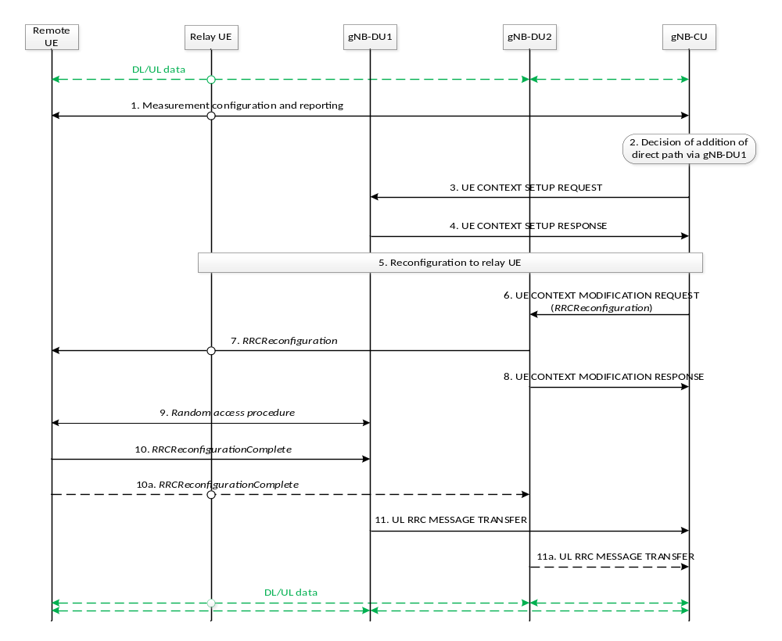
Figure 8.22.1-1: Signalling procedure of inter-DU direct path addition on top of indirect path
1. The Uu measurement configuration and measurement report signalling are performed between MP Remote UE and the gNB-CU to evaluate both relay link measurement and Uu link measurement. The MP Remote UE may report Uu measurement results of neighboring cells and a list of MP Relay UE L2 ID and cell ID of one or multiple candidate MP Relay UE(s).
2. The gNB-CU decides to add the direct path to MP Remote UE under a different gNB-DU (i.e., gNB-DU1).
NOTE: Mode 1 resource configuration cannot be configured for MP Remote UE in inter-gNB-DU multi-path relay in this release.
3. The gNB-CU sends the UE CONTEXT SETUP REQUEST message for the MP Remote UE to the gNB-DU1, which contains at least the direct path configuration.
4. The gNB-DU1 responds to the gNB-CU with a UE CONTEXT SETUP RESPONSE message.
5. The gNB-CU sends an RRCReconfiguration message to the MP Relay UE to update the indirect path configuration if necessary.
6. The gNB-CU sends the UE CONTEXT MODIFICATION REQUEST message for MP Remote UE by including the direct path addition information and the RRCReconfiguration message to the gNB-DU2. The gNB-DU2 may update the stored UE context for MP Remote UE. The contents in the RRCReconfiguration message may include at least direct path addition configuration, RLC channel configuration, bearer mapping and the associated radio bearer(s).
7. The gNB-DU2 sends the RRCReconfiguration message to the MP Remote UE.
8. The gNB-DU2 sends the UE CONTEXT MODIFICATION RESPONSE message to the gNB-CU.
9. The MP Remote UE performs random access procedure at the gNB-DU1.
10. The MP Remote UE sends the RRCReconfigurationComplete message to the gNB-DU1 via direct path in order to complete the direct path addition procedure.
10a. In case the SRB1 with duplication is configured, the MP Remote UE also sends the RRCReconfigurationComplete message to the gNB-DU2 via indirect path.
11. The gNB-DU1 sends the UL RRC MESSAGE TRANSFER message to gNB-CU by including the RRCReconfigurationComplete message received in step 10.
11a. In case the SRB1 with duplication is configured, the gNB-DU2 also sends the UL RRC MESSAGE TRANSFER message to gNB-CU by including the RRCReconfigurationComplete message received in step 10a.

8.22.2 Inter-DU indirect path addition on top of direct path
The signalling flow for inter-DU indirect path addition is shown in Figure 8.22.2-1.
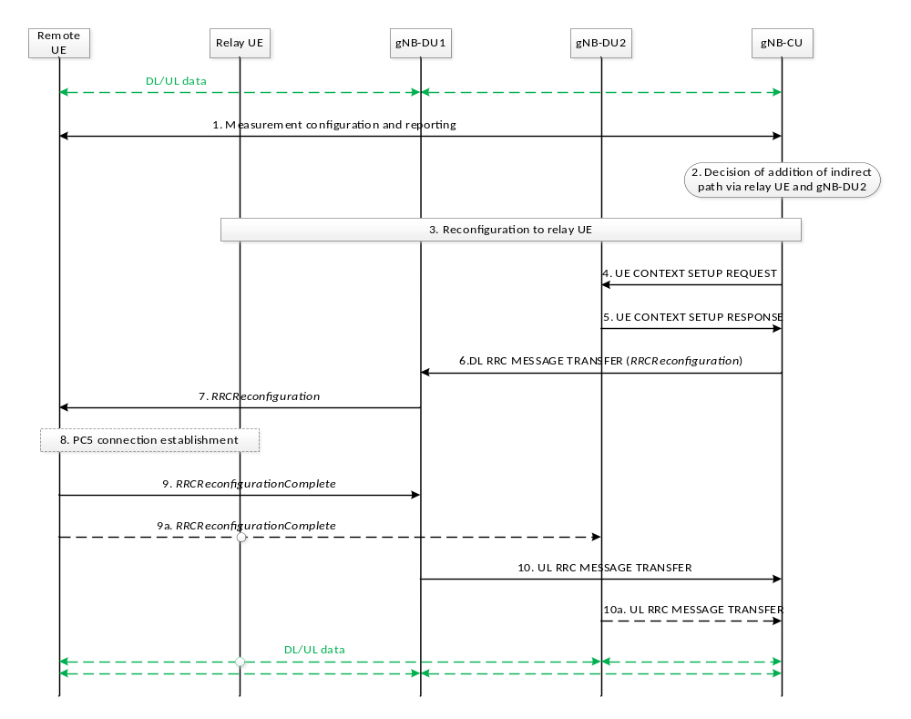
Figure 8.22.2-1 Signalling procedure of inter-DU indirect path addition on top of direct path
1. If the MP Remote UE is connected with the MP Relay UE using PC5 link, the Uu measurement configuration and measurement report signalling are performed between MP Remote UE and the gNB-CU to evaluate relay link measurement and Uu link measurement. The MP Remote UE may report Uu measurement results of neighboring cells and a list of MP Relay UE L2 ID and cell ID of one or multiple candidate MP Relay UE(s).
In case that the MP Remote UE is connected with the MP Relay UE using N3C and the MP Relay UE is in RRC_CONNECTED state, the MP Remote UE reports at least the list of the C-RNTI and the cell ID of one or multiple candidate MP Relay UE(s).
2. The gNB-CU decides to add the indirect path via MP Relay UE to MP Remote UE under a different gNB-DU (i.e., gNB-DU2).
NOTE: Mode 1 resource configuration cannot be configured for MP Remote UE in inter-gNB-DU multi-path relay in this release.
3. The reconfiguration to MP Relay UE is performed among MP Relay UE, the gNB-DU2 and the gNB-CU if MP Relay UE is in RRC_CONNECTED state. The gNB-CU sends an RRCReconfiguration message to the MP Relay UE. If the MP Relay UE is in RRC_IDLE/INACTIVE state, this step is skipped and the configuration to the target MP Relay UE is performed in Step 9/9a.
4. The gNB-CU sends the UE CONTEXT SETUP REQUEST message for the MP Remote UE to the gNB-DU2, which contains the indirect path addition configuration at least.
5. The gNB-DU2 responds to the gNB-CU with a UE CONTEXT SETUP RESPONSE message.
6. The gNB-CU sends the DL RRC MESSAGE TRANSFER message for MP Remote UE by including the RRCReconfiguration message to gNB-DU1. If the MP Remote UE is connected with the MP Relay UE using the PC5 link, the contents in the RRCReconfiguration message may include at least indirect path addition configuration, PC5 Relay RLC channel configuration for relay traffic, bearer mapping and the associated radio bearer(s). If the MP Remote UE is using N3C, the contents in the RRCReconfiguration message may include at least indirect path addition configuration, bearer mapping and the associated radio bearer(s).
7. The gNB-DU1 sends the RRCReconfiguration message to the MP Remote UE.
8. If the MP Remote UE is using the PC5 link, the MP Remote UE establishes PC5 connection with the target MP Relay UE. If the MP Remote UE is connected with the MP Relay UE using N3C, this step is skipped.
9. The MP Remote UE sends the RRCReconfigurationComplete message to the gNB-DU1 via direct path in order to complete the indirect path addition procedure.
9a. In case the SRB1 with duplication is configured, the MP Remote UE also sends the RRCReconfigurationComplete message to the gNB-DU2 via indirect path.
NOTE: In the case that the target MP Relay UE for indirect path addition is in RRC_IDLE/INACTIVE state, how the MP Remote UE triggers the MP Relay UE to be in RRC_CONNECTED state is specified in TS 38.300 [2].
10. The gNB-DU1 sends the UL RRC MESSAGE TRANSFER message to gNB-CU by including the RRCReconfigurationComplete message received in step 9.
10a. In case the SRB1 with duplication is configured, the gNB-DU2 also sends the UL RRC MESSAGE TRANSFER message to gNB-CU by including the RRCReconfigurationComplete message received in step 9a.

8.22.3 Intra-DU direct path addition on top of indirect path
The signaling flow for intra-DU direct path addition is shown in Fig. 8.22.3-1. This procedure is only applicable to the MP Remote UE using PC5 link.
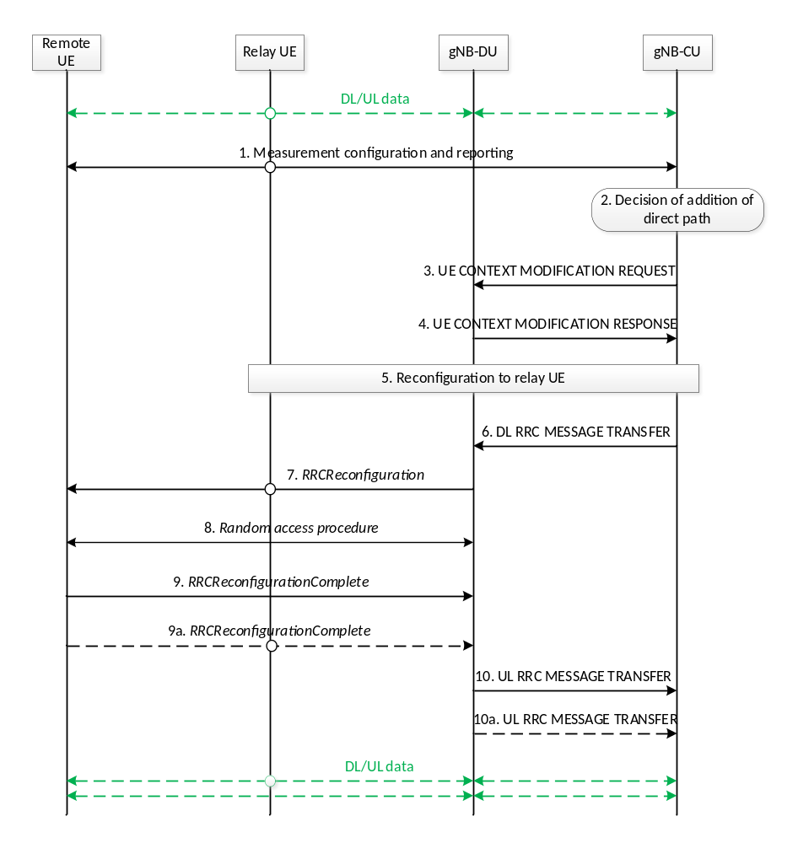
Figure 8.22.3-1: Signalling procedure of intra-DU direct path addition on top of indirect path
1. The Uu measurement configuration and measurement report signalling are performed between MP Remote UE and gNB-CU to evaluate both relay link measurement and Uu link measurement. The MP Remote UE may report Uu measurement results of neighboring cells and a list of MP Relay UE L2 ID and cell ID of one or multiple candidate MP Relay UE(s).
2. The gNB-CU decides to add the direct path to MP Remote UE under the same gNB-DU.
3. The gNB-CU sends the UE CONTEXT MODIFICATION REQUEST message for the MP Remote UE to the gNB-DU, which contains at least the direct path configuration.
4. The gNB-DU responds to the gNB-CU with a UE CONTEXT MODIFICATION RESPONSE message.
5. The gNB-CU sends an RRCReconfiguration message to the MP Relay UE to update the indirect path configuration if necessary.
6. The gNB-CU sends the DL RRC MESSAGE TRANSFER message for MP Remote UE by including the RRCReconfiguration message to the gNB-DU. The contents in the RRCReconfiguration message may include at least direct path addition configuration, RLC channel configuration, bearer mapping and the associated radio bearer(s).
7. The gNB-DU sends the RRCReconfiguration message to the MP Remote UE.
8. The MP Remote UE performs random access procedure at the gNB-DU.
9. The MP Remote UE sends the RRCReconfigurationComplete message to the gNB-DU via direct path in order to complete the direct path addition procedure.
9a. In case the SRB1 with duplication is configured, the RRCReconfigurationComplete message is also sent to the gNB-DU via indirect path.
10/10a. The gNB-DU sends the UL RRC MESSAGE TRANSFER message to gNB-CU by including the RRCReconfigurationComplete message.

8.22.4 Intra-DU indirect path addition on top of direct path
The signaling flow for intra-DU indirect path addition is shown in Fig. 8.22.4-1.
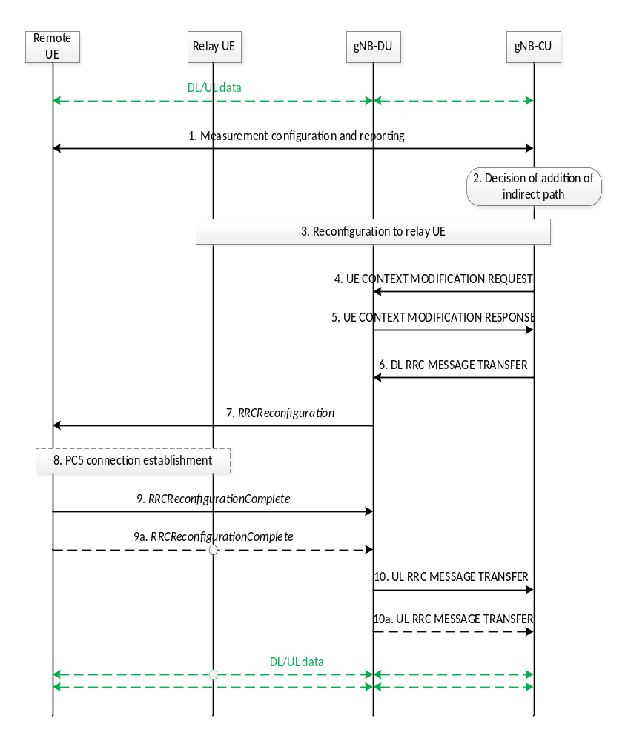
Figure 8.22.4-1: Signalling procedure of intra-DU indirect path addition on top of direct path
1. If the MP Remote UE is connected with the MP Relay UE using PC5 link, the Uu measurement configuration and measurement report signalling are performed between MP Remote UE and gNB-CU to evaluate relay link measurement and Uu link measurement. The MP Remote UE may report Uu measurement results of neighboring cells and a list of MP Relay UE L2 ID and cell ID of one or multiple candidate MP Relay UE(s).
In case that the MP Remote UE is connected with the MP Relay UE using N3C and the MP Relay UE is in RRC_CONNECTED state, the MP Remote UE reports at least the list of the C-RNTI and the cell ID of one or multiple candidate MP Relay UE(s).
2. The gNB-CU decides to add the indirect path via MP Relay UE to MP Remote UE under the same gNB-DU.
3. The reconfiguration to MP Relay UE is performed among MP Relay UE, gNB-DU and gNB-CU if MP Relay UE is in RRC_CONNECTED state. The gNB-CU sends an RRCReconfiguration message to the MP Relay UE. If the MP Relay UE is in RRC_IDLE/INACTIVE state, this step is skipped and the configuration to the target MP Relay UE is performed in Step 9/9a.
4. The gNB-CU sends the UE CONTEXT MODIFICATION REQUEST message for the MP Remote UE to the gNB-DU, which contains the indirect path addition configuration at least.
5. The gNB-DU responds to the gNB-CU with a UE CONTEXT MODIFICATION RESPONSE message.
6. The gNB-CU sends the DL RRC MESSAGE TRANSFER message for MP Remote UE by including the RRCReconfiguration message to gNB-DU. If the MP Remote UE is connected with the MP Relay UE using the PC5 link, the contents in the RRCReconfiguration message may include at least indirect path addition configuration, PC5 Relay RLC channel configuration for relay traffic, bearer mapping and the associated radio bearer(s). If the MP Remote UE is using N3C, the contents in the RRCReconfiguration message may include at least indirect path addition configuration, bearer mapping and the associated radio bearer(s).
7. The gNB-DU sends the RRCReconfiguration message to the MP Remote UE.
8. If the MP Remote UE is using the PC5 link, the MP Remote UE establishes PC5 connection with the target MP Relay UE. If the MP Remote UE is using N3C, this step is skipped.
9. The MP Remote UE sends the RRCReconfigurationComplete message to the gNB-DU via direct path to complete the indirect path addition procedure.
9a. In case the SRB1 with duplication is configured, the RRCReconfigurationComplete message is also sent to the gNB-DU via indirect path.
NOTE: In the case that the target MP Relay UE for indirect path addition is in RRC_IDLE/INACTIVE state, how the MP Remote UE triggers the MP Relay UE to be in RRC_CONNECTED state is specified in TS 38.300 [2].
10/10a. The gNB-DU sends the UL RRC MESSAGE TRANSFER message to gNB-CU by including the RRCReconfigurationComplete message.

