3GPP TSG-RAN WG3 Meeting #123 R3-241047
Athens, Greece, 26th February – 01st March 2024
CR-Form-v12.2
CHANGE REQUEST
 | 38.413 | CR | 1084 | rev | 1 | Current version: | 18.0.0
For HELP on using this form: comprehensive instructions can be found at
http://www.3gpp.org/Change-Requests.

Proposed change affects: | UICC apps |  | ME |  | Radio Access Network | X | Core Network | X

Title: | Correction of MBS Assistance Information Support
Source to WG: | Nokia, Nokia Shanghai Bell, Ericsson, CATT, CBN, CMCC, Google, Huawei, Lenovo, NEC, Qualcomm, Samsung, ZTE
Source to TSG: | R3
Work item code: | NR_MBS_enh-Core |  |  |  |  |  | Date: |  |  | 2024-02-26
Category: | F |  |  |  |  |  | Release: |  |  | Rel-18
 | Use one of the following categories:  F (correction)  A (mirror corresponding to a change in an earlier release)  B (addition of feature),  C (functional modification of feature)  D (editorial modification)  S (adding to the sourcing companies’ CR statistics)  Detailed explanations of the above categories can  be found in 3GPP TR 21.900. |  |  |  |  |  |  |  | Use one of the following releases:  Rel-8 (Release 8)  Rel-9 (Release 9)  Rel-10 (Release 10)  Rel-11 (Release 11)  …  Rel-16 (Release 16)  Rel-17 (Release 17)  Rel-18 (Release 18)  Rel-19 (Release 19)
Reason for change: |  | RAN3 received the LS in R3-237152 to transfer the MBS Assistance information from SMF to target NG-RAN node for Xn based handover or connection resume. Target SMF need to trigger an NGAP PDU Session Modification procedure after every Xn handover or connection resume and include the MBS Assistance Information in the NGAP PDU Session Modification Request message but this generates significant additional processing and signaling.  However, the transfer is actually only really needed when the source NG-RAN node does not support the MBS Inactive Mode Reception.  In order to limit the extra SMF processing and signaling, it is useful if SMF can learn in advance whether an NG-RAN node supports the MBS multicast Reception in RRC inactive state, and only need to trigger NGAP PDU Session Modification procedure to provide MBS Assistance Information in case the source NG-RAN node does not support multicast Reception in RRC inactive state.
Summary of change: |  | The MBS Support Indicator IE is extended with new codepoint to indicate support of Multicast Reception in RRC inactive state and the existing codepoint is renamed.  Impact assessment towards the previous version of the specification (same release):  This CR has an isolated impact towards the previous version of the specification (same release).  This CR has an impact on the MBS function.
Consequences if not approved: |  | If the SMF is not aware of the non-homogenous NG-RAN deployment it would need to generate PDU session modification at Xn mobility.
Clauses affected: |  | 8.2.1.2, 8.2.3.2, 8.4.2.2, 8.4.4.2, 9.3.1.210, 9.4.5
 |  | Y | N
Other specs |  |  | X | Other core specifications |  |  |  | TS/TR … CR …
affected: |  |  | X | Test specifications |  |  |  | TS/TR ... CR ...
(show related CRs) |  |  | X | O&M Specifications |  |  |  | TS/TR ... CR ...
Other comments:
This CR's revision history:

<<<<<<<<<<<<<<<<<<<< First Change >>>>>>>>>>>>>>>>>>>>

8.2.1.2 Successful Operation
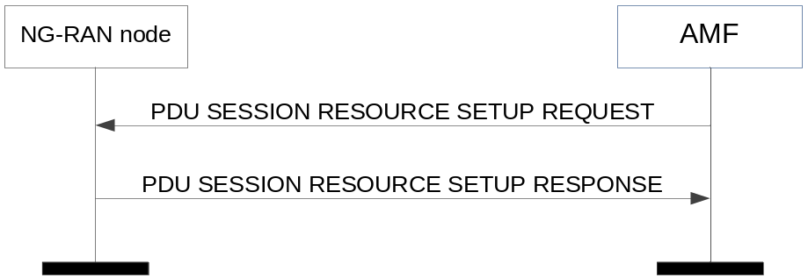
Figure 8.2.1.2-1: PDU session resource setup: successful operation
The AMF initiates the procedure by sending a PDU SESSION RESOURCE SETUP REQUEST message to the NG-RAN node.

<<<<<<<<<<<<<<<<<<<< Unmodified Text Omitted >>>>>>>>>>>>>>>>>>>>
If the PDU Set QoS Parameters IE is included in the PDU SESSION RESOURCE SETUP REQUEST message, the NG-RAN node shall, if supported, report in the PDU SESSION RESOURCE SETUP RESPONSE message the PDU Set based Handling Indicator IE in the PDU Session Resource Setup Response Transfer IE. If the PDU Set based Handling Indicator IE is included in the PDU Session Resource Setup Response Transfer IE in the PDU SESSION RESOURCE SETUP RESPONSE message, the SMF shall, if supported, handle this information as specified in TS 23.501 [9].
If the MBS Support Indicator IE is included in the PDU Session Resource Setup Response Transfer IE in the PDU SESSION RESOURCE SETUP RESPONSE message, the SMF shall, if supported, handle this information as specified in TS 23.247 [44].
Interactions with Handover Preparation procedure:

<<<<<<<<<<<<<<<<<<<< Unmodified Text Omitted >>>>>>>>>>>>>>>>>>>>

8.2.3.2 Successful Operation
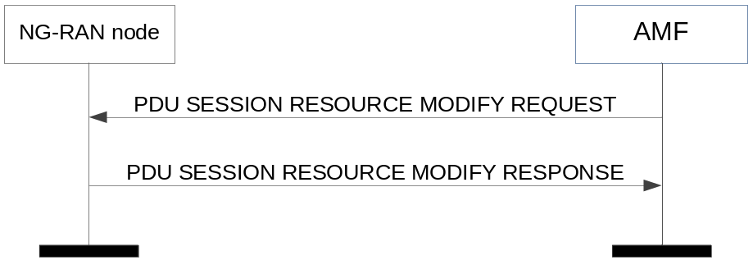
Figure 8.2.3.2-1: PDU session resource modify: successful operation
The AMF initiates the procedure by sending a PDU SESSION RESOURCE MODIFY REQUEST message to the NG-RAN node.
<<<<<<<<<<<<<<<<<<<< Unmodified Text Omitted >>>>>>>>>>>>>>>>>>>>
If the PDU Set QoS Parameters IE is included in the PDU SESSION RESOURCE MODIFY REQUEST message, the NG-RAN node shall, if supported, report in the PDU SESSION RESOURCE MODIFY RESPONSE message the PDU Set based Handling Indicator IE in the PDU Session Resource Modify Response Transfer IE. If the PDU Set based Handling Indicator IE is included in the PDU Session Resource Modify Response Transfer IE in the PDU SESSION RESOURCE MODIFY RESPONSE message, the SMF shall, if supported, handle this information as specified in TS 23.501 [9].
If the MBS Support Indicator IE is included in the PDU Session Resource Modify Response Transfer IE in the PDU SESSION RESOURCE MODIFY RESPONSE message, the SMF shall, if supported, handle this information as specified in TS 23.247 [44].
Interactions with Handover Preparation procedure:

<<<<<<<<<<<<<<<<<<<< Unmodified Text Omitted >>>>>>>>>>>>>>>>>>>>

8.4.2.2 Successful Operation
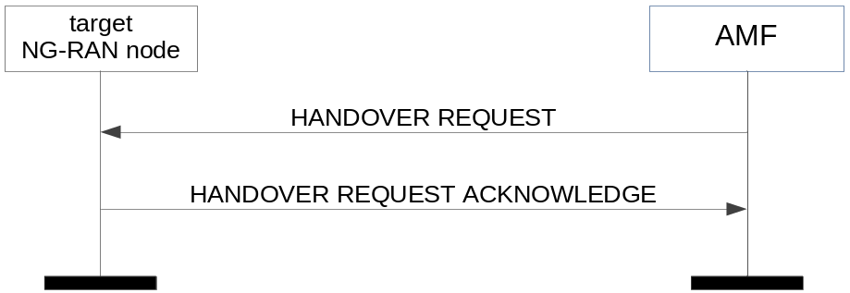
Figure 8.4.2.2-1: Handover resource allocation: successful operation
The AMF initiates the procedure by sending the HANDOVER REQUEST message to the target NG-RAN node.

<<<<<<<<<<<<<<<<<<<< Unmodified Text Omitted >>>>>>>>>>>>>>>>>>>>
If the Partially Allowed NSSAI IE is contained in the HANDOVER REQUEST message, the NG-RAN node shall, if supported, deduce from it the partially allowed network slices for the UE, store and replace any previously received Partially Allowed NSSAI and use it as specified in TS 23.501 [9].
If the MBS Support Indicator IE is included in the Handover Request Acknowledge Transfer IE in the HANDOVER REQUEST ACKNOWLEDGE message, the SMF shall, if supported, handle this information as specified in TS 23.247 [44].
Interactions with RRC Inactive Transition Report procedure:

<<<<<<<<<<<<<<<<<<<< Unmodified Text Omitted >>>>>>>>>>>>>>>>>>>>

8.4.4.2 Successful Operation
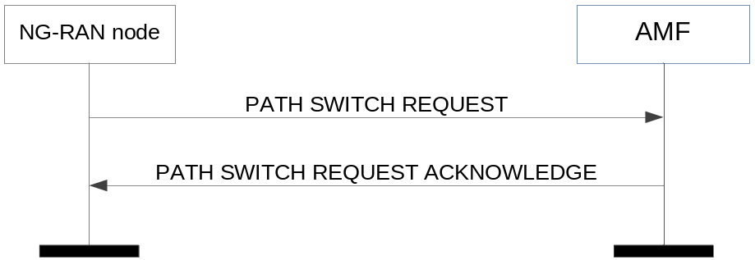
Figure 8.4.4.2-1: Path switch request: successful operation
The NG-RAN node initiates the procedure by sending the PATH SWITCH REQUEST message to the AMF. Upon reception of the PATH SWITCH REQUEST message the AMF shall, for each PDU session indicated in the PDU Session ID IE, transparently transfer the Path Switch Request Transfer IE to the SMF associated with the concerned PDU session.
<<<<<<<<<<<<<<<<<<<< Unmodified Text Omitted >>>>>>>>>>>>>>>>>>>>
The NG-RAN node shall, if supported, report in the PATH SWITCH REQUEST message the PDU Set based Handling Indicator IE in the Path Switch Request Transfer IE. If the PDU Set based Handling Indicator IE is included in the Path Switch Request Transfer IE in the PATH SWITCH REQUEST message, the SMF shall, if supported, handle this information as specified in TS 23.501 [9].
If the MBS Support Indicator IE is included in the Path Switch Request Transfer IE in the PATH SWITCH REQUEST message, the SMF shall, if supported, handle this information as specified in TS 23.247 [44].
If the Security Indication IE is included within the Path Switch Request Acknowledge Transfer IE of the PATH SWITCH REQUEST ACKNOWLEDGE message, the NG-RAN node shall behave as specified in TS 33.501 [13].

<<<<<<<<<<<<<<<<<<<< Unmodified Text Omitted >>>>>>>>>>>>>>>>>>>>

<<<<<<<<<<<<<<<<<<<< Unmodified Text Omitted >>>>>>>>>>>>>>>>>>>>

9.3.1.210 MBS Support Indicator
This IE indicates whether MBS is supported for the NG-RAN node.
IE/Group Name | Presence | Range | IE type and reference | Semantics description
MBS Support Indicator | M |  | ENUMERATED (multicast supported, …, multicast supported with reception in RRC inactive)

<<<<<<<<<<<<<<<<<<<< Unmodified Text Omitted >>>>>>>>>>>>>>>>>>>>

9.4.5 Information Element Definitions
-- ASN1START
-- **************************************************************
--
-- Information Element Definitions
--
-- **************************************************************

NGAP-IEs {
itu-t (0) identified-organization (4) etsi (0) mobileDomain (0)
ngran-Access (22) modules (3) ngap (1) version1 (1) ngap-IEs (2) }

DEFINITIONS AUTOMATIC TAGS ::=

BEGIN
<<<<<<<<<<<<<<<<<<<< Unmodified Text Omitted >>>>>>>>>>>>>>>>>>>>

MBSSessionSetupOrModResponseTransfer ::= SEQUENCE {
mBS-SessionTNLInfoNGRAN MBS-SessionTNLInfoNGRAN OPTIONAL,
iE-Extensions ProtocolExtensionContainer { {MBSSessionSetupOrModResponseTransfer-ExtIEs} } OPTIONAL,
...
}

MBSSessionSetupOrModResponseTransfer-ExtIEs NGAP-PROTOCOL-EXTENSION ::= {
...
}

MBS-SupportIndicator ::= ENUMERATED {
multicast-supported,
...,
multicast-supported-with-reception-in-RRC-inactive
}

<<<<<<<<<<<<<<<<<<<< End of Changes >>>>>>>>>>>>>>>>>>>>

