3GPP TSG-RAN2 Meeting #122 R2-2304803

Incheon, Rep of Korea, 22th -26th May, 2023
CR-Form-v12.2
CHANGE REQUEST
 | 38.321 | CR | 1614 | rev | - | Current version: | 17.4.0
For HELP on using this form: comprehensive instructions can be found at
http://www.3gpp.org/Change-Requests.

Proposed change affects: | UICC apps |  | ME | X | Radio Access Network | X | Core Network

Title: | Correction to MAC spec for Positoning Enhancements
Source to WG: | Huawei, HiSilicon, Ericsson, ZTE
Source to TSG: | RAN2
Work item code: | NR_pos_enh-Core |  |  |  |  |  | Date: |  |  | 2023-05-22
Category: | F |  |  |  |  |  | Release: |  |  | Rel-17
 | Use one of the following categories:  F (correction)  A (mirror corresponding to a change in an earlier release)  B (addition of feature),  C (functional modification of feature)  D (editorial modification)  Detailed explanations of the above categories can  be found in 3GPP TR 21.900. |  |  |  |  |  |  |  | Use one of the following releases:  Rel-8 (Release 8)  Rel-9 (Release 9)  Rel-10 (Release 10)  Rel-11 (Release 11)  …  Rel-16 (Release 16)  Rel-17 (Release 17)  Rel-18 (Release 18)  Rel-19 (Release 19)
Reason for change: |  | Issue1: The current spec mentions that the UE shall transmit periodic SRS or semi-persistent SRS when the validation for the SRS has passed. However, the semi-persistent SRS is still subject to the activation/deactivation command from the network and is not solely dependent on the validation for SRS transmission in RRC_INACTIVE. This needs to be clarified in the spec.  Issue2: UE can request Positioning Measurement Gap Activation/Deactivation Request using MAC CE only if Scheduling Request Configuration has been configured by RRC layer. In MAC specification, in section 5.25 it mentions to trigger a Scheduling Request for Positioning Measurement Gap Activation/Deactivation Request MAC CE. However, it is unclear as what configurations UE shall check before triggering the SR; since;  - There are two ways to send SR from the UE to the network (a) by PUCCH resource and (b) by RACH procedure  - For (a), a UE can only send the SR on PUCCH with RRC configuration  - While for (a), when there is no SR configuration corresponding to the triggered SR, the UE would trigger SR on PRACH, according to the clause specified in 5.4.4.  Thus, in section 5.25; the reference for section 5.4.4 should be provided where it says The MAC entitity Shall “trigger a Scheduling Request for Positioning Measurement Gap Activation/Deactivation Request MAC CE.”, so that it is clear as how UE can send the SR from the UE to the NW for intended positioning measurement gap activation/deactivation.  Issue3: There is a typo in the section for SP positoning SRS activation/deactivation MAC CE
Summary of change: |  | 1/ Add reference to the section for SP positioning SRS activation/deactivation for the transmission of SP posSRS in RRC_INACTIVE  2/ In section 5.25 for “Positioning Measurement Gap Activation/Deactivation Request” a reference to section 5.4.4 has been added.  3/ Change the word ‘withn’ to ‘within’.
Consequences if not approved: |  | Change1: SP posSRS can be transmitted without SP posSRS activation, which is wrong  Impact analysis  Impacted functionality:  Positioning SRS transmission in RRC_INACTIVE  Inter-operability:  If the UE is implemented according to the CR while the network is not, there is no inter-operability issue since the network wouldn’t expect the UE to transmit SRS and thus would not attempt to receive SRS  If the network is implemented according to the CR while the UE is not, the netowrk would not receive SP SRS transmission and which would cause SRS measurement failure.  Chagne2: In section 5.25 for “Positioning Measurement Gap Activation/Deactivation Request” a reference to section 5.4.4 has been added.  Impact analysis  Impacted functionality:  Positioning Measurement Gap Activation/Deactivation Request  Interoperability Issue:  None  Chagne3: Change a typo, editorial issue  Impact analysis  Impacted functionality:  SP Positioning SRS activation/deactivation MAC CE  Interoperability Issue:  None
Clauses affected: |  | 5.25, 5.26.1, 6.1.3.36
 |  | Y | N
Other specs |  |  | X | Other core specifications |  |  |  | TS/TR ... CR ...
affected: |  |  | X | Test specifications |  |  |  | TS/TR ... CR ...
(show related CRs) |  |  | X | O&M Specifications |  |  |  | TS/TR ... CR ...
Other comments:
This CR's revision history: |  | Ver0 in RAN2#122: R2-2304803

==================================CHANGE BEGINS===================================

5.25 Positioning Measurement Gap Activation/Deactivation Request
If the UE is configured with pre-configured positioning measurement gap and the request of the activation/deactivation of the positioning measurement gap by UL MAC CE, the UE may request the network to activate or deactivate the Positioning measurement gap with UL MAC CE for Positioning Measurement Gap Activation/Deactivation Request in clause 6.1.3.40.
The MAC entity shall, when triggered by the upper layer to send Positioning Measurement Gap Activation/Deactivation Request, cancel the triggered Positioning Measurement Gap Activation/Deactivation Request, if any and trigger another Positioning Measurement Gap Activation/Deactivation Request according to the upper layer's request.
The MAC entity shall,
1>if Positioning Measurement Gap Activation/Deactivation Request MAC CE has been triggered, and not cancelled:
2> if indication from upper layer has been received that the triggered Positioning Measurement Gap Activation/Deactivation Request MAC CE should be cancelled; or
2> if the pre-configured measurement gap indicated in the Positioning Measurement Gap Activation/Deactivation Request MAC CE has already been activated/deactivated according to clause 5.18.20:
3> cancel the triggered Positioning Measurement Gap Activation/Deactivation Request MAC CE.
2> if UL-SCH resources are available for a new transmission and these UL-SCH resources can accommodate the Positioning Measurement Gap Activation/Deactivation Request MAC CE plus its subheader as a result of logical channel prioritization:
3> instruct the Multiplexing and Assembly procedure to generate the Positioning Measurement Gap Activation/Deactivation Request MAC CE according to the upper layer's request;
3> cancel triggered Positioning Measurement Gap Activation/Deactivation Request MAC CE.
2> else:
3> trigger a Scheduling Request for Positioning Measurement Gap Activation/Deactivation Request MAC CE as specified in clause 5.4.4.
================================NEXT CHANGE========================================

5.26 Positioning SRS transmission in RRC_INACTIVE

5.26.1 General
Periodic and semi-persistent Positioning SRS can be configured for Positioning SRS transmission in RRC_INACTIVE.
The MAC entity shall, if the TA of the configured Positioning SRS is valid according to clause 5.26.2, and the conditions for positioning SRS transmission in clause 7.3.1 of TS 38.213 [6] and clause 6.2.1.4 of TS 38.214 [7] are satisfied:
- instruct to the lower layer according to TS 38.214 [7] to transmit Positioning Periodic SRS or activated Semi-Persistent SRS according to clause 5.18.17,.
====================================NEXT CHANGE===================================

6.1.3.36 SP Positioning SRS Activation/Deactivation MAC CE
The SP Positioning SRS Activation/Deactivation MAC CE is identified by a MAC subheader with eLCID as specified in Table 6.2.1-1b. It has a variable size with following fields:
- A/D: This field indicates whether to activate or deactivate indicated SP Positioning SRS resource set. The field is set to 1 to indicate activation, otherwise it indicates deactivation;
- Positioning SRS Resource Set's Cell ID: This field indicates the identity of the Serving Cell, which contains activated/deactivated SP Positioning SRS Resource Set. If the C field is set to 0, this field also indicates the identity of the Serving Cell which contains all resources indicated by the Spatial Relation for Resource ID_{i} fields, if present. The length of the field is 5 bits;
- Positioning SRS Resource Set's BWP ID: This field indicates a UL BWP as the codepoint of the DCI bandwidth part indicator field as specified in TS 38.212 [9], which contains activated/deactivated SP Positioning SRS Resource Set. If the C field is set to 0, this field also indicates the identity of the BWP which contains all resources indicated by the Spatial Relation for Resource ID_{i} fields, if present. The length of the field is 2 bits;
- C: This field indicates whether the octets containing Resource Serving Cell ID field(s) and Resource BWP ID field(s) within the field Spatial Relation for Resource ID _{i} are present, except for Spatial Relation Resource ID_{i} with DL-PRS or SSB. When A/D is set to 1, if this field is set to 1, the octets containing Resource Serving Cell ID field(s) and Resource BWP ID field(s) in the field Spatial Relation for Resource ID_{i} are present, otherwise if this field is set to 0, they are not present. When A/D is set to 0, this field is always set to 0 that they are not present;
- SUL: This field indicates whether the MAC CE applies to the NUL carrier or SUL carrier configuration. This field is set to 1 to indicate that it applies to the SUL carrier configuration, and it is set to 0 to indicate that it applies to the NUL carrier configuration;
- Positoining SRS Resource Set ID: This field indicates the SP Positioning SRS Resource Set identified by SRS-PosResourceSetId as specified in TS 38.331 [5], which is to be activated or deactivated. The length of the field is 4 bits;
- Spatial Relation for Resource ID_{i}: The field Spatial Relation for Resource ID_{i} is only present if MAC CE is used for activation, i.e. the A/D field is set to 1. M is the total number of Positioning SRS resource(s) configured under the SP Positioning SRS resource set indicated by the field Positioning SRS Resource Set ID. There are 4 types of Spatial Relation for Resource ID_{i}, which is indicated by the F (F₀ and F₁) field within. The fields within Spatial Relation for Resource ID_{i} are shown in Figures 6.1.3.36-2 to 6.1.3.36-5 for the 4 types of Spatial Relations for Resource ID_{i};
- S: This field indicates whether the fields Spatial Relation for Resource ID_{i} for the positioning SRS resource i within the positioning SRS resource set are present. If the field is set to 1, the fields Spatial Relation for Resource IDi are present; otherwise, they are absent;
- R: Reserved bit, set to 0.
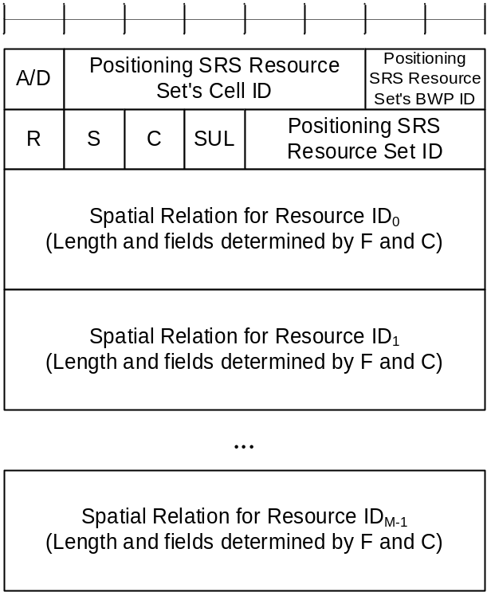
Figure 6.1.3.36-1: SP Positioning SRS Activation/Deactivation MAC CE
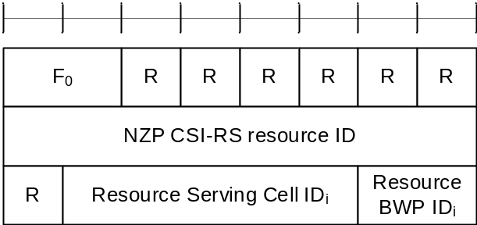
Figure 6.1.3.36-2: Spatial Relation for Resource ID_{i} with NZP CSI-RS
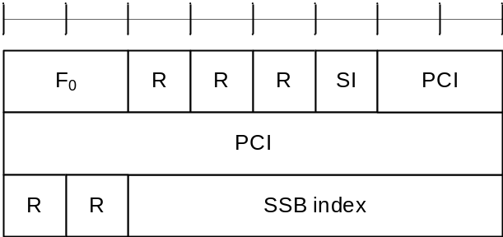
Figure 6.1.3.36-3: Spatial Relation for Resource ID_{i} with SSB
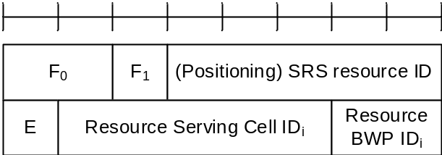
Figure 6.1.3.36-4: Spatial Relation for Resource ID_{i} with SRS
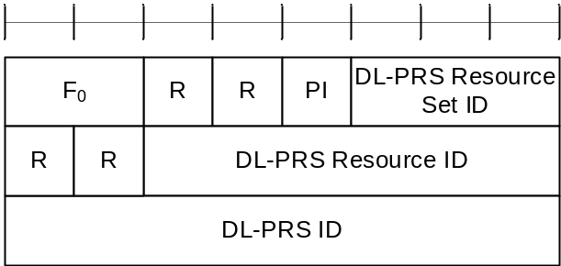
Figure 6.1.3.36-5: Spatial Relation for Resource ID_{i} with DL-PRS
The field Spatial Relation for Resource ID_{i} consists of the following fields:
- F₀: This field indicates the type of a resource used as a spatial relation for the i^{th} Positioning SRS resource within the Positioning SRS Resource Set indicated with the field Positioning SRS Resource Set ID. The field is set to 00 to indicate NZP CSI-RS resource index is used; it is set to 01 to indicate SSB index is used; it is set to 10 to indicate SRS resource index is used; it is set to 11 to indicate DL-PRS index is used. The length of the field is 2 bits;
- F₁: This field indicates the type of SRS resource used as spatial relation for the i^{th} Positioning SRS resource within the SP Positioning SRS Resource Set indicated with the field Positioning SRS Resource Set ID when F₀ is set to 10. The field is set to 0 to indicate SRS resource index SRS-ResourceId as defined in TS 38.331 [5] is used; the field is set to 1 to indicate Positioning SRS resource index SRS-PosResourceId as defined in TS 38.331 [5] is used;
- NZP CSI-RS Resource ID: This field contains an index of NZP-CSI-RS-ResourceID, as specified in TS 38.331 [5], indicating the NZP CSI-RS resource, which is used to derive the spatial relation for the positioning SRS. The length of the field is 8 bits;
- SSB index: This field contains an index of SSB SSB-Index as specified in TS 38.331 [5] and/or TS 37.355 [23]. The length of the field is 6 bits;
- PCI: This field contains physical cell identity PhysCellId as specified in TS 38.331 [5] and/or TS 37.355 [23]. The length of the field is 10 bits;
- SRS resource ID: When F₁ is set to 0, the field indicates an index for SRS resource SRS-ResourceId as defined in TS 38.331 [5]; When F₁ is set to 1, the field indicates an index for Positioning SRS resource SRS-PosResourceId as defined in TS 38.331 [5]. The length of the field is 5 bits representing the index from 0 to 31;
- E: This field indicates the extension of SRS resource ID as the MSB of SRS resource ID. The total length of the extended SRS resource ID is 6 bits. If E bit is set to 1, the SRS resource ID value is 5-bit SRS resource ID field + 32;
- DL-PRS Resource Set ID: This field contains an index for DL-PRS Resource Set nr-DL-PRS-ResourceSetId as defined in TS 37.355 [23]. The length of the field is 3 bits;
- DL-PRS Resource ID: This field contains an index for DL-PRS resource nr-DL-PRS-Resource-Id as defined in TS 37.355 [23]. The length of the field is 6 bits;
- DL-PRS ID: This field contains an identity for DL-PRS resource dl-PRS-ID as defined in TS 37.355 [23]. The length of the field is 8 bits;
- PI: This field indicates whether the field DL-PRS resource ID is present within the Spatial Relation for Resource ID_{i} with DL-PRS. If the field is set to 1, the octet containing the field DL-PRS resource ID is present; otherwise, the octet is omitted;
- SI: This field indicates whether the field SSB index is present within the Spatial Relation for Resource ID_{i} with SSB. If the field is set to 1, the octet containing the field SSB index is present; otherwise, the octet is omitted;
- Resource Serving Cell ID_{i}: This field indicates the identity of the Serving Cell on which the resource used for spatial relationship derivation for the i^{th} Positioning SRS resource is located. The length of the field is 5 bits;
- Resource BWP ID_{i}: This field indicates a UL BWP as the codepoint of the DCI bandwidth part indicator field as specified in TS 38.212 [9], on which the resource used for spatial relationship derivation for the i^{th} Positioning SRS resource is located. The length of the field is 2 bits.

==================================END OF CHANGES==================================

