NAME- GHANSHYAM THAKKAR ENROLLMENT NO.- 200280111051 BATCH- A2, 5TH SEM

**200280111079 JAIMIN PANCHAL**

# 200280111051 - Ghanshyam

## QUESTION 1

EXERCISE 3

1. Give the register value for each of the following instructions after it is executed. Assume R0=0x4545, R1=0x5454 and R2=0xFF00.

1. AND R3, R2, R0
2. AND R3, R2, R2
3. AND R3, R0, #0xFF
4. ORR R3, R0, #0x0F
5. ORR R3, R2, R1
6. EOR R0, R0, #0x45
7. EOR R0, R0, R0

## CODE:

AREA PROG,CODE,READONLY ENTRY

LDR R0,=0X4545 LDR R1,=0X5454 LDR R2,=0XFF00 AND R3,R2,R0 AND R4,R2,R2 AND R5,R0,#0XFF ORR R6,R0,#0X0F ORR R7,R2,R1 EOR R8,R0,#0X45 EOR R9,R0,R0 END

**200280111079 JAIMIN PANCHAL**

# 200280111051 - Ghanshyam

## OUTPUT:

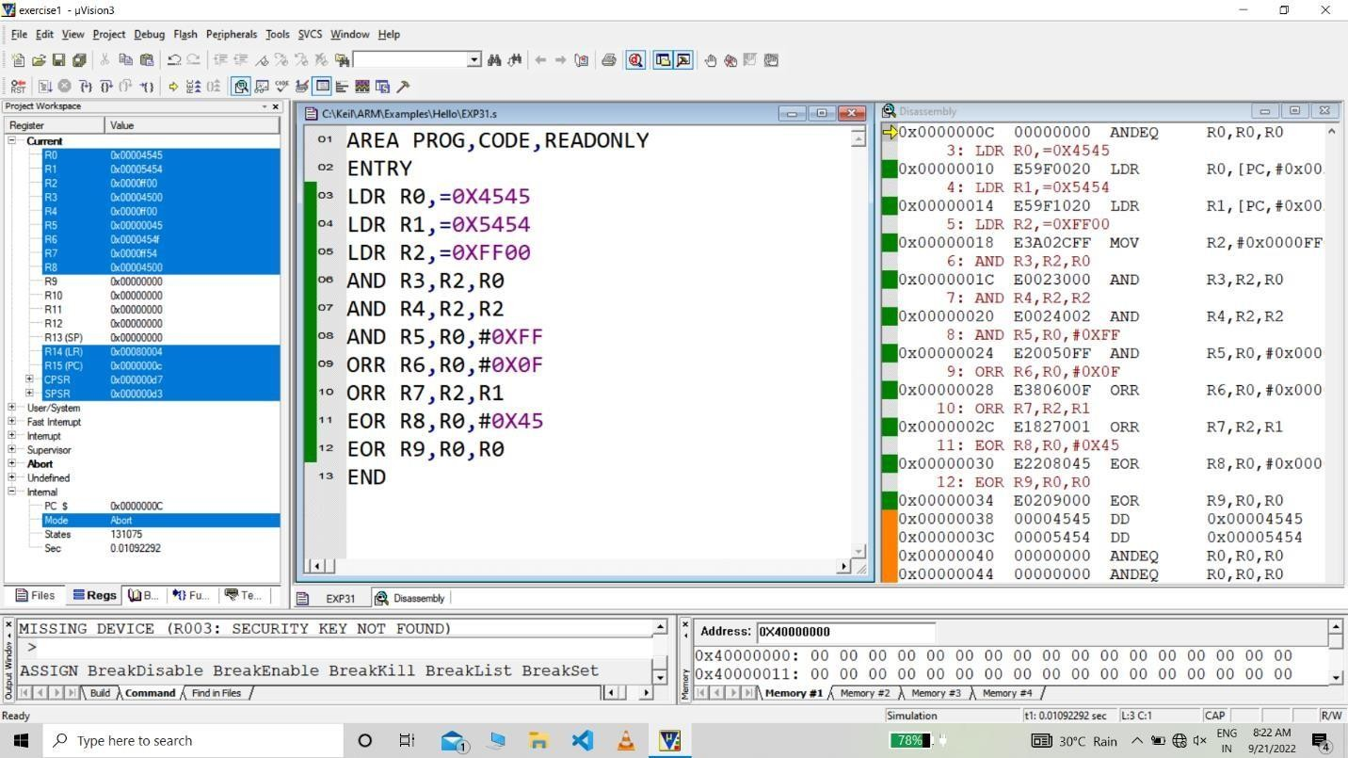

**200280111079 JAIMIN PANCHAL**

# 200280111051 - Ghanshyam

## QUESTION 2

Write an instruction that sets bit 6 of R1 without affecting other bits.

## CODE:

AREA LDCE,CODE,READONLY ENTRY

MOV R1,#0X00 MOV R2,#0X40 ORR R1,R1,R2 END

## OUTPUT:

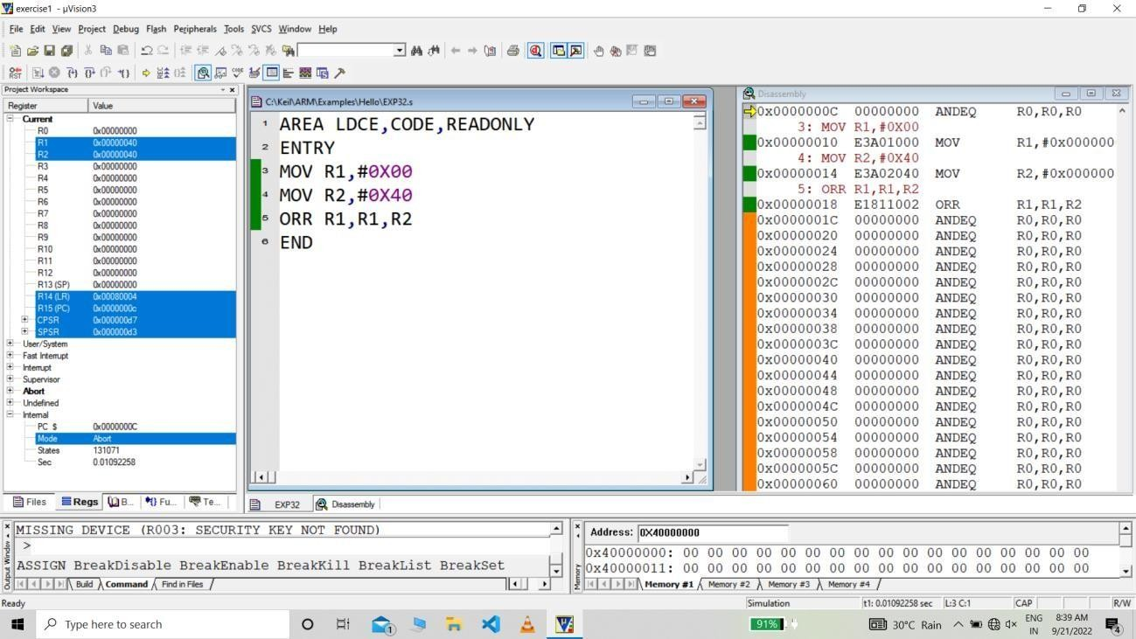

**200280111079 JAIMIN PANCHAL**

# 200280111051 - Ghanshyam

## QUESTION 3

Write an instruction that clear bit 13 of R2 without affecting other bits.

## CODE:

AREA PROG,CODE,READONLY ENTRY

LDR R2,=0XFFFFFFFF LDR R1,=0XFFFFDFFF AND R2,R1,R2

END

## OUTPUT:

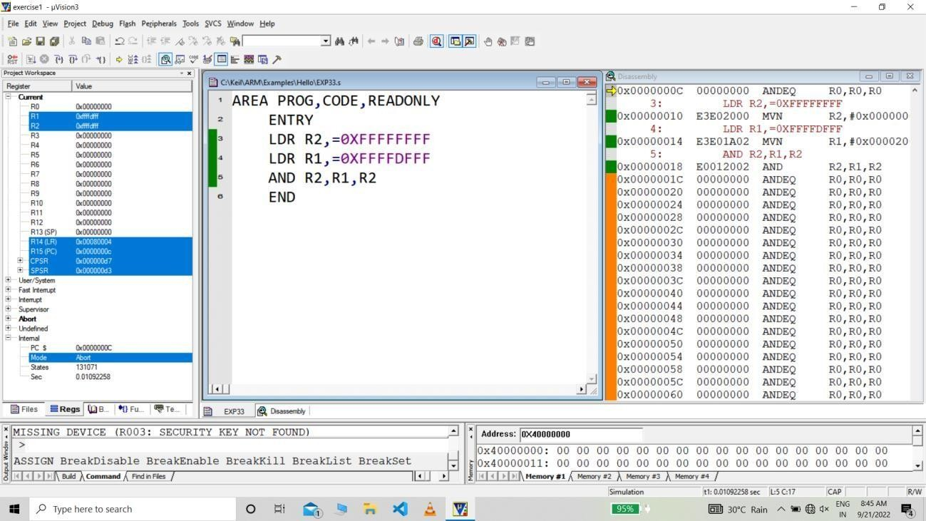

**200280111079 JAIMIN PANCHAL**

# 200280111051 - Ghanshyam

## QUESTION 4

Write a program to multiply the following values. (R1=0x5578, R2=0xaaa, R3=0xaabb987f, R4=0x12345678).

1. Multiply R1 and R2
2. Multiply R1 and R3
3. Multiply R3 and R4
4. Perform (R1 * R3 + R3)

## CODE:

AREA PROG,CODE,READONLY ENTRY

LDR R1,=0X5578 LDR R2,=0Xaaa

LDR R3,=0Xaabb987f LDR R4,=0X12345678 LDR R10,=0X00

MUL R5,R1,R2 UMULL R6,R7,R1,R3 UMULL R8,R9,R3,R4 UMLAL R3,R10,R1,R3 END

**200280111079 JAIMIN PANCHAL**

OUTPUT:

# 200280111051 - Ghanshyam

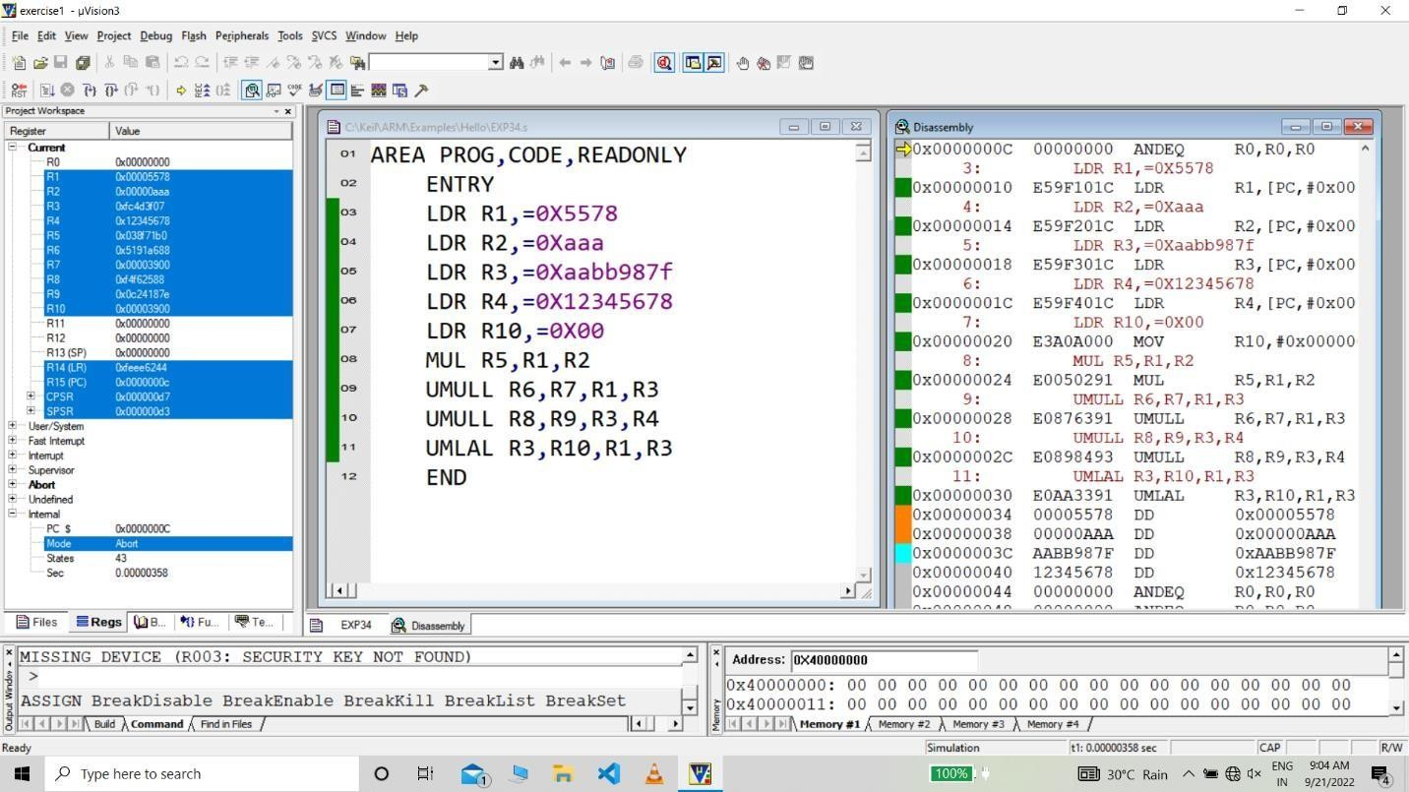

**200280111079 JAIMIN PANCHAL**

# 200280111051 - Ghanshyam

## QUESTION 5

Write a program to convert unpacked BCD number into ASCII number.

## CODE:

AREA PROG,CODE,READONLY ENTRY

MOV R1,#0X08 ADD R1,R1,#0X30 END

## OUTPUT:

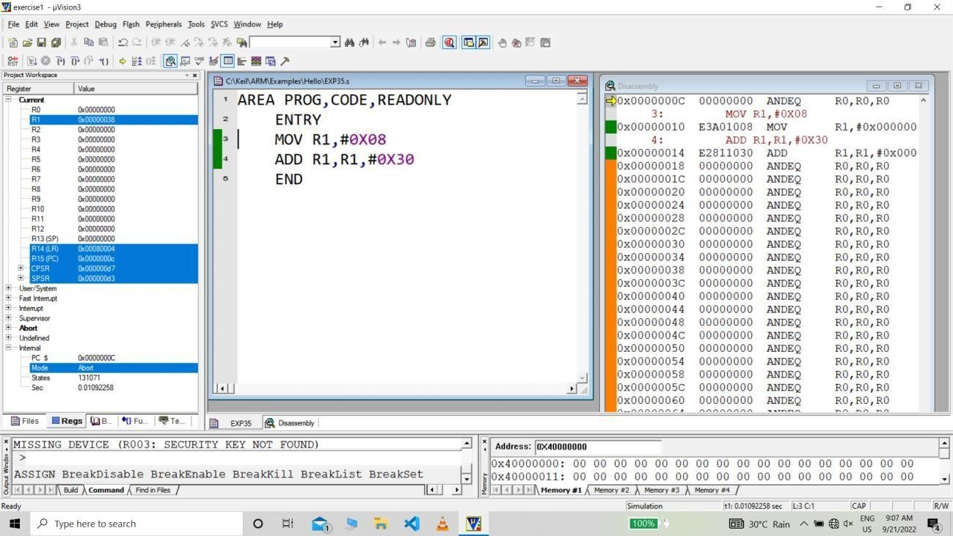

**200280111079 JAIMIN PANCHAL**

# 200280111051 - Ghanshyam

## QUESTION 6

Write a program to convert packed BCD number into ASCII number.

## CODE:

AREA LDCE,CODE,READONLY ENTRY

LDR R1,=0X38 AND R3,R1,#0X0F ADD R3,R3,#0X30 MOV R4,R1,LSR#4 AND R5,R4,#0X0F ADD R5,R5,#0X30 END

## OUTPUT:

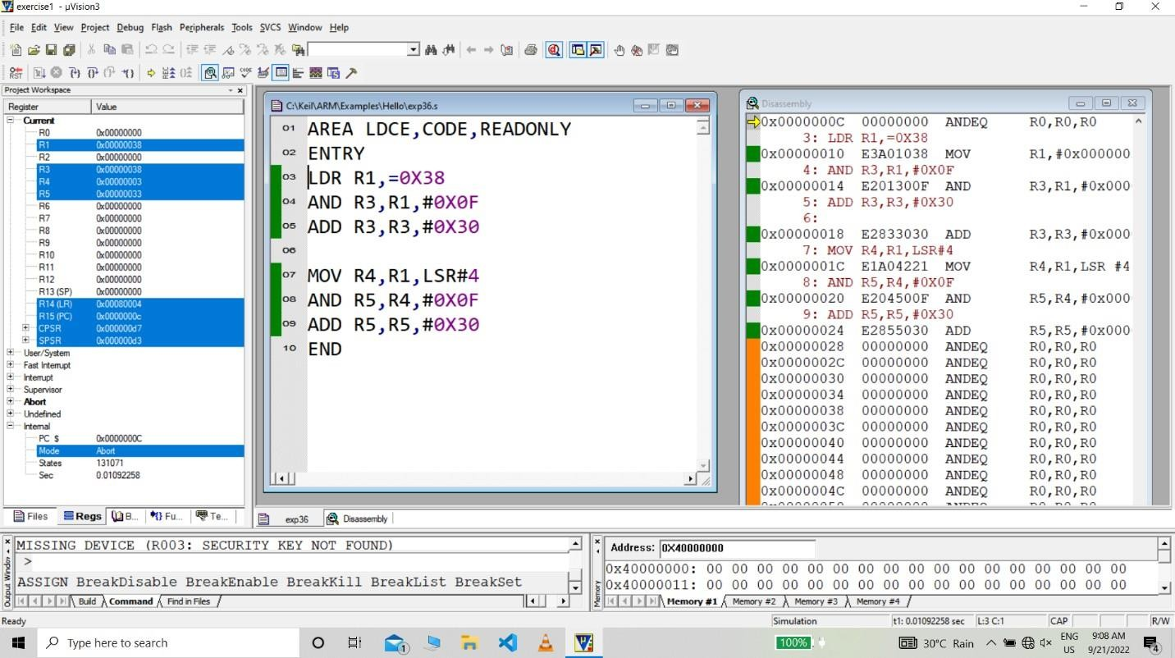

**200280111079 JAIMIN PANCHAL**

# 200280111051 - Ghanshyam

## QUESTION 7

Write a program to convert ASCII number into packed BCD number.

## CODE:

AREA PROG,CODE,READONLY ENTRY

MOV R1,#0X36 MOV R2,#0X38 SUB R3,R1,#0X30 SUB R4,R2,#0X30

ADD R5,R4,R3,LSL #4 END

## OUTPUT:

