**Setup your Environment to Run and Debug your Apps on a Real Device**

**On the Android devices (Android 4.2 or higher) :**

1. Enable *Developer Options Menu*   
   (this menu item is originally hidden)
   * Go to: *Settings -> About phone*  
     and tap *Build number* seven times

Example screenshots with moto *g* phones:

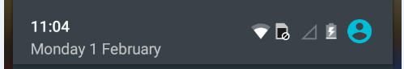



Settings

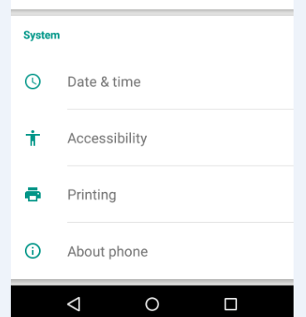

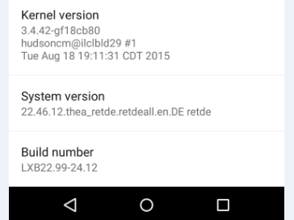

tap 7x

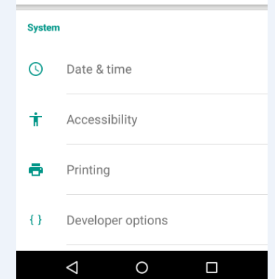

*Developer options* is now visible

1. Allow *USB Debugging*
   * Go to: *Settings -> Developer options*
   * Check the checkbox *USB debugging*

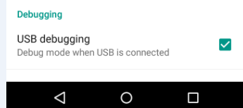

**On your PC (Windows 7) :**

1. Connect your Android device via USB to the PC. Let Windows install the required drivers.
2. Check in the Windows *Device Manager* whether the device drivers for your Android device are properly installed.

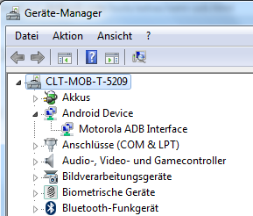

* If the drivers are properly installed, continue with point 3.
* 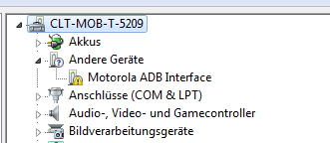If the drivers are not yet installed:  
    
    
    
    
    
    
    
    
  Download and install an OEM drivers from the manufacturer of your Android device:  
  <http://developer.android.com/tools/extras/oem-usb.html#Drivers>
* For the *moto g* mobile phone, install the[*Motorola Device Manager*](https://motorola-global-portal.custhelp.com/app/answers/detail/a_id/88481/)   
  (this also installs the device drivers).

1. 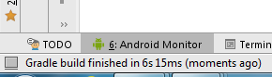With the Android device connected to the PC, start Android Studio and open the project to be debugged. Wait until the automatic build process is finished.

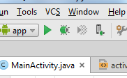  
Start the App: Click on the run icon.

1. **On your Android device** appears a message asking you to allow USB debugging.  
   If you don’t want to be asked again, check the checkbox: *Always allow from this computer*  
   Click *OK*

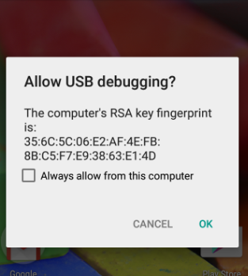

You may check this checkbox

1. **In Android Studio** the *Device Chooser* window has popped up and you should now find there your Android device listed.  
   Select *Choose running device*, select your Android device and click *OK*.  
     
   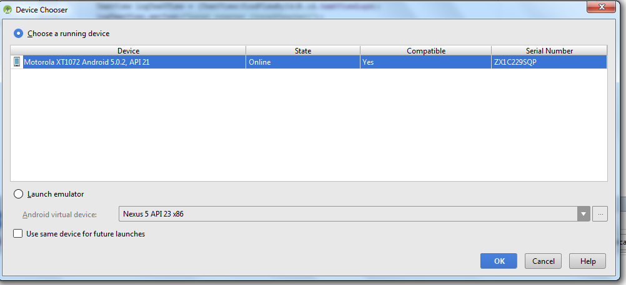
2. After a certain time the App starts up and runs on your Android device.

eand 2016