**Moodlight User Manual**

**Installing the Moodlight app**

1. Download the file “app-release.apk” from Github (<https://github.com/spectre3141/ETP2/tree/master/android_app/ETP_Moodlight/app/release>)

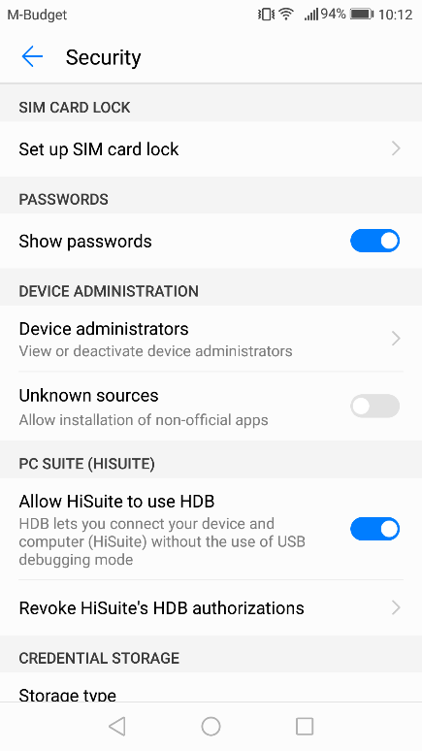

1. Either manually enable “installation of non-official apps” or just open the downloaded file and click “settings” to open the right settings page
2. Now open the apk file (again) and click “install”
3. The application should now be installed. Its name is simply “Moodlight”, you can use your phones search function if necessary
4. When you successfully installed the Moodlight app you might want to disable the “Allow installation of non-official apps”. In case you don’t find the according settings, try searching for “unknown” because the option is called “unknown sources”

**Setting up the Moodlight**

1. Ensure, that the lampshade is mounted correctly to avoid eye damage
2. Plug in the power supply
3. Turn on the device (flick the power switch to ON)
4. Open the Moodlight app and connect, as explained under **App functionality**, to the Device

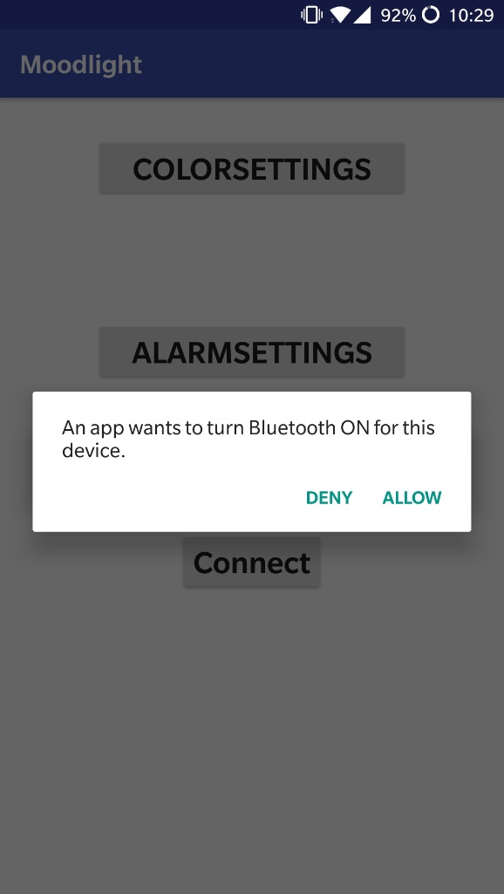**App functionality**

Start the moodlight app. After starting, the app will ask you to turn on Bluetooth if not already turned on. Click “Allow”, otherwise the app will terminate.

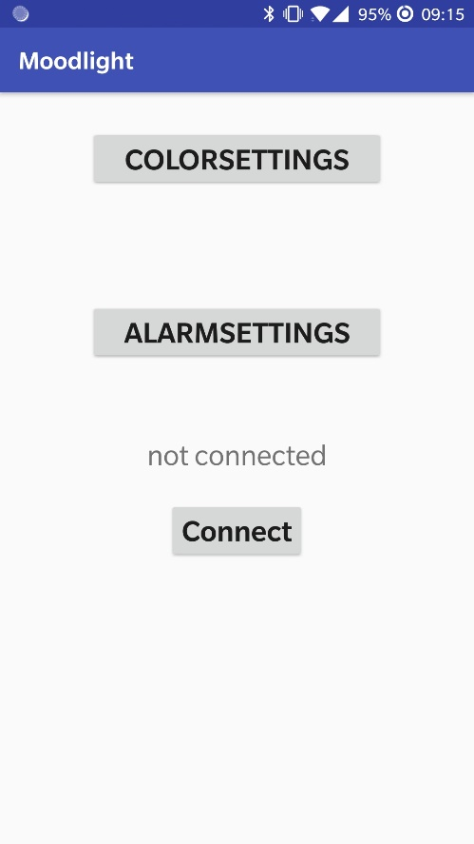

**Home screen**

After opening the app you see the home screen of the app.

**COLORSETTINGS** opens the color options of the Moodlight.

**ALARMSETTINGS** lets you set up the alarm clock of the Moodlight.

**Connect** lets you connect to the Moodlight.

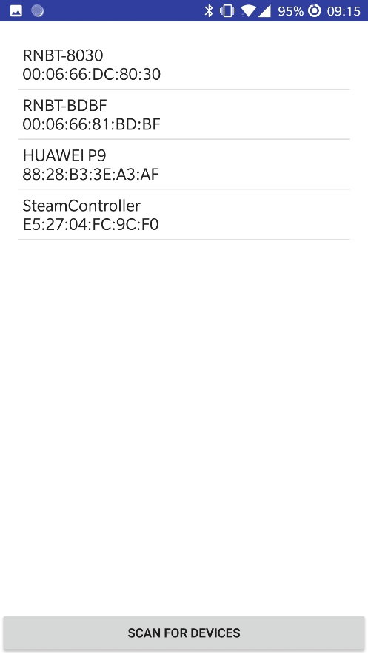**Connecting via Bluetooth**

Press scan for devices if the Moodlight does not show up in the device list.

Tap on the Moodlight in the list to connect to it.

The app will take you back to the home screen.

After a few seconds the text field above the connect button will show the name of the connected device or “connection failed”. If the connection failed try again.

**BILD CONNECTED**

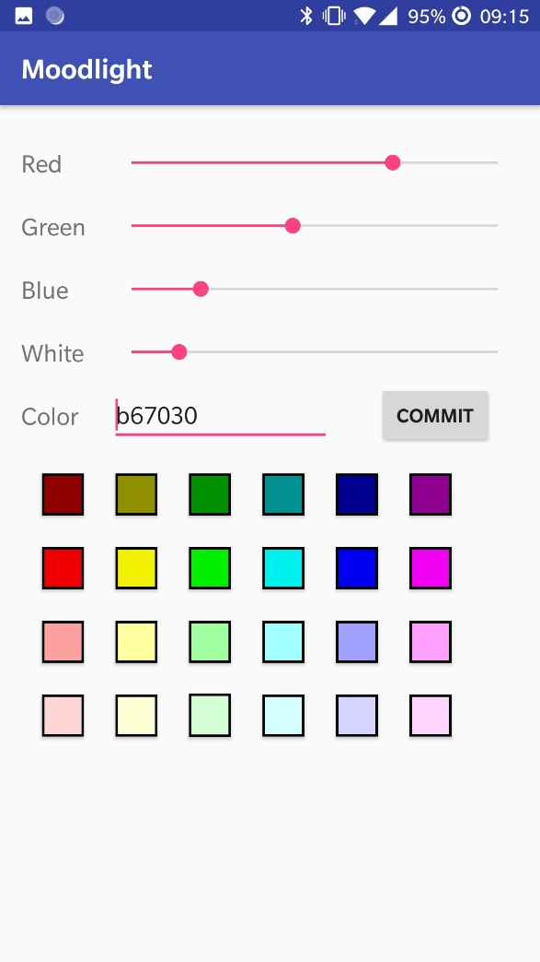**COLORSETTINGS**

With the four sliders you can choose the brightness of each color channel.

In the text box you can type in hexadecimal values to set the color of the Moodlight. The order is red, green and blue. Note that the keyboard shows all keys, but allows only the the digits {0..9} & {a..f}. Press the commit button to send the color settings.

You can tap the colored boxes in the low screen half to choose between various predefined colors.

Press the android back button to return to the Moodlights home screen.

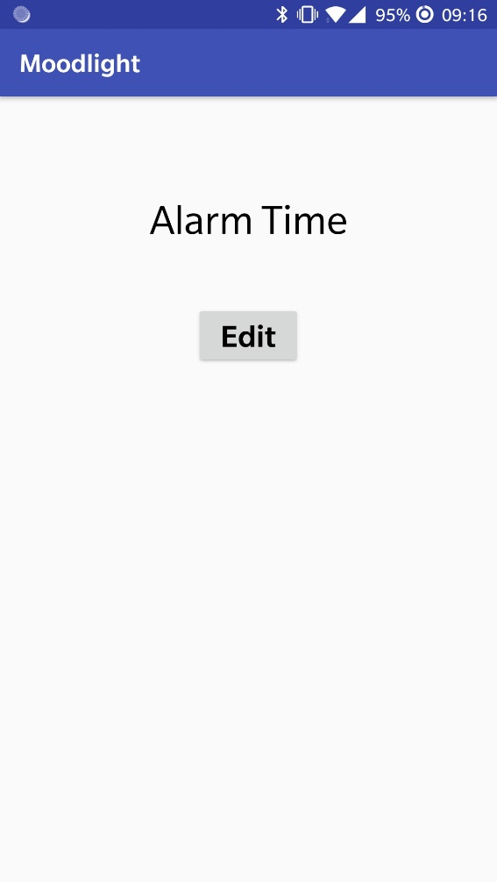

**ALARMSETTINGS**

Press Edit to choose a time in hours and minutes for the alarm.

The alarm will start after the set duration.

Press the android back button to return to the Moodlights home screen.

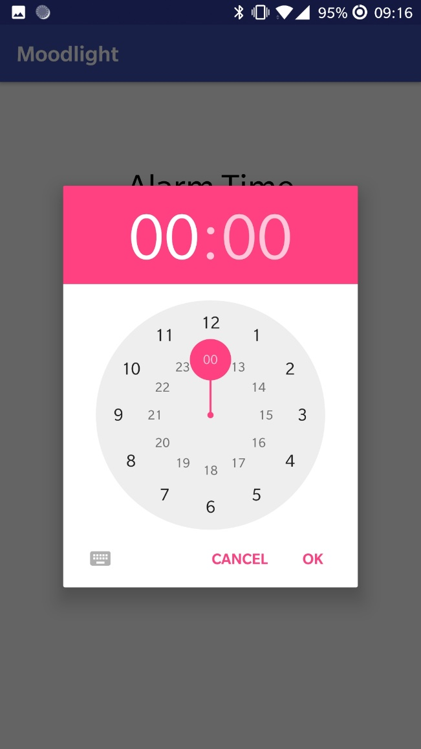

**Safety Warnings**

Do not look at the LED’s directly, they are very bright and may cause eye damage. Also note that the Moodlight is capable of emitting intense blue light and Blue-light hazards are not properly researched yet.  
There is no danger of electro shocks because the Moodlight works at 24VDC.  
There is no danger to burn yourself or set fire because, because the components run on low temperature.

**Contact**

In case you encounter problems not described in the user manual or have further questions, contact us:

Felix Baumann  
[baumafel@students.zhaw.ch](mailto:baumafel@students.zhaw.ch?subject=Moodlight)

Jonas Schönenberger  
[schoejo2@students.zhaw.ch](mailto:schoejo2@students.zhaw.ch?subject=Moodlight)