SC-100 Microsoft Cybersecurity Architect

Security Best Practices and Priorities

Zero Trust and Best Practice Frameworks

Best practices are the recommended ways to do things which are effective or efficient.

Microsoft embedded security best practices in various forms such as:
- Microsoft Cyber Security Reference Architecture
- Microsoft Cloud Security Benchmark
- Cloud Adoption Framework (CAF)
- Azure Well Architected Framework (WAF)
- Microsoft Security Best Practices

Antipatterns are the common mistakes that lead to negative outcomes.

Microsoft observed multiple antipatterns that decreases security posture:
- We do not patch unless its critical
- Waiting for patch perfection instead of building resilience
- Broken accountability model which holds security team accountable for negative outcome of patches.
- Over-customizing patch selection
- Focusing only on Operating Systems means teams do not patch containers, apps, firmware, appliances, and OT/IOT devices.

How architects use best practices
- Integrating best practices into security architecture and policies.
- Advising security leaders on how to integrate best practices into business and technical processes, and culture.
- Advising technical teams on implementing best practices, which technology would be easy to implement best practices.
- Advising others in organizations such as IT architects, application owners, developers, and more on how to integrate best practices.

Follow best practices unless you have a reason to avoid them.
Adapt but do not over-customize.
Adopting best practices will reduce common mistakes and improve overall security effectiveness and efficiency.

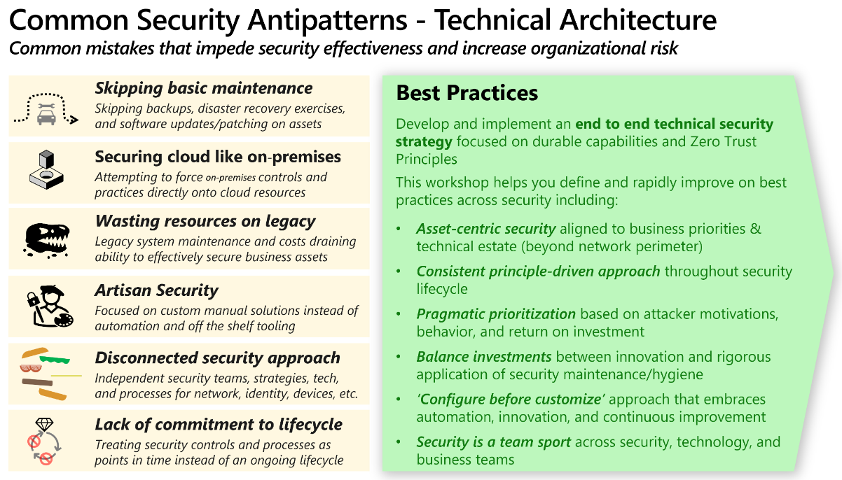

Which framework should I choose?

https://learn.microsoft.com/en-us/training/modules/introduction-zero-trust-best-practice-frameworks/1-introduction-best-practices

