Powershell attacks

PowerShell
- Task automation and configuration management framework from Microsoft.
- Consisting of a command-line shell and associated scripting language
- Built on the .NET Framework;
- Enabling administrators to perform administrative tasks on both local and remote Windows systems
- Why attackers love PowerShell?
- It is installed and enabled by default;
- Most attacker logic can be written in PowerShell without the need to install malicious binaries (interaction with .NET & Windows API, execution of payloads directly from memory, downloading & execution code from another system, etc.);
- It has remote access capabilities by default;
- As a script, It is easy to obfuscate and difficult to detect with signature-based approach;
- Many sysadmins use and trust it, allowing PowerShell malware to blend in with regular administration work;
- Most organizations are not watching PowerShell activity
- PowerShell Execution Policies aren’t about security
- Execution Policy is not a security measure as it is known and can be easily overcome.
- It has been developed to prevent the damage they cause users run the script by accident
- PowerShell Execution Policies aren’t about security A lot of ways to bypass it!

Detection of PowerShell abuses

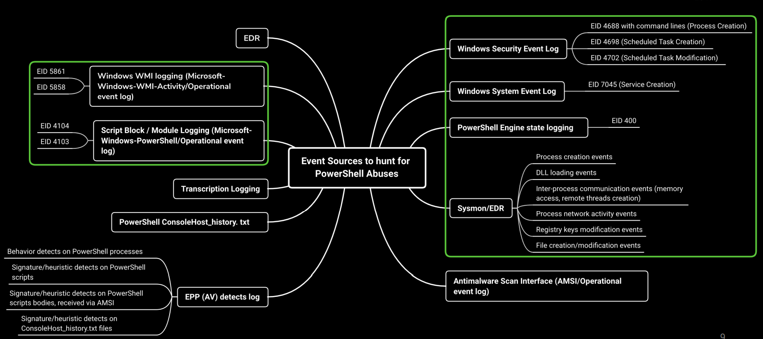

PowerShell abuse patterns

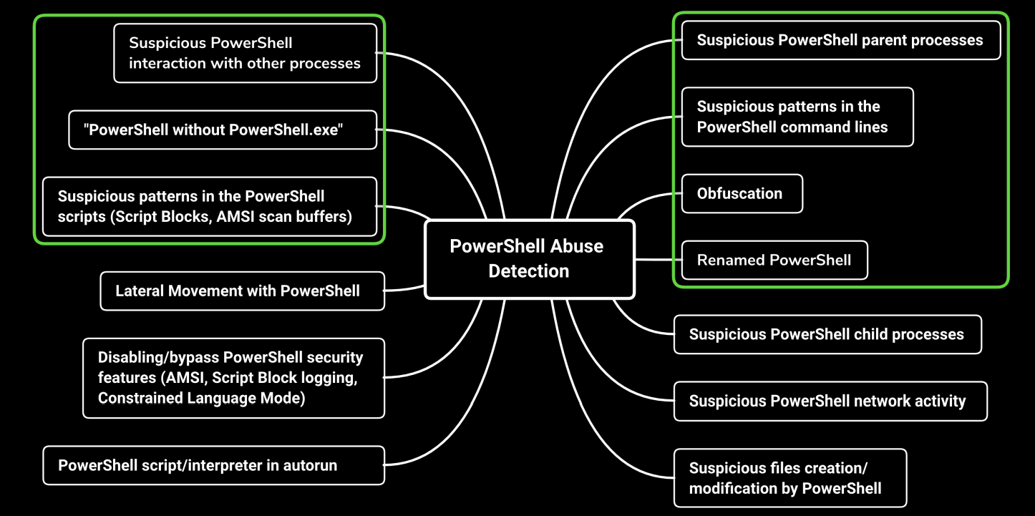

Well-known PowerShell Offensive Frameworks
- PowerSploit
- PowerCat
- Empire
- DarkObserver
- PowerMemory
- Invoke-Mimikatz
- Invoke-Mimikittenz
- Offensive-PowerShell
- Kautilya
- Nishang
- PoshRat
- PowerShell Suite
- OWA-Toolkit
- Sherlock
- Invoke-Phant0m

Search for commandlet and function names from well-know PowerShell offensive frameworks in PowerShell command lines and script blocks:
- Get-GPPPassword
- Get-Keystrokes
- Get-MicrophoneAudio
- Get-ModifiablePath
- Get-TimedScreenshot
- Invoke-AllChecks
- Invoke-AmsiBypass
- Invoke-DllInjection
- Invoke-Mimikatz
- Invoke-NinjaCopy
- Invoke-PsUACme
- Invoke-ReflectivePEInjection
- Invoke-Shellcode
- PowerUp
- PowerView

Suspicious PowerShell parent process

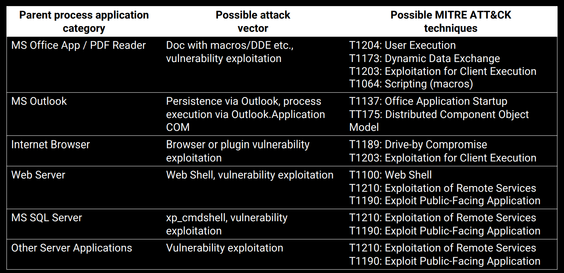

Suspicious PowerShell parent process
- amigo.exe
- browser.exe
- chrome.exe
- excel.exe
- firefox.exe
- httpd.exe
- iexplore.exe
- jbosssvc.exe
- microsoftedge.exe
- microsoftedgecp.exe
- MicrosoftEdgeSH.exe
- msaccess.exe
- mshta.exe
- mspub.exe
- nginx.exe
- outlook.exe
- php-cgi.exe
- powerpnt.exe
- regsvr32.exe
- rundll32.exe
- safari.exe
- services.exe
- sqlagent.exe
- sqlserver.exe
- sqlservr.exe
- tomcat
- visio.exe
- vivaldi.exe
- w3wp.exe
- winword.exe
- wmiprvse.exe

Path Traversal
- Linux Server Path Traversal Exploitation
- Basic Path Traversal
- Blocked Traversal Sequence
- Validated Path Traversal
- Path Disclosure in URL
- Null Byte Bypass
- Windows Server Path Traversal Exploitation
- Basic Path Traversal
- Double dots with Forward-Backward Slashes
- Blocked Traversal Sequence

