Azure VM login with Entra Account

Azure Windows VMs login through Entra will NOT Work when:

Device & Configuration Issues
- Azure VM is NOT Entra-joined or Entra Hybrid-joined: The VM must be joined to Entra ID or Hybrid AD + Entra.
- Azure VM does NOT have "Login with Entra ID" feature enabled: Enabling Entra login on the VM is a mandatory configuration.
- Local client machine is NOT Entra-joined or Entra-registered: The connecting device must be Entra-joined or Entra-registered.
- Azure VM is based on an unsupported OS/image: Some custom or outdated OS images may lack Entra login support (e.g., missing agents).
- Remote Desktop Protocol (RDP) is disabled or blocked by NSG/firewall: Even if Entra login is correctly set up, RDP must be accessible.
- Azure VM does not have outbound connectivity to Microsoft identity endpoints: The VM needs to reach Entra ID endpoints (login.microsoftonline.com, etc.) to authenticate users.

User & Permissions Issues
- User is NOT assigned the correct RBAC role (Virtual Machine User Login or Administrator Login): The user needs RBAC permission at VM, RG, or subscription level.
- User account is disabled, deleted, or unlicensed: Disabled or non-licensed accounts cannot authenticate.
- Incorrect username format used (e.g., not using UPN): Must use full Entra ID UPN (e.g., user@domain.com) — short names like user will fail.

Token & Policy Issues
- Conditional Access policies block login (e.g., device not compliant, MFA failure): Policies may block the session even if config is correct.
- Trusted Platform Module (TPM) or Hello for Business setup issues (in some CA/MFA scenarios): If CA policies require specific credential types, these may block RDP Entra login.
- Client-side cached credentials or session tokens are invalid/expired: May result in unexpected login failures or credential prompts.

Client App/Protocol Issues
Only supported on Windows classic Remote Desktop Connection app (mstsc.exe)

Client | Status | Reason
Microsoft Store Remote Desktop App (UWP) | ❌ Not supported | Does not support Entra ID login tokens
Microsoft Remote Desktop (macOS, iOS, Android) | ❌ Not supported | No Entra token auth support
Third-party clients (Remmina, FreeRDP, etc.) | ❌ Not supported | Cannot process Entra token-based login
Azure Bastion (Standard SKU) | ❌ Fails in practice | Though documented as supported, it does not work reliably and often fails even in properly configured environments — this is a known issue internally at Microsoft and among cloud practitioners.

Summary Checklist

Requirement | If Missing → Entra Login Fails
VM is Entra-joined or hybrid-joined | ✅ Required
VM has Entra login enabled | ✅ Required
Client machine is Entra-joined/registered | ✅ Required
User has proper RBAC (VM User Login) | ✅ Required
Supported RDP client (MSTSC.exe only) | ✅ Required
VM has access to Entra ID endpoints | ✅ Required
User account active & licensed | ✅ Required

Only working method for Azure Windows VM login through Entra Account

✅ Only Working Method for Microsoft Entra ID Login to Azure Windows VMs

Requirement | Description
Client | mstsc.exe (classic Remote Desktop Connection)
Client OS | Windows 10 or 11 (modern versions)
Client Device State | Must be Microsoft Entra-joined or Entra-registered
Azure VM | Must be Microsoft Entra-joined or Hybrid Entra-joined
VM Feature | "Login with Entra ID" must be enabled
User Identity | Must use UPN format (e.g., user@domain.com)
RBAC Role | Must be assigned Virtual Machine User Login or Virtual Machine Administrator Login
RDP Port (3389) | Must be open and reachable
Internet Access | VM must reach Microsoft identity endpoints (e.g., login.microsoftonline.com)

✅ Final Validation:
The only currently reliable and supported way to log in to Azure Windows VMs using Microsoft Entra ID is:
🔐 mstsc.exe from a Windows 10/11 device that is Entra-joined or Entra-registered, connecting to an Azure VM that is Entra-joined, with Login with Entra ID enabled and correct RBAC assigned.

Not asking MFA while login

Why is MFA not prompted when using Microsoft Entra ID login to Azure Windows VMs via RDP?

✅ By default, RDP with Entra ID does not enforce MFA
Even though you're using a Microsoft Entra account, logging into an Azure Windows VM via RDP does not automatically trigger MFA — unless you explicitly enforce it via Conditional Access (CA).

How to Enforce MFA for Entra VM Logins
To require MFA during RDP login to Azure VMs using Entra accounts, you must Create a Conditional Access Policy targeting Azure Windows VM sign-ins

Step-by-Step: Enforce MFA on Azure VM Entra Login
- Go to Microsoft Entra Admin Center (formerly Azure AD):
https://entra.microsoft.com
- Navigate to:
Protection ➝ Conditional Access ➝ New policy
- Configure the policy:
  - Name: e.g., Require MFA for Entra VM login
  - Assignments → Users: Choose users or groups
  - Assignments → Cloud apps or actions:
    - Choose "Microsoft Azure Windows VM Sign-In"
  - Conditions → Device platforms: (Optional) Limit to Windows
  - Grant controls:
    - Select "Require multi-factor authentication"
- Enable policy and save

Result:
Now, MFA will be required whenever a user tries to log in to an Entra-joined Azure VM using Entra credentials (e.g., via mstsc.exe), as long as the Conditional Access policy applies.

Important Notes
- No CA = No MFA: Entra login alone does not prompt for MFA.
- CA policy must target the special app Microsoft Azure Windows VM Sign-In (not the generic “All cloud apps”).
- The first login may prompt for MFA if it's a new device registration — but not after that unless enforced.

Windows login through RDP Connection

It will only support the Windows OS builtin Remote Desktop Service feature. Microsoft/Windows Store Remote Desktop App will not support it.

Requirements:

OS version: Windows Server 2022 Datacenter Azure Edition

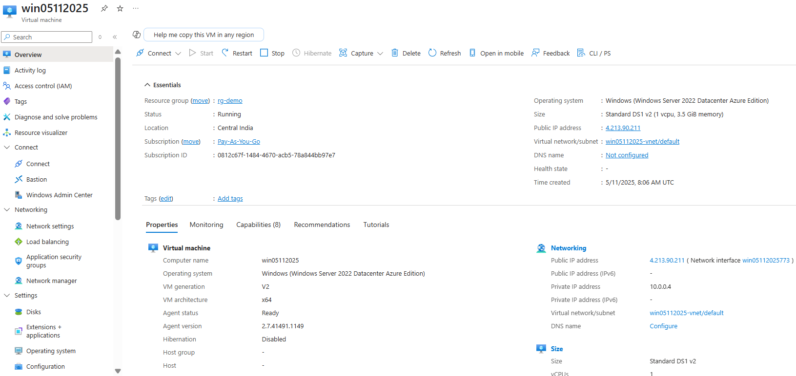

AADLoginforWindows extension installed
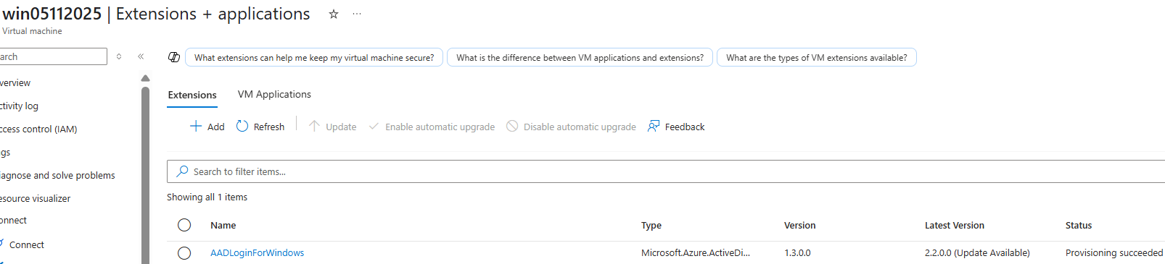

Network settings
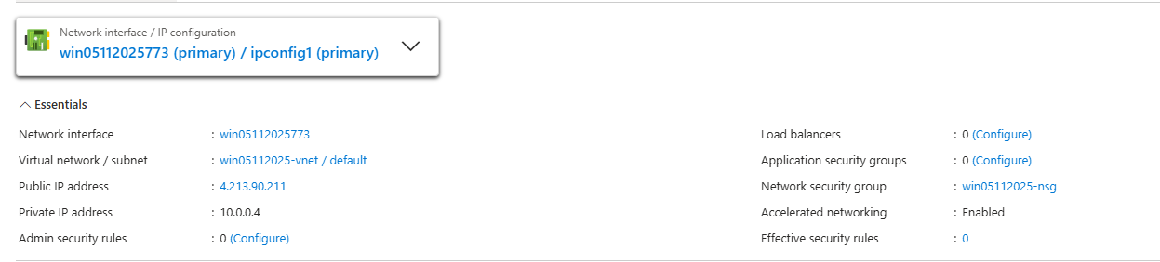
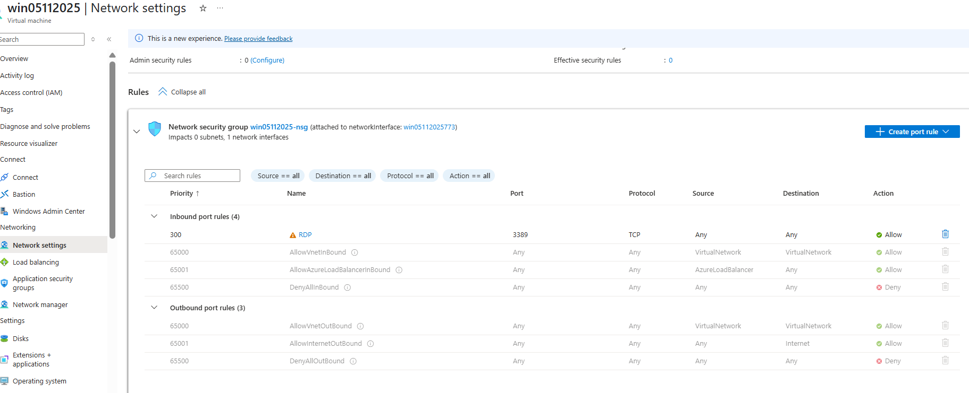

Entra domain joined

When local device is not Entra joined?

Here local device desktop2025 domain join is disabled.
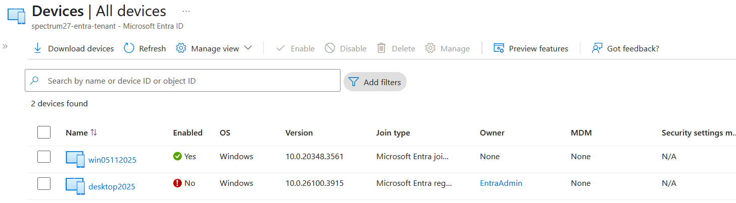

Login with Public IP of VM: 4.213.90.211
Username: polaris-az@spectrum27.onmicrosoft.com

Let’s enter login details in RDP service
Note: the option “Use a web account to sign in to the remote computer” is not checked

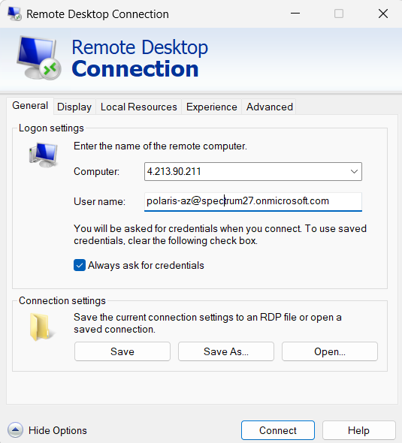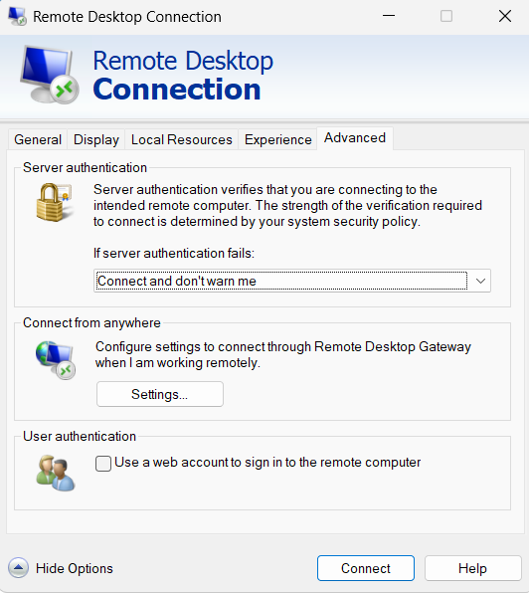

Click on “Connect”, you will see below screen.
Enter password, then press OK.
It will show error: “The logon attemot failed”

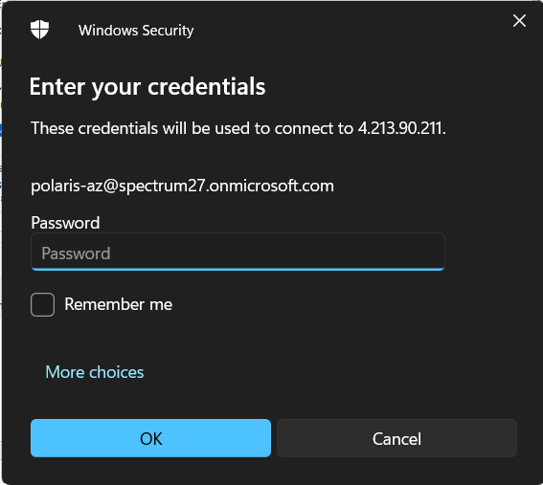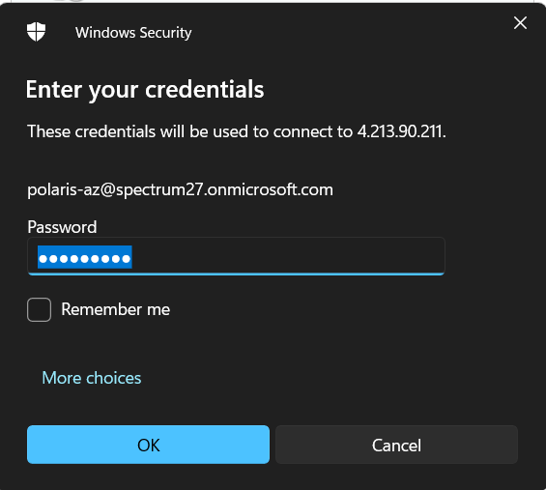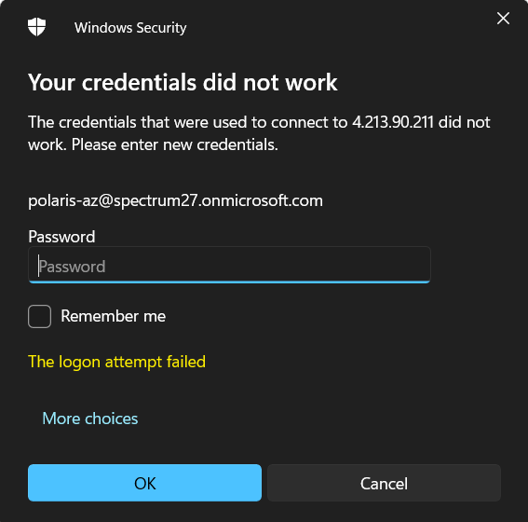

Verify the config status on Azure VM

Loggedin through local account to verify the configuration status.

AzureADJoined showing Yes.

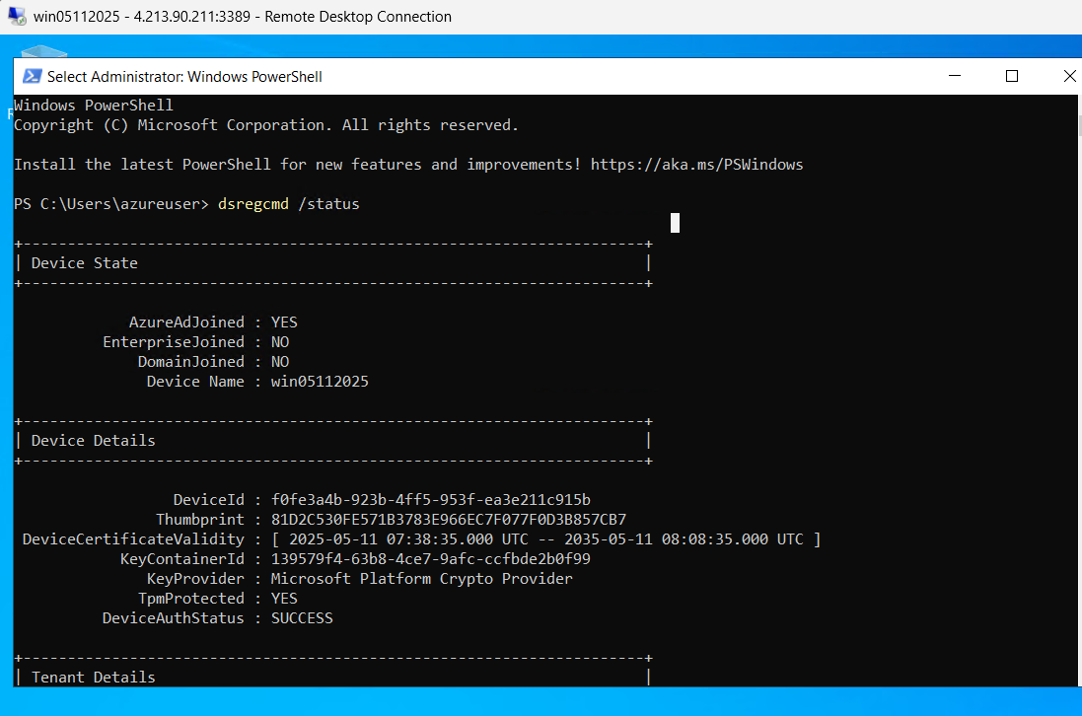

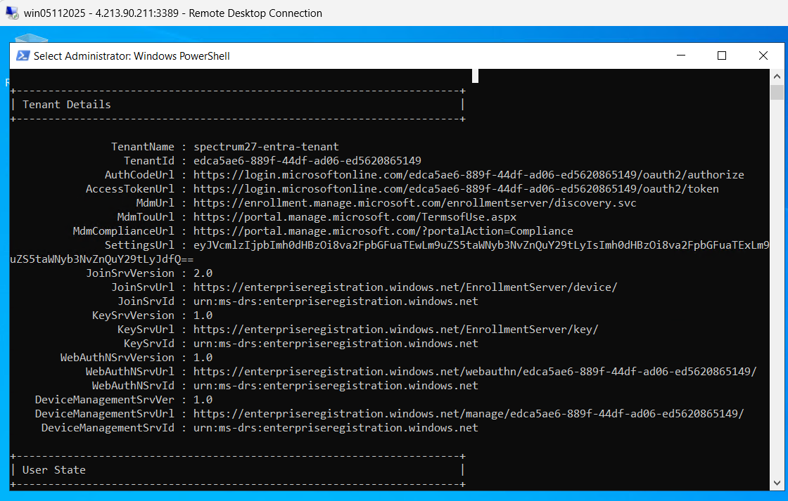

AzureADPrt showing NO
PRT stands for Primary Request Token

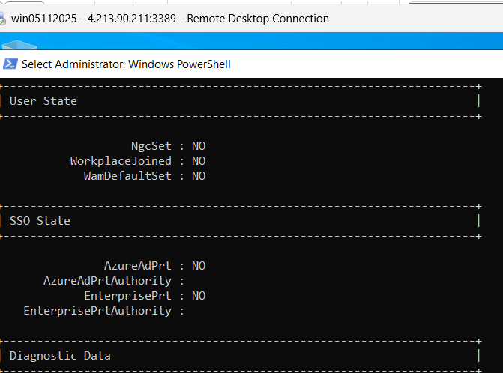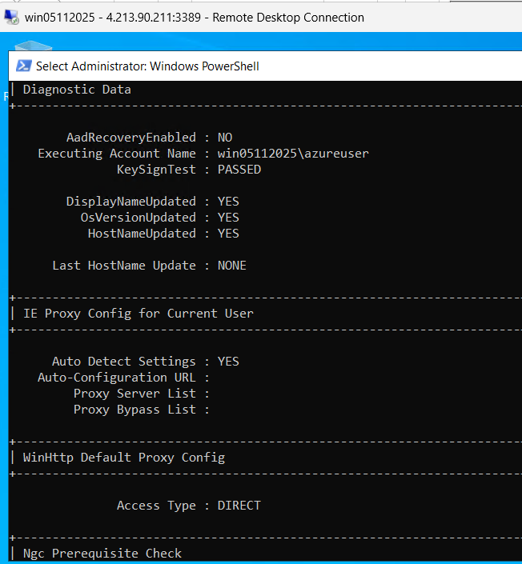

Access Type showing Direct
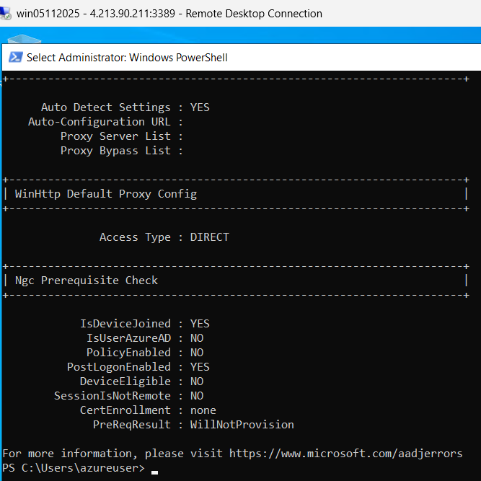

When local device is Entra Joined?

Here local device desktop2025 domain join is enabled.
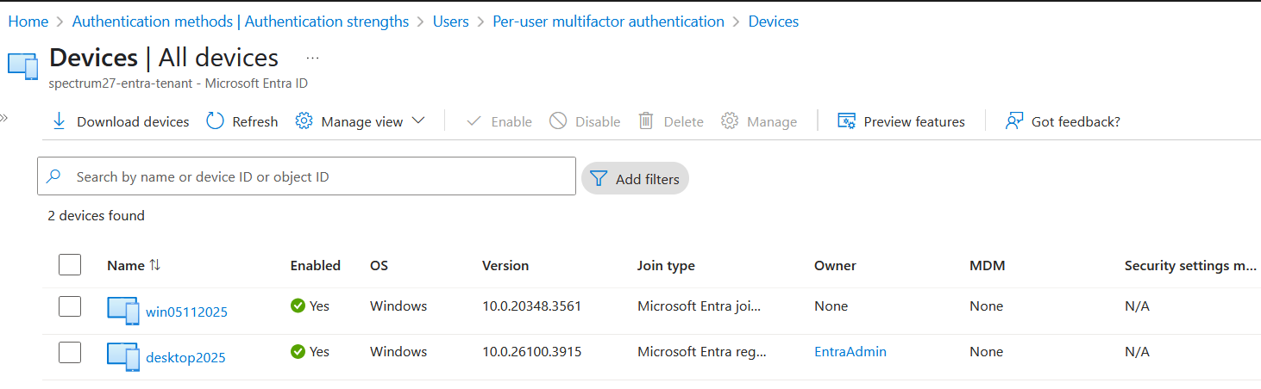

Login with Public IP of VM: 4.213.90.211
Username: AzureAD\polaris-az@spectrum27.onmicrosoft.com

Let’s enter login details in RDP service
Note: the option “Use a web account to sign in to the remote computer” is not checked

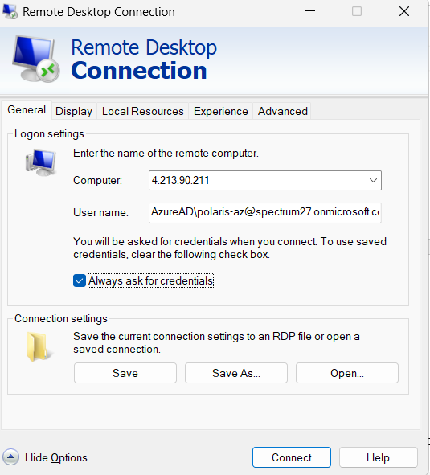

Click on “Connect”, you will see below screen.
Enter password, then press OK.

Login will successful



Verify the config status on Azure VM

AzureADJoined showing Yes
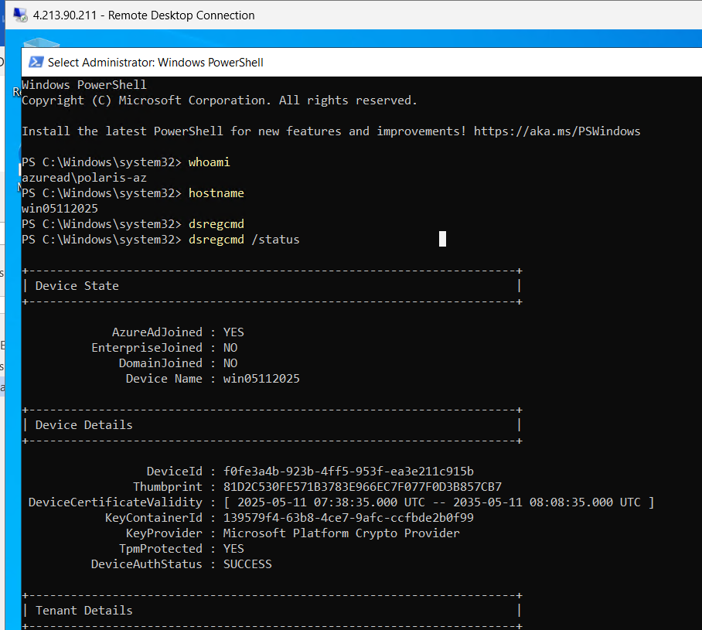

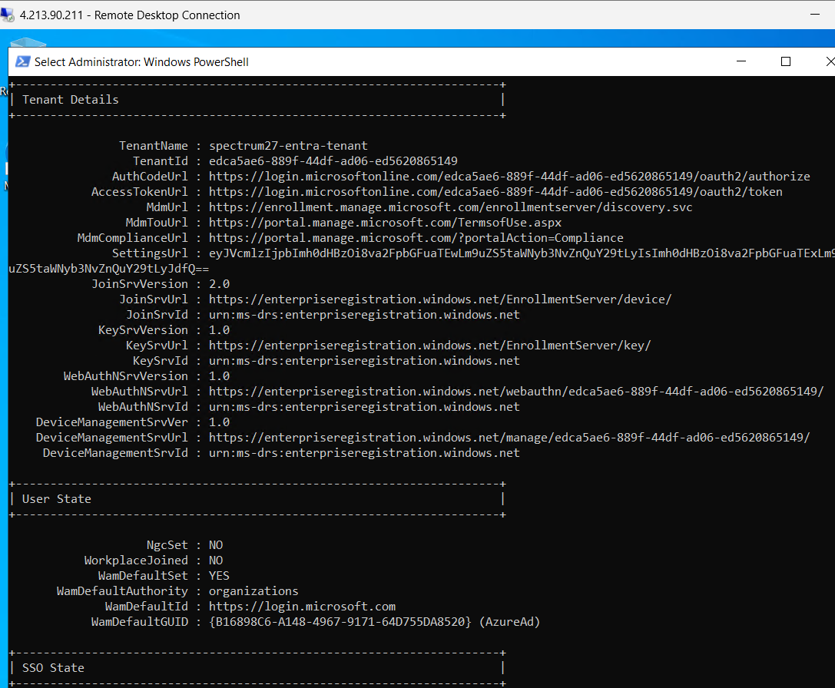

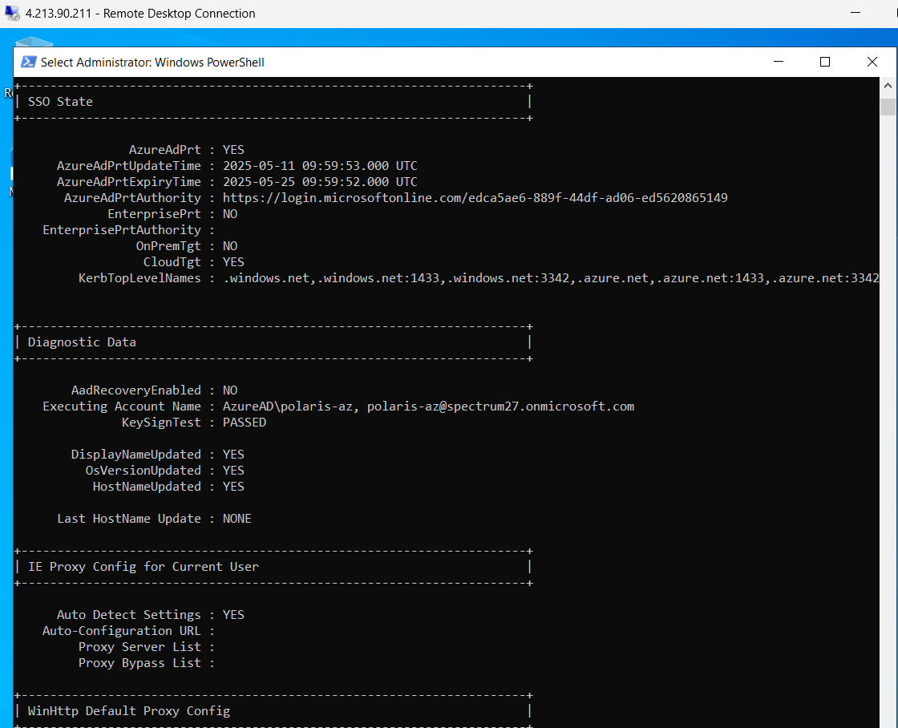

AzureADUser showing Yes

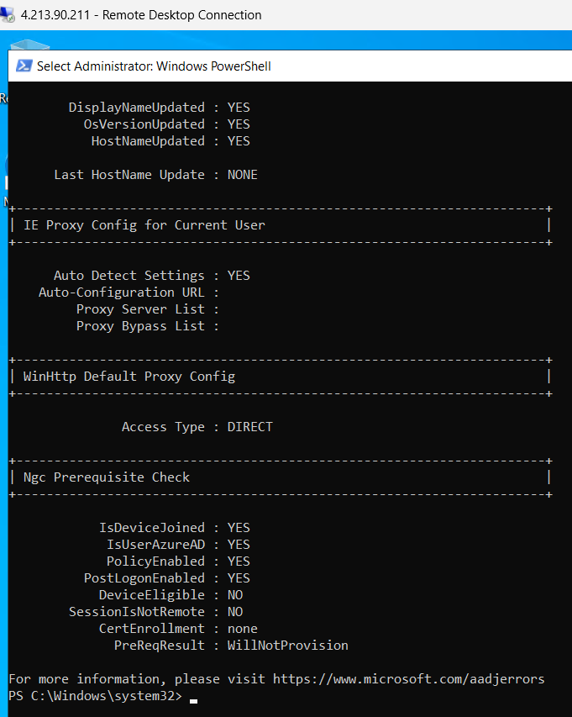

Windows login through Azure Bastion

URLs:
https://learn.microsoft.com/azure/active-directory/devices/howto-vm-sign-in-azure-ad-windows#using-conditional-access

Azure Linux VM

Network requirements
- https://enterpriseregistration.windows.net: For device registration.
- http://169.254.169.254: Azure Instance Metadata Service endpoint.
- https://login.microsoftonline.com: For authentication flows.
- https://pas.windows.net: For Azure RBAC flows.

Azure VM OS requirements
- Windows 10 version 20H2 or later,
- Windows 11
- Windows Server 2022

Client/Local machine requirement
- Remote connection on Azure Windows VMs can be performed only from Windows 10 or later machines which are either registered/hybrid-joined/joined to same Microsoft Entra ID Tenant where VM is present.
- Windows client machine you're using for RDP should be Microsoft Entra registered, joined, or hybrid joined to the same directory as the VM.

Access requirement
User must have one of the two Azure roles assigned to respective Entra user account:
- Virtual Machine Administrator Login
- Virtual Machine User Login.

Microsoft Entra Authentication for Azure Windows VMs will not work when:
- Microsoft Entra Guest account can't connect to Azure VMs through Microsoft Entra authentication.
- Microsoft Entra authentication for Azure VMs will not work if MFA per user is enabled on Entra user account
- Windows Store RDP client (red icon) which is not supported Connecting to Azure AD-joined VMs.

How to login?
- During login user must enter credentials in format AzureAD\username@domain.com on Windows built-in RDP Client.

Add Entra user in local group.

net localgroup "Remote Desktop Users" /add "AzureAD\polaris-az@spectrum27.onmicrosoft.com"

AzureAD\polaris-az@spectrum27.onmicrosoft.com
Qoxo@7251

f0fe3a4b-923b-4ff5-953f-ea3e211c915b.centralindia.cloudapp.azure.com

From <https://portal.azure.com/#@spectrum27.onmicrosoft.com/resource/subscriptions/0812c67f-1484-4670-acb5-78a844bb97e7/resourceGroups/rg-demo/providers/Microsoft.Network/publicIPAddresses/polariswindowsvm1001-ip/configuration>

lwhttltqkc4uviv4owjc2vgcxh.rx.internal.cloudapp.net

winvm232578390203.centralindia.cloudapp.azure.com
Above yellow market section should match the VM Hostname

polatestwin12345.centralindia.cloudapp.azure.com

dsregcmd /status
AzureAdJoined : YES
AzureAdPrt : YES

Check Windows Version: Windows key + R --> winver

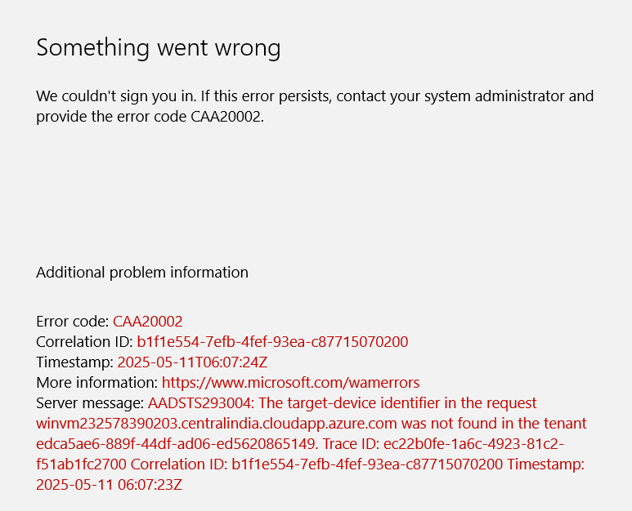

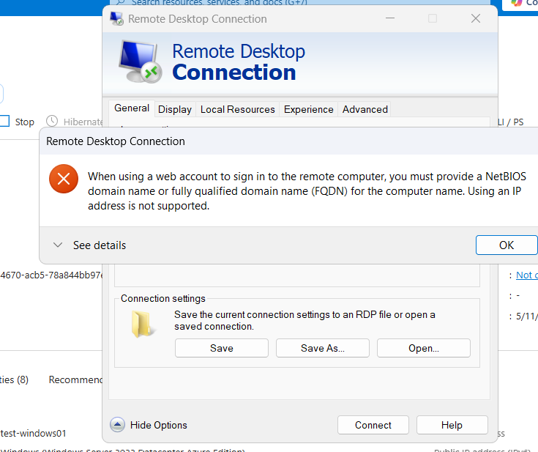

---------------------------------------------------------------------------------------------------------------------------------------------------

Linux VM

Choose default authentication type: Username/password

Login to Linux VM using AZ CLI

Login to Linux VM using Cloud shell

Login with SSH clients that support OpenSSH
- Export the SSH configuration for use with SSH clients that support OpenSSH

By default Windows powershell don’t have Azure CLI package, that needs to be installed.
https://learn.microsoft.com/en-us/cli/azure/install-azure-cli-windows?view=azure-cli-latest&pivots=winget

winget install --exact --id Microsoft.AzureCLI

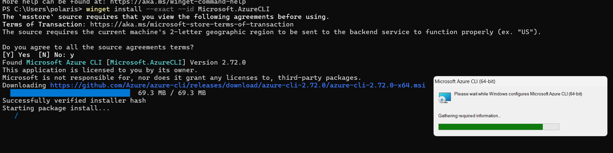

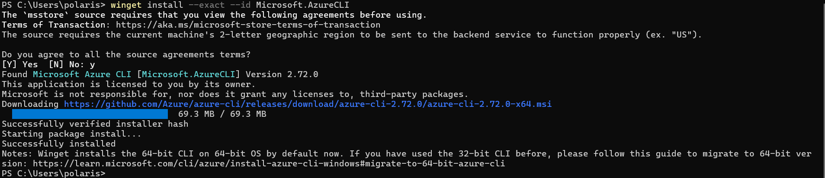

Need to install #az ssh

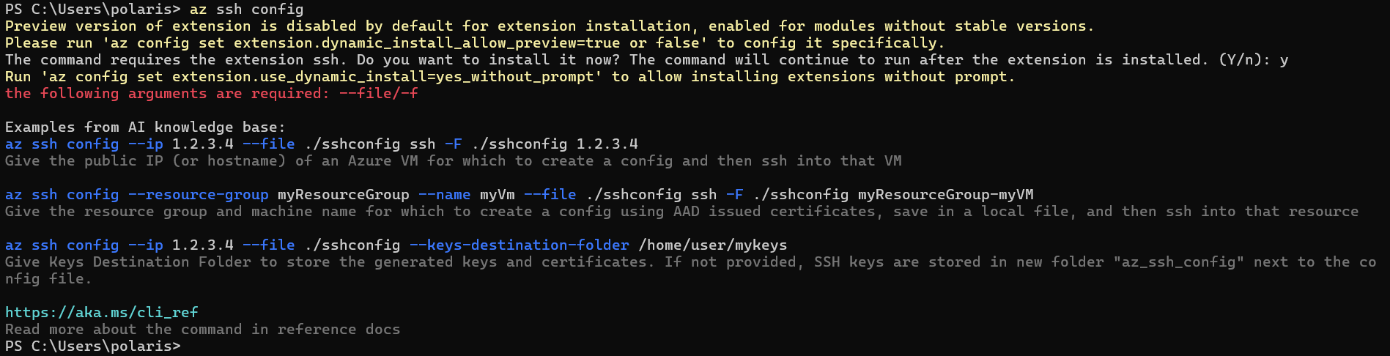

First need to login the Entra/Azure Tenant:

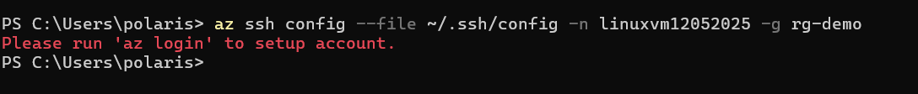

Login to specific user through Terminal.

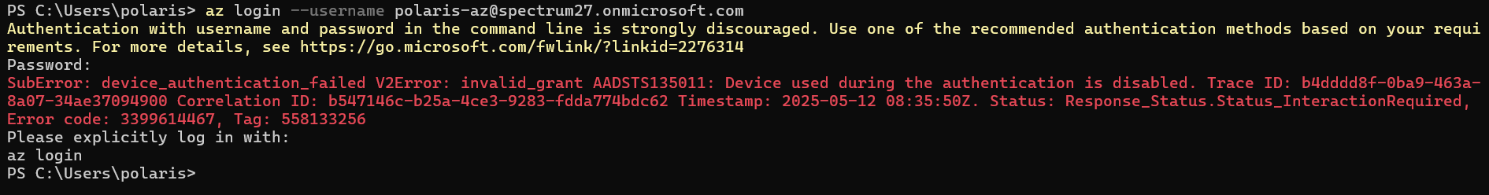

Login with device code

az login --use-device-code

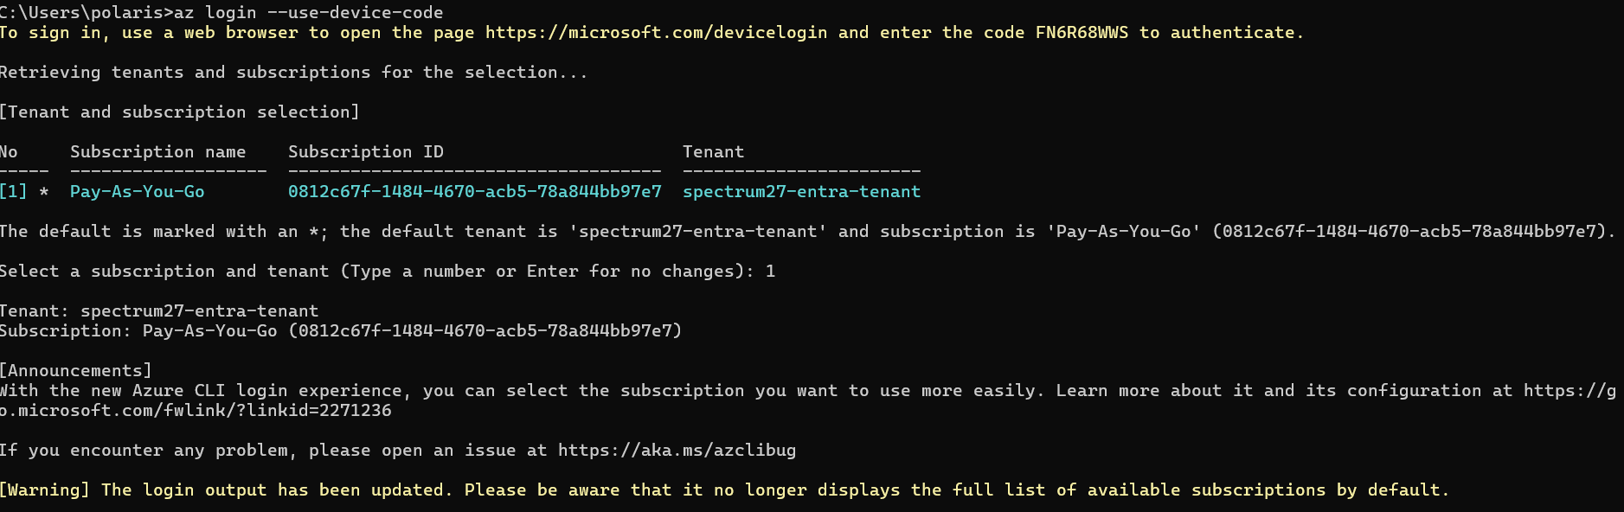

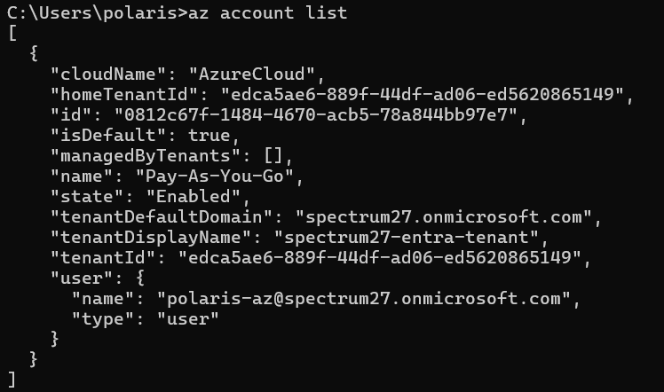

When trying to export SSH config as mentioned in below link, but its not working.
https://learn.microsoft.com/en-us/entra/identity/devices/howto-vm-sign-in-azure-ad-linux#export-the-ssh-configuration-for-use-with-ssh-clients-that-support-openssh

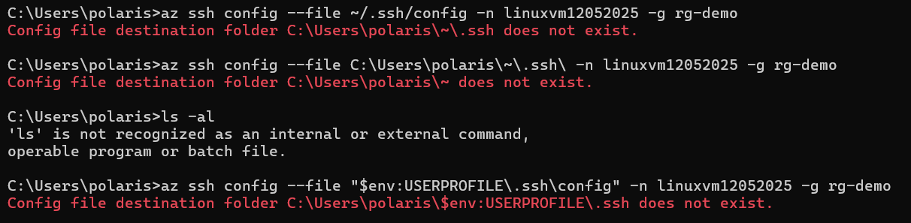

az ssh vm -n linuxvm12052025 -g rg-demo

