Q4 Report

Instructions to run code:
Put the 2 datasets ORL and CroppedYale inside a folder named “data” and run myMainScript.m

1. ORL Dataset

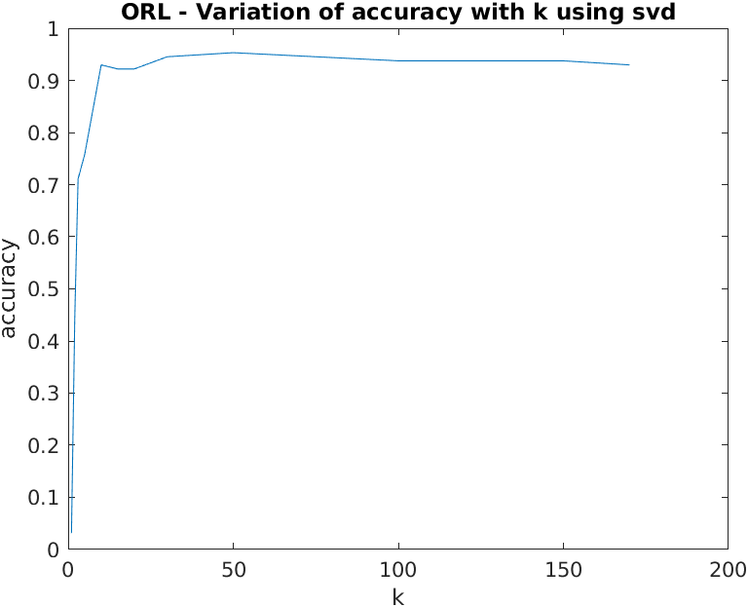

Max accuracy – 95.31% at k=50
using svd

The results are confirmed by using eig for the L matrix , which gives the same accuracies and plot.

2. Yale dataset

a) Taking the squared difference between all the eigencoefficients

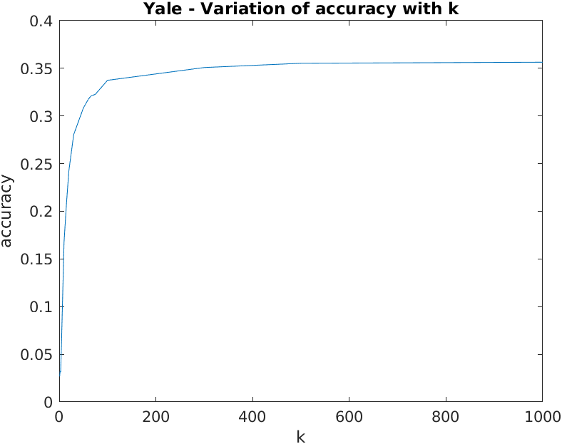

Maximum accuracy achieved is 35.64% at k=1000

b) Taking the squared difference between all except the three eigencoefficients corresponding to the eigenvectors with the three largest eigenvalues
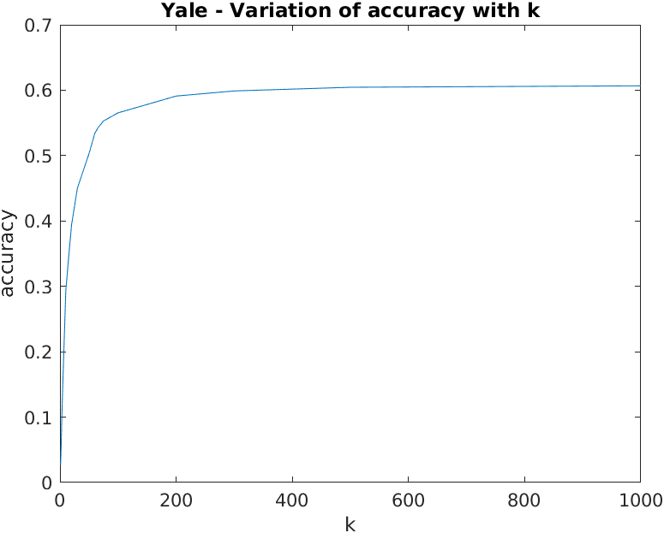

Maximum accuracy achieved is 60.67% at k=1000

