**THM_ESA_DIST2SCPOT**

The program THM_ESA_DIST2SCPOT estimates the spacecraft potential from the electron distribution by estimating the effect of photoelectrons at low energies. It estimates the potential by comparing the slope of the low energy electron distribution to the expected slope of secondary electrons. (The slope of the secondary electron distribution is approximately -2.0, see McFadden etal. 2008SSRv..141..477M)

For a given time interval, the procedure is as follows:

1) Obtain the omni-directional electron distribution. The default is to use reduced mode electron data; this can be changed using the esa_datatype keyword in THM_DIST2SCPOT. Once the distribution is found, then calculate the slope of the electron distribution. The slope of the distribution between the energies E0, and E1 is given by:

M = (log(F1)-log(F0))/(log(E1)-log(E0),

where F is the differential electron energy flux in eV/sec/cm^2/eV.

2) Next we compare the low-energy slope with the expected slope of secondary electrons, which is estimated to be between -2.0 at 8 eV and -4.0 at 50 eV. (These numbers are empirical, except for the lower limit). **The upper limit of the photoelectron part of the distribution is then estimated to be the highest energy for which the slope is steeper than the secondary electron slope.**

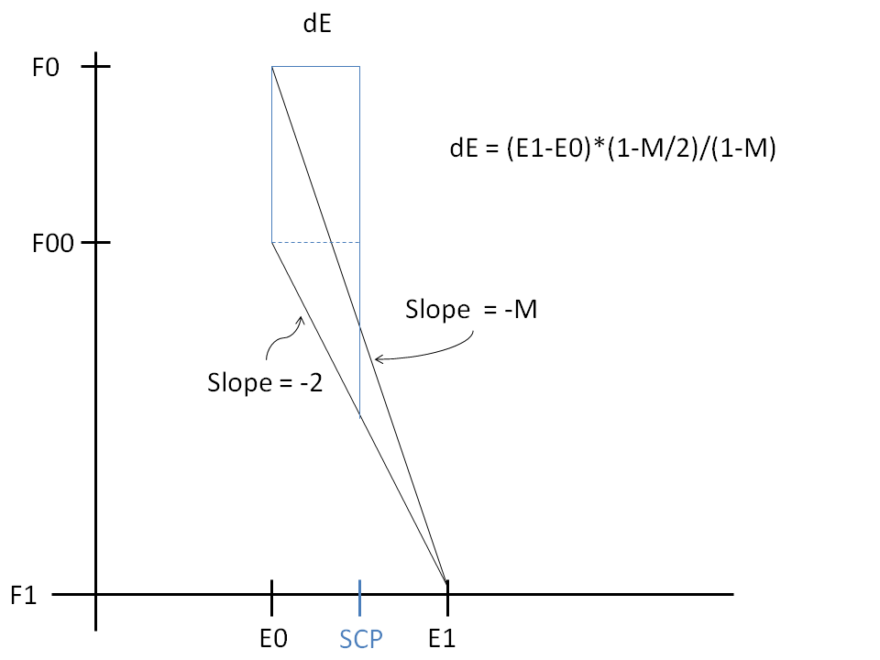

**Figure 1:** A diagram of the calculation used to obtain the spacecraft potential from an electron distribution. In the figure, F0 and F1 denote the electron flux at E0 and E1, respectively. F00 denotes the flux as it would have been for secondary electrons, with slope of -2. The value for dE is obtained by assuming that the photoelectron distribution has an infinite slope at the value of the spacecraft potential, and that the area under the blue shape plus the area under the line with slope = -2 is equal to the area under the curve with slope = -M.

3) Since slopes are calculated between energy values, the original estimate for M is at E0. We 'unquantize' by an amount that depends on the difference between the actual slope and the secondary electron slope, so that the final value of the estimated potential is:

SCP = E0 + dE

SCP = E0+(E1-E0)*(1-M/2)/(1-M)

For M=2, the lowest possible value, SCP = E0. For an infinite slope, SCP is the midpoint between E0 and E1.

4) Also, we require that the electron distribution has to exhibit at least two distinct peaks; a low-energy peak must be present with electron flux greater than 3.0e7 eV/sec/cm^2/eV, and a higher energy peak with electron flux greater than 1.0e-3 times the value of the overall peak of the distribution. (These parameters are the default values, and can be changed via the photoelectron_threshold and noise_threshold keywords.)

5) If the test for low energy photoelectrons fails, i.e., if the distribution does not show two peaks, OR the low energy, possible photoelectron peak is below 3.0e7, OR the low energy slope is not steeper that the secondary electron slope, OR if there is a high energy peak, but one that is too small, then the value for the SC_POT estimate is set to the lowest energy in the electron distribution.

**USING THM_ESA_EST_DIST2SCPOT**

The function thm_esa_dist2scpot works on single time intervals. For a time range with multiple times, use the program THM_ESA_EST_DIST2SCPOT. Here are some examples for how to use this program:

date = '2015-06-07' & probe = 'a'

The default is to process the full day, using PEER data

thm_esa_est_dist2scpot, date, probe

The output tplot variable is: th(probe)_est_scpot:

If you set the /plot keyword, then a diagnostic plot will appear

thm_esa_est_dist2scpot, date, probe, /plot

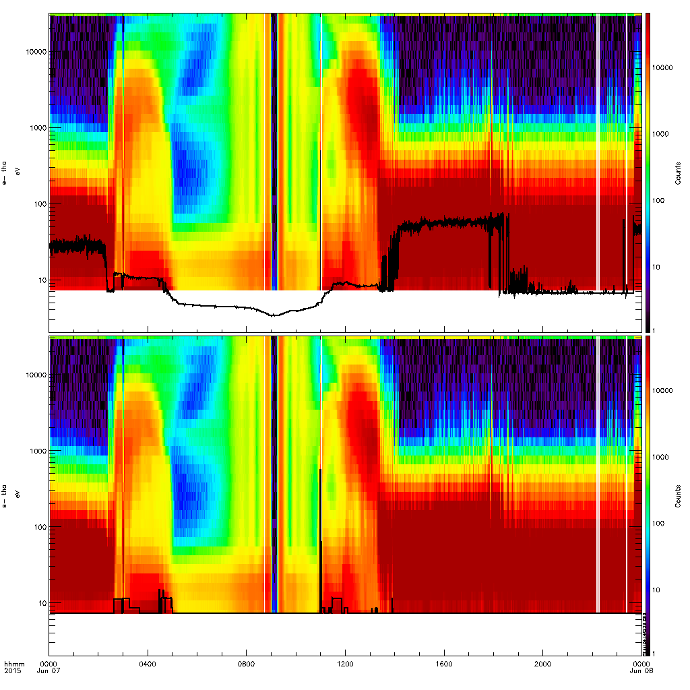

**Figure 2:** This is a diagnostic plot for THA, for 2015-06-07. In the top panel, the ESA count distribution is overplotted by the 'PXXM_POT' variable, i.e., the on-board estimate for the potential. In the bottom panel the estimated SC potential is overplotted. For the most part, the program did not find photoelectrons, and the potential is set to the lowest electron energy. Note that the PXXM_POT variable has some very high values from 0200 to 0400 UT and again for 1400 to 1900 UT – these are due to problems caused by high densities and are incorrect.

**RANDOM DATE AND PROBE**

For fun, try the /random_dp keyword. This will pick a random date and probe, and plot the results.

thm_esa_est_dist2scpot, date, probe, /random_dp

For the figure below, the date came up 2012-06-07, and probe was ‘A’.

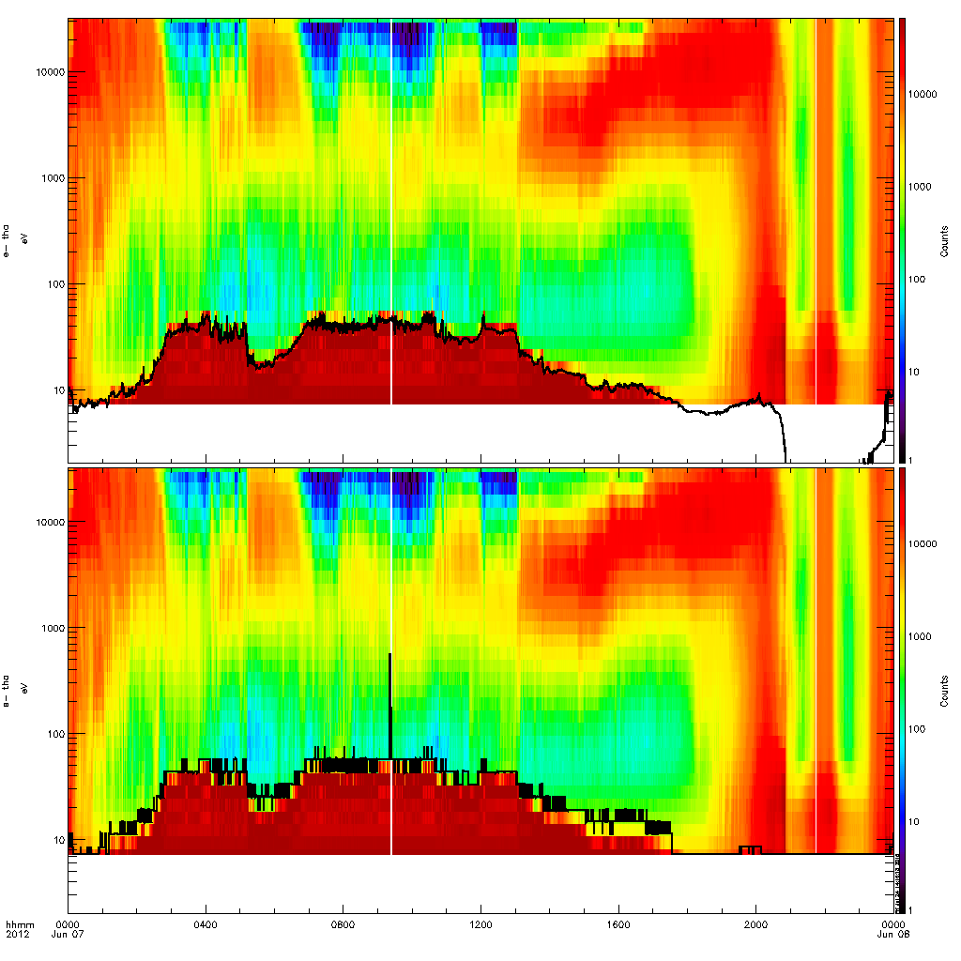

**Figure 3:** Same diagnostic plot, for 2012-06-07, THA. Here there are photoelectrons, and the spacecraft potential estimate is close but slightly larger than the PXXM_POT value. For this date/probe, the PXXM_POT value looks to be pretty good.

**USING THM_ESA_TEST_SPEC3D2:**

To look at electron spectra and potential values for individual times, use the THM_ESA_TEST_SPEC3D2 program:

thm_esa_test_spec3d2, date, probe

A plot of the electron data for all modes for the give day shows up. Click on the plot to choose the time, the result is a plot of the peef, peer and peeb distributions for the time. A vertical black line on each panel shows the PXXM_POT potential value, and the vertical red line shows the value estimated from the distribution.

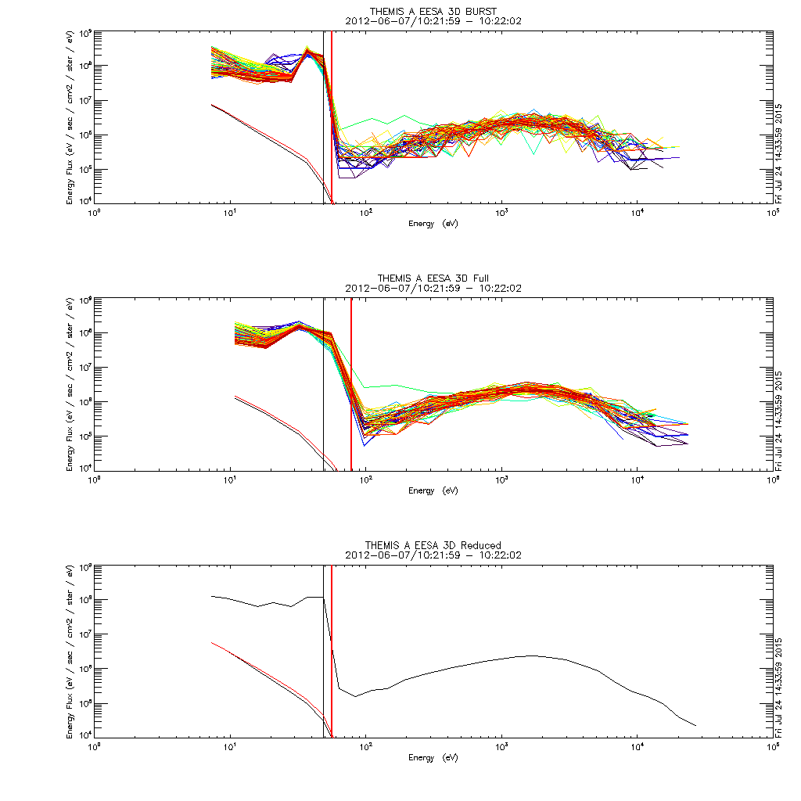

**Figure 4:** Individual spectra with the on-board PXXM_POT estimate (black vertical line) and the value estimated using THM_ESA_DIST2SCPOT (red line), for THA data on 2012-06-07. Note that the value estimated from the distribution is slightly larger than the on-board value. This looks like an effect of the quantization of electron energy bin midpoint values.

This program also has the /random_dp option.

**CALLING FROM THM_LOAD_ESA_POT AND USING FOR DENSITY/MOMENT CALCULATIONS:**

To call from THM_LOAD_ESA_POT, use the use_dist2scpot keyword. Here we use THA data for 2015-06-07. Recall from Figure 2 that the on-board potential for this date/probe had bad time intervals with overestimated (50 – 100 V) values.

timespan, '2015-06-07'

thm_load_esa_pot, probe = 'a', /use_dist2scpot

The output is in the 'tha_esa_pot' variable. Next use copy_data to copy this variable to a new variable for comparisons with the default potential.

copy_data, 'tha_esa_pot', 'tha_esa_pot_dist2scpot'

Get the default sc potential. The default is to use PXXM_POT for slow-survey time intervals and VAF data (from EFI) during fast-survey times.

thm_load_esa_pot, probe = 'a'

copy_data, 'tha_esa_pot', 'tha_esa_pot_def'

tplot, ['tha_esa_pot_dist2scpot', 'tha_esa_pot_def']

**DENSITY COMPARISON**

The spacecraft potential is used in calculating the electron density, to compare the ground-processed density for different sc_pot options, use the sc_pot_name keyword in thm_part_moments. (The default in thm_part_moments is to use the pxxm_pot variable, which we will not use here.)

thm_load_esa_pkt, probe='a'

thm_part_moments, probe='a', inst=['peer','peir'], sc_pot_name='tha_esa_pot_def', suffix = '_def'

thm_part_moments, probe='a', inst=['peer','peir'], sc_pot_name='tha_esa_pot_dist2scpot', suffix = '_dist2scpot'

Plot densities:

tplot, ['tha_peer_density_def', 'tha_peer_density_dist2scpot']

The density plot below shows the comparison of the default and dist2scpot density values. In this case, the dist2scpot value for the density is a better approximation for the true electron density. This example and more can be found in the crib sheet: thm_crib_dist2scpot.pro

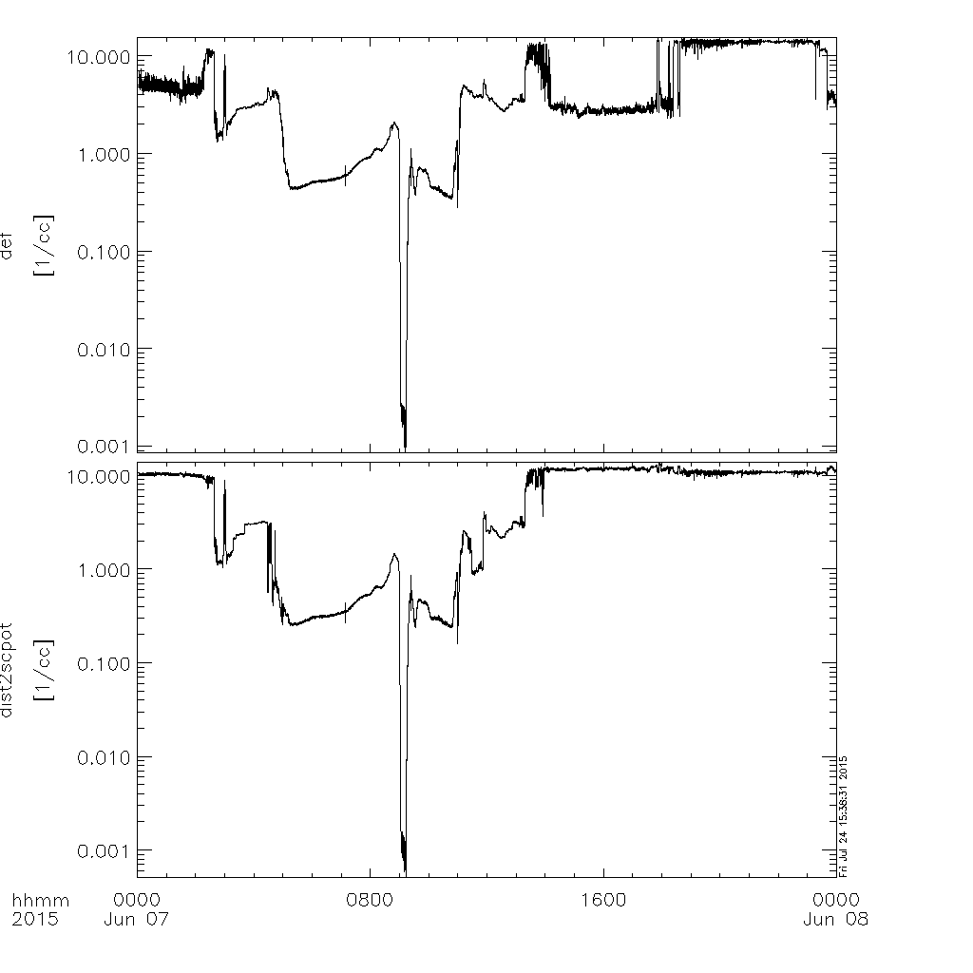

**Figure 5:** Comparison of electron density calculated for the default THM_ESA_POT variable and the estimated value from THM_ESA_EST_DIST2SCPOT. Note that the factor of 5 drops in density present in the default plot from 0200 to 0400 and 1500 to 1900 does not show up in the dist2scpot (middle) plot.