Contents

Introduction 1

Prerequisites 2

Initial Steps 2

Login to Windows Azure Management Portal 2

Windows Azure Management Portal 2

Creating a WordPress Web Site Service 3

Create a New Web Site from Gallery 3

Choose WordPress Web App 3

Configure Web Site 3

Configure Database 4

Web Site Deployment 4

Configure Your WordPress Site 5

Navigate To Your WordPress Site 5

Setup WordPress 5

Login to WordPress 5

WordPress Dashboard 6

# Introduction

The purpose of this document is to show the attendee how to set up a WordPress blog using Windows Azure Web Sites and gallery images.

The gallery makes available a wide range of popular web applications developed by Microsoft, third party companies, and open source software initiatives. Web applications created from the gallery do not require installation of any software; you only need a web browser to connect to the Windows Azure Management Portal.

In this tutorial, you'll learn:

* How to create a new web site through the gallery.
* How to deploy the site through the Windows Azure Portal.

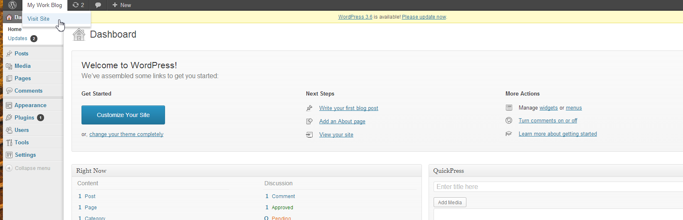You'll build a Word press blog that uses a default template. The following illustrations shows the completed application (user frontend and administration backend):

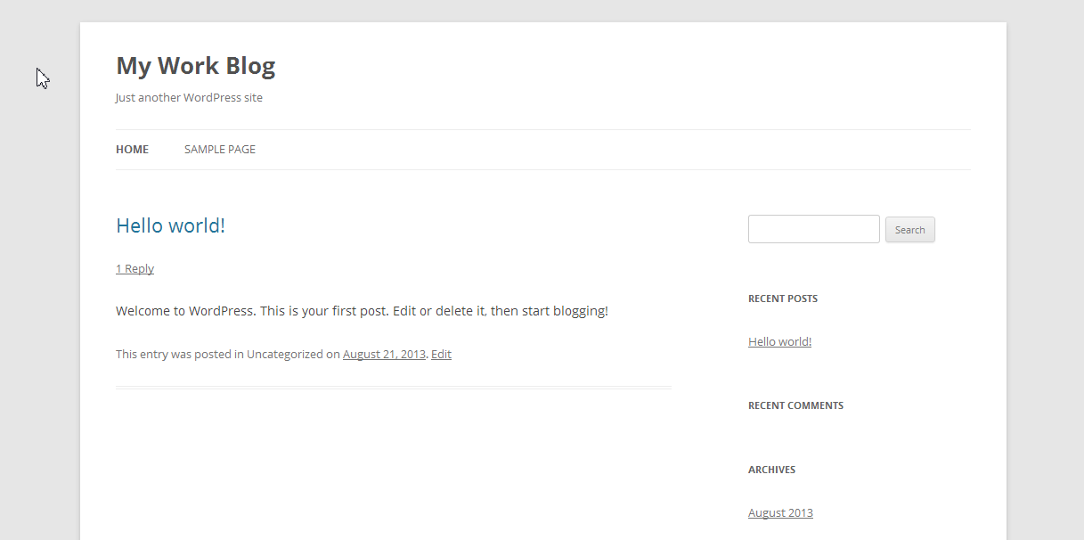

## Prerequisites

To complete this tutorial, you need a Windows Azure Account.

# Initial Steps

## Login to Windows Azure Management Portal

At first, you need to login to Windows Azure. Navigate your browser to [manage.windowsazure.com](https://manage.windowsazure.com) and enter your credentials:

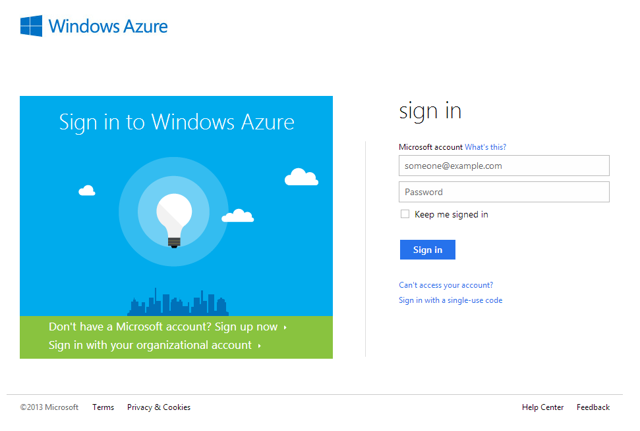

## Windows Azure Management Portal

After logging in, you will see the management dashboard of Windows Azure. It should list all of your Windows Azure resources (if you have any). In the bottom left corner, you will find the “New” button that allows you to begin using Windows Azure services:

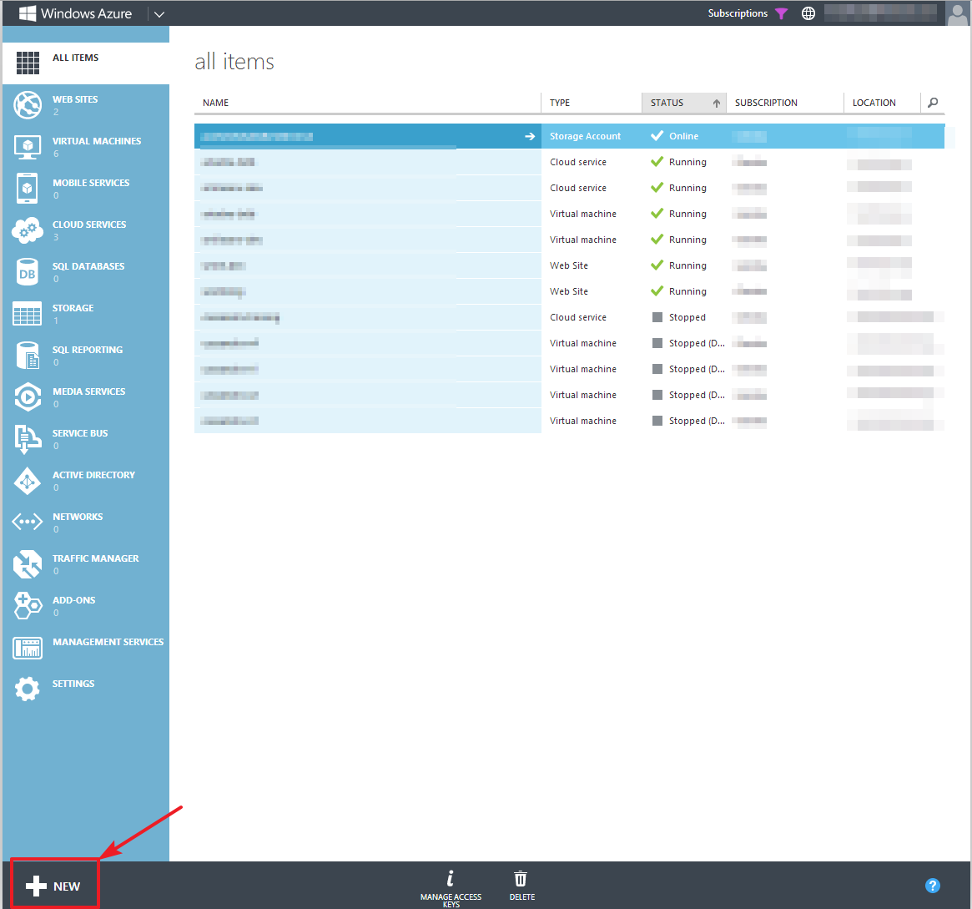

# Creating a WordPress Web Site Service

## Create a New Web Site from Gallery

Navigate to the “New” button in the bottom left corner and click it:

C:\Users\Gernot\Documents\projects\elastacloud\msr-courseware\repo\2. Getting Started with Virtual Machines and Websites\screenshots\a - create wordpress site\02 new button.png

This brings up a window which will allow you to select the type of Azure service you would like to use. Choose Compute >> Web Site >> From Gallery as in the screenshot below:

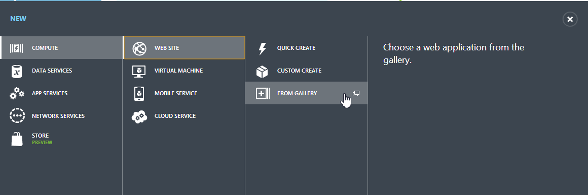

## Choose WordPress Web App

A pop-up window will appear containing a wizard that allows you to configure your new web app. In this window, choose Blogs >> WordPress. Afterwards, click on the Next arrow in the bottom right corner of the Window to continue:

## C:\Users\Gernot\Documents\projects\elastacloud\msr-courseware\repo\2. Getting Started with Virtual Machines and Websites\screenshots\a - create wordpress site\04 select wordpress.png

## Configure Web Site

On the next screen, you can configure your new WordPress app. Enter a URL name of your chose. Leave “Create a new MySQL database” selected. From the Region drop-down, choose a location close to you or the target audience for your blog; make note of this location, since you will need it on the next screen. Click on the Next arrow to continue with the wizard:

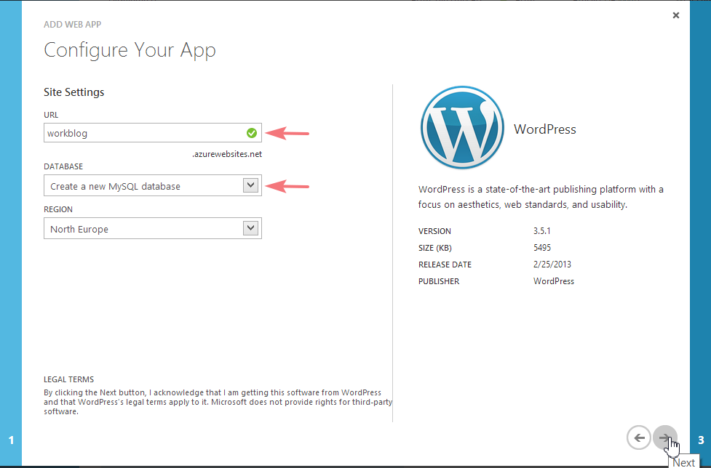

## 

## Configure Database

On the next page, you can specify a name for your database. The database will store all the dynamic content (blog posts, comments) of your WordPress blog. You can also leave the default name if you want to. As in the prior screen, there is a Region drop-down; be sure to choose the same option here to ensure that your web site and database are in the same location. Select the box at the bottom of the screen to agree to ClearDB's usage terms for your hosted MySQL database. Then click the check to complete the site creation:

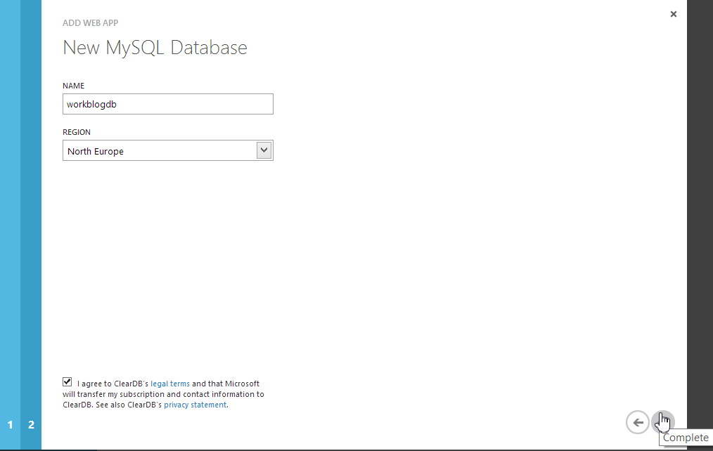

## Web Site Deployment

After you click the “Complete” button, Windows Azure will deploy your web site. This can take a short time. You can find the progress at the bottom of the Azure Management Dashboard. The progress will be updated once the deployment completes:



# Configure Your WordPress Site

## Navigate To Your WordPress Site

After creating the web site, you will need to navigate to your WordPress site in order to configure it for the first time. Use the URL you defined earlier to access it. In case you have forgotten the URL, you can easily find it by choosing “Web Sites” in the bar on the left then clicking the provided link in the URL column:

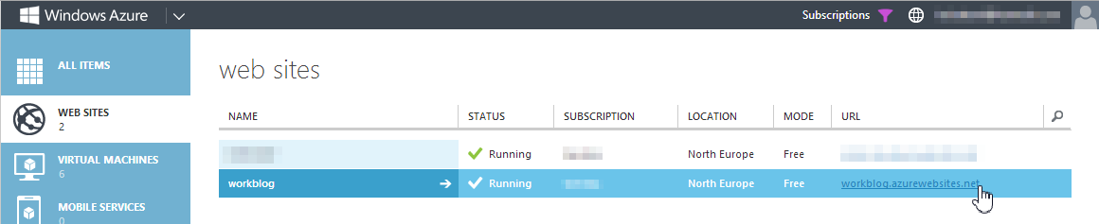

## Setup WordPress

You will need to perform an initial configuration of your WordPress site. Enter the site title, a username, a password as well as your e-mail address. Note that you can always change this information later. After entering all the information, click on the Install WordPress button:

## C:\Users\Gernot\Documents\projects\elastacloud\msr-courseware\repo\2. Getting Started with Virtual Machines and Websites\screenshots\a - create wordpress site\09 setup wordpress.png

## Login to WordPress

The installation procedure should finish rather quickly. You will be prompted to login to WordPress. Use the user name and password you provided in the previous step:

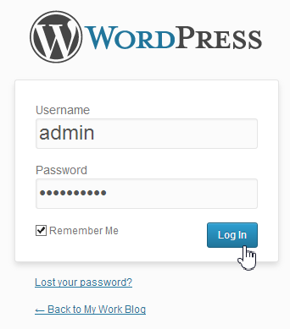

## WordPress Dashboard

You will be forwarded to the WordPress dashboard, the place where you can administer your blog, change the theme and write new blog posts.



In the menu bar at the top, you can also choose to visit your site – this will be the site your readers will see:



Copyright 2013 Microsoft Corporation. All rights reserved.   
Except where otherwise noted, these materials are licensed under the terms of the Apache License, Version 2.0. You may use it according to the license as is most appropriate for your project on a case-by-case basis. The terms of this license can be found in http://www.apache.org/licenses/LICENSE-2.0.