HElikopter

Project

Automotive Systems  
Faculty Graduate School

**Repository**

# Table of content

Table of content 2

Problem 3

Implementation 4

Artikel I. Literaturverzeichnis 11

# Problem

The program for the Helicopter shall be provided over a central Repository. The Repository includes the latest software version. The Helicopter shall be able to do software updates OTA. These updates can be implemented in the Helicopter in a mannor, where the update is made at boot. This implementation is out of scope in this document.

# Implementation

1. Build Package

1: Decide on the name of your package. Standard debian notation is all lowercase in the following format:

<project>_<major version>.<minor version>-<package revision>

For example, you could name your first package...



2: Create a directory to make your package in. The name should be the same as the package name. 

3: Pretend that the packaging directory is actually the root of the file system. Put the files of your program where they would be installed to on a system.



4: Now create a special metadata file with which the package manager will install your program...



Put something like this in that file...



(the space before each line in the description is important)

The tree architecture should look like that:

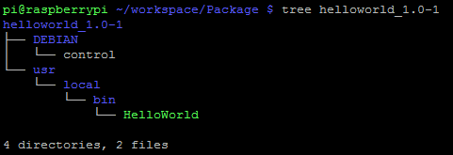

5: Now you just need to make the package:



Output is a finished Debain Package with the file ending .deb

1. Upload Package

You can create your own repository with the tool **reprepro** on Linux

With **reprepro**, you can easily create and manage your own package repositories. The tool is located in the Ubuntu repositories and can be used to provide own packages or to mirror existing repositories. For situations where complete repositories are to be mirrored for provision in their own local network, there are alternatives such as apt-mirror.

**Installation:**

**Reprepro** can be installed under Linux over the repository



You can find useful information on how to set up a repos:



**Configuration:**

In the following example, a separate user with username “repo” was created to provide the packages in the home directory.



For the packages, a separate directory is created as well as a directory for the configuration of the repos:



The first configuration step is to create the distribution file, which determines which distribution, architecture, etc., the repository is used for. Further examples of the distributions file can be found in (1) (wiki.debian.org) and (2) (debian-administration.org):



"Origin" and "Label" are descriptive fields which are copied into the release file. "Codename" is a mandatory field and specifies the unique identifier of the distribution (e.g., precise, quantal for Ubuntu, wheezy for Debian) (3) :

Codename: This required field is the unique identifier.

The "Suite" parameter specifies the common parameters such as "stable", "unstable" or "testing":

Suite: This optional field is simply copied into the release files. In Debian it contains the names like stable, testing or unstable. To create symlinks from the Suite to the Codename, use the createsymlinks command of reprepro.

"Architectures" and "Components" specify the target architecture of the system (32-bit, 64-bit, "source" for source code) as well as the components of the distribution (main, contrib etc.):

Architectures: This required field lists the binary architectures

**Include packages:**

When using the "Suite" option in the "distributions" file, symbolic links are generated from "stable" to "precise" in the first step:



This produces following folder structure (DB files are not incuded at initial set up, these are added when a repository is added):

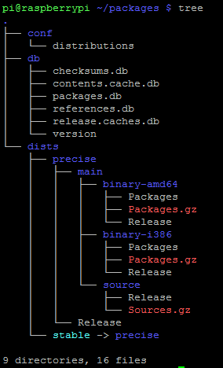

A first package is now added to the repository. This is made with the .deb file we created in step 1:



The contents of the repos are listed for checking purposes:



The tree overview shows where the packages are located in the directory structure:

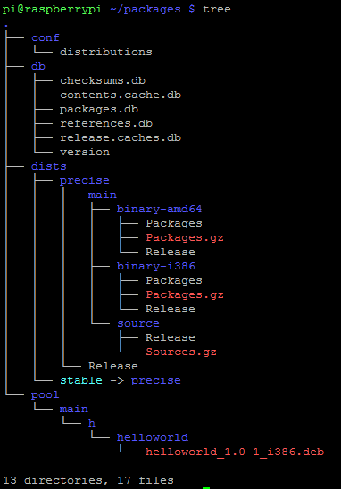

**Remove Packages:**

To remove packages, the remove command is called. The following example also restricts the removal to a specific architecture:



1. Distribute the package via Apache

There are several ways to distribute the repos via a web server. For all variants, the internal configuration files "/ conf" and "/ db" should be protected against unauthorized access. The following setup uses "mod userdir" to publish to the home directory of the user "repository". The first step is to activate the "userdir" module: (4)



For security reasons and because no other user should use "userdir", the userdir configuration file is modified as follows:



We then created the public_html folder in the home directory of repository:



A symbolic link provides the packages in the public_html:



A change in the file directories prevents access to the configuration folders:



**Create a “.list” file**  
The ".list" file simplifies adding the repos for the user: (5)



The IP address must be adapted according to the correct hostname!

1. Include Package to local mirror list

A user can add and use the repo as follows:



# Literaturverzeichnis

1. **apt-mirror. [Online] https://wiki.ubuntuusers.de/apt-mirror/.**

**2. reprepro. [Online] http://mirrorer.alioth.debian.org/.**

**3. CONFIG FILES. [Online] http://mirrorer.alioth.debian.org/reprepro.1.html#CONFIG%20FILES.**

**4. Apache. [Online] https://httpd.apache.org/docs/2.2/howto/public_html.html.**

**5. Debian repository. [Online] https://wiki.debian.org/DebianRepository/SetupWithReprepro?action=show&redirect=SettingUpSignedAptRepositoryWithReprepro.**