**Hardware**

**1. Install X-CTU software**

X-CTU is a stand-alone tool for configuring XBee modules. To install X-CTU:

1. Insert the Hardware and Software Setup CD in the PC’s CD/DVD drive.

2. On the Home page, click “Gateway, Host, Enterprise Documentation/Software.

3. Click X-CTU.

4. Click Install X-CTU.

**2. Install USB Drivers**

1. Find the PKGU(USB) windows driver file named “usb-drivers_windows”.

2. Plug in the USB cable between the PKG-U and the computers.

3. When the operating system asks for the drivers, browse to the temporary directory and complete the installation. Attention: there are two drivers needed to be installed, one is a USB driver and the other is a virtual COM port driver.

**3. Configure XBee**

This step is to make sure XBee is attached to PC correctly.

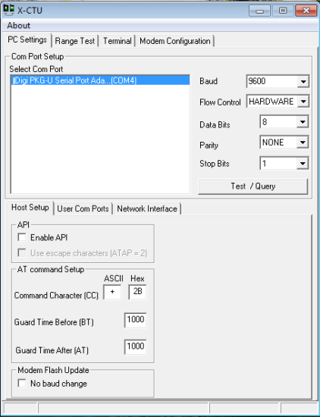 1. Launch the X-CTU Software.

2. Under the “PC setting” tab, find the selected com port as shown in below. This port number is quite important as it is required to be predefined in java code before implementation.

3. Verify that the baud rate and data settings match the internal settings of the radios. The default settings for the radio are Baud Rate: 9600, Flow Control: HARDWARE, Data Bits: 8, Parity: None, and Stop Bits:1.

**Software**

**1. Eclipse configuration**

1. Find the file named “External file”, which contains jar and dll files.

2. Place the corresponding files under those paths:

JAVA_HOME/lib/ext/RXTXcomm.jar

JAVA_HOME/bin/rxtxSerial.dll

**2. Create project**

1. Create new Java project in Eclipse.

2. Create new package under project, with name “valiquad.comm”.

3. Import java files, which locates in file “Finalcopter”

4. Add external jar. Details: select project, click properties->Java Build Path->

->Libraries->Add External JARs. There two jars needed, one is “jcommon-1.0.14.jar”, the other is “jfreechart-1.0.13.jar”. Both locates in the file “External file”.

**3. Implementation**

1. Predefine the com port in class “Application” and “connectSet”

2. Power up the Quadrocopter.

3. Run the file “Application”. This class is implemented to read sensor values and store data in files.

Attention: In case there is “access restriction” error, follow the next steps

1). Open project properties.  
2). Select Java Build Path node.  
3). Select Libraries tab.  
4). Remove JRE System Library.  
5). Add Library JRE System Library.

4. In the Console window, there will be some commands as shown below. First is the file name expected to be saved, second is the corresponding sensor ID. The saved file will be located in the same workspace with the project.

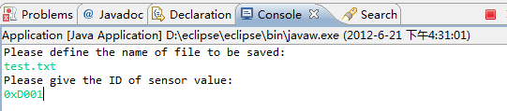

5. Run the file “TimeSeriesDemo”. This class is implemented to plot the sensor values in real time graph as shown below.

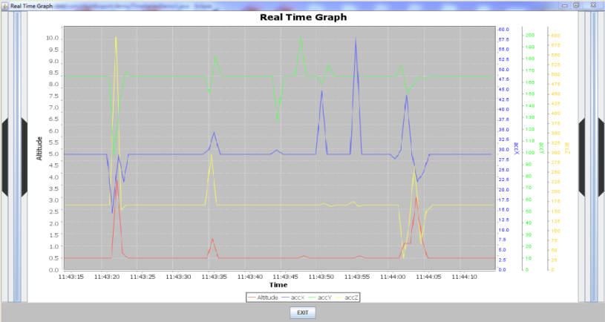

6. To zoom the graph, place the mouse on expected position, keep on left button and drag; To recover, keep on left button and drag forward; To move the graph, click the bar on left side of screen to back, click the bar on right side of screen to forward, keep on left button and drag forward to recover.