Quadcopter Model

Automotive Systems Master

Software Based Automotive Systems

ASM2-SB / SS 2015

<Document>

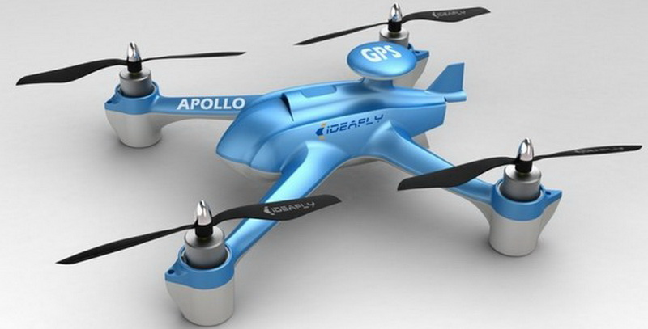

*Prof. Dr.Ing. Jörg Friedrich*

*Tutor: M.S. Vikas Agrawal*

Jha Vikas Kumar

Mahawar Nitesh Kumar

Please do only use the predefined style sheets!