Project Quadrocopter

Automotive Systems Master

Software Based Automotive Systems

ASM2-SB / SS 2010

Subsystem_Interfaces

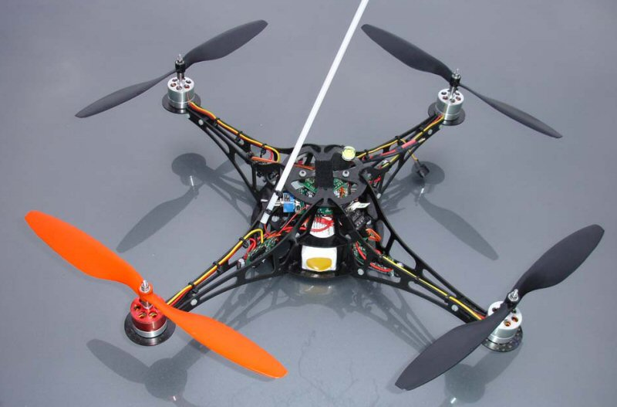

*Prof. Dr. rer. nat. (Purdue Univ.) Dipl.-Ing. Jörg Friedrich*

*Tutor: Dionysios Satikidis*

Joachim Schwab

Sreekanth Sundaresh

Nina Vetlugina

Marc Weber

Contents

1 Introduction 2

2 Subsystem Quadrocopter Controller 2

2.1 Inputs 3

2.2 Outputs 3

2.3 Parameters 4

2.4 Constants 4

3 Subsystem Sensor Filter 5

3.1 Inputs 5

3.2 Outputs 5

3.3 Parameters 6

3.4 Constants 6

# Introduction

This document gives an overview of the various interfaces between the subsystems of Copter system as implemented in the MATLAB/Simulink®.

Following subsystems are implemented in Simulink®’s S-Function (C-Code).

* Quadrocopter Controller
* Sensor Filter

# Subsystem Quadrocopter Controller

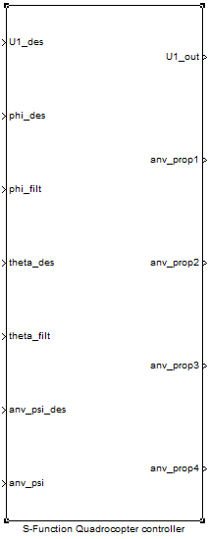

## Inputs

|  |  |  |  |
| --- | --- | --- | --- |
| **Signal** | **Type** | **Resolution** | **Unit** |
| U1_des | int16 | 0.001 | N |
| phi_des | int16 | 0.001 | rad |
| phi_filt | int16 | 0.001 | rad |
| theta_des | int16 | 0.001 | rad |
| theta_filt | int16 | 0.001 | rad |
| anv_psi_des | int16 | 0.001 | rad/s |
| anv_psi | int16 | 0.001 | rad/s |

## Outputs

|  |  |  |  |
| --- | --- | --- | --- |
| **Signal** | **Type** | **Resolution** | **Unit** |
| U1_out | int16 | 0.001 | N |
| anv_prop1 | int16 | 1 | rpm |
| anv_prop2 | int16 | 1 | rpm |
| anv_prop3 | int16 | 1 | rpm |
| anv_prop4 | int16 | 1 | rpm |

## Parameters

|  |  |  |  |  |
| --- | --- | --- | --- | --- |
| **Signal** | **Type** | **Resolution** | **Unit** | **Default Value** |
| Kp_phi | int16 | 0.01 | 1/s2 | 20.00 |
| Ki_phi | int16 | 0.01 | 1/s3 | 5.00 |
| Kd_phi | int16 | 0.01 | 1/s | 3.00 |
| Kp_theta | int16 | 0.01 | 1/s2 | 20.00 |
| Ki_theta | int16 | 0.01 | 1/s3 | 5.00 |
| Kd_theta | int16 | 0.01 | 1/s | 3.00 |
| Kp_anv_psi | int16 | 0.01 | 1/s | 20 |
| Ki_anv_psi | int16 | 0.01 | 1/s2 | 2 |
| Kd_anv_psi | int16 | 0.01 | - | 2 |
| I_x | int16 | 0.001 | Nms2 | 0.009 |
| I_y | int16 | 0.001 | Nms2 | 0.009 |
| I_z | int16 | 0.001 | Nms2 | 0.016 |
| l_boom | int16 | 0.001 | m | 0.166 |

## Constants

|  |  |
| --- | --- |
| **Signal** | **Value** |
| S_FUNCTION_NAME | sfun_Copter_Controller_discrete |
| S_FUNCTION_LEVEL | 2 |
| NUMINPORTS | 7 |
| NUMOUTPORTS | 5 |
| NUMPARAMS | 1 |
| THRUST2RPM_DATAPOINTS | 10 |

# Subsystem Sensor Filter

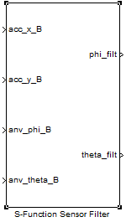

## Inputs

|  |  |  |  |
| --- | --- | --- | --- |
| **Signal** | **Type** | **Resolution** | **Unit** |
| acc_x_B | int16 | 0.1 | m/s2 |
| acc_y_B | int16 | 0.1 | m/s2 |
| anv_phi_B | int16 | 0.01 | rad/s |
| anv_theta_B | int16 | 0.01 | rad/s |

## Outputs

|  |  |  |  |
| --- | --- | --- | --- |
| **Signal** | **Type** | **Resolution** | **Unit** |
| phi_filt | int16 | 0.0001 | rad |
| theta_filt | int16 | 0.0001 | rad |

## Parameters

|  |  |  |  |  |
| --- | --- | --- | --- | --- |
| **Signal** | **Type** | **Resolution** | **Unit** | **Default Value** |
| LPFP | int16 | 0.01 | - | 0.05 |
| HPFP | int16 | 0.01 | - | 0.95 |
| LPFR | int16 | 0.01 | - | 0.05 |
| HPFR | int16 | 0.01 | - | 0.95 |

## Constants

|  |  |
| --- | --- |
| **Signal** | **Value** |
| S_FUNCTION_NAME | sfun_Sensor_Filter_discrete |
| S_FUNCTION_LEVEL | 2 |
| NUMINPORTS | 4 |
| NUMOUTPORTS | 2 |
| NUMPARAMS | 1 |