**User interface**

This part was built according “XBee Communication” document.

**1.1 Status Request**

The main window of program fulfills the requirements to make a status request with possibilities to choose period interval (requirement 3.4).

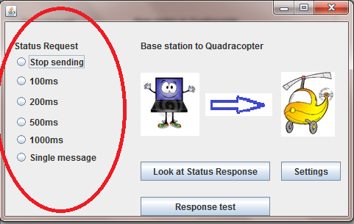

Program detects the com port automatically and try to send request.

The message consists information about ID, DLC, chosen request byte and CRC

C:\Users\mediamarkt\Desktop\Javqa\request.png

The CRC is calculated by BytesTransformation class. Method CRC This class is used always when it is necessary to make any manipulation with bytes.

**1.2 Status Response**

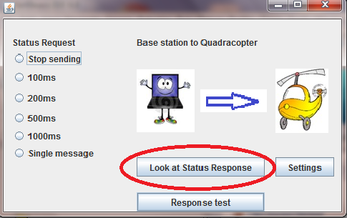

Pressing the “Look at Status Response” calls SimpleRead_response.Start().

This class obtains the data from the com port. In this class we predefined the order of coming message regarding the table 3. “System states”.

As we have a lot of coming parameters only a few are reflected in the GUI.

Speed: front rotor, left rotor, rear rotor, right rotor are .

All other parameters except raw data are include in printed variant of message.

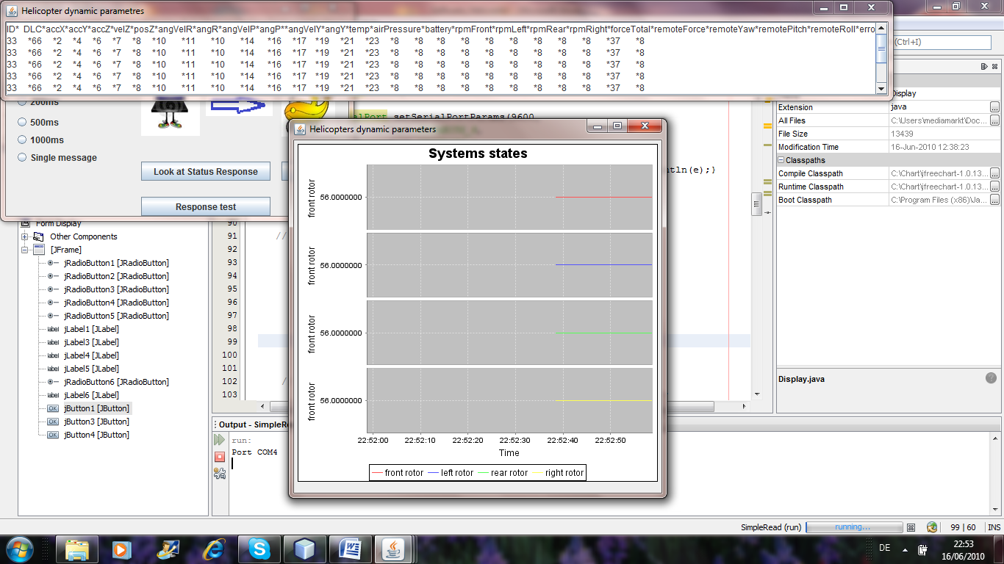

1.3. Parameter request

Sending parameter request from base station to helicopter possible with use of page Settings.

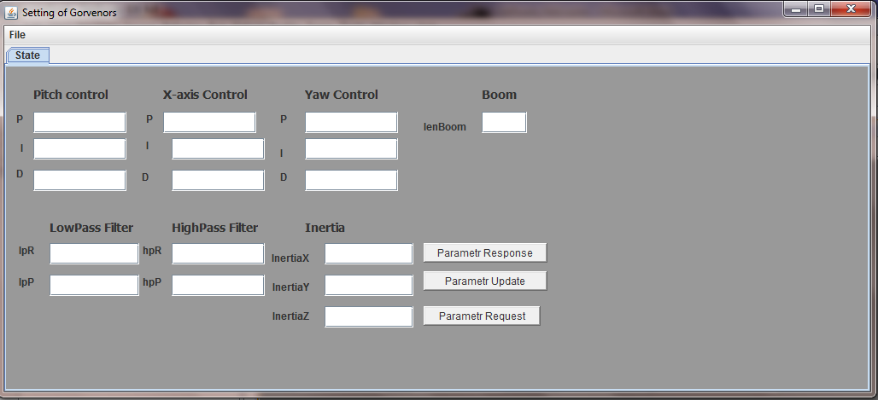

Parameter Update. Taking parameters from text areas of this form and forming the message.

Parameter Response displays static parameters of helicopter which are send via wireless communication.

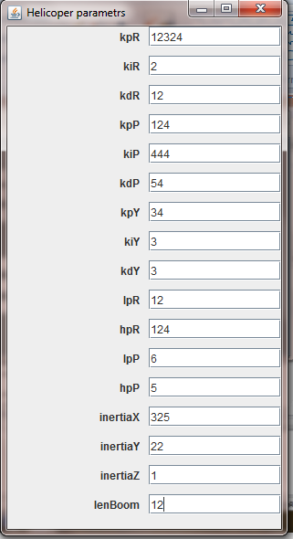

2.2 Chooser

From the Settings of Governors it is possible to save settings or download default one.

