Project Quadrocopter

Automotive Systems Master

Software Based Automotive Systems

ASM2-SB / SS 2010

Weight Table

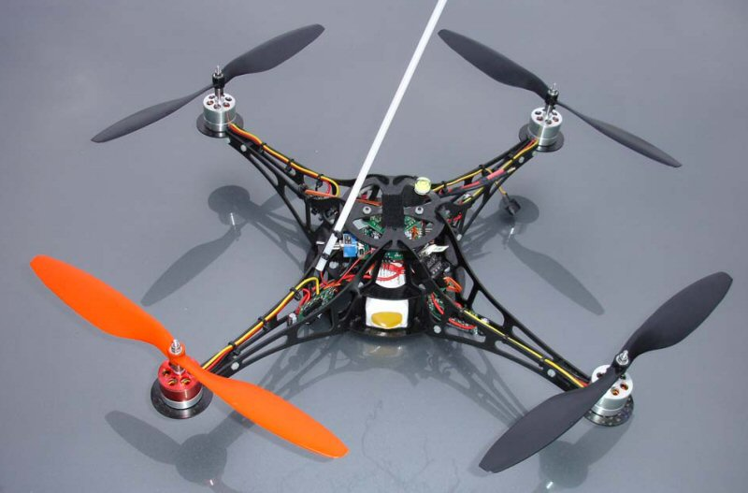

*Prof. Dr. rer. nat. (Purdue Univ.) Dipl.-Ing. Jörg Friedrich*

*Tutor: Dionysios Satikidis*

Joachim Schwab

Sreekanth Sundaresh

Nina Vetlugina

Marc Weber

# Center

|  |  |
| --- | --- |
| **Base plate**  23g | Untitled:DCIM:101MSDCF:DSC00126.JPG |
| **Middle plate**  13g | Untitled:DCIM:101MSDCF:DSC00127.JPG |
| **Upper plate**  12g | Untitled:DCIM:101MSDCF:DSC00123.JPG |
| **Fixings**  10g | Untitled:DCIM:101MSDCF:DSC00134.JPG |
| **Flight control**  52g | Untitled:DCIM:101MSDCF:DSC00129.JPG |
| **Brushless control**  17g | Untitled:DCIM:101MSDCF:DSC00130.JPG |

# Arm

|  |  |
| --- | --- |
| **Arm**  10g | Untitled:DCIM:101MSDCF:DSC00122.JPG |
| **Fixing**  1g | Untitled:DCIM:101MSDCF:DSC00136.JPG |
| **Motor carrier**  5g | Untitled:DCIM:101MSDCF:DSC00125.JPG |
| **Motor**  66g | Untitled:DCIM:101MSDCF:DSC00132.JPG |
| **Propeller**  7g | Untitled:DCIM:101MSDCF:DSC00128.JPG |