Quadrocopter

Quadrocopter Analysis, Implementation and Research Document

Vikas Agrawal

Document versions

1.0 | Vikas Agrawal | 23.09.2015 | Created

Table of Contents
1 Introduction 4
2 Management 4
Pricing 4
3 Simulations 8
01_Control_one_angle 8
01_PID_Control_one_angle 8
02_Control_two_angles 8
03_control_2_angles_and_yawrate 8
04_discrete_control_phi_theta_rpsi 8
05_discrete_control_with_noise 8
06_discrete_noise_Quantified 8
07_discrete_control_angle_from_acc 9
07_PID_Discrete 9
08_HIL 9
08_PID_HIL 9
Final_System 9
4 Matlab Files 9
calc_stability.m 9
Control_lib.mdl 9
Control_lib.mdl 9
Copter_Library.mdl 10
Copter_Animation.m 10
crc16.c 10
crc16.mexw32 10
double2uint8.c 10
double2uint8.mexw32 10
*_sfun.mexw32 10
quadrocopter_param.m 10
5 Hardware 11
Quadrocopter Hardware 11
Sensors 11
6 Software 11
Dragon Board Software 11
Raspberry Software 11
Visualisation Software 11

Introduction
The document describes all the work done in the areas of analysis, implementation, simulation and reseach of the quadrcopter and the quadrocopter components.
      - Management
      - Simulations
      - Hardware
      - Software

Management

Pricing

# | Shop | Picture | Description | Art.-Nr. | Price per Unit | Total price | Link
5 | REICHELT | 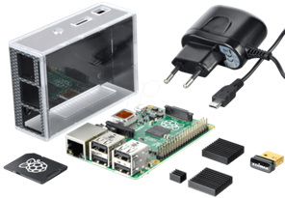 | Raspberry Pi B+ (All-In Package) including additionally: | RASP B+ ALL IN | 59,95 € | 299,75 € | http://www.reichelt.de/Einplatinen-Computer/RASP-B-ALL-IN/3/index.html?&ACTION=3&LA=3&ARTICLE=148139&GROUPID=6666
 |  |  | > Power supply (Micro-USB Stecker, 5V/1.2A)
 |  |  | > MicroSD-Card 8GB
 |  |  | > Housing for Rasp Pi B+
 |  |  | > WiFi USB-Dongle (EDIMAX 150MBit/s)
5 | REICHELT | 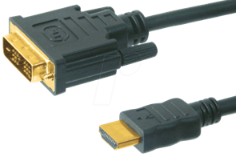 | HDMI-auf-DVI Cable | AK HDMI-DVI 2,0 | 3,80 € | 19,00 € | http://www.reichelt.de/AK-HDMI-DVI-2-0/3/index.html?&ACTION=3&LA=446&ARTICLE=69657&artnr=AK+HDMI-DVI+2%2C0&SEARCH=hdmi+auf+dvi
5 | REICHELT | 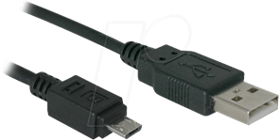 | Cable USB 2.0A to Micro-USB B (1,8m) | AK 676-AB2 | 1,95 € | 9,75 € | http://www.reichelt.de/USB-Kabel/AK-676-AB2/3/index.html?&ACTION=3&LA=3&ARTICLE=133000&GROUPID=6099
5 | REICHELT | 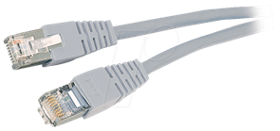 | Cross-Over-Kabel, doppelt geschirmt, 2 Meter | PATCHKABEL-X 2 | 1,20 € | 6,00 € | http://www.reichelt.de/Patchkabel-Netzwerkkabel-cross-over/PATCHKABEL-X-2/3/index.html?&ACTION=3&LA=2&ARTICLE=25802&GROUPID=5848&artnr=PATCHKABEL-X+2
10 | REICHELT | 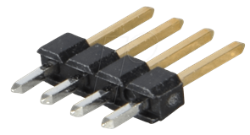 | Stiftleisten 2,54 mm, 1X04, gerade | MPE 087-1-004 | 0,10 € | 1,00 € | http://www.reichelt.de/Stiftleisten/MPE-087-1-004/3/index.html?&ACTION=3&LA=2&ARTICLE=119881&GROUPID=3220&artnr=MPE+087-1-004
20 | REICHELT | 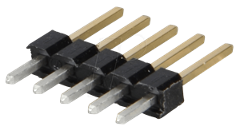 | Stiftleisten 2,54 mm, 1X05, gerade | MPE 087-1-005 | 0,12 € | 2,40 € | http://www.reichelt.de/Stiftleisten/MPE-087-1-005/3/index.html?&ACTION=3&LA=2&ARTICLE=119882&GROUPID=3220&artnr=MPE+087-1-005
10 | REICHELT | 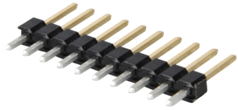 | Stiftleisten 2,54 mm, 1X10, gerade | MPE 087-1-010 | 0,25 € | 2,50 € | http://www.reichelt.de/Stiftleisten/MPE-087-1-010/3/index.html?&ACTION=3&LA=2&ARTICLE=119885&GROUPID=3220&artnr=MPE+087-1-010
10 | REICHELT | 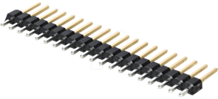 | Stiftleisten 2,54 mm, 1X20, gerade | MPE 087-1-020 | 0,33 € | 3,30 € | http://www.reichelt.de/Stiftleisten/MPE-087-1-020/3/index.html?&ACTION=3&LA=2&ARTICLE=119888&GROUPID=3220&artnr=MPE+087-1-020
10 | REICHELT | 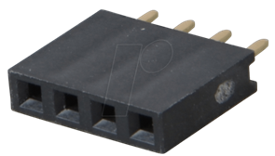 | Buchsenleisten 2,54 mm, 1X04, gerade | MPE 094-1-004 | 0,19 € | 1,90 € | http://www.reichelt.de/Buchsenleisten/MPE-094-1-004/3/index.html?&ACTION=3&LA=2&ARTICLE=119913&GROUPID=3221&artnr=MPE+094-1-004
10 | REICHELT | 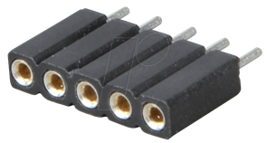 | Präz.-Buchsenleisten 2,54 mm, 1X05, gerade | MPE 115-1-005 | 0,35 € | 3,50 € | http://www.reichelt.de/Buchsenleisten/MPE-115-1-005/3/index.html?&ACTION=3&LA=2&ARTICLE=119953&GROUPID=3221&artnr=MPE+115-1-005
10 | REICHELT | 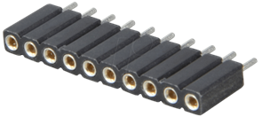 | Präz.-Buchsenleisten 2,54 mm, 1X10, gerade | MPE 115-1-010 | 0,71 € | 7,10 € | http://www.reichelt.de/Buchsenleisten/MPE-115-1-010/3/index.html?&ACTION=3&LA=2&ARTICLE=119955&GROUPID=3221&artnr=MPE+115-1-010
5 | REICHELT | 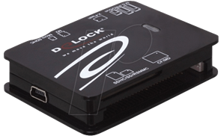 | USB2.0 Card Reader All-in-1 | DELOCK 91471 | 6,15 € | 30,75 € | http://www.reichelt.de/DELOCK-91471/3/index.html?&ACTION=3&LA=446&ARTICLE=106309&artnr=DELOCK+91471&SEARCH=sd+card+reader
5 | EXP-Tech | 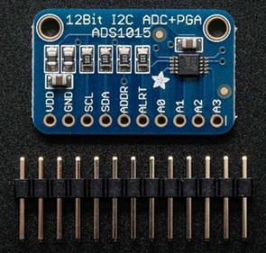 | 4channel 12bit (3.3kSPS) ADC over I2C | EXP-R15-038 | 9,25 € | 46,25 € | http://www.exp-tech.de/adafruit-ads1015-12-bit-adc-4-channel-with-progrmmable-gain-amplifier
5 | EXP-Tech | 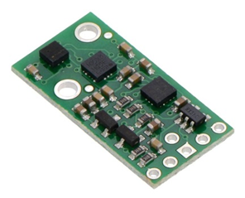 | Pololu AltIMU-10 v4 | EXP-R25-371 | 26,61 € | 133,05 € | http://www.exp-tech.de/pololu-altimu-10-v4-gyro-accelerometer-compass-and-altimeter-l3gd20h-lsm303d-and-lps25h-carrier
5 | EXP-Tech | 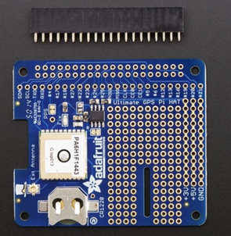 | Adafruit Ultimate GPS HAT | EXP-R15-665 | 53,50 € | 267,50 € | http://www.exp-tech.de/adafruit-ultimate-gps-hat-for-raspberry-pi-a-or-b-mini-kit
10 | EXP-Tech | 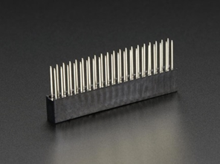 | GPIO Header for Raspberry Pi B+ (stackable) | EXP-R15-621 | 2,50 € | 25,00 € | http://www.exp-tech.de/gpio-header-for-raspberry-pi-b-extra-long-2x20-female-header
5 | EXP-Tech | 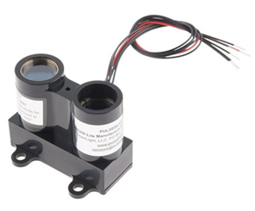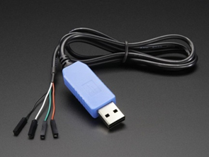 | USB to TTL Serial Cable (GPS-Prototyping) | EXP-R15-015 | 9,47 € | 47,35 € | http://www.exp-tech.de/usb-to-ttl-serial-cable-debug-console-cable-for-raspberry-pi?___SID=U
5 | EXP-Tech |  | PULSEDLight LIDAR Lite (Distance-Measurement Unit) | EXP-R05-729 | 94,90 € | 474,50 € | http://www.exp-tech.de/lidar-lite
5 | EXP-Tech | 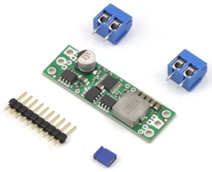 | Pololu Step-Down Spannungsregler D15V70F5S3 | EXP-R25-037 | 22,80 € | 114,00 € | http://www.exp-tech.de/pololu-step-down-spannungsregler-d15v70f5s3
2 | Bürklin | 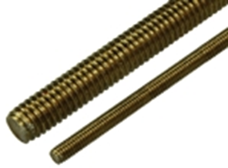 | Gewindestangen DIN 975 Messing Typ BS. M2.5 (1000mm) | 16 H 322 | 5,21 € | 10,42 € | https://www.buerklin.com/default.asp?event=ShowArtikel(16H322)&context=subset:0;sel:SE;search:gewindestange;se_name:vt;patchid:;tags:;pagecount:100&l=d&jump=ArtNr_16H322&ch=25059
1 | Bürklin | 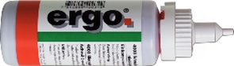 | Schrauben-Sicherungsmittel Typ Ergo 4003/4052/4101, mittelfest (10g) | 12 L 585 | 6,60 € | 6,60 € | https://www.buerklin.com/default.asp?event=ShowArtikel(12L585)&context=subset:0;sel:SE;search:Typ%C2%A0Ergo%C2%A04003/4052/4101;se_name:vt;patchid:;tags:;pagecount:100&l=d&jump=ArtNr_12L585&ch=69315
1 | Bürklin | 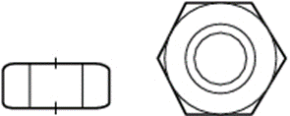 | Sechskantmuttern Mat. 4.8-Zn DIN 934/ISO 4032 Typ BS 3200, Gew. M 2,5 (100 Stk.) | 16 H 722 | 1,67 € | 1,67 € | https://www.buerklin.com/default.asp?event=ShowArtikel(16H722)&context=subset:0;sel:P;search:Sechskantmuttern;patchid:;tags:Sechskantmuttern;pagecount:100&l=d&jump=ArtNr_16H722&ch=61185
50 | Bürklin | 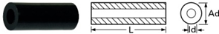 | Distanzrollen aus Polyamid Typ Fastpoint 10 (10090BB0113.5, M 2,5, L 13,5, Ad 5,0, Id 2,7 mm) | 18 H 5045 | 0,08 € | 4,00 € | https://www.buerklin.com/default.asp?event=ShowArtikel(18H5045)&context=subset:0;sel:P;search:Distanzh%C3%BClsen;patchid:;tags:Distanzh%C3%BClsen;pagecount:100&l=d&jump=ArtNr_18H5045
50 | Bürklin | 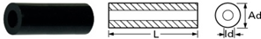 | Distanzrollen aus Polyamid Typ Fastpoint 10 (10090BB0110.0, M 2,5, L 10, Ad 5,0, Id 2,7 mm) | 18 H 5044 | 0,07 € | 3,50 € | https://www.buerklin.com/default.asp?event=ShowArtikel(18H5044)&context=subset:0;sel:P;search:Distanzh%C3%BClsen;patchid:;tags:Distanzh%C3%BClsen;pagecount:100&l=d&jump=ArtNr_18H5044&ch=74532
1 | Bürklin | 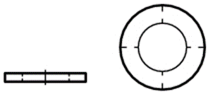 | Unterlegscheiben aus PA 6.6 DIN 125/ISO 7089 Typ 05., M2.5 (100 Stk.) | 16 H 942 | 2,83 € | 2,83 € | https://www.buerklin.com/default.asp?event=ShowArtikel(16H942)&context=subset:0;sel:SE;search:unterlegschreiben;se_name:vt;patchid:;tags:;pagecount:100&l=d&jump=ArtNr_16H942&ch=10217
 |  |  |  | Summe |  | 1.523,62 €
 |  |  |  | Price per Kit |  | 304,72 €

Simulations

01_Control_one_angle
Vereinfachtes Modell eines Winkels des Quadrocopters

01_PID_Control_one_angle
Wie Control_one_angle mit der Erweiterung, dass die verwendeten Motoren einen ungleichen Schub erzeugen, und dass dieser mit einer PID Regler Kaskade geregelt wird.

02_Control_two_angles
Vereinfachtes Modell bei dem Roll und Pitch geregelt mit einer P-Regler-kaskade geregelt werden.

03_control_2_angles_and_yawrate
Wie 02_Control_two_angles mit dem Unterschied, dass zusätzlich die Winkelgeschwindigkeit des YAW geregelt wird.

04_discrete_control_phi_theta_rpsi
Die diskretisierte Regelung des Modells 03_control_2_angles_and_yawrate

05_discrete_control_with_noise
Wie 04_discrete_control_phi_theta_rpsi mit dem Unterschied, dass den Regelgrößen ein Rauschen überlagert wird.

06_discrete_noise_Quantified
Wie 05_discrete_control_with_noise mit dem Unterschied, dass die Regelgrößen zusätzich quantifiziert werden, um die Abtastung eines
Milrcontrollers zu simulieren.

07_discrete_control_angle_from_acc
Wie 06_discrete_noise_Quantified mit dem Unterschied, dass die Winkel-information zuerst in eine Beschleunigung und anschließend wieder in einen Winkel zurückgerechnet wird.

07_PID_Discrete
Vollständiges Modell der Quadrocopterregelung unter Verwendung einer PID-Reglerkaskade.

08_HIL
Vollständiges Modell der Quadrocopterregelung Regelung mit dem Block für den Modell in Loop test. Verwendet zusätzlich den Embedded MATLAB Block für die P-Reglerkaskade.

08_PID_HIL
Wie 08_HIL mit dem Unterschied, dass der Embedded MATLAB Block die Regelung per PID-Regler beinhaltet.

Final_System
Enhält das Gesamtsystem für die P-Reglerkaskade/Zustandsregler. Finales System ist jedoch im Ordner 08_PID_HIL !!!

scratch
Enthält MATLAB-Dateien für Versuche.

Matlab Files

calc_stability.m
Dieses M-File wertet das Modell Quadrocopter_control bezüglich der Eigenwerte(Polstellen der Regelstrecke) aus.

Control_lib.mdl
Dieses M-File wertet das Modell Quadrocopter_control bezüglich der Eigenwerte(Polstellen der Regelstrecke) aus.

Control_lib.mdl
Diese Bibliothek beinhaltet Simulink Blöcke, welche für die Regelung verwendet wurden.

Copter_Library.mdl
Diese Bibliothek beinhaltet Simulink Blöcke welche für die Regelstrecke, Animation und Sensoren verwendet wurden.

Copter_Animation.m
Level 1 S-Function welche die Animation des Quadrocopters beinhaltet, wird von einem S-Function Block verwendet( siehe Copter_Library.mdl).

crc16.c
Mex-Function zum Berechnen der CRC16-Prüfsumme für das Quadrocopter ZigBee Modell.

crc16.mexw32
Compilierte Mex-Funktion aus crc16.c.

double2uint8.c
Mex-Function zum konvertieren von double zu unsigned int8.

double2uint8.mexw32
Compilierte Mex-Funktion aus double2uint8.mexw32.

*_sfun.mexw32
Diese Dateien beinhalten die Compilierten Embedded MATLAB teile der Modelle mit dem Namen *.mdl. !!! Anmerkung: Auf Grund von Pfadtiefen kann es erforderlich werden Modelle zuerst in diesem Pfad auszuführen und dort die *_sfunc.mexw32 Dateien erstellen zu lassen. Anschließend können diese in den entsprechenden Ordner kopiert/verschoben werden.

quadrocopter_param.m
Diese Datei erzeugt die Parameter für den Quadrocopter im Workspace

Hardware

Quadrocopter Hardware
BLMotor282734

Sensors

Timeline

2012

Flying drone will be quite helpful in a lot of cases, thanks to its agility and size. It can scout out regions which are out of reach for humans or dangerous to humans, e.g. in Nuclear Plant Fukushima. The ultimate goal of our project, Quadrocopter, is to create an autonomous drone which is capable to perform scout missions or some simple instructions (like buying pizza) in any landscape.
In this semester, we will try to further improve the algorithm used in the microcontroller and install new functions which would lead us to the ultimate goal in future. The two new functions will be ‘soft landing’ and ‘stay in position’.
Soft landing: By flipping a switch on remote control, user may instruct the quadrocopter to perform an autonomous landing. In order to achieve this, an ultrasonic sensor will be integrated to estimate the height from ground.
Stay in position: By flipping a switch on remote control, user may instruct the quadrocopter to stay in that position, until further instruction. Any external disturbance will be compensated automatically. In order to achieve this, a GPS sensor will be integrated to record the position. To improve the accuracy, the integrated accelerometers and Gyro sensors might be used in control.
Remote visualisation on PC will be developed as well as it will be helpful during the function development and future autonomous flying. Through zigBee connection, parameters on microcontroller can be transmitted wirelessly to PC and be further processed.

Copter_SimulinkModel/
Copter_Software/
Docs/
GPSModel/
xBee/

Altitude sensor.docx
Description_xBee.docx
GPS_Description.docx
Remote controller.docx
autocruising,hovering and landing description.docx

Steps to execute the Copter_SimulinkModel/

Matlab R2011b
System_Design_Quadrocopter_2012.mdl
Choose the CWD as the current path before starting the Simulink model.
Start Simulink model *.mdl.
Close the graph. ( not required for the project ).
Start the simulation by pressing the play button.

Best and the only case:
- The program starts with auto cruising.
- Switch to Hovering.
- Switch to landing

Known Issues:
The oscilloscope logs in the data and it can be seen after the test has been done. This will show the trajectory of the quadrocopter.

Negative axis should be removed.
The manual remote controlling should be limited to the system or universe.
Oscilloscope should contain the trigger points of hovering, manual mode and softlanding to determine the actions involved.

Steps to execute the Copter_SimulinkModel/
( Chandana )

Launch the Freescale Codewarrior IDE 5.9.0
Open the project file ( *.mcp ) - Quadrocopter_modified.mcp
Make the project.

Read the switches every 200 ms and if any of it is switched on, then the mode will be switched respective modes.

To retain the original software none of the switches should be turned on.
If any of them is turned on, then the flowchart logic will be followed the changed software can be tested. However, not everything is implemented but just the structure for future implementation.
A variable flight_mode to see the value of the switch.

Known Issues:
Replace the goto command with a switch case.
Implement goto hovering mode and got softlanding function. The only function that has been implemented is the manual mode.
The timing is critical and should be carefully optimised.
If the value for the switches is initialised is not clear.

fchSteps to debug and flash the software

Red on the left and the port is close to the power switch.
Press the debug button.
Click load on the window and load the project.abs file. Load the symbolic table project.abs.

QH_remote.c

Read_Switch reads the
QH_heightsensor.c
QH_heightsensor.h
Has the software for the altitude sensor. Please see the documentation Altidtude_Sensor.doc

Software

Dragon Board Software

Raspberry Software

The layers are
- Application layer. Example GPS Position Hold functionality
- Signal Processing layer: Example sensor fusion
  - Post processing GPS data
  - Post processing IMU data ( acceleration, rotational speed and pressure data to calculate roll, yaw and pitch )
  - Sensor fusion of sensor signals of the IMU
- Hardware Abstraction Layer: Example GPS data from the sensor
- Low Level Driver: Example peripherals integrated in the kernel.
- Datastructures : rtSigAllStatePayload ( includes time stamp + all imu + kalman and complementary orientation data ), rtSigPayload ( time stamp + normal orientation data ), rtImuPayload ( timestamp + all imu data )

Visualisation Software

The Helikopter-Oscilloscope is a JAVA based program and is run to visualise the incoming data. To run the software, it is important that the build path contains all the necessary libraries. This is done by adding the libraries to the Reference Library such as jfreechart, jcommon etc.
Also exclude RXTXComm.src from the Source files.

