State of the Art

The quadrocopter project of the University of Applied Sciences Esslingen was launched with the goal to build a system from the scratch, which is developed by students, scientific workers and Professors of the \HSE. In a first project the Printed Circuit Board which hosts the parts necessary to control the quadrocopter was designed by students at the faculty of Mechatronics and Electrical Engineering in Göppingen. This project groups’ focus was then on the simulation, implementation of the basic functions and visualization of the actual condition of the aircraft. The first two project groups already show the benefit of this project, a multidisciplinary development including hardware design, application development, embedded programming, simulation and the interfaces between these special fields. In the year 2009, the Faculty of Information technology adopted the development of the project with the aim to solve problems which came up in the previous development, and to redesign the soft- and hardware architecture. So a new hardware design was developed in a corporation between the two faculties with the outcome of a \CCU which can detect inertial movements in 6 \DOF s and can control the four actuators of the qaudrocopter via so called brushless controllers. The software development for the flight control was initialized in the context of the Automotive Systems Master Project 2009. The outcomes of this Master Project included a clearly modular Hardware Abstraction Layer, an Application Layer with the modules which are necessary for remote control and flight control, and initial Simulation and Evaluation tools for the flight behaviour. One of the biggest unresolved problems since yet is the development of a robust controller and the elimination of drifts which especially come up at the hovering state. The practice and the experience of previous developments show, that it is indispensable to proof new developments with a simulation before they will be realized at the real \UAV. So the main topic and the focus of this Master´s Thesis will be on the development of a simulation which shows potential solutions of the mentioned problems and the research and evaluation of the outcome results.

<Bilder der Hauptplatine um Gyros und Acc sensor zu zeigen>

Basic Background

Improvements of high density power storage, integrated miniature actuators and sensors, facilitate the development of \MAV s and new areas of research for unmanned and autonomous flying systems [BourMouSie04]. This new area of interest brought also a new area of problems. One of these is the fact that the pilot of the aerial vehicle does not exist, because the \UAV flights autonomous or the pilot observes and controls the \UAV via remote control. In both cases it is necessary that the \UAV system can detect its absolute position, to provide the pilot a better quality of control, or furthermore to manoeuvre autonomous. The following articles also describe this problem with different views and approaches. [see GrzGriBur09, WenMasZel10, BluHolLinMolSurViaTre08].

„Fully autonomous flights require high precision in aircraft positioning, especially in
takeoff and landing phases.“

WenMasZel10 S.1

This necessity of location determination requires measurement unit, which provides the detection of the movements in the given \DOF. Because of low-cost and low-complexity reasons, the most popular components which are used to reach a nearly satisfactorily level of flight stabilization, are inertial sensors. These sensors combined together called \IMU and have the ability to detect the acceleration of translational or rotational movements. Furthermore a control system can be used in a closed loop feedback system together with the \IMU, and can correct theoretically nearly every disturbance in a continual system [Bou08 S.52, CasLozAle05]. The limitation of resolution of the sensors and the necessity of integrating the acceleration values for position and velocity determination, have in real systems a big impact in aspects of error propagation and detection of smoothly movements [Tip08 S.27]. For a better appreciation of the movements, the following figure visualizes the influence of the thrust in relation to the movements in the \DOF s. Thereby the values of ω [rad/s] represents the least needed speed of rotation, for creating the required thrust for the hovering state. This state can be described as a state, in which forces in the x- and y-axis equals zero, and the uplift force in direction of the z-axis, has the same absolute value as the gravitational force. The value of Δω characterizes the purposed deviation of the required force in hovering state, and is used for navigation of the quadrocopter.
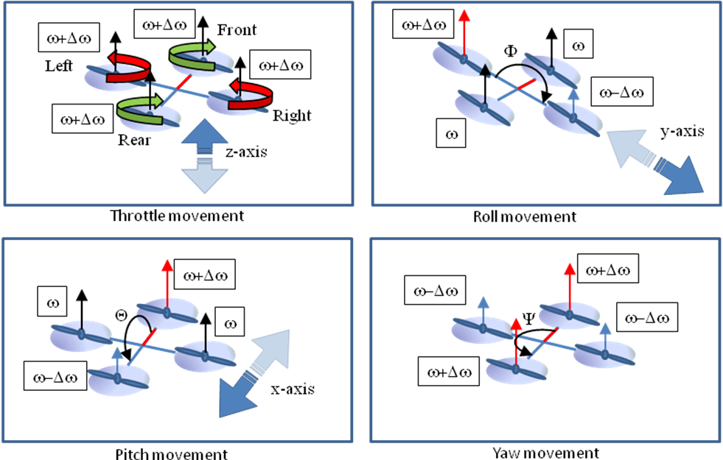

To keep the equilibrium of rotational kinematics and to prevent self-rotation, the motor direction of rotation equals crosswise. The quadrocopter has six \DOF which can be distinguished as angular and translational movements. Translational movements can be executed in x-, y- and z- axis.
Accelerating all rotors, with the same thrust ω to the value of ω+Δω will affect a movement in z-direction. Movements to the negative direction of the z-axis are possible, if the thrust of the four rotors is smaller as the gravitational force of the aerial vehicle.
The roll movements can be described as a change of the angle around the x-axis. Thereby the left and right rotors execute a force difference, by slowing down the one and simultaneous increasing the other thrust with Δω. Related to the thrust difference and angular movement, the aerial vehicle creates a force to the y-axis.
Equivalent to roll, the pitch movement is executed with a change of the angle around the y-axis. Also the pitch movement creates a translational movement across the x-axis. Pitch and roll can only reach a stable angular state and accelerate to the x- or y-axis, if the value of Δω is the same at the diagonal rotors. Otherwise, the quadrocopter would pure rotate across the corresponding axis.
The yaw movement is a rotation around the z-axis. This angular movement results in combination of pairwise different thrusts and takes as long as the thrusts are different [Bre08].

Synthesizing the weaknesses of \MEMS like noise or the limited resolution, together with the characteristics of the kinematics of the quadrocopter shows the problems which come up in case of \MAV control with a \IMU with \MEMS.
As mentioned smoothly accelerations could be a drawback for the control system, because this kind of accelerations gets lost in the sensor noise. Regarding the kinematics of the quadrocopter, we have seen that translational movements can only be reached with angular movements across the x- and y-axis of with increasing or decreasing the thrust on every rotor in the z-axis. Imprecise noisy sensors would affect a wrong thrust regulation at the actuators. Thereby it is highly improbable, that all four rotors affected by the noise equal and accelerate in the z-axis. More probable as a uncontrollable acceleration in the direction of the z-axis, is that pair wise two rotors have the some drift and create so an unexpected yaw rotation. Finally the most probable will be a wrong thrust regulation at one rotor, but for a short time interval. So the most likely error drifts will exist at the x- and y-axis. So the hovering state will be nearly impossible to reach, just with \MEMS acceleration sensors, because the x- and y- movements have to be zero.

The following figure shows the described problem area of \MEMS sensors in the
concrete case of the sensors which are mounted at the quadrocopter \CCU of the
\HSE. The mechanical characteristics of the translational acceleration sensor [datasheet] were simulated under consideration of the change of the position of
the quadrocopter and the applied acceleration. We can see that accelerations
which are small enough get lost in the sensor noise and are invisible for the
quadrocopter. Furthermore the quadrocopter reacts in \verb|t=12| if the
acceleration transcends the threshold value of the sensor noise.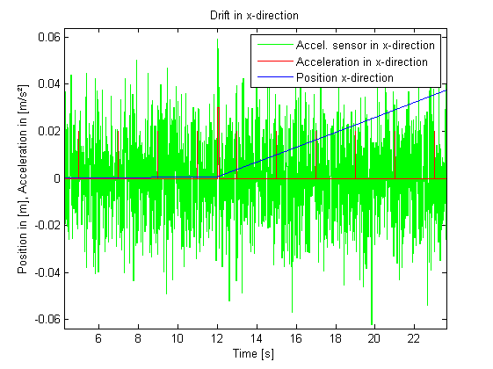

This example shows that the quadrocopter would start drift in the x-direction, causes small acceleration disturbances, but the \CCU would still believe that the movement in this direction is zero.

