An enormous quantity of researches, which were sponsored by industry companies or universities, was executed to find a better approach to stabilize UAV s by using different sensors. Movement detection approaches, which are ultrasonic, sonar or \RF based, show that it is necessary to have known reference points, to get a reliable result [see EckDreGer09, BulHeiEst02]. The problem of this approach is that the environment has to be prepared before the UAV flight. This preparation is a drawback in point of flexibility in different operation places. Anyway, approaches with ultrasonic, \RF or sonar sensors show that the localization of \UAV s needs a kind of global feedback, to correct the UAV s absolute position. One of the first motivations for a vision based sensor was presented by Ettlinger et al. [EttNecIfjWas04]. In this paper the authors suggest that vision is the only one practical solution for obstacles of flight stability, and showed an onboard approach for a \GUAV by detecting the horizon with a forward looking camera and estimating and control the flight attitude. Further vision based attitude control approaches also were used for \HUAV s with the difference of a down looking camera for reference point free movement detection, or an off-Board camera which tracks the global position of the \UAV. The off-board camera approach was researched by Altug et al. [AlstOstTay02], and later with an on-board off-board camera combination [AltOstTay03], with the result of a less sensitive feature detection and position localization as the on-board camera approach. Off-Board camera tracking shows also in the developments of extremely reliable and precise localization of a \UAV and is actual used in the development of aggressive autonomous flights of multiple \MAV s in the experiments of Mellinger et al. [Daniel Mellinger, Nathan Michael, and Vijay Kumar. Trajectory Generation and Control for Precise Aggressive Maneuvers with Quadrotors. Int. Symposium on Experimental Robotics, December 2010. (to be presented)]. Previous experiments were executed with a similar environment configuration but with a single \MAV by Gurdan et al. [GurStuAchDotHirRus07] with a sensor sample rate of 1KHz which shows a fast and reaction to disturbances. The advantage of the Off-Board camera tracking system is that the image capturing and position tracking is executed outside the \UAV and prevents complex on-Board calculations for movement and position estimation. The drawbacks of this Off-Board Tracking methods are that they need a previous prepared testbed for the flying environment, which is build up with a motion tracking system [see VICON Motion Capture System:MicMelLinKum10, S.1].

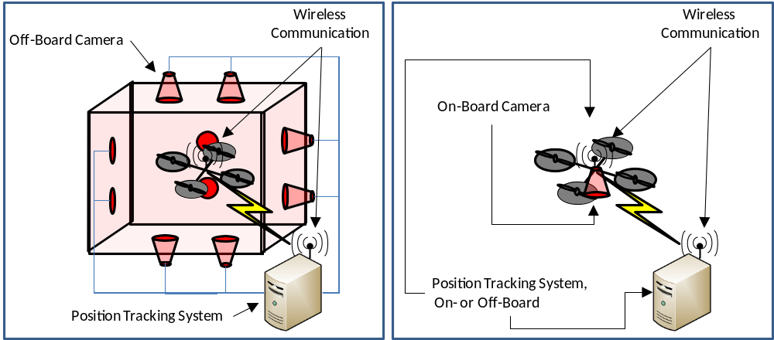

On-Board vs. Off-Board image processing

Problems such as a limited power resource, a poor level of algorithm complexity for image processing resulting from the limited calculating on-board performance and the endeavour to economise weight, lead to outsourcing the image processing to a remote system which is not concerned to the on-Board problems. Langer et al. [LanSuePro08] uses an off-Board image processing to track a landing pad for autonomous landing. Thereby the images are transmitted in this approach over Wifi communication to a host PC, which tracks the landing pad, and sends back information of position control. Thereby it was shown that the landing algorithm has to run at maximal 100Hz to work with the transmitting delays of the images. This landing algorithm shows that it is possible to outsource successfully the image processing in consideration of the sample rate which the algorithm needs. Ahrens et al. used for the vision-based guidance also an onboard camera connected via Wifi to a host PC for image processing and for stabilization of the hovering state of the \UAV, but with infra red marker points in the flying environment. Unless the drawback of flexibility for the operation environment related to the marker points, Ahrens et al. [AhrLevAndHow09] shows that the drawback of an off-board image processing image transmission delay cannot be improved, but the computation time of the ego-movement calculations of the \UAV can be decreased at the host PC with usage of the marker points. By regarding the drawback of the image transmission delay of the Off-Board image processing, On-Board approaches were developed with the focus to the Real-Time behaviour of the image processing. Tippetts [Tip08] realized an On-Board approach with a \FPGA which uses a complex feature tracking algorithm but runs with 100MHz sampling rate. The characteristics of the feature tracking with a \FPGA can result a fast movement tracking method, but it not an efficient method in the behaviour of power consumption because the hardware is not optimized for the image processing tasks. In contrast to that and inspired by the functionality of optical mice, Langer et al. [LanSuePro09] showed an approach for detecting the spatial movement of a \UAV with optical mice sensors which have an optimized hardware for image processing and are lightweight.

<Bild mit On-Board und Off-Board image processing struktur>

Hardware-based vs. Software-based image processing
Mice sensors for movement detection of \UAVs also used in the investigations of Beyeler et al. [BeyChrFlo09]. These sensors calculate the optical flow of the captured images and estimates the movement direction of the \UAV in hardware and can provide a high sample rate. In contrast to the fast movement detection, a disadvantage is that these sensors have limitations related to the operating environments. These limitations are the concrete light and distance range which is required from the manufacturer [Example Datasheet with limitations of the operating environment, p.p. 7 -15, ADNS3080_Optical_Mouse_Sensor05]. The most of the experiments with an stabilization approach with mice sensors uses optical lens to reach a higher degree of operating distance, but the effort is in most of the cases is not satisfactory to the results [Performance of the optical flow based position controller, p. 6, LanSuePro09]. Software based image processing approaches have a more flexible extension and change behaviour, but they work not as fast as hardware based approaches. Further advantages of software based image processing is, that the most of the commercial and open source computer vision \API s also provide implemented estimators and filters to correct the captured input and to decrease noise of the images. Stowers et al. realized a heading estimation for a quadrocopter, with an onboard \SBC which runs the open source computer vision toolkit OpenCV. This software based image processing approach show strengths in the modularity of the image processing architecture and in the interchangeability of the vision system [Flight Control, Vision Processing, p.p. 1 – 6, StoBaiHayMil09].

Vision based movement detection approaches
Sequential captured images contain a huge amount of information about the absolute and relative movement of objects in every direction. So several vision based movement detection approaches were researched in the topic of \UAV stabilization with different requirements to the information which extracted from the vision process. A simple approach for a relative vision based control of a \UAV was implemented by Boabdallah [Position Sensor, Bou07, p.p. 110-114] by using a down looking camera and the Canny edge detector [Can86] and the Douglas Peuker Algorithm for curve equalisation [DouPeu73]. The drawback of this approach is that the field of vision must contain forms with edges which mean that the approach cannot result a satisfactory result if no edges are detected. A further approach for detecting relative movements and to build up a map for autonomous navigation is visual \SLAM. This approach tracks features in the field of vision, and reconstructs a relation or so-called “mapping” to tracked features of previous images. The realization of \SLAM [see WilKleRei07] in a \UAV was executed in the work of Bloesch et al. [BloWeiScaSie10] under consideration of real-time characteristics. The behaviour of the algorithm shows that the localization of the tracked features and the simultaneous mapping has a big impact at the time delay of the calculation. So the experiments and the control algorithms were researched and designed for 7.5 Hz sample rate. Another popular tracking method for movement detection is given with the Optical Flow, which can be described as movement observation of tracked objects or pixels in a sequence of images. Algorithms to calculating the Optical Flow were introduced by Horn and Schunk [HorSch80], Lukas and Kanade [LucKan81]. Few years after introducing the Lucas-Kanade-Algorithm, Lucas described the theoretical approach of visual navigation by using the Optical Flow. Thereby he described the possibility to detect movements and to calculate correspondence velocities. These velocities can be combined to a vector field which can describe movements in every direction [p.p 40 – 45, Luc84].

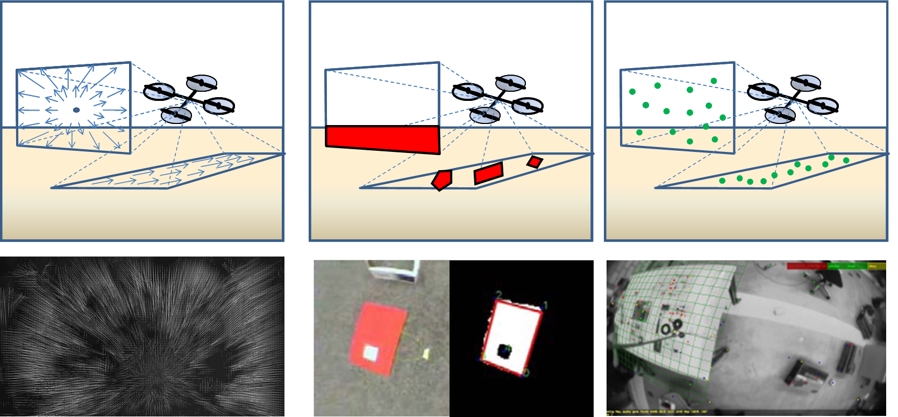

Optical flow Edge detection SLAM

IMU- and vision-based control approaches
The closed loop feedback architecture is an approved method for controlling systems and a nearly used in the most of the systems controls in industry and society. So the most of the researches in the \UAV stabilization topic were and still are executed with closed loop control architecture which is built up as \MIMO architecture. The differences between the researched approaches are the amount of the inputs and outputs of the physical process, the type of controller, the used measurements and the sampling rate. Thereby the type and behaviour of the controller is close related to the measurements and the physical process [DeoBi01, S.3]. The classical control approach using \PID Controler was researched in several \HUAV projects [Sik08, pp 24-31] [Bou07, pp 43-68]. These researches show that the PID control is not robust enough to handle with measurement errors and to control multiple \DOFs. So the most of the released control approaches with PID technique extends the control architecture with estimators and filters to get more precise measurements. Another approach for control improvement was introduced by Luenberger [Lue71] and describes a closed loop control approach, called state-observer, which simulates the process in real time parallel to the true process by using the input and output vector of the closed loop system and corrects the control strategy [ST2_K7_Zustands-Regler_005_aa_ALL-II]. Bloesch et al. [BloWieScaSie10, p 5] showed in their research, that the problematic of sensors with non-negligible time delay can be solved to an adequate result, by using a state-observer. The reason for that is that the state-observer allows configuring and control the stability behaviour of the closed loop feedback architecture by parameterise the state-observer. If a process can be observed or furthermore controlled, is related to the states, in which it can be, and furthermore to the measurements of the \DOF. In this project here it has to be determined how correction values, which are provided from the optical sensor with a slower sampling rate, can includes into the control algorithm of the aircraft.
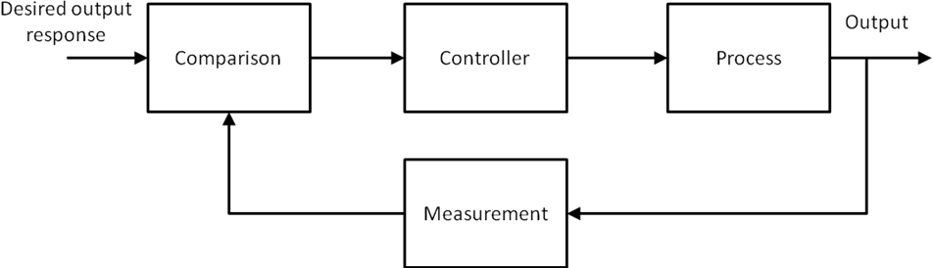

Proposed solution

This chapter shows several approaches for movement detection and stabilization of \UAVs. The found methods were critically analyzed and assessed with the result to investigate the following techniques which are shown in figure XX. The proposed solution to eliminate the stabilization problems of the quarocopter has to be a vision-based for achieving the goal of flexibility and independence of operational environment. Related to the off-board image processing, the problem of the processing delay could be solved with a state-observer. Furthermore the optical movement detection should work without reference points, so the optical flow method has to be researched by using a software-based detection approach for more flexibility and replaceability. Because the approach of the flight control is teleoperated, and movement detection and flight stabilization does not have to allow aggressive flight maneuvers, it is simpler to realize the camera view on-board. This proposed solution has to be simulated, to check the feasibility and find out the limitations.

