The development Process

Model Based Design

\MBD is a popular method to encounter problems which come up in the development of mechatronic products. These systems almost involve mechanical, electrical control and embedded components which are developed in different teams of engineers with a specialized focus on the part of the complete project. Some of these components are related on the result of other components before there can be developed. This problem can be solved with Model Based Design and the advantage to develop modules of the complete project by simulating their environment. So the development can run highly parallel with the benefit that the modules can be continuous tested in each phase of the project [EsLamTur10].

The following figure shows the phases and the corresponding key capabilities of \MBD.
The first phase of \MBD is the realization of the researched and required components into a simulation environment. Thereby physical components, environmental model and algorithms are abstracted to systems, by using domain-specific modeling tools, with a well defined edges and intercommunication. The developed systems in the design phase can be tested simultaneously, to analyze the system performance and correctness. Other key capabilities of \MBD are given in the implementation phase. The \MBD tool MATLAB allow to generate embedded code from the designed systems, or to combine handwritten code with the build simulation of the design phase. So the implemented modules can be similarly tested in the adopted simulation environment. Finally components which have passed the tests at the implementation phase can be integrated together. Ultimately the final product can also be tested with the \MBD tool by simulating the environment of the product e.g. in a \HIL test bench. [http://www.mathworks.co.uk/model-based-design/]

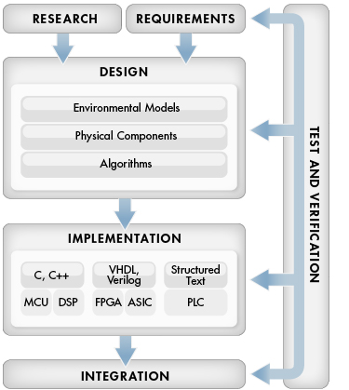

Spiral Model

During the initial survey we have seen many approaches for aircraft stability and movement detection of \UAVs. The most of these approaches were developed iterative under consideration of the upcoming problems and obstacles [see AltOstMah02, AltOstTay03] [see LanSuePro08, LanSuePro09]. This procedure model also will be appropriate to this project, because the potential risks are difficult to identify. So the outcome of the development process have to be a prototype which can be evaluated, tested and extended. A process model, which provides an appropriate structure to face the iterative prototyping strategy under the consideration of the risk aspects, is given with the spiral model.
The classical spiral model can has typically four phases in which the product is developed in an incremental evolutionary process. Derivates of this classical model which focus the customer evaluation for quality improvements can have tree, five or six phases. In the context of this project, the classical four phases spiral model is used for scientific and feasibility study and don’t has to provide further customer communication phases [Pre01].

A typical cycle of the four phases spiral model begins with the identification of the objectives of the potion which has to been elaborated like performance, functionality, flexibility and so far. The next step is to evaluate the alternatives relative to the objectives and constraints, and to determine significant sources of risks. As next the product of the next level iteration is executed. In the special case of this project, it is comfortable to use \MBD in this phase by using the results of the previous phase as input. This input can be a planed prototype or requirements which describe the changes to execute. The output of the \MBD phase can be used again in the planning phase for the next iteration [Boe88].

Requirement
Risk Analysis
Determination of objectives,
alternatives, constraints
Plan next iteration
Evaluate alternatives, identify
and resolve risks
Develop and identify next level product
Concept of
operation
Development
plan
Prototype 1
Prototype 2
Prototype 3
Risk Analysis
Risk Analysis
Planning changes
Defining outcomes of changes
MBD
Design
Implementation
Integration
Requirements
Test and Verification
Defining outcomes

Overall Design model
The overall design model gives an overview of the components of the simulation which has to be realized in the context of this project and the corresponding applied techniques. As we can see in figure XX, the left side of the simulation abstracts the embedded system of the quadrocopter. Inside these components, the plant or physical model has to simulate the movement behaviour in the \DOF of the quadrocopter. Furthermore the controller has to correct the position of the \UAV and to compensate outside disturbances with information of the \IMU and the distributed correction value of the base station. The environment simulation, which has to include the underground and disturbances simulation, will be triggered to start just as the rest of the simulation with a task which describes the ideal flight manoeuvre. The transmissions of the camera, \IMU and correction data have to be delayed in relation to a configurable transmission rate. The image processing has to be executed with an application, realized in OpenCV [OpenCV Project] and invoked by Matlab[S-Function]. The calculated drift from image processing finally has to be compared with the received values of the \IMU to determine the position correction value. This correction has to transmit to the embedded system and included in the correction of the controller. The novel aspect of the project here is reflected in the approach to simulate the complete embedded system, the transmission process, the base station and to realize the image processing in an application. The strength of this approach is that the simulation can give better results and a deep insight to the concurrent processes and helps to understand the challenges and limitations of the investigated scheme.

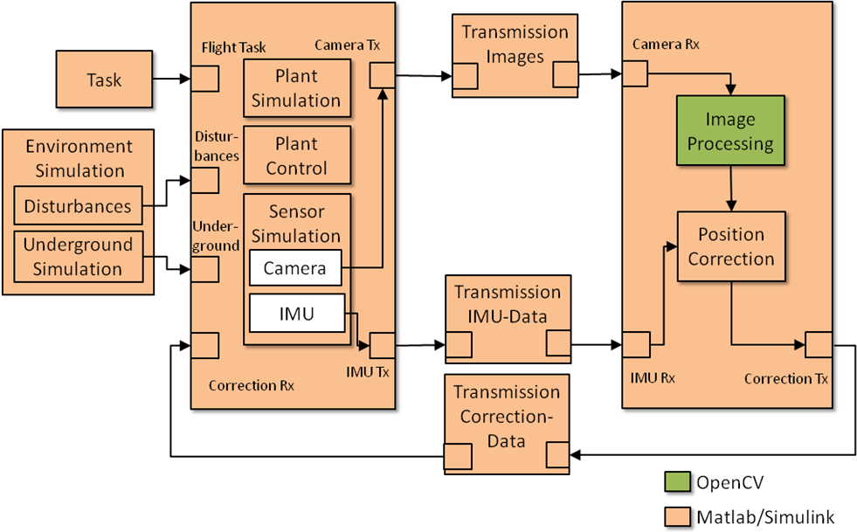

Investigative Principles

Create Plant Model

The plant, the physical system of the quadrocopter is a model which includes a mathematical description of the motion behavior of the aircraft. Thereby these equations of motions can be determined with a method for plant design, called Euler-Lagrange formalism, which considers two references for the model description. These references are the Body-Fixed frame, which describes the relative movements from the aircraft perspective, and the global movements of the quadrocopter of the observer perspective. Thereby the Euler-Lagrange formalism determines the degrees of freedom with the corresponding equations of motions of the both frames, and furthermore the kinematics and energies of the system. After that the equations of motion can be resolved, under consideration of the accelerations. So the resulting plant model shows the mathematical behaviour of the aircraft, in relation to the accelerations in the \DOFs. In this project here, the physical model will be used for the simulation of the flight behaviour and for the analysis of the controllability of the quadrocopter with the usage of the accelerations in the \DOFs and the velocity information of the visual movement detection.

<Beobachtbarkeit, Regelbarkeit, etc. >

<Bild mit Kräften und Achsen>

Environment Simulation
The Environment simulation includes the behaviour of outside disturbances, the simulation of the camera
Camera Simulation, outside Disturbances, Transmission Simulation, Transmission
Environment simulations of flight experiments almost require complex atmospheric models to simulate the nearly real behaviour of the disturbances which influence the aircraft. In the case of the simulation which has to be realized in the context of this project, it is not necessary to spend effort to create a physical environmental model for
. The environmental components which have to been simulated are the underground which will be filmed from the on-Board camera of the quadrocopter, and the disturbances related to the event time. So a test scenario can be summarized as a set of disturbances in the test time period and the underground which is filmed.

Disturbances 30

Motion Tracking
One of the key capabilities of Computer Vision is the tacking of motions. This intention can be executed with the usage of several algorithms, which mostly need reference markers or concrete forms [See Initial Survey…]. One method which provides motion tracking without such requirements to the environment is as mentioned in the [chapter…] the optical flow. This visual motion tracking method is the result of the observation of several tracked points in a sequence of pictures. With the movement information of these points, the relative movement of the aircraft and the velocity can be calculated under the consideration of the frame rate. This tracking method will be used in context of this project to observe the relative movement of the quadrocopter from an on-Board camera.

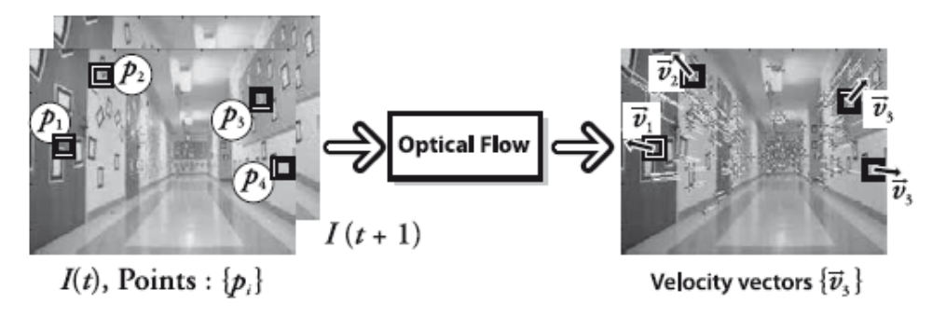

Image processing, Motion detection, Information filtering and Estimating OpenCV related to MATLAB and Optical Flow.

Controller Development
Control Analysis, Controller Design & Implementation (discretisation) 20

Experimental methods

