

School of Engineering and Design
Electronic and Computer Engineering

M.Sc. Course in Distributed Computer Systems Engineering

Master’s Thesis Topic Proposal

Analysis of a distributed spatial
movement detection with optical sensors
in a quadrotor helicopter

Student: Dionysios Satikidis
Student ID: 0939903
Preferred Supervisor: Dr. Malcolm Ellis
Date: January 9, 2010
The University of Applied Sciences Esslingen actuates since years a remote control quadrotor helicopter, which is used for demonstrations and student research projects. Another purpose of the quadrotor helicopter project is to evaluate new innovative technologies which are also used in the automotive industry and to prove that these are marketable. Consequently this helicopter contains several popular hard- and software components, like an OSEK real time operating system, GPS-module, ZigBee-module and acceleration sensors.

Analysis of the helicopter’s stabilization and navigation system indicate that movement detection of the acceleration sensors raises technical difficulties. The fact that these sensors work imprecise, due to CPU noise and quantification errors causes dramatic error propagation in the calculation of the board location by using double integration of the acceleration values.

A solution of this problem involves analyzing and implementing optical movement detection. This purpose bases on the movement of similar objects through image sequences, which could be calculated in deterministic time slots and do not need neuronal structures, which are complex and non deterministic.

The point of view of the Master´s Thesis will be the option of distributing the complete image processing or parts of it to a server, which communicates wireless with the helicopter and corrects the error drift. As well the potential drawbacks and fallacies, like unacceptable communication latencies have to be considered in detail by implementing experimental prototypes and simulations.

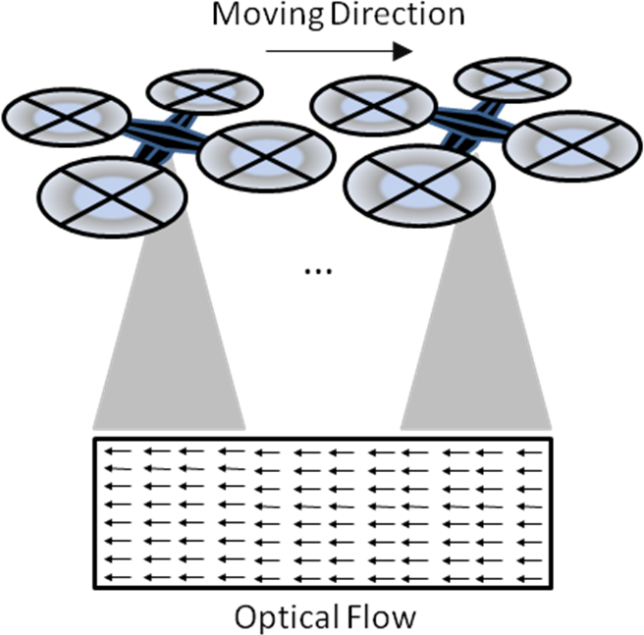
Figure 1: Spatial movement detection with Optical Flow

See http://www.osek-vdx.org/
See de.wikipedia.org/wiki/Global_Positioning_System
See http://www.zigbee.org/
See Figure 1

