A MAJOR PROJECT ON

MULTIPLE VEHICLE TRACKING AND SPEED ESTIMATION USING OPTICAL FLOW METHOD
Submitted in partial fulfillment of the requirement for the award of degree of

MASTER OF ENGINEERING
(ELECTRONICS AND COMMUNICATION)

Submitted By

MANJARI GUPTA
(University Roll No. 8582)
(College Roll No. 19 /E&C/08)

Under the guidance of:

MRS. S.NDU
(Sr. Lecturer)
Department of Electronics and Communication



DEPARTMENT OF ELECTRONICS & COMMUNICATION ENGINEERING

DELHI COLLEGE OF ENGINEERING

BAWANA ROAD,DELHI-110042

(UNIVERSITY OF DELHI)

2008-2010

CERTIFICATE

This is to certify that the project entitled “Multiple Vehicle Tracking and Speed Estimation Using Optical Flow Method” is the work of Manjari Gupta, University Roll No. 8582, a student of Delhi College of Engineering. This work was completed under my supervision and guidance and forms a part of the Master of Engineering (Electronics and Communication) course and curriculum. She has completed the work with utmost sincerity and diligence.

Further it is also certified that the matter and the results in this project are original and have not been submitted for any degree or diploma in any other college to the best of my knowledge.

Prof. Rajiv Kapoor Mrs. S. Indu

Head of the Department (Sr. Lecturer)

Department of Electronics and Communication, Project Guide

Delhi College of Engineering, Department of Electronics and

Delhi. Communication,

Delhi College of Engineering, Delhi.

ACKNOWLEDGEMENT

I would like to thank my Guide Mrs S.Indu for giving me the opportunity to work under her guidance. The project “Multiple Vehicle Tracking and Speed Estimation Using Optical Flow Method” gave me the opportunity to explore this new and challenging field. Doing the project under the madam had been a fulfilling & learning experience for me.

Further, I would like to use this opportunity to pay my regards to Prof. Rajiv Kapoor (Head of Department, ECE) for his overall help and guidance during the course.

Manjari Gupta
(Roll No. 19/E&C/08)
M.E. (Electronics and Communication)
Deptt. of Electronics and Communication
Delhi College of Engineering, Delhi.

Abstract

The dissertation presents a novel velocity estimation method for ground vehicles. We will analyze here an extremely simple model that already exhibits quite complicated behavior. We consider a one-lane road with a number of cars on it.
MATLAB and SIMULINK are good tools for studying models of such behavior. The system developed currently uses MATLAB 7.0 R2006B.
The task here is to compute direction of motion of vehicle, graphically represent the vehicle trajectory and automatically estimate vehicle speed from video sequences acquired with a fixed mounted camera.
The method uses optical flow algorithm to calculate changes in the intensity of the pixels of the images. These apparent velocity components are then subjected to various image processing techniques to obtain centroid of the vehicle across the frames. The distance traveled by the vehicle is calculated using the movement of the centroid over the frames. The image coordinates of the centroid are mapped to World space. The world coordinate distance is further mapped to actual distance using pixel to distance ratio. Using this information the velocity of the vehicle is estimated.
The accuracy of our method was calculated by measuring the velocity manually and comparing with calculated values.

Table of Contents

- Introduction and Problem Definition
  - Introduction to an Image…………………………………………….. 6
  - Motion Estimation……………………………………………………….. 6
  - Methods of Motion Estimation………………………………………………..7
  - Evaluation of the Performance of a Motion Estimation Algorithm………..8
  - Applications of Motion Estimation…………………………………………8
  - Assumptions
  - Outline of the Dissertation.……... . . . . . . . . . . . . . . . . …………… 9

- State of Art

- Optical Flow Method
  - Introduction to Optical Flow . . . . . . . . . . . . . . . . . . . . . . . . . . ………….10
  - Computation of Optical Flow……………………………………………….10
  - Optical Flow Assumptions
  - The 2D Motion Constraint Equation….……………………………………11
  - Horn–Schunck Method……………………………………………………...13
  - Lucas–Kanade Method…………………………………………...14
  - Classification and Overview of Existing Optical Flow Techniques………16
  - Limitations of Optical Flow Method………………………………………...17
- Camera Calibration
4.1 Introduction
4.2 Camera Model
4.2.1 Introduction
4.2.2 Extrinsic Parameters
4.2.3 Intrinsic Parameters

- Description of Method
5.1 Preprocessing
5.1.1 Calibration Parameters
5.1.2 Pixel to Distance Ratio
5.2 Steps Followed

- Implementation

- Experimental Results and Conclusions
  - Simulation Results
7.1.1 Tracking One Vehicle
7.1.2 Tracking Multiple Vehicles
  - Conclusion

Bibliography

List of Figures
Figure 1 : Sequence of images over time 1
Figure 2: Motion vector definition of current frame a) at time t-1 b) at time t 2
Figure 3: Pixel movement from image (a) to image (b) 8
Figure 4: a) Original Video b) Optical Flow representation of (a) 9
Figure 5: The image at (x, y, t) is the same as at (x + δx, y + δy, t + δt) 11
Figure 6: The aperture problem 13
Figure 7: Diagram of Pitch, Yaw and Roll 22
Figure 8: Parameter to relate the world, camera and image coordinate system 24
Figure 9 : Input Block 30
Figure 10: Thresholding and Region Filtering Block 32
Figure 11: Velocity Threshold Block 32
Figure 12 : Display Results Block 35
Figure 13: Original Video Clip 38
Figure 14: Threshold Image 38
Figure 15: Tracking the Vehicle 39
Figure 16: Centroid of the Vehicle 39
Figure 17: Vehicle Trajectory 40
Figure 18: Original Video with Two Vehicles at different speeds 41
Figure 19: Threshold Image with moving vehicle (white) & background (black) 41
Figure 20: Centroid for each vehicle is superimposed 42
Figure 21: Image showing only centroid for each vehicle 42
Figure 22: First half 43
Figure 23: Second half 43
Figure 24: Tracking two vehicles using Blob 44
Figure 25: Vehicle Trajectory for both vehicles 45

List of Tables
Table 1: Comparison of Measured and Calculated Velocity (Single Vehicle) 40
Table 2: Comparison of Measured and Calculated Velocity (Multiple Vehicles) 45

Chapter 1

Introduction
  - Introduction to an Image

An Image sequence (or video) is a series of 2-D images that are sequentially ordered in time. Image sequences can be acquired by video or motion picture cameras, or generated by sequentially ordering 2-D still images as in computer graphics and animation.

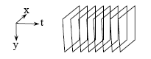
Figure 1 : Sequence of images over time

1.2 Motion Estimation

Motion estimation is a very important task in video analysis. It can be used to find the motion fields, to identify moving objects and to find their velocity. It is the process of determining motion vectors that describe the transformation from one 2D image to another; usually from adjacent frames in a video sequence. The motion displacement vector has two components Ux,Uy along the x ,y coordinates. The motion velocity is equal to the magnitude of motion vector.
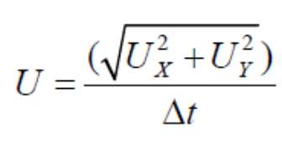 (1.1)
Where 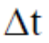is the time difference between two frames.

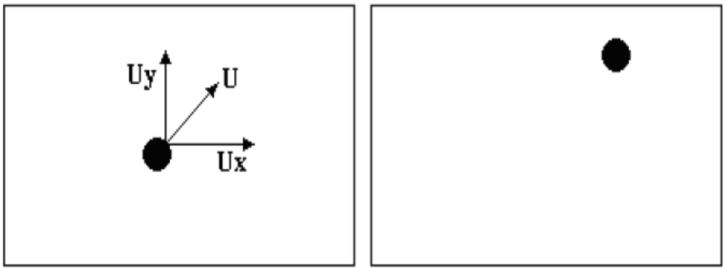
(a) (b)

Figure 2: Motion vector definition of current frame a) at time t-1 b) at time t

A great deal of information can be extracted by recording time-varying image sequences using a fixed camera. An image sequence (or video) is a series of 2-D images that are sequentially ordered with respect to time. Motion estimation is defined here as the estimation of the displacement and velocity of features in image frame with respect to the previous frame in a time sequence of 2D images.

1.3 Methods of Motion Estimation
The methods for finding motion vectors can be categorized into direct methods and indirect methods. Direct methods are pixel based methods while indirect methods are feature based methods.

Feature/Region Matching: Motion is estimated by correlating or matching features (e.g. edges) or regional intensities (e.g. blocks of pixels) from one frame to another, usually with a statistical function applied over a local or global area. The purpose of the statistical function is to remove matches that do not correspond to the actual motion.
Examples include:
- Block-matching algorithm
- Phase correlation and frequency domain methods

Gradient based methods: Gradient-based methods use spatial and temporal partial derivatives to estimate image flow at every position in the image.
- Optical flow
- Pixel recursive algorithms

1.4 Evaluation of the Performance of a Motion Estimation Algorithm

In general, a motion estimation algorithm can be evaluated according to one or more of the following factors:

- Capability of producing displacement estimates with high spatial resolution
- Capability of handling motion discontinuities and the occlusion problem
- Sensitivity to the noise in the data
- Accuracy of the displacement estimates – Does the estimated field correspond to actual motion?

Obviously, in the ideal case, it is desirable to have displacement estimates that favorably respond to all of these factors. However, some of these factors may or may not be of utmost importance depending on the nature of the application that will utilize the displacement estimates.
For instance, the accuracy of displacement estimates is of utmost importance in applications such as motion compensated frame interpolation. The visual quality of the resulting frames may drastically degrade when structures from one frame to another may not correspond to each other in the sense of motion. On the other hand in data compression utilizing motion-compensated prediction for example, the degradation in image quality due to inaccurate displacement estimates may not be that drastic. For instance, the hypothetical "miscorrespondence" (in the sense of motion) is acceptable for data compression applications, but may be disastrous for frame interpolation. As an other example, note that having a low-entropy as well as a spatially uniform displacement vector field is particularly desirable in data compression applications that utilize motion- compensated prediction where both the entropy and the displacement vector field are compressed and encoded.

  - Applications of Motion Estimation

- Video Compression - Video compression refers to reducing the quantity of data used to represent digital video images, and is a combination of spatial image compression and temporal motion compensation.
- Video Indexing
- Activity Recognition
- 3D reconstruction
- Filtering
- Moving object tracking
- Correct camera jitters (stabilization)

  - Assumptions

- Used to estimate and track motion of cars only
- The camera is stationary and mounted on a fixed height.
- The pixel to distance ratio is calculated one time and stored for video analysis.
- No occlusion handling is provided
- All objects in the scene are rigid, no shape changes allowed. This assumption is often relaxed to local rigidity. This assumption assures that optical flow actually captures real motions in a scene rather than expansions, contractions, deformations and/or shears of various scene objects.

  - Outline of the Dissertation

The dissertation is organized as follows:

Chapter 1 provides a general introduction to image and motion estimation techniques. It also explains the importance of motion estimation in current day.

Chapter 2 describes the state of art i.e. comparison of the classical work with that of the current work.

Chapter 3 provides the literature review of existing research that expounded the essential knowledge of the vehicle tracking using optical flow method.

Chapter 4 describes the camera model and explains the camera parameters. It also establishes the relation between Image coordinates and World coordinates.

Chapter 5 describes the method followed in detail. It gives the details of the pre requisites and explains the steps followed in detail.

Chapter 6 describes the Simulink blocks of MATLAB used in the method. It explains the purpose of each block and relates the input and output of the block.

Chapter 7 gives the simulation results and the output figures. The result obtained is tabulated and concludes the work.

Chapter 2

State of Art
Video sequences of road and traffic scenes are currently used for various purposes, such as studies of the traffic character of freeways. Speed of the vehicles is an important parameter in traffic analysis.
Several approaches have been used to determine velocities from image sequences. This includes development of applications using image processing and pattern recognition algorithm [3], which is computationally expensive. Another method for motion estimation is background subtraction [4]. However, this method is not widely used for velocity calculation.
The estimation of optical flow plays a key-role in several computer vision problems, including motion detection and segmentation, frame interpolation, three-dimensional scene reconstruction, robot navigation, video shot detection, mosaic creation and video compression. Works in the field of an optical flow calculation has been conducted for more than 30 years. There are many articles that have been written on the subject of optical flow methods [5-17]. Methods of an optical flow appear to be useful for segmentation of images, and also for detection of obstacles from moving objects [11].
A sparse optical flow method was developed achieve maximum efficiency and to decrease computing expenses. The optical flow is not applied throughout the picture, but only at feature points [1, 5, 6, 7 and 8]. [2] Methods to calculate velocity of a vehicle using moving camera have also been implemented and finds application in robotics.
The proposed method can be used for speed estimation of moving robots or even moving traffic. The method is simple and computationally inexpensive. The methods used in the existing literature for velocity estimation are quite complex and even require different terrine for velocity estimation which is impossible for a moving traffic.

Chapter 3

Optical Flow
  - Introduction to Optical Flow
Optical flow is the distribution of apparent velocities of movement of brightness patterns in an image. [17] Optical flow is an approximation of the local image motion based upon local derivatives in a given sequence of images. That is, in 2D it specifies how much each image pixel moves between adjacent images while in 3D in specifies how much each volume voxel moves between adjacent volumes.
Closely related to motion estimation is optical flow, where the vectors correspond to the perceived movement of pixels. In motion estimation an exact 1:1 correspondence of pixel positions is not a requirement.
[13]Optical flow is the distribution of apparent velocities of movement of brightness patterns in an image. Optical flow can arise from relative motion of objects and the viewer [21, 22]. Consequently, optical flow can give important information about spatial arrangement of the objects viewed and the rate of change of this arrangement [18].
Sequences of ordered images allow the estimation of motion as either instantaneous image velocities or discrete image displacements. Fleet and Weiss provide a tutorial introduction to gradient based optical flow. John L. Barron, David J. Fleet, and Steven Beauchemin provide a performance analysis of a number of optical flow techniques. It emphasizes the accuracy and density of measurements.
Optical flow method arises from relative motion between object and camera. This method calculates pixel velocity vector which gives the following information:
1. How quickly is the pixel moving across the image?
2. In which direction is the pixel moving?

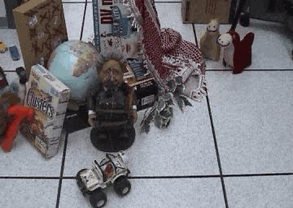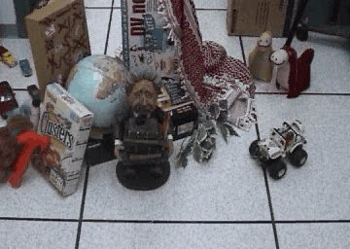
- (b)
Figure 3: Pixel movement from image (a) to image (b)

3.2 Computation of Optical Flow
In an image, each pixel corresponds to the intensity value obtained by the projection of an object in 3-D space onto the image plane. When the objects move, their corresponding projections also change position in the image plane. Optical flow is a vector field that shows the direction and magnitude of these intensity changes from one image to the other.
Computation of differential optical flow is, essentially, a two-step procedure:
1. Measure the spatio-temporal intensity derivatives (which is equivalent to measuring the velocities normal to the local intensity structures)
2. Integrate normal velocities into full velocities, for example, either locally via a least squares calculation or globally via a regularization.

There are clear mathematical relationships between the magnitude of the optic flow and where the object is in relation to you. If you double the speed with which you travel, the optic flow you see will also double. If an object is brought twice as close to you, the optic flow will again double. Also the optic flow will vary depending on the angle between your direction of travel and the direction of the object you are looking at. The optic flow is the fastest when the object is to your side by 90 degrees, or directly above or below you. If the object is brought closer to the forward or backward direction, the optic flow will be less. An object directly in front of you will have no optic flow, and appear to stand still.

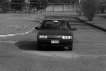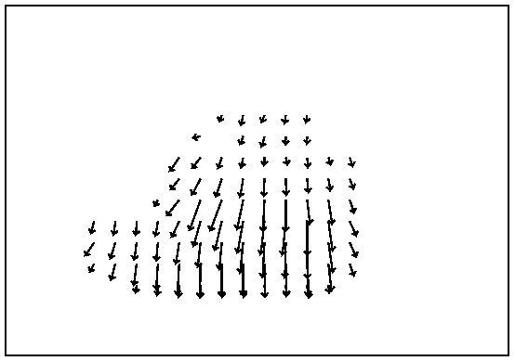
- (b)
Figure 4: a) Original Video b) Optical Flow representation of (a)

From this figure, we see that the flow vectors appear to emanate from a central point known as the focus of expansion [Gibson, 1979], and that points closer to the camera move more quickly across the image plane. Properties like this are thought to be important for biological vision systems [Gibson, 1979] and have been exploited in machine vision to track moving objects [Papanikolopoulos and Khosla, 1991],recover observer motion [Lawton, 1983], detect obstacles [Ancona, 1992], avoid collisions [Nelson and Aloimonos, 1989] and recover scene depth [Adiv,1985].
There are other, non-robotic, applications of optical flow as well; particularly in the areas of medical imaging and image compression [Pratt, 1979].

3.3 Optical Flow Assumptions
The common assumption taken while calculating optical flow is brightness consistency.
That is, image measurements (example brightness) in a small region remain the same although their location may change.
Optical flow calculation assumes spatial coherence and temporal persistence.

Spatial Coherence:

- Neighboring points in the scene typically belong to the same surface and hence typically have similar motions.
- Since they also project to nearby points in the image, we expect spatial coherence in image flow.

Temporal Persistence:

- The image motion of the surface patch changes gradually with time.

3.4 The 2D Motion Constraint Equation
The optical flow methods try to calculate the motion between two image frames which are taken at times t and t + δt at every voxel position. These methods are called differential since they are based on local Taylor series approximations of the image signal; that is, they use partial derivatives with respect to the spatial and temporal coordinates.
Assume I (x, y, t) is the center pixel in a n×n neighborhood and moves by δx, δy in time δt to I (x+δx, y +δy, t+δt). Since I (x, y, t) and I (x + δx, y + δy, t + δt) are the images of the same point (and therefore the same) we have:

I (x, y, t) = I (x + δx, y + δy, t + δt) (3.1)
This assumption forms the basis of the 2D Motion Constraint Equation and is illustrated in Figure 5.
The assumption is true to a first approximation (small local translations) provided δx, δy, δt are not too big. We can perform a 1st order Taylor series expansion about I (x, y, t) in equation (1) to obtain: 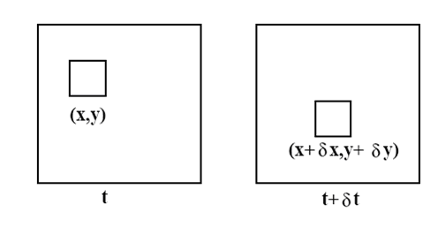

Figure 5: The image at (x, y, t) is the same as at (x + δx, y + δy, t + δt)

(3.2)
where H.O.T. means higher order terms, which are small enough to be ignored.
From these equations it follows that:

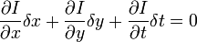

Or

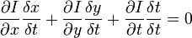 (3.3)

which results in

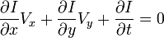 (3.4)

where V_{x},V_{y} are the x and y components of the velocity or optical flow of I(x,y,t)
and , and are the derivatives of the image at (x,y,t) in the corresponding directions. I_{x},I_{y} and I_{t} can be written for the derivatives in the following.
Thus:
I_{x}V_{x} + I_{y}V_{y} = − I_{t}
or
(3.5)
This last equation is called the optical flow constraint equation since it expresses a constraint on the components V_{x} and V_{y} of the optical flow.
This is an equation in two unknowns and cannot be solved as such. This is known as the aperture problem of the optical flow algorithms. To find the optical flow another set of equations is needed, given by some additional constraint. All optical flow methods introduce additional conditions for estimating the actual flow.

Aperture Problem: The aperture problem is that there is not enough information in a small area to uniquely determine motion.
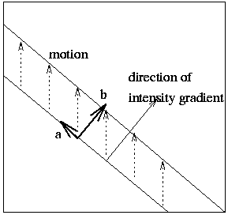
Figure 6: The aperture problem
The aperture problem is illustrated in figure 6. We are only able to measure the component of optical flow that is in the direction of the intensity gradient (Direction b). We are unable to measure the component tangential to the intensity gradient (Direction a).
Inability to determine the component of the optical flow at right angles to the direction of motion is known as the aperture problem.
In order to solve the aperture problem, we impose additional constraints.

3.5 Horn–Schunck Method
The Horn–Schunck method of estimating optical flow is a global method which introduces a global constraint of smoothness to solve the aperture problem. Thus, it tries to minimize distortions in flow and prefers solutions which show more smoothness.
The flow is formulated as a global energy functional which is then sought to be minimized. This function is given for two-dimensional image streams as:
(3.6)
where Ix, Iy and It are the derivatives of the image intensity values along the x, y and time dimensions respectively, is the optical flow vector, and the parameter α is a regularization constant. Larger values of α lead to a smoother flow. This functional can be minimized by solving the associated Euler–Lagrange equations. These are
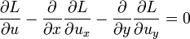
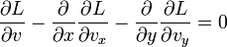
where L is the integrand of the energy expression, giving
I_{x}(I_{x}u + I_{y}v + I_{t}) − α²Δu = 0
I_{y}(I_{x}u + I_{y}v + I_{t}) − α²Δv = 0
where subscripts again denote partial differentiation and 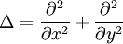 denotes the Laplace operator. In practice the Laplacian is approximated numerically using finite differences, and may be written where is a weighted average of u calculated in a neighborhood around the pixel at location (x,y). Using this notation the above equation system may be written
which is linear in u and v and may be solved for each pixel in the image. However, since the solution depends on the neighboring values of the flow field, it must be repeated once the neighbors have been updated. The following iterative scheme is derived:
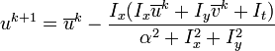 (3.7)
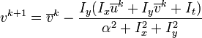 (3.8)
where the superscript k+1 denotes the next iteration, which is to be calculated and k is the last calculated result. This is in essence the Jacobi method applied to the large, sparse system arising when solving for all pixels simultaneously.
Advantages of the Horn–Schunck algorithm
- Yields a high density of flow vectors, i.e. the flow information missing in inner parts of homogeneous objects is filled in from the motion boundaries.
Disadvantages of the Horn–Schunck algorithm
- It is more sensitive to noise than local methods.

  - Lucas–Kanade Method

The Lucas–Kanade method is a two-frame differential method for optical flow estimation developed by Bruce D. Lucas and Takeo Kanade. It introduces an additional term to the optical flow by assuming the flow to be constant in a local neighbourhood around the central pixel under consideration at any given time.
The additional constraint needed for the estimation of the flow field is introduced in this method by assuming that the flow (V_{x},V_{y}) is constant in a small window of size mXm with m > 1, which is centered at Pixel x,y and numbering the pixels within as 1...n, n = m2, a set of equations can be found:
(3.8)
With this there are more than two equations for the two unknowns and thus the system is over-determined.
Hence:
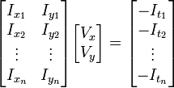 (3.9)
or
(3.10)

To solve the over-determined system of equations, besides other methods, the least squares method can also be used:
or
or
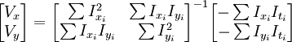 (3.11)
with the sums running from i=1 to n.
This means that the optical flow can be found by calculating the derivatives of the image along all dimensions. A weighting function W(i,j), with should be added to give more prominence to the central pixel of the window. Gaussian functions are preferred for this purpose however, other functions or weighting schemes are also possible. Besides computing local translations, the flow model can also be extended to affine image deformations.
The Lucas-Kanade algorithm can be used in combination with statistical methods to improve the performance in presence of outliers as in noisy images. A statistical analysis marks the outliers and the flow is then estimated based on the remaining equations or weighted accordingly.
When applied to image registration, such as stereo matching or images with large displacements, the Lucas–Kanade method is usually carried out in a coarse-to-fine iterative manner, in such a way that the spatial derivatives are first computed at a coarse scale in scale-space (or a pyramid), one of the images is warped by the computed deformation, and iterative updates are then computed at successively finer scales.

Advantages of the Lucas–Kanade algorithm
- Robust in the presence of noise
Disadvantages of the Lucas–Kanade algorithm
- One of the characteristics of the Lucas–Kanade algorithm, and that of other local optical flow algorithms, is that it does not yield a very high density of flow vectors, i.e. the flow information fades out quickly across motion boundaries and the inner parts of large homogenous areas show little or no motion.
  - Classification and Overview of Existing Optical Flow Techniques

According to Barron [6] existing optical flow techniques can be classified into four categories:

- Differential techniques, like that of Horn and Schunck, use the derivatives of image intensity.
- Matching techniques determine the translation for which image regions of two consecutive frames are best matched and use this for the computation of velocity.
- Energy-based techniques use the energy output of velocity-tuned filters.
- Phase-based techniques, like that of Fleet and Jepson, use the phase output of bandpass filters.

  - Limitations of Optical Flow Method

- Optical flow may be zero even when the 3-D object is in motion
Imagine a rotating sphere with a perfectly uniform surface distribution. In this case, the sphere’s image does not change in time and thus the apparent motion is zero. That is, the optical flow calculation fails for motion homogenous objects.
- Nonzero optical flow can be estimated even when the 3-D object remains still.
Imagine that the uniform sphere is stationary but a moving light source is illuminating the sphere. Since the shading of the surface changes, the points in the image of the sphere appear to move.

Chapter 4

Camera Calibration

4.1 Introduction
[23]Camera calibration often referred to as camera resectioning, is a way of examining an image, or a video, and deducing what the camera situation was at the time the image was captured. Camera calibration is used primarily in robotic applications, and when modeling scenes virtually based on real input. Traditionally, camera calibration was a difficult and tedious process, but modern software applications make it quite easy to achieve, even for home users.
One of the main uses of camera calibration is to figure out where a camera was in relation to a scene in a photograph. Let’s say you’ve taken a picture of a large room with a gridded floor, and in that room you’ve placed a chair and a table. You’ve then inputted that image into a modeling program, and built a 3-dimension model around the scene. Into that scene, you can then place any number of other virtual objects, such as modeled characters to interact with the scene, or other props.
Camera calibration can also be used to figure out other things about the camera in relation to the scene. For example, using formulas we can figure out the focal length that the scene was shot at. We can also figure out the skew factor of the image, and any lens distortion that may have been introduced, creating a pincushion effect. We can also figure out whether the actual camera pixels were square or not, and what the horizontal and vertical scaling factors for the pixels might have been.
One can also use camera calibration or resectioning to take an image sent to a computer, and figure out where various coordinates are in the real world. This type of deduction is crucial to the functioning of robots that are meant to interact visually with the physical world. These robots can then use a photographic or video input, device and calibrate in order to figure out where objects it sees might actually be in the real world, in actual terms of distance and vector.
This is one of the major areas of study in robotics, as faster, more accurate, methods of resectioning allow robots to interact with the world in more sophisticated ways. A robot with a poor ability to discern the distance of objects will have to rely largely on trial and error to move over terrain or manipulate object, whereas one that is able to accurately model its own place in the world in relation to other objects, is able to move seamlessly and fluidly in the world.
In our application, the camera is fixed with a fixed and limited field of view (FOV). The camera calibration is done using Camera calibration toolbox [19].The internal parameters (Focal length, Skew factor, Distortion, Principal point, Pixel error) and external parameters (Rotation matrix, Translation matrix) of the camera are computed and stored for processing. The 2D centroid coordinates obtained are then converted to 3D coordinates using camera calibration parameters [20]. Since the vehicle travels in straight line one of the 3D coordinate remains constant. We assume z-coordinate to be constant.

  - Camera Model

4.2.1 Introduction
To recover the imaging process parameters, the first and most natural information one needs is the camera location with respect to a fixed coordinate frame. The origin of the camera reference frame is positioned at the center of projection of the line. So, the camera looks from this point to the outside world. The z-axis of the camera frame corresponds to the optical axis. This is an imaginary axis passing through the middle of lens. The x-axis is parallel to the horizontal axis of the image from left to right and y-axis is parallel to the vertical axis in the upward direction.

The world and cameras’ coordinate system are related through a set of parameters, such as the focal length of the lens, the position and orientation of the camera, and the position of the principal point. The camera parameters are divided into two groups: the extrinsic and intrinsic parameters. The extrinsic parameters can change with time and describes the position and orientation of the camera, and the intrinsic parameters are permanent in the camera and do not change with time, such as the focal length and the position of the principal point.

4.2.2 Extrinsic Parameters
The extrinsic parameters describe the external conditions of the camera, which are its position and attitude. To describe the position of the camera, the translation T and the rotation R of an absolute coordinate system fixed on calibration target is expressed in the camera coordinate system. With the use of homogenous coordinates (see Appendix D for a detailed explanation of homogenous coordinates) it is possible to express the rotation and translation in the same transformation matrix as it is now apparent that only six extrinsic parameters are needed to express the external condition of the camera. These are the three parameters that define the attitude of the camera and the three coordinates of the translation vector.
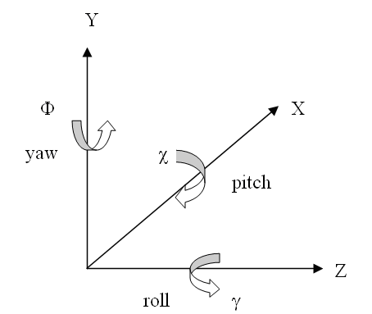
Figure 7: Diagram of Pitch, Yaw and Roll

The attitude of the camera is often expressed with the Euler angles: roll (γ), pitch (χ), and yaw (Φ). The attitude (or rotation matrix) of the camera can be computed by considering rotation around each axis. The direction of rotation is assumed to be in clockwise direction around the axis when looking down axis from the origin as shown in Fig.7.
The three rotation matrices corresponding to three axes are constructed as:
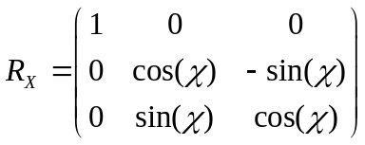
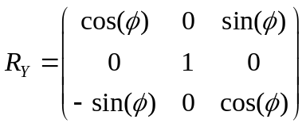 (4.1)

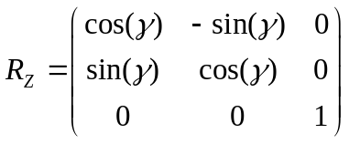
A series of rotation can be performed through successive multiplication of the transformation matrices from right to left. For e.g. For composing three elementary rotations: x-roll followed by y-roll and then a z-roll, the overall rotation is given by:
R = R_{Z}. R_{Y}. R_{X}

On putting the values from (4.1), we get

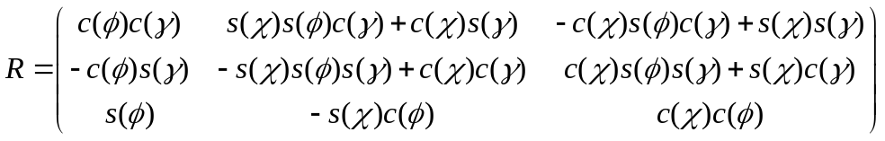(4.2)

where c = cos and s = sin

4.2.3Intrinsic Parameters
A camera transforms the real 3D space into a 2D image plane. The focal length in pixels (αx , αy), coordinate of image center in pixels (u0, v0) and skew parameter (s) forms the intrinsic parameters of a camera. They form a 3*3 upper triangular matrix called as calibration matrix.

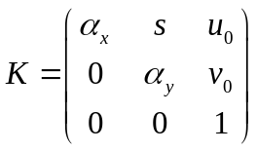 (4.3)

By combining the camera extrinsic and intrinsic parameters, a camera projection matrix P (of order 3*4) is formed as:

P = K [R | T] (4.4)

Extrinsic Parameters
Intrinsic Parameters
3D World Coordinates
3D Camera Coordinates
2D Image Coordinates
Figure 8: Parameter to relate the world, camera and image coordinate system

Chapter 5

Description of Method

5.1 Preprocessing

5.1.1 Calibration Parameters
The camera is mounted on a fixed height. The video sequence was captured using a digital camera and was then converted to 120X160 pixel resolution and 15 fps sample rate video.
The Camera calibration parameters are calculated using camera calibration toolbox [19].
The intrinsic parameters (Focal length, Skew factor, Distortion, Principal point, Pixel error) and extrinsic parameters (Rotation matrix, Translation matrix) are calculated and stored for further analysis.
The camera calibration is done as a one time activity hence saves computational overhead.

5.1.2 Pixel to Distance Ratio (c_{to}d)
The world coordinates obtained using [20] give the position of the object in world space. However, the distance traveled by the car in world space (in millimeters) does not signify the actual distance traveled. Pixel to Distance ratio maps coordinate distance to actual distance.
Assuming that the studied road is planar and straight, given one known ground distance along the road axis, 1D measurement of vehicle position in the correctly scaled road direction is possible [24].
For a small motion of the vehicle, the distance actually traveled by the vehicle is measured manually. This distance is represented as d_{manual} (in centimeters).
Let A(x₁,y₁) and B(x₂,y₂) be the 2D coordinates of the starting and end point of motion of the vehicle respectively. The corresponding world space coordinates of A and B is calculated [20].

A (x₁, y₁) → A(X₁, Y₁, Z₁)
B (x₂,y₂) → B(X₂, Y₂, Z₂)

d_{calculate} = √ (X₁-X₂)² +(Y₁-Y₂)²+(Z₁-Z₂)² (5.1)
_{where} d_{calculate} (in millimeters) is the distance traveled by the vehicle in 3D space.
The pixel to distance ratio is calculated as:

c_{to}d = d_{manual} ÷ d_{calculate} _{(5.2)}

The coordinate to distance ratio (ctod) represents actual distance traveled by the vehicle in centimeters for 1mm apparent distance traveled by the vehicle in image frames.
Calculating coordinate to distance ratio is a one time activity and ratio is stored.

5.2 Steps Followed

- Input Video stream is captured.
- Convert AVI file from RGB to Intensity.
- The Intensity is then sent to Optical Flow block and velocity vectors in the form of matrix are obtained.
- The matrix is then sent to ‘Threshold and Region Filtering Block’.
- Inside the block there is a Velocity Threshold block which calculates the mean threshold velocity and gives a binary threshold image.
- This Threshold image is then divided into 2 halves using Submatrix block and processed individually. The video sequence is sent to Blob Analysis block. This block calculates statistics for labeled regions in a binary image. These labeled regions are known as blob.
- The Blob Analysis block returns region of motion and the coordinates of centroid of the moving objects in the video sequence.
- The Threshold Image (in Binary form), coordinates of Bounding box and centroid are sent to ‘Display Results’ block.
- Centroid is superimposed on the original video using Draw Markers block.
- The video obtained in step (9) is subtracted from original (divided) video to obtain image with centroid only.
- The individual halves are stored in different AVI files.
- The halves are concatenated to obtain the video sequence with superimposed centroid.
- The video is then read and converted to frames.
- Each image is converted from gray level to binary.
- Reading each frame, the 2D coordinates of centroid for car are extracted and stored in a matrix with corresponding frame number.
The structure of the matrix is such that:
Frame Number | x - coordinate | y - coordinate

- The calibration parameters for the fixed camera (calculated earlier) are used to convert 2D coordinates to 3D coordinates. That is, 2D Image coordinates are converted to 3D World coordinates using calibration parameters.
A new matrix is obtained:
Frame Number | X - Coordinate | Y - Coordinate | Z - Coordinate

- The Euclidean distance between each successive matrix element is calculated.
Distance between 2 centroid P (x_{i,,}y_{i}, z_{i}) and Q(x_{j,,}y_{j}, z_{j}) in world space is calculated as

dist_{ij} = √ (x_{i}-x_{j})² +(y_{i}-y_{j})²+(z_{i}-z_{j})² ^{(5.3)}
Where n= total number of frames captured, i= 1 to n-1 and j=i+1 to n

- The total distance traveled (in millimeters) by the object across the images is calculated.
Total number of world coordinates traveled (in mm) is given by:
^{n-1, n}
D = ∑ dist_{ij} _{(5.4)}
^{i=1, j=i+1}
- This distance is converted to actual distance traveled (in centimeters) using pixel to distance ratio (c_{to}d) which is calculated earlier (from preprocessing).
The total distance traveled by the vehicle under consideration is calculated as:
d_{traveled} = D * c_{to}d _{(5.5)}
where d_{traveled} (in centimeters) is the total distance traveled by the vehicle.

- The time of the motion (in seconds) is calculated using the following relation:
t_{traveled} = n / fps (5.6)
where n = number of frames for which motion of car was studied,
fps = frame rate of the AVI (number of frames per second) . This is obtained from the AVI information.

- Estimated velocity of the vehicle in centimeters per second is calculated as:
Vel (cm/s) = d_{traveled} (cm) / t_{traveled} (s) (5.7)

- Steps 13 to 21 are repeated for second half of the video sequence.

Chapter 6

Implementation

Block Diagram

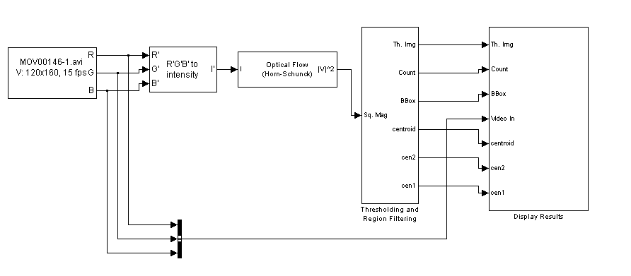
Figure 9 : Input Block

Input Block

The input block is “From Multimedia File” Block. The From Multimedia File block reads video frames and/or audio samples from a multimedia file and import them into a Simulink model. Video processing requires the Video and Image Processing Blockset. The output ports of the From Multimedia File block change according the content of the multimedia file. If the file contains video frames, the R, G, and B ports appear on the block. If the file contains audio samples, the Audio port appears on the block. The choices of output depend on the multimedia file and can include Video only, Audio only, or Video and audio.

RGB to Intensity Block

This is a “Color Space Conversion” block. It converts color information between color spaces. Use the Conversion parameter to specify the color spaces you are converting between. Your choices are R'G'B' to Y'CbCr, Y'CbCr to R'G'B', R'G'B' to intensity, R'G'B' to HSV, HSV to R'G'B', sR'G'B' to XYZ, XYZ to sR'G'B', sR'G'B' to L*a*b*, and L*a*b* to sR'G'B'.

Optical Flow

The Optical Flow block estimates the direction and speed of object motion
from one image to another or from one video frame to another using the Horn-Schunck method. Input to this block is the Video and output is either matrix of velocity magnitudes (|V|^2) or matrix of velocity components in complex form (V).

The squared velocity magnitude is then sent to ‘Thresholding and Region Filtering Block’ shown in Figure 10. This block contains two parts: Velocity Threshold and Region Filtering.
The Velocity Threshold block calculates the threshold velocity and using that generates the Threshold Image.
The Region Filtering block uses the segmented / threshold image and calculated the statistically connected regions.
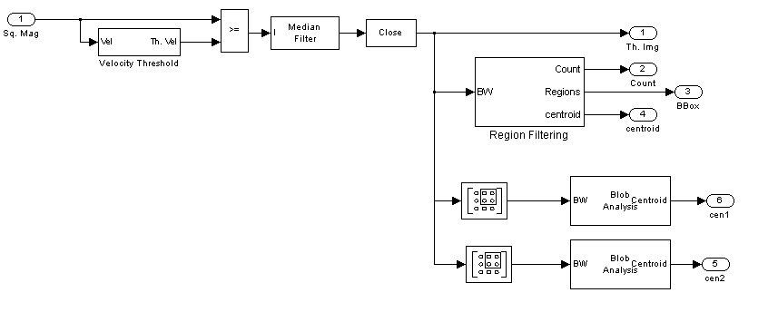
Figure 10: Thresholding and Region Filtering Block

Velocity Threshold block

Thresholding is the simplest method of image segmentation. The process of thresholding returns a threshold image differentiating the objects in motion (in white) and static background (in black). More precisely, it is the process of assigning a label to every pixel in an image such that pixels with the same label share certain visual characteristics.

This block calculates the threshold velocity from the velocity components obtained from optical flow block. Below is the block diagram of this block:

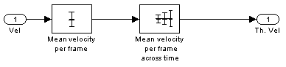

Figure 11: Velocity Threshold Block
Mean velocity per frame

This is a “2D Mean” block. The 2-D Mean block computes the mean of each input matrix or the mean value in a sequence of inputs over time. It can also compute the mean over a particular region of interest (ROI).

Mean velocity per frame across time

This is“2D Mean” block. The block works in running mean mode, i.e. the block computes the mean for each element of a series of M-by-N inputs.

Median Filter

A Median Filter is then applied to remove salt and pepper noise from the thresholded image without significantly reducing the sharpness of the image Median filtering is a simple and very effective noise removal filtering process and an excellent filter for eliminating intensity spikes.
The Median Filter block replaces the central value of an M-by-N neighborhood
with its median value. If the neighborhood has a center element, the block places the median value there. If the neighborhood does not have an exact center, the block has a bias toward the upper-left corner and places the median value there. The block pads the edge of the input image so, pixels within [M/2 N/2] of the edges may appear distorted because the median value is less sensitive than the mean to extreme values. The Median Filter block can remove salt and pepper noise from an image without significantly reducing the sharpness of the image. Use the Neighborhood size parameter to specify the size of the neighborhood over which the block computes the median. We can enter a scalar value that represents the number of rows and columns in a square matrix or a vector that represents the number of rows and columns in a rectangular matrix.

Submatrix block

The Submatrix block extracts a contiguous submatrix from the M-by-N input matrix u. A length-M 1-D vector input is treated as an M-by-1 matrix. The Row span parameter provides three options for specifying the range of rows in u to be retained in submatrix output y:
All rows - Specifies that y contains all M rows of u.
One row - Specifies that y contains only one row from u. The Starting row parameter is enabled to allow selection of the desired row.
Range of rows - Specifies that y contains one or more rows from u. The Row and Ending row parameters are enabled to allow selection of the desired range of rows.
The Column span parameter contains a corresponding set of three options for specifying the range of columns in u to be retained in submatrix y: All columns, One column, or Range of columns.
The One column option enables the Column parameter, and Range of columns options enables the Starting column and Ending column parameters.
The output has the same frame status as the input.

Blob Analysis block

The labeled region in the binary image is then statistically analyzed. For each frame, the Blob analysis block of Matlab calculates the statistics for the connected region of binary image obtained by previous operations. This block returns 4-by N matrix of bounding box coordinates, 2 by N matrix of centroid coordinates, where N is the number of blobs.

Variable Selector block

The Variable Selector block extracts a subset of rows or columns from the M-by-N input matrix u at each input port. You specify the number of input and output ports in the Number of input signals parameter. When the Select parameter is set to Rows, the Variable Selector block extracts rows from each input matrix, while if the Select parameter is set to Columns, the block extracts columns.

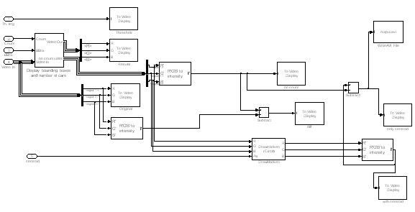
Figure 12 : Display Results Block

This block displays results in desired fashion. Below are the components of this block:

Threshold Image

The Threshold image differentiating the objects in motion (in white) and static background (in black) is displayed using “To Video Display” block.

Bus Creator

The Bus Creator block combines a set of signals into a bus, i.e., a group of signals represented by a single line in a block diagram. The Bus Creator block, when used in conjunction with the Bus Selector block, allows you to reduce the number of lines required to route signals from one part of a diagram to another. This makes your diagram easier to understand.

Bus Selector

The Bus Selector block outputs a specified subset of the elements of the bus at its input. The block can output the selected elements as multiple standalone signals or as elements of a new bus. When selecting elements from the bus, each element is output from a separate port from top to bottom, or left to right, on the block.

Draw Markers block

The Draw Markers block can draw multiple circles, x-marks, plus signs, stars, or squares on images by overwriting pixel values. As a result, the shapes are embedded on the output image. This block uses Bresenham's circle drawing algorithm to draw circles and Bresenham's line drawing algorithm to draw all other markers. This block is used to draw circles representing centroid of moving cars.

Chapter 7

Experimental Results and Conclusion

7.1 Simulation Results
All the coding and matrix representations have been implemented in MATLAB.
The proposed method was subjected to various experiments in order to check its accuracy and feasibility.
As a process of initialization, camera is calibrated and coordinate to distance ratio is calculated. Further, the video sequences were captured using a digital camera with 15 fps sample rate and resizing the images to 120 X160 pixel resolution.

7.1.1 Tracking One Vehicle
The proposed method was first implemented for one vehicle. A camera was mounted on a height and the video was captured. The calibration parameters were calculated using Calibration toolbox. The pixel to distance ratio was calculated and was stored for further analysis.
The experiment was repeated for multiple videos and the result is tabulated.
Below are the output results in the form of images.

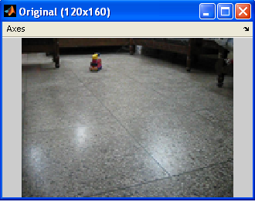
Figure 13: Original Video Clip

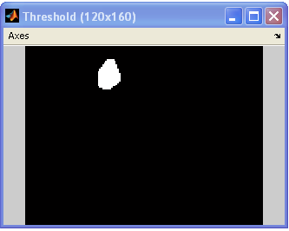
Figure 14: Threshold Image
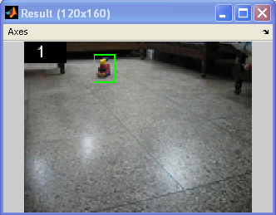
Figure 15: Tracking the Vehicle

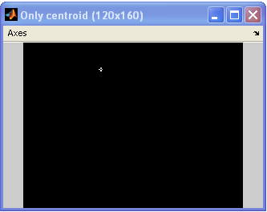
Figure 16: Centroid of the Vehicle
Using the centroid location in Image space, the vehicle path was estimated. The 3D plot is between 2D coordinates of centroid and the corresponding frame number. Thus, the vehicle trajectory is estimated and shown in Figure 17.
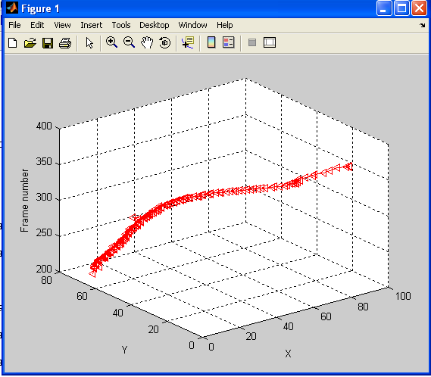

Figure 17: Vehicle Trajectory

Table 1: Comparison of Measured and Calculated Velocity (Single Vehicle)
Measured Velocity  v(cm/s) | Computed Velocity  v′ (cm/s) | Error  │v-v′│(cm/s) | % Error
18.90 | 18.59 | 0.31 | 1.6
18.71 | 18.424 | 0.288 | 1.54
25.82 | 26.096 | 0.276 | 1.06
26.69 | 26.58 | 0.109 | 0.412
24.62 | 24.54 | 0.0784 | 0.318

7.1.2 Tracking Multiple Vehicles
The proposed method was then extended for two vehicles. The video stream was divided into two halves and the process of tracking and speed estimation was repeated.

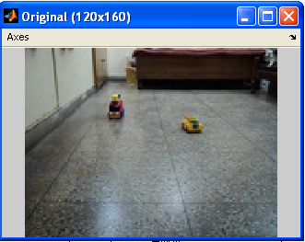

Figure 18: Original Video with Two Vehicles at different speeds

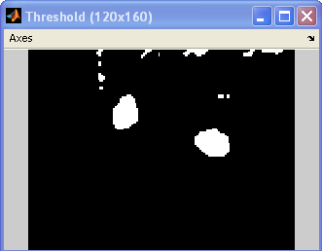

Figure 19: Threshold Image with moving vehicle (white) & background (black)
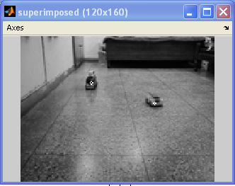

Figure 20: Centroid for each vehicle is superimposed

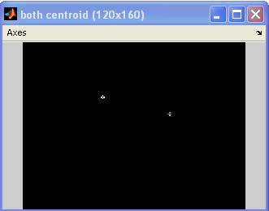

Figure 21: Image showing only centroid for each vehicle

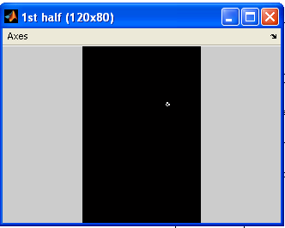

Figure 22: First half
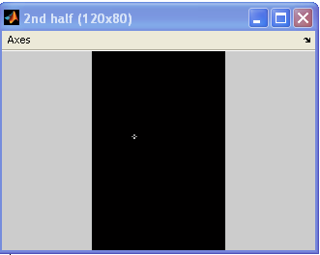

Figure 23: Second half

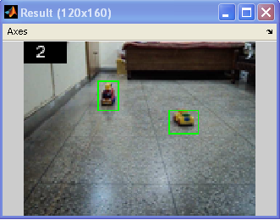

Figure 24: Tracking two vehicles using Blob

The 2D coordinates of centroid for each vehicle are used to plot their respective trajectories. Figure 21 shows vehicle path in image space for each vehicle plotted against the respective frame numbers.
A number of video sequences are then studied and the result is tabulated in
Table 2.
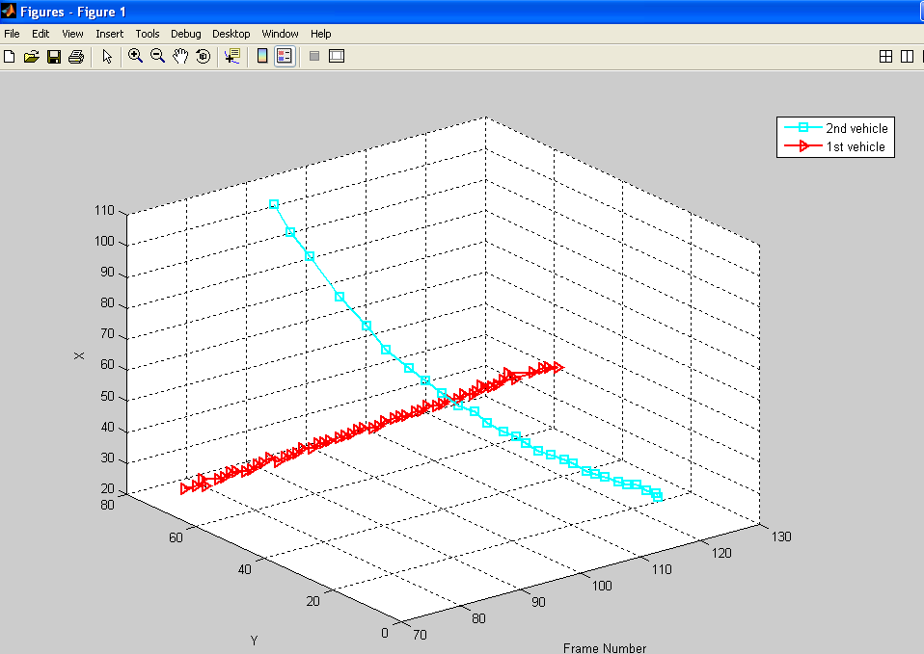

Figure 25: Vehicle Trajectory for both vehicles

Table 2: Comparison of Measured and Calculated Velocity (Multiple Vehicles)

Measured Velocity  (cm/s) |  | Computed Velocity  (cm/s) |  | Error  │v-v′│  (cm/s) |  | % Error
V1 | V2 | V1’ | V2’
5.625 | 38.50 | 5.5585 | 38.4595 | 0.0665 | 0.0405 | 1.182 | 0.105
9.4158 | 41.81 | 9.4842 | 42.0147 | 0.0683 | 0.2047 | 0.7264 | 0.346
11.705 | 28.70 | 11.6879 | 28.4646 | 0.017 | 0.2358 | 0.146 | 0.821
10.896 | 33.94 | 10.439 | 33.6008 | 0.4572 | 0.339 | 4.19 | 0.999
9.7839 | 44.424 | 9.3365 | 44.1545 | 0.0447 | 0.269 | 0.457 | 0.6055

7.2 Conclusion
The system works overall as expected. The vehicle velocity can be estimated to a relatively high accuracy of about ±0.212 cm/sec and within a percentage error of 0.986 % for one vehicle.
For a two vehicle tracking system, the velocity estimation error is about ±0.130 cm/sec and ±0.217 cm/sec accurate and falls within the permissible percentage error of 1.34 % and 0.57 % for each vehicle.

It outperforms advanced algorithms in terms of lower computational power needed, and is more stable then the fast ones. The method requires only one time calculation of the camera parameters and coordinates to distance ratio and hence saves computational overhead.

Not too surprisingly, the work in this dissertation has by no means addressed all the issues. This method is more successful when the camera is stationary with a moving object in view. In the case of a moving camera the overall global flow will "hide" objects moving against the motion of the camera.

The algorithms and methods have been implemented in Mat lab in this dissertation. If these should be used in future projects they probably need to be improved and coded in another faster language and with a specific hardware that handles the calculations.

The proposed method can be used for speed estimation of moving robots or even moving traffic. The method is simple and computationally inexpensive. The methods used in the existing literature for velocity estimation are quite complex and even require different terrine for velocity estimation which is impossible for a moving traffic.

Bibliography

- Chi-Cheng Cheng, and Hui-Ting Li .‘Feature-Based Optical Flow Computation’ .International Journal of Information Technology Vol.12 No.7 2006.
- Savan Chhaniyara, Pished Bunnun, Lakmal D. Seneviratne and Kaspar Althoefer.
‘Optical Flow Algorithm for Velocity Estimation of Ground Vehicles: A Feasibility Study’. International Journal on smart sensing and intelligent systems, VOL. 1, NO. 1, MARCH 2008.
- E. Atkoˇci ¯unas, R. Blake, A. Juozapaviˇcius, M. Kazimianec. ‘Image Processing in Road Traffic Analysis’. Nonlinear Analysis: Modelling and Control, 2005, Vol. 10, No. 4, 315–332.
- Alan M. McIvor.‘Background Subtraction Techniques’.
- P.H.S. Torr, A Zisserman, ‘Feature-Based Method for Structure and Motion Estimation’, Vision Algorithms:Theory and Practice, 2000, pp 278-294.
- C. Harris, M. Stephens, ‘A Combined Corner And EdgeDetector’, Proceedings of the 4th Alvey VisionConference, 1988, pp 147-151.
- J. Weijer, ‘Robust Optical Flow from Photometric Invariants’, ICIP, Vol. 3, 2004, pp.1835-1838.
- J. Shi, C. Tomasi, ‘Good features to track’, Proc. IEEE Comput. Soc. Conf. Comput. Vision and Pattern Recogn., 1994, pp. 593-600.
- A. Akbarzadch et al., ‘Towards urban 3D reconstruction from video’, Third International Symposium on 3D Data Processing, Visualization and Transmission, June 2006.
- C. Fermuller, D. Shulman, and Y. Aloimonos, ‘The Statistics of Optical Flow’, Computer Vision and Image Understanding 82, pages 1–32, 2001.
- C. Braillon, C. Pradalier, J. Crowley, C. Laugier, ‘Real-time moving obstacle detection using optical flow models’, Proc. of the IEEE Intelligent Vehicle Symp., 2006, pp.466-471.
- A. Dev, B.J.A Krose, F.C.A. Green, ‘Heading Direction for a Mobile Robot from Optical Flow’, Proc. of the IEEE International Conference on Robotics & Automation, Leuven, Belgium, May 1998.
- B.K.P. Horn, B.G. Schunk, ‘Determining Optical Flow’,Artificial Intelligence, Vol. 2, 1981, pp 185-203.
- J.L. Barron, D.J. Fleet, S.S. Beauchemin, T.A. Burkitt,’Performance of Optical Flow Techniques’, Computer Society Conference on Computer Vision and Pattern Recognition, 1992, pp. 236-242.
- T. Brox, A. Bruhn, N. Papenberg, J. Weickert, ‘High Accuracy Optical Flow Estimation Based on a Theory for Warping’, Proc. 8th European Conference on Computer Vision, Springer LNCS 3024, vol. 4, 2004, pp. 25-36.
- S. Baker, I. Matthews, ‘Lucas-Kanade 20 Years On: A Unifying Framework’, IJCV, Vol. 56, No. 3, March 2004,pp. 221-255.
- J.L. Barron, N.A. Thacker, ‘Tutorial: Computing 2D and 3D Optical Flow’, Tina Memo No. 2004-012, 2005.
- Gibson J.J., ‘On the analysis of change in Optic array’, Scandinavian J. Psychol.
- J.Y. Bouget .’Camera Calibration Toolbox For Matlab’.
http://www.vision.caltech.edu/bouget/calib_doc/.
- Davide Scaramuzza. ‘Omnidirectional Camera and Calibration Toolbox for Matlab’.
- Gibson J.J., “The Perception of the Visual World”, Riverside Press,Cambridge 1950.
- Gibson J.J., “The senses considered as Perceptual Systems”, Houghton-Mifflin,Boston,M.A,1966.
- http://www.wisegeek.com/
- Lazaros Grammatikopoulos, George Karras, Elli Petsa, “Automatic Estimation of Vehicle Speed from Uncalibrated Video Sequences”, International Symposium on Modern Technologies, Education and Professional Practice in Geodesy and related fields, Sofia, 03 – 04 November, 2005.
- Matter from
www.wikipedia.com
www.google.com

