Echtzeitsysteme

Project Description “Car Locking System”
Prof. Dr. Jörg Friedrich

Table of Contents
1 Introduction 2
2 System Overview 2
Features 3
Sensors and Input Elements 3
Actuators and Display Elements 3
Lock Operating States 4
3 Implementation Constraints 4
4 Problem Solving Procedure 5
Requirements Development 5
Design 6
Implementation on Host 6
Implementation on Target 7
System Integration 7
System Tests 7
When are You Done? 8
5 Supporting Processes 8
Project Management 8
Configuration Management 8

Introduction
In this project you shall develop the software for an automobile locking system. You shall use the Dragon12 board with a stepper motor, switches, and sensors to simulate the function of a single door. As part of this project you are supposed to combine 5 of these modules to a complete system for a car with four doors and a trunk lock.

System Overview
The system shall provide a reasonable feature set as is state of the art in current car models. You are responsible to create enough features to satisfy your customers, this hand out does not provide a full specification!
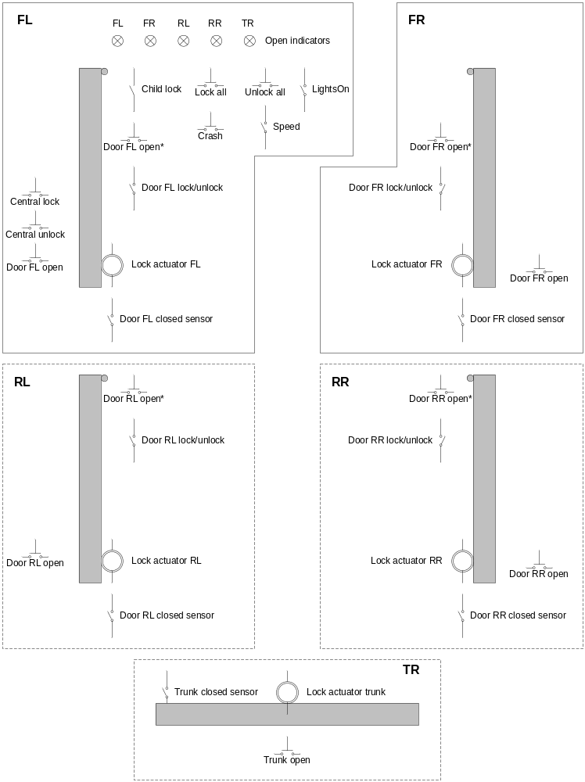
Figure 1: Electrical elements for the car locking system
The reason is that in the process of engineering the locking system you shall use requirement engineering techniques to develop good requirements.

Features
To assist you in the process, the following list of features shall be provided:
- Central locking and unlocking; all locks shall be handable from one place
- Child security locking; children may not open the rear doors from the inside
- Theft avoidance support; doors cannot be unlocked from the inside.
- Acoustic reminder if lights have been left on and driver’s door is opened
- Crash detection; unlock all doors some time after crash
- Crash safety; doors are automatically unlocked if communication to master controller is lost
- Display of open doors
- Automatic door lock after car starts moving
- Central lock/unlock from inside
- Close all windows function
Figure 1 depicts the elements that are available to you in designing your project. Some hardware engineer has already thought about the product and provided the required elements. The following sections describe some foundations of car locking systems.
FL stands for front left (door), FR stands for front right, RL for rear left, RR for rear right, and TR for trunk.

Sensors and Input Elements
Door XX open: press to open the door, this simulates the outside handle
Door XX open*: press to open the door, this simulates the inside handle
Trunk open: press to open trunk (for example from remote control)
Door XX closed sensor: detects if door is closed
Door XX lock/unlock: lock or unlock door from the inside

Central lock: press to lock all doors (for example from remote control)
Central unlock: press to unlock all doors (for example from remote control)
Child lock: prevent children from opening the rear doors from the inside
Crash: a crash was detected
Speed: car moves with more than 10 km/h
LightsOn: the lights are turned on (this is a sensor)
Lock all: switch inside the car to lock all doors
Unlock all: switch inside the car to unlock all doors

Actuators and Display Elements
Lock actuator XX: stepper motor that moves a lock between the unlocked, locked and theft secure statuses.
FL, FR, RL, RR, TR: LEDs indicating if one of the doors or trunk is open
Beeper: shall beep if driver’s door is open and lights are on, or car moves and doors are open

Lock Operating States
A lock can be in one of three states: opened, locked, theft secured. The difference between locked and theft secured is that in the locked state the lock can be unlocked from the inside, while in the theft secured state the lock can only be unlocked from the outside. The trunk lock only has two states: locked and unlocked.

Implementation Constraints
The implementation shall take place on a Dragon12 board provided in the lab. Each door lock shall be implemented on a separate board, and the boards shall be connected via a CAN bus system. There are four different implementations required:
- The front left door (drivers door), which acts as a master controller
- The front right door
- The rear doors
- The trunk door
To accommodate the input and output elements of the front left door controller, an extension to the Dragon12-board is required, since the board itself does not have enough switches.
The Door XX closed sensor shall be implemented using the infrared transmitter of the Dragon12 board. It shall be made sure that different boards of the same car do not interfere with each other.
The software image shall be the same for all four implementations. There shall be a code set by a DIP switch which tells the controller in what operating mode it shall be.

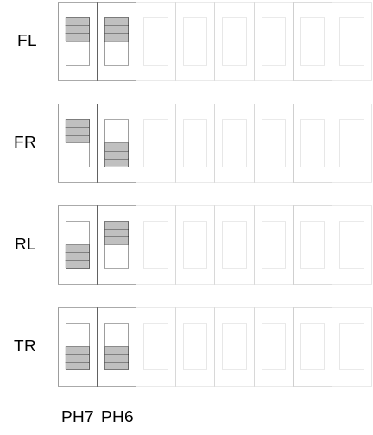
Figure 2: Operating mode and SW1 DIP switch setting

Table 1: Relation between sensors and elements on Dragon12-board

Sensor name | Element on Dragon12
Door XX open | SW2 (Port H, bit 3)
Door XX open* | SW3 (Port H, bit 2)
Trunk open | SW3 (Port H, bit 2)
Door XX closed sensor | infrared transmitter
Door XX lock/unlock | SW4 (Port H, bit 1)

Problem Solving Procedure
The problem solving procedure shall consist of the following steps in that order:
      - Develop solid requirements and document them. You may ask your instructor if there are questions you cannot answer yourself by simple reasoning and where you would need your “customer”.
      - Develop an overview schematic which shows how all sensors (switches) and actuators connect to the microcontroller (port, pin, polarity).
      - Design the system using UML notation, design your directory layout
      - Do the software construction and implementation on the host (standard PC) using either Visual .NET or DevCpp development environment
      - Develop the hardware related software functionality on the target
      - Integrate all software parts on the target
      - Integrate the entire system with five controllers
      - Execute tests and document the test results
The following roles are involved:
      - Requirements engineer (tasks 1 and 2)
      - Software architect (tasks 2, 3, and 7)
      - Software engineer (application) (tasks 4, 6, and 7)
      - Software engineer (hardware) (tasks 5, 6 and 7)
      - Integration and test engineer (tasks 1, 7 and 8)
The requirements engineer shall also act as the project manager.

Requirements Development
From the list of features provided above develop a set of requirements and a solution concept. If you are in doubt or feel that you need additional information from your “customer” ask your instructor. Assign a unique identifier to each requirement. For each requirement state a test criterion how you want to prove that this requirement has been fulfilled.
Make sure that the solution concept is not the solution itself. Try to abstract as much as possible, without loosing necessary detail. To describe the solution concept use natural language, block diagrams, state charts, activity charts, and message sequence charts.
The requirements engineer is responsible for the development of the requirement and solution concept, possibly in cooperation with the software architect and integration and test engineer.

Design
Before any software is implemented a design is required. The design should consist of UML state charts, activity charts, and message sequence diagrams (optional). You may use your solution concept as a base for the development of the design.
The first level directory layout in which the implementation shall take place has to look like:
- Application (containing all software parts common to both the host and the target environment)
- HAL-Host (containing software that represents the hardware related functions for the host environment, like switch input, LCD driver and timer events)
- HAL-Target (containing software that exercises the target hardware, like the real switch drivers, LED driver, etc.)
- IDE-Host (containing the project files for the host ide (e.g. Visual Studio or DevCpp) and the simulation input and output files)
- IDE-Target (containing the CodeWarrior project files and auxiliary files)
The main function shall be contained in a module called “main.c”. There must not be more than one “main.c”, and this “main.c” must be placed in the Application directory. There shall be no “define” to distinguish between host and target environment; this can be implemented using the IDEs by including alternate files (e.g. hidef.h containing an empty EnableInterrupts definition for the host environment).
The software architect is responsible for the design. The software architect is also responsible that the implementation corresponds to the design.

Implementation on Host
After the design is completed and discussed with peers software can be written. However, you shall not write any software for the target yet but rather write software on the development host in such a fashion that it is later on easily possible to transfer it to the target.
You therefore have to simulate switch inputs, timer events and outputs. This simulation environment shall be designed such that a simple exchange of small files shall suffice to move to the target platform. Here is an example.
You do not have a stepper motor on the host. Therefore on the host you replace the real stepper motor driver with a routine that prints out the number of steps, left or right the motor has taken. So on the host the routine contains mostly a printf()-statement, while on the target the routine with the same signature really moves the output pins to drive the stepper motor.
For the input signals you read them from an input file in case of the host, and from a driver in case of the target. You just have to make sure that the interface to the main application is the same for both cases.
The input files shall look like this (the format is important):
+10 // system advances by 10 timer ticks
SW5 // switch 5 was pressed for one tick
AD:496 // AD converter outputs 496, should be 2 min, 5 s
+5 // another 5 ticks, absolute time here 16 ticks
AD:24 // AD converter outputs 24, should be 5 s
SW5 // switch 5, increment preset by one second
SW5+1000 // switch pressed for 1000 ticks (10 seconds)
CAN 0x23 0x1f 0x44 // a CAN Message
…
You develop several input files that let you go through different scenarios. You run these input files on the host and check simulation output. Only when you have completed this step you move on.
The simulation shall generate an output file in the following format:
<tickcount> -- Stepper 16 left
<tickcount> -- Stepper 30 right
…
<tickcount> -- LED: FR .. .. .. TR
…
<tickcount> -- BeeperOn
<tickcount> -- BeeperOff
…
The simulation output file shall contain the text in the exact format described above (watch for proper spacing), and shall generate output only when displayed values change. Only the output that changes shall be written to the output file. The tickcount variable represents the number of ticks from the start of simulation as an 8 digit right aligned integer with leading spaces. Beeper On and Beeper Off events shall be output as “BeeperOn” and “BeeperOff”.
The software engineer (application) is responsible for the development of the software on the host. Close interaction may be required with the software engineer (hardware).

Implementation on Target
On the target, you need to develop special driver software for the timer, the beeper, the CAN bus, the stepper motor, the switch inputs, and the LEDs. This software you have to develop and test on the target.
After you have tested this software, you take the application that has already been simulated on the host and port it to the target. This step should require only little time and there should be no logical errors any more in the application.
The software engineer (hardware) is responsible for the development of the hardware related software on the target system.

System Integration
At this point you have to integrate five boards to a complete system. You have to connect the boards using proper cabling. You run tests to show that the system does not work as intended. You involve the software engineer (application) and the software engineer (hardware) in the integration process.
The integration and test engineer is responsible for the integration process.

System Tests
The final tests shall demonstrate that all requirements have been fulfilled. There shall be a test plan, and a complete test protocol. The test plan shall emphasize exceptional conditions and not just concentrate on standard operation.
The integration and test engineer is responsible for the final testing.

When are You Done?
Check off the following points before submitting your solution:
- The state chart design conforms to UML notation and properly and in sufficient detail describes what is going on (all states, all events)
- The directory layout is exactly as described above
- The simulation runs on the same computer where the target IDE for downloading the target software is installed (it can be your computer, but it has to be the same)
- There is no need to touch any files in the Application directory to switch between host and target environment
- The HAL-xx directories do not contain application logic, just driver software
- The C-code is of professional quality (no paths in include statements, no copy/paste style software parts, guards in include files, good names, etc.)
- The state, event, and action names from the design show up in the implementation
- The input and output file formats are exactly as described above
- Debouncing shall work properly
- The requirements are properly implemented
- Test plan has been executed and results have been documented

Supporting Processes

Project Management
You shall create a project plan with a work breakdown structure. You shall keep the project plan up to date on a weekly basis.
You shall conduct weekly project meetings, with a brief agenda, and a small protocol to summarize the meeting results.
You shall keep track of all tasks and open issues using the the issue tracking software provided to your team. All team members shall record the amount of work they have put into the project in the issue tracking system. Issues include bugs found in the integration and test process, and open points with regard to the architecture and requirements.
The status of the project shall be presented to the instructor on the dates provided in the milestone plan.

Configuration Management
All documents and source code shall be managed using the Subversion configuration management system provided to you. There shall be proper links between bug reports and the related fixes in the repository, using messages including the bug number like this: “#342”, where 342 is the bug number the fix relates to.

